Appendix. Supplemental Information

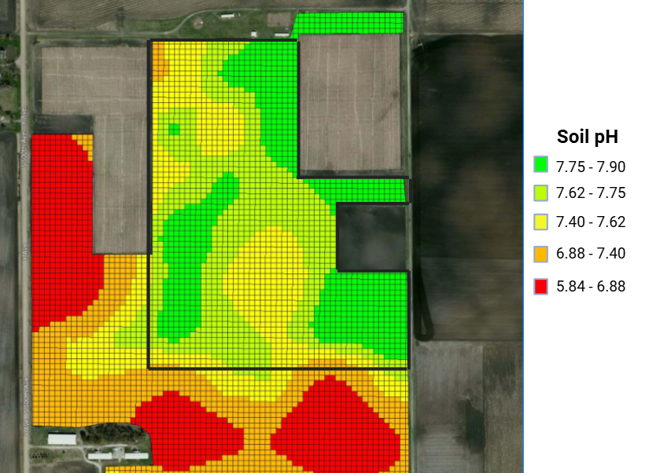
SI Figure 1. Soil pH map of the Wetland and Prairie Research and Restoration site (WPRR) in Ames, Iowa from 2016. Site boundaries are outlined in black.

SI Table 1. Scientific name and assigned abbreviation of species sampled in subplots during August of 2023. Status refers to whether the species were included in the seed mix or were volunteer species.
Scientific Name | Abbreviation | Status
Ambrosia artemisiifolia | Ambart | Volunteer
Andropogon gerardii | Andrger | Seed mix
Arnoglassum plantaginea | Arnoplant | Seed mix
Artemisia ludoviciana | Artludo | Seed mix
Asclepias incarnata | Asclincarn | Seed mix
Asclepias syriaca | Asclsyr | Seed mix
Asclepias tuberosa | Ascltub | Seed mix
Asclepias verticillata | Ascver | Volunteer
Astragalus canadensis | Astrcan | Seed mix
Baptisia alba | Baptalba | Seed mix
Bouteloua curtipendula | Boutcurt | Seed mix
Bromus inermis | Brominerm | Volunteer
Cheopodium album | Chenalb | Volunteer
Cirsium arvense | Cirsarv | Volunteer
Convolvulus arvensis | Conarv | Volunteer
Coreopsis palmata | Corepalm | Seed mix
Dalea candida | Dalcand | Seed mix
Dalea purpurea | Dalpurp | Seed mix
Desmodium canadense | Desmcan | Seed mix
Echinacea pallida | Echpall | Seed mix
Elymus canadensis | Elymcan | Seed mix
Elymus repens | Elymrep | Volunteer
Erigeron annuus | Erigann | Volunteer
Erigeron canadensis | Erigcan | Volunteer
Erynigium yuccifolium | Erynyuc | Seed mix
Euphorbia prostrata | Euphpro | Volunteer
Helianthus grosseserratus | Heligross | Seed mix
Helianthus rigidus | Heliophel | Seed mix
Heliopsis helianthoides | Helirig | Seed mix
Koeleria macrantha | Koelmacr | Seed mix
Lactuca canadensis | Lactcan | Volunteer
Lactuca serriola | Lactser | Volunteer
Lespedeza capitata | Lespcap | Seed mix
Liatris pycnostachya | Liatpyc | Seed mix
Melilotus alba | Melalb | Volunteer
Monarda fistulosa | Monfist | Seed mix
Panicum virgatum | Panvirg | Seed mix
Penstemon digitalis | Penstdig | Seed mix
Phleum pratense | Phlepra | Volunteer
Physalis heterophylla | Physhet | Volunteer
Plantago major | Plantmaj | Volunteer
Poa pratensis | Poaprat | Volunteer
Pycnanthemum virginianum | Pycnvirg | Seed mix
Ratibida pinnata | Ratpinn | Seed mix
Rudbeckia hirta | Rudbhirt | Seed mix
Rudbeckia subtomentosa | Rudsub | Seed mix
Schizachyrium scoparius | Schizsco | Seed mix
Seteria faberi | Setfab | Volunteer
Seteria pumila | Setpum | Volunteer
Seteria viridis | Setvir | Volunteer
Silphium laciniatum | Silplac | Seed mix
Solidago canadesis | Solidcan | Volunteer
Solidago gigantia | Solidgig | Volunteer
Solidago rigidum | Solidrig | Seed mix
Solidago speciosa | Solidspec | Seed mix
Sorghastrum nutans | Sorgnut | Seed mix
Sporobolus compositus | Sporcomp | Seed mix
Sporobolus heterolepis | Sporhet | Seed mix
Symphyotrichum ericoides | Sympheri | Seed mix
Symphyotrichum laeve | Symplav | Seed mix
Symphyotrichum novae-angliae | Sympnov | Seed mix
Symphyotrichum pilosum | Symppil | Volunteer
Taraxacum officinale | Taroffic | Volunteer
Thalictrum dasycarpum | Thaldasy | Seed mix
Trifolium repens | Trifpra | Volunteer
Trifolium pratense | Trifrep | Volunteer
Verbena stricta | Verbstr | Seed mix
Vernonia fasciculata | Vernfas | Seed mix
Zizia aurea | Ziziaur | Seed mix

SI Table 2. Terms in split-plot ANOVA models for each response (Y) variable used.
Model
Y ~ Grass ratio + Replicate : Grass ratio + pH Treatment + Grass ratio * pH Treatment

