Suplementary material
Combined toxicity of chlorpyrifos and nanoplastics in the marine amphipod Parhyale hawaiensis: implications for chlorpyrifos risk assessment in Latin American coasts
Shirley V. Daniela Fonseca-Peñaª*; Juan de Jesús Chi-Domínguezª, Uriel Arreguin-Rebolledo^{b}; Marcela Cabrera^{c}, Mariana V. Capparelli^{a*}

ª Estación El Carmen, Instituto de Ciencias del Mar y Limnología, Universidad Nacional Autónoma de Mexico, Carretera Carmen-Puerto Real Km 9.5, 24157, Ciudad del Carmen, Campeche, Mexico.
^{b}Unidad Académica Mazatlán, Instituto de Ciencias del Mar y Limnología, Universidad Nacional Autónoma de México, Calle Joel Montes Camarena s/n, Mazatlán Sinaloa 82000, Mexico.
^{c}Grupo de Investigación de Recursos Hídricos y Acuáticos, Facultad de Ciencias de la Vida, Universidad Regional Amazónica Ikiam, Tena, Ecuador.
*Corresponding authors
E-mail: mcapparelli@cmarl.unam.mx (M. Capparelli)
E-mail: shirleyvdanielafonsec@gmail.com (S.V.D. Fonseca-Peña)

Culture quality (Control-chart)
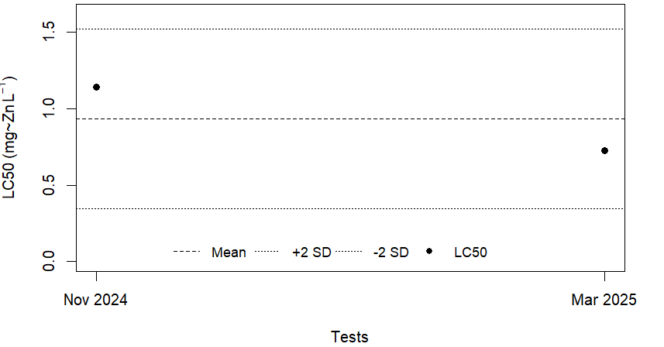
Figure S1. Culture quality of Parhyale hawaiensis with acute toxicity tests using zinc (Zn) as a reference toxicant during the test period. SD: standard deviation; LC50: mean lethal concentration.

Table S1. Operating conditions for the GC-NPD
Column | Rtx-OPP2-30ms
Gas carrier | Helium
Flow | 1 ml min⁻¹
Gradiente | Initially 65 °C
Gradiente | 20 °C·min⁻¹ to 180 °C (hold time of 2 min)
Gradiente | 5 °C·min⁻¹ to 280 °C (hold time of 3 min)
Injection volume | 3 ul
Injection temperature | 250°C
Injection mode | Splitless
Detector temperature | 300°C

Table S2. (A) Measured concentrations of chlorpyrifos at the initial and after four (4) days of exposure. B. Measured concentrations of chlorpyrifos in water in the presence of 100 µg/L polyethylene nanoparticles (NPs-Low). C. Measured concentrations of chlorpyrifos in water in the presence of 1000 µg/L polyethylene nanoparticles (NPs-High). Dissipation rate constant (k), half-life values (DT50). (ND) not detected, (-) not measured.

A.
Nominal concentration (µg/L) | Measured initial concentration (µg/L) | Measured concentration 4 days (µg/L) | K | DT50 | Disspation %
Control | ND | -
0.01 | 0.01 | 0.009 | 0.03 | 26.32 | 10
0.1 | 0.12 | 0.09 | 0.07 | 9.64 | 25
1 | 0.98 | 0.6 | 0.12 | 5.65 | 39
10 | 12.02 | 6.4 | 0.16 | 4.40 | 47
100 | 101 | 39.9 | 0.23 | 2.99 | 60
 |  |  | 0.12 | 9.80

B.

Nominal concentration (µg/L) | Measured initial concentration (µg/L) | Measured concentration 4 days (µg/L) | K | DT50 | Disspation %
0.01+NPslow | 0.009 | 0.007 | 0.06 | 11.03 | 22
0.1+NPslow | 0.1 | 0.062 | 0.12 | 5.80 | 38
1+NPslow | 0.95 | 0.546 | 0.14 | 5.01 | 43
10+NPslow | 10 | 6.34 | 0.11 | 6.08 | 37
100+NPslow | 99 | 39.84 | 0.23 | 3.05 | 60
 |  |  |  | 6.19

C.

Nominal concentration (µg/L) | Measured initial concentration (µg/L) | Measured concentration 4 days (µg/L) | K | DT50 | Disspation %
0.01+NPshigh | 0.009 | 0.0052 | 0.14 | 5.05 | 42
0.1+NPshigh | 0.1 | 0.05 | 0.17 | 4.00 | 50
1+NPshigh | 0.95 | 0.5 | 0.16 | 4.32 | 47
10+NPshigh | 10 | 5.8 | 0.14 | 5.09 | 42
100+NPshigh | 99 | 39.31 | 0.23 | 3.00 | 60

Table S3. Results of the Cox proportional hazard model for: (A) Survival and (B) immobility of Parhyale hawaiensis exposed to chlorpyrifos and its mixtures with micro- and nanoplastics. N.C.: Negative control; M.C.: Methanol control; ns: not significant; ** Significant; *** Highly significant.

A.
Assay | Treatment | N | Events (Dead) | Hazard Ratios (IC95%) | p-value
CPF-alone | N.C. | 31 | 0 | 1.0 (baseline) | ns
 | M.C. | 31 | 0 | 1.0 (baseline) | ns
 | 0.01 | 30 | 4 | 1.0 (baseline) | ns
 | 0.1 | 31 | 11 | 2.83 (0.90-8.88) | 0.075
 | 1 | 28 | 15 | 5.91 (1.96-17.83) | 0.0016**
 | 10 | 28 | 26 | 15.85 (5.47-45.95) | <0.001***
 | 100 | 32 | 32 | 53.06 (17.53-160.64) | <0.001***
CPF+MNPs_Low | N.C. | 32 | 0 | 1.0 (baseline) | ns
 | M.C. | 32 | 0 | 1.0 (baseline) | ns
 | MNPs_Low(100) | 32 | 0 | 1.0 (baseline) | ns
 | 0.01 | 31 | 0 | 1.0 (baseline) | ns
 | 0.1 | 31 | 19 | 5.21x10⁷ (3.05-8.90x10⁷) | <0.001***
 | 1 | 27 | 20 | 7.71x10⁷ (4.58-1.30x10⁸) | <0.001***
 | 10 | 31 | 31 | 2.92x10⁸ (1.87-4.65x10⁸) | <0.001***
 | 100 | 32 | 32 | 4.06x10⁹ (1.83-8.99x10⁹) | <0.001***
CPF+MNPs_High | N.C. | 32 | 0 | 1.0 (baseline) | ns
 | M.C. | 32 | 0 | 1.0 (baseline) | ns
 | MNPs_High(1000) | 32 | 0 | 1.0 (baseline) | ns
 | 0.01 | 32 | 0 | 1.0 (baseline) | ns
 | 0.1 | 32 | 11 | 9.75x10⁶ (4.99-19.06x10⁶) | <0.001***
 | 1 | 32 | 13 | 1.18x10⁷ (6.27-22.12x10⁶) | <0.001***
 | 10 | 31 | 31 | 8.04x10⁷ (5.09-12.71x10⁷) | <0.001***
 | 100 | 32 | 32 | 4.21x10⁸ (2.42-7.33x10⁸) | <0.001***

B.
Assay | Treatment | N | Events (immobile) | Hazard Ratios (IC95%) | p-value
CPF-alone | N.C. | 31 | 0 | 1.0 (baseline) | 0.986
 | M.C. | 31 | 0 | 1.0 (baseline) | 0.986
 | 0.01 | 30 | 10 | 1.05 (0.55-2.02) | 0.878
 | 0.1 | 31 | 11 | 1.05 (0.55-2.02) | 0.878
 | 1 | 28 | 20 | 3.56 (2.12-5.99) | <0.001***
 | 10 | 28 | 28 | 9.15 (5.58-15.02) | <0.001***
 | 100 | 32 | 32 | 743.5 (166.8-3314.4) | <0.001***
CPF+MNPs_Low | N.C. | 32 | 0 | 1.0 (baseline) | ns
 | M.C. | 32 | 0 | 1.0 (baseline) | ns
 | MNPs_Low(100) | 32 | 0 | 1.0 (baseline) | ns
 | 0.01+MNPs_Low | 31 | 0 | 1.0 (baseline) | ns
 | 0.1+MNPs_Low | 31 | 31 | 2.23x10⁹ (1.41-3.51x10⁹) | <0.001***
 | 1+MNPs_Low | 27 | 22 | 6.81x10⁸ (3.79x10⁸-1.23x10⁹) | <0.001***
 | 10+MNPs_Low | 31 | 31 | 5.04x10⁹ (3.18x10⁹-7.97x10⁹) | <0.001***
 | 100+MNPs_Low | 32 | 32 | 2.10x10¹⁰ (1.20x10¹⁰-3.66x10¹⁰) | <0.001***
CPF+MNPs_High | N.C. | 32 | 0 | 1.0 (baseline) | ns
 | M.C. | 32 | 0 | 1.0 (baseline) | ns
 | MNPs_High(1000) | 32 | 0 | 1.0 (baseline) | ns
 | 0.01+MNPs_High | 32 | 0 | 1.0 (baseline) | ns
 | 0.1+MNPs_High | 32 | 30 | 1.15x10⁹ (0-∞) | -
 | 1+MNPs_High | 32 | 21 | 8.04x10⁸ (0-∞) | -
 | 10+MNPs_High | 31 | 31 | 4.64x10¹⁰(0-∞) | -
 | 100+MNPs_High | 32 | 32 | 4.64x10¹⁰ (0-∞) | -

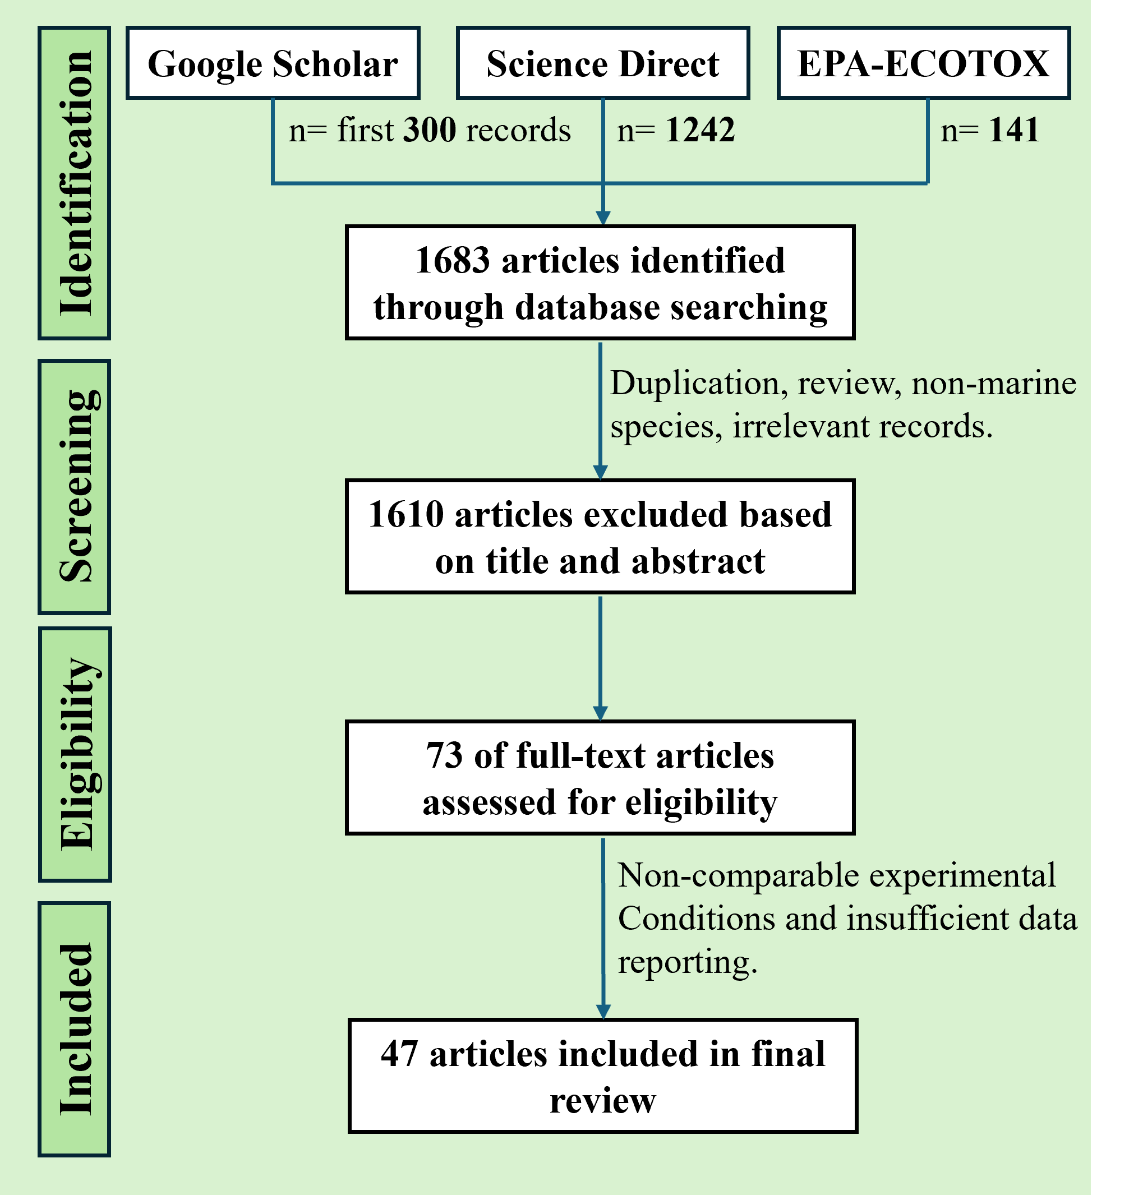
Figure 2. Flow diagram of the literature search and study selection process

Table S4. Taxonomic composition of species used for the construction of chlorpyrifos (CPF) species sensitivity distributions (SSDs) in the Latin American and non-Latin American marine datasets.

Latin name | Phylum | Class | Order | Family | Genus
Phaeodactylum tricornutum | Bacillariophyta | Bacillariophyceae | Naviculales | Phaeodactylaceae | Phaeodactylum
Skeletonema costatum | Bacillariophyta | Bacillariophyceae | Thalassiosirales | Skeletonemataceae | Skeletonema
Dunaliella tertiolecta | Chlorophyta | Chlorophyceae | Chlamydomonadales | Dunaliellaceae | Dunaliella
Prorocentrum minimum | Dinophyta | Dinophyceae | Prorocentrales | Prorocentraceae | Prorocentrum
Acartia tonsa | Arthropoda | Copepoda | Calanoida | Acartiidae | Acartia
Americamysis bahia | Arthropoda | Malacostraca | Mysida | Mysidae | Americamysis
Artemia franciscana | Arthropoda | Branchiopoda | Anostraca | Artemiidae | Artemia
Artemia parthenogenetica | Arthropoda | Branchiopoda | Anostraca | Artemiidae | Artemia
Artemia salina | Arthropoda | Branchiopoda | Anostraca | Artemiidae | Artemia
Artemia sp. | Arthropoda | Branchiopoda | Anostraca | Artemiidae | Artemia
Eriocheir sinensis | Arthropoda | Malacostraca | Decapoda | Varunidae | Eriocheir
Gammarus palustris | Arthropoda | Malacostraca | Amphipoda | Gammaridae | Gammarus
Gladioferens pectinatus | Arthropoda | Hexanauplia | Calanoida | Centropagidae | Gladioferens
Homarus americanus | Arthropoda | Malacostraca | Decapoda | Nephropidae | Homarus
Litopenaeus stylirostris | Arthropoda | Malacostraca | Decapoda | Penaeidae | Litopenaeus
Maja squinado | Arthropoda | Malacostraca | Decapoda | Majidae | Maja
Metapenaeus monoceros | Arthropoda | Malacostraca | Decapoda | Penaeidae | Metapenaeus
Neomysis integer | Arthropoda | Malacostraca | Mysida | Mysidae | Neomysis
Palaemon serratus | Arthropoda | Malacostraca | Decapoda | Palaemonidae | Palaemon
Palaemonetes pugio | Arthropoda | Malacostraca | Decapoda | Palaemonidae | Palaemonetes
Parhyale hawaiensis | Arthropoda | Malacostraca | Amphipoda | Hyalidae | Parhyale
Penaeus sp. | Arthropoda | Malacostraca | Decapoda | Penaeidae | Penaeus
Penaeus vannamei | Arthropoda | Malacostraca | Decapoda | Penaeidae | Penaeus
Sarsamphiascus tenuiremis | Arthropoda | Copepoda | Harpacticoida | Miraciidae | Sarsamphiascus
Siriella armata | Arthropoda | Malacostraca | Mysida | Mysidae | Siriella
Aphanius dispar | Chordata | Actinopterygii | Cyprinodontiformes | Aphaniidae | Aphanius
Aphanius iberus | Chordata | Actinopterygii | Cyprinodontiformes | Aphaniidae | Aphanius
Atherinops affinis | Chordata | Actinopterygii | Atheriniformes | Atherinopsidae | Atherinops
Chanos chanos | Chordata | Actinopterygii | Gonorynchiformes | Chanidae | Chanos
Ciona intestinalis | Chordata | Ascidiacea | Phlebobranchia | Cionidae | Ciona
Gambusia affinis | Chordata | Actinopterygii | Cyprinodontiformes | Poeciliidae | Gambusia
Lates calcarifer | Chordata | Actinopterygii | Carangiformes | Latidae | Lates
Menidia beryllina | Chordata | Actinopterygii | Atheriniformes | Atherinopsidae | Menidia
Mugil cephalus | Chordata | Actinopterygii | Mugiliformes | Mugilidae | Mugil
Oryzias latipes | Chordata | Actinopterygii | Beloniformes | Adrianichthyidae | Oryzias
Psetta maxima | Chordata | Actinopterygii | Pleuronectiformes | Scophthalmidae | Scophthalmus
Tilapia guineensis | Chordata | Actinopterygii | Cichliformes | Cichlidae | Tilapia
Acropora millepora | Cnidaria | Anthozoa | Scleractinia | Acroporidae | Acropora
Paracentrotus lividus | Echinodermata | Echinoidea | Camarodonta | Parechinidae | Paracentrotus
Tisochrysis lutea | Haptophyta | Coccolithophyceae | Isochrysidales | Isochrysidaceae | Tisochrysis
Aulacomya ater | Mollusca | Bivalvia | Mytilida | Mytilidae | Aulacomya
Donax faba | Mollusca | Bivalvia | Cardiida | Donacidae | Donax
Ischadium recurvum | Mollusca | Bivalvia | Mytilida | Mytilidae | Ischadium
Mytilus galloprovincialis | Mollusca | Bivalvia | Mytilida | Mytilidae | Mytilus
Ruditapes decussatus | Mollusca | Bivalvia | Venerida | Veneridae | Ruditapes
Brachionus plicatilis | Rotifera | Eurotatoria | Ploima | Brachionidae | Brachionus
Proales similis | Rotifera | Eurotatoria | Ploima | Proalidae | Proales

Table S5. Acute toxicity data of chlorpyrifos on marine organisms Latin America (A). Acute toxicity data of chlorpyrifos on marine organisms Non-Latin America (B).

 | A.
 | Latin name | Group | Effect | Time | Stage life | Endpoint | Concentration  (µg/L) | I.C. | SMAVs  (µg/L) | Place | References
 | Artemia franciscana | Arthropod | Mortality | 24 h |  | LC50 | 18000.00 |  | 18000 | Mossoró, Brazil | Varó et al. (1998)
 | Artemia persimilis | Arthropod | Mortality | 24 h |  | LC50 | 8450 |  | 8450 | Argentinan | Varó et al. (1998)
 | Parhyale hawaiensis | Arthropod | Mortality | 96 h | Neonates | LC50 | 0.32 | 0.11-0.93 | - | Cd del Carmen, Mexico, Gulf of Mexico | This study
 | Parhyale hawaiensis | Arthropod | Mobility | 96 h | Neonates | EC50 | 0.1 | 0.03-0.33 | 0.178 | Cd del Carmen, Mexico, Gulf of Mexico | This study
 | Penaeus sp. | Arthropod | Mortality | 48 h |  | LC50 | 2.07 |  | 2.07 | Mazatlán, Sinaloa, México | Osuna et al. (1997)
Penaeus vannamei |  | Arthropod | Mortality | 96 h |  | LC50 | 2.10 | 2.04–2.16 | - | CENIACUA, Cartagena, Colombia | Duarte-Restrepo et al. (2020)
 | Penaeus vannamei | Arthropod | Mortality | 48 h |  | LC50 | 4.8 |  | 2.1 | Sinaloa, Mexico | Galindo et al. (1996)
 | Litopenaeus stylirostris | Arthropod | Mortality | 48 h |  | LC50 | 2265.70 |  | 2265.7 | California Gulf  Mexico | Galindo et al. (2002)
 | Aulacomya ater | Molluscs | Mortality | 96 h |  | LC50 | 16.00 |  | 16 | Coliumo Bay, Chile | Führer et al. (2012)
 | Ischadium recurvum | Molluscs | Mortality | 96 h |  | LC50 | 960 | 890-1040 | 960 | Florida, USA | Hemming and Waller. (2004)
 | Proales similis | Rotifer | Mortality | 24 h | neonates | LC50 | 280 | 197–405 | 280 | northwestern Mexico | Arreguin-Rebolledo et al. (2023)

B.
 | Latin name | Group | Effect |  |  | Time | Stage life | Endpoint | Concentration  (µg/L) | I.C. | SMAVs  (µg/L) | Place | References
 | Dunaliella tertiolecta | Algae |  | Growth | 96 h |  |  | EC50 | 769 | 727–814 | 769 | Texas USA | DeLorenzo and Serrano (2003)
 | Phaeodactylum tricornutum | Algae |  | Growth | 72 h |  |  | EC50 | 1117 | 1047–1229 | 1117 | Spain | Tato and Beiras (2019）
 | Prorocentrum minimum | Algae |  | Growth | 96 h |  |  | EC50 | 221.385 |  | 221.385 | Laizhou Bay China | Ge et al. (2025)
 | Skeletonema costatum | Algae |  | Growth | 96 h |  |  | EC50 | 572 |  | - | China | Zhang et al. (2023）
 | Skeletonema costatum | Algae |  | Growth | 96 h |  |  | EC50 | 574.112 |  | 573.055 | Laizhou Bay China | Ge et al. (2025)
 | Tisochrysis lutea | Algae |  | Growth | 72 h |  |  | EC50 | 246.3 | 213-301 | 246.3 | Spain | Tato and Beiras (2019)
 | Acartia tonsa | Arthropod |  | Mortality | 48 h |  |  | LC50 | 1.34 | 0.35-5.31 | - | Spain | Bellas and Gil. (2020)
 | Acartia tonsa | Arthropod |  | Feeding | 48 h |  |  | EC50 | 0.77 | 0.20-3.01 | - | Spain | Bellas and Gil. (2020)
 | Acartia tonsa | Arthropod |  | Fecundity | 48 h |  |  | EC50 | 1.07 | 0.21-5.48 | - | Spain | Bellas and Gil. (2020)
 | Acartia tonsa | Arthropod |  | Development | 48 h |  |  | EC50 | 4.01 | 1.27-12.69 | - | Spain | Bellas and Gil. (2020)
 | Acartia tonsa | Arthropod |  | Population | 48 h |  |  | EC50 | 0.50 | 0.19-1.30 | 1.172 | Spain | Bellas and Gil. (2020)
 | Americamysis bahia | Arthropod |  | Mortality | 96 h |  |  | LC50 | 0.029 | 0.016-0.045 | 0.029 | South Caroline USA | Key et al. (2013)
 | Sarsamphiascus tenuiremis | Arthropod |  | Mortality | 96 h |  | Male | LC50 | 0.610 | 0.12–1.27 | - | South Caroline USA | Bejarano et al. (2005)
 | Sarsamphiascus tenuiremis | Arthropod |  | Mortality | 96 h |  | Female | LC50 | 3.56 | 2.23–5.16 | 1.473 | South Caroline USA | Bejarano et al. (2005)
 | Artemia franciscana | Arthropod |  | Mortality | 24 h |  |  | LC50 | 18000.00 |  | - | San Francisco, CA, USA | Varó et al. (1998)
 | Artemia franciscana | Arthropod |  | Mortality | 24 h |  |  | LC50 | 18000.00 |  | 18000 | Utah, USA | Varó et al. (1998)
 | Artemia parthenogenetica | Arthropod |  | Mortality | 24 h |  |  | LC50 | 1990 |  | - | Bonmatí (Alicante), Spain | Varó et al. (1998)
 | Artemia parthenogenetica | Arthropod |  | Mortality | 24 h |  |  | LC50 | 4510 |  | - | Xiao Tan (Shandong), China | Varó et al. (1998)
 | Artemia parthenogenetica | Arthropod |  | Mortality | 24 h |  |  | LC50 | 10950 |  | - | Petrola (Albacate) Spain | Varó et al. (1998)
 | Artemia parthenogenetica | Arthropod |  | Mortality | 24 h |  |  | LC50 | 18000 |  | - | Olmeda (Guadalajara), Spain | Varó et al. (1998)
 | Artemia parthenogenetica | Arthropod |  | Mortality | 24 h |  |  | LC50 | 18000 |  | - | Delta del Ebro (Tarragona), Spain | Varó et al. (1998)
 | Artemia parthenogenetica | Arthropod |  | Mortality | 24 h |  |  | LC50 | 18000 |  | - | Bjurliu Lake, Kazakstan | Varó et al. (1998)
 | Artemia parthenogenetica | Arthropod |  | Mortality | 24 h |  |  | LC50 | 18000 |  | - | Gerri (Lérida), Spain | Varó et al. (1998)
 | Artemia parthenogenetica | Arthropod |  | Mortality | 24 h |  |  | LC50 | 18000 |  | - | Torrevieja (Alicante), Spain | Varó et al. (1998)
 | Artemia parthenogenetica | Arthropod |  | Mortality | 24 h |  | Nauplii | LC50 | 18000 |  | - | Torrevieja (Alicante), Spain | Varó et al. (2000)
 | Artemia parthenogenetica | Arthropod |  | Mortality | 24 h |  | Juveniles | LC50 | 3900 |  | - | Torrevieja (Alicante), Spain | Varó et al. (2000)
 | Artemia parthenogenetica | Arthropod |  | Mortality | 24 h |  | Adults | LC50 | 80 |  | 6604.491 | Torrevieja (Alicante), Spain | Varó et al. (2000)
 | Artemia salina | Arthropod |  | Mortality | 48 h |  |  | LC50 | 6 | 2–9 | - | Cádiz, Spain | Albendin et al. (2021)
 | Artemia salina | Arthropod |  | Mortality | 24 h |  |  | LC50 | 385 | 90-670 | - | Snowville, USA | Rao et al. (2007)
 | Artemia salina | Arthropod |  | Development | 24 h |  |  | EC50 | 123 |  | - | Snowville, USA | Rao et al. (2007)
 | Artemia salina | Arthropod |  | Mortality | 24 h |  |  | LC50 | 950 |  | - | Megrine, Tunissia | Varó et al. (1998)
 | Artemia salina | Arthropod |  | Mortality | 24 h |  |  | LC50 | 1860 |  | - | Málaga, Spain | Varó et al. (1998)
 | Artemia salina | Arthropod |  | Mortality | 24 h |  |  | LC50 | 5120 |  | - | Chott Garaet et Tarf, Argelia | Varó et al. (1998)
 | Artemia salina | Arthropod |  | Mortality | 24 h |  |  | LC50 | 3190.000 |  | 503.469 | Torrevieja (Alicante), Spain | Varó et al. (1998)
 | Artemia sp. | Arthropod |  | Mortality | 24 h |  |  | LC50 | 1967 |  | 1967 | Italy | Guzzella et al. (1997)
 | Eriocheir sinensis | Arthropod |  | Mortality | 96 h |  |  | LC50 | 23.65 |  | 23.65 | China | Li et al. (2006)
 | Gladioferens pectinatus | Arthropod |  | Mortality | 48 h |  | Nauplii | LC50 | 4.3 | 3.8–4.9 | 4.3 | New Zealand - Portobello Bay to Karepiro Bay | Charry et al. (2019)
 | Gammarus palustris | Arthropod |  | Mortality | 96 h |  |  | LC50  Static | 0.30 | 0.12-0.79 | - | South Carolina, USA | Leight and Van Dolah (1999)
 | Gammarus palustris | Arthropod |  | Mortality | 96 h |  |  | LC50  Renew | 0.19 | 0.15-0.24 | 0.238 | South Carolina,  USA | Leight and Van Dolah (1999)
 | Maja squinado | Arthropod |  | Mortality | 48 h |  | zoea I | LC50 | 0.79 | 0.52–1.19 | 0.79 | Rıa de Arousa Galicia, NW Spain | Bellas et al. (2005)
 | Homarus americanus | Arthropod |  | Mortality | 48 h |  |  | LC50 | 1.33 |  | 1.33 | Canada | Taylor et al. (2019)
 | Neomysis integer | Arthropod |  | Mortality | 96 h |  |  | LC50 | 0.13 | 0.11–0.16 | - | Looe River Estuary (Cornwall, UK) | Roast et al. (1999)
 | Neomysis integer | Arthropod |  | Mortality | 96 h |  |  | LC50 | 0.19 | 0.16–0.23 | 0.157 | Looe River Estuary (Cornwall, UK) | Roast et al. (1999)
 | Palaemon serratus | Arthropod |  | Mortality | 48 h |  | zoea I | LC50 | 0.22 | 0.16–0.29 | 0.22 | Rıa de Arousa Galicia, NW Spain | Bellas et al. (2005)
 | Palaemonetes pugio | Arthropod |  | Mortality | 96 h |  |  | LC50 | 0.69 | 0.36–0.97 | - | South Caroline USA | Key et al. (2013)
 | Palaemonetes pugio | Arthropod |  | Mortality | 96 h |  | Newly hatched | LC50 | 0.15 | 0.11–0.18 | - | Leadenwah Creek – South Carolina | Key and Fulton. (2006)
 | Palaemonetes pugio | Arthropod |  | Mortality | 96 h |  | 18  day-old | LC50 | 0.46 | 0.36–0.58 | - | Leadenwah Creek – South Carolina | Key and Fulton (2006)
 | Palaemonetes pugio | Arthropod |  | Mortality | 96 h |  | Post larvae | LC50 | 0.15 | 0.13–0.18 | - | Leadenwah Creek – South Carolina | Key and Fulton. (2006)
 | Palaemonetes pugio | Arthropod |  | Mortality | 24 h |  | Newly hatched | EC50 | 0.42 | 0.29–0.60- | - | Leadenwah Creek – South Carolina | Key and Fulton. (2006)
 | Palaemonetes pugio | Arthropod |  | Mortality | 24 h |  | 18  day-old | EC50 | 0.27 | 0.21–0.35 | - | Leadenwah Creek – South Carolina | Key and Fulton. (2006)
 | Palaemonetes pugio | Arthropod |  | Mortality | 24 h |  | Post  larvae | EC50 | 0.87 | 0.62–1.23 | 0.354 | Leadenwah Creek – South Carolina | Key and Fulton. (2006)
 | Penaeus vannamei | Arthropod |  | Mortality | 96 h |  | Post larvae | LC50 | 0.68 | 0.50–0.87 | - | Goa (India) | Pawar et al. (2020)
 | Penaeus vannamei | Arthropod |  | Mortality | 96 h |  | Juveniles | LC50 | 0.73 | 0.69–1.06 | 0.704 | Goa (India) | Pawar et al. (2020)
 | Siriella armata | Arthropod |  | Mortality | 96 h |  | Neonates  <24 h old | LC50 | 0.13 |  | 0.13 | Galicia, NW Iberian Peninsula | Pérez et al. (2015)
 | Metapenaeus monoceros | Arthropod |  | Mortality | 24 h |  | Juveniles | LC50 | 0.1 |  | 0.1 | Sandspit mangrove - Pakistan | Shoaib and Siddiqui (2015)
 | Ciona intestinalis | Fish |  | Development | 48 h |  | Embryos | EC50 | 5666 | 5087–6349 | 5666 | Ria de Vigo Galicia, Spain | Bellas et al. (2005)
 | Acropora millepora | Cnidaria |  | Development | 96 h |  | Larvae  6 d old | EC50 | 1 |  | 1 | High Island - Australian | Markey et al. (2007)
 | Paracentrotus lividus | Echinoderm |  | Development | 48 h |  | Embryos | EC50 | 300 | 350–400 | - | Ria de Vigo Galicia, Spain | Bellas et al. (2005)
 | Paracentrotus lividus | Echinoderm |  | Development | 48 h |  | Embryos | EC50 | 269.6 |  | - | Ria de Vigo Galicia, Spain | Rial et al. (2023)
 | Paracentrotus lividus | Echinoderm |  | Development | 48 h |  | Embryos | EC50 | 194.6 |  | 250.607 | Bay of Naples, Italy | Buono et al. (2012)
 | Aphanius dispar | Fish |  | Mortality | 24 h |  | Juveniles | LC50 | 2.50 |  | 2.5 | Sandspit mangrove Pakistan | Shoaib et al. (2012)
 | Mugil cephalus | Fish |  | Mortality | 96 h |  | Juvenile | LC50 | 1.12 | 1.03-1.22 | - | Kovalam - India | Marigoudar et al. (2018b)
 | Mugil cephalus | Fish |  | Mortality | 96 h |  | Larvae | LC50 | 3.45 | 2.77–4.06 | 1.965 | Goa, India | Dake et al. (2021)
Aphanius iberus |  | Fish |  | Mortality | 72 h |  |  | LC50 | 18.01 |  | 18.01 | Valencian, Spain | Varó et al. (2000)
 | Atherinops affinis | Fish |  | Mortality | 96 h |  | Larvae  7 d old | LC50 | 4.50 | 3.4-5.9 | 4.5 | Granite Canyon, California - USA | Hemmer et al. (1992)
 | Chanos chanos | Fish |  | Mortality | 96 h |  |  | LC50 | 3.56 |  | - | Pamban coasts - India | Palanikumar et al. (2014)
 | Chanos chanos | Fish |  | Mortality | 96 h |  | Juvenile | LC50 | 3.20 | 2.19-5.83 | 3.375 | Chennai, Tamil Nadu - India | Marigoudar et al. (2018b)
 | Gambusia affinis | Fish |  | Mortality | 96 h |  |  | LC50 | 520.00 |  | 520 | Castellón Spain | Varó et al. (2000)
 | Lates calcarifer | Fish |  | Mortality | 96 h |  | Juvenile | LC50 | 1.07 | 0.95–1.19 | 1.07 | Tamil Nadu, India. | Marigoudar et al. (2018a)
 | Menidia beryllina | Fish |  | Mortality | 96 h |  |  | LC50 | 10.20 | 9.0-1 1.6 | 10.2 | Blackwater Bay – Florida USA | Hemmer et al. (1992)
 | Oryzias latipes | Fish |  | Mortality | 96 h |  |  | LC50 | 120.00 |  | 120 | Kyushu, Japan | Khalil et al. (2013)
 | Psetta maxima | Fish |  | Mortality | 48 h |  | Embryos | LC50 | 116.6 | 77.4–173.2 | - | Mougás, Galicia, NWSpain | Mhadhbi and Beiras. (2012)
 | Psetta maxima | Fish |  | Mortality | 96 h |  | Larvae | LC50 | 94.65 | 69.2–154.3 | 105.053 | Mougás, Galicia, NWSpain | Mhadhbi and Beiras. (2012)
 | Tilapia guineensis | Fish |  | Mortality | 96 h |  | Juvenile | LC50 | 2.00 |  | 2 | Nigeria | Chindah et al. 2004
 | Donax faba | Molluscs |  | Mortality | 96 h |  |  | LC50 | 247.72 | 112.2-445.9 | 247.72 | PalkBay Coast - India | Janakidevi et al. (2013)
 | Mytilus galloprovincialis | Molluscs |  | Development | 48 h |  | Larvae | EC50 | 153.50 | 137–172.6 | - | Vigo, Galicia, Spain | Beiras and Bellas (2008)
 | Mytilus galloprovincialis | Molluscs |  | Physiology | 96 h |  |  | EC50 | 4500 |  | - | Cesenatico, North-East Italy | Dondero et al. (2011)
 | Mytilus galloprovincialis | Molluscs |  | Mortality | 96 h |  |  | LC50 | 22500.00 |  | - | Mediterranean Spanish coast | Serrano et al. (1995)
 | Mytilus galloprovincialis | Molluscs |  | Development | 48 h |  | Embryos | EC50 | 224.9 |  | 1367.329 | Vigo, Galicia, Spain | Rial et al. (2023)
 | Ruditapes decussatus | Molluscs |  | Mortality | 96 h |  |  | LC50 | 308.06 | 242.4–394.3 | - | Oued Maltine, Tunisian, Mediterranean | Fathallah (2014)
 | Ruditapes decussatus | Molluscs |  | Embryotoxicity | 96 h |  |  | EC50 | 339.5 | 254.6–470 | 323.398 | Oued Maltine, Tunisian, Mediterranean | Fathallah (2014)
 | Brachionus plicatilis | Rotifer |  | Mortality | 24 h |  | Neonates | EC50 | 1667 |  | - | Italy | Guzzella et al. (1997)
 | Brachionus plicatilis | Rotifer |  | Mortality | 24 h |  |  | LC50 | 10670.00 | 9310-12030 | 4217.450 | Valencia, Spain | Ferrando and Andreu-Moliner (1991)

Table S6. Goodness-of-fit statistics for distribution models used in SSD fitting corresponding to (A). Latin American and (B). Non-Latin American. AD: Anderson-Darling statistic; KS: Kolmogorov-Smirnov statistic; CvM: Cramer-von Mises statistic; AIC: Akaike´s Information Criterion; AICC: Akaike´s Information Criterion corrected for sample size; BIC: Bayesian Information Criterion; DELTA: Information Criterion differences; Weight: Information Criterion weight. “DELTA” and “Weight” are based on “AIC” for censored data and “AICC” for non-censored data. Optimal distribution.

A.
Distribution | AD | KS | CvM | AIC | AICc | BIC | DELTA | Weight
Gamma | 0.293 | 0.187 | 0.0442 | 137 | 139 | 137 | 0 | 0.285
Weibull | 0.309 | 0.177 | 0.0482 | 137 | 139 | 137 | 0.298 | 0.245
Log-normal | 0.348 | 0.174 | 0.0578 | 137 | 139 | 138 | 0.598 | 0.211
Log-logistic | 0.338 | 0.175 | 0.0543 | 138 | 140 | 139 | 1.56 | 0.131
Gumbel | 0.383 | 0.2 | 0.0631 | 138 | 140 | 139 | 1.61 | 0.128
Log-normal-log-normal | 0.162 | 0.12 | 0.0196 | 139 | 159 | 140 | 20.2 | 0

B.
Distribution | AD | KS | CvM | AIC | AICC | BIC | DELTA | Weight
Log-normal-log-normal | 0.159 | 0.057 | 0.022 | 467 | 469 | 476 | 0 | 0.956
Log-normal | 0.983 | 0.153 | 0.189 | 476 | 476 | 480 | 7.64 | 0.021
Gumbel | 0.797 | 0.154 | 0.139 | 476 | 477 | 480 | 7.98 | 0.018
Log-logistic | 1.05 | 0.145 | 0.188 | 480 | 480 | 484 | 11.7 | 0.003
Weibull | 1.15 | 0.182 | 0.207 | 481 | 481 | 484 | 12.2 | 0.002
Gamma | 2.04 | 0.21 | 0.377 | 488 | 489 | 492 | 19.9 | 0

Table S7. Chlorpyrifos concentrations detected in marine ecosystems to Latin America (A). non-Latin America (B), and their corresponding risk quotient (RQ) values

A)
Place | Concentrations µg/L | RQ | Reference
Laguna de terminos, Mexico | 0.000072 | 0.002 | Carvalho et al., 2009
North-central coastal zone of Sinaloa, Mexico. | 0.03  0.11 | 0.94  3.44 | Leyva-Morales et al., 2024
Gulf California | 1.5 | 47 | Arellano-Aguilar et al., 2017
Navachiste coastal lagoon | 1.7 | 53,3 | Arellano-Aguilar et al., 2017
Pabelloes coastal lagoon | 1.39 | 43.57 | Arellano-Aguilar et al., 2017

B)
Place | Concentrations µg/L | RQ | Reference
Laizhou Bay, China. | 0.000351  0.001091 | 0.00626  0.019 | Ge et al., 2025
Everglades South Florida | 0.0062 | 0.11 | Carrier and Rand., 2008
Mar Menor lagoon - Spain | 0.052  0.20 | 0.92  3.57 | Campillo et al., 2013
Mar Menor lagoon - Spain | 0.0458 | 0.81 | Moreno-Gonzalez et al., 2013
Bohai Bay | 0.00032 | 0.005 | Zhao et al., 2025
Lagoa de Sto André – Estuarine waters- Portugal | 3.7 | 66.07 | Sousa et al., 2020
Fuseta -Estuarine waters -Portugal | 4.095 | 73.125 | Sousa et al., 2020
Tavira – Seawater - Portugal | 0.226 | 4.03 | Sousa et al., 2020

