Supplementary Figures

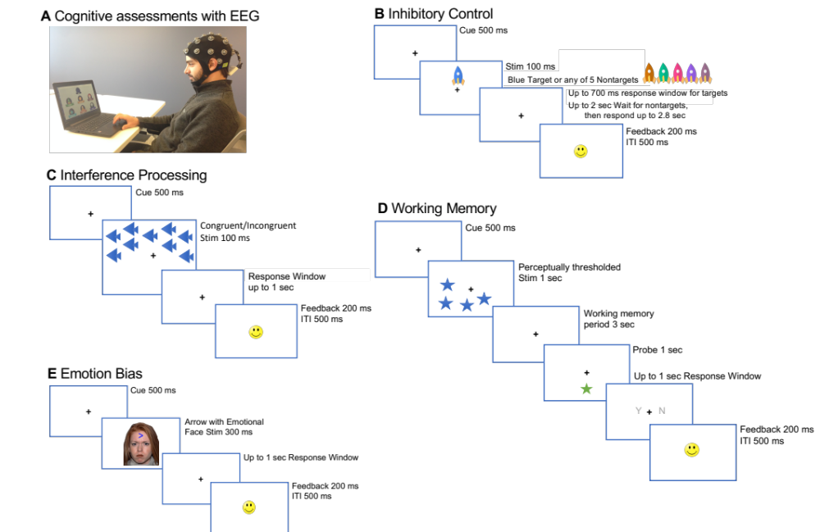

Supplementary Figure 1. Task design for each of the externally-oriented cognitive tasks performed by all subjects. (A) Setup for cognitive assessments with EEG. Task design shown with temporal sequence from top to bottom slide for (B) inhibitory control task, (C) interference processing (Flanker) task, (D) working memory (visuo-spatial delayed match to probe task with perceptually thresholded stimuli), and (D) emotion bias task (presenting neutral as well happy, sad or angry faces on equivalent number of trials).
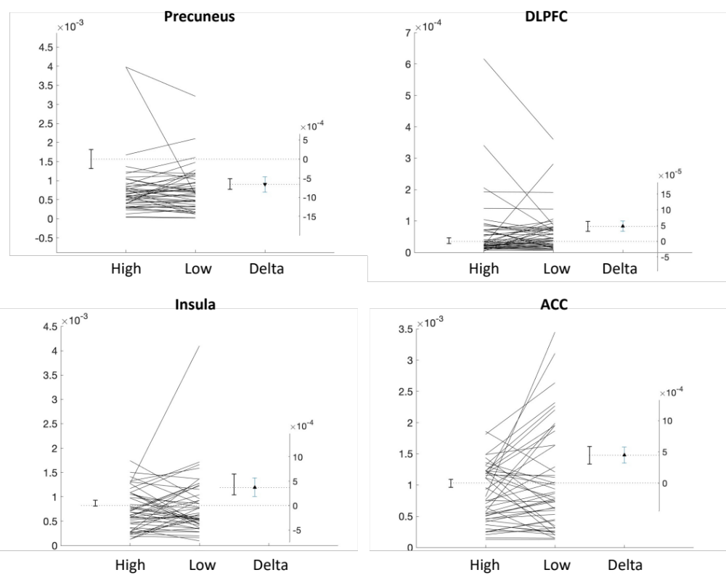

Supplementary Figure 2. Estimation plots (or paired Gardner-Altman plots) corresponding to the alpha neural activations in the pre-breath reporting window for the four brain regions plotted in Figure 2C, namely the bilateral Precuneus, left DLPFC, left Insula and bilateral ACC, shown for high consistency versus low consistency performance trials and their estimated delta difference.

Supplementary Figure 3. Estimation plots (or paired Gardner-Altman plots) corresponding to the alpha band functional connectivity in the pre-breath reporting window across the four brain regions (bilateral Precuneus, left DLPFC, left Insula and bilateral ACC) plotted in Figure 2D, shown for high consistency versus low consistency performance trials and their estimated delta difference.

