Table 3 Comparative statistical summary of altmetric indicators in the full OpenAlex corpus (n = 8,493 publications)

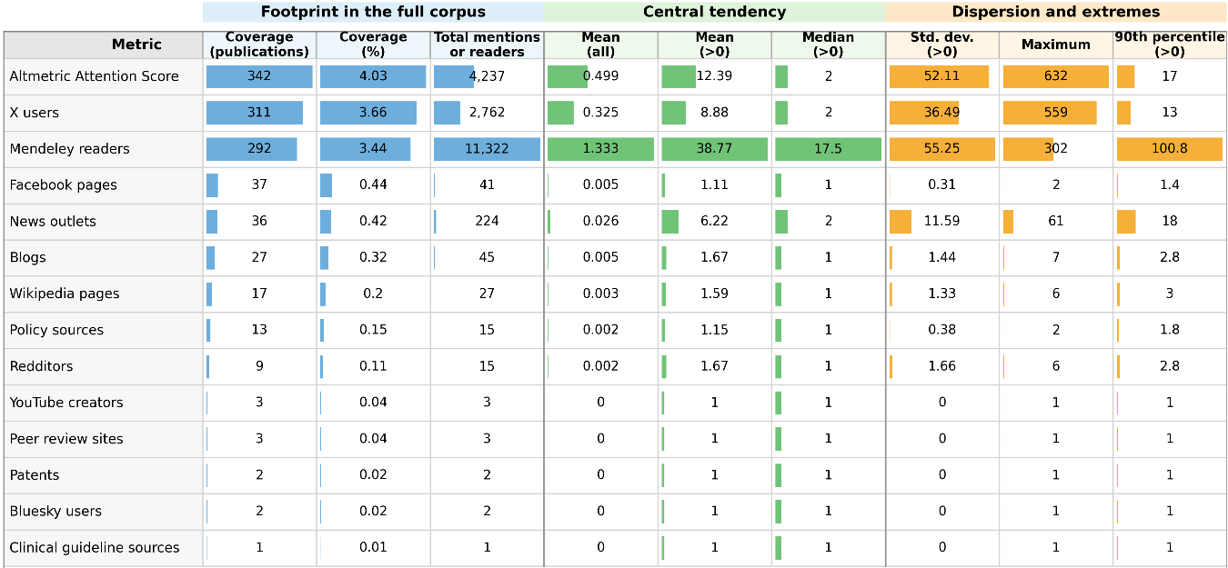

Table 4 Open access pathways and differentiated patterns of visibility and citation in the subset with DOIs

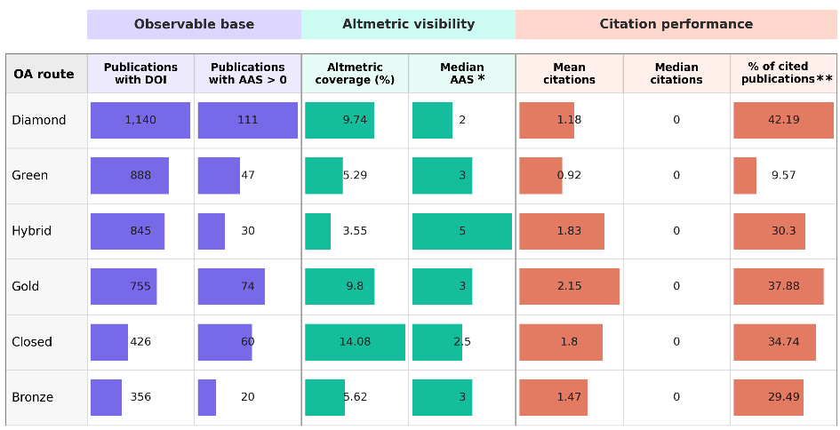

*The median AAS was calculated only for publications with AAS > 0.
**This indicator is included because the median number of citations was 0 across all pathways, which limits its discriminatory capacity when considered in isolation.

