Appendices

Appendix A. Search queries applied to scientific output databases

Database | Search queries
Scielo | ((Coleções: Cuba) AND (Ano de publicação: 2021) OR (Ano de publicação: 2020) OR (Ano de publicação: 2022) OR (Ano de publicação: 2023) OR (Ano de publicação: 2024) AND (SciELO Áreas Temáticas: Ciências Sociais Aplicadas))
Redalyc | ((“Cuba”) AND (“2024” OR “2023” OR “2022” OR “2021” OR “2020”) AND (“Educación” OR “Economía y Finanzas” OR “Administración y Contabilidad” OR “Multidisciplinarias (Ciencias Sociales)” OR “Multidisciplinarias (Ciencias, Ciencias Sociales, Artes y Humanidades)” OR “Ciencias de la Información” OR “Derecho” OR “Historia” OR “Psicología” OR “Sociología” OR “Estudios Territoriales” OR “Geografía” OR “Comunicación” OR “Política” OR “Estudios de Turismo” OR “Lengua y Literatura” OR “Antropología” OR “Estudios Culturales” OR “Demografía” OR “Filosofía” OR “Relaciones Internacionales”))
Lens | Year Published = (2020 - 2024) AND Field of Study = (Political science, Philosophy, Geography, Sociology, Pedagogy, Population, Economics, Context (language use), Welfare economics, Epistemology, Demography, Politics, Library science, Linguistics, Social science, Knowledge management, Social psychology, Economic growth, Public relations, Tourism, Higher education, History) AND Institution Country/Region = (Cuba)
Scopus | AFFILCOUNTRY (Cuba) AND (LIMIT-TO (PUBYEAR, 2020) OR LIMIT-TO (PUBYEAR, 2021) OR LIMIT-TO (PUBYEAR, 2022) OR LIMIT-TO (PUBYEAR, 2023) OR LIMIT-TO (PUBYEAR, 2024)) AND (LIMIT-TO (SUBJAREA, "SOCI") OR LIMIT-TO (SUBJAREA, "ECON"))
OpenAlex | (domain IS “Social Sciences”) AND (country IS “Cuba”) AND (year IS WITHIN RANGE “2020-2024”)

Appendix B. Source-selection exercise across candidate databases*

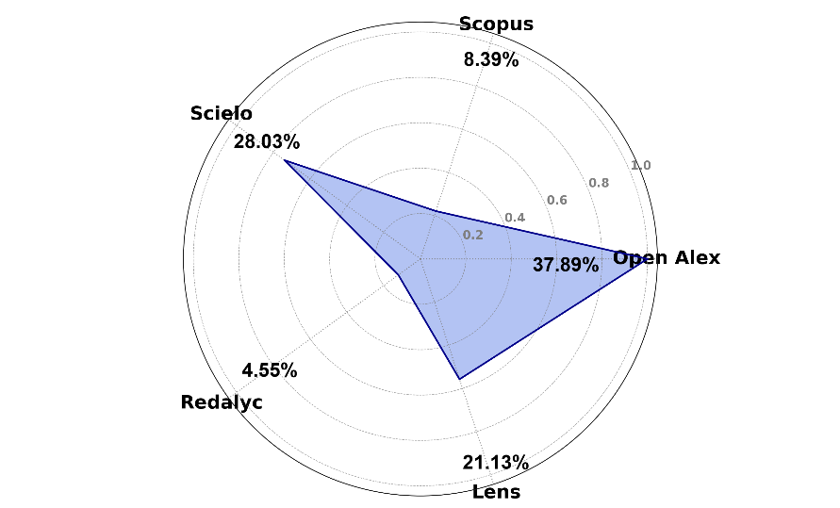

*The figure summarizes retrieval outputs obtained through database-specific search strategies used to support preliminary source selection. Because subject taxonomies, metadata structures, and filtering capabilities differ across platforms, these results should not be interpreted as directly comparable coverage estimates.

Appendix C. Data cleaning flow diagram

