Supplemental Materials for: Biochemical contributions to soil aggregation under Miscanthus × giganteus

Table of Contents
Table S1 Percentage of soil aggregates in five size classes ................................................... p. 47
Table S2 Total extractable carbohydrate concentrations ....................................................... p. 48
Table S3 Concentrations of individual carbohydrate monomers ........................................... p. 49
Table S4 Concentrations of individual amino acids and amino sugars .................................. p. 50
Fig. S1 Photographs of turfgrass alleyways ....................................................................... p. 51
Fig. S2 Boxplots of soil properties .................................................................................... p. 52
Fig. S3 Mean concentrations of total and individual amino compounds ........................... p. 53
Fig. S4 Correlation matrix of soil biochemical pools and aggregate stability metrics ...... p. 54
Table S1. Mean (± standard deviation) percentage of soil aggregates in five size classes (0.125–3 mm) under maize, miscanthus, and turfgrass across three LAMPS sites (n = 4 per treatment) and ANOVA results†

Site | Treatment | 0.125 mm | 0.375 mm | 0.75 mm | 1.5 mm | 3 mm
Northwest | Maize | 41.0 (12.6) | 29.1 (2.41) | 12.7 (3.59) | 7.40 (4.73) | 9.88 (6.51) a
 | Miscanthus | 33.7 (12.6) | 25.1 (3.16) | 12.7 (4.33) | 9.25 (2.72) | 19.2 (9.74) ab
 | Turfgrass | 52.7 (10.3) | 32.3 (6.13) | 8.46 (2.04) | 2.99 (1.14) | 3.50 (1.38) b
Central | Maize | 50.6 (5.78) | 33.3 (5.26) | 6.73 (4.00) | 3.07 (1.61) | 6.36 (3.27)
 | Miscanthus | 38.2 (5.96) | 33.2 (6.32) | 13.6 (2.78) | 7.33 (2.14) | 7.58 (3.16)
 | Turfgrass | 41.8 (8.79) | 27.5 (3.46) | 14.1 (4.48) | 7.87 (5.52) | 8.73 (2.61)
Southeast | Maize | 58.0 (8.96) a | 28.0 (6.22) | 6.99 (1.95) a | 2.24 (0.68) a | 4.80 (1.59)
 | Miscanthus | 32.1 (15.3) a | 26.9 (6.05) | 11.1 (2.90) ab | 6.80 (2.14) b | 23.1 (17.7)
 | Turfgrass | 20.9 (5.63) b | 26.0 (3.26) | 16.4 (3.94) b | 11.4 (1.99) c | 25.2 (7.69)
Source of Variation |  | p-values
 | Site | 0.255 | 0.113 | 0.986 | 0.830 | 0.011
 | Treatment | 0.003 | 0.648 | 0.012 | 0.011 | 0.018
 | Site × Treatment | 0.001 | 0.148 | 0.004 | 0.001 | 0.011
†: p-values shown, and lowercase letters denote significant differences among treatments within each site (Sidak-adjusted, α = 0.05)

Table S2 Mean (± standard deviation) total extractable carbohydrate concentrations (mg kg⁻¹ soil) in surface soils (0–15 cm) at the LAMPS sites (n = 4 unless outliers removed) and ANOVA results†
Site | Treatment | Total Extractable Carbohydrates
Northwest | Maize | 5527 (939) ab
 | Miscanthus | 6202 (805) a
 | Turfgrass | 5035 (569) b
Central | Maize | 5523 (314) b
 | Miscanthus | 6545 (303) ab
 | Turfgrass | 6855 (265) a
Southeast | Maize | 4294 (650) b
 | Miscanthus | 5113 (555) ab
 | Turfgrass | 6046 (798) a
Source of Variation |  | p-values
 | Site | <0.001
 | Treatment | 0.006
 | Site × Treatment | 0.013
†: p-values shown, and lowercase letters denote significant differences among treatments within each site (Sidak-adjusted, α = 0.05)
Table S3 Mean (± standard deviation) concentrations of individual soil carbohydrate monomers (mg kg⁻¹) in surface soils (0–15 cm) at the LAMPS sites (n = 4 unless outliers removed) and ANOVA results†

Site | Treatment | Arabinose | Fucose | Galactose | Glucose | Mannose | Rhamnose | Xylose
Northwest | Maize | 1586 (256) a | 103 (20.0) a | 798 (107) a | 1850 (338) ab | 450 (52.3) a | 254 (51.1) a | 486 (127) b
 | Miscanthus | 1674 (322) a | 93.9 (8.7) a | 827 (86.6) a | 2133 (282) a | 489 (55.5) a | 290 (25.7) a | 695 (38.3) a
 | Turfgrass | 1463 (194) a | 84.0 (13.3) a | 784 (68.7) a | 1614 (194) b | 444 (61.6) a | 255 (7.3) a | 389 (61.3) b
Central | Maize | 1474 (147) a | 133 (28.9) a | 859 (79.5) a | 1776 (79.4) b | 516 (45.4) a | 267 (39.3) b | 498 (31.5) b
 | Miscanthus | 1733 (93.6) a | 148 (35.2) a | 981 (117) a | 2174 (111) a | 495 (132) a | 323 (39.4) ab | 691 (72.6) a
 | Turfgrass | 1707 (95.3) a | 172 (16.7) a | 999 (23.0) a | 2254 (102) a | 613 (45.2) a | 375 (16.6) a | 736 (67.6) a
Southeast | Maize | 1251 (186) a | 69.3 (13.3) b | 662 (97.8) b | 1372 (202) b | 406 (68.6) a | 193 (42.9) a | 341 (56.0) b
 | Miscanthus | 1378 (194) a | 81.5 (10.2) b | 712 (60.9) ab | 1717 (187) ab | 419 (59.5) a | 217 (15.0) a | 588 (83.2) a
 | Turfgrass | 1598 (254) a | 138 (32.0) a | 916 (93.3) a | 2034 (208) a | 466 (57.9) a | 281 (54.7) a | 613 (97.6) a
Source of Variation |  | p-values
 | Site | 0.546 | 0.248 | 0.789 | 0.075 | 0.495 | 0.275 | 0.002
 | Treatment | 0.030 | 0.191 | 0.071 | <0.001 | 0.145 | 0.005 | 0.001
 | Site × Treatment | 0.205 | 0.005 | 0.026 | 0.015 | 0.565 | 0.072 | 0.004
†: p-values shown, and lowercase letters denote significant differences among treatments within each site (Sidak-adjusted, α = 0.05)
Table S4 Mean (± standard deviation) concentrations of individual soil amino acids and amino sugars (mg kg⁻¹) in surface soils (0–15 cm) at the LAMPS sites (n = 4 unless outliers removed) and ANOVA results†

Site | Treatment | Arginine | Ornithine | Lysine | Galactosamine | Glucosamine | Alanine | Threonine | Glycine | Valine | Hydroxyproline | Serine
Northwest | Maize | 1162 (210.5) a | 80 (30.1) a | 660 (55.6) a | 588 (112.5) a | 1647 (274.1) a | 533 (49.0) a | 384 (59.4) a | 644 (40.0) a | 406 (103.8) a | 51 (12.1) a | 347 (56.6) a
 | Miscanthus | 1230 (122.3) a | 97 (18.8) a | 742 (126.2) a | 634 (101.7) a | 1635 (260.9) a | 563 (98.4) a | 409 (79.2) a | 660 (117.3) a | 420 (106.0) a | 49 (7.9) a | 370 (67.2) a
 | Turfgrass | 1064 (169.8) a | 83 (31.1) a | 608 (79.1) a | 543 (97.1) a | 1505 (277.5) a | 490 (58.0) a | 349 (83.9) a | 584 (59.7) a | 387 (144.8) a | 48 (17.7) a | 321 (78.9) a
Central | Maize | 1053 (15.8) a | 87 (38.0) a | 702 (37.9) a | 456 (53.6) a | 1219 (273.2) a | 519 (45.1) a | 368 (34.9) a | 613 (35.1) a | 370 (55.1) a | 42 (3.7) a | 322 (17.3) a
 | Miscanthus | 1306 (103.1) ab | 107 (27.0) a | 906 (96.7) b | 611 (128.5) a | 1519 (433.1) a | 708 (92.8) b | 481 (17.4) a | 814 (77.1) b | 513 (17.8) a | 52 (7.8) a | 436 (2.8) ab
 | Turfgrass | 1437 (143.2) b | 122 (14.5) a | 835 (51.1) ab | 688 (153.5) a | 1923 (380.3) a | 685 (30.7) b | 510 (97.5) a | 741 (12.0) b | 498 (58.6) a | 49 (6.0) a | 436 (60.0) b
Southeast | Maize | 964 (98.2) a | 84 (14.1) a | 584 (63.1) a | 492 (32.8) a | 1655 (130.3) a | 364 (18.2) a | 252 (6.5) a | 467 (29.7) a | 284 (91.9) a | 32 (9.7) a | 234 (19.8) a
 | Miscanthus | 1070 (185.4) ab | 100 (29.9) a | 554 (71.7) a | 515 (61.2) a | 1587 (191.4) a | 417 (42.4) a | 284 (31.5) a | 506 (53.9) a | 314 (67.9) a | 34 (4.5) a | 255 (20.3) a
 | Turfgrass | 1303 (31.6) b | 106 (14.8) a | 683 (30.1) a | 574 (19.4) a | 1808 (84.9) a | 569 (51.4) b | 386 (13.8) b | 660 (60.0) b | 436 (75.9) a | 51 (4.5) b | 363 (4.5) b
Source of Variation |  | p-values
 | Site | 0.027 | 0.206 | <0.001 | 0.177 | 0.750 | <0.001 | <0.001 | <0.001 | 0.024 | 0.022 | <0.001
 | Treatment | 0.016 | 0.164 | 0.112 | 0.125 | 0.166 | 0.001 | 0.032 | 0.015 | 0.154 | 0.270 | 0.017
 | Site × Treatment | 0.017 | 0.744 | 0.008 | 0.094 | 0.062 | <0.001 | 0.035 | 0.001 | 0.281 | 0.216 | 0.014
Site | Treatment | Proline | Isoleucine | Leucine | Methionine | Histidine | Phenylalanine | Glutamic Acid | Aspartic Acid | Cystine | Tyrosine
Northwest | Maize | 298 (63.1) a | 232 (37.0) a | 333 (50.3) a | 45 (8.8) a | 71 (16.1) a | 110 (31.4) a | 253 (64.7) a | 375 (48.3) a | 56 (6.0) a | 129 (18.5) a
 | Miscanthus | 302 (62.7) a | 244 (66.6) a | 348 (83.9) a | 47 (11.6) a | 70 (6.9) a | 91 (64.1) a | 313 (118.3) a | 413 (97.2) a | 53 (4.8) a | 136 (16.1) a
 | Turfgrass | 270 (96.9) a | 207 (54.2) a | 300 (66.0) a | 41 (11.9) a | 57 (18.6) a | 160 (231.2) a | 254 (135.7) a | 358 (70.5) a | 54 (12.2) a | 134 (15.8) a
Central | Maize | 254 (39.9) a | 246 (32.2) a | 321 (35.4) a | 51 (4.7) a | 77 (14.4) a | 124 (31.0) a | 199 (97.6) a | 296 (101.9) a | 38 (7.2) a | 138 (11.9) a
 | Miscanthus | 330 (21.3) a | 336 (45.5) a | 457 (77.7) ab | 87 (37.8) a | 68 (18.9) a | 81 (23.5) a | 506 (243.8) a | 476 (6.7) a | 40 (25.7) a | 167 (8.8) ab
 | Turfgrass | 360 (51.4) a | 284 (26.6) a | 450 (42.4) b | 59 (14.0) a | 119 (33.2) a | 96 (94.5) a | 526 (192.4) a | 300 (156.3) a | 31 (20.7) a | 201 (13.1) b
Southeast | Maize | 174 (15.1) b | 132 (23.3) b | 199 (21.5) a | 23 (7.0) a | 53 (18.2) a | 176 (177.8) a | 62 (59.0) a | 199 (43.0) a | 43 (12.5) a | 115 (50.8) a
 | Miscanthus | 205 (18.7) a | 164 (29.1) a | 244 (28.0) a | 30 (8.4) a | 63 (19.4) a | 98 (33.5) a | 76 (62.2) a | 137 (120.3) a | 26 (18.1) a | 115 (27.5) a
 | Turfgrass | 318 (24.9) b | 257 (10.3) b | 380 (27.1) b | 52 (10.5) b | 81 (0.5) a | 90 (81.7) a | 189 (122.0) a | 200 (149.9) a | 28 (23.8) a | 159 (6.7) a
Source of Variation |  | p-values
 | Site | 0.002 | <0.001 | <0.001 | <0.001 | 0.003 | 0.907 | <0.001 | <0.001 | 0.005 | 0.001
 | Treatment | 0.028 | 0.055 | 0.003 | 0.112 | 0.083 | 0.648 | 0.040 | 0.640 | 0.425 | 0.008
 | Site × Treatment | 0.037 | 0.006 | 0.003 | 0.014 | 0.027 | 0.863 | 0.103 | 0.285 | 0.800 | 0.175
†: p-values shown, and lowercase letters denote significant differences among treatments within each site (Sidak-adjusted, α = 0.05)
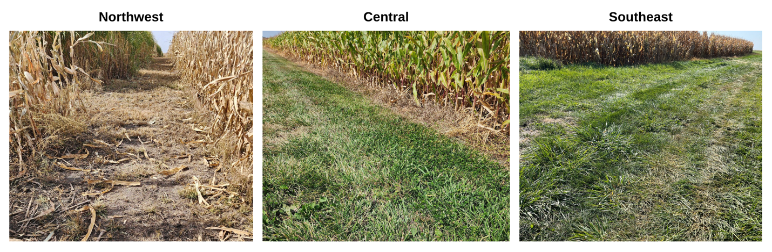
Fig. S1 Turfgrass alleyways adjacent to maize and miscanthus plots at the LAMPS sites in Iowa, USA. These perennial alleyways served as the turfgrass reference treatment in this study
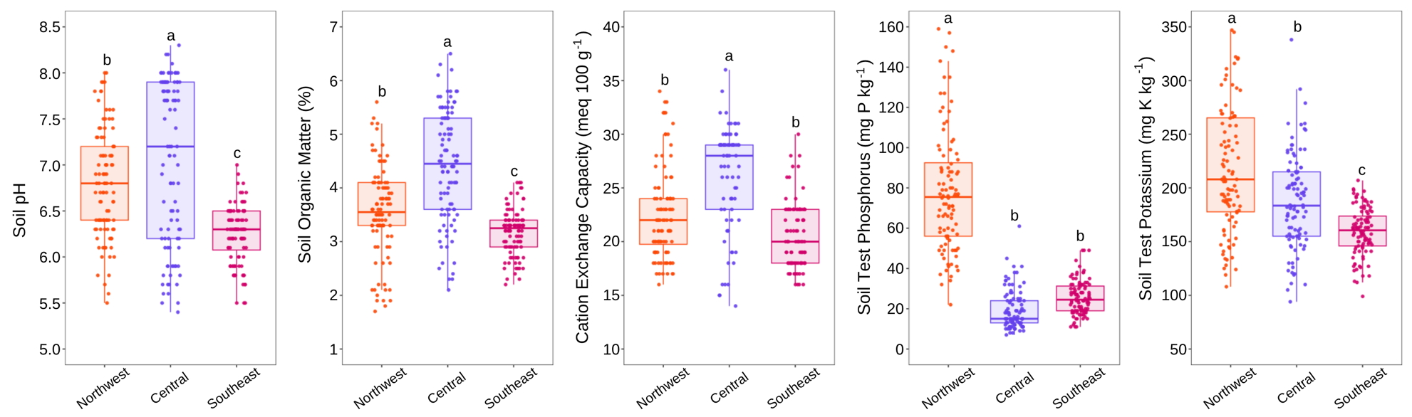
Fig. S2 Selected soil properties collected at the Northwest, Central, and Southeast LAMPS sites in 2015 and 2016. Boxplots are shown with 10th, 25th, 50th (median), 75th, and 90th percentiles for each property and site. Each data point is composite soil core (0-30cm) collected from 1.8 ha fields (n = 40 to 100 per site). Lowercase letters indicate difference between site means (α = 0.05)

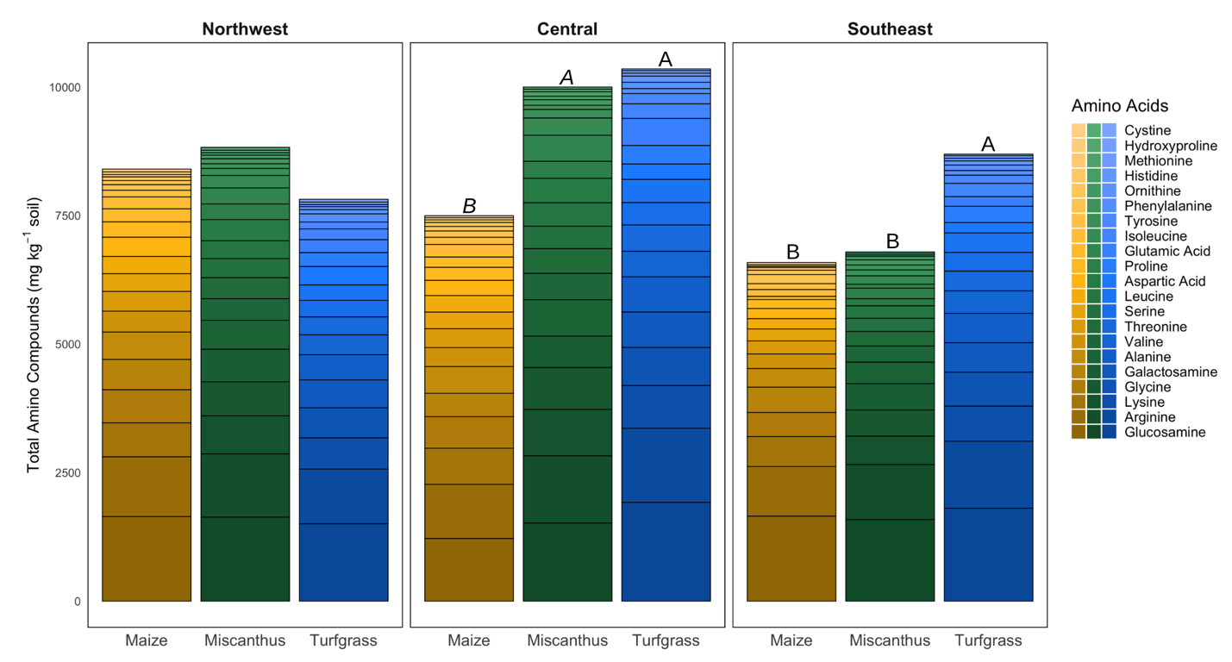
Fig. S3 Mean concentrations of total and individual amino compounds (mg kg⁻¹ soil) in the 0–15 cm depth under maize, miscanthus, and turfgrass at three LAMPS sites (n = 4 field replicates per treatment per site, unless outliers removed). Capital letters indicate significant differences among treatments within sites for total amino compounds (Sidak-adjusted, α = 0.05). See Table S3 for individual amino compound details.
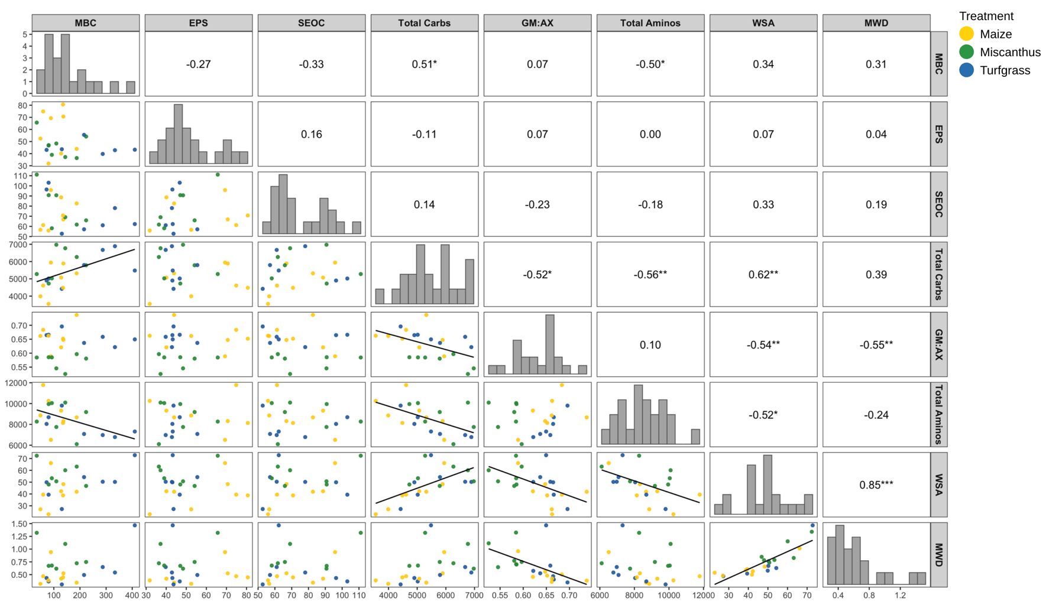
Fig. S4 Pairwise correlations between soil biochemical and aggregate metrics (n = 36, unless outliers removed), with scatterplots (lower panels), Pearson r-values (upper panels), and histograms (diagonal). Asterisks denote significance (* p ≤ 0.10, ** p ≤ 0.05, *** p ≤ 0.001). The GM:AX ratio represents predominantly microbial-associated carbohydrate monomers (galactose + mannose) relative to plant-associated carbohydrate monomers (arabinose + xylose). Black regression lines are shown only for significant correlations (p ≤ 0.05)

