Supplementary Material

Tables

Table S1.
The main effects for smoother parameters for generalized additive mixed-effect model used to assess dynamic and static environmental variables on the detection efficiency of V9s, V13s and V16s in a fine-scale positioning array of VR2ARs. Effective degrees of freedom are the number of knots (i.e., controls wiggliness) for each parameter while reference degrees of freedom represent one minus the number of knots used, while both χ² and p indicate whether a smoother is non-linear.

Smoother Term | Tag Type | Tag Power | Effective Degrees of Freedom | Reference Degrees of Freedom | χ² | p
Bottom Depth (m) | V16-6x-BLU-2 | L | 3.23 | 9 | 55.01 | 0.00
Bottom Depth (m) | V16-6x-BLU-2 | H | 6.07 | 9 | 73.44 | 0.00
Bottom Depth (m) | V13-1x-BLU-3 | L | 6.35 | 9 | 79.75 | 0.00
Bottom Depth (m) | V13-1x-BLU-3 | H | 4.01 | 9 | 93.04 | 0.00
Bottom Depth (m) | V9-2x-BLU-3 | L | 7.60 | 9 | 111.78 | 0.00
Bottom Depth (m) | V9-2x-BLU-3 | H | 5.09 | 9 | 90.70 | 0.00
Bottom Temperature (°C) | V16-6x-BLU-2 | L | 3.56 | 4 | 56.84 | 0.00
Bottom Temperature (°C) | V16-6x-BLU-2 | H | 3.30 | 4 | 25.97 | 0.00
Bottom Temperature (°C) | V13-1x-BLU-3 | L | 3.69 | 4 | 94.17 | 0.00
Bottom Temperature (°C) | V13-1x-BLU-3 | H | 3.63 | 4 | 72.18 | 0.00
Bottom Temperature (°C) | V9-2x-BLU-3 | L | 3.41 | 4 | 76.18 | 0.00
Bottom Temperature (°C) | V9-2x-BLU-3 | H | 3.41 | 4 | 55.58 | 0.00
Bottom Temperature (°C)  by Day-of-Year | V16-6x-BLU-2 | L | 12.53 | 48 | 135.76 | 0.00
Bottom Temperature (°C)  by Day-of-Year | V16-6x-BLU-2 | H | 10.13 | 48 | 47.31 | 0.00
Bottom Temperature (°C)  by Day-of-Year | V13-1x-BLU-3 | L | 6.89 | 48 | 34.71 | 0.00
Bottom Temperature (°C)  by Day-of-Year | V13-1x-BLU-3 | H | 16.55 | 48 | 321.92 | 0.00
Bottom Temperature (°C)  by Day-of-Year | V9-2x-BLU-3 | L | 2.79 | 48 | 6.25 | 0.03
Bottom Temperature (°C)  by Day-of-Year | V9-2x-BLU-3 | H | 12.45 | 48 | 68.95 | 0.00
Day-of-Year | V16-6x-BLU-2 | L | 0.00 | 11 | 0.00 | 0.46
Day-of-Year | V16-6x-BLU-2 | H | 1.83 | 11 | 3.94 | 0.01
Day-of-Year | V13-1x-BLU-3 | L | 4.87 | 11 | 17.16 | 0.00
Day-of-Year | V13-1x-BLU-3 | H | 0.00 | 11 | 0.00 | 0.68
Day-of-Year | V9-2x-BLU-3 | L | 6.26 | 11 | 48.57 | 0.00
Day-of-Year | V9-2x-BLU-3 | H | 6.48 | 11 | 17.09 | 0.00
Distance Away (m) | V16-6x-BLU-2 | L | 5.97 | 9 | 86.25 | 0.00
Distance Away (m) | V16-6x-BLU-2 | H | 4.94 | 9 | 42.68 | 0.00
Distance Away (m) | V13-1x-BLU-3 | L | 5.97 | 9 | 274.94 | 0.00
Distance Away (m) | V13-1x-BLU-3 | H | 5.57 | 9 | 168.55 | 0.00
Distance Away (m) | V9-2x-BLU-3 | L | 6.99 | 9 | 374.59 | 0.00
Distance Away (m) | V9-2x-BLU-3 | H | 7.48 | 9 | 327.53 | 0.00
Longitude, Latitude | V16-6x-BLU-2 | L | 7.92 | 13 | 43.99 | 0.00
Longitude, Latitude | V16-6x-BLU-2 | H | 10.31 | 13 | 99.93 | 0.00
Longitude, Latitude | V13-1x-BLU-3 | L | 8.28 | 13 | 55.14 | 0.00
Longitude, Latitude | V13-1x-BLU-3 | H | 9.03 | 13 | 103.10 | 0.00
Longitude, Latitude | V9-2x-BLU-3 | L | 10.76 | 13 | 84.42 | 0.00
Longitude, Latitude | V9-2x-BLU-3 | H | 7.15 | 13 | 31.33 | 0.00
Transmitter ID |  |  | 11.21 | 13 | 154.50 | 0.00

Table S2.
The main effects for smoother parameters for generalized additive mixed-effect model used to assess dynamic and static environmental variables on the detection efficiency of internal transmitter of VR2ARs in a fine-scale positioning array. Effective degrees of freedom are the number of knots (i.e., controls wiggliness) for each parameter while reference degrees of freedom represent one minus the number of knots used, while both χ² and p indicate whether a smoother is non-linear.
Smoother Term | Distance Away From a Receiver | Effective Degrees of Freedom | Reference Degrees of Freedom | χ² | p
Bottom Depth (m) | 251-450 m | 2.80 | 9 | 20.50 | 0.00
Bottom Depth (m) | 451-650 m | 2.60 | 9 | 25.49 | 0.00
Bottom Depth (m) | 651-850 m | 1.50 | 9 | 15.69 | 0.00
Bottom Depth (m) | 851-1000 m | 3.52 | 9 | 9.76 | 0.00
Bottom Depth (m) | 1001-1500 m | 0.41 | 9 | 0.70 | 0.00
Bottom Temperature (°C) | 251-450 m | 0.00 | 9 | 0.00 | 0.82
Bottom Temperature (°C) | 451-650 m | 3.33 | 9 | 19.01 | 0.00
Bottom Temperature (°C) | 651-850 m | 6.45 | 9 | 144.90 | 0.00
Bottom Temperature (°C) | 851-1000 m | 5.48 | 9 | 41.28 | 0.00
Bottom Temperature (°C) | 1001-1500 m | 6.23 | 9 | 81.67 | 0.00
Bottom Temperature (°C)  by Day-of-Year | 251-450 m | 11.72 | 46 | 30.37 | 0.00
Bottom Temperature (°C)  by Day-of-Year | 451-650 m | 0.00 | 47 | 0.00 | 0.36
Bottom Temperature (°C)  by Day-of-Year | 651-850 m | 22.72 | 48 | 222.11 | 0.00
Bottom Temperature (°C)  by Day-of-Year | 851-1000 m | 8.10 | 47 | 21.73 | 0.00
Bottom Temperature (°C)  by Day-of-Year | 1001-1500 m | 14.31 | 47 | 71.54 | 0.00
Day-of-Year | 251-450 m | 5.27 | 11 | 28.88 | 0.00
Day-of-Year | 451-650 m | 7.91 | 11 | 208.73 | 0.00
Day-of-Year | 651-850 m | 6.27 | 11 | 38.09 | 0.00
Day-of-Year | 851-1000 m | 9.68 | 11 | 72.88 | 0.00
Day-of-Year | 1001-1500 m | 9.23 | 11 | 60.24 | 0.00
Longitude, Latitude | 251-450 m | 20.18 | 44 | 626.06 | 0.00
Longitude, Latitude | 451-650 m | 28.20 | 49 | 1498.73 | 0.00
Longitude, Latitude | 651-850 m | 54.82 | 76 | 3495.56 | 0.00
Longitude, Latitude | 851-1000 m | 26.85 | 44 | 420.69 | 0.00
Longitude, Latitude | 1001-1500 m | 56.66 | 79 | 2361.70 | 0.00
Transmitter ID |  | 63.43 | 66 | 5250.51 | 0.00

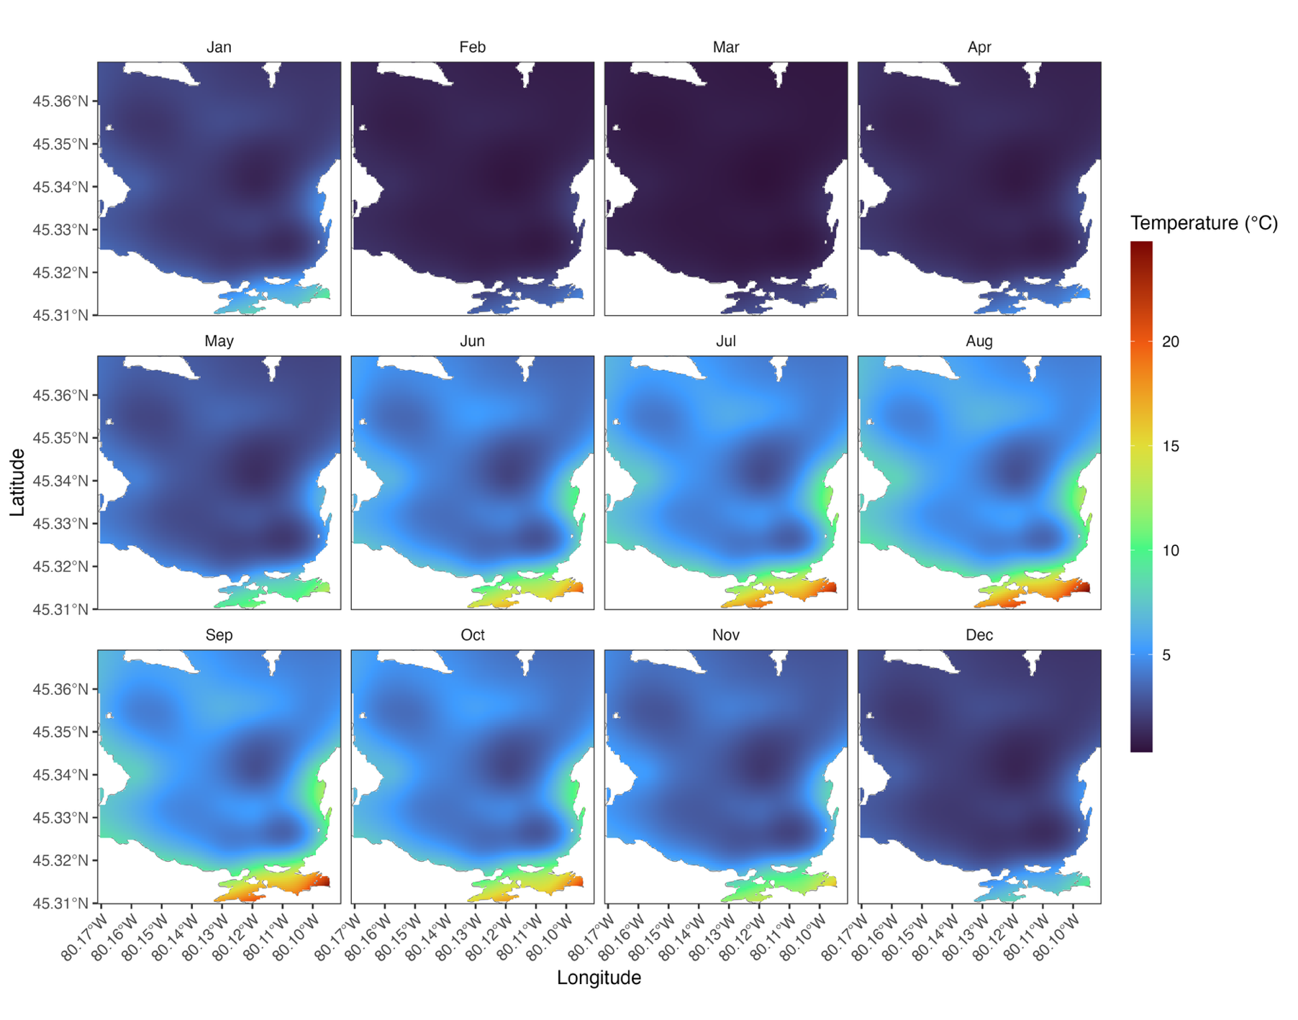
Figures

Figure S1.
Predicted benthic water temperature estimated by daily recorded temperatures (°C) from VR2AR receivers. Predictions were created using a generalized additive model with a scaled student t distribution and a log link function. Model structure consisted of mean daily temperature and spatial thin-plate smoother of receiver deployment location (longitude, latitude) and cubical cyclical regression smoother of day-of-year. Predictions displayed are the first day-of-year of each month, as displaying each day would be cumbersome.

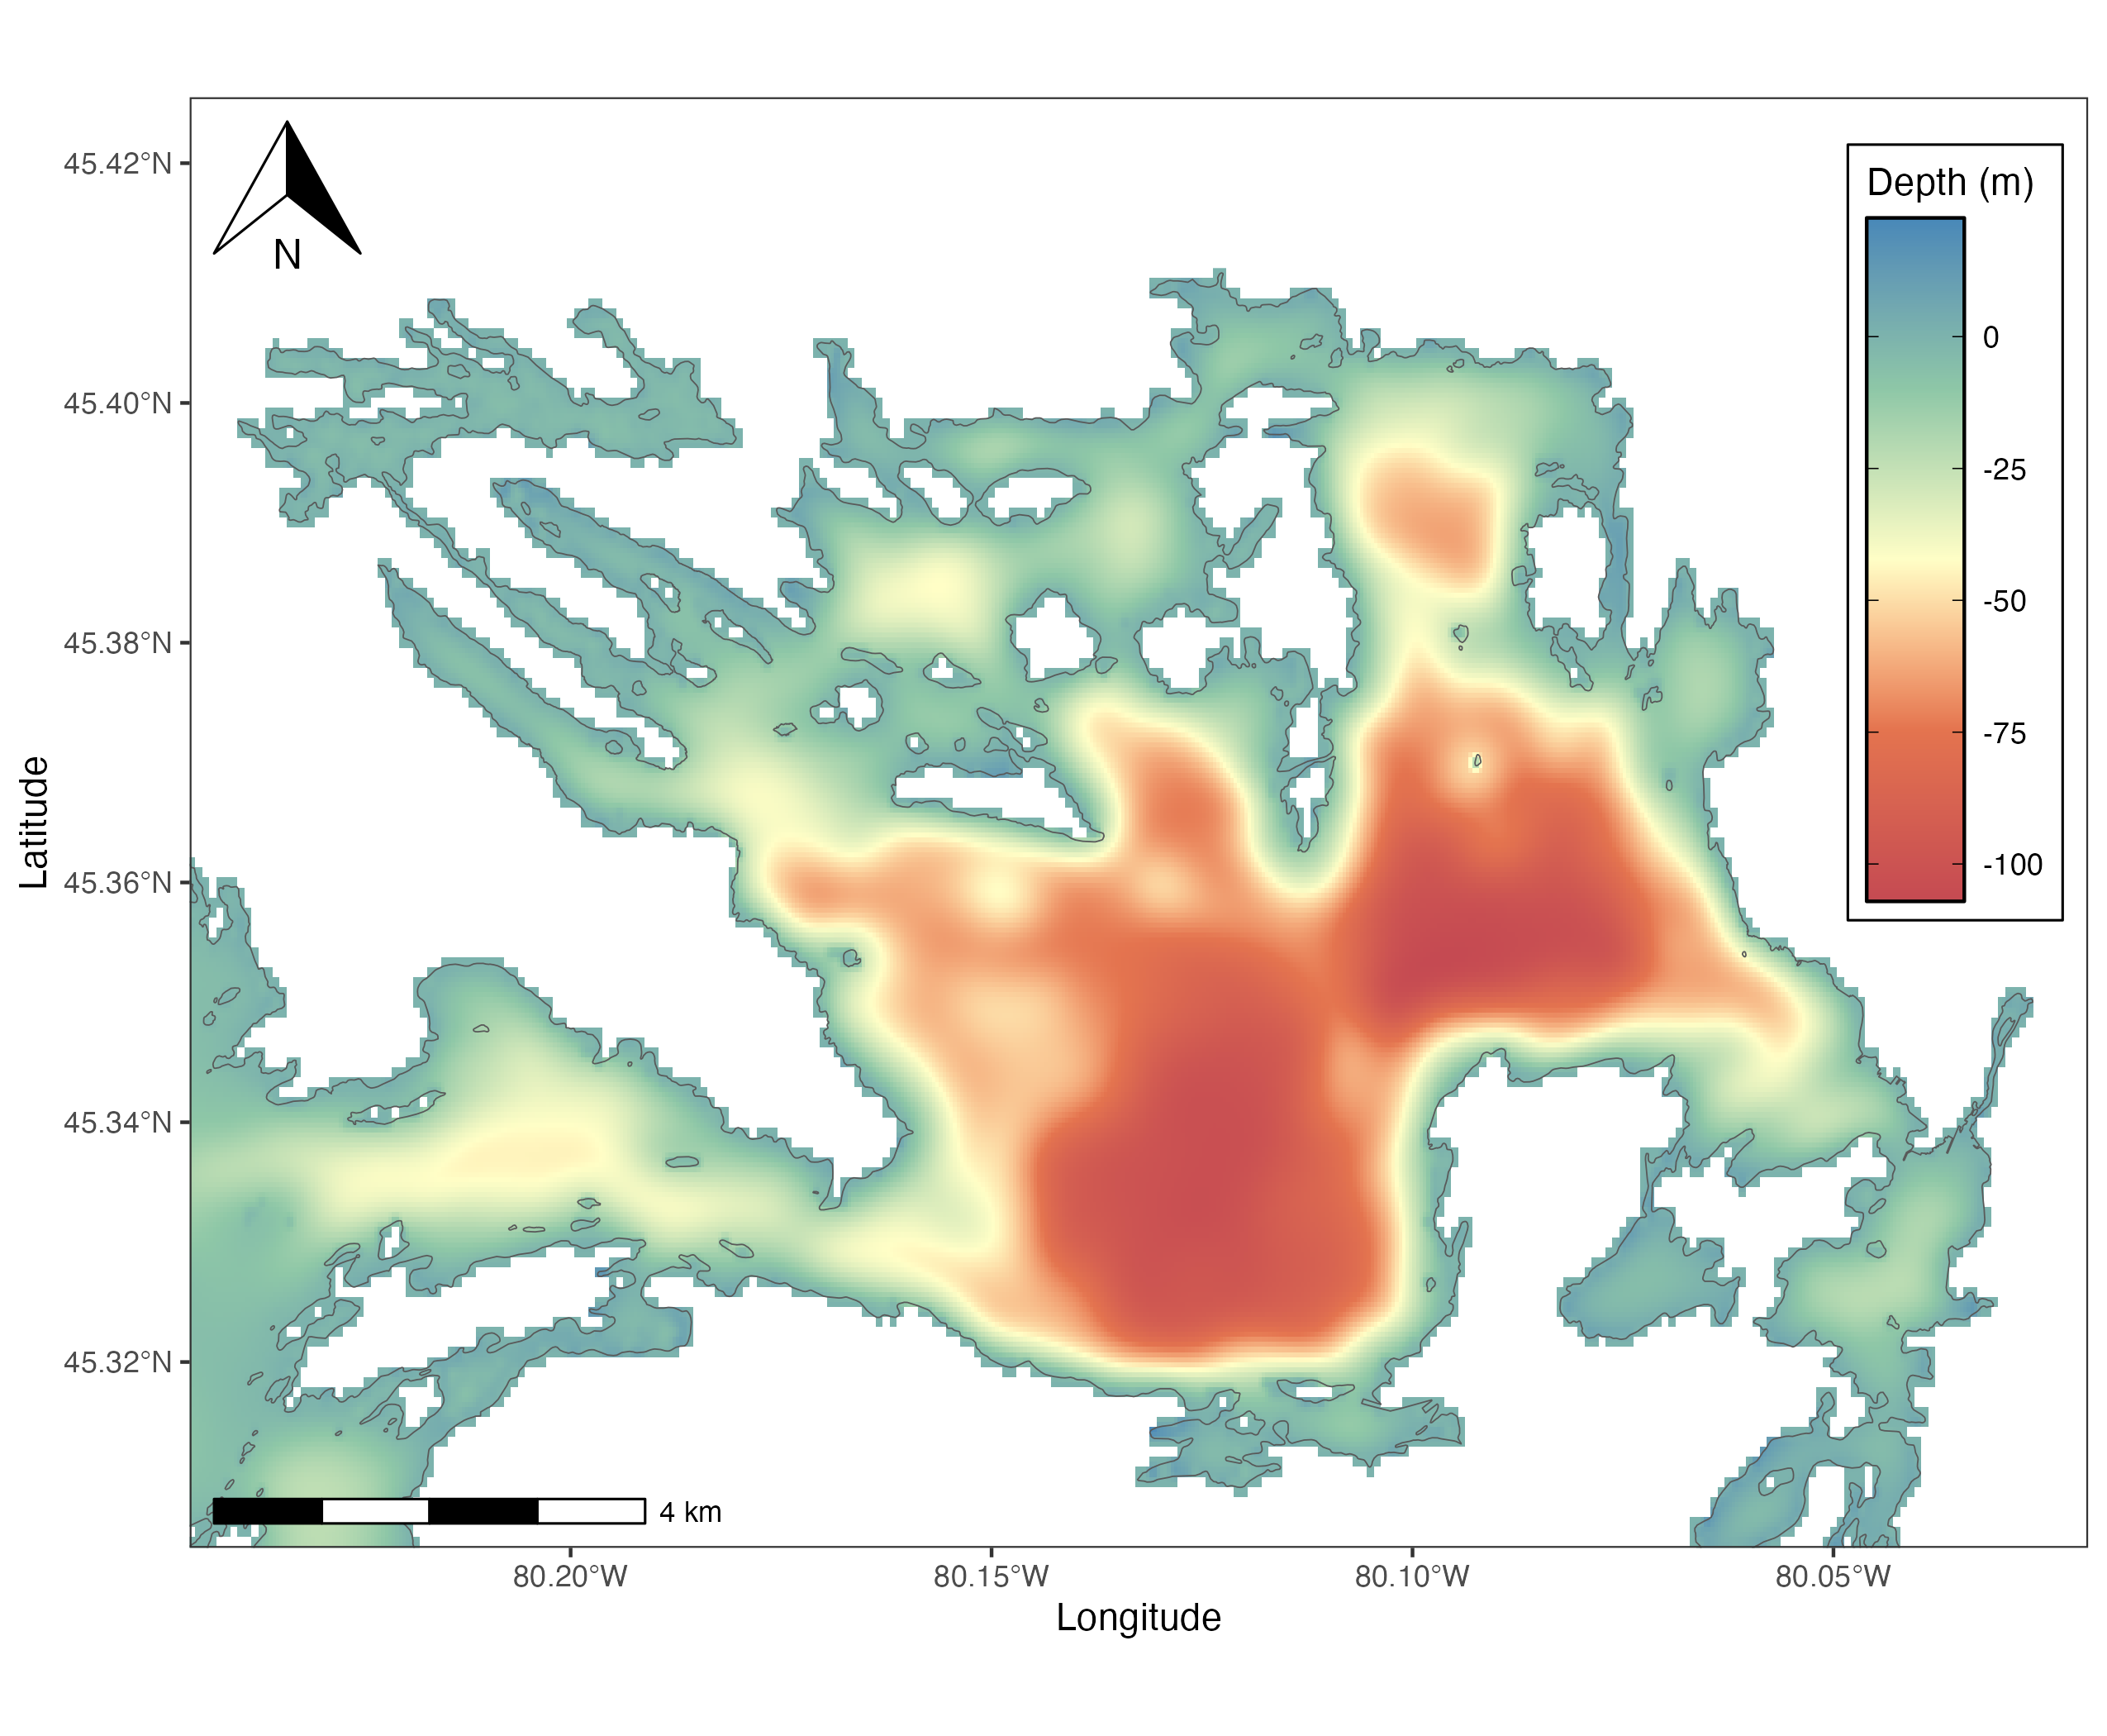

Figure S2.
Bathymetric depth of Parry Sound, Georgian Bay, Lake Huron, derived from the National Oceanic and Atmospheric Administration.

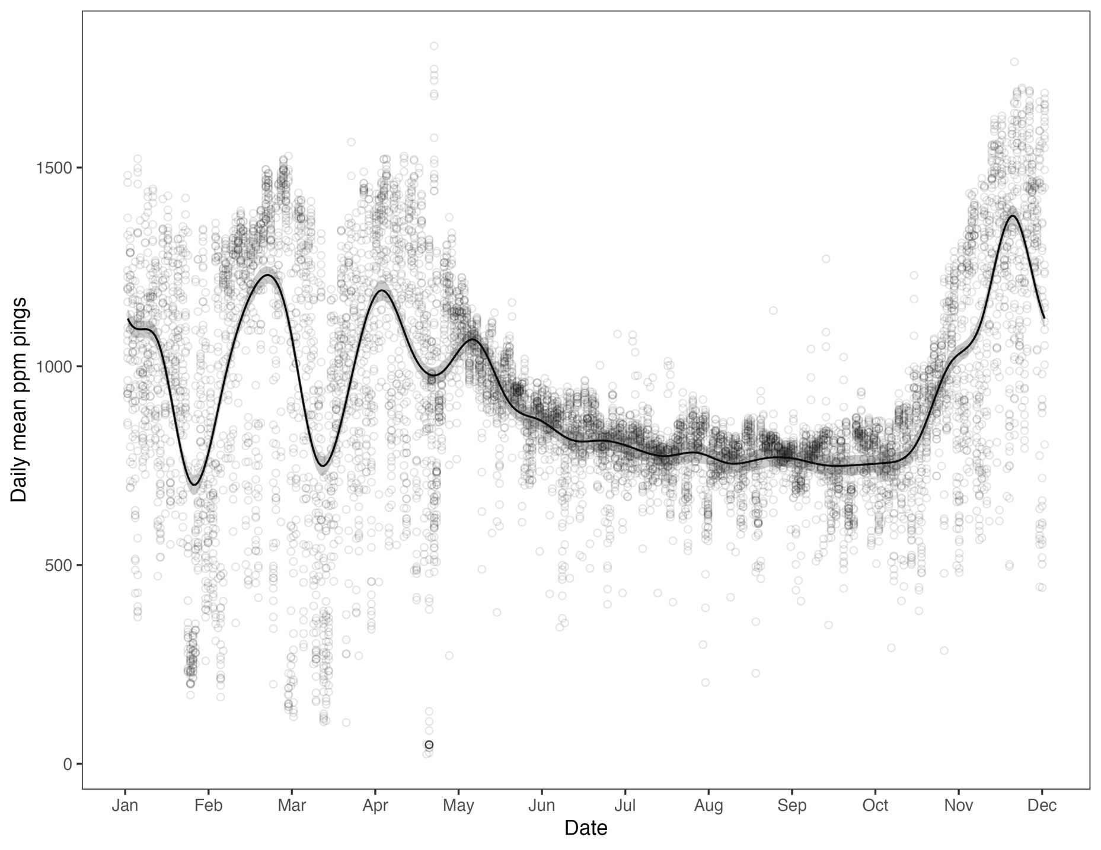
Figure S3.
Daily mean PPM pings for receivers deployed in FSPA in Parry Sound, Georgian Bay, Lake Ontario. The black line is a generalized additive mixed-effect model that used a Gaussian distribution and link function set to identity. The model consisted of a response variable of the daily mean PPM pings recorded by each receiver with a predictor variable of day-of-year and a random effect of individual receiver.

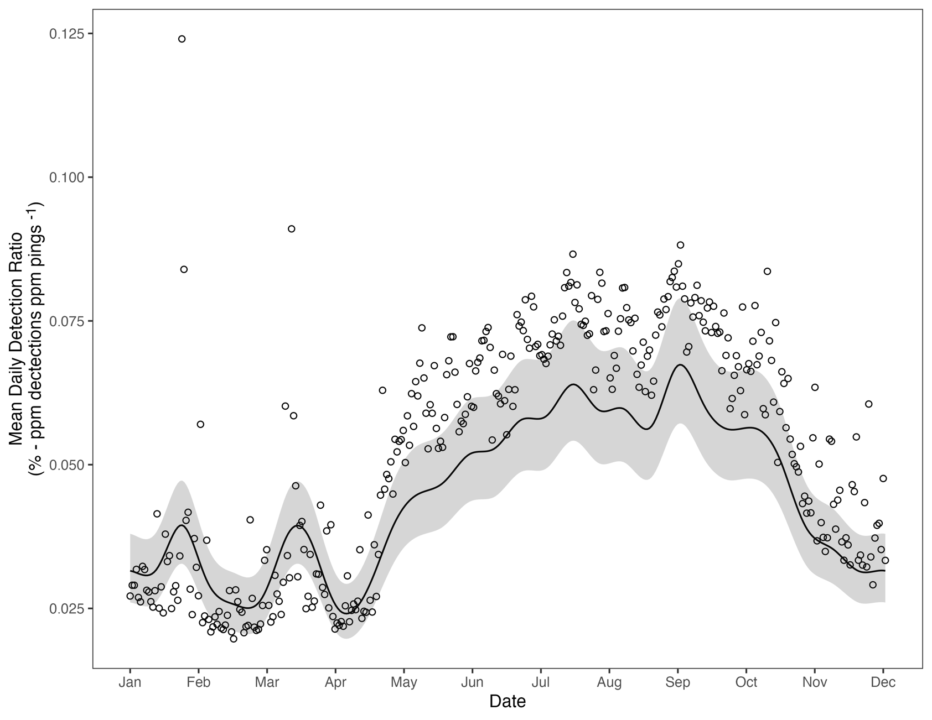
Figure S4.
The Daily Detection Ratio for VR2AR receivers deployed in Parry Sound, Georgian Bay, Lake Ontario. Daily Detection Ratio was derived by calculating the number of PPM Pings that resulted in completed PPM detections for each tag type by taking the expected PPM pings (i.e., 8 pings completes a detection for A69-1601 codespace) and multiplying it by the number of detections for each codespace. This number was then divided by the number of PPM pings detected throughout the day to create a ratio of the number of PPM pings that successfully resulted in detecting a tag. The black line is a generalized additive mixed-effect model that used a Beta distribution and link function set to probit. The model consisted of a response variable of the daily mean detection ratio by each receiver with a predictor variable of day-of-year and a random effect of individual receiver.

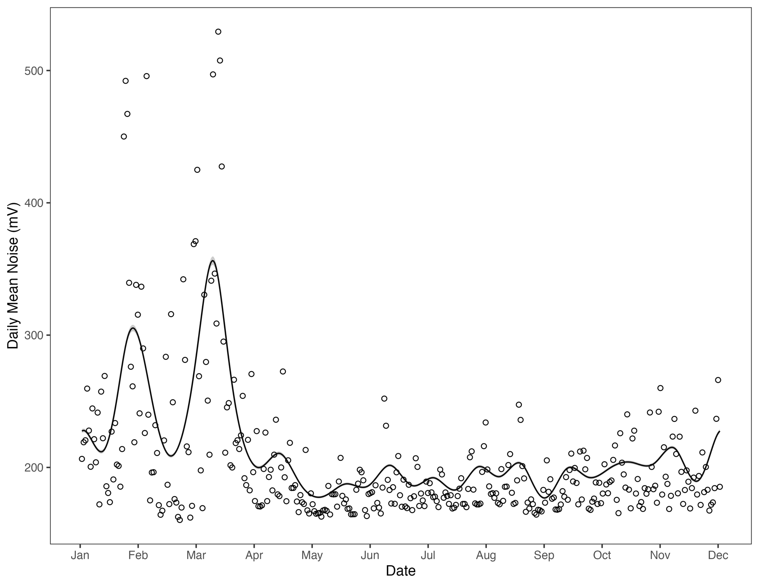
Figure S5.
Daily mean noise (mV) recorded by VR2ARs deployed in a FSPA in Parry Sound, Georgian Bay, Lake Ontario. The black line is a generalized additive mixed-effect model that used a Gamma distribution and link function set to inverse. The model consisted of a response variable of the daily mean noise recorded by each receiver with a predictor variable of day-of-year and a random effect of individual receiver.

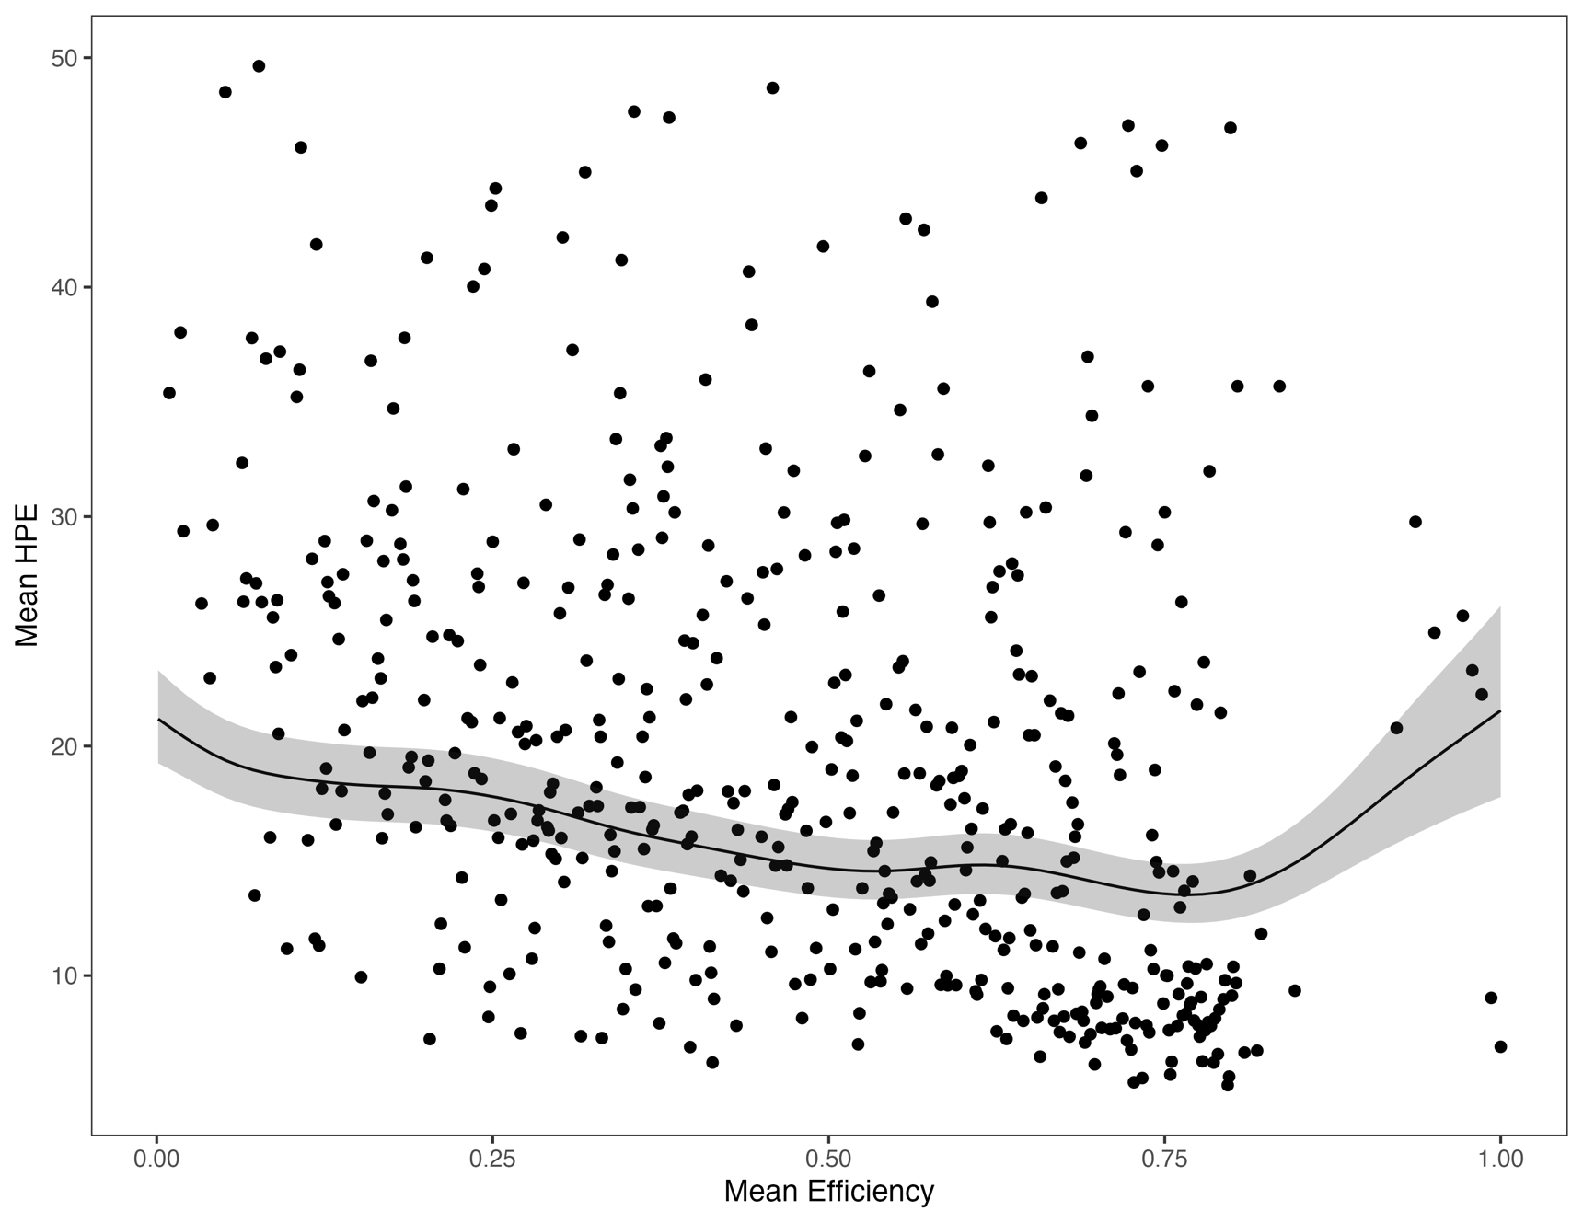
Figure S6.
Mean daily horizontal position error (HPE) derived from estimated sync tag positions compared against the daily mean detection efficiency for VR2ARs modeled using a generalized additive mixed effects model.

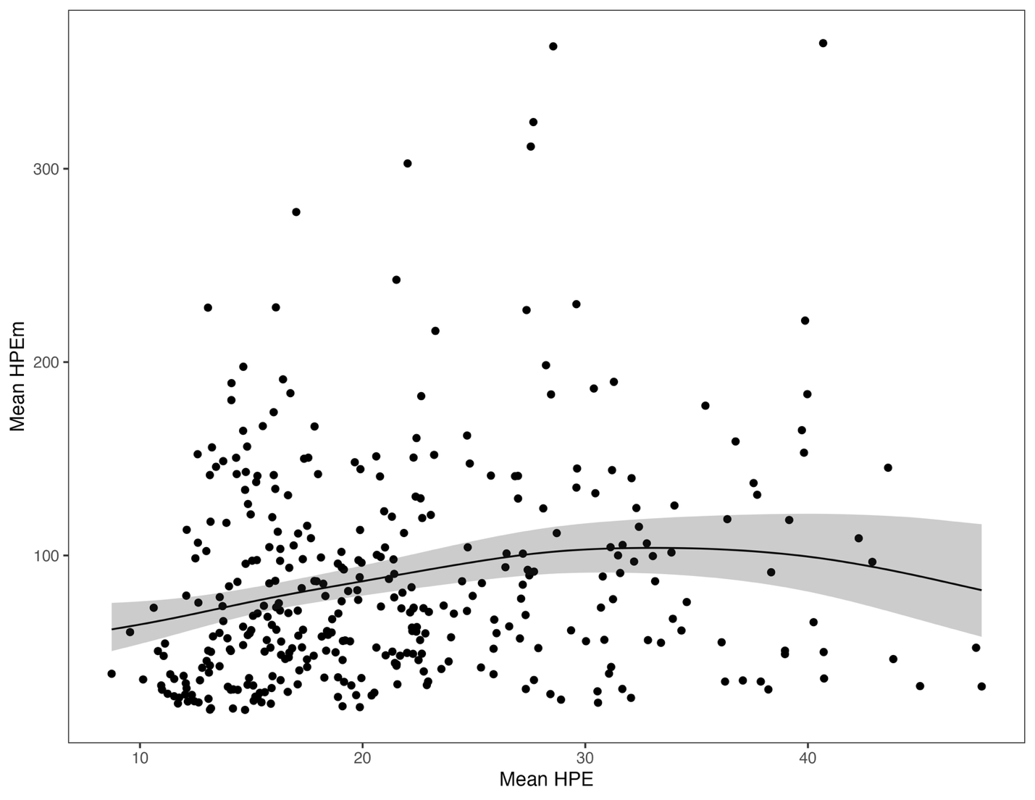
Figure S7.
Daily mean horizontal positioning error in metres (HPEm) compared against the daily mean horizontal positioning error (HPE). The black line is a generalized additive mixed effects model. with the 95% confidence intervals.

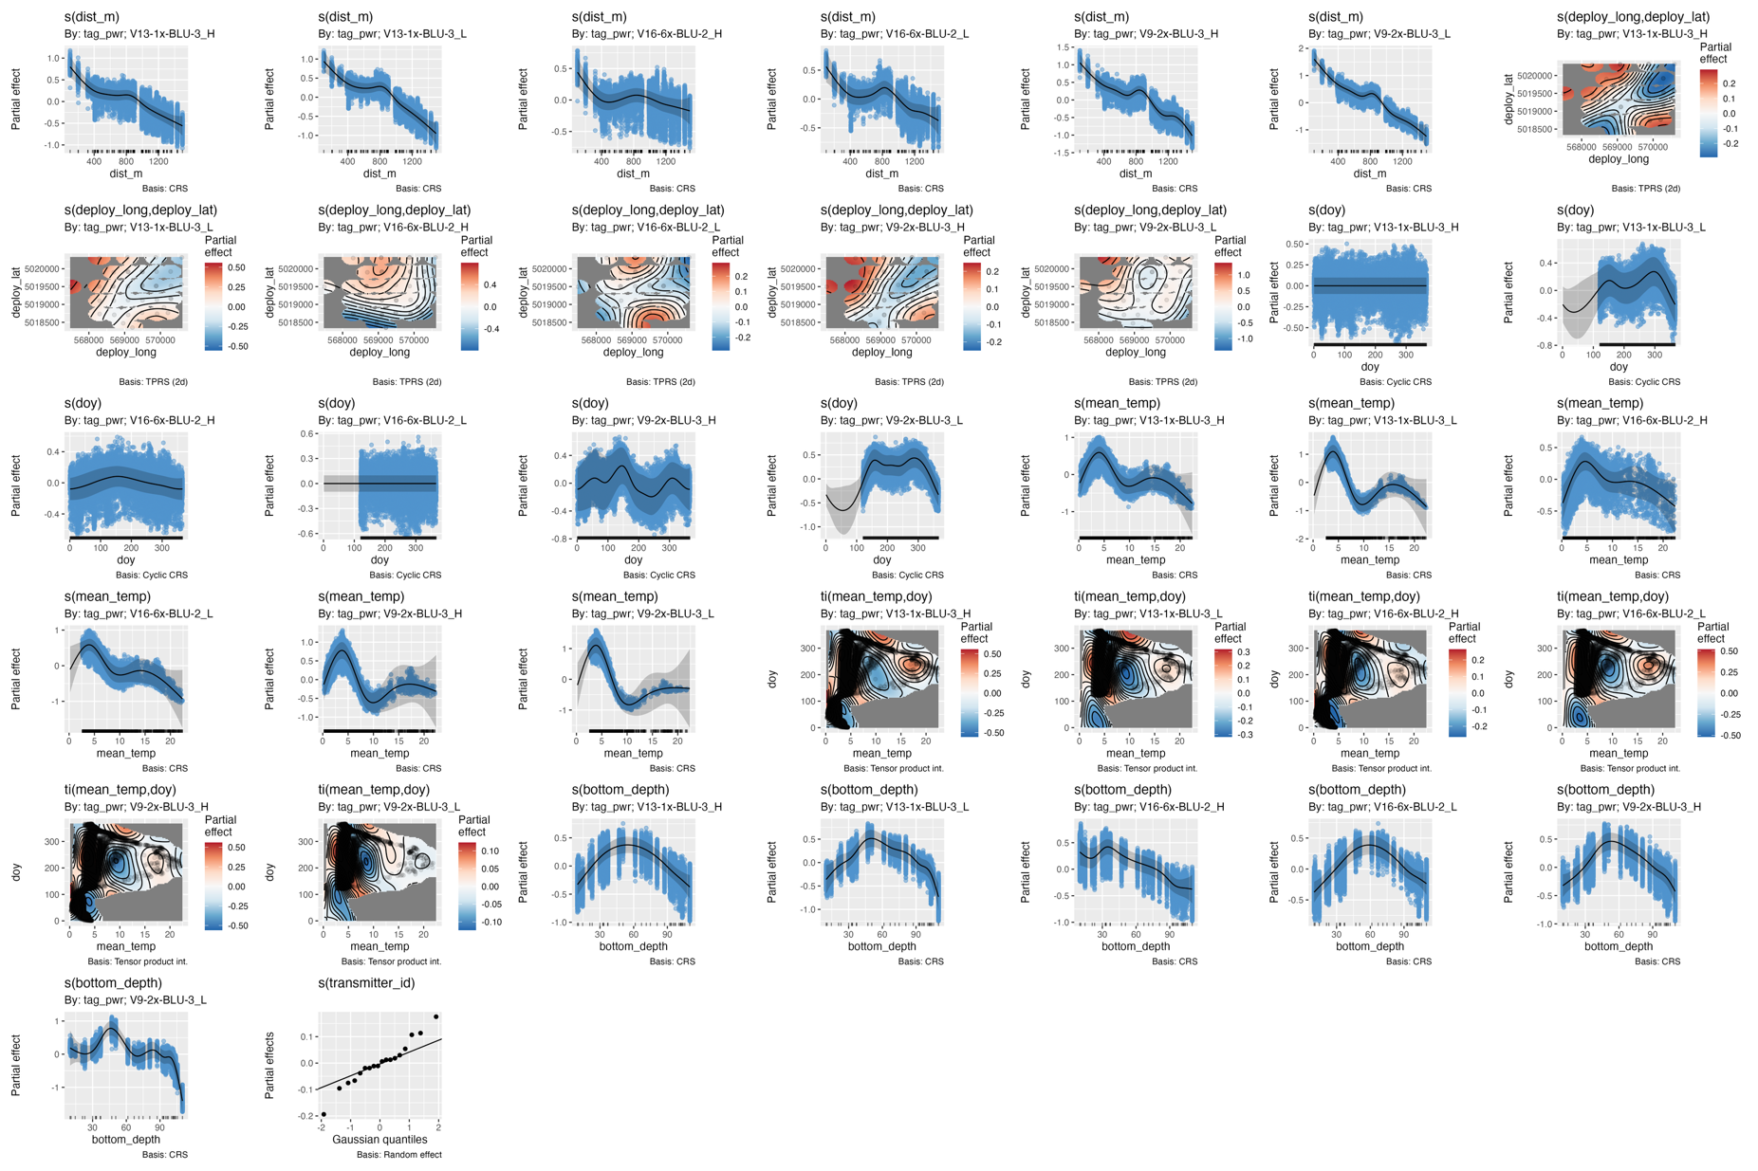
Figure S8.
Partial effects for a generalized additive mixed-effect model used to assess dynamic and static environmental variables on the detection efficiency of V16, V13, and V9 tags in a fine-scale positioning array of VR2ARs. Blue points represent model residual.

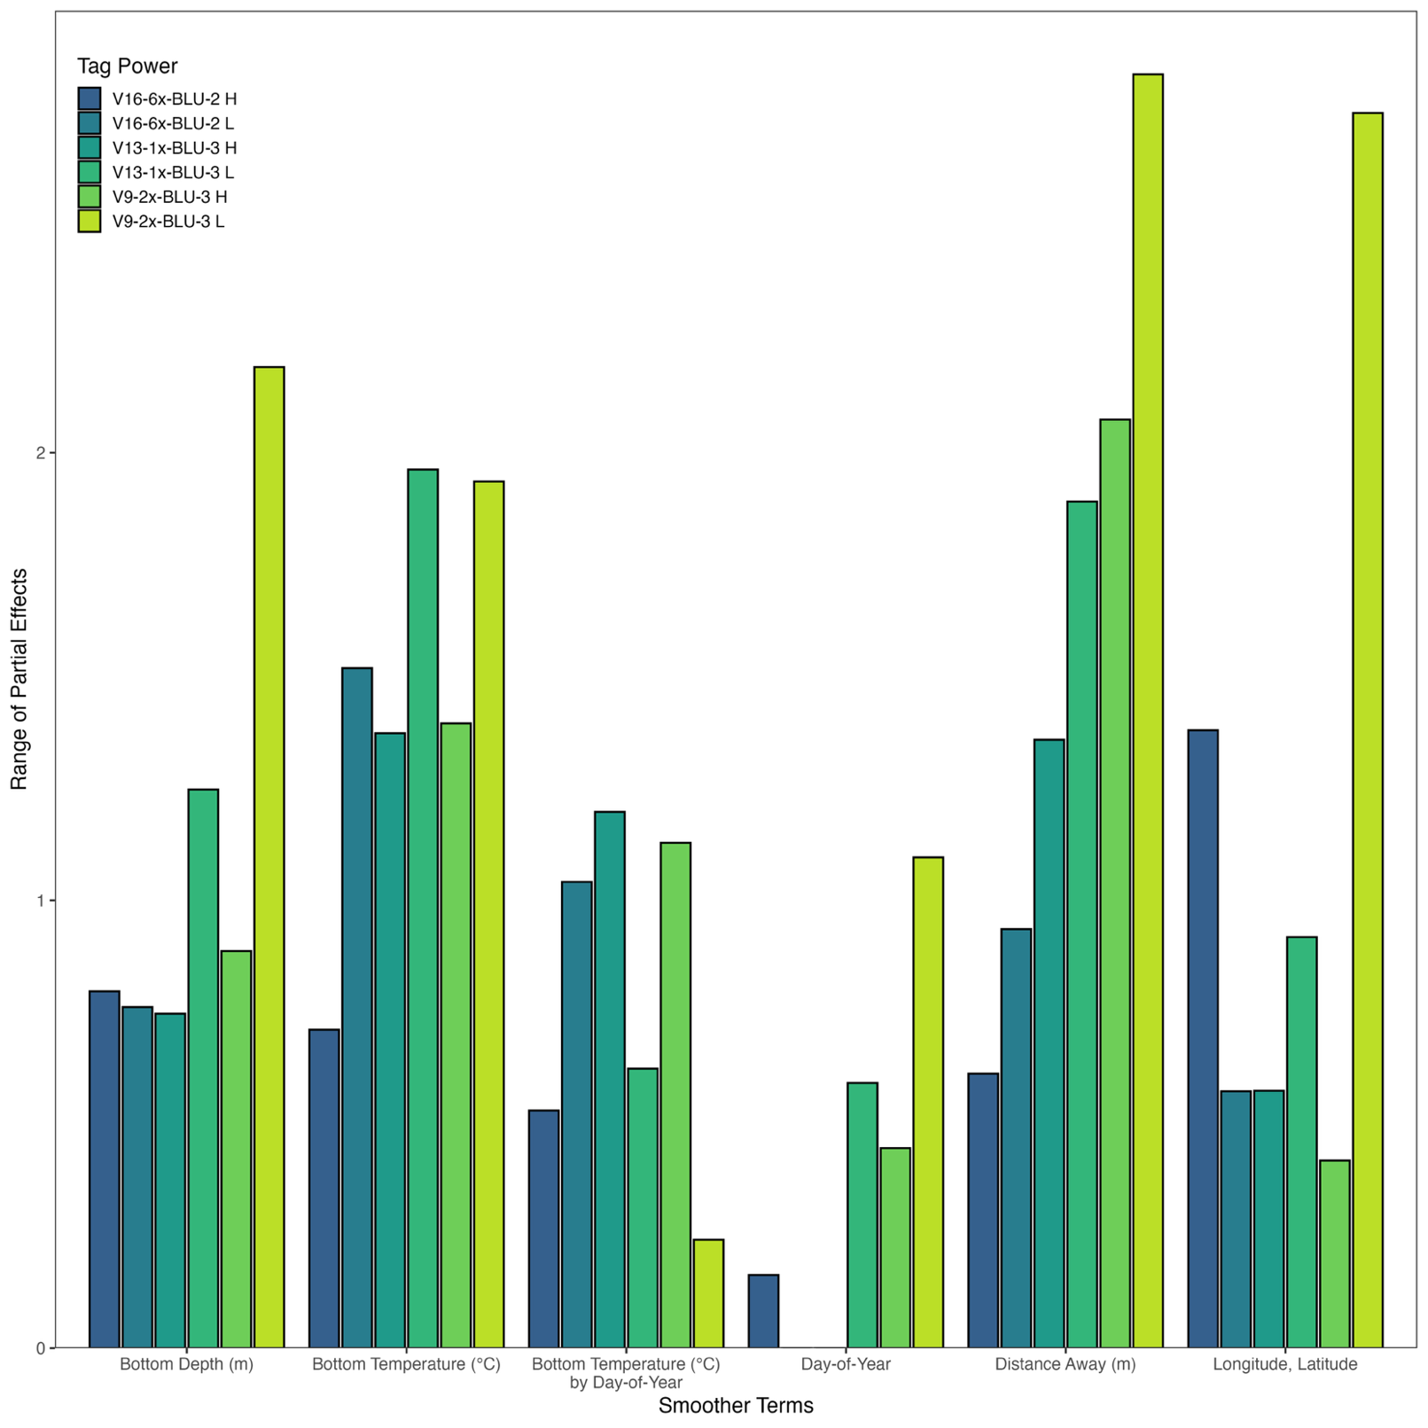
Figure S9.
The range of partial effects for each smoother term used in generalized additive mixed-effect model used to assess dynamic and static environmental variables on the detection efficiency of V9 V13, and V16, tags in a fine-scale positioning array of VR2ARs. The larger the range, the larger the effect of a given term.

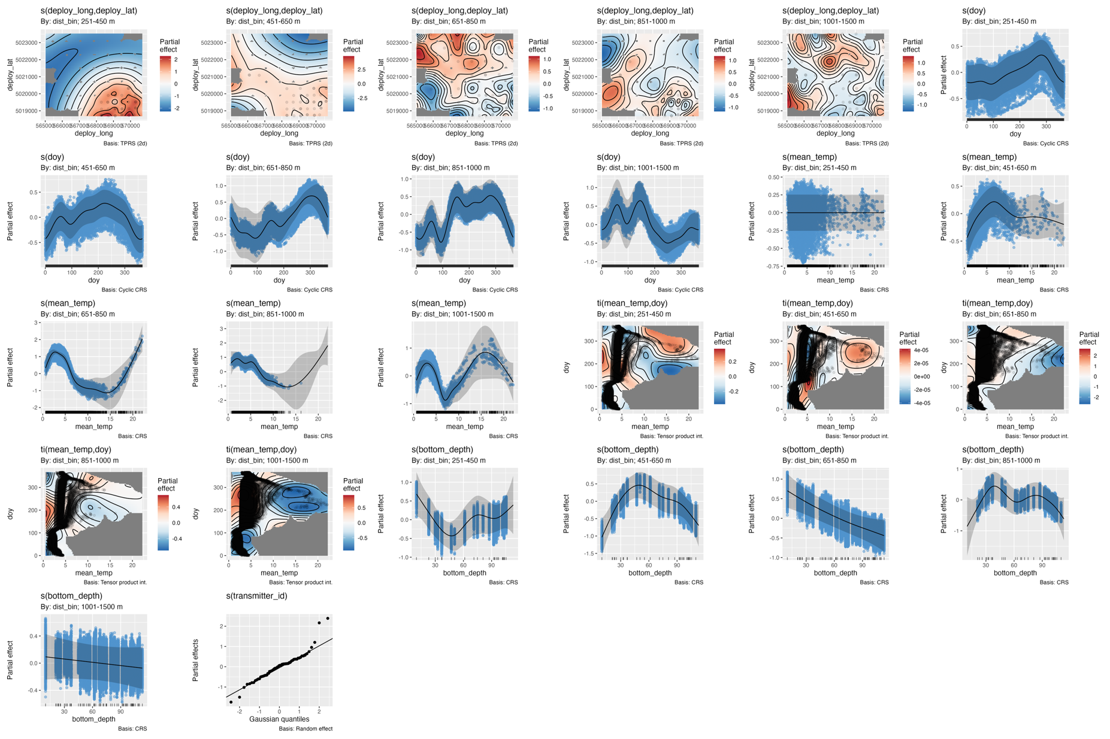
Figure S10.
Partial effects for a generalized additive mixed-effect model used to assess dynamic and static environmental variables on the detection efficiency of internal transmitters of VR2ARs used in a fine-scale positioning array. Blue points represent model residuals.

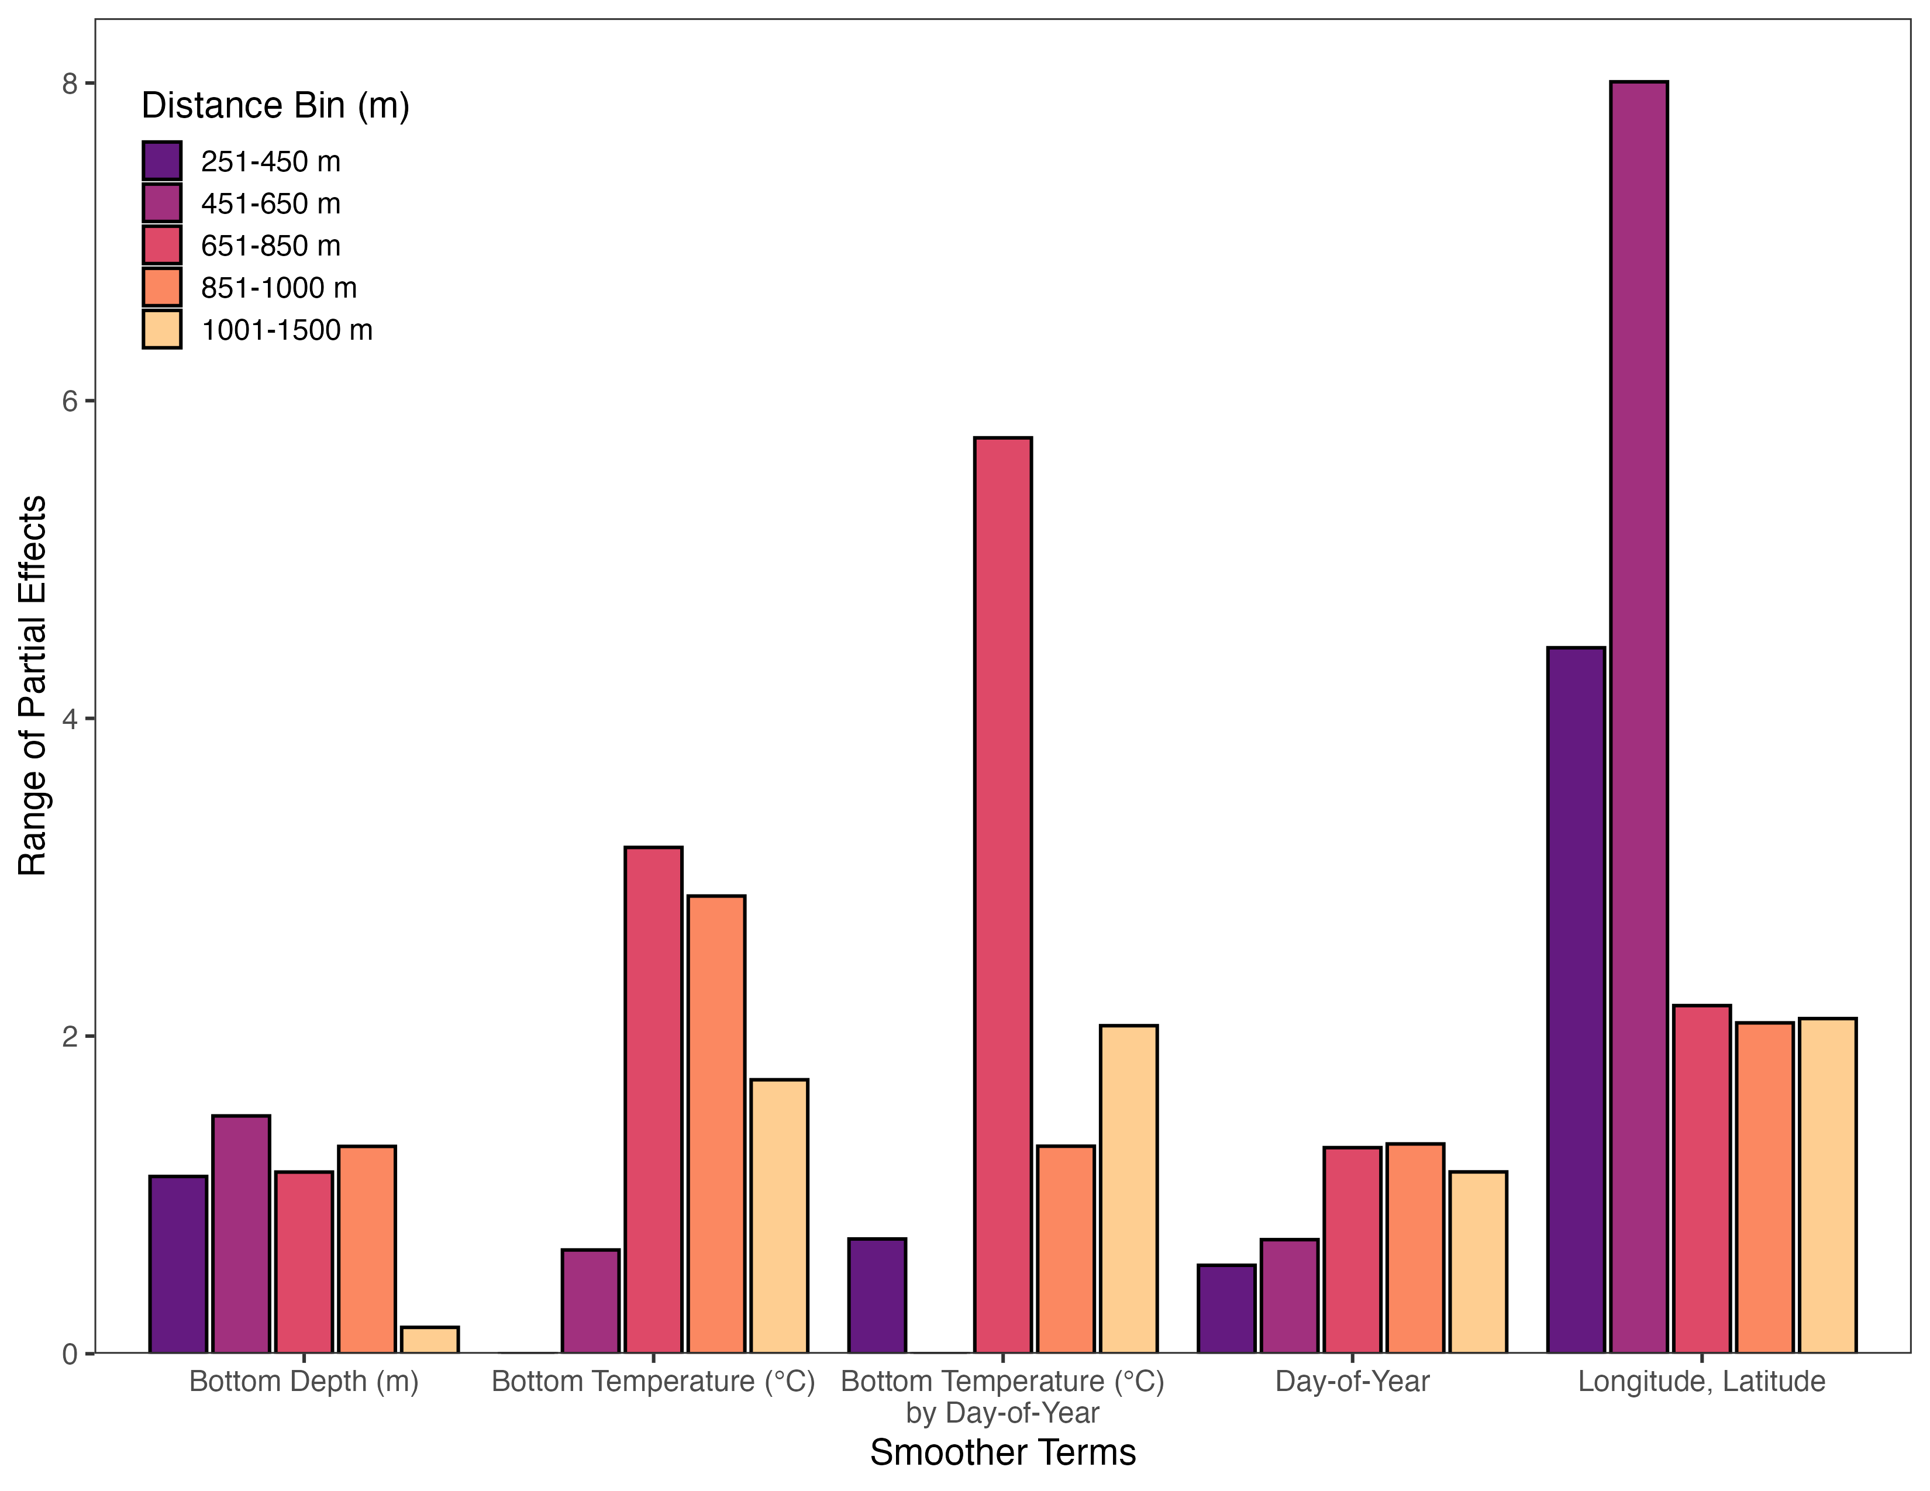
Figure S11.
The range of partial effects for each smoother term used in generalized additive mixed-effect model used to assess dynamic and static environmental variables on the detection efficiency of internal transmitters of VR2ARs for a fine-scale positioning array. The larger the range, the larger the effect of a given term.

