Supporting information
Hydraulic Retention Time and Electric Stimuli as Key Levers for Tailoring Mixotrophic Consortia Toward Enhanced Volatile Fatty Acid Production and Carbon Capture
Ana Clara Bonizol Zaniª, Adalgisa Rodrigues de Andradeª, and Valeria Reginattoª*
ªDepartment of Chemistry, Faculty of Philosophy, Sciences and Letters at Ribeirão Preto (FFCLRP), University of São Paulo, Avenida Bandeirantes, 3900, Ribeirão Preto, São Paulo 14040-030, Brazil

*Corresponding Author
E-mail: valeriars@ffclrp.usp.br
Phone: +55 16 3315-0431

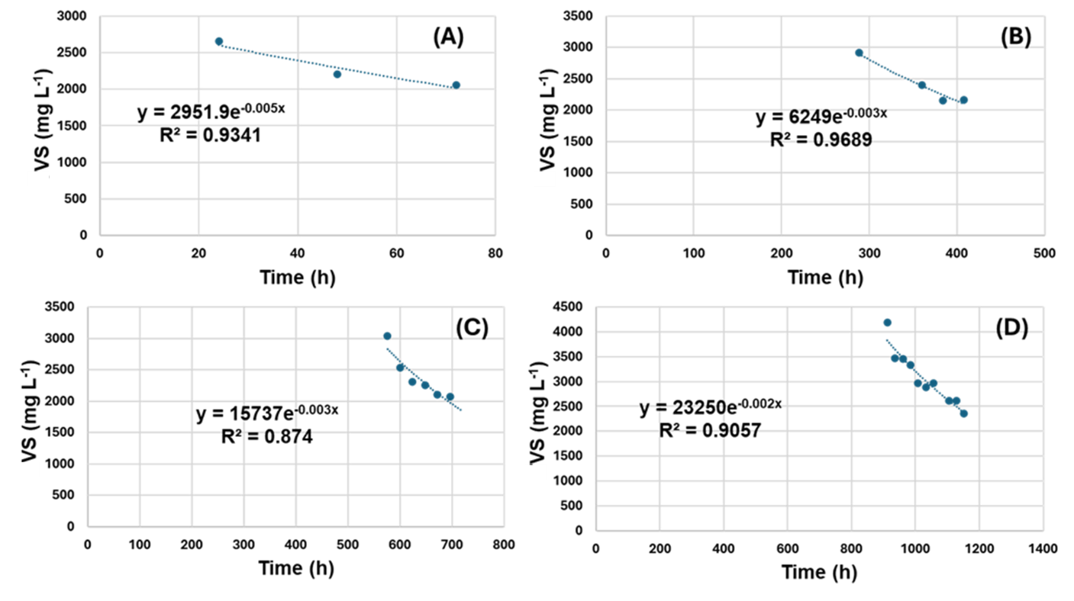
Fig. S1: Exponential fitting model for washout in E_BR at HRT = 33 h (A), HRT = 19 h (B), HRT = 14ª h (C) and HRT = 14^{b} h after batch test (D).
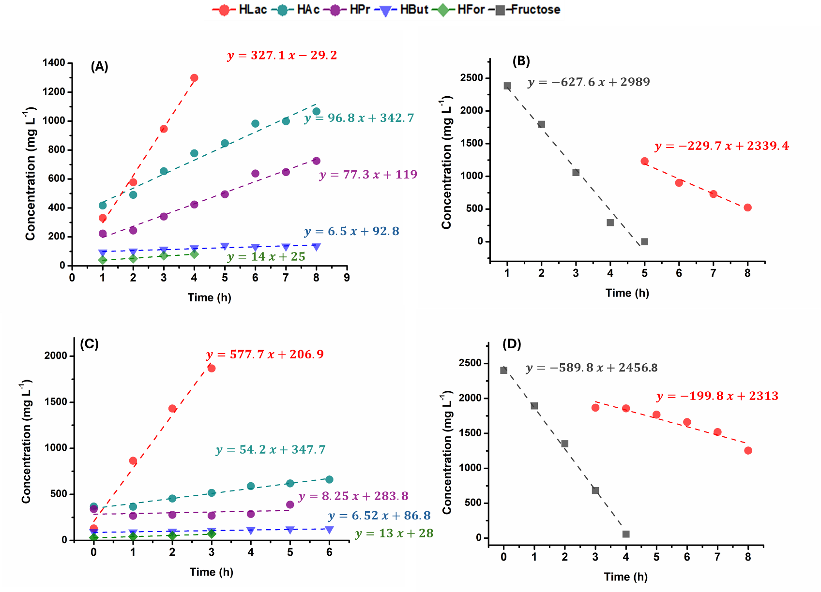
Fig. S2: Linear regression analysis of batch kinetics: (A) carboxylic acid production (HAc, HPr, and HBut) during BI; (B) fructose and HLac consumption during BI; (C) carboxylic acid production during BII; (D) fructose and HLac consumption during BII.
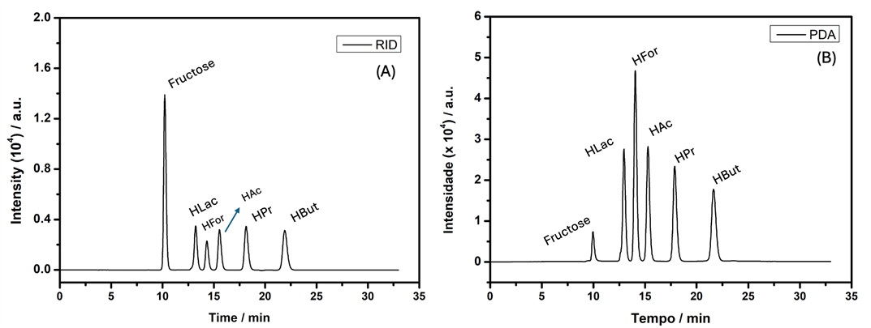
Fig. S3: HPLC-RID analysis: Fructose presents a retention time (t_{R}) of 10.2 min (A). HPLC-PDA analysis: lactic, formic, acetic, propionic, and butyric acids present retention times (t_{R}) of 12.9, 14.0, 15.2, 17.8 and 21.6 min, respectively (B). Chromatographic conditions: mobile phase employed, consisting of 5.0 mmol L⁻¹ of H₂SO₄ (flow: 0.6 mL min⁻¹) and column temperature of 60 °C.

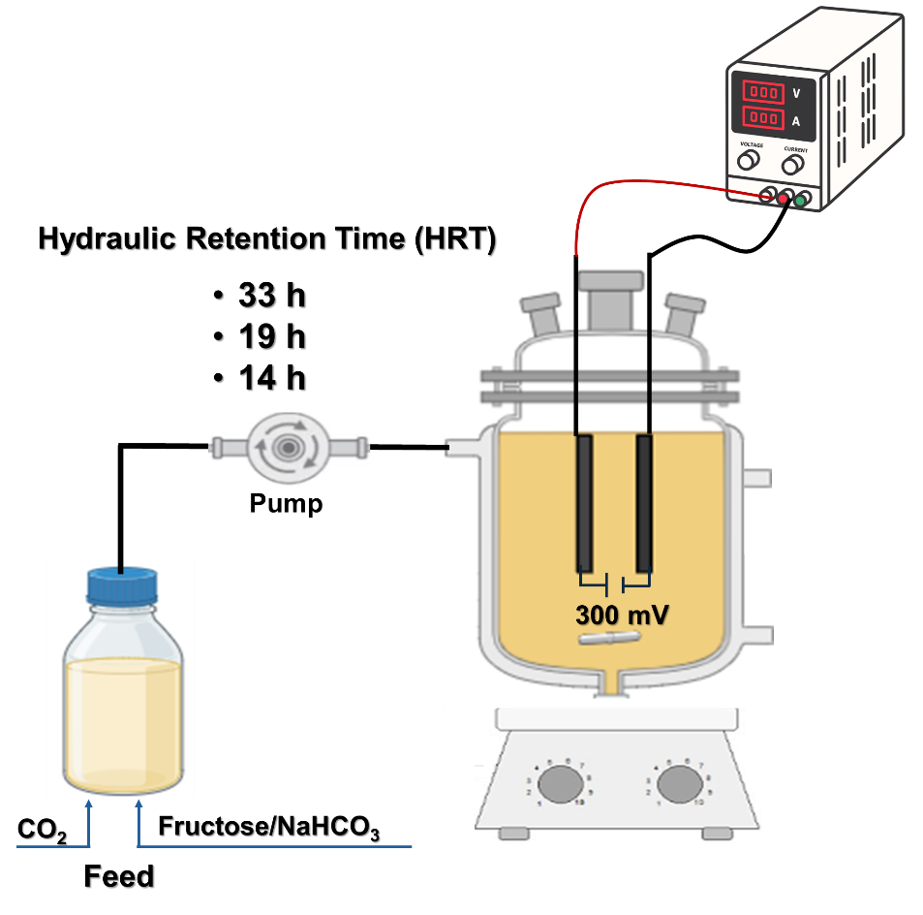
Figure S4: Experimental apparatus

