Additional File 1: Supplementary Tables and Figures for patRoon 3.0: Enhanced non-target analysis workflows with ion mobility separation and other major improvements
Rick Helmus*ª, Jan C. Speckerª, Christine Gallampois^{b} and Emma L. Schymanski^{c}
ª Institute for Biodiversity and Ecosystem Dynamics, University of Amsterdam, Science Park 904, 1098 XH Amsterdam, the Netherlands
^{b} Department of Chemistry, Umeå University, Linneaus väg 6, 901 87 Umeå, Sweden
^{c} Luxembourg Centre for Systems Biomedicine, University of Luxembourg, 6 avenue du Swing, Belvaux L-4367, Luxembourg
* Corresponding author: r.helmus@uva.nl

Table of contents
Supplementary tables 2
Table S1 2
Table S2 2
Table S3 3
Table S4 4
Table S5 4
Supplementary figures 5
Figure S1 5
Figure S2 5
Figure S3 6
References 6

Supplementary tables
Table S1. Developed or interfaced algorithms for the automatic peak detection in extracted ion chromatograms or extracted ion mobilograms.
Algorithm | Remarks
piek | Based on the peak detection algorithm from [1], which was optimized with OpenMP multithreading [2].
OpenMS [3] | The data is exported as chromatographic traces in a temporary mzML [4] file, subsequently processed with the MRMTransitionGroupPicker tool of OpenMS, and the results are then imported through a C++ interface using pugixml [5] and Rcpp [6–8].
XCMS [9] | Using the xcms::peaksWithCentWave() function.
enviPick [10] | Using the enviPick::mzpick() function.

Table S2. Scoring terms used by the greedy sample analysis feature grouping algorithm.
Score | Calculation
retention time (RT) proximity | $${score}_{RT}=1-\frac{1}{n}\sum_{i=1}^{n}{\frac{\left|{RT}_{i}{-RT}_{ref}\right|}{{RT}_{tolerance}}}$$
m/z proximity | $${score}_{mz}=1-\frac{1}{n}\sum_{i=1}^{n}{\frac{\left|{mz}_{i}{-mz}_{ref}\right|}{{mz}_{tolerance}}}$$
mobility proximity | $${score}_{mobility}=1-\frac{1}{n}\sum_{i=1}^{n}{\frac{\left|{mobility}_{i}{-mobility}_{ref}\right|}{{mobility}_{tolerance}}}$$
replicate intensity similarity | $${score}_{intensity}=\frac{1}{n}\sum_{i=1}^{n}{\frac{{intensity}_{i}}{{max⁡(intensity}_{replicate})}}$$
group score¹ | $${score}_{group}={score}_{RT}∙{wt}_{RT}+{score}_{mz}∙{wt}_{mz}+{score}_{mobility}∙{wt}_{mobility}+{score}_{intensity}∙{wt}_{intensity}$$
¹: score_{mobility} is zero in non-IMS workflows and score_{RT} and score_{mz} are zero when updating sample grouped features in post mobility assignment workflows; ref: reference feature: most intense feature or a sibling from the same sample analysis; wt: configurable weight
Table S3. Acquisition parameters used for the AgilentST dataset.
LC | Instrumentation | Infinity II HPLC (Agilent, Solna, Sweden)
LC | Stationary phase | C18
LC | Column | Kinetex (2.6 µm, 100 Å, 150 x 2.1 mm, Phenomenex, Torrance, CA, USA)
LC | Column temperature | 40 °C
LC | Pump flow | 0.5 ml/min
LC | Mobile phase | A: ultra-pure waterª  B: methanol^{b}
LC | Elution gradient | 10% B (t=0 min); gradual increase to 95% B (t=50 min); hold at 95% B (t=60 min). Equilibration time: 5 min.
LC | Injection volume | 1 µl
LC | Calibration reference ion delivery | Isocratic pump Infinity 1260 (Agilent). Operated at a 0.08 mL/min. Reference ions in acetonitrile/water (95:5, v/v).
IMS-HRMS | Instrumentation | 6560 IM-QTOF (Agilent)
IMS-HRMS | Polarity mode | Positive
IMS-HRMS | Ionization source | Dual AJS ESI
IMS-HRMS | Ionization parameters | Gas temperature: 225 °C  Gas flow: 5 l/min  Nebulizer: 30 psig  Sheath gas temperature: 350 °C  Sheath gas flow: 12  VCap: 4500 V  Nozzle Voltage: 500 V  Fragmentor: 275 V  Oct RF Vpp: 550
IMS-HRMS | Frame scan rate | 1.1/sec
IMS-HRMS | IM Transient Rate | 21/frame
IMS-HRMS | m/z scan range | 50 – 1700
IMS-HRMS | Max Drift time | 45 ms
IMS-HRMS | Trap fill time | 20000 µs
IMS-HRMS | Trap release time | 150 µs
IMS-HRMS | Calibration (m/z and mobility) | ESI-L LCMS Tuning mix (Agilent)
IMS-HRMS | Software | MassHunter B.08.00
ª: obtained from a Milli-Q device (Merck Millipore, Solna Sweden); ^{b}: obtained from LiChrosolv hypergrade (Merck, Darmstadt, Germany)

Table S4. Processing parameters used for extraction ion mobilogram (EIM) data.
 | EIM summing¹ | EIM smoothing
AgilentST
Direct mobility assignment | None | None
Post mobility assignment | Peakª (max ±4 seconds) | None
Vendor | Peakª | None
BrukerEff
Direct mobility assignment | Fixed (2s) | Centered moving average (n=15)
Post mobility assignment | Peakª (max ±4 seconds) | Savitzky-Golay (n=31^{b})
Vendor | Peakª | Savitzky-Golay (n=15^{b})
ª: Summation of EIMs across the chromatographic peak; ^{b}: the reported smoothing width of the vendor visually appeared to be ~50% of the width as used by the smoothing implementation of patRoon.

Table S5. EIMs obtained with direct and post mobility assignment for four unknown features with deviating CCS data from BrukerEff .
Direct mobility assignment | Post mobility assignment
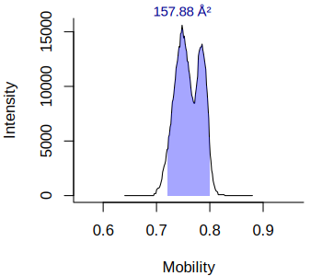 | 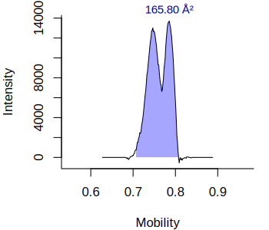
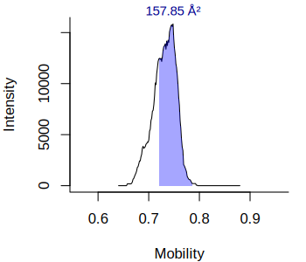 | 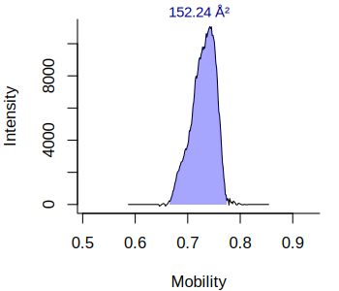
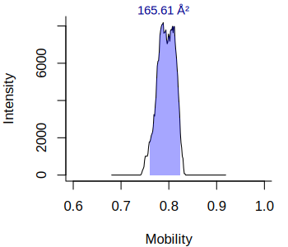 | 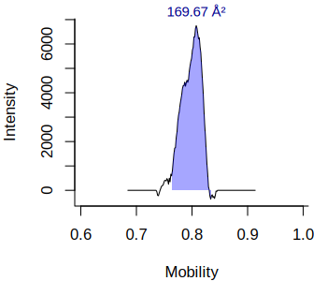
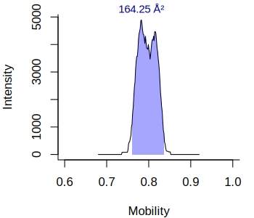 | 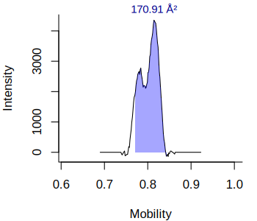

Supplementary figures
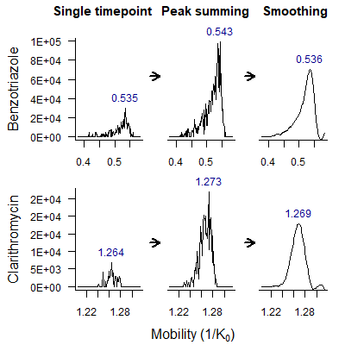
Figure S1. Illustration on how summing EIM data over the chromatographic peak and subsequent smoothing improves the mobility determination for two compounds in the BrukerEff dataset.
a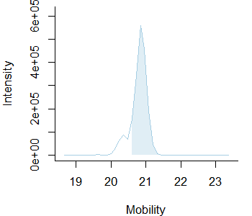 | b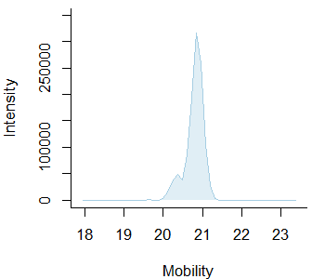
Figure S2. Obtained EIMs and mobility assignments of mepronil obtained in the AgilentST dataset with (a) direct mobility assignment and (b) post mobility assignment.

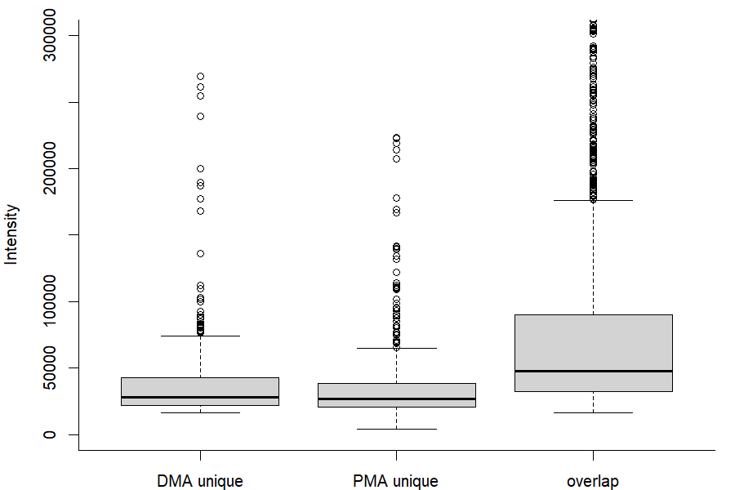
Figure S3. Intensities for features uniquely assigned to the evaluated direct and post mobility assignment workflows and overlapping features. The y scale is truncated at 300,000 for clarity, which excludes 123 features with higher intensities.

References
1. Dietrich C, Wick A, Ternes TA Open source feature detection for non-target LC-MS analytics. Rapid Communications in Mass Spectrometry n/a:e9206. https://doi.org/10.1002/rcm.9206
2. OpenMP consortium OpenMP. https://www.openmp.org/. Accessed 23 Dec 2025
3. Röst HL, Sachsenberg T, Aiche S, et al (2016) OpenMS: a flexible open-source software platform for mass spectrometry data analysis. Nature Methods 13:741–748. https://doi.org/10.1038/nmeth.3959
4. Martens L, Chambers M, Sturm M, et al (2011) mzML—a Community Standard for Mass Spectrometry Data. Molecular & Cellular Proteomics 10:. https://doi.org/10.1074/mcp.R110.000133
5. Kapoulkine A pugixml. https://pugixml.org/. Accessed 3 Apr 2026
6. Eddelbuettel D, François R (2011) Rcpp: Seamless R and C++ Integration. Journal of Statistical Software 40:1–18. https://doi.org/10.18637/jss.v040.i08
7. Eddelbuettel D (2013) Seamless R and C++ Integration with Rcpp. Springer, New York
8. Eddelbuettel D, Balamuta JJ (2017) Extending R with C++: A Brief Introduction to Rcpp. PeerJ Preprints 5:e3188v1. https://doi.org/10.7287/peerj.preprints.3188v1
9. Louail P, Brunius C, Garcia-Aloy M, et al (2025) xcms in Peak Form: Now Anchoring a Complete Metabolomics Data Preprocessing and Analysis Software Ecosystem. Anal Chem 97:27639–27645. https://doi.org/10.1021/acs.analchem.5c04338
10. Loos M enviPick: Peak Picking for High Resolution Mass Spectrometry Data. https://github.com/blosloos/enviPick. Accessed 31 Mar 2026

