Supplementary information for

Monolithic silicon micromechanical metastructures for compliant MEMS devices

Authors:
Bingdong Chang¹, Mads Holmgaard Jensen¹, Jiawei Wang¹, Ada Ioana Bunea², Rasmus Ellebæk Christiansen¹, Debabrata Adhikari¹, Tianbo Yu¹, Anpan Han¹

- DTU Construct, Technical University of Denmark, 2800 Kgs. Lyngby, Denmark
- DTU Nanolab, Technical University of Denmark, 2800 Kgs. Lyngby, Denmark

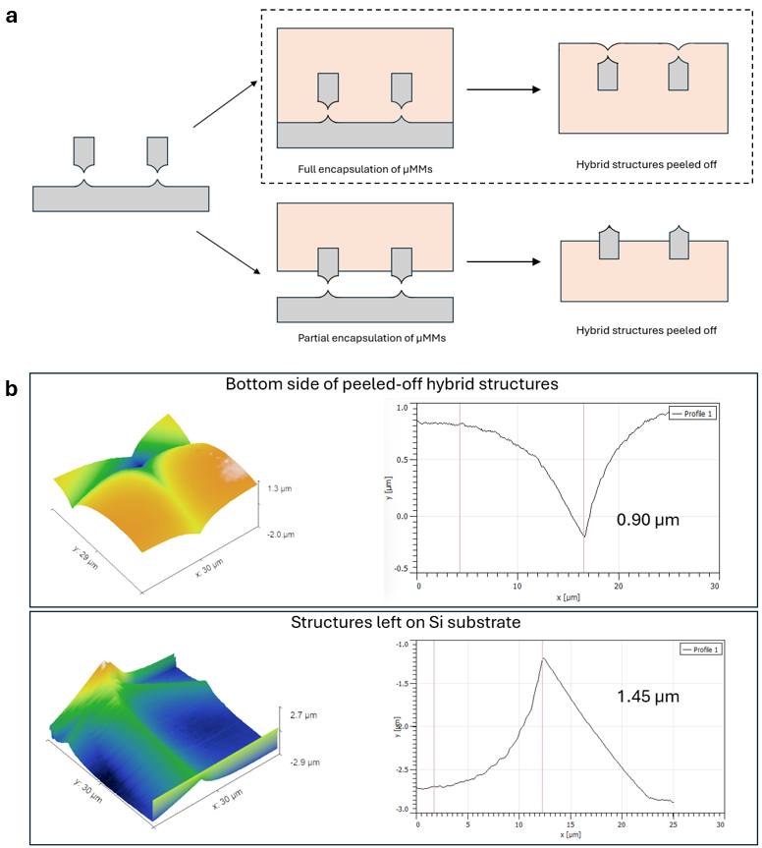
Figure S1. (a) Schematic drawing showing the difference of surface morphology in Si µMMs/PDMS hybrid structures, when µMMs are partially encapsulated or fully encapsulated by PDMS. (b) AFM scanning on the bottom side of hybrid structures, the concave feature at µMMs region suggest fully encapsulated Si µMMs inside PDMS membrane.

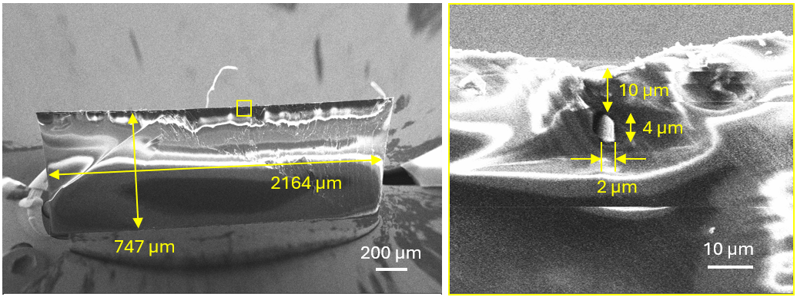
Figure S2. SEM image showing the crosssection of µMMs/PDMS hybrid structure. The µMMs are fully embedded in the PDMS substrate with a depth of around 10 µm.

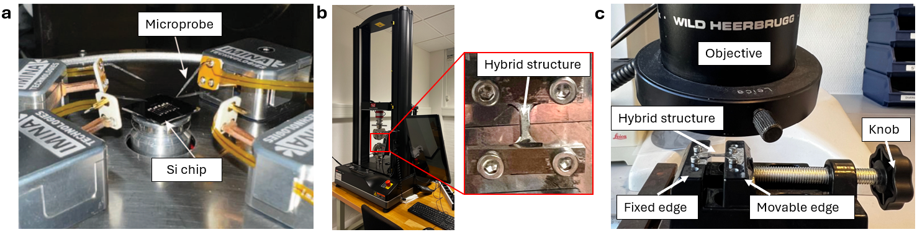
Figure S3. Different mechanical test setups used in this study. (a) Microprobe station coupled with a SEM system to characterize mechanical properties of freestanding Si µMMs. (b) A tensile test system to investigate Si µMMs/PDMS hybrid structures. A zoomed-in image shows the sample fabricated with ASTM-standardized geometry. (c) A linear stage placed under an optical microscope to investigate lattice deformation of MMs in the hybrid structures, when tensile load is added by adjusting the knob.

Numerical simulation
The numerical simulations for mechanical studies were performed with the solid mechanics module in COMSOL Multiphysics. Stationary studies were used and all the materials were considered as linear elastic materials. The governing equation in the simulations is Hooke’s law in a tensor form: $σ_{ij}=C_{ijkl}:ε_{kl}$, where C_{ijkl} is the stiffness tensor of the material. The strain is evaluated based on the displacement field by $ε=\frac{1}{2}(∇u+{(∇u)}^{T})$, where u is the displacement vector. For freestanding Si µMMs, we used the elasticity matrix of bulk Si as below based on previous literature:
$$\left[\begin{matrix}\begin{matrix}σ_{1} \\ σ_{2} \\ σ_{3}\end{matrix} \\ \begin{matrix}σ_{4} \\ σ_{5} \\ σ_{6}\end{matrix}\end{matrix}\right]=\left[\begin{matrix}194.5 & 35.7 & 64.1 & 0 & 0 & 0 \\ 35.7 & 194.5 & 64.1 & 0 & 0 & 0 \\ 64.1 & 64.1 & 165.7 & 0 & 0 & 0 \\ 0 & 0 & 0 & 79.6 & 0 & 0 \\ 0 & 0 & 0 & 0 & 79.6 & 0 \\ 0 & 0 & 0 & 0 & 0 & 50.9\end{matrix}\right]\left[\begin{matrix}\begin{matrix}ε_{1} \\ ε_{2} \\ ε_{3}\end{matrix} \\ \begin{matrix}ε_{4} \\ ε_{5} \\ ε_{6}\end{matrix}\end{matrix}\right] (GPa)$$
The 3D geometry is based on the fabricated Si µMMs. A representative geometry of ATC-typed µMMs is illustrated below in Figure S1a, including the anchor, truss, and µMM region. The generated mesh is presented in Figure S1b. To investigate stress distribution and deformation morphology, we attributed a fixed constraint condition to the anchor and set a prescribed displacement to the truss along x-direction.
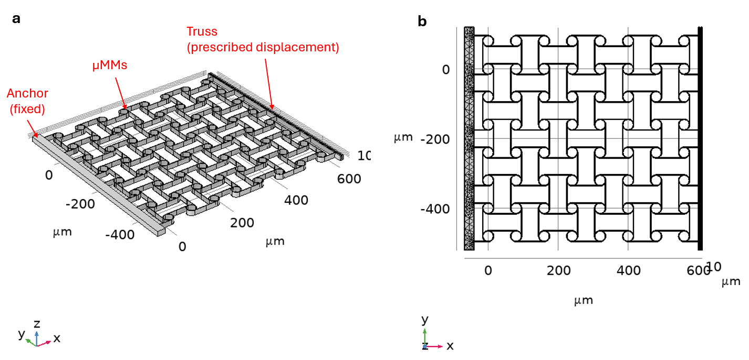
Figure S4. (a) Geometry of simulated Si µMMs with an ATC lattice type. (b) Generated mesh based on the geometry in (a).
For mesh generation of 3D geometries, we performed mesh sensitivity analysis with different mesh settings (Figure S2). Two global parameters were evaluated, including maximal surface strain and effective Young’s modulus. Based on the analysis, we have chosen “finer” mesh for the numerical study, which generated 302410 elements and 106429 mesh vertices for the geometry in Figure S1. The von Mises stress distribution is then simulated, and deformation can be evaluated directly (Figure S2b).
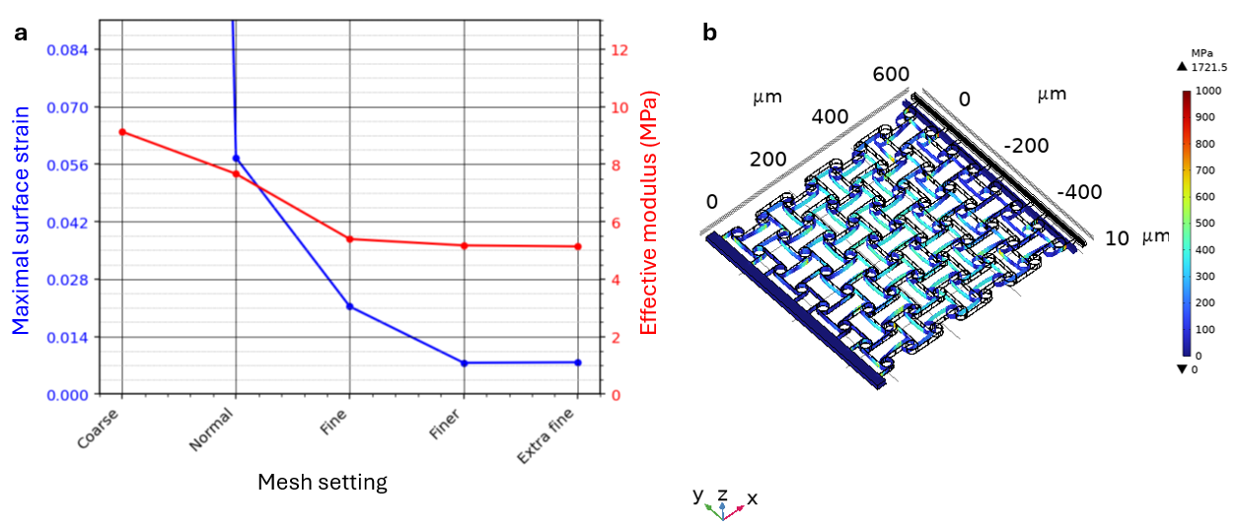
Figure S5. (a) Mesh sensitivity analysis for 3D simulation of freestanding µMMs as in Figure S1. (b) Stress distribution and deformation with a prescribed displacement of 30 µm.
For Si µMMs/PDMS hybrid structures, we included PDMS material that encapsulates the whole region of µMMs. The interface between PDMS and Si was defined as a “rigid connector” without considering the boundary deformation at the interface region. To reduce the calculation time, we only included part of the whole hybrid structures with a size of 500 µm by 500 µm and a thickness of 30 µm (Figure S3a). A “finer” mesh setting was attributed to Si µMMs, while the PDMS region was set with a larger mesh size to reduce the time for simulation.

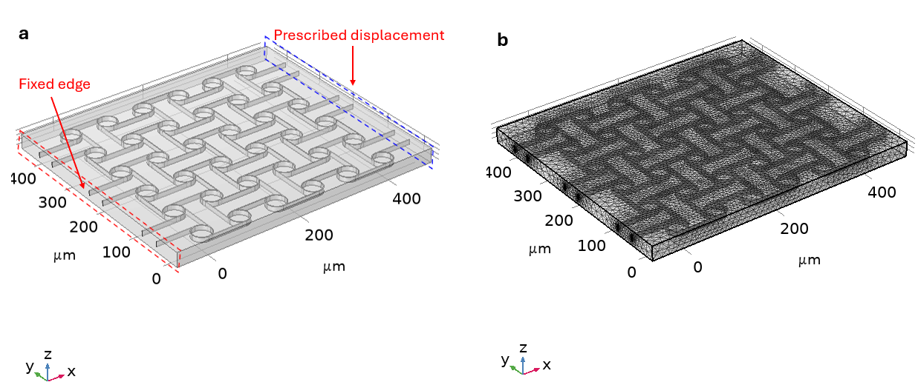
Figure S6. (a) Model for µMMs/PDMS hybrid structures. (b) Mesh generated for the geometry in (a).
Like the procedure in the simulations of freestanding µMMs, we set a prescribed displacement for one edge of the hybrid structures and evaluate the stress distribution as well as the mechanical deformation. Figure S4 shows the stress distribution for the geometry in Figure S3, when a tensile strain of 0.2 is applied on the hybrid structures along the x-direction.
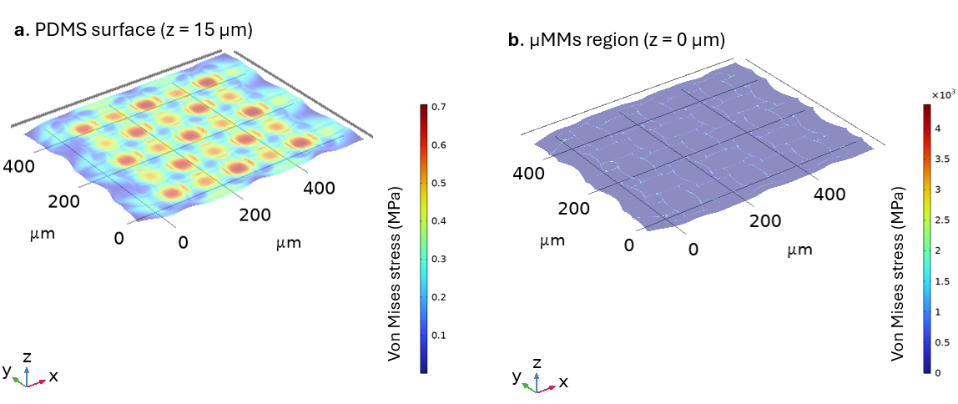
Figure S7. Simulated stress distribution inside µMMs/PDMS hybrid structures with a prescribed strain of 0.2 in the x-direction. Two planes are presented at (a) z = 15 µm on the surface of PDMS, and (b) z = 0 µm where µMMs is located.

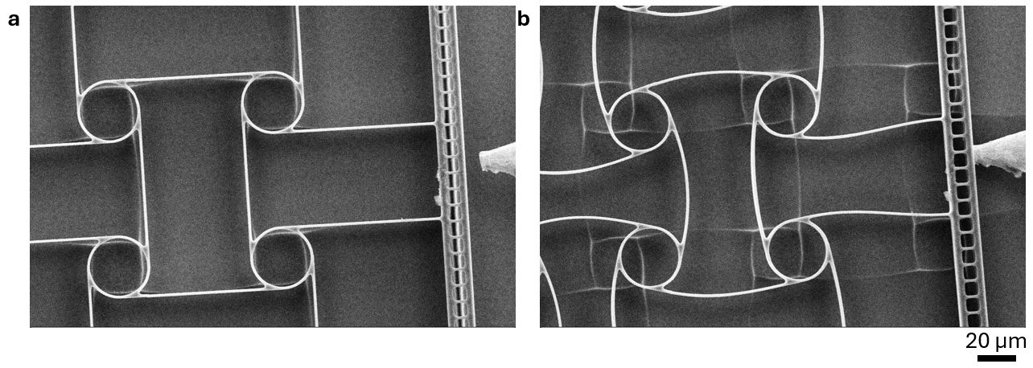
Figure S8. SEM images showing the deformation of µMMs under a compressive load. No deformation can be observed on the truss.

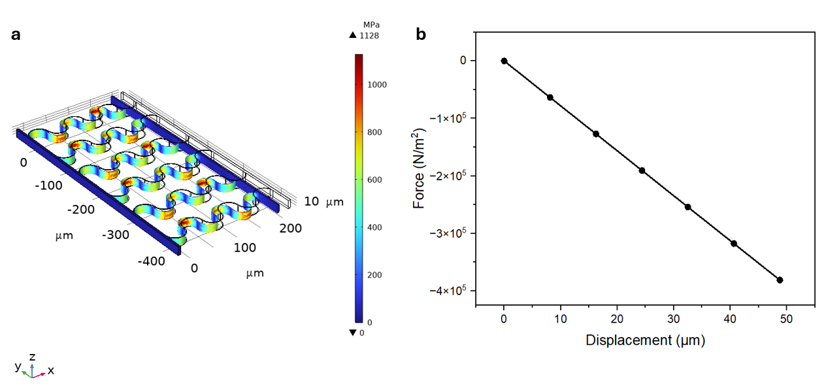
Figure S9. 3D FEM simulation of the spring-based structure for estimating E_{eff} of µMMs (a). A uniaxial force up to 3 mN is applied on the truss boundary, and the displacement was evaluated for the truss. (b) A linear relation between applied force and displacement can be observed, suggesting a linear elastic property of the spring structure.

Table 1. Comparison of different studies on ATC-type MMs.
Material | Manufacturing method | Lattice type | Unit cell size (L) | Ligament width (t) | Effective Young’s modulus | Reference
ABS plastic | Fusion deposition molding | 2D ATC | 12 ~ 24 mm | 1 mm | 1 ~ 5 MPa | ¹
ABS plastic | Fusion deposition molding | 2D ATC | 12 mm | 1 mm | - | ²
Nylon powder | Selective laser sintering | 2D ATC | 25 mm | 1.5 mm | 3.11 MPa | ³
Steel | Laser cutting | 2D hierarchical ATC | 15 mm | 1.5 mm | 20 MPa | ⁴
Steel | Laser cutting | 2D ATC | 20 mm | 2 mm | - | ⁵
Single crystalline Si | 3D plasma etching | 2D ATC | 80 µm | 1.3 µm | ~ 10 MPa | ^{This study}

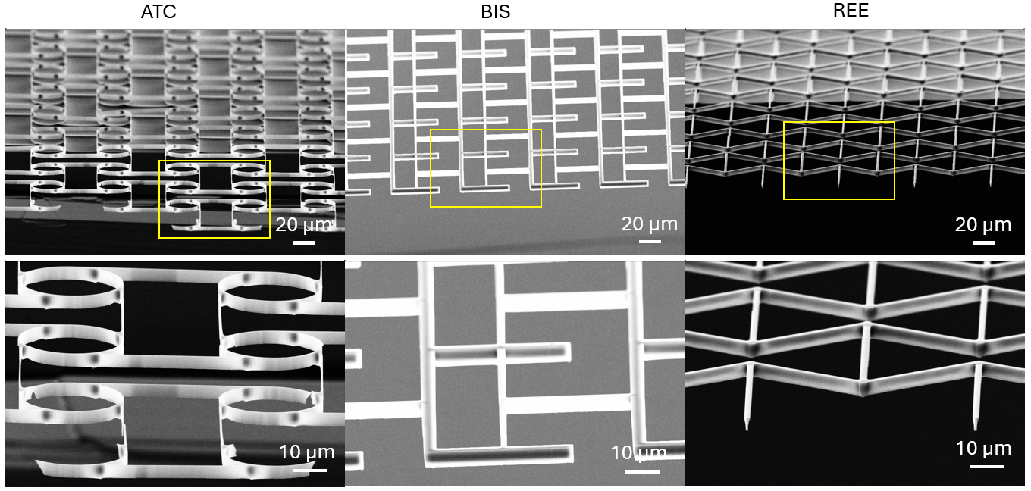
Figure S10. SEM images showing large area µMMs with three different lattice types. Samples were cleaved and tilted to better show the morphology of structures. Zoomed-in pictures at the bottom show more details of representative unit cells (in the yellow box).

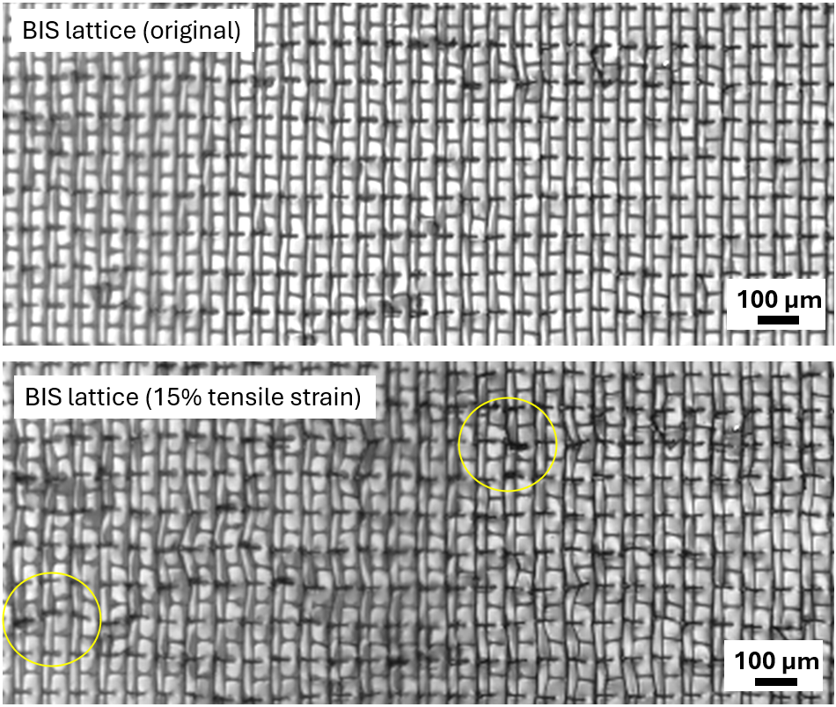
Figure S11. Microscopic image of BIS-type Si µMMs/PDMS hybrid structures as fabricated (top) and under ~ 15% tensile strain (bottom). Non-uniform deformation patterns can be observed in the field of view, and structure twisting as well as fracture are noticeable (highlighted in the yellow circles).

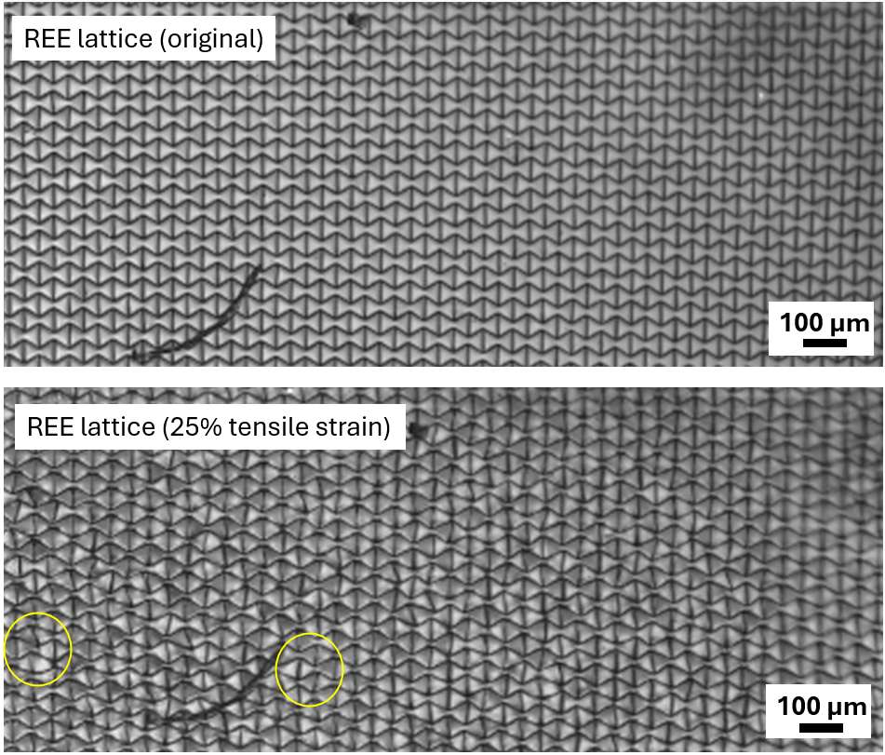
Figure S12. Microscopic image of REE-type Si µMMs/PDMS hybrid structures as fabricated (top) and under 25% tensile strain (bottom). Non-uniform deformation patterns can be observed on individual unit cells, especially on the lower left part. Yellow circles highlight structure fracture locally.

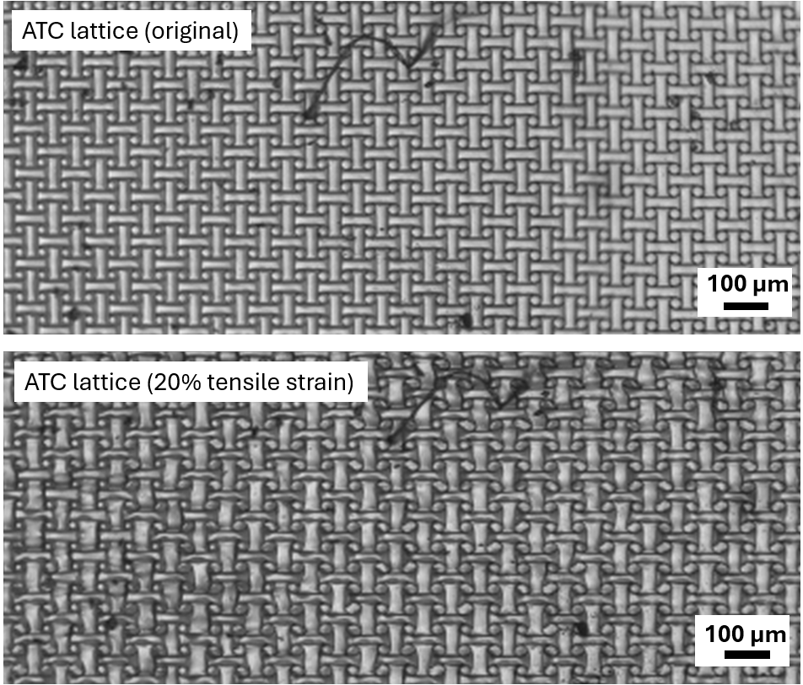
Figure S13. Microscopic image of ATC-type Si µMMs/PDMS hybrid structures as fabricated (top) and under 10% tensile strain (bottom). Uniform deformation patterns of unit cells can be observed over the field of view, and a compressive deformation is present for nodes.

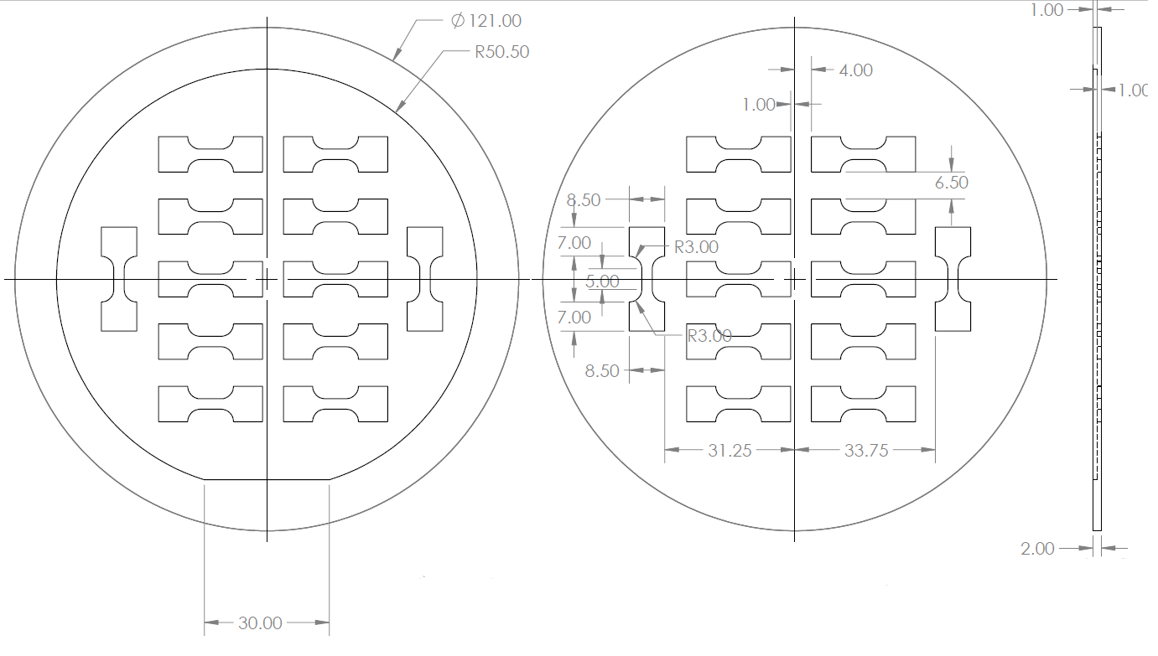
Figure S14. Geometric design of dogbone-shaped aluminum mask for embedding µMMs into PDMS membrane. An indent is designed to fix the major flat of a 4-inch Si wafer. 12 dogbone-shaped specimens could be cut directly from the same wafer to ensure a good uniformity of PDMS thickness (unit in mm).

Reference
1. Chen, Y. J., Scarpa, F., Liu, Y. J. & Leng, J. S. Elasticity of anti-tetrachiral anisotropic lattices. Int. J. Solids Struct. 50, (2013).
2. Günaydin, K. et al. In-plane compression behavior of anti-tetrachiral and re-entrant lattices. Smart Mater. Struct. 28, (2019).
3. Alderson, A. et al. Elastic constants of 3-, 4- and 6-connected chiral and anti-chiral honeycombs subject to uniaxial in-plane loading. Compos. Sci. Technol. 70, (2010).
4. Wu, W. et al. Mechanical properties of hierarchical anti-tetrachiral metastructures. Extreme Mech. Lett. 16, (2017).
5. Tabacu, S., Negrea, R. F. & Negrea, D. Experimental, numerical and analytical investigation of 2D tetra-anti-chiral structure under compressive loads. Thin-Walled Structures 155, (2020).

