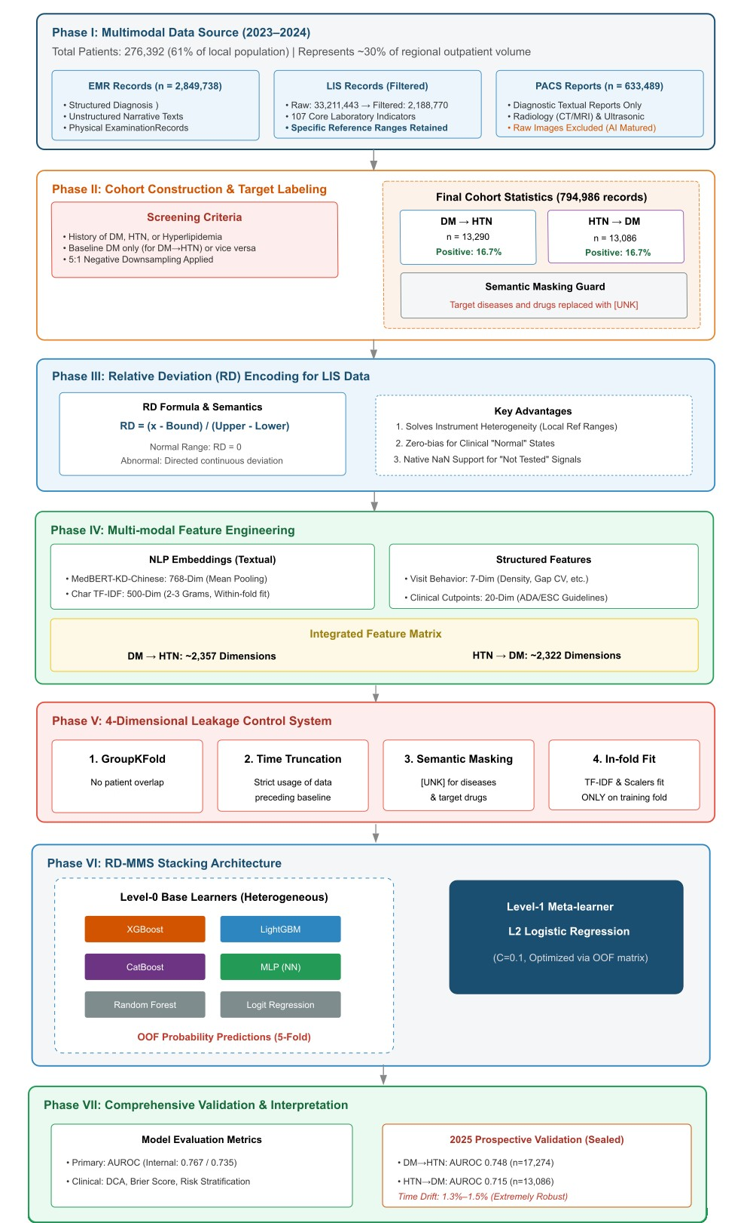
Supplementary material
Fig. S1 Detailed Study Design and Patient Flow Diagram. The figure presents the end-to-end pipeline of RD-MMS across seven sequential phases: multimodal data integration (Phase I), cohort construction and target labeling with semantic masking (Phase II), RD encoding of LIS data (Phase III), multimodal feature engineering (Phase IV), four-dimensional leakage control (Phase V), stacking ensemble training via 5-fold GroupKFold ross-validation (Phase VI), and comprehensive validation including internal OOF evaluation and external validation on the sealed 2025 holdout cohort (Phase VII). Key statistics are annotated at each phase.

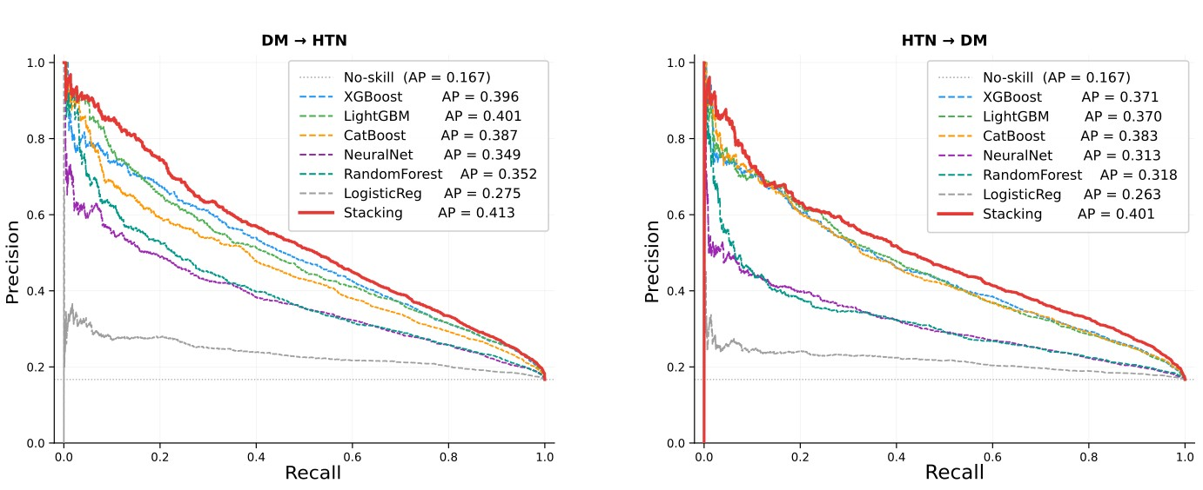
Fig. S2 Precision-Recall Curves: Internal Validation (5-fold OOF). Left panel: DM-to-HTN task;right panel: HTN-to-DM task. The dotted horizontal line at 0.167 represents the no-skill baseline.The Stacking ensemble achieves the highest average precision in both tasks (AP = 0.413 and 0.401,respectively), representing 2.4–2.5 times the no-skill baseline. All curves are derived from complete 5-fold patient-level OOF prediction vectors.

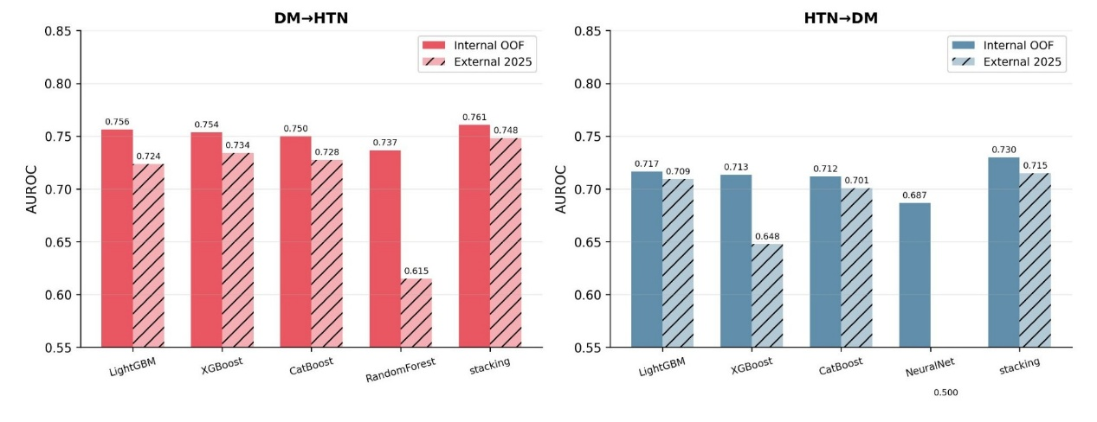Fig. S3 Internal vs. External Validation: AUROC Comparison. Grouped bar charts compare internal OOF AUROC (solid bars) and external 2025 holdout AUROC (hatched bars) for five models in the DM-to-HTN (left) and HTN-to-DM (right) tasks. Random Forest exhibits the largest temporal degradation (DM-to-HTN: Δ = 0.122; HTN-to-DM: Δ = 0.039), while the Stacking ensemble shows the smallest drift (DM-to-HTN: Δ = 0.013; HTN-to-DM: Δ = 0.015).

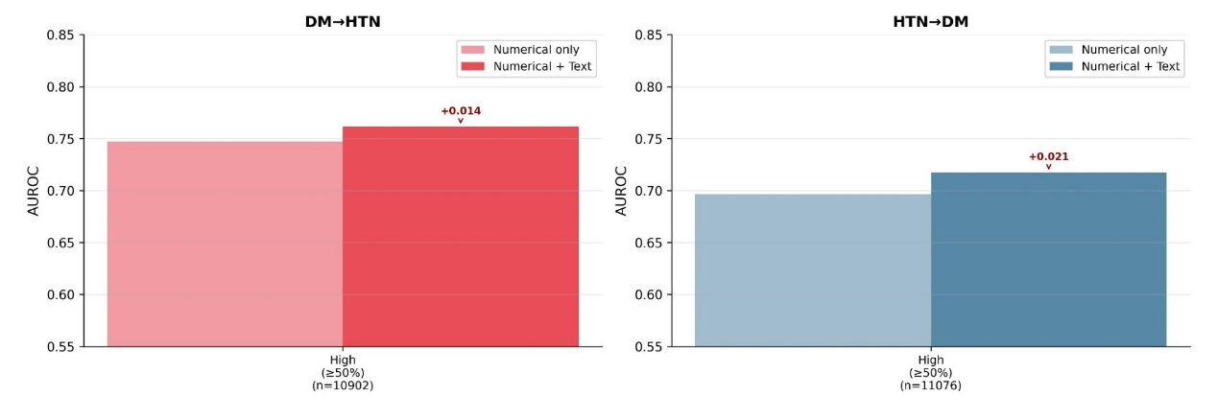Fig. S4 AUROC by Laboratory Test Coverage Group. Grouped bar charts compare the numericalonly (light bars) and full multimodal RD-MMS (dark bars) configurations within the high-coverage patient stratum (laboratory test coverage ≥50%: DM-to-HTN n = 10,902; HTN-to-DM n = 11,076). Text features provide gains of +0.014 (DM-to-HTN) and +0.021 (HTN-to-DM) even in patients with relatively complete laboratory data, indicating that their contribution is additive rather than purely compensatory.

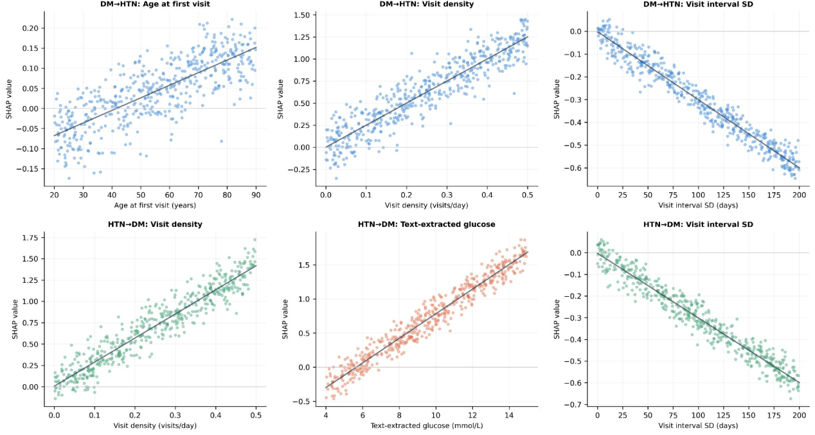
Fig. S5 SHAP Dependence Plots: Main Effects (Top 3 Features). Scatter plots show feature value (x-axis) against SHAP value (y-axis) with a fitted trend line for the top 3 features in each task. Upper row (DM-to-HTN, blue): age at first visit shows a monotonically increasing effect from approximately age 40; visit density shows a positive linear relationship; visit interval SD shows a steep negative association. Lower row (HTN-to-DM, green/orange): visit density shows a strong positive linear effect;text-extracted glucose (orange) shows a near-linear positive association; visit interval SD shows a negative effect consistent with the DM-to-HTN task.

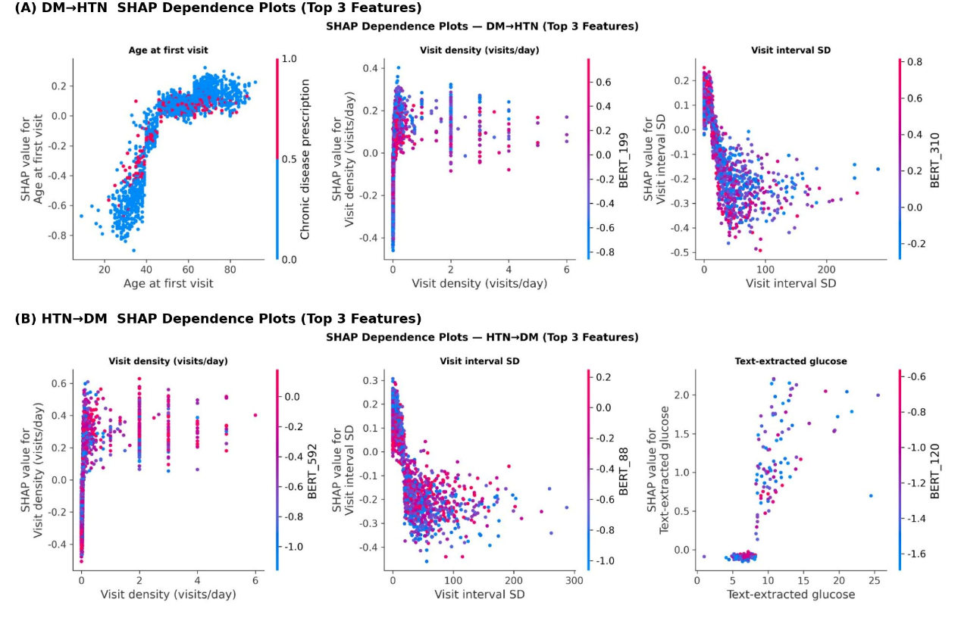
Fig. S6 SHAP Dependence Plots: Feature×BERT Interaction Effects (Top 3 Features). Scatter plots display the same features as Supplementary Fig. S5, with point color encoding the strongest BERT-dimension interaction term selected automatically by SHAP. Panel A (DM-to-HTN): age at first visit is modulated by chronic disease prescription status; visit density is modulated by BERT199; visit interval SD by BERT310. Panel B (HTN-to-DM): visit density and visit interval SD effects are modulated by BERT592 and BERT88, respectively; text-extracted glucose×BERT120 shows divergent patterns between patients whose notes contain specific glycemic keywords. Together with Supplementary Fig. S5, these plots confirm that BERT embeddings contribute independent interaction-level information beyond the main effects of numerical features.

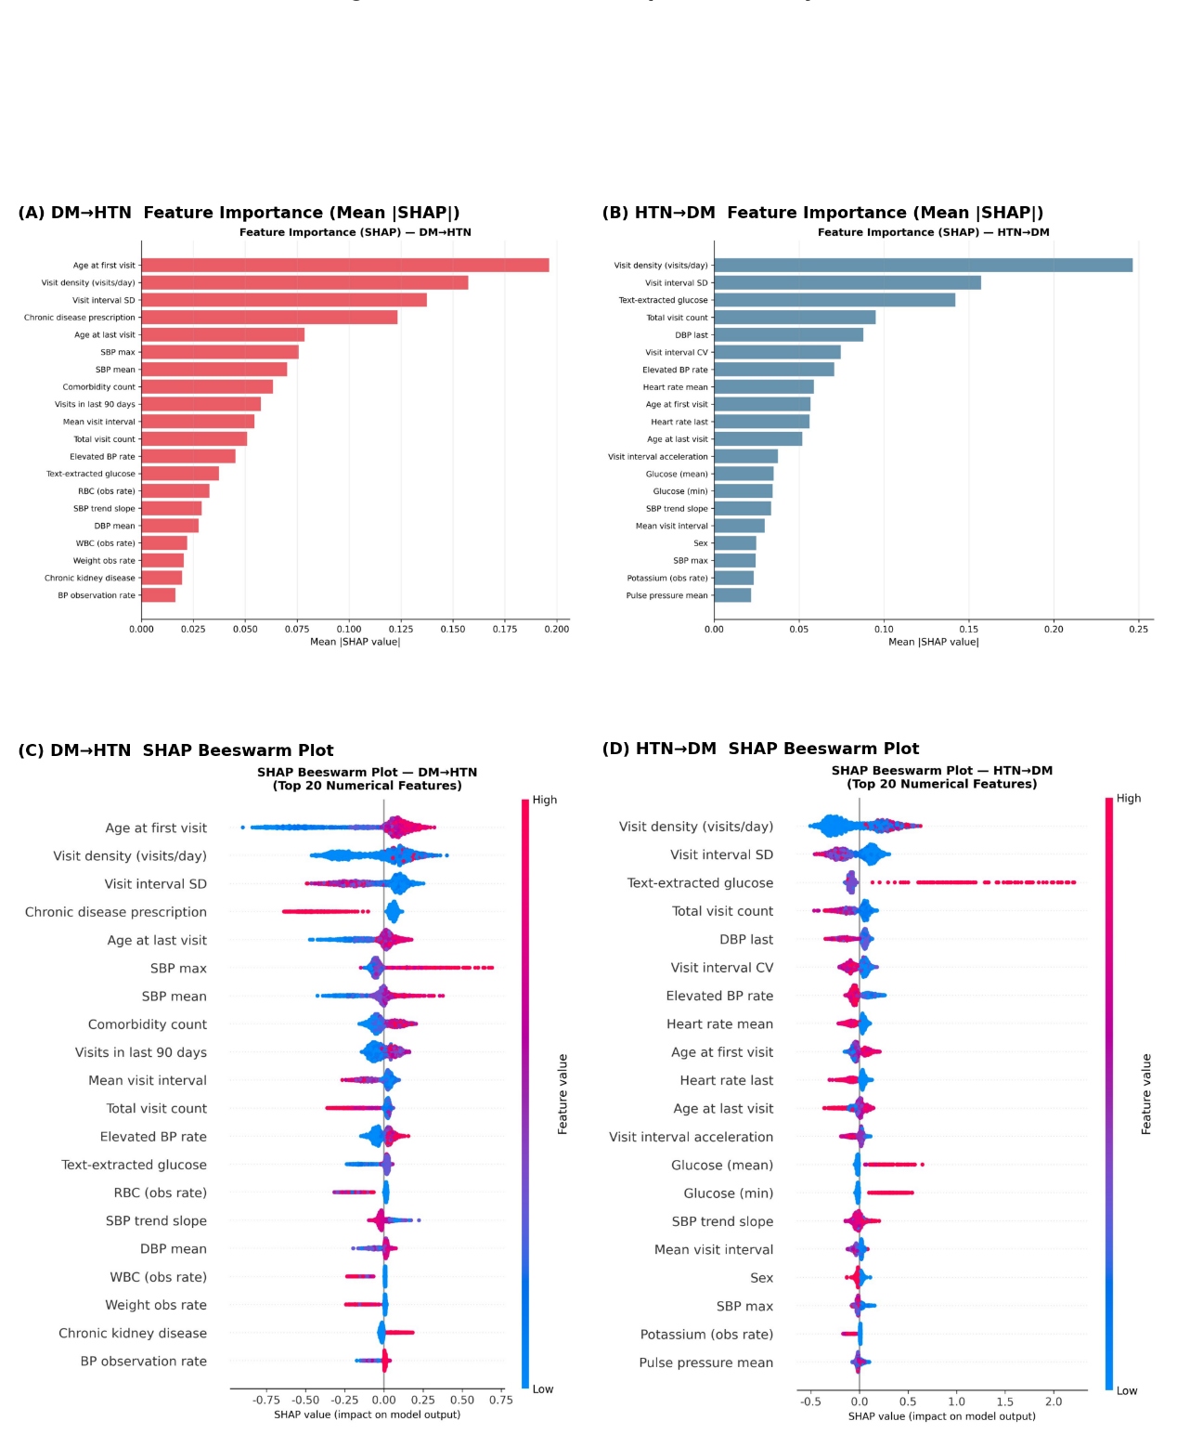
Fig. S7 SHAP Feature Importance Analysis (XGBoost, n = 2,000 random samples). Panels A and B show horizontal bar charts of mean |SHAP| for the top 20 features in the DM-to-HTN and HTNto-DM tasks, respectively. Panels C and D show the corresponding SHAP beeswarm plots; each dot represents one patient, the x-axis encodes SHAP value (positive: increases risk; negative: decreases risk), and dot color encodes feature value (red: high, blue: low). In DM-to-HTN, age at first visit and blood pressure trajectory features dominate; in HTN-to-DM, visit density and text-extracted glucose rank highest.

