Supplementary Data 1

Figure 1. Linear calibration curve of vanillin
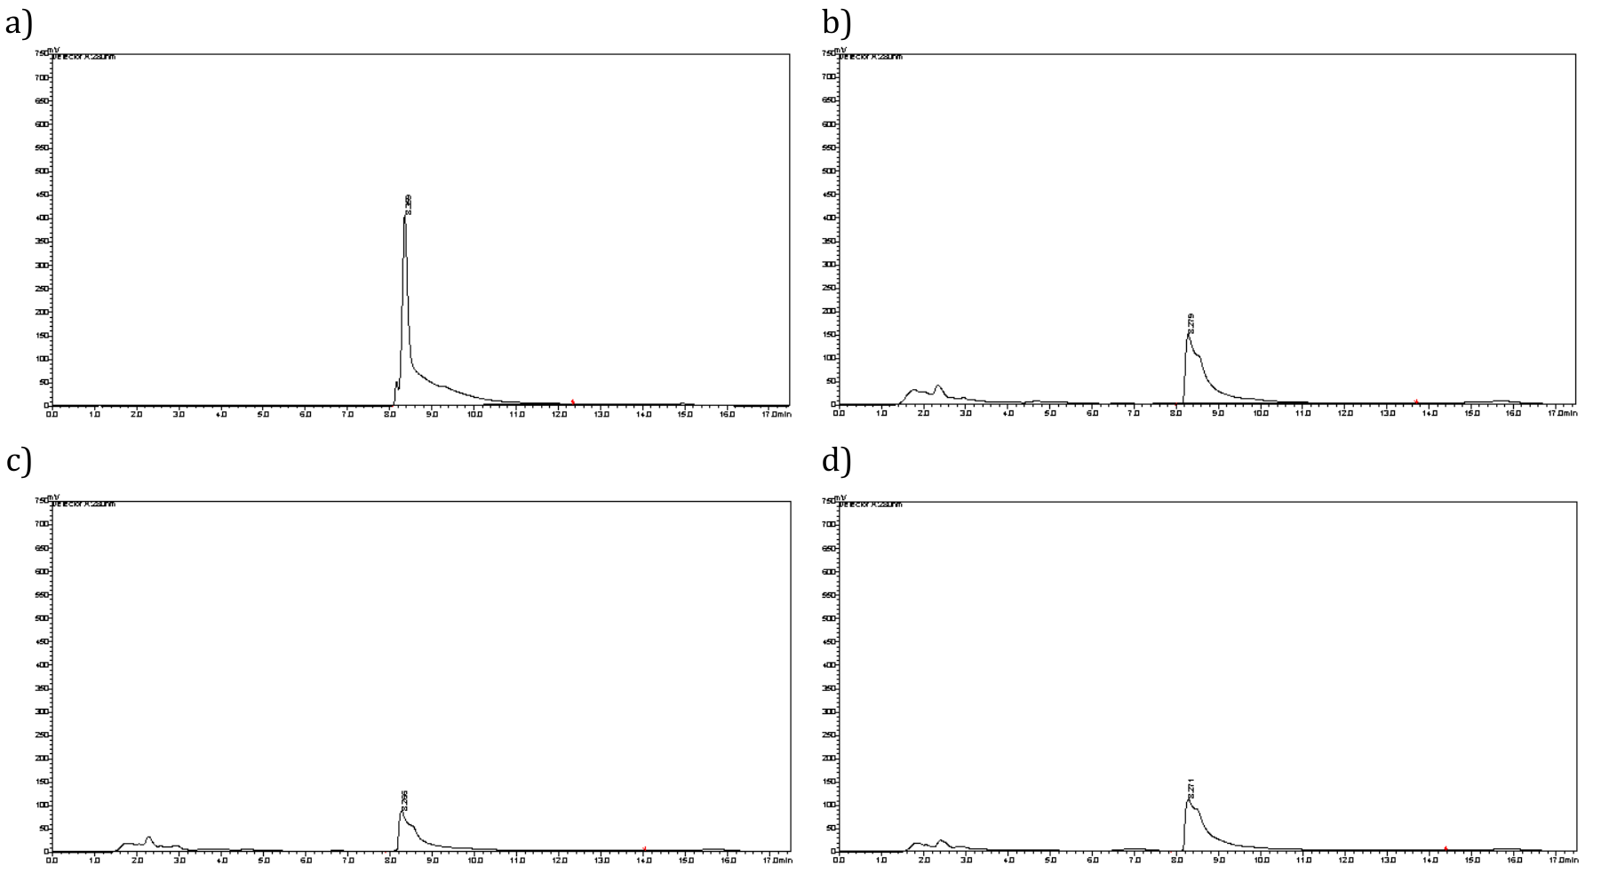

Figure 2. HPLC Chromatograms from various vegetative parts of V. planifolia plantlet in vitro. Vanillin was obtained from (a) standard, (b) stem treated with FA, (c) leaf treated with AC + MeJA, and d) root treated with AC + FA.

