Supporting Information

MicroPET Imaging of Bacterial Infection with Specifically Nitroreductase Responsive ¹⁸F-labeled Nitrogen Mustard Analogues

Lumei Huang^{a,b,†}, Jianyang Fang^{a,b,†}, Shouqiang Hongª, Huanhuan Liu^{a,b}, Haotian Zhu^{a,b}, Lixia Feng^{a,b}, Rongqiang Zhuang^{a,b}, Xilin Zhao^{a,c}, Zhide Guo^{a,b,}*, Xianzhong Zhang^{a,b,}*

ª State Key Laboratory of Molecular Vaccinology and Molecular Diagnostics, School of Public Health, Xiamen University. Xiamen 361102, Fujian, China.
^{b} Center for Molecular Imaging and Translational Medicine, School of Public Health, Xiamen University, Xiamen 361102, Fujian, China
^{c} Public Health Research Institute, New Jersey Medical School, Rutgers University, Newark, NJ 07103, USA.

* For correspondence:
E-mail: zhangxzh@xmu.edu.cn (X.Z.); gzd666888@xmu.edu.cn (Z.G.)
† Lumei Huang and Jianyang Fang are contributed equally to this work.

Table of Contents
1. Materials and methods 3
2. Synthesis and characterization of ¹⁹F-NTRP and ¹⁹F-NTRPH 3
2.1 2,2'-((4-nitrophenyl)azanediyl)bis(ethan-1-ol) (1) 3
2.2 (4-nitrophenyl)azanediyl)bis(ethane-2,1-diyl)bis(4-methylbenzenesulfonate) (2) 3
2.3 2-(2-fluoroethyl)(4-nitrophenyl)aminoethyl 4-methylbenzenesulfonate (¹⁹F-NTRP) 4
2.4 2-(4-aminophenyl)(2-fluoroethyl)aminoethyl 4-methylbenzenesulfonate (¹⁹F-NTRPH) 4
3. Synthesis and characterization of ¹⁹F-NCRP and ¹⁹F-NCRPH 5
3.1 2,2'-((3,4-dinitrophenyl)azanediyl)bis(ethan-1-ol) (3) 5
3.2 N,N-bis(2-chloroethyl)-3,4-dinitroaniline (4) 5
3.3 N,N-bis(2-chloroethyl)-3-fluoro-4-nitroaniline (¹⁹F-NCRP) 6
3.4 N1,N1-bis(2-chloroethyl)-3-fluorobenzene-1,4-diamine (¹⁹F-NCRPH) 6
4. Radiosynthesis of ¹⁸F-NTRP 6
5. Radiosynthesis of ¹⁸F-NCRP 7
6. Partition Coefficient of ¹⁸F-NTRP and ¹⁸F-NCRP 8
7. Stability of ¹⁸F-NTRP and ¹⁸F-NCRP in vitro 8
8. Specificity and Selectivity of ¹⁸F-NTRP or ¹⁸F-NCRP to Nitroreductase 8
9. In Vitro Cellular Uptake of ¹⁸F-NTRP and ¹⁸F-NCRP 9
10. Cellular Efflux Assay of ¹⁸F-NCRP 9
11. Bacterial Infection models 10
12. Infection and Inflammation Models 10
13. PET Imaging 10
14. Metabolite Analysis of ¹⁸F-NTRP and ¹⁸F-NCRP 10
15. Biodistribution of ¹⁸F-NTRP and ¹⁸F-NCRP in Normal Mice 11
16. Data and Statistical Analysis 11
17. Supplementary Figures 12
18. References 15

1. Materials and methods
Reagents and solvents were purchased from commercial resources and used without further purification. The ¹H NMR spectra and ¹³C NMR were obtained on a Zhongke Niujin Magnetic BIXI-I 400 (Wuhan China)). High-resolution mass spectrometry (HRMS) was acquired from a Q Exactive LC-MS system (Waters, USA). Radiosynthesis was performed on an All-in-One module (Trasis, Ans, Belgium) with full automation. HPLC analysis was achieved on Waters 1525 (USA) and an HYPERSIL GOLD C18 column (Thermo Scientific, 5 µm, 10 mm × 250 mm). PET-CT imaging was performed using an Inveon scanner (Siemens Medical Solutions USA, Inc.). The samples associated with low dosage radioactivity were measured by a gamma counter (WIZARD 2480, Perkin-Elmer, Downers Grove, IL, USA). Autoradiography was obtained on Cyclone Plus Storage Phosphor System (PerkinElmer Instruments Inc. USA). The centrifuge used in log P determination was Eppendorf Centrifuge 5424 R (Eppendorf, Germany).

2. Synthesis and characterization of ¹⁹F-NTRP and ¹⁹F-NTRPH

2.1 2,2'-((4-nitrophenyl)azanediyl)bis(ethan-1-ol) (1)
1-chloro-4-nitrobenzene (13.8 g 0.1 mol), 2,2'-azanediylbis(ethan-1-ol) (25 g 0.2 mol), potassium carbonate (41.4 g 0.3 mol) were combined in a 250 mL bottle. The mixture was heated to 120 °C and stirred for 4 h. After reacted, the mixture was cool to room temperature, followed by dropped into 2500 mL water slowly. Aqueous solution was extracted with ethyl acetate for three times. Organic solution was dried with anhydrous Na₂SO₄. After evaporation of the ethyl acetate under vacuum, the crude product was purified by column chromatography (ethyl acetate/hexane = 1 : 2) to afford yellow solid 1 (13.78 g, 61%). ¹H NMR (CDCl₃, 400 Hz) δ: 3.77 (t, 4H, J = 4.8 Hz), 4.02 (t, 4H, J = 4.8 Hz), 6.73 (d, 2H, J = 8.4 Hz), 7.77 (d, 2H, J = 8.4 Hz). ¹³C NMR (CDCl₃, 100 Hz) δ: 58.9, 62.8, 113.4, 123.8, 138.5, 156.9. HRMS (FTMS ESI⁺): m/z calculated for C₁₀H₁₄N₂O₄⁺ ([M + H]⁺), 227.0954; found 227.0951.

2.2 (4-nitrophenyl)azanediyl)bis(ethane-2,1-diyl)bis(4-methylbenzenesulfonate) (2)
Compound 1 (2.26 g 0.01 mol) was dissolved in 20 mL dry dichloromethane then added with Et₃N (2.01 g, 0.02 mol), the solution was stirred at 0 °C for 30 min, then a solution of p-toluene sulfochloride (4.75 g, 0.025 mol) in 5 mL dry dichloromethane was dropwise to the mixture. After 30 min, the solution was diluted with 80 mL dichloromethane. Combined organic phase was washed with brine for three times, then dried over anhydrous Na₂SO₄ and concentrated under vacuum. The residue was purified by column chromatography (ethyl acetate/hexane = 1 : 5) to afford yellow powder 2 (3.47 g, 65 %). ¹H NMR (CDCl₃, 400 Hz) δ: 2.45 (s, 6H), 3.74 (t, 4H, J = 4.8 Hz), 4.19 (t, 4H, J = 4.8 Hz), 6.47 (d, 2H, J = 8.0 Hz), 7.32 (dd, 4H, J = 8.0 Hz), 7.67 (d, 4H, J = 8.0 Hz), 8.04 (d, 2H, J = 8.0 Hz). ¹³C NMR (CDCl₃, 100 Hz) δ: 21.5, 58.4, 61.7, 112.5, 124.9, 129.1, 130.8, 137.8, 144.6, 156.1. HRMS (FTMS ESI⁺): m/z calculated for C₂₄H₂₆N₂O₈NaS₂⁺ ([M + Na]⁺), 557.1029; found 557.1228.

2.3 2-(2-fluoroethyl)(4-nitrophenyl)aminoethyl 4-methylbenzenesulfonate (¹⁹F-NTRP)
Compound 2 (2.67 g 0.005 mol) and tetrabutylammonium fluoride (3.13 g, 0.012 mol) were dissolved in 50 mL acetonitrile, the mixture was heated to 80 °C and maintained for 1 h. After removal of acetonitrile under vacuum, crude product was purified by column chromatography (ethyl acetate/hexane = 1 : 8) to afford yellow solid ¹⁹F-NTRP (0.67 g 35 %) ¹H NMR (CDCl₃, 400 Hz) δ: 2.45 (s, 3H), 3.62 (d, 2H, J = 4.8 Hz), 4.13 (d, 2H, J = 4.8 Hz), 4.62 (t, 2H, J = 4.8 Hz), 4.73 (t, 2H, J = 4.8 Hz) 6.57 (d, 2H, J = 8.0 Hz), 7.32 (d, 2H, J = 8.0 Hz), 7.67 (d, 2H, J = 8.0 Hz), 8.04 (d, 2H, J = 8.0 Hz). ¹³C NMR (CDCl₃, 100 Hz) δ: 21.5, 58.4, 60.3, 62.7, 86.5, 112.6, 124.5, 129.2, 130.3, 137.4, 142.8, 144.5, 156.5. HRMS (FTMS ESI⁺): m/z calculated for C₁₇H₁₉FN₂O₅NaS⁺ ([M + Na]⁺), 405.0897; found 405.0986.

2.4 2-(4-aminophenyl)(2-fluoroethyl)aminoethyl 4-methylbenzenesulfonate (¹⁹F-NTRPH)
Aammonium chloride (0.16 g, 0.003 mol) and reduced iron powder (0.168 g, 0.03 mol) were dissolved in MeOH and water (5 mL : 5 mL), mixture was stirred at room temperature for 30 min. After that, the solution of ¹⁹F-NTRP (0.382 g, 0.001mol in MeOH) was dropwise into the mixture above. Solution was heated to 80 °C for 1 h, then filtrated with filter paper to removed redundant iron power. Solvent was removed under vacuum, residue was purified by column chromatography (ethyl acetate/hexane = 1 : 3) to yield yellow solid ¹⁹F-NTRPH (0.193 g, 55%) ¹H NMR (DMSO-d₆, 400 Hz) δ: 2.41 (s, 3H), 3.72 (d, 2H, J = 4.8 Hz), 4.03 (d, 2H, J = 4.8 Hz), 4.51 (t, 2H, J = 4.8 Hz), 4.62 (t, 2H, J = 4.8 Hz) 6.07 (d, 2H, J = 8.0 Hz), 6.72 (d, 2H, J = 8.0 Hz), 7.57 (d, 2H, J = 8.0 Hz), 7.89 (d, 2H, J = 8.0 Hz). ¹³C NMR (CDCl₃, 100 Hz) δ: 21.5, 58.4, 60.3, 62.7, 86.5, 112.6, 124.5, 129.2, 130.3, 137.4, 139.6, 142.8, 144.5. HRMS (FTMS ESI⁺): m/z calculated for C₁₇H₂₁FN₂O₃NaS⁺ ([M + Na]⁺), 375.1155; found 375.1266.

3. Synthesis and characterization of ¹⁹F-NCRP and ¹⁹F-NCRPH

3.1 2,2'-((3,4-dinitrophenyl)azanediyl)bis(ethan-1-ol) (3)
4-chloro-1,2-dinitrobenzene (5 g 0.025 mol), 2,2'-azanediylbis(ethan-1-ol) (3.9 g 0.037 mol), potassium carbonate (10.35 g 0.75 mol) were combined in a 50 mL bottle. Mixture was stirred at 50 °C for 10 min. After cooled to room temperature, above mixture was dissolve in 50 methanol. Solution was filtrated to removed potassium carbonate. Residue was purified by column chromatography (ethyl acetate/hexane = 1 : 1) to afford red oily liquid 3 (3.86 g, 57%). ¹H NMR (CDCl₃, 400 Hz) δ: 3.40 (t, 4H, J = 16 Hz), 3.71 (t, 4H, J = 12 Hz), 7.06 (d, 1H, J = 12 Hz), 7.51 (s, 1H), 7.75 (d, 1H, J = 8.0 Hz). ¹³C NMR (CDCl₃, 100 Hz) δ: 58.2, 61.3, 108.2, 118.4,125.7, 134.3, 145.9, 155.1. HRMS (FTMS ESI⁺): m/z calculated for C₁₀H₁₃N₃NaO₆⁺ ([M + Na]⁺), 294.0702; found 294.1002

3.2 N,N-bis(2-chloroethyl)-3,4-dinitroaniline (4)
Compound 3 (2.71 g 0.01 mol) was dissolved in 50 mL anhydrous dichloromethane. Triethylamine (3.03 g 0.03 mol) was added to the solution, the mixture was stirred at room temperature for 15 min. A solution of thionyl chloride (3.54 g, 0.03 mol) in 5 mL anhydrous dichloromethane was dropwise into the mixture above slowly. After that, the mixture was heated to reflux for 2 h, then cooled to room temperature. The reacted solution was diluted with 50 mL dichloromethane and 50 mL saturated sodium carbonate was added to neutralizing hydrochloric acid. The organic phase was washed with water three times and dried over anhydrous sodium sulfate. The solvent was removed under vacuum and residue was purified by column chromatography (hexane/ethyl acetate = 1 : 3) to afford red oily liquid 4 (2.08 g, 68%). ¹H NMR (CDCl₃, 400 Hz) δ: 3.57 (t, 4H, J = 12 Hz), 3.65 (t, 4H, J = 12 Hz), 7.17 (d, 1H, J = 8 Hz), 7.52 (s, 1H), 7.78 (d, 1H, J = 8.0 Hz). ¹³C NMR (CDCl₃, 100 Hz) δ:43.1, 53.9, 108.5, 118.7,125.5, 134.2, 145.9, 155.3. HRMS (FTMS ESI⁺): m/z calculated for C₁₀H₁₁Cl₂N₃NaO₄⁺ ([M + Na]⁺), 330.0025; found 330.0209.

3.3 N,N-bis(2-chloroethyl)-3-fluoro-4-nitroaniline (¹⁹F-NCRP)
Compound 4 (1.4 g 0.005 mol) and tetrabutylammonium fluoride (1.3 g, 0.005 mol) was dissolved in 5 mL tetrahydrofuran, the mixture was heated to 70 °C for 1 h. After remove the solvent under vacuum. Crude products was purified by column chromatography (hexane/ethyl acetate = 1 : 5) to afford yellow solid ¹⁹F-NCRP (0.64 g, 46%) ¹H NMR (CDCl₃, 400 Hz) δ: 3.50 (t, 4H, J = 12 Hz), 3.60 (t, 4H, J = 16 Hz), 6.34 (d, 1H, J = 8 Hz), 6.53 (s, 1H), 7.86 (d, 1H, J = 8.0 Hz). ¹³C NMR (CDCl₃, 100 Hz) δ:43.4, 53.7, 103.5, 108.7,126.2, 126.9, 155.9, 157.3. HRMS (FTMS ESI⁺): m/z calculated for C₁₀H₁₁Cl₂FN₂NaO₂⁺ ([M + Na]⁺), 303.008; found 303.0173.

3.4 N1,N1-bis(2-chloroethyl)-3-fluorobenzene-1,4-diamine (¹⁹F-NCRPH)
Aammonium chloride (0.16 g, 0.003 mol) and reduced iron powder (0.168 g, 0.03 mol) were dissolved in MeOH and water (5 mL : 5 mL), mixture was stirred at room temperature. After 30 min, the solution of ¹⁹F-NCRP (0.28 g, 0.001mol in MeOH) was dropwise into the mixture, then heated to 80 °C for 1 h. Solution was filtrated with to removed iron powder, followed by removed solvent under vacuum. Crude product was purified by semi-preparative HPLC (Thermo, AcclaimTM, 5 μm, 10.0 × 250 mm; 65% methanol and 35% water, 3 mL/min.) to afford yellow powder ¹⁹F-NCRPH (0.075 g, 30%)¹H NMR (CDCl₃, 400Hz) δ: 3.59 (t, 4H, J = 12 Hz), 3.63 (t, 4H, J = 12 Hz), 6.42 (d, 1H, J = 8 Hz), 6.61 (s, 1H), 6.69 (d, 1H, J = 8.0 Hz). ¹³C NMR (CDCl₃, 100 Hz) δ: 43.2, 53.8, 103.6, 109.7,118.5, 124.9, 142.9, 159.3. HRMS (FTMS ESI⁺): m/z calculated for C₁₀H₁₃Cl₂FN₂⁺ ([M + Na]⁺), 273.0338; found 273.1331.

4. Radiosynthesis of ¹⁸F-NTRP
The radiosynthesis of ¹⁸F-NTRP was accomplished on an All-in-One module (Trasis, Ans, Belgium) with full automation. Briefly, 7.4 – 25.9 GBq ¹⁸F-fluoride ion was produced by proton irradiation of enriched H₂¹⁸O via a reaction of ¹⁸O (p, n) ¹⁸F by the cyclone cyclotron (IBA). The solvation of ¹⁸F-fluoride in H₂¹⁸O was transmitted to synthesis hot cell and trapped on preactivated Sep-Pak Light QMA Carb cartridge (Waters), then eluted to vial with a solution of 3 mg potassium carbonate and 12 mg of Kryptofix in 0.9 mL acetonitrile and 0.1 mL water. The residual water in ¹⁸F-fluoride solution was evaporated at 120 °C for 20 min. 4 mg tosylate precursor in 1 mL anhydrous acetonitrile was added into the reaction vial, heated at 90 °C for 10 min. The reaction mixture was cooled to 45 and diluted with 5 mL water and 4 mL acetonitrile, then delivered to HPLC loop for HPLC purification (Waters XBridge BEH C18 OBD Prep column, 130A, 5 μm, 10 × 250 mm) with a mobile phase of acetonitrile and water (50 : 50), 5 mL/min. The product in the mobile phase was collected into a 50 vial, diluted with 30 mL water. Diluent was concentrated in a C18 cartridge (Waters) and washed with 10 mL water 3 times to remove the acetonitrile. The trapped product was eluted with ethanol 1 mL, followed by diluted with 19 mL of normal saline and through a 0.22 μm nylon filter to formulated the final ¹⁸F-NTRP injection. After being shaken well, the injection of ¹⁸F-NTRP was ready for quality control (QC) and animal studies.

5. Radiosynthesis of ¹⁸F-NCRP
The radiosynthesis of ¹⁸F-NCRP was accomplished on an All-in-One module (Trasis, Ans, Belgium) with full automation. Briefly, 11.1 - 22.2 GBq ¹⁸F-fluoride ion was produced by proton irradiation of enriched H₂¹⁸O via a reaction of ¹⁸O (p, n) ¹⁸F by the cyclone cyclotron (IBA). The solvation of ¹⁸F-fluoride in H₂¹⁸O was transmitted to synthesis hot cell and trapped on preactivated Sep-Pak Light QMA Carb cartridge (Waters), then eluted to vial with a solution of 3 mg potassium carbonate and 12 mg of Kryptofix in 0.9 mL acetonitrile and 0.1 mL water. The residual water in ¹⁸F-fluoride solution was evaporated at 120 °C for 20 min. 4 mg nitro-precursor in 0.5 mL anhydrous DMSO was added into the reaction vial, heated at 70 °C for 15 min. The reaction mixture was cooled to 45 °C and diluted with 8 mL water, then delivered to a C18 cartridge (Waters) to remove the DMSO. Crude product in C18 was eluted with 2 mL methanol and diluted with 8 mL water. Followed by eluent was injected into the HPLC loop for HPLC purification (Thermo, AcclaimTM, 5 μm, 10.0 × 250 mm) with a mobile phase of methanol and water (65% : 35%), 5 mL/min. The product in the mobile phase was collected into a 50 vial, diluted with 30 mL water. Diluent was concentrated in a C18 cartridge (Waters) and washed with 30 mL water to remove the methanol. The trapped product was eluted with ethanol 1 mL, followed by diluted with 9 mL of normal saline and through a 0.22 μm nylon filter to formulated the final ¹⁸F-NCRP injection. After being shaken well, the injection of ¹⁸F-NCRP was ready for quality control (QC) and animal studies.

6. Partition Coefficient of ¹⁸F-NTRP and ¹⁸F-NCRP
Partition coefficients (log P) of ¹⁸F-NTRP or ¹⁸F-NCRP were performed in 1-octanol and phosphate-buffered saline (PBS, pH = 7.4), both pre-equilibrated with each other for 14 days. About 0.37 MBq ¹⁸F-NTRP or ¹⁸F-NCRP (100 μL) injection was added in a 4 mL plastic centrifuge tube preloaded with 1.9 mL PBS and 2 mL 1-octanol. The tube was vortexed for 5 min followed by centrifugation at 12,000 g for 5 min. Triplet 100 μL aliquots from each phase were collected and measured radioactivity by an automatic gamma counter[1]. The partition coefficient was expressed as log P, which was calculated as the formula:
P = Counts in 1-octanol / Counts in PBS

7. Stability of ¹⁸F-NTRP and ¹⁸F-NCRP in vitro
The in vitro stabilities of ¹⁸F-NTRP or ¹⁸F-NCRP were measured according to a previously published method[2]. Briefly, ¹⁸F-NTRP or ¹⁸F-NCRP (3.7 MBq, 100 μL) was incubated in 1 mL saline, followed by analyzing the RCP of ¹⁸F-NTRP or ¹⁸F-NCRP with radio-HPLC at 0.5, 1 and 2 h. Stability in serum was determined by incubating 7.4 MBq ¹⁸F-NTRP or ¹⁸F-NCRP in 2 mL bovine serum at 37 °C. 0.5 mL serum was extracted at 0.5, 1, and 2 h moment, and 100 μL acetonitrile was added to quench the metabolism. Followed by centrifugation at 12, 000 g for 5 min to remove the impurities. Finally, filtered with a 0.22 μm millipore filter, and the RCP of the filtrate was analyzed with radio-HPLC. (HPLC condition: Thermo, AcclaimTM, 5 μm, 4.6 × 250 mm, 100Å; ¹⁸F-NTRP: 65% acetonitrile and 35% water, 1 mL/min; ¹⁸F-NCRP: 65% methanol and 35% water, 1 mL/min).

8. Specificity and Selectivity of ¹⁸F-NTRP or ¹⁸F-NCRP to Nitroreductase
About 7.4 MBq ¹⁸F-NTRP or ¹⁸F-NCRP injection was diluted with Tris- HCl buffer, (0.05 M, pH 7.4, containing 5 mM EDTA). Then nicotinamide adenine dinucleotide (NADH, 200 μM, 200 μL) and NTR (1 μg/mL, 100 μL) were added into the solution. The mixture was incubated at 37 °C for 2 h under the atmosphere of nitrogen. Finally, reduced products ¹⁸F-NTRPH and ¹⁸F-NCRPH were characterized by radio-HPLC. In selectivity study, 7.4 MBq ¹⁸F-NTRP or ¹⁸F-NCRP injection was added into 0.5 mL H₂O₂ (0.05 M), KO₂ (0.05 M), KCl (0.05 M), GSH (0.05 M), Cys (0.05 M), Phe (0.05 M), Gly (0.05 M), Tyr (0.05 M), Arg (0.05 M), Glucose (0.05 M), Citric acid (0.05 M), Ascorbic acid (0.05 M), Nitroreductase (1 μg/mL, 100 μL) + NADH (200 μM, 200 μL) respectively. All the mixture was incubated at 37 °C for 2 h. After incubation, samples were analyzed with radio-HPLC. Selectivity study results were expressed as the transformation rate of ¹⁸F-NTRP to ¹⁸F-NTRPH and ¹⁸F-NCRP to ¹⁸F-NCRPH. HPLC condition: Thermo, AcclaimTM, 5 μm, 4.6 × 250 mm, 100Å; ¹⁸F-NTRP: 50% acetonitrile and 50% water, 1 mL/min; ¹⁸F-NCRP: 65% methanol and 35% water, 1 mL/min.

9. In Vitro Cellular Uptake of ¹⁸F-NTRP and ¹⁸F-NCRP
E. coli and S. aureus were aerobically grown to OD = 600 in culture media at 37 °C. To evaluate the uptake of ¹⁸F-NTRP and ¹⁸F-NCRP, E. coli and S. aureus were incubated in a fresh medium containing ¹⁸F-NTRP or ¹⁸F-NCRP (0.074 MBq/mL) at 37 °C with rapid agitation. As a control, heat-killed E. coli and S. aureus (90 °C for 30 min) were incubated with ¹⁸F-NTRP or ¹⁸F-NCRP similarly. 0.2 mL of aliquots were taken out at 15, 30, 60, and 90 min after incubation respectively. Samples were then sedimented by centrifugation (10,000 g, 5 min) and dissociative radioactivity was removed by washing cold saline. Four replicates were performed for each assay. Accumulated radioactivity in cellular was measured by an automated gamma counter.

10. Cellular Efflux Assay of ¹⁸F-NCRP
Cellular efflux was performed co-incubating E. coli with ¹⁸F-NCRP. E. coli (10⁶ CFU/mL) was incubated in the medium with ¹⁸F-NCRP (0.11 MBq/mL) at 37 °C for 60 min firstly. After incubation, the culture solution was removed by centrifugated at 10,000 g for 5 min. E. coli was washed with cold normal saline three times to remove the dissociative radioactivity. After that, E. coli was re-incubating in a fresh LB medium without any radioactivity and rapid agitation. Next, 0.2 mL of aliquots were removed at 10, 20, and 30 min respectively and centrifugated at 10,000 g for 5 min, washed with cold normal saline three times. Each assay and time were four replicates. Residual radioactivity in E. coli was measured by an automated gamma counter.

11. Bacterial Infection models
The experimental procedures, animal use, and care protocols were approved by the Institutional Animal Care and Use Committee of Xiamen University. All experimental protocols were carried out under the relevant guidelines. Healthy BABL/c mice (3 - 4 weeks, 20 g, male) were intramuscularly injected with S. aureus (10⁷ CFU in 100 μL culture) and E. coli (10⁷ CFU in 100 μL culture) in left or right musculature. 20 – 24 hours after infection, mice were imaged by PET-CT with ¹⁸F-NTRP or ¹⁸F-NCRP.

12. Infection and Inflammation Models
Briefly, healthy BABL/c mice (3 - 4 weeks, 20 g, male) were injected with 100 μL of the E. coli culture in the left shoulder musculature. Freund's complete adjuvant (100 μL) was injected into the right shoulder musculature. After 20 - 24 hours of infection, mice were imaged by PET-CT with ¹⁸F-NTRP, ¹⁸F-NCRP, or ¹⁸F-FDG.

13. PET Imaging
All the PET-CT imaging studies were performed using an Inveon scanner PET-CT. The mice model was injected with ¹⁸F-NTRP or ¹⁸F-NCRP or ¹⁸F-FDG (7.4 -8.14 MBq, 100 - 150 μL) via tail vein. At 40 min post-injection, mice (n = 3 - 4) were placed on the PET-CT system under light isoflurane anesthesia (1.5% to 2.0% isoflurane, under physiological temperatures. Imaging was using a single static 30 min PET acquisition, followed by 16.5 min micro-CT scan attenuation correction and anatomical co-registration. OSEM 3D method was used in image reconstruction. After PET-CT imaging, infected mice were euthanized. The infected triceps of mice were collected and exposed to phosphor plated for 3 hours to obtaining autoradiography images.

14. Metabolite Analysis of ¹⁸F-NTRP and ¹⁸F-NCRP
Healthy BABL/c mice (3 - 4 weeks, 20 g, male) were injected with 37 - 38 MBq ¹⁸F-NTRP or ¹⁸F-NTRP via tail vein. At 2, 10, 30, and 60 min (n = 3 mice at each point) post-injection, 0.5 mL blood and urine samples were collected from mice. Blood and urine samples were diluted with 200 μL normal saline and added with 500 μL acetonitrile to precipitate the protein. The mixtures were vibrated drastic for 5 min, followed by centrifugation at 10,000 g for 10 min for separating supernatant from the pellet. Finally, after being filtered with a 0.22 μm nylon filter, all the supernatants were analyzed with radio-HPLC[3]. HPLC condition: Thermo, AcclaimTM, 5 μm, 4.6 × 250 mm, 100Å; ¹⁸F-NTRP: 65% acetonitrile and 35% water, 1 mL/min; ¹⁸F-NCRP: 65% methanol and 35% water, 1 mL/min.

15. Biodistribution of ¹⁸F-NTRP and ¹⁸F-NCRP in Normal Mice
Healthy BABL/c mice (3 - 4 weeks, 20 g, male) were divided into four groups stochastically. Each mouse was injected with ¹⁸F-NTRP or ¹⁸F-NCRP (0.37 MBq, 100 μL) vial tail vein. At 2, 10, 30, 60 min post-injection (each group n = 4), mice were sacrificed, major organs and tissues were collected. Samples were weighed immediately after dissection; associated radioactivity was measured by an automated gamma counter. The biodistribution results were expressed as percentage injected activity dose per gram of sample (% ID/g, mean ± standard deviation (SD)).

16. Data and Statistical Analysis
Quantitative radiotracer uptake in vitro was calculated as counts per minute (CPM). Error bars represent means ± SD. Statistical differences among groups were determined by Student’s t-test. Differences were considered significant when p < 0.05.

17. Supplementary Figures

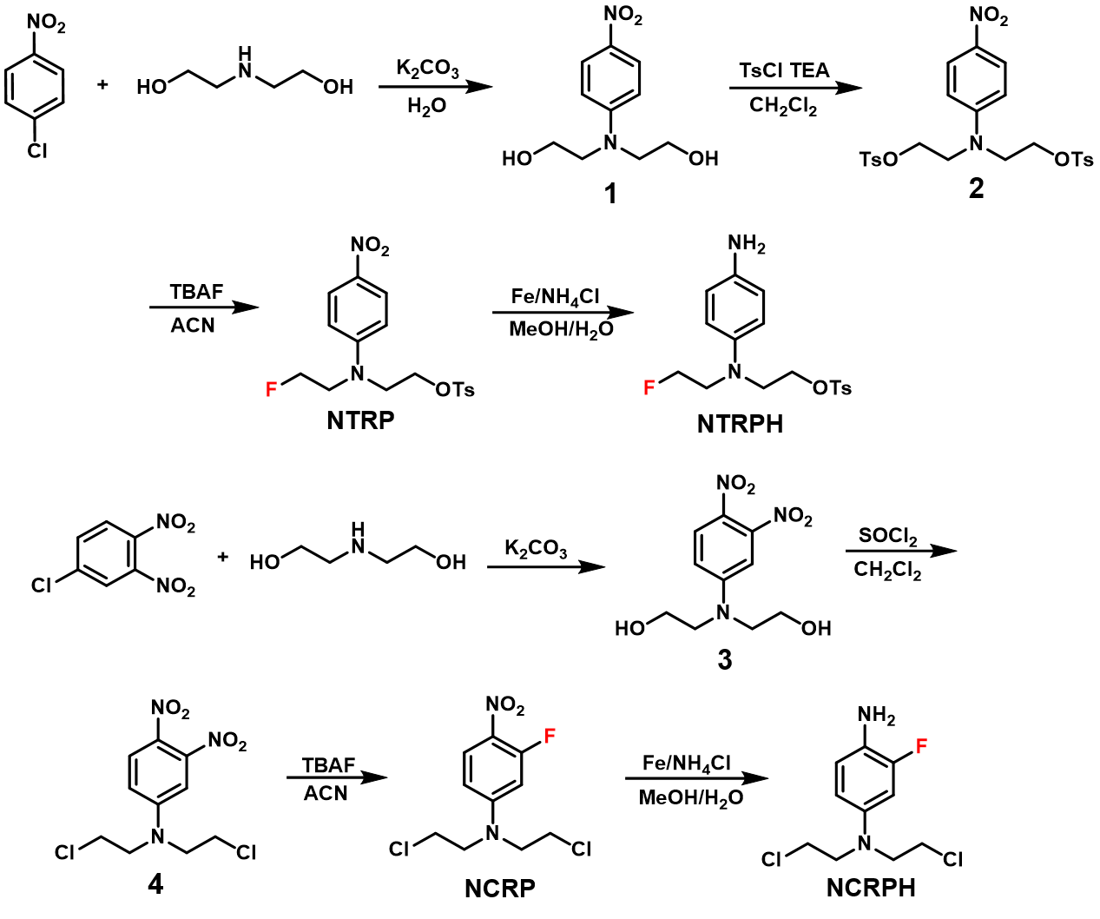
Figure S1 Synthesis of precursors and reference compounds of ¹⁸F-NTRP and ¹⁸F-NCRP

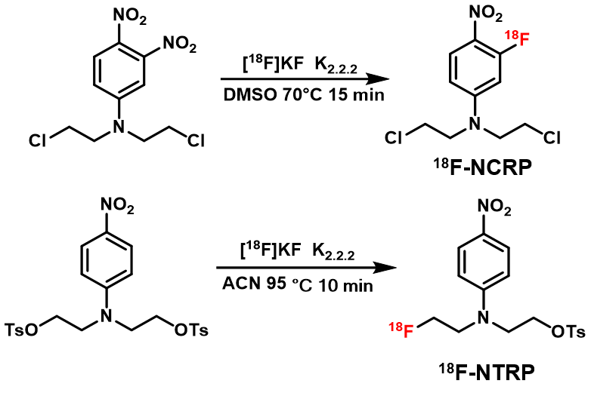
Figure S2 Radiosynthesis of ¹⁸F-NTRP and ¹⁸F-NCRP

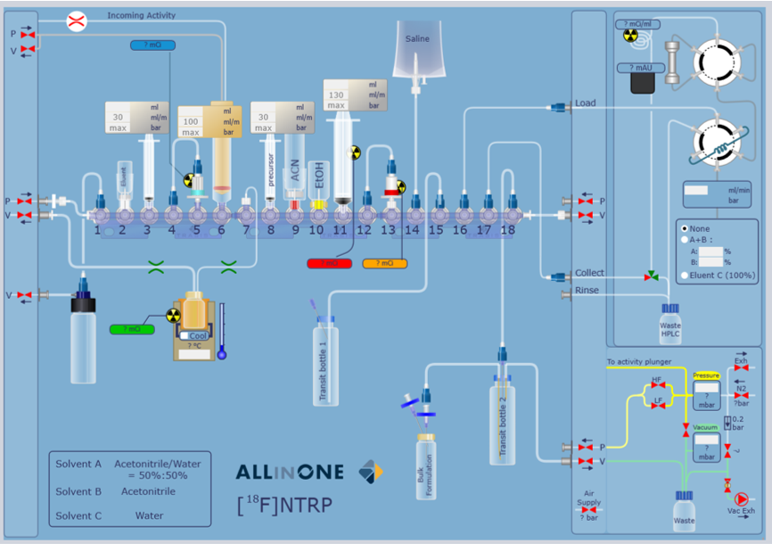
Figure S3 Schematic of the All-In-One automated module for radiosynthesis of ¹⁸F-NTRP

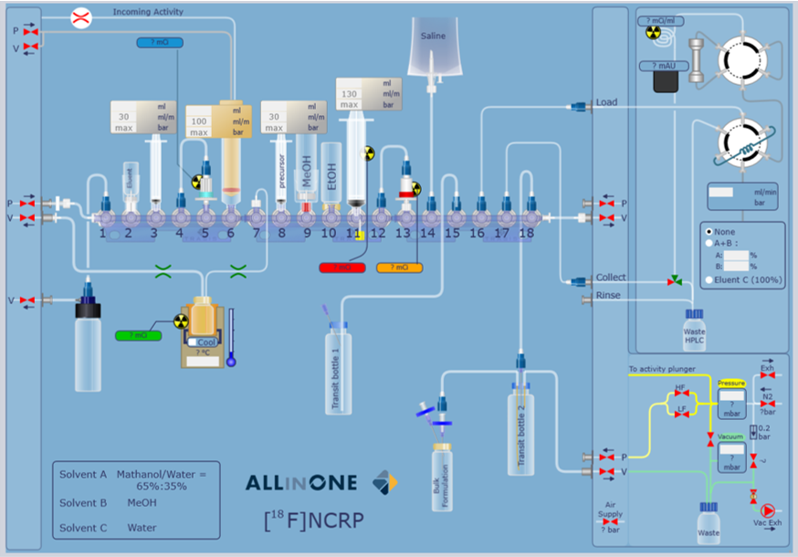
Figure S4 Schematic of the All-In-One automated module for radiosynthesis of ¹⁸F-NCRP

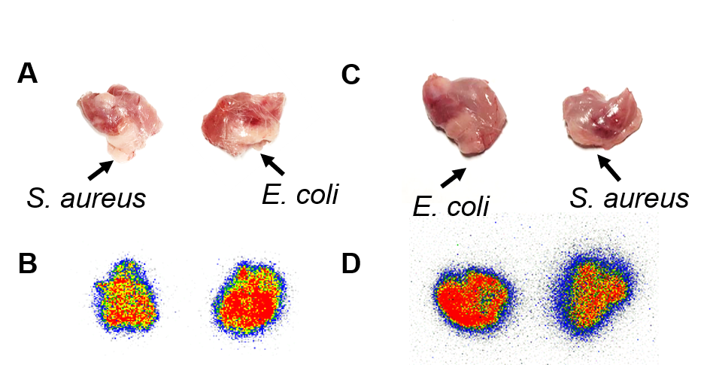
Figure S5 The photo of excised triceps from model mice after PET imaging of (A) ¹⁸F-NTRP and (C) ¹⁸F-NCRP. Autoradiography images of excised triceps showed that the radioactivity derived from (B) ¹⁸F-NTRP and (D) ¹⁸F-NCRP was concentrated in both E. coli and S. aureus infected triceps.

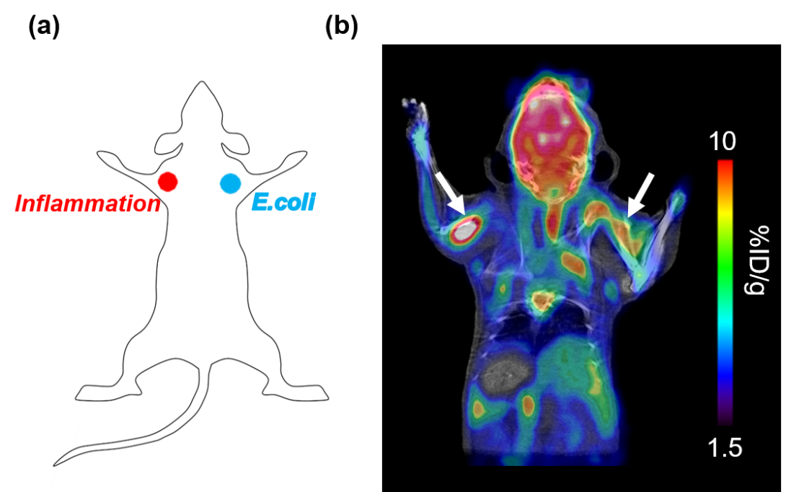
Figure S6. Mice were injected with Freund's adjuvant (100 μL) in the left triceps and E. coli (10⁷ CFUs) in the right triceps and imaged with ¹⁸F-FDG using a microPET-CT.

18. References
[1] Huang L M, Li Z J, Zhang D L, Li H, Shi C R, Zhang P, Su X H, Zhang X Z. Highly specific and sensitive radioiodinated agent for in vivo imaging of superoxide through superoxide-initiated retention. Anal. Chem. 2018; 90: 12971−12978.
[2] Xu D, Zhuang R Q, You L Y, Guo Z D, Wang X Y, Peng C Y, Zhang D L, Zhang P, Wu H, Pan W M, Zhang X Z. ¹⁸F–labeled estradiol derivative for targeting estrogen receptor-expressing breast cancer. Nu Med Bio. 2018; 59: 48-55.
[3] Mou T T, Zhao Z Q, Fang W, Peng C, Guo P, Liu B L, Ma Y C, Zhang X Z. Synthesis and preliminary evaluation of ¹⁸F-labeled pyridaben analogues for myocardial perfusion imaging with PET. J Nucl Med. 2012; 53 (3): 472-479.

