Table S1. Estimates of the broad-sense heritability of the stunting phenotype in the S. lycopersicum Moneymaker x S. pimpinellifolium G1.1596 RIL population, with either all RILs or only the RILs with a reliable phenotype. Heritability was estimated using a one-way ANOVA.

Heritability (H²) and correlation coefficient (R²) | H² experiment 1 | H² experiment 2 | H² experiment 1 + 2 combined | R² between experiment 1 & 2
All RILs | 0.14 | 0.08 | 0.06 | 0.08
Only RILs with the most consistent phenotype | 0.09 | 0.081 | 0.10 | 0.17

Table S2. Estimates of the broad-sense heritability of the G1.1615 RILs. H² represents the broad-sense heritability of the stunting of V. dahliae-inoculated plants, with either all 99 RILs or only the 91 RILs after removal of the eight RILs with the largest variability in phenotype between the two screens. The broad-sense ANOVA was estimated using a one-way ANOVA.

Heritability H² | Experiment 1 | Experiment 2 | Experiment 1 + 2
All 99 RILs | 0.21 | 0.16 | 0.15
91 RILs with most consistent phenotype | 0.19 | 0.13 | 0.17

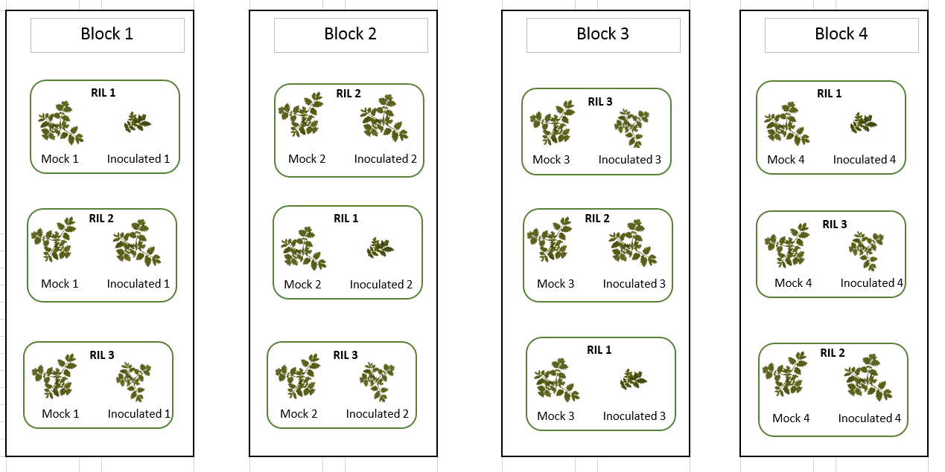
Figure S1. Overview of the first four blocks of the paired randomized block design that was used to position the RILs in the greenhouse. RILs were randomized across the greenhouse over six blocks in pairs of mock-treated and inoculated plants such that a mock-treated and inoculated plant are always immediately adjacent.

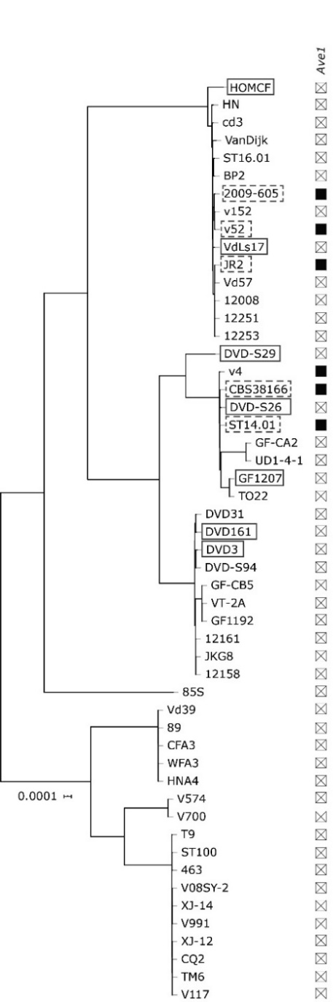
Figure S2. Phylogenetic tree of a selection of sequenced V. dahliae strains. Boxes with solid lines represent the race 2 or 3 V. dahliae strains used in this study. Boxes with dashed lines represent the selected race 1 V. dahliae strains. Phylogenetic relationships between sequenced V. dahliae strains were inferred using Realphy (Langmead and Salzberg 2012). The phylogenetic tree was modified from Chavarro-Carrero (unpublished).

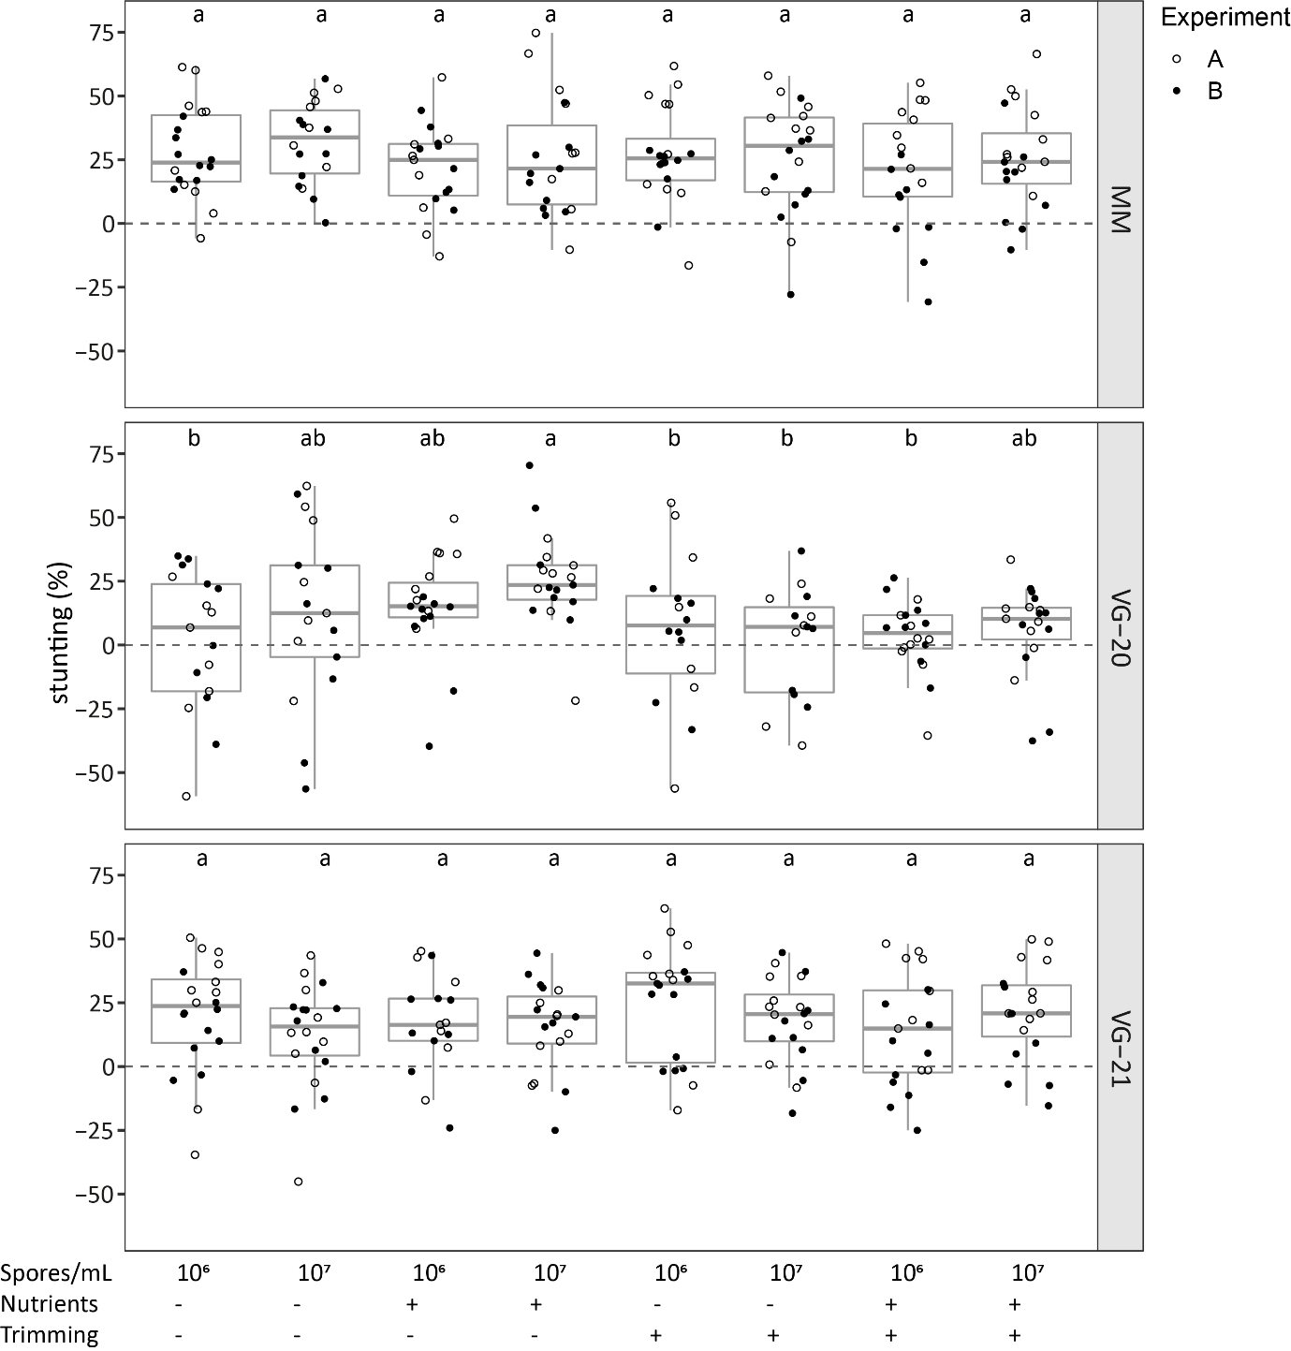
Figure S3. Stunting (%) based on the canopy area of V. dahliae-inoculated plants when compared with mock-inoculated plants at 21 dpi of the tomato genotypes Moneymaker (top), G1.1615 (middle) and G1.1596 (bottom). Conidiospore concentration, addition of nutrients and trimming of the roots were compared. The depicted data comes from two independent experiments (filled versus non-filled dots) with n≥ 9 (ANOVA with Fisher’s unprotected LSD, α = 0.001).

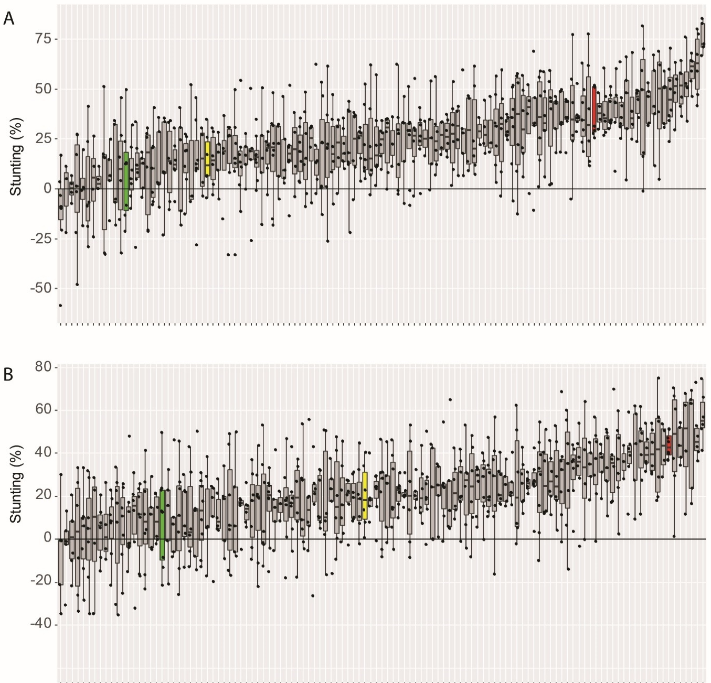

Figure S4. Stunting of Moneymaker (red), G1.1596 (green), the F1 (yellow), and the RILs (grey) at 24-25 days post-inoculation with V. dahliae DVDS29. (A) represents the first and (B) represents the second experiment. Stunting reflects the relative reduction in canopy area of V. dahliae-inoculated plants relative to the canopy area of mock-inoculated plants of the same genotype.

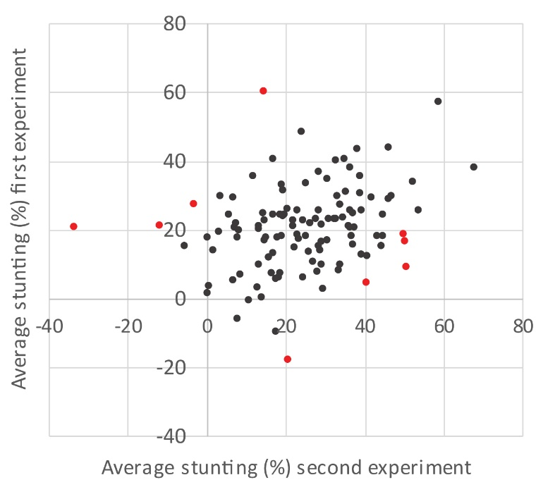
Figure S5. Comparison of the average stunting of the S. lycopersicum Moneymaker x S. pimpinellifolium G1.1596 RILs in the first screen (x-axis) and the second screen (y-axis). Red dots show the RILs with the least reproducible phenotypes.

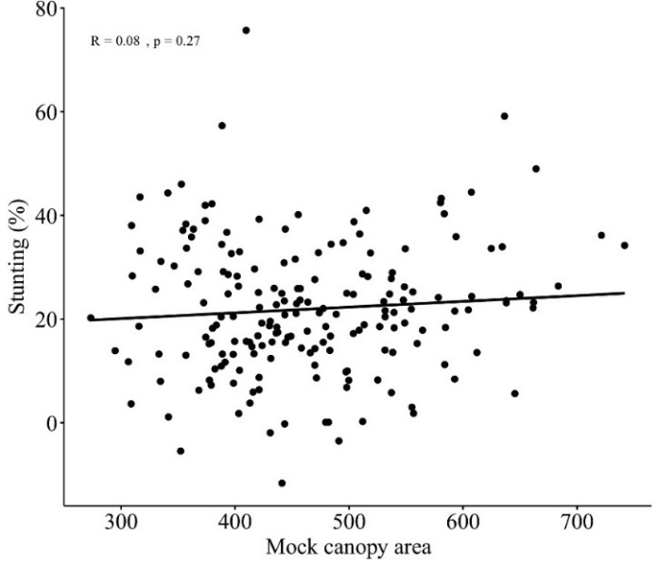
Figure S6. Pearson correlation analysis between the Canopy area of non-inoculated plants and the level of stunting of inoculated plants of the S. lycopersicum Moneymaker x S. pimpinellifolium G1.1596 RIL population

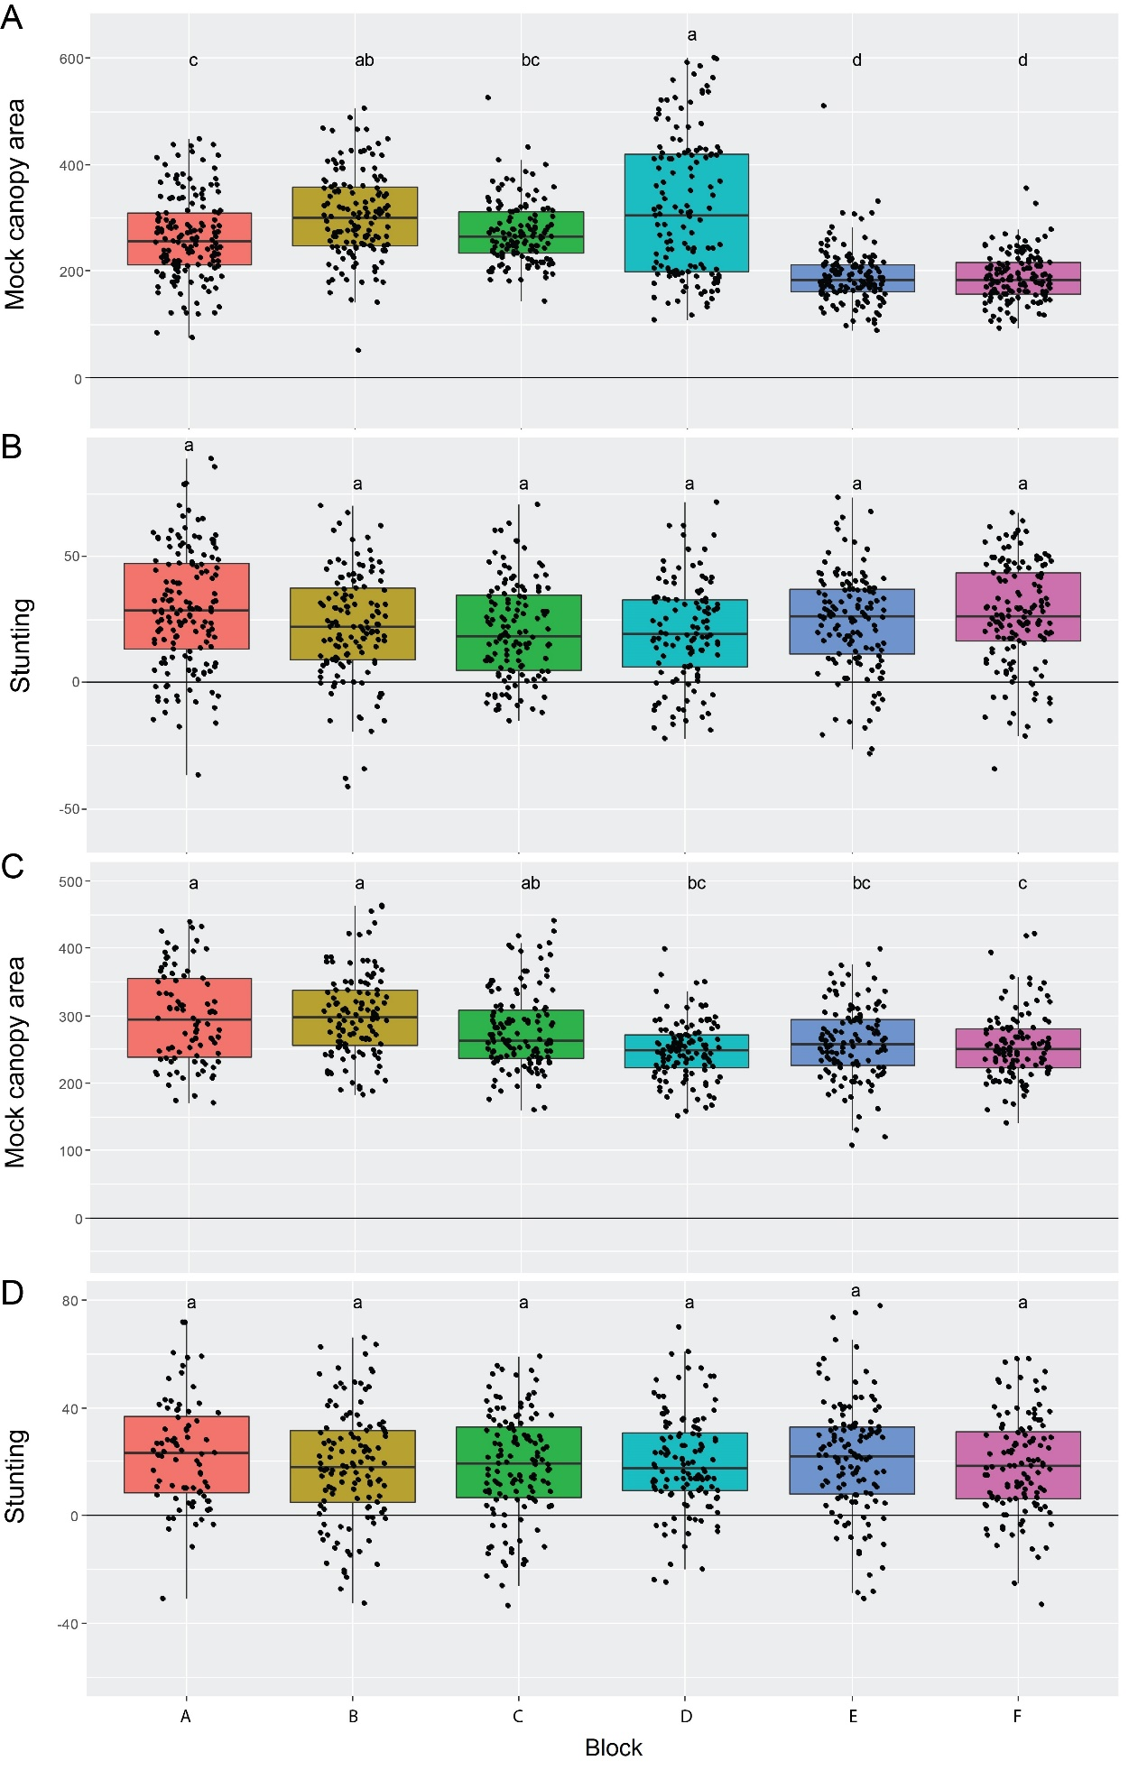

Figure S7. Distribution of the canopy area of mock-inoculated plants (A, C) and stunting of V. dahliae-inoculated plants (B, D) from the six blocks (x-axis) of the G1.1615 RIL population in the greenhouse. Phenotypes were measured at 24 or 25 dpi. Boxplots with different letter labels are significantly different as determined by a one-way ANOVA, followed by a Fishers’ LSD test (p=0.01)

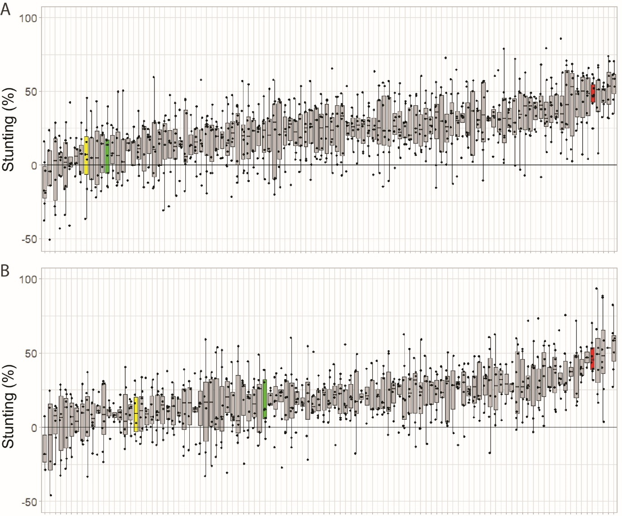
Figure S8. Stunting of V. dahliae-inoculated plants of the Moneymaker parent (red), the G1.1615 parent (green), the F1 (yellow), and the RILs (grey) at 24-25 days post-inoculation in the first (A) and second (B) screen.

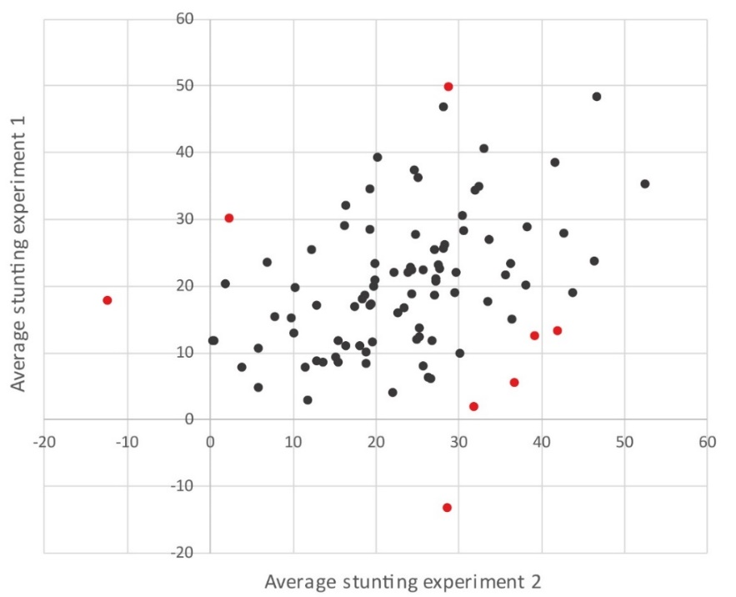
Figure S9. Comparison of the average stunting of V. dahliae-inoculated RILs of the G1.1615 x Moneymaker population (individual dots) in the first experiment (y-axis) and the second experiment (x-axis). Red dots represent the eight RILs with the largest variability in phenotype between the two experiments.

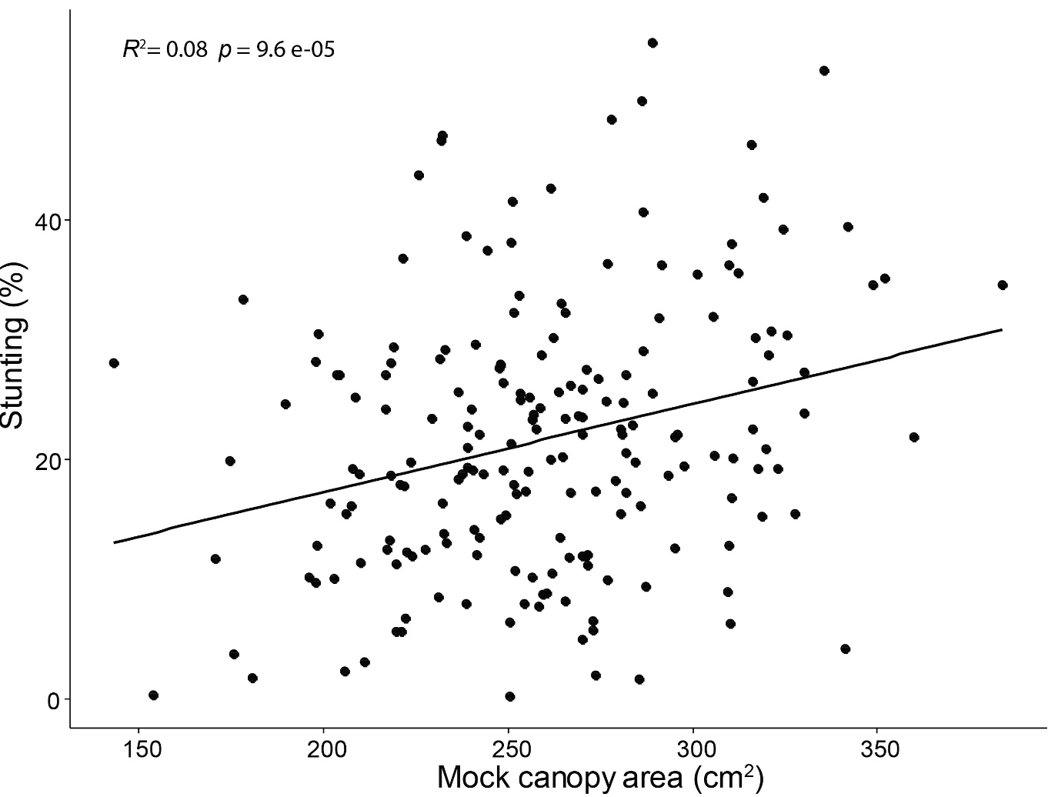
Figure S10. Correlation analysis between the average canopy area of mock-inoculated RILs of the G1.1615 x Moneymaker population, and the average stunting of V. dahliae – inoculated RILs of the G1.1615 x Moneymaker population.

