Supplementary information to
Differences in the causes of light and extreme precipitation for the Qaidam Basin in summer

Yan Li et al.

Supplementary Fig.1
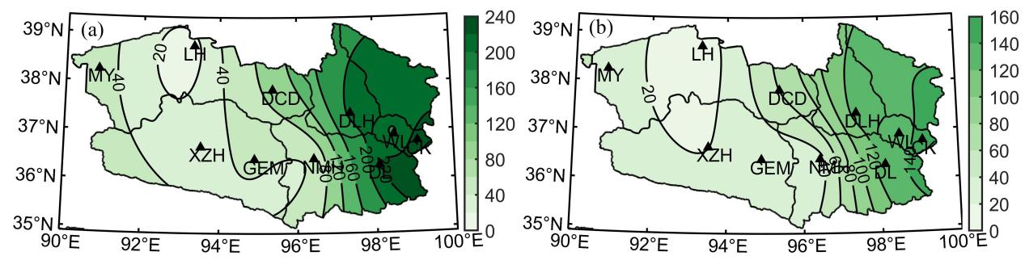
Fig1. The spatial distribution of the annual averaged precipitation in the QB (units:mm)

Supplementary Fig.2
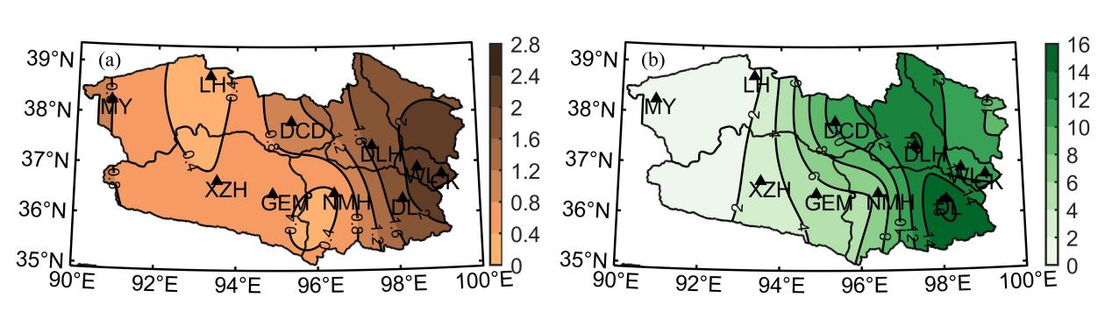
Fig2. The spatial distribution of the averaged precipitation of (a) light precipitation events and (b) the extreme precipitation events (units:mm)

Supplementary Fig. 3
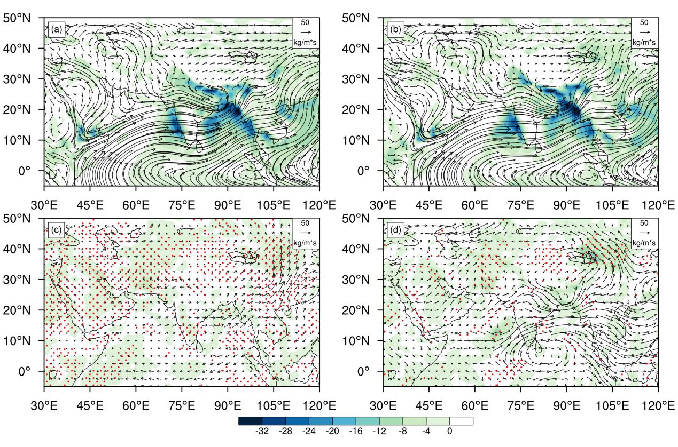
Fig.3 Composite of the vertically integrated of moisture flux (vectors, units:kg.m⁻¹.s⁻¹) and moisture flux divergence (shaded, units: 10⁻⁵ kg.m⁻².s⁻¹) of (a) the light precipitation events, and (b) the extreme precipitation events. The anomaly of vertically integrated of moisture flux (vectors, units:kg.m⁻¹.s⁻¹) and moisture flux divergence (shaded, units: 10⁻⁵ kg.m⁻².s⁻¹) of (c) the light precipitation events, and (d) the extreme precipitation events, the dotted areas indicate pass the 90% significance level, which is displayed by the JRA55

Supplementary Fig. 4
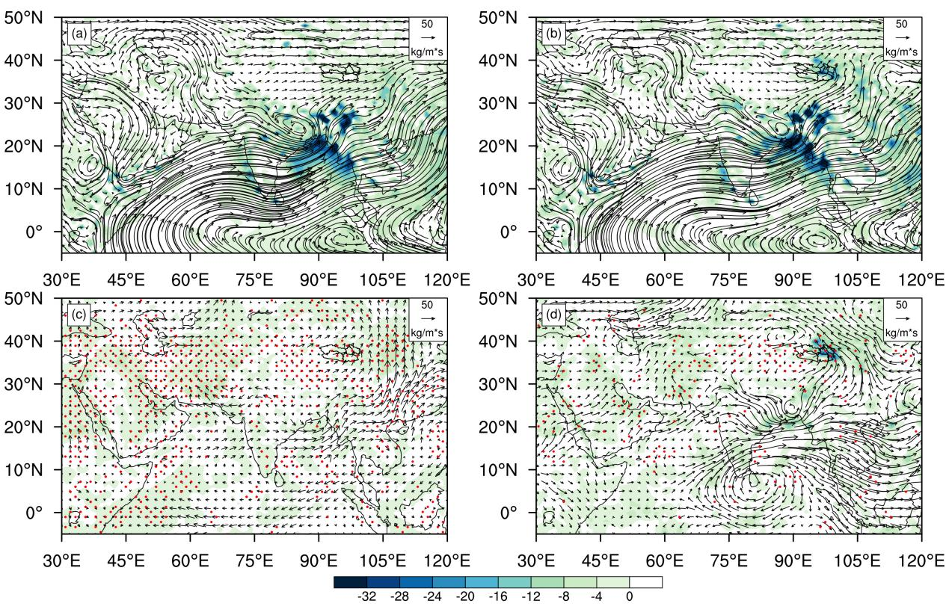
Fig.4 Composite of the vertically integrated of moisture flux (vectors, units:kg.m⁻¹.s⁻¹) and moisture flux divergence (shaded, units: 10⁻⁵ kg.m⁻².s⁻¹) of (a) the light precipitation events, and (b) the extreme precipitation events. The anomaly of vertically integrated of moisture flux (vectors, units:kg.m⁻¹.s⁻¹) and moisture flux divergence (shaded, units: 10⁻⁵ kg.m⁻².s⁻¹) of (c) the light precipitation events, and (d) the extreme precipitation events, the dotted areas indicate pass the 90% significance level, which is displayed by the ERA5

