edge to the cervical point is 8.7 mm and thus the root length 11.8 mm.
Table 2 Crown designs for the lateral incisor. NoAt: Control design without any attachment; recV: Ideal vertical rectangular attachment. recVf: Vertical rectangular attachment with excessive material at the base. recVfs: Vertical rectangular attachment with excessive material at the base and shifted; bevC: Beveled attachment in the center of the facial crown surface. bevO: Beveled attachment occlusally shifted. bevG: Beveled attachment shifted towards the gingival margin
NoAt | No attachment |  | Facial-lingual view  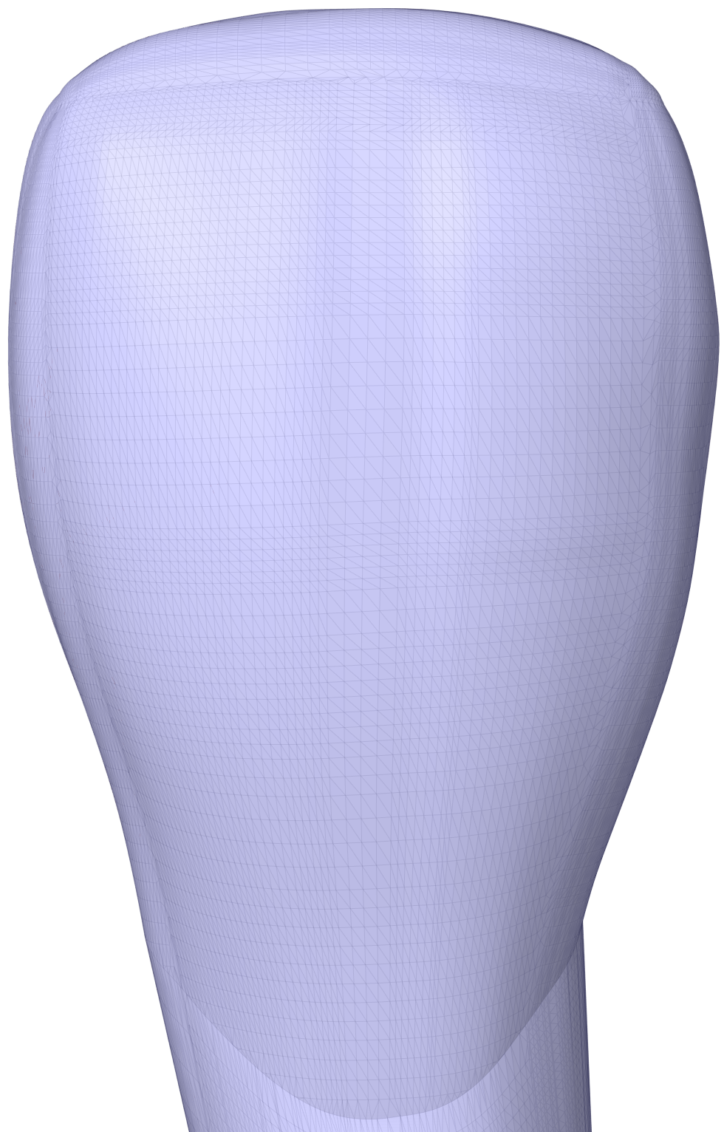 | Distal-mesial view  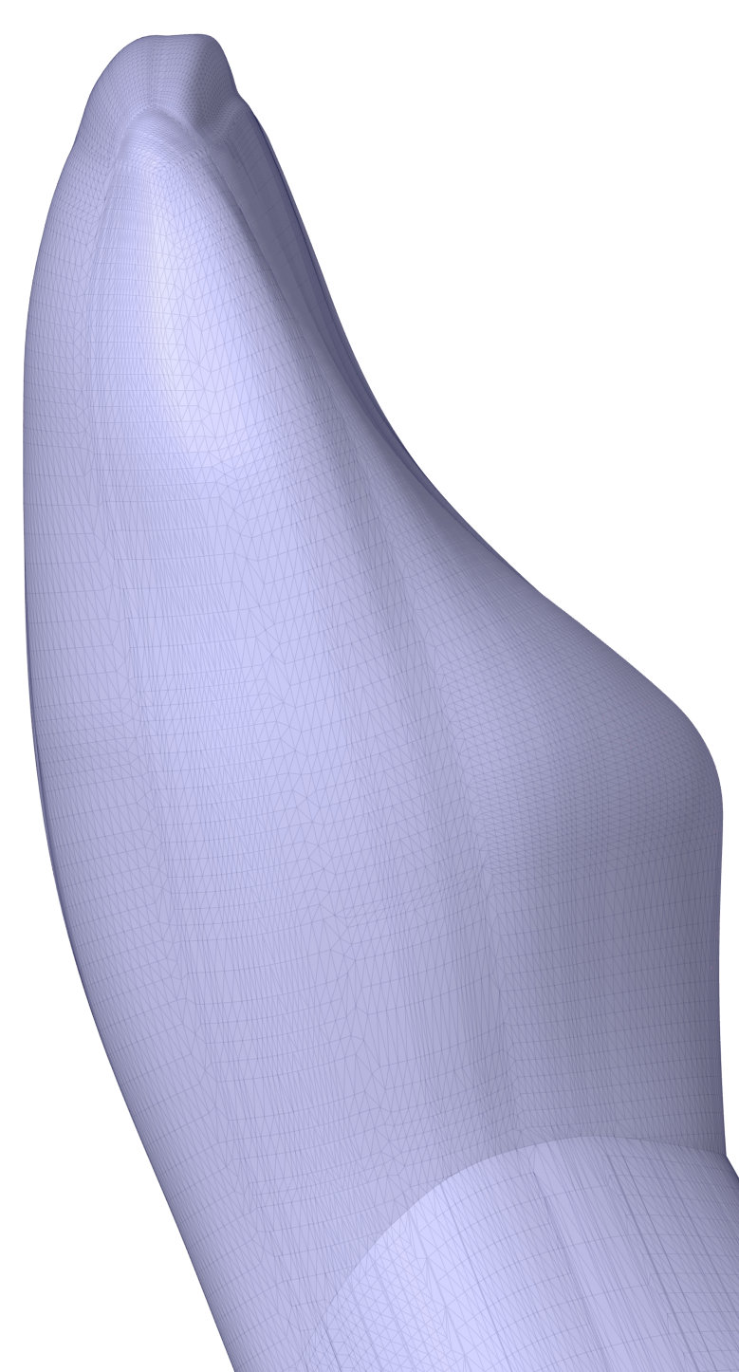
recV | Position | Center | 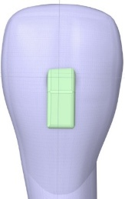  1.5 mm  3 mm | 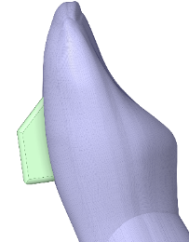  1 mm
recV | Height | 3 mm
recV | Depth | 1 mm
recV | Width | 1.5 mm
recV | Beveling angle | 45°
recV | Edge blend radius | 0.2 mm
recV | Disc radius | None
recV | Disc depth | None
recVf | Position | Center | 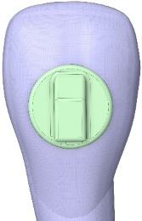  +1 mm | 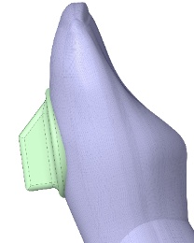  1.2…1.5 mm
recVf | Height | 3 mm
recVf | Depth | 1 mm
recVf | Width | 1.5 mm
recVf | Beveling angle | 45°
recVf | Edge blend radius | 0.2 mm
recVf | Disc radius | 2 mm
recVf | Disc depth | 0.3 mm
recVfs | Position | 1 mm shift to incisal edge | 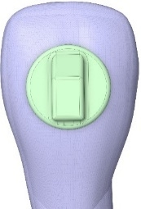 | 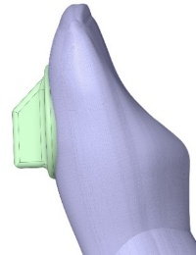
recVfs | Height | 3 mm
recVfs | Depth | 1 mm
recVfs | Width | 1.5 mm
recVfs | Beveling angle | 45°
recVfs | Edge blend radius | 0.2 mm
recVfs | Disc radius | 2 mm
recVfs | Disc depth | 0.3 mm
bevC | Position | Center | 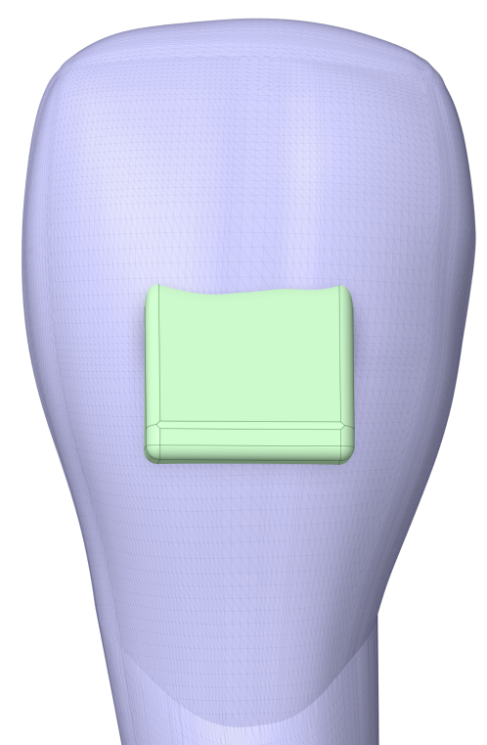 | 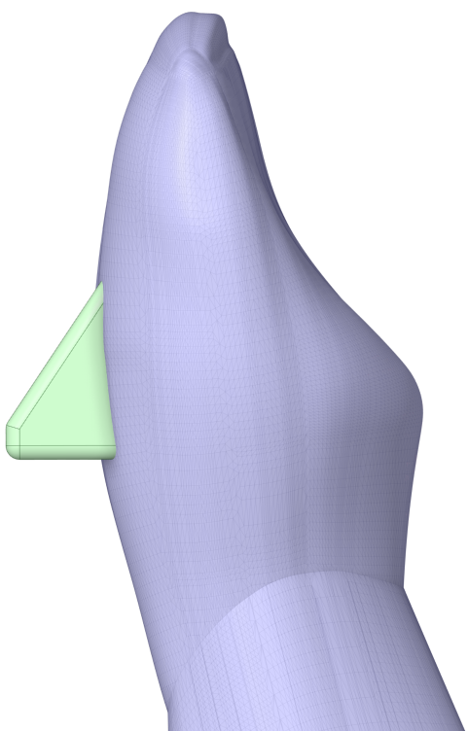
bevC | Height | 2.5 mm
bevC | Depth | 1.5 mm
bevC | Width | 3.0 mm
bevC | Beveling angle | 33.69°
bevC | Edge blend radius | 0.2 mm
bevO | Position | 2 mm occlusal shift | 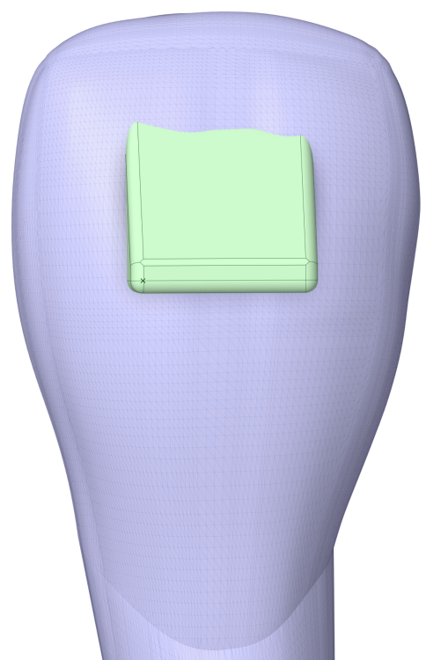  +2 mm | 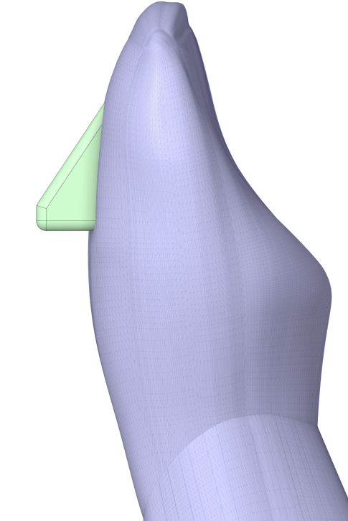
bevO | Height | 2.5 mm
bevO | Depth | 1.5 mm
bevO | Width | 3.0 mm
bevO | Beveling angle | 33.69°
bevO | Edge blend radius | 0.2 mm
bevG | Position | 2 mm apical shift | 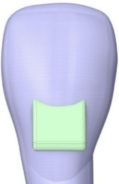  -2 mm | 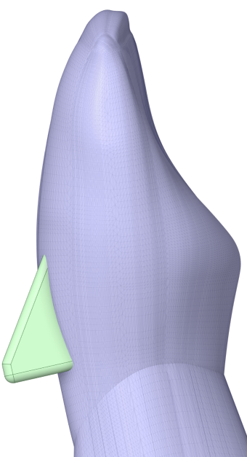
bevG | Height | 2.5 mm
bevG | Depth | 1.5 mm
bevG | Width | 3.0 mm
bevG | Beveling angle | 33.69°
bevG | Edge blend radius | 0.2 mm

