Supporting Information

Photocatalytic Defluoroalkylation and Hydrodefluorination of Trifluoromethyls using o-Phosphinophenolate

Table of Contents

1. General information | S3
2. Preparation of Catalysts | S4
3. Preparation of Substrates | S5
4. Investigation of the Key Reaction Parameters | S6
5. Experimental Procedures and Spectral Data | S9
6. Experimental Studies on Mechanism | S36
7. References | S44
8. ¹H-NMR, ¹³C-NMR, and ¹⁹F-NMR Spectra | S46

- General Information
- Materials:
All reactions were carried out in oven-dried Schlenk tubes under argon atmosphere (purity≥99.999%) unless otherwise mentioned. Commercial reagents were purchased from Adamas-beta, TCI and Aldrich. Organic solutions were concentrated under reduced pressure on Buchi rotary evaporator. The LED lamps were purchased from Kessil (PR160-427 nm, 440 nm, 456 nm, 467 nm). The Photo Reaction Setup was purchased from HepatoChem.
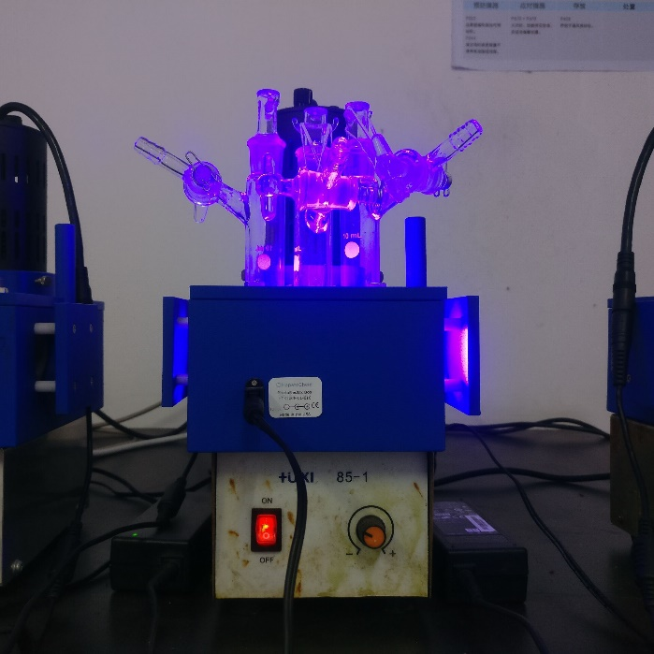
Supplementary Figure 1. The Photo Reaction Setup and violet LED lamps

- Analytical Methods:
¹H-NMR, ¹⁹F-NMR and ¹³C-NMR spectra were recorded on a Bruker Avance 400 spectrometer at ambient temperature. Data for ¹H-NMR are reported as follows: chemical shift (ppm, scale), multiplicity (s = singlet, d = doublet, t = triplet, q = quartet, m = multiplet and/or multiplet resonances, br = broad), coupling constant (Hz), and integration. Data for ¹³C- NMR are reported in terms of chemical shift (ppm, scale), multiplicity, and coupling constant (Hz). HRMS analysis was performed on Finnigan LCQ advantage Max Series MS System. ESI-mass data were acquired using a Thermo LTQ Orbitrap XL Instrument equipped with an ESI source and controlled by Xcalibur software. UV-Vis spectrum was measured by UV-3600. Flash column chromatographic purification of products was accomplished using forced-flow chromatography on Silica Gel (200-300 mesh).
- Preparation of Catalysts
  - General Procedure for preparation of catalyst
PO catalysts PO1, PO3, PO4, PO5, PO6, PO7 were known compounds and prepared according to the literature procedures.¹⁻⁶
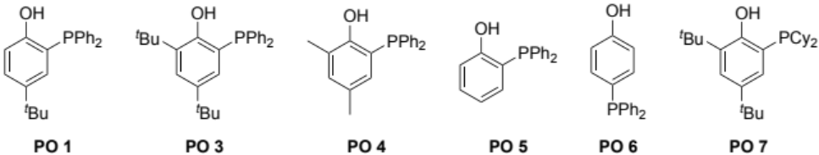
Other PO catalysts used in this work were prepared by the following method：
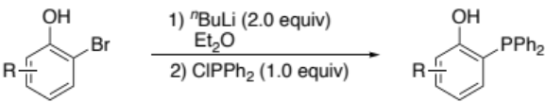
The Catalyst o-Phosphinophenol (PO) was prepared according to a previous published protocol.⁷ n-Butyl lithium (1.6 M in hexane, 20 mmol) was added into a solution of o-bromophenol (10 mmol) in Et₂O (22 mL) at -78 ºC, giving immediately a white suspension. The cold bath was removed and stirring was continued at room temperature for 30 mins. Chlorodiphenylphosphine (10 mmol) was added into this solution at -78 ºC. After stirring for 3 h, the cold bath was removed and stirring was continued at 0 ºC for 18 h. The mixture was extracted with aqueous solutions of NaH₂PO₄ (0.1 M), and the combined organic layers were washed with brine, dried over Na₂SO₄, filtered and concentrated in vacuo. The crude residue was purified by flash column chromatography on silica gel to give desired product.
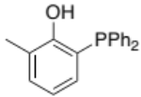
2-(diphenylphosphaneyl)-6-methylphenol (PO2): Following the general procedure, obtained in 75% yield as white solid after silica gel chromatography. (2.19 g, eluent: petroleum ether/ethyl acetate = 10/1).
Mp = 143 – 145 ºC
¹H NMR (400 MHz, CDCl₃) δ 7.42 – 7.27 (m, 10H), 7.16 (dd, J = 7.1, 1.1 Hz, 1H), 6.94 – 6.71 (m, 2H), 6.41 (d, J = 7.9 Hz, 1H), 2.26 (s, 3H).
¹³C NMR (101 MHz, CDCl₃) δ 157.6 (d, J = 18.8 Hz), 135.1 (d, J = 3.8 Hz), 133.4 (d, J = 18.6 Hz), 132.9, 132.33 (d, J = 3.4 Hz), 129.0, 128.7 (d, J = 7.3 Hz), 124.5 (d, J = 1.8 Hz), 120.7 (d, J = 2.9 Hz), 120.0 (d, J = 3.0 Hz), 16.3 (d, J = 2.6 Hz).
³¹P NMR (162 MHz, CDCl₃) δ -29.9.
HRMS (ESI) m/z: [M+H]⁺ Calcd. for C₁₉H₁₈OP, 293.1090; found, 293.1092.
- Preparation of Substrates
  - General Procedure for preparation of trifluoroacetamides and pentafluoropropionamides
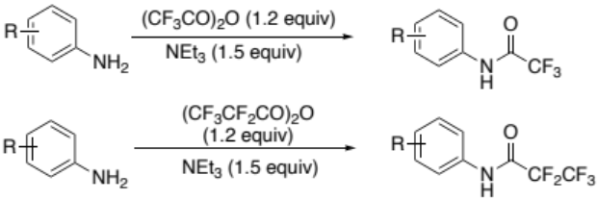
General Procedure 1: Trifluoroacetamides and Pentafluoropanamides.⁸ To a solution of aniline and Et₃N (1.5 equiv) in CH₂Cl₂ was added trifluoroacetic anhydride (1.2 equiv) dropwise at 0 °C. After addition, the mixture was stirred at room temperature until TLC to indicate aniline disappeared. The reaction was then quenched with H₂O and extracted three times with CH₂Cl₂. The combined organic layers were washed with brine, dried over Na₂SO₄, filtered and concentrated in vacuo. The crude residue was purified by flash column chromatography on silica gel to give desired products.

  - General Procedure for preparation of trifluoroacetates
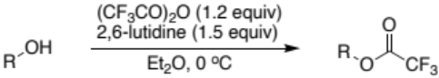
General Procedure 2: Trifluoroacetates.⁸ To a solution of alcohol and 2,6-lutidine (1.5 equiv) in Et₂O was added trifluoroacetic anhydride (1.3 equiv) dropwise at 0 °C. After addition, the mixture was stirred at 0 °C until TLC indicated that alcohol disappeared. The reaction was then poured into H₂O and extracted with 1N HCl (×2), saturated aqueous NaHCO₃, brine, dried over Na₂SO₄, filtered, and concentrated in vacuo. The crude residue was purified by flash column chromatography on silica gel to give desired products.
- Investigation of the Key Reaction Parameters
Supplementary Table 1: Parameters affecting defluoroalkylation of trifluoroacetamides
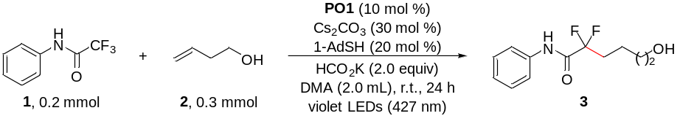
Entry | Variations from standard conditions | Yield (%)ª
1 | none | 90
2 | DMF instead of DMA | 89
3 | DMSO instead of DMA | 91
4 | NMP instead of DMA | 80
5 | MeCN instead of DMA | 23
6 | THF instead of DMA | 4
7 | Acetone instead of DMA | 7
8 | 1,4-Dioxane instead of DMA | 0
9 | Toluene instead of DMA | 0
10 | DCM instead of DMA | 0
11 | PO2 instead of PO1 | 90
12 | PO3 instead of PO1 | 87
13 | PO4 instead of PO1 | 93
14 | PO5 instead of PO1 | 65
15 | PO6 instead of PO1 | 15
16 | PO7 instead of PO1 | < 5
17 | CySH instead of 1-Adamantanethiol | 75
18 | DABCO instead of 1-Adamantanethiol | 0
19 | Triethylsilane instead of HCO₂K | 30
20 | HCO₂Na instead of HCO₂K | 82
21 | HCO₂Li instead of HCO₂K | 92
22 | HCO₂Cs instead of HCO₂K | 70
23 | 2 (0.4 mmol) instead of 2 (0.3 mmol) | 96
24 | PO1 (2 mol%) instead of PO1 (10 mol%) | 52
25 | PO1 (5 mol%) instead of PO1 (10 mol%) | 67
26 | 1-AdSH (5 mol%) instead of 1-AdSH (20 mol%) | 59
27 | 1-AdSH (10 mol%) instead of 1-AdSH (20 mol%) | 72
28 | 440 nm instead of 427 nm | 70
29 | 456 nm instead of 427 nm | trace
30 | 467 nm instead of 427 nm | trace
31 | PPh₃ instead of PO1 | trace
32 | 4-t-Bu-C₆H₄-OH instead of PO1 | 0
33 | PPh₃ + 4-t-Bu-C₆H₄-OH (1:1, 10 mol%) instead of PO1 (10 mol%) | 10
34 | w/o PO1 | 0
35 | w/o 1-AdSH | trace
36 | w/o HCO₂K | 18
37 | w/o light | 0
38 | Under air | trace
ªYield determined by ¹H-NMR using diphenylmethane as an internal standard.

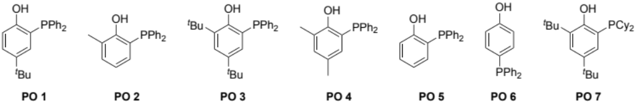

Supplementary Table 2: Parameters affecting hydrodefluorination of trifluoroacetamides
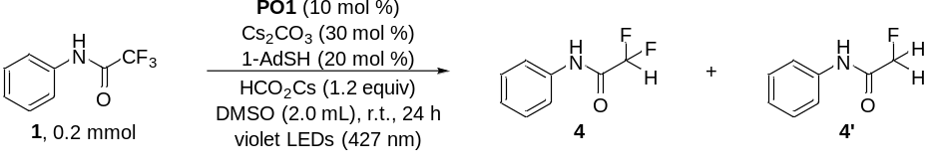
Entry | Variations from standard conditions | Yield 4 (%)ª | Yield 4’(%)ª
1 | none | 94 | < 5
2 | HCO₂Cs (2.0 equiv) instead of HCO₂Cs (1.2 equiv) | 79 | 17
3 | HCO₂Cs (3.0 equiv) instead of HCO₂Cs (1.2 equiv) | 60 | 38
4 | DMA instead of DMSO | 65 | trace
5 | DMF instead of DMSO | 50 | trace
6 | w/o 1-AdSH | 12 | n.d.
7 | w/o HCO₂Cs | 10 | n.d.
ªYield determined by ¹H-NMR using diphenylmethane as internal standard.

- Experimental Procedures and Spectral Data
5.1 General Procedure
General Procedure A: trifluoroacetamide (1.0 equiv, 0.2 mmol) (if solid), Alkene (1.5 equiv, 0.3 mmol) (if solid), PO1 (10 mol%), Cs₂CO₃ (30 mol%), 1-adamananethiol (20 mol%), HCO₂K (2.0 equiv, 0.4 mmol) were placed in a transparent Schlenk tube equipped with a stirring bar. The tube was evacuated and filled with argon (three times). To these solids, trifluoroacetamide (1.0 equiv, 0.2 mmol) (if liquid), alkene (1.5 equiv, 0.3 mmol) (if liquid), and anhydrous DMA (2 mL) were added via a gastight syringe under argon atmosphere. The reaction mixture was stirred under irradiation with violet LEDs (427 nm) in a photoreactor at room temperature for 24 h. The mixture was quenched with brine and extracted with ethyl acetate (3 × 10 mL). The organic layers were combined and concentrated under vacuo. The product was purified by flash column chromatography on silica gel.

General Procedure B: trifluoacatete (2.0 equiv, 0.4 mmol) (if solid), alkene (1.0 equiv, 0.2 mmol) (if solid), PO1 (10 mol%), Cs₂CO₃ (30 mol%), 1-adamananethiol (20 mol%), HCO₂K (2.0 equiv, 0.4 mmol) were placed in a transparent Schlenk tube equipped with a stirring bar. The tube was evacuated and filled with argon (three times). To these solids, trifluoacetate (2.0 equiv, 0.4 mmol) (if liquid), alkene (1.0 equiv, 0.2 mmol) (if liquid), and anhydrous DMA (2 mL) were added via a gastight syringe under argon atmosphere. The reaction mixture was stirred under irradiation with violet LEDs (427 nm) in a photoreactor at room temperature for 24 h. The mixture was quenched with brine and extracted with ethyl acetate (3 × 10 mL). The organic layers were combined and concentrated under vacuo. The product was purified by flash column chromatography on silica.

General Procedure C: trifluoroacetamide (1.0 equiv, 0.2 mmol) (if solid), PO1 (10 mol%), Cs₂CO₃ (30 mol%), 1-adamananethiol (20 mol%), HCO₂Cs (1.2 equiv, 0.24 mmol) were placed in a transparent Schlenk tube equipped with a stirring bar. The tube was evacuated and filled with argon (three times). To these solids, trifluoroacetamide (1.0 equiv, 0.2 mmol) (if liquid) and anhydrous DMSO (2 mL) were added via a gastight syringe under argon atmosphere. The reaction mixture was stirred under irradiation with violet LEDs (427 nm) in a photoreactor at room temperature for 24 h. The mixture was quenched with brine and extracted with ethyl acetate (3 × 10 mL). The organic layers were combined and concentrated under vacuo. The product was purified by flash column chromatography on silica.

General Procedure D: trifluomethyl (hetero) arenes (1.0 equiv, 0.2 mmol) (if solid), alkene (1.5 equiv, 0.3 mmol) (if solid), PO1 (10 mol%), Cs₂CO₃ (30 mol%), 1-adamananethiol (20 mol%), HCO₂Li (2.0 equiv, 0.4 mmol) were placed in a transparent Schlenk tube equipped with a stirring bar. The tube was evacuated and filled with argon (three times). To these solids, trifluomethyl (hetero) arenes (1.0 equiv, 0.2 mmol) (if liquid), alkene (1.5 equiv, 0.3 mmol) (if liquid), and anhydrous DMSO (2 mL) were added via a gastight syringe under argon atmosphere. The reaction mixture was stirred under irradiation with violet LEDs (427 nm) in a photoreactor at room temperature for 24 h. The mixture was quenched with brine and extracted with ethyl acetate (3 × 10 mL). The organic layers were combined and concentrated under vacuo. The product was purified by flash column chromatography on silica.

5.2 Spectral Data
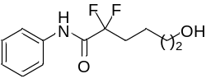
2,2-difluoro-6-hydroxy-N-phenylhexanamide (3): Following the general procedure A, obtained in 86% yield as white solid after silica gel chromatography. (41.9 mg, eluent: petroleum ether/ethyl acetate = 2/1).
Mp = 61 – 63 ºC
¹H NMR (400 MHz, CDCl₃) δ 8.09 (s, 1H), 7.57 (d, J = 7.9 Hz, 2H), 7.37 (t, J = 7.9 Hz, 2H), 7.19 (t, J = 7.4 Hz, 1H), 3.66 (t, J = 5.7 Hz, 2H), 2.32 – 2.12 (m, 2H), 1.73 (s, 1H), 1.62 (dd, J = 7.0, 4.0 Hz, 4H).
¹³C NMR (101 MHz, CDCl₃) δ 162.2 (t, J = 28.6 Hz), 136.0, 129.2, 125.6, 120.3, 118.3 (t, J = 253.6 Hz), 62.2, 33.5 (t, J = 23.2 Hz), 31.9, 18.1 (t, J = 4.5 Hz).
¹⁹F NMR (376 MHz, CDCl₃) δ -105.5 (2F, td, J = 17.3, 2.9 Hz).
HRMS (ESI) m/z: [M+Na]⁺ Calcd. for C₁₂H₁₅F₂NO₂Na, 266.0963; found, 266.0962.
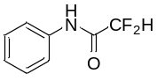
2,2-difluoro-N-phenylacetamide (4): Following the general procedure C, obtained in 94% yield as white solid after silica gel chromatography. (32.1 mg, eluent: petroleum ether/ethyl acetate = 15/1). The compound data was in agreement with the literature (Science 2021, 371, 1232−1240).
¹H NMR (400 MHz, CDCl₃) δ 7.92 (s, 1H), 7.57 (d, J = 8.0 Hz, 2H), 7.38 (t, J = 7.9 Hz, 2H), 7.21 (t, J = 7.4 Hz, 1H), 6.02 (t, J = 54.4 Hz, 1H).
¹³C NMR (101 MHz, CDCl₃) δ 160.3 (t, J = 24.1 Hz), 135.7, 129.3, 125.9, 120.3, 108.6 (t, J = 254.2 Hz).
¹⁹F NMR (376 MHz, CDCl₃) δ -125.5 (2F, dd, J = 54.4, 2.3 Hz).
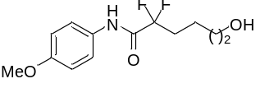
2,2-difluoro-6-hydroxy-N-(4-methoxyphenyl)hexanamide (5): Following the general procedure A, obtained in 80% yield as white solid after silica gel chromatography. (43.5 mg, eluent: petroleum ether/ethyl acetate = 2/1).
Mp = 90 – 92 ºC
¹H NMR (400 MHz, d₆-DMSO) δ 10.38 (s, 1H), 7.59 (d, J = 9.1 Hz, 2H), 6.93 (d, J = 9.1 Hz, 2H), 3.74 (s, 3H), 3.41 (t, J = 5.7 Hz, 2H), 2.25 – 2.04 (m, 2H), 1.52 – 1.42 (m, 4H).
¹³C NMR (101 MHz, d₆-DMSO) δ 162.3 (t, J = 29.4 Hz), 156.8, 130.7, 122.9, 118.7 (t, J = 251.5 Hz), 114.3, 60.7, 55.7, 34.1 (t, J = 23.3 Hz), 32.2, 18.6 (t, J = 4.3 Hz).
¹⁹F NMR (376 MHz, d₆-DMSO) δ -104.1 (2F, t, J = 17.3 Hz).
HRMS (ESI) m/z: [M+Na]⁺ Calcd. for C₁₃H₁₇F₂NO₃Na, 296.1069; found, 296.1072.
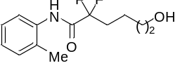
2,2-difluoro-6-hydroxy-N-(o-tolyl)hexanamide (6): Following the general procedure A, obtained in 70% yield as colorless oil after silica gel chromatography. (36.0 mg, eluent: petroleum ether/ethyl acetate = 2/1).
¹H NMR (400 MHz, CDCl₃) δ 7.91 (s, 1H), 7.83 (d, J = 7.9 Hz, 1H), 7.23 (dd, J = 7.5, 3.6 Hz, 2H), 7.15 (t, J = 7.1 Hz, 1H), 3.67 (t, J = 5.7 Hz, 2H), 2.29 (s, 3H), 2.27 – 2.14 (m, 2H), 1.71 (s, 1H), 1.68 – 1.59 (m, 4H).
¹³C NMR (101 MHz, CDCl₃) δ 162.2 (t, J = 28.6 Hz), 133.8, 130.7, 129.4, 127.0, 126.3, 122.9, 118.5 (t, J = 253.4 Hz), 62.2, 33.5 (t, J = 23.3 Hz), 31.9, 18.1 (t, J = 4.5 Hz), 17.5.
¹⁹F NMR (376 MHz, CDCl₃) δ -105.4 (2F, td, J = 17.2, 3.2 Hz).
HRMS (ESI) m/z: [M+Na]⁺ Calcd. for C₁₃H₁₇F₂NO₂Na, 280.1120; found, 280.1124.
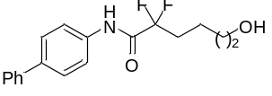
N-([1,1'-biphenyl]-4-yl)-2,2-difluoro-6-hydroxyhexanamide (7): Following the general procedure A, obtained in 85% yield as white solid after silica gel chromatography. (54.3 mg, eluent: petroleum ether/ethyl acetate = 2/1).
Mp = 162 – 164 ºC
¹H NMR (400 MHz, Acetone-d₆) δ 9.79 (s, 1H), 7.88 (d, J = 8.3 Hz, 2H), 7.83 – 7.61 (m, 4H), 7.46 (dd, J = 7.9, 7.4 Hz, 2H), 7.42 – 7.22 (m, 1H), 3.58 (s, 2H), 2.36 – 2.11 (m, 2H), 1.71 – 1.48 (m, 4H).
¹³C NMR (101 MHz, Acetone-d₆) δ 162.2 (t, J = 28.6 Hz), 140.2, 137.5, 136.9, 128.9, 127.2, 127.2, 126.6, 120.9, 118.6 (t, J = 272.0 Hz), 61.0, 33.8 (t, J = 23.4 Hz), 32.2, 18.3 (t, J = 4.6 Hz).
¹⁹F NMR (376 MHz, Acetone-d₆) δ -106.1 (2F, td, J = 17.1, 1.4 Hz).
HRMS (ESI) m/z: [M+Na]⁺ Calcd. for C₁₈H₁₉F₂NO₂Na, 342.1276; found, 342.1277.
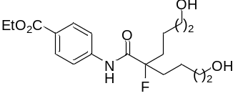
ethyl 4-(2-fluoro-6-hydroxy-2-(4-hydroxybutyl)hexanamido)benzoate (8): Following the general procedure A, obtained in 63% yield as white solid after silica gel chromatography. (46.5 mg, eluent: petroleum ether/ethyl acetate = 1/1).
Mp = 90 – 92 ºC
¹H NMR (400 MHz, CDCl₃) δ 8.41 (d, J = 8.6 Hz, 1H), 8.02 (d, J = 8.7 Hz, 2H), 7.67 (d, J = 8.7 Hz, 2H), 4.36 (q, J = 7.1 Hz, 2H), 3.60 (t, J = 5.8 Hz, 4H), 2.15 – 1.96 (m, 4H), 1.94 – 1.72 (m, 2H), 1.69 – 1.49 (m, 6H), 1.39 (t, J = 7.1 Hz, 3H).
¹³C NMR (101 MHz, CDCl₃) δ 170.6 (d, J = 20.4 Hz), 166.1, 140.8, 130.8, 126.6, 119.2, 101.1 (d, J = 188.8 Hz), 62.2, 61.0, 36.9 (d, J = 22.0 Hz), 32.4, 19.5 (d, J = 3.1 Hz), 14.3.
¹⁹F NMR (376 MHz, CDCl₃) δ -164.3 – -164.6 (1F, m).
HRMS (ESI) m/z: [M+Na]⁺ Calcd. for C₁₉H₂₈FNO₅Na, 392.1844; found, 392.1843.
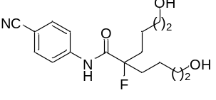
N-(4-cyanophenyl)-2-fluoro-6-hydroxy-2-(4-hydroxybutyl)hexanamide (9): Following the general procedure A, obtained in 50% yield as colorless oil after silica gel chromatography. (32.2 mg, eluent: petroleum ether/ethyl acetate = 1/1).
¹H NMR (400 MHz, CDCl₃) δ 8.32 (d, J = 9.0 Hz, 1H), 7.73 (d, J = 8.9 Hz, 2H), 7.65 (d, J = 8.8 Hz, 2H), 3.79 – 3.54 (m, 4H), 2.16 – 1.96 (m, 3H), 1.96 – 1.77 (m, 3H), 1.62 – 1.53 (m, 6H).
¹³C NMR (101 MHz, CDCl₃) δ 170.7 (d, J = 20.4 Hz), 140.7, 133.4, 119.8, 118.6, 107.9, 101.2 (d, J = 188.7 Hz), 62.4, 36.9 (d, J = 22.1 Hz), 32.4, 19.5 (d, J = 3.2 Hz).
¹⁹F NMR (376 MHz, CDCl₃) δ -164.0 – -164.8 (1F, m).
HRMS (ESI) m/z: [M+H]⁺ Calcd. for C₁₇H₂₄FN₂O₃, 323.1765; found, 323.1763.
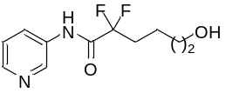
2,2-difluoro-6-hydroxy-N-(pyridin-3-yl)hexanamide (10): Following the general procedure A, obtained in 68% yield as colorless oil after silica gel chromatography. (33.2 mg, eluent: petroleum ether/ethyl acetate = 2/1).
¹H NMR (400 MHz, CDCl₃) δ 8.69 (s, 1H), 8.47 (s, 1H), 8.43 (d, J = 4.4 Hz, 1H), 8.19 (d, J = 8.4 Hz, 1H), 7.34 (dd, J = 8.4, 4.7 Hz, 1H), 3.68 (t, J = 5.7 Hz, 2H), 2.31 – 2.15 (m, 2H), 1.95 (s, 1H), 1.68 – 1.60 (m, 4H).
¹³C NMR (101 MHz, CDCl₃) δ 162.8 (t, J = 29.5 Hz), 146.4, 141.6, 133.3, 127.9, 123.9, 118.1 (t, J = 253.4 Hz), 62.1, 33.5 (t, J = 23.1 Hz), 31.9, 18.1 (t, J = 4.4 Hz).
¹⁹F NMR (376 MHz, CDCl₃) δ -105.2 (2F, td, J = 17.3, 2.5 Hz).
HRMS (ESI) m/z: [M+H]⁺ Calcd. for C₁₁H₁₅F₂N₂O₂, 245.1096; found, 245.1104.
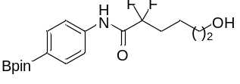
2,2-difluoro-6-hydroxy-N-(4-(4,4,5,5-tetramethyl-1,3,2-dioxaborolan-2-yl)phenyl)hexanamide (11): Following the general procedure A, obtained in 88% yield as colorless oil after silica gel chromatography. (64.9 mg, eluent: petroleum ether/ethyl acetate = 2/1).
¹H NMR (400 MHz, CDCl₃) δ 8.08 (s, 1H), 7.81 (d, J = 8.5 Hz, 2H), 7.59 (d, J = 8.5 Hz, 2H), 3.67 (t, J = 5.9 Hz, 2H), 2.35 – 2.11 (m, 2H), 1.74 (s, 1H), 1.67 – 1.60 (m, 4H), 1.34 (s, 12H).
¹³C NMR (101 MHz, CDCl₃) δ 162.1 (t, J = 28.7 Hz), 138.6, 135.9, 119.1, 118.2 (t, J = 253.8 Hz), 83.9, 62.2, 33.4 (t, J = 23.1 Hz), 31.9, 24.9, 18.1 (t, J = 4.4 Hz).
¹⁹F NMR (376 MHz, CDCl₃) δ -105.4 (2F, td, J = 17.3, 3.0 Hz).
HRMS (ESI) m/z: [M+Na]⁺ Calcd. for C₁₈H₂₆BF₂NO₄Na, 392.1815; found, 392.1818.
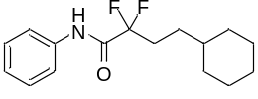
4-cyclohexyl-2,2-difluoro-N-phenylbutanamide (15): Following the general procedure A, obtained in 84% yield as white solid after silica gel chromatography. (47.0 mg, eluent: petroleum ether/ethyl acetate = 30/1).
Mp = 70 – 72 ºC
¹H NMR (400 MHz, CDCl₃) δ 7.98 (s, 1H), 7.58 (d, J = 7.6 Hz, 2H), 7.37 (t, J = 7.9 Hz, 2H), 7.19 (t, J = 7.4 Hz, 1H), 2.35 – 2.05 (m, 2H), 1.68 (t, J = 17.5 Hz, 5H), 1.46 – 1.33 (m, 2H), 1.31 – 1.08 (m, 4H), 0.90 (dd, J = 21.8, 11.0 Hz, 2H).
¹³C NMR (101 MHz, CDCl₃) δ 162.2 (t, J = 28.9 Hz), 136.1, 129.2, 125.5, 120.2, 118.7 (t, J = 253.4 Hz), 37.2, 33.0, 31.4 (t, J = 23.1 Hz), 28.8 (t, J = 3.8 Hz), 26.5, 26.2.
¹⁹F NMR (376 MHz, CDCl₃) δ -105.6 (2F, td, J = 17.4, 2.6 Hz).
HRMS (ESI) m/z: [M+Na]⁺ Calcd. for C₁₆H₂₁F₂NONa, 304.1483; found, 304.1490.
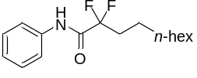
2,2-difluoro-N-phenyldecanamide (16): Following the general procedure A, obtained in 83% yield as white solid after silica gel chromatography. (46.1 mg, eluent: petroleum ether/ethyl acetate = 30/1).
Mp = 45 – 47 ºC
¹H NMR (400 MHz, CDCl₃) δ 7.97 (s, 1H), 7.58 (d, J = 8.0 Hz, 2H), 7.37 (t, J = 7.9 Hz, 2H), 7.19 (t, J = 7.4 Hz, 1H), 2.28 – 2.04 (m, 2H), 1.57 – 1.46 (m, 2H), 1.39 – 1.21 (m, 10H), 0.87 (t, J = 6.7 Hz, 3H).
¹³C NMR (101 MHz, CDCl₃) δ 162.1 (t, J = 28.5 Hz), 136.1, 129.2, 125.5, 120.2, 118.5 (t, J = 253.3 Hz), 33.8 (t, J = 23.1 Hz), 31.8, 29.2, 29.14, 29.07, 22.6, 21.6 (t, J = 4.3 Hz), 14.1.
¹⁹F NMR (376 MHz, CDCl₃) δ -105.5 (2F, td, J = 17.5, 3.0 Hz).
HRMS (ESI) m/z: [M+H]⁺ Calcd. for C₁₆H₂₄F₂NO, 284.1820; found, 284.1829.
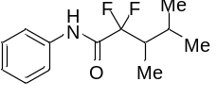
2,2-difluoro-3,4-dimethyl-N-phenylpentanamide (17): Following the general procedure A, obtained in 85% yield as colorless oil after silica gel chromatography. (41.0 mg, eluent: petroleum ether/ethyl acetate = 30/1).
¹H NMR (400 MHz, CDCl₃) δ 8.07 (s, 1H), 7.58 (dd, J = 8.6, 1.0 Hz, 2H), 7.43 – 7.30 (m, 2H), 7.24 – 7.13 (m, 1H), 2.55 – 2.31 (m, 1H), 2.19 – 1.99 (m, 1H), 1.05 – 0.96 (m, 6H), 0.92 (d, J = 6.8 Hz, 3H).
¹³C NMR (101 MHz, CDCl₃) δ 162.6 (t, J = 28.9 Hz), 136.1, 129.2, 125.5, 120.3, 120.2 (t, J = 257.2 Hz), 41.4 (t, J = 20.6 Hz), 26.3 (t, J = 2.5 Hz), 21.9, 17.4 (t, J = 1.6 Hz), 6.8 (dd, J = 5.6, 4.2 Hz).
¹⁹F NMR (376 MHz, CDCl₃) δ -109.8 (1F, dd, J = 252.6, 19.4 Hz), -111.4 (1F, dd, J = 252.6, 16.9 Hz).
HRMS (ESI) m/z: [M+H]⁺ Calcd. for C₁₃H₁₈F₂NO, 242.1351; found, 242.1357.
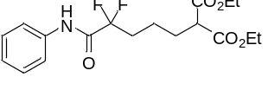
diethyl 2-(4,4-difluoro-5-oxo-5-(phenylamino)pentyl)malonate (18): Following the general procedure A, obtained in 80% yield as colorless oil after silica gel chromatography. (59.5 mg, eluent: petroleum ether/ethyl acetate = 5/1).
¹H NMR (400 MHz, CDCl₃) δ 8.01 (s, 1H), 7.62 – 7.54 (m, 2H), 7.37 (t, J = 8.0 Hz, 2H), 7.19 (t, J = 7.4 Hz, 1H), 4.19 (qd, J = 7.1, 1.5 Hz, 4H), 3.34 (t, J = 7.4 Hz, 1H), 2.22 (ddd, J = 25.4, 17.2, 8.0 Hz, 2H), 1.98 (dd, J = 15.9, 7.6 Hz, 2H), 1.64 – 1.54 (m, 2H), 1.25 (t, J = 7.1 Hz, 6H).
¹³C NMR (101 MHz, CDCl₃) δ 169.1, 161.9 (t, J = 28.6 Hz), 136.0, 129.2, 125.6, 120.2, 118.0 (t, J = 253.7 Hz), 61.5, 51.7, 33.3 (t, J = 23.4 Hz), 28.1, 19.5 (t, J = 4.4 Hz), 14.0.
¹⁹F NMR (376 MHz, CDCl3) δ -105.5 (2F, td, J = 17.3, 2.9 Hz).
HRMS (ESI) m/z: [M+Na]⁺ Calcd. for C₁₈H₂₃F₂NO₅Na, 394.1437; found, 394.1443.
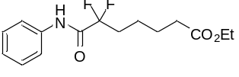
ethyl 6,6-difluoro-7-oxo-7-(phenylamino)heptanoate (19): Following the general procedure A, obtained in 85% yield as colorless oil after silica gel chromatography. (52.6 mg, eluent: petroleum ether/ethyl acetate = 5/1).
¹H NMR (400 MHz, CDCl₃) δ 8.02 (s, 1H), 7.58 (d, J = 8.2 Hz, 2H), 7.37 (t, J = 7.8 Hz, 2H), 7.19 (t, J = 7.4 Hz, 1H), 4.12 (q, J = 7.1 Hz, 2H), 2.33 (t, J = 7.3 Hz, 2H), 2.28 – 2.13 (m, 2H), 1.77 – 1.65 (m, 2H), 1.63 – 1.49 (m, 2H), 1.24 (t, J = 7.1 Hz, 3H).
¹³C NMR (101 MHz, CDCl₃) δ 173.2, 162.0 (t, J = 28.8 Hz), 136.0, 129.2, 125.6, 120.2, 118.2 (t, J = 253.7 Hz), 60.4, 33.9, 33.5 (t, J = 23.3 Hz), 24.4, 21.2 (t, J = 4.4 Hz), 14.2.
¹⁹F NMR (376 MHz, CDCl₃) δ -105.5 (2F, td, J = 17.4, 3.1 Hz).
HRMS (ESI) m/z: [M+Na]⁺ Calcd. for C₁₅H₁₉F₂NO₃Na, 322.1225; found, 322.1231.
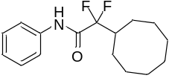
2-cyclooctyl-2,2-difluoro-N-phenylacetamide (20): Following the general procedure A, obtained in 80% yield as white solid after silica gel chromatography. (47.0 mg, eluent: petroleum ether/ethyl acetate = 30/1).
Mp = 52 – 54 ºC
¹H NMR (400 MHz, CDCl₃) δ 8.03 (s, 1H), 7.58 (d, J = 8.0 Hz, 2H), 7.37 (t, J = 7.8 Hz, 2H), 7.19 (t, J = 7.4 Hz, 1H), 2.89 – 2.39 (m, 1H), 1.99 – 1.69 (m, 4H), 1.67 – 1.36 (m, 10H).
¹³C NMR (101 MHz, CDCl₃) δ 162.5 (t, J = 29.1 Hz), 136.1, 129.2, 125.5, 120.23 (t, J = 253.4 Hz), 120.21, 40.6 (t, J = 20.5 Hz), 26.5, 26.2, 25.5 (t, J = 3.7 Hz), 25.4.
¹⁹F NMR (376 MHz, CDCl₃) δ -112.21 (2F, dd, J = 17.5, 2.1 Hz).
HRMS (ESI) m/z: [M+H]⁺ Calcd. for C₁₆H₂₂F₂NO, 282.1664; found, 282.1670.
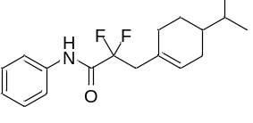
2,2-difluoro-3-(4-isopropylcyclohex-1-en-1-yl)-N-phenylpropanamide (21): Following the general procedure A, obtained in 87% yield as white solid after silica gel chromatography. (53.5 mg, eluent: petroleum ether/ethyl acetate = 30/1). The compound data was in agreement with the literature (Science 2021, 371, 1232−1240).
¹H NMR (400 MHz, CDCl₃) δ 7.95 (s, 1H), 7.54 (d, J = 7.9 Hz, 2H), 7.36 (t, J = 7.9 Hz, 2H), 7.19 (t, J = 7.4 Hz, 1H), 5.67 (s, 1H), 2.82 (t, J = 17.5 Hz, 2H), 2.23 – 1.94 (m, 3H), 1.87 – 1.67 (m, 2H), 1.44 (dd, J = 13.1, 6.5 Hz, 1H), 1.35 – 1.08 (m, 2H), 0.85 (t, J = 6.5 Hz, 6H).
¹³C NMR (101 MHz, CDCl₃) δ 162.2 (t, J = 28.6 Hz), 136.0, 129.2, 129.1, 128.1, 125.6, 120.3, 117.7 (t, J = 249.5 Hz), 41.7 (t, J = 23.2 Hz), 39.5, 32.1, 30.1, 29.2, 26.4, 19.9, 19.6.
¹⁹F NMR (376 MHz, CDCl₃) δ -103.9 (2F, td, J = 17.4, 2.5 Hz).
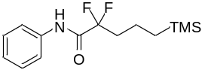
2,2-difluoro-N-phenyl-5-(trimethylsilyl)pentanamide (22): Following the general procedure A, obtained in 85% yield as colorless oil after silica gel chromatography. (48.3 mg, eluent: petroleum ether/ethyl acetate = 30/1).
¹H NMR (400 MHz, CDCl₃) δ 8.21 (s, 1H), 7.73 (d, J = 7.8 Hz, 2H), 7.52 (t, J = 7.9 Hz, 2H), 7.34 (t, J = 7.4 Hz, 1H), 2.46 – 2.21 (m, 2H), 1.87 – 1.57 (m, 2H), 0.84 – 0.59 (m, 2H), 0.15 (s, 9H).
¹³C NMR (101 MHz, CDCl₃) δ 164.3 (t, J = 28.8 Hz), 138.1, 131.2, 127.6, 122.3, 120.2 (t, J = 253.4 Hz), 39.5 (t, J = 22.7 Hz), 18.5, 18.3 (t, J = 4.5 Hz), 0.3.
¹⁹F NMR (376 MHz, CDCl₃) δ -105.5 (2F, td, J = 17.5, 3.0 Hz).
HRMS (ESI) m/z: [M+H]⁺ Calcd. for C₁₄H₂₂F₂NOSi, 286.1433; found, 286.1432.
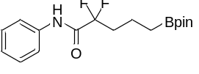
2,2-difluoro-N-phenyl-5-(4,4,5,5-tetramethyl-1,3,2-dioxaborolan-2-yl)pentanamide (23): Following the general procedure A, obtained in 73% yield as colorless oil after silica gel chromatography. (49.5 mg, eluent: petroleum ether/ethyl acetate = 20/1).
¹H NMR (400 MHz, CDCl₃) δ 8.02 (s, 1H), 7.58 (d, J = 7.8 Hz, 2H), 7.37 (t, J = 7.2 Hz, 2H), 7.19 (t, J = 7.4 Hz, 1H), 2.37 – 2.10 (m, 2H), 1.64 (dt, J = 15.7, 7.8 Hz, 2H), 1.24 (s, 12H), 0.86 (t, J = 7.7 Hz, 2H).
¹³C NMR (101 MHz, CDCl₃) δ 162.2 (t, J = 28.6 Hz), 136.1, 129.2, 125.5, 120.2, 118.3 (t, J = 253.3 Hz), 83.2, 36.0 (t, J = 22.9 Hz), 24.8, 16.3 (t, J = 4.6 Hz), 10.8.
¹⁹F NMR (376 MHz, CDCl₃) δ -105.3 (2F, td, J = 17.4, 3.0 Hz).
HRMS (ESI) m/z: [M+Na]⁺ Calcd. for C₁₇H₂₄BF₂NO₃Na, 362.1710; found, 362.1705.
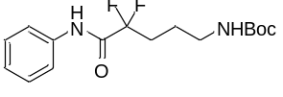
tert-butyl (4,4-difluoro-5-oxo-5-(phenylamino)pentyl)carbamate (24): Following the general procedure A, obtained in 83% yield as colorless oil after silica gel chromatography. (54.5 mg, eluent: petroleum ether/ethyl acetate = 5/1).
¹H NMR (400 MHz, CDCl₃) δ 8.11 (s, 1H), 7.58 (d, J = 7.8 Hz, 2H), 7.36 (t, J = 7.4 Hz, 2H), 7.19 (t, J = 7.3 Hz, 1H), 4.66 (s, 1H), 3.19 (d, J = 4.9 Hz, 2H), 2.50 – 2.02 (m, 2H), 1.84 – 1.67 (m, 2H), 1.43 (s, 9H).
¹³C NMR (101 MHz, CDCl₃) δ 161.9 (t, J = 28.7 Hz), 155.9, 136.0, 129.2, 125.6, 120.3, 118.1 (t, J = 253.7 Hz), 79.4, 39.8, 31.1 (t, J = 23.7 Hz), 28.4, 22.5.
¹⁹F NMR (376 MHz, CDCl₃) δ -105.3 (2F, t, J = 17.2 Hz).
HRMS (ESI) m/z: [M+Na]⁺ Calcd. for C₁₆H₂₂F₂N₂O₅Na, 351.1491; found, 351.1500.
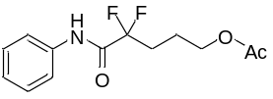
4,4-difluoro-5-oxo-5-(phenylamino)pentyl acetate (25): Following the general procedure A, obtained in 72% yield as colorless oil after silica gel chromatography. (39.1 mg, eluent: petroleum ether/ethyl acetate = 5/1).
¹H NMR (400 MHz, CDCl₃) δ 8.05 (s, 1H), 7.58 (d, J = 7.9 Hz, 2H), 7.37 (t, J = 7.9 Hz, 2H), 7.20 (t, J = 7.4 Hz, 1H), 4.13 (t, J = 6.4 Hz, 2H), 2.39 – 2.19 (m, 2H), 2.06 (s, 3H), 1.98 – 1.82 (m, 2H).
¹³C NMR (101 MHz, CDCl₃) δ 171.0, 161.8 (t, J = 28.7 Hz), 136.0, 129.3, 125.7, 120.2, 118.0 (t, J = 253.9 Hz), 63.2, 30.6 (t, J = 23.7 Hz), 21.1 (t, J = 4.4 Hz), 20.9.
¹⁹F NMR (376 MHz, CDCl₃) δ -105.7 (2F, td, J = 17.4, 2.6 Hz).
HRMS (ESI) m/z: [M+Na]⁺ Calcd. for C₁₃H₁₅F₂NO₃Na, 294.0912; found, 294.0919.
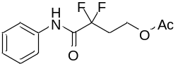
3,3-difluoro-4-oxo-4-(phenylamino)butyl acetate (26): Following the general procedure A, obtained in 69% yield as colorless oil after silica gel chromatography. (35.5 mg, eluent: petroleum ether/ethyl acetate = 5/1).
¹H NMR (400 MHz, CDCl₃) δ 8.06 (s, 1H), 7.59 (d, J = 7.6 Hz, 2H), 7.37 (t, J = 8.0 Hz, 2H), 7.20 (t, J = 7.4 Hz, 1H), 4.33 (t, J = 6.3 Hz, 2H), 2.68 – 2.49 (m, 2H), 1.97 (s, 3H).
¹³C NMR (101 MHz, CDCl₃) δ 170.7, 161.5 (t, J = 28.1 Hz), 136.0, 129.3, 125.6, 120.2, 117.5 (t, J = 253.7 Hz), 57.5 (t, J = 5.9 Hz), 33.2 (t, J = 23.8 Hz), 20.7.
¹⁹F NMR (376 MHz, CDCl₃) δ -105.5 (2F, td, J = 17.5, 3.0 Hz).
HRMS (ESI) m/z: [M+Na]⁺ Calcd. for C₁₂H₁₃F₂NO₃Na, 280.0756; found, 280.0763.
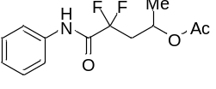
4,4-difluoro-5-oxo-5-(phenylamino)pentan-2-yl acetate (27): Following the general procedure A, obtained in 58% yield as colorless oil after silica gel chromatography. (31.4 mg, eluent: petroleum ether/ethyl acetate = 5/1).
¹H NMR (400 MHz, CDCl₃) δ 8.13 (s, 1H), 7.59 (d, J = 8.0 Hz, 2H), 7.36 (t, J = 7.9 Hz, 2H), 7.19 (t, J = 7.4 Hz, 1H), 5.27 (ddq, J = 12.6, 6.3, 3.1 Hz, 1H), 2.75 – 2.52 (m, 1H), 2.37 (dtd, J = 17.9, 14.7, 3.3 Hz, 1H), 1.89 (s, 3H), 1.32 (d, J = 6.4 Hz, 3H).
¹³C NMR (101 MHz, CDCl₃) δ 170.5, 161.6 (t, J = 28.1 Hz), 136.1, 129.2, 125.6, 120.1, 116.7 (t, J = 243.9 Hz), 64.9 (t, J = 5.2 Hz), 39.7 (t, J = 23.3 Hz), 21.0, 20.8.
¹⁹F NMR (376 MHz, CDCl₃) δ -102.9 – -105.9 (2F, m).
HRMS (ESI) m/z: [M+Na]⁺ Calcd. for C₁₃H₁₅F₂NO₃Na, 294.0912; found, 294.0913.
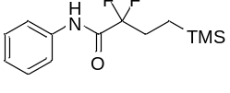
2,2-difluoro-N-phenyl-4-(trimethylsilyl)butanamide (28): Following the general procedure A, obtained in 90% yield as colorless oil after silica gel chromatography. (48.7 mg, eluent: petroleum ether/ethyl acetate = 30/1).
¹H NMR (400 MHz, CDCl₃) δ 8.03 (s, 1H), 7.59 (d, J = 7.9 Hz, 2H), 7.37 (t, J = 7.9 Hz, 2H), 7.19 (t, J = 7.4 Hz, 1H), 2.30 – 2.02 (m, 2H), 0.78 – 0.56 (m, 2H), 0.03 (s, 9H).
¹³C NMR (101 MHz, CDCl₃) δ 164.6 (t, J = 28.9 Hz), 138.4, 131.5, 127.8, 122.5, 121.2 (t, J = 253.7 Hz), 31.0 (t, J = 24.3 Hz), 10.0 (t, J = 2.7 Hz), 0.3.
¹⁹F NMR (376 MHz, CDCl₃) δ -107.1 (2F, td, J = 16.7, 2.9 Hz).
HRMS (ESI) m/z: [M+Na]⁺ Calcd. for C₁₃H₁₉F₂NOSiNa, 294.1096; found, 294.1100.
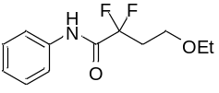
4-ethoxy-2,2-difluoro-N-phenylbutanamide (29): Following the general procedure A, obtained in 76% yield as colorless oil after silica gel chromatography. (36.9 mg, eluent: petroleum ether/ethyl acetate = 5/1).
¹H NMR (400 MHz, CDCl₃) δ 8.06 (s, 1H), 7.57 (d, J = 8.1 Hz, 2H), 7.36 (t, J = 7.0 Hz, 2H), 7.18 (t, J = 7.2 Hz, 1H), 3.66 (t, J = 6.3 Hz, 2H), 3.46 (q, J = 7.0 Hz, 2H), 2.61 – 2.40 (m, 2H), 1.10 (t, J = 7.0 Hz, 3H).
¹³C NMR (101 MHz, CDCl₃) δ 161.9 (t, J = 28.4 Hz), 136.2, 129.2, 125.4, 120.1, 161.8 (t, J = 253.7 Hz), 66.5, 63.6 (t, J = 6.0 Hz), 34.3 (t, J = 23.5 Hz), 14.9.
¹⁹F NMR (376 MHz, CDCl₃) δ -104.4 (2F, td, J = 16.1, 2.8 Hz).
HRMS (ESI) m/z: [M+Na]⁺ Calcd. for C₁₂H₁₅F₂NO₂Na, 266.0963; found, 266.0970.
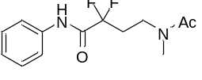
2,2-difluoro-4-(N-methylacetamido)-N-phenylbutanamide (30): Following the general procedure A, obtained in 85% yield as colorless oil after silica gel chromatography. (45.9 mg, eluent: petroleum ether/ethyl acetate = 5/1).
¹H NMR (400 MHz, CDCl₃) δ 8.96 (s, 1H), 7.66 (dd, J = 8.6, 1.0 Hz, 2H), 7.39 – 7.32 (m, 2H), 7.17 (t, J = 7.4 Hz, 1H), 3.65 (t, J = 6.5 Hz, 2H), 3.01 (s, 3H), 2.51 – 2.30 (m, 2H), 2.00 (s, 3H).
¹³C NMR (101 MHz, CDCl₃) δ 171.5, 161.8 (t, J = 28.5 Hz), 136.5, 129.1, 125.3, 120.4, 117.3 (t, J = 253.7 Hz), 41.2 (t, J = 5.6 Hz), 36.0, 31.4 (t, J = 23.7 Hz), 21.8.
¹⁹F NMR (376 MHz, CDCl₃) δ -104.7 (2F, td, J = 16.0, 1.9 Hz).
HRMS (ESI) m/z: [M+Na]⁺ Calcd. for C₁₃H₁₆F₂N₂O₂Na, 293.1072; found, 293.1075.
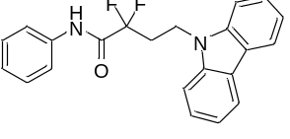
4-(9H-carbazol-9-yl)-2,2-difluoro-N-phenylbutanamide (31): Following the general procedure A, obtained in 73% yield as white solid after silica gel chromatography. (53.1 mg, eluent: petroleum ether/ethyl acetate = 10/1).
Mp = 155 – 157 ºC
¹H NMR (400 MHz, CDCl₃) δ 8.07 (d, J = 7.7 Hz, 2H), 7.88 (s, 1H), 7.54 – 7.41 (m, 6H), 7.36 (t, J = 8.0 Hz, 2H), 7.26 – 7.17 (m, 3H), 4.69 – 4.60 (m, 2H), 2.91 – 2.61 (m, 2H).
¹³C NMR (101 MHz, CDCl₃) δ 161.2 (t, J = 27.9 Hz), 139.8, 135.7, 129.2, 125.9, 125.8, 123.2, 120.5, 120.3, 119.4, 117.2 (t, J = 254.8 Hz), 108.4, 36.2 (t, J = 5.8 Hz), 32.6 (t, J = 23.0 Hz).
¹⁹F NMR (376 MHz, CDCl₃) δ -104.64 (2F, td, J = 17.0, 2.8 Hz).
HRMS (ESI) m/z: [M+H]⁺ Calcd. for C₂₂H₁₉F₂N₂O, 365.1460; found, 365.1460.
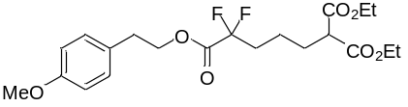
1,1-diethyl 5-(4-methoxyphenethyl) 5,5-difluoropentane-1,1,5-tricarboxylate (32): Following the general procedure B, obtained in 86% yield as colorless oil after silica gel chromatography. (73.9 mg, eluent: petroleum ether/ethyl acetate = 20/1).
¹H NMR (400 MHz, CDCl₃) δ 7.14 (d, J = 8.5 Hz, 2H), 6.85 (d, J = 8.5 Hz, 2H), 4.42 (t, J = 7.0 Hz, 2H), 4.20 (q, J = 7.0 Hz, 4H), 3.79 (s, 3H), 3.29 (t, J = 7.5 Hz, 1H), 2.95 (t, J = 7.0 Hz, 2H), 2.12 – 1.96 (m, 2H), 1.91 (dd, J = 15.8, 7.7 Hz, 2H), 1.60 – 1.37 (m, 2H), 1.27 (t, J = 7.1 Hz, 6H).
¹³C NMR (101 MHz, CDCl₃) δ 169.0, 164.0 (t, J = 33.0 Hz), 158.5, 129.9, 128.7, 115.9 (t, J = 250.4 Hz), 114.0, 67.2, 61.5, 55.2, 51.6, 34.1 (t, J = 23.4 Hz), 33.9, 28.0, 19.4 (t, J = 4.4 Hz), 14.0.
¹⁹F NMR (376 MHz, CDCl₃) δ -106.0 (2F, t, J = 16.7 Hz).
HRMS (ESI) m/z: [M+H]⁺ Calcd. for C₂₁H₂₉F₂O₇, 431.1876; found, 431.1875.
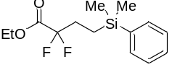
ethyl 4-(dimethyl(phenyl)silyl)-2,2-difluorobutanoate (33): Following the general procedure B, obtained in 83% yield as colorless oil after silica gel chromatography. (47.5 mg, eluent: petroleum ether).
¹H NMR (400 MHz, CDCl₃) δ 7.46 – 7.36 (m, 2H), 7.35 – 7.22 (m, 3H), 4.22 (q, J = 7.1 Hz, 2H), 2.10 – 1.74 (m, 2H), 1.25 (t, J = 7.1 Hz, 3H), 0.94 – 0.70 (m, 2H), 0.23 (s, 6H).
¹³C NMR (101 MHz, CDCl₃) δ 164.4 (t, J = 33.2 Hz), 137.6, 133.5, 129.3, 127.9, 116.8 (t, J = 250.2 Hz), 62.7, 29.4 (t, J = 24.3 Hz), 13.9, 6.9 (t, J = 2.6 Hz), -3.4.
¹⁹F NMR (376 MHz, CDCl₃) δ -107.4 (2F, t, J = 16.1 Hz).
HRMS (ESI) m/z: [M+Na]⁺ Calcd. for C₁₄H₂₀F₂O₂Si, 309.1093; found, 309.1090.
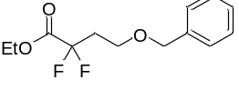
ethyl 4-(benzyloxy)-2,2-difluorobutanoate (34): Following the general procedure B, obtained in 85% yield as colorless oil after silica gel chromatography. (43.9 mg, eluent: petroleum ether/ethyl acetate = 30/1).
¹H NMR (400 MHz, CDCl₃) δ 7.38 – 7.26 (m, 5H), 4.46 (s, 2H), 4.17 (q, J = 7.1 Hz, 2H), 3.65 (t, J = 6.1 Hz, 2H), 2.52 – 2.33 (m, 2H), 1.24 (t, J = 7.2 Hz, 3H).
¹³C NMR (101 MHz, CDCl₃) δ 164.0 (t, J = 34.1 Hz), 137.7, 128.4, 127.8, 127.7, 115.3 (t, J = 249.9 Hz), 73.3, 63.4 (t, J = 6.3 Hz), 62.7, 35.3 (t, J = 23.6 Hz), 13.8.
¹⁹F NMR (376 MHz, CDCl₃) δ -105.7 (2F, t, J = 15.3 Hz).
HRMS (ESI) m/z: [M+Na]⁺ Calcd. for C₁₃H₁₆F₂O₃Si, 281.0960; found, 281.0969.
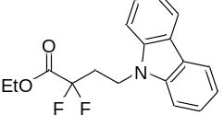
ethyl 4-(9H-carbazol-9-yl)-2,2-difluorobutanoate (35): Following the general procedure B, obtained in 89% yield as colorless oil after silica gel chromatography. (56.4 mg, eluent: petroleum ether/ethyl acetate = 30/1).
¹H NMR (400 MHz, CDCl₃) δ 8.07 (d, J = 7.8 Hz, 2H), 7.47 (ddd, J = 8.2, 7.1, 1.2 Hz, 2H), 7.38 (d, J = 8.2 Hz, 2H), 7.31 – 7.20 (m, 2H), 4.65 – 4.39 (m, 2H), 4.12 (q, J = 7.1 Hz, 2H), 2.83 – 2.43 (m, 2H), 1.20 (t, J = 7.2 Hz, 3H).
¹³C NMR (101 MHz, CDCl₃) δ 163.4 (t, J = 32.3 Hz), 139.8, 126.0, 123.2, 120.6, 119.5, 115.1 (t, J = 250.9 Hz), 108.4, 63.2, 35.9 (t, J = 5.9 Hz), 33.3 (t, J = 23.2 Hz), 13.8.
¹⁹F NMR (376 MHz, CDCl₃) δ -105.9 (2F, t, J = 16.6 Hz).
HRMS (ESI) m/z: [M+H]⁺ Calcd. for C₁₈H₁₈F₂NO₂, 318.1300; found, 318.1313.
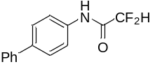
N-([1,1'-biphenyl]-4-yl)-2,2-difluoroacetamide (36): Following the general procedure C, obtained in 80% yield as white solid after silica gel chromatography. (39.4 mg, eluent: petroleum ether/ethyl acetate = 10/1).
Mp = 163 – 165 ºC
¹H NMR (400 MHz, d₆-DMSO) δ 10.85 (s, 1H), 7.83 – 7.75 (m, 2H), 7.73 – 7.62 (m, 4H), 7.52 – 7.42 (m, 2H), 7.41 – 7.31 (m, 1H), 6.42 (t, J = 53.7 Hz, 1H).
¹³C NMR (101 MHz, d₆-DMSO) δ 165.8 (t, J = 25.9 Hz), 144.6, 141.9, 141.6, 134.2, 132.5, 132.3, 131.6, 125.8, 113.6 (t, J = 246.6 Hz).
¹⁹F NMR (376 MHz, d₆-DMSO) δ -125.1 (2F, d, J = 53.6 Hz).
HRMS (ESI) m/z: [M+Na]⁺ Calcd. for C₁₄H₁₁F₂NONa, 270.0701; found, 270.0707.
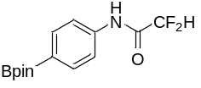
2,2-difluoro-N-(4-(4,4,5,5-tetramethyl-1,3,2-dioxaborolan-2-yl)phenyl)acetamide (37): Following the general procedure C, obtained in 75% yield as colorless oil after silica gel chromatography. (44.5 mg, eluent: petroleum ether/ethyl acetate = 10/1).
¹H NMR (400 MHz, CDCl₃) δ 8.00 (s, 1H), 7.82 (d, J = 8.5 Hz, 2H), 7.59 (d, J = 8.5 Hz, 2H), 6.01 (t, J = 54.4 Hz, 1H), 1.34 (s, 12H).
¹³C NMR (101 MHz, CDCl₃) δ 160.3 (t, J = 24.9 Hz), 138.2, 135.9, 119.2, 108.5 (t, J = 254.3 Hz), 83.9, 24.8.
¹⁹F NMR (376 MHz, CDCl₃) δ -125.5 (2F, d, J = 54.3 Hz).
HRMS (ESI) m/z: [M+H]⁺ Calcd. for C₁₄H₁₉BF₂NO₃, 298.1421; found, 298.1415.
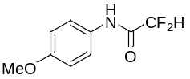
2,2-difluoro-N-(4-methoxyphenyl)acetamide (38): Following the general procedure C, obtained in 90% yield as white solid after silica gel chromatography. (36.2 mg, eluent: petroleum ether/ethyl acetate = 15/1). The compound data was in agreement with the literature (Science 2021, 371, 1232−1240).
¹H NMR (400 MHz, CDCl₃) δ 7.93 (s, 1H), 7.47 (d, J = 8.9 Hz, 2H), 6.89 (d, J = 9.0 Hz, 2H), 6.01 (t, J = 54.4 Hz, 1H), 3.80 (s, 3H).
¹³C NMR (101 MHz, CDCl₃) δ 160.2 (t, J = 24.4 Hz), 157.4, 128.6, 122.2, 114.4, 108.6 (t, J = 253.8 Hz), 55.5.
¹⁹F NMR (376 MHz, CDCl₃) δ -125.5 (2F, dd, J = 54.4, 2.0 Hz).
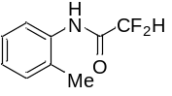
2,2-difluoro-N-(o-tolyl)acetamide (39): Following the general procedure C, obtained in 83% yield as white solid after silica gel chromatography. (30.7 mg, eluent: petroleum ether/ethyl acetate = 15/1).
Mp = 64 – 66 ºC
¹H NMR (400 MHz, CDCl₃) δ 7.83 (d, J = 7.9 Hz, 1H), 7.77 (s, 1H), 7.25 – 7.20 (m, 2H), 7.16 (t, J = 7.4 Hz, 1H), 6.04 (t, J = 54.4 Hz, 1H), 2.29 (s, 3H).
¹³C NMR (101 MHz, CDCl₃) δ 160.4 (t, J = 24.2 Hz), 133.4, 130.8, 129.5, 127.1, 126.5, 122.9, 108.8 (t, J = 254.0 Hz), 17.4.
¹⁹F NMR (376 MHz, CDCl₃) δ -125.4 (2F, dd, J = 54.4, 2.5 Hz).
HRMS (ESI) m/z: [M+H]⁺ Calcd. for C₉H₁₀F₂NO, 186.0725; found, 186.0721.
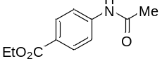
ethyl 4-acetamidobenzoate (40): Following the general procedure C, obtained in 96% yield as white solid after silica gel chromatography. (39.8 mg, eluent: petroleum ether/ethyl acetate = 1/1). The compound data was in agreement with the literature (Angew. Chem., Int. Ed. 2016, 55, 3823−3827).
¹H NMR (400 MHz, CDCl₃) δ 7.99 (d, J = 8.5 Hz, 2H), 7.94 (s, 1H), 7.61 (d, J = 8.3 Hz, 2H), 4.36 (q, J = 7.1 Hz, 2H), 2.20 (s, 3H), 1.38 (t, J = 7.1 Hz, 3H).
¹³C NMR (101 MHz, CDCl₃) δ 168.8, 166.3, 142.2, 130.7, 125.8, 118.8, 60.9, 24.7, 14.3.
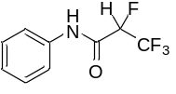
2,3,3,3-tetrafluoro-N-phenylpropanamide (41): Following the general procedure C, obtained in 90% yield as white solid after silica gel chromatography. (39.8 mg, eluent: petroleum ether/ethyl acetate = 15/1). The compound data was in agreement with the literature (Science 2021, 371, 1232−1240).
¹H NMR (400 MHz, CDCl₃) δ 7.96 (s, 1H), 7.57 (dd, J = 8.5, 1.0 Hz, 2H), 7.39 (dd, J = 10.8, 5.1 Hz, 2H), 7.22 (t, J = 7.4 Hz, 1H), 5.21 (dq, J = 46.5, 6.4 Hz, 1H).
¹³C NMR (101 MHz, CDCl₃) δ 158.9 (d, J = 18.2 Hz), 135.7, 129.3, 125.9, 120.5 (qd, J = 280.4, 25.7 Hz), 120.3, 85.7 (dq, J = 205.4, 34.0 Hz).
¹⁹F NMR (376 MHz, CDCl₃) δ -75.7 (3F, d, J = 11.0 Hz), -200.1 (1F, q, J = 11.0 Hz).
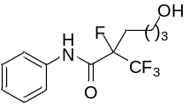
2-fluoro-6-hydroxy-N-phenyl-2-(trifluoromethyl)hexanamide (43): Following the general procedure C, obtained in 80% yield as white solid after silica gel chromatography. (46.9 mg, eluent: petroleum ether/ethyl acetate = 1/1).
Mp = 65– 67 ºC
¹H NMR (400 MHz, CDCl₃) δ 8.16 (s, 1H), 7.57 (dd, J = 8.5, 0.9 Hz, 2H), 7.37 (t, J = 8.0 Hz, 2H), 7.20 (t, J = 7.4 Hz, 1H), 3.65 (td, J = 6.1, 1.6 Hz, 2H), 2.53 – 2.27 (m, 1H), 2.16 – 2.00 (m, 1H), 1.70 (s, 1H), 1.68 – 1.57 (m, 3H), 1.56 – 1.41 (m, 1H).
¹³C NMR (101 MHz, CDCl₃) δ 162.1 (d, J = 19.5 Hz), 136.0, 129.2, 125.7, 121.8 (qd, J = 285.1, 28.5 Hz), 120.5, 95.9 (dq, J = 202.7, 30.3 Hz), 61.8, 31.9, 30.12 (d, J = 20.2 Hz), 18.5 (d, J = 2.5 Hz).
¹⁹F NMR (376 MHz, CDCl₃) δ -78.3 (3F, d, J = 6.7 Hz), -169.8 – -183.4 (1F, m).
HRMS (ESI) m/z: [M+H]⁺ Calcd. for C₁₃H₁₆F₄NO₂, 294.1112; found, 294.1116.
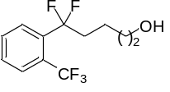
5,5-difluoro-5-(2-(trifluoromethyl)phenyl)pentan-1-ol (44): Following the general procedure D, obtained in 81% yield as colorless oil after silica gel chromatography. (43.4 mg, eluent: petroleum ether/ethyl acetate = 2/1). The compound data was in agreement with the literature (J. Am. Chem. Soc. 2018, 140, 163−166).
¹H NMR (400 MHz, CDCl₃) δ 7.78 (d, J = 7.9 Hz, 1H), 7.67 – 7.56 (m, 2H), 7.52 (t, J = 7.3 Hz, 1H), 3.63 (t, J = 6.1 Hz, 2H), 2.40 – 2.10 (m, 2H), 1.96 (s, 1H), 1.70 – 1.55 (m, 4H).
¹³C NMR (101 MHz, CDCl₃) δ 136.1 (t, J = 28.0 Hz), 131.8, 129.8, 128.1 (t, J = 9.1 Hz), 127.5 (q, J = 6.5 Hz), 127.1 (q, J = 32.4 Hz), 123.6 (q, J = 273.5 Hz), 122.5 (t, J = 244.8 Hz), 62.5, 39.3 (t, J = 26.9 Hz), 32.1, 18.7 (t, J = 3.6 Hz).
¹⁹F NMR (376 MHz, CDCl₃) δ -57.7 (3F, t, J = 16.1 Hz), -93.3 (2F, h, J = 16.5 Hz).
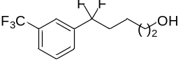
5,5-difluoro-5-(3-(trifluoromethyl)phenyl)pentan-1-ol (45): Following the general procedure D, obtained in 80% yield as colorless oil after silica gel chromatography. (42.9 mg, eluent: petroleum ether/ethyl acetate = 2/1). The compound data was in agreement with the literature (J. Am. Chem. Soc. 2018, 140, 163−166).
¹H NMR (400 MHz, CDCl₃) δ 7.63 (s, 1H), 7.60 – 7.51 (m, 2H), 7.44 (t, J = 7.8 Hz, 1H), 3.49 (t, J = 6.1 Hz, 2H), 2.37 – 1.74 (m, 2H), 1.72 – 1.19 (m, 4H).
¹³C NMR (101 MHz, CDCl₃) δ 138.4 (t, J = 27.5 Hz), 130.9 (q, J = 32.7 Hz), 129.1, 128.4 (t, J = 5.6 Hz), 126.7 – 126.4 (m), 123.8 (q, J = 272.3 Hz), 122.3 (t, J = 242.8 Hz), 122.1 – 121.7 (m), 62.1, 38.7 (t, J = 27.2 Hz), 31.9, 18.8 (t, J = 4.1 Hz).
¹⁹F NMR (376 MHz, CDCl₃) δ -62.8 (3F, s), -96.2 (2F, t, J = 16.4 Hz).
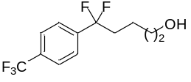
5,5-difluoro-5-(4-(trifluoromethyl)phenyl)pentan-1-ol (46): Following the general procedure D, obtained in 78% yield as colorless oil after silica gel chromatography. (41.8 mg, eluent: petroleum ether/ethyl acetate = 2/1). The compound data was in agreement with the literature (J. Am. Chem. Soc. 2018, 140, 163−166).
¹H NMR (400 MHz, CDCl₃) δ 7.68 (d, J = 8.1 Hz, 2H), 7.59 (d, J = 8.1 Hz, 2H), 3.60 (t, J = 6.1 Hz, 2H), 2.30 – 2.00 (m, 2H), 1.80 – 1.38 (m, 4H).
¹³C NMR (101 MHz, CDCl₃) δ 140.9 (t, J = 27.4 Hz), 131.8 (q, J = 32.7 Hz), 125.7 – 125.4 (m, 2xC), 123.8 (q, J = 272.3 Hz), 122.4 (t, J = 242.9 Hz), 62.2, 38.7 (t, J = 27.1 Hz), 31.9, 18.9 (t, J = 4.1 Hz).
¹⁹F NMR (376 MHz, CDCl₃) δ -62.9 (3F, s), -96.5 (2F, t, J = 16.3 Hz).
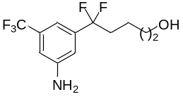
5-(3-amino-5-(trifluoromethyl)phenyl)-5,5-difluoropentan-1-ol (47): Following the general procedure D, obtained in 88% yield as yellow oil after silica gel chromatography. (49.8 mg, eluent: petroleum ether/ethyl acetate = 2/1).
¹H NMR (400 MHz, CDCl₃) δ 7.05 (s, 1H), 6.92 (s, 1H), 6.90 (s, 1H), 3.62 (t, J = 6.2 Hz, 2H), 3.12 (s, 2H), 2.20 – 2.02 (m, 2H), 1.74 – 1.40 (m, 4H).
¹³C NMR (101 MHz, CDCl₃) δ 146.9, 139.5 (t, J = 27.1 Hz), 132.0 (q, J = 32.4 Hz), 123.8 (q, J = 272.5 Hz), 122.4 (t, J = 243.0 Hz), 114.4 (t, J = 5.9 Hz), 112.6 – 112.3 (m), 111.8 – 111.3 (m), 62.4, 38.6 (t, J = 27.3 Hz), 32.1, 18.9 (t, J = 4.1 Hz).
¹⁹F NMR (376 MHz, CDCl₃) δ -62.9 (3F, s), -96.1 (2F, t, J = 16.3 Hz).
HRMS (ESI) m/z: [M+Na]⁺ Calcd. for C₁₂H₁₄F₅NONa, 306.0888; found, 306.0894.
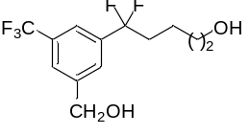
5,5-difluoro-5-(3-(hydroxymethyl)-5-(trifluoromethyl)phenyl)pentan-1-ol (48): Following the general procedure D, obtained in 85% yield as colorless oil after silica gel chromatography. (50.6 mg, eluent: petroleum ether/ethyl acetate = 2/1).
¹H NMR (400 MHz, CDCl₃) δ 7.67 (s, 1H), 7.64 (d, J = 7.0 Hz, 2H), 4.77 (s, 2H), 3.60 (t, J = 5.9 Hz, 2H), 2.26 (s, 1H), 2.21 – 2.07 (m, 2H), 1.62 – 1.40 (m, 4H).
¹³C NMR (101 MHz, CDCl₃) δ 142.6, 138.6 (t, J = 27.5 Hz), 131.3 (q, J = 32.7 Hz), 126.6 (t, J = 5.6 Hz), 124.9 – 124.5 (m), 123.7 (q, J = 272.5 Hz), 122.4 (t, J = 243.0 Hz), 121.3 – 120.7 (m), 63.9, 62.3, 38.6 (t, J = 27.1 Hz), 31.9, 18.9 (t, J = 4.1 Hz).
¹⁹F NMR (376 MHz, CDCl₃) δ -62.7 (3F, s), -95.7 (2F, t, J = 16.3 Hz).
HRMS (ESI) m/z: [M+Na]⁺ Calcd. for C₁₃H₁₅F₅O₂Na, 321.0884; found, 321.0893.
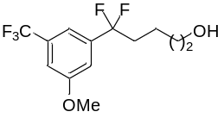
5,5-difluoro-5-(3-methoxy-5-(trifluoromethyl)phenyl)pentan-1-ol (49): Following the general procedure D, obtained in 73% yield as colorless oil after silica gel chromatography. (43.5 mg, eluent: petroleum ether/ethyl acetate = 5/1).
¹H NMR (400 MHz, CDCl₃) δ 7.30 (s, 1H), 7.17 (s, 2H), 3.88 (s, 3H), 3.64 (t, J = 6.1 Hz, 2H), 2.20 – 2.02 (m, 2H), 1.77 – 1.11 (m, 4H).
¹³C NMR (101 MHz, CDCl₃) δ 159.9, 139.9 (t, J = 27.5 Hz), 132.3 (q, J = 32.7 Hz), 123.5 (q, J = 272.6 Hz), 122.1 (t, J = 243.3 Hz), 114.4 (t, J = 5.8 Hz), 114.3 – 113.5 (m), 112.1– 111.7 (m), 62.4, 55.7, 38.7 (t, J = 27.2 Hz), 32.1, 18.9 (t, J = 4.1 Hz).
¹⁹F NMR (376 MHz, CDCl₃) δ -62.8 (3F, s), -96.1 (2F, t, J = 16.4 Hz).
HRMS (ESI) m/z: [M+Na]⁺ Calcd. for C₁₃H₁₅F₅O₂Na, 321.0884; found, 321.0880.
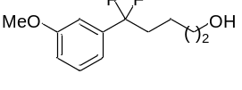
5,5-difluoro-5-(3-methoxyphenyl)pentan-1-ol (50): Following the general procedure D, obtained in 50% yield as colorless oil after silica gel chromatography. (23.0 mg, eluent: petroleum ether/ethyl acetate = 5/1).
¹H NMR (400 MHz, CDCl₃) δ 7.33 (t, J = 7.9 Hz, 1H), 7.04 (d, J = 7.6 Hz, 1H), 6.99 (s, 1H), 6.95 (d, J = 8.2 Hz, 1H), 3.83 (s, 3H), 3.63 (t, J = 6.2 Hz, 2H), 2.45 – 1.98 (m, 2H), 1.65 – 1.56 (m, 2H), 1.55 – 1.47 (m, 2H).
¹³C NMR (101 MHz, CDCl₃) δ 159.6, 138.8 (t, J = 26.6 Hz), 129.6, 122.8 (t, J = 242.5 Hz), 117.2 (t, J = 6.2 Hz), 115.1, 110.7 (t, J = 6.6 Hz), 62.5, 55.4, 38.8 (t, J = 27.6 Hz), 32.2, 19.0 (t, J = 4.2 Hz).
¹⁹F NMR (376 MHz, CDCl₃) δ -95.4 (2F, t, J = 16.1 Hz).
HRMS (ESI) m/z: [M+Na]⁺ Calcd. for C₁₂H₁₆F₂O₂Na, 253.1011; found, 253.1009.
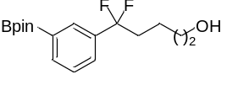
5,5-difluoro-5-(3-(4,4,5,5-tetramethyl-1,3,2-dioxaborolan-2-yl)phenyl)pentan-1-ol (51): Following the general procedure D, obtained in 78% yield as colorless oil after silica gel chromatography. (50.9 mg, eluent: petroleum ether/ethyl acetate = 2/1).
¹H NMR (400 MHz, CDCl₃) δ 7.88 (s, 1H), 7.84 (d, J = 7.3 Hz, 1H), 7.55 (d, J = 7.7 Hz, 1H), 7.41 (t, J = 7.5 Hz, 1H), 3.60 (t, J = 6.1 Hz, 2H), 2.32 – 2.04 (m, 2H), 1.69 – 1.41 (m, 4H), 1.34 (s, 12H).
¹³C NMR (101 MHz, CDCl₃) δ 136.7 (t, J = 26.5 Hz), 136.0, 131.1 (t, J = 6.0 Hz), 127.8, 127.7 (t, J = 6.0 Hz), 123.1 (t, J = 242.3 Hz), 84.1, 62.4, 38.9 (t, J = 27.5 Hz), 32.2, 24.9, 18.9 (t, J = 4.1 Hz).
¹⁹F NMR (376 MHz, CDCl₃) δ -95.6 (2F, t, J = 16.3 Hz).
HRMS (ESI) m/z: [M+Na]⁺ Calcd. for C₁₇H₂₅BF₂O₃Na, 349.1757; found, 349.1787.
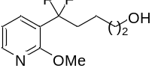
5,5-difluoro-5-(2-methoxypyridin-3-yl)pentan-1-ol (52): Following the general procedure D, obtained in 90% yield as colorless oil after silica gel chromatography. (41.6 mg, eluent: petroleum ether/ethyl acetate = 2/1).
¹H NMR (400 MHz, CDCl₃) δ 8.22 (d, J = 4.5 Hz, 1H), 7.78 (d, J = 7.4 Hz, 1H), 6.94 (dd, J = 7.4, 5.0 Hz, 1H), 4.00 (s, 3H), 3.63 (t, J = 6.4 Hz, 2H), 2.51 – 2.11 (m, 2H), 1.66 – 1.55 (m, 2H), 1.51 – 1.37 (m, 2H).
¹³C NMR (101 MHz, CDCl₃) δ 160.5 (t, J = 4.4 Hz), 148.3, 135.8 (t, J = 8.3 Hz), 121.8 (t, J = 227.8 Hz), 119.4 (t, J = 27.4 Hz), 116.4, 62.5, 53.7, 36.1 (t, J = 26.1 Hz), 32.2, 19.0 (t, J = 4.2 Hz).
¹⁹F NMR (376 MHz, CDCl₃) δ -96.3 (2F, t, J = 16.9 Hz).
HRMS (ESI) m/z: [M+H]⁺ Calcd. for C₁₁H₁₆F₂NO₂, 232.1144; found, 232.1147.
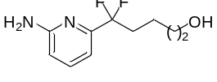
5-(6-aminopyridin-2-yl)-5,5-difluoropentan-1-ol (53): Following the general procedure D, obtained in 57% yield as colorless oil after silica gel chromatography. (24.6 mg, eluent: petroleum ether/ethyl acetate = 2/1).
¹H NMR (400 MHz, CDCl₃) δ 7.50 (t, J = 7.8 Hz, 1H), 6.93 (d, J = 7.4 Hz, 1H), 6.53 (d, J = 8.3 Hz, 1H), 4.71 (s, 2H), 3.64 (t, J = 6.2 Hz, 2H), 2.26 (ddd, J = 24.3, 16.4, 7.9 Hz, 2H), 1.60 (dt, J = 12.9, 6.6 Hz, 2H), 1.56 – 1.45 (m, 2H).
¹³C NMR (101 MHz, CDCl₃) δ 158.2, 152.9 (t, J = 28.9 Hz), 138.6, 121.6 (t, J = 241.7 Hz), 109.9, 109.8 (t, J = 5.3 Hz), 62.3, 35.9 (t, J = 25.7 Hz), 32.0, 18.6 (t, J = 4.3 Hz).
¹⁹F NMR (376 MHz, CDCl₃) δ -99.7 (2F, t, J = 16.6 Hz).
HRMS (ESI) m/z: [M+H]⁺ Calcd. for C₁₀H₁₅F₂N₂O, 217.1147; found, 217.1146.
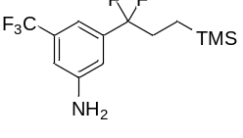
3-(1,1-difluoro-3-(trimethylsilyl)propyl)-5-(trifluoromethyl)aniline (54): Following the general procedure D, obtained in 92% yield as yellow oil after silica gel chromatography. (57.3 mg, eluent: petroleum ether/ethyl acetate = 20/1).
¹H NMR (400 MHz, CDCl₃) δ 7.21 (s, 1H), 7.07 (s, 1H), 7.05 (s, 1H), 3.96 (s, 2H), 2.31 – 1.94 (m, 2H), 0.87 – 0.57 (m, 2H), 0.15 (s, 9H).
¹³C NMR (101 MHz, CDCl₃) δ 149.2, 141.9 (t, J = 27.4 Hz), 134.3 (q, J = 32.3 Hz), 126.1 (q, J = 272.4 Hz), 125.2 (t, J = 243.1 Hz), 116.9 (t, J = 5.9 Hz), 114.7 – 114.5 (m), 114.4 – 113.6 (m), 36.0 (t, J = 28.5 Hz), 10.9 (t, J = 2.6 Hz), 0.2.
¹⁹F NMR (376 MHz, CDCl₃) δ -62.9 (3F, s), -97.9 (2F, t, J = 15.9 Hz).
HRMS (ESI) m/z: [M+H]⁺ Calcd. for C₁₃H₁₉F₅NSi, 312.1201; found, 312.1210.
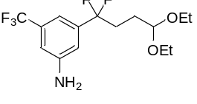
3-(4,4-diethoxy-1,1-difluorobutyl)-5-(trifluoromethyl)aniline (55): Following the general procedure D, obtained in 76% yield as yellow oil after silica gel chromatography. (51.8 mg, eluent: petroleum ether/ethyl acetate = 9/1).
¹H NMR (400 MHz, CDCl₃) δ 7.06 (s, 1H), 6.92 (s, 1H), 6.90 (s, 1H), 4.49 (t, J = 5.6 Hz, 1H), 3.62 (dq, J = 9.4, 7.1 Hz, 2H), 3.47 (dq, J = 9.4, 7.1 Hz, 2H), 2.33 – 1.98 (m, 2H), 1.91 – 1.71 (m, 2H), 1.19 (t, J = 7.1 Hz, 6H).
¹³C NMR (101 MHz, CDCl₃) δ 147.0, 139.4 (t, J = 27.1 Hz), 132.1 (q, J = 32.4 Hz), 123.8 (q, J = 272.4 Hz), 122.3 (t, J = 242.8 Hz), 114.3 (t, J = 6.0 Hz), 112.5 – 112.2 (m), 111.7 – 111.2 (m), 101.8, 61.5, 34.0 (t, J = 27.7 Hz), 26.8 (t, J = 3.7 Hz), 15.3.
¹⁹F NMR (376 MHz, CDCl₃) δ -63.0 (3F, s), -96.4 (2F, t, J = 16.6 Hz).
HRMS (ESI) m/z: [M+Na]⁺ Calcd. for C₁₅H₂₀F₅NO₂Na, 364.1306; found, 364.1313.
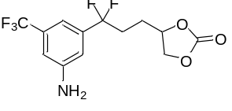
4-(3-(3-amino-5-(trifluoromethyl)phenyl)-3,3-difluoropropyl)-1,3-dioxolan-2-one (56): Following the general procedure D, obtained in 72% yield as yellow oil after silica gel chromatography. (46.8 mg, eluent: petroleum ether/ethyl acetate = 2/1).
¹H NMR (400 MHz, CDCl₃) δ 7.05 (s, 1H), 6.95 (s, 1H), 6.90 (s, 1H), 4.90 – 4.70 (m, 1H), 4.57 (t, J = 8.2 Hz, 1H), 4.25 – 3.97 (m, 1H), 2.48 – 2.11 (m, 2H), 1.96 (dd, J = 14.9, 7.3 Hz, 2H).
¹³C NMR (101 MHz, CDCl₃) δ 154.6, 147.3, 138.7 (t, J = 26.8 Hz), 132.3 (q, J = 32.6 Hz), 123.7 (q, J = 272.2 Hz), 121.5 (t, J = 243.5 Hz), 114.0 (t, J = 5.9 Hz), 112.9 – 112.7 (m), 111.9 – 109.5 (m), 75.9, 69.2, 34.4 (t, J = 28.2 Hz), 27.3 (t, J = 3.6 Hz).
¹⁹F NMR (376 MHz, CDCl₃) δ -63.1 (3F, s), -96.7 (1F, ddd, J = 245.5, 21.0, 11.7 Hz), -97.8 (1F, ddd, J = 245.5, 20.5, 12.6 Hz).
HRMS (ESI) m/z: [M+H]⁺ Calcd. for C₁₃H₁₃F₅NO₃, 326.0810; found, 326.0815.
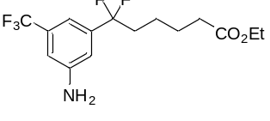
ethyl 6-(3-amino-5-(trifluoromethyl)phenyl)-6,6-difluorohexanoate (57): Following the general procedure D, obtained in 84% yield as yellow oil after silica gel chromatography. (57.0 mg, eluent: petroleum ether/ethyl acetate = 9/1).
¹H NMR (400 MHz, CDCl₃) δ 7.04 (s, 1H), 6.92 (s, 1H), 6.90 (s, 1H), 4.11 (q, J = 7.1 Hz, 2H), 3.63 (s, 2H), 2.30 (t, J = 7.4 Hz, 2H), 2.21 – 1.98 (m, 2H), 1.66 (dt, J = 15.2, 7.5 Hz, 2H), 1.53 – 1.40 (m, 2H), 1.24 (t, J = 7.1 Hz, 3H).
¹³C NMR (101 MHz, CDCl₃) δ 173.4, 146.9, 139.5 (t, J = 27.2 Hz), 132.1 (q, J = 32.4 Hz), 123.8 (q, J = 272.5 Hz), 122.2 (t, J = 243.0 Hz), 114.4 (t, J = 5.9 Hz), 112.8 – 112.2 (m), 111.9 – 111.2 (m), 60.4, 38.6 (t, J = 27.4 Hz), 34.0, 24.5, 21.9 (t, J = 4.0 Hz), 14.2.
¹⁹F NMR (376 MHz, CDCl₃) δ -63.0 (3F, s), -96.2 (2F, t, J = 16.3 Hz).
HRMS (ESI) m/z: [M+Na]⁺ Calcd. for C₁₅H₁₈F₅NO₂Na, 362.1150; found, 362.1150.
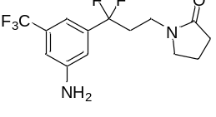
1-(3-(3-amino-5-(trifluoromethyl)phenyl)-3,3-difluoropropyl)pyrrolidin-2-one (58): Following the general procedure D, obtained in 88% yield as yellow oil after silica gel chromatography. (56.7 mg, eluent: petroleum ether/ethyl acetate = 2/1).
¹H NMR (400 MHz, CDCl₃) δ 7.05 (s, 1H), 6.93 (s, 2H), 3.53 – 3.44 (m, 2H), 3.34 (t, J = 7.0 Hz, 2H), 2.46 – 2.34 (m, 2H), 2.34 – 2.28 (m, 2H), 1.95 (dt, J = 15.4, 7.5 Hz, 2H).
¹³C NMR (101 MHz, CDCl₃) δ 175.2, 147.1, 138.7 (t, J = 26.7 Hz), 132.1 (q, J = 32.5 Hz), 123.7 (q, J = 272.6 Hz), 121.3 (t, J = 243.5 Hz), 114.5 (t, J = 6.1 Hz), 112.8 – 112.6 (m), 111.4 – 110.9 (m), 47.3, 36.8 (t, J = 5.0 Hz), 36.1 (t, J = 27.4 Hz), 30.9, 17.9.
¹⁹F NMR (376 MHz, CDCl₃) δ -63.0 (3F, s), -96.1 (2F, t, J = 16.3 Hz).
HRMS (ESI) m/z: [M+H]⁺ Calcd. for C₁₄H₁₆F₅N₂O, 323.1177; found, 323.1183.
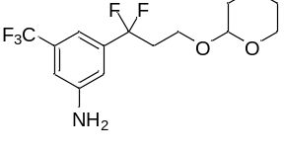
3-(1,1-difluoro-3-((tetrahydro-2H-pyran-2-yl)oxy)propyl)-5-(trifluoromethyl)aniline (59): Following the general procedure D, obtained in 82% yield as yellow oil after silica gel chromatography. (55.6 mg, eluent: petroleum ether/ethyl acetate = 9/1).
¹H NMR (400 MHz, CDCl₃) δ 7.09 (s, 1H), 6.92 (s, 2H), 4.52 (s, 1H), 3.88 (dt, J = 10.2, 6.9 Hz, 1H), 3.77 (ddd, J = 11.1, 7.9, 3.0 Hz, 1H), 3.59 – 3.37 (m, 2H), 2.56 – 2.35 (m, 2H), 1.77 – 1.39 (m, 6H).
¹³C NMR (101 MHz, CDCl₃) δ 147.0, 139.2 (t, J = 26.8 Hz), 132.0 (q, J = 32.4 Hz), 123.8 (q, J = 272.5 Hz), 121.5 (t, J = 243.1 Hz), 114.3 (t, J = 6.3 Hz), 112.5 – 112.3 (m), 112.1 – 111.3 (m), 98.9, 62.2, 61.3 (t, J = 5.2 Hz), 39.0 (t, J = 27.1 Hz), 30.5, 25.3, 19.3.
¹⁹F NMR (376 MHz, CDCl₃) δ -63.0 (3F, s), -94.5 (2F, dt, J = 39.8, 16.1 Hz).
HRMS (ESI) m/z: [M+H]⁺ Calcd. for C₁₅H₁₉F₅NO₂, 340.1330; found, 340.1325.
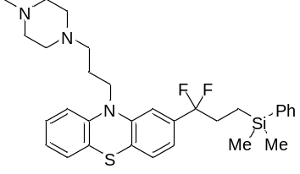
2-(3-(dimethyl(phenyl)silyl)-1,1-difluoropropyl)-10-(3-(4-methylpiperazin-1-yl)propyl)-10H-phenothiazine (60): Following the general procedure D, obtained in 70% yield as colorless oil after silica gel chromatography. (77.2 mg, eluent: dichloromethane /methanol = 10/1).
¹H NMR (400 MHz, CDCl₃) δ 7.50 – 7.41 (m, 2H), 7.33 (dd, J = 5.6, 1.4 Hz, 3H), 7.19 – 7.07 (m, 3H), 6.91 (t, J = 8.2 Hz, 4H), 3.91 (t, J = 6.8 Hz, 2H), 2.47 – 2.42 (m, 10H), 2.25 (s, 3H), 2.11 – 1.99 (m, 2H), 1.96 – 1.81 (m, 2H), 0.92 – 0.71 (m, 2H), 0.26 (s, 6H).
¹³C NMR (101 MHz, CDCl₃) δ 145.4, 144.8, 138.0, 136.5 (t, J = 26.9 Hz), 133.5, 129.2, 127.9, 127.5, 127.4, 127.2, 127.0, 124.6, 123.5 (t, J = 243.1 Hz), 122.8, 119.2 (t, J = 6.0 Hz), 115.8, 112.2 (t, J = 6.4 Hz), 55.5, 55.1, 53.2, 46.0, 45.3, 33.8 (t, J = 29.2 Hz), 24.3, 8.1 (t, J = 2.0 Hz), -3.3.
¹⁹F NMR (376 MHz, CDCl₃) δ -96.5 (2F, t, J = 15.6 Hz).
HRMS (ESI) m/z: [M+H]⁺ Calcd. for C₃₁H₄₀F₂N₃SSi, 552.2675; found, 552.2668.
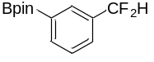
2-(3-(difluoromethyl)phenyl)-4,4,5,5-tetramethyl-1,3,2-dioxaborolane (61): Following the general procedure D, obtained in 70% yield as colorless oil after silica gel chromatography. (35.5 mg, eluent: petroleum ether/ethyl acetate = 15/1).
¹H NMR (400 MHz, CDCl₃) δ 8.02 – 7.86 (m, 2H), 7.61 (d, J = 7.7 Hz, 1H), 7.46 (t, J = 7.6 Hz, 1H), 6.64 (t, J = 56.4 Hz, 1H), 1.35 (s, 12H).
¹³C NMR (101 MHz, CDCl₃) δ 137.1 (t, J = 1.8 Hz), 133.7 (t, J = 22.3 Hz), 131.9 (t, J = 6.1 Hz), 128.2 (t, J = 6.0 Hz), 128.1, 114.9 (t, J = 238.6 Hz), 84.2, 24.9.
¹⁹F NMR (376 MHz, CDCl₃) δ -110.3 (2F, d, J = 56.4 Hz).
HRMS (ESI) m/z: [M+Na]⁺ Calcd. for C₁₃H₁₇BF₂O₂Na, 277.1182; found, 277.1184.

- Experimental Studies on Mechanism
6.1 Measurement of quantum yield
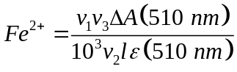According to the procedure of Glorius⁹ and Melchiorre¹⁰, the photon flux of the LEDs (λmax = 427 nm) was determined by standard ferrioxalate actinometry. A 0.15 M solution of ferrioxalate was prepared by dissolving potassium ferrioxalate hydrate (0.737 g) in 10 mL H2SO4 (0.05 M). A buffered solution of 1,10-phenanthroline was prepared by dissolving sodium acetate (5.63 g) and phenanthroline (25 mg) in 25 mL H2SO4 (0.5 M) at the same time. Both solutions were stored in the dark. To determine the photon flux of the LED, the ferrioxalate solution (1.0 mL) was placed in a cuvette and irradiated for 900 seconds at λmax = 427 nm. After irradiation, the phenanthroline solution (0.175 mL) was added to the cuvette and the mixture was stirred in the dark for 1 hour to allow the ferrous ions to completely coordinate to the phenanthroline. The absorbance of the solution was measured at 510 nm. A non-irradiated sample was also prepared and the absorbance at 510 nm was measured. Using then the Beer’s Law, the number of moles of Fe²⁺ produced by light irradiation is obtained by:

where v₁ is the irradiated volume (1 mL), v₂ is the aliquot of the irradiated solution taken for the determination of the ferrous ions (1 mL), v₃ is the final volume after complexation with phenanthroline (10 mL), l is the optical path-length of the irradiation cell (1 cm), ΔA(510 nm) the optical difference in absorbance between the irradiated solution and the one stored in the dark, ε(510 nm) is that of the complex Fe(phen)₃²⁺(11100 L mol⁻¹cm⁻¹).
The photon flux (F) is obtained by using the following equation:
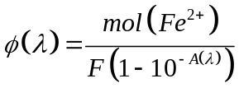

Wher Ф (λ) = The quantum yield for Fe²⁺ formation at 420 nm is 1.1. A(λ) = ferrioxalate actinometer absorbance at 420 nm, which was measured placing 1 mL of the solution in a cuvette of pathlength 1 cm by UV/Vis spectrophotometry. We obtained an absorbance value of 3.5. The photon flux (F) is 3.1 x 10⁻⁹ einsteins/s.
To obtain the quantum yield (Φ). The number of moles of the product 3 were determined by ¹H-NMR analysis using diphenylmethane as internal standard. As such, a photocatalytic reaction was performed under the set of optimized reaction conditions under visible light irradiation of 427 nm blue LEDs. After 900 s of light irradiation, 2.0 x 10⁻⁶ moles of 3 were obtained. The quantum yield of this reaction was calculated using the following equation:
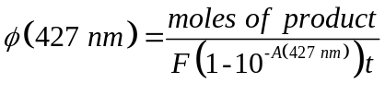

Where A(427 nm) = is the absorbance at 427 nm of the photocatalytic reaction which was measured placing 1 mL of the solution in a cuvette of path length 1 cm by UV/Vis spectrophotometry.
t = is the reaction time.
The quantum yield (Ф) of the reaction is 4.4.
6.2 UV-vis absorption spectroscopic measurements
Stock solutions of 1, 2, PO1, AdSH, HCO₂K were prepared with the same concentration used in the reaction. Cs₂CO₃ was used in 150 mol% to ensure generation of PO anion under measurement condition. The solutions were prepared in the presence of air using DMA as solvent.

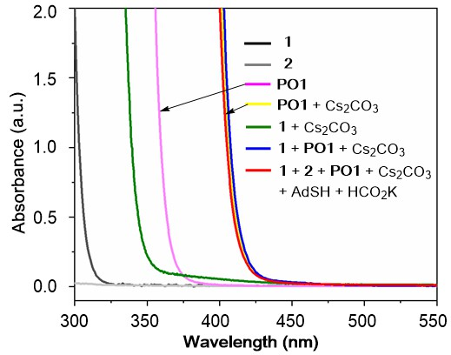
Supplementary Figure 2. UV/vis absorption spectra of catalyst, substrate, and reaction mixture.

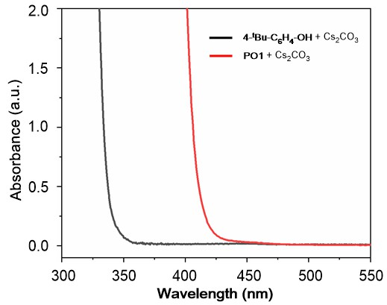
Supplementary Figure 3. UV/vis absorption spectra of 4-tert-Butylphenol anion and PO1 anion.
6.3 Stern-Volmer Quenching Study
To evaluate the role of PO1 anion in this process, we conducted Stern-Volmer fluorescence quenching experiments.¹¹ The samples were prepared mixing the PO1 anion (5 × 10⁻⁴ M, freshly prepared in situ by the deprotonation of PO1 with Cs₂CO₃) with the required amount of 1 in a total volume of 1 mL of dry DMA in a 10 × 10 mm light path quartz fluorescence cuvette under an argon atmosphere. The excitation wavelength was fixed at 384 nm, the emission light was acquired from 400 nm to 700 nm. Quenching was not observed in similar experiments using 2 and 1-adamantanethiol.
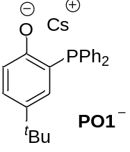
Supplementary Figure 4. Quenching of the PO1 anion emission (5 × 10⁻⁴ M in DMA) in the presence of increasing amounts of 1.

Supplementary Figure 5. Stern-Volmer quenching plot of substrate I.

Other reaction components:

Supplementary Figure 6. Stern-Volmer quenching plot of 2.

Supplementary Figure 7. Stern-Volmer quenching plot of 1-adamantanethiol.

6.4 Electrochemical Measurements
6.4.1 Cyclic Voltammogram of Catalyst
Tetrabutylammonium hexafluorophosphate (1161 mg, 3.0 mmol) was added to a 0.01 M solution of the PO1 anion catalyst (generated in situ by the deprotonation of the PO1 catalyst with 1.3 equiv Cs₂CO₃) in 30 mL of dry DMSO and the solution was vigorously bubbled with Ar for 5 minutes prior to the measurement. The oxidation/reduction potential was measured using platinum disc working electrode, a platinum wire counter electrode, and a saturated calomel electrode (SCE) at 0.1 V/s scan rate.
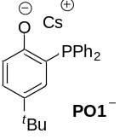
E_{p/2} = 0.06 V
Supplementary Figure 8. The cyclic voltammogram of the PO1 anions vs SCE in DMSO at 0.1V/s.

With this data in hand we calculated the redox potential of the excited PO1 anion employing the following equation:¹²
E_{p/2}(PO1·/ PO1⁻*) = E_{p/2}(PO1·/ PO1⁻) – E₀₋₀(PO1⁻*/ PO1⁻)

E_{p/2}(PO1·/ PO1⁻) = 0.06 V vs. SCE, In the absence of vibrational structures, E₀₋₀ can be roughly estimated from the position of the long wavelength tail (λ_{tail}) of the absorption spectrum.¹³ λ_{tail} corresponds to 420 nm, which translates into an E₀₋₀(PO1⁻*/ PO1⁻) of 2.95 eV for the PO1 anion.
E_{p/2}(PO1·/ PO1⁻*) = E_{p/2}(PO1·/ PO1⁻) – E₀₋₀(PO1⁻*/ PO1⁻) = 0.06 – 2.95 = – 2.89 V vs. SCE

6.4.2 Cyclic Voltammogram of Substrate
Electrochemical potentials were obtained with a standard set of conditions to main internal consistency. Samples were prepared with 0.3 mmol of substrate in 30 mL of 0.1 M tetrabutylammonium hexafluorophosphate in dry, degassed acetonitrile. Measurements employed a glassy carbon working electrode, platinum wire counter electrode, saturated calomel reference electrode, and a scan rate of 0.1 V/s. Reductions were measured by scanning potentials in the negative direction; the glassy carbon electrode was polished between each scan.

Supplementary Figure 9. Cyclic voltammogram of 2,2,2-trifluoro-N-phenylacetamide.

Supplementary Figure 10. Cyclic voltammogram of N-benzyl-2,2,2-trifluoroacetamide.

Supplementary Figure 11. Cyclic voltammogram of 2,2,2-trifluoroacetamide.

Supplementary Figure 12. Cyclic voltammogram of ethyl 2,2,2-trifluoroacetate.

- References
- Kovacs, M. S., Hein, P., Sattarzadeh, S., Patrick, B. O., Emge, T. J. & Orvig, C. Complexes of phosphine–phenolate ligands with the [Re₌O]³⁺ and [Re(HNNC₅H₄N)(NNC₅H₄N)]²⁺ cores. J. Chem. Soc. Dalton Trans. 2001, 3015−3024 (2001).
- Bakewell, C., Cao, T.-P.-A., Le Goff, X. F., Long, N. J., Auffrant, A. & Williams, C. K. Yttrium phosphasalen initiators for rac-lactide polymerization. Organometallics 32, 1475−1483 (2013).
- Fliedel, C., Rosa, V., Alves, F. M., Martins, A. M., Avilés, T. & Dagorne, S. P,O-Phosphinophenolate zinc(II) species: synthesis, structure and use in the ring-opening polymerization (ROP) of lactide, ε-caprolactone and trimethylene carbonate. Dalton Trans. 44, 12376–12387 (2015).
- Fischer, M., Schaper, R., Jaugstetter, M., Schmidtmann, M. & Beckhaus, R. Electrophilic d⁰ cations of group 4 Metals (M = Ti, Zr, Hf) derived from monopentafulvene complexes: direct formation of tridentate Cp,O,P‑ligands. Organometallics 37, 1192−1205 (2108).
- García-Márquez, A., Frontera, A., Roisnel, T. & Gramage-Doria, R. Ultrashort H^{δ+}⋯H^{δ−} intermolecular distance in a supramolecular system in the solid state. Chem. Commun. 57, 7112–7115 (2021).
- Heinicke, J., Köhler, M., Peulecke, N., He, M., Kindermann, M. K., Keim, W. & Fink, G. 2-Phosphanylphenolate nickel catalysts for the polymerization of ethylene. Chem. Eur. J. 9, 6093–6107 (2003).
- Bakewell, C., Cao, T.-P-A., Long, N., Le Goff, X. F., Auffrant, A. & Williams, C. K. Yttrium phosphasalen initiators for rac-lactide polymerization: excellent rates and high iso-selectivities. J. Am. Chem. Soc. 134, 20577−20580 (2012).
- Yu, Y.-J., Zhang, F.-L., Peng, T.-Y., Wang, C.-L., Cheng, J., Chen, C., Houk, K. N. & Wang, Y.-F. Sequential C–F bond functionalizations of trifluoroacetamides and acetates via spin-center shifts. Science 371, 1232–1240 (2021).
- Tlahuext-Aca, A., Garza-Sanchez, R. A., Schäfer, M. & Glorius, F. Visible-light-mediated synthesis of ketones by the oxidative alkylation of styrenes. Org. Lett. 20, 1546−1549 (2018).
- Woźniak, Ł., Murphy, J. J. & Melchiorre, P. Photo-organocatalytic enantioselective perfluoroalkylation of β-ketoesters. J. Am. Chem. Soc. 137, 5678–5681 (2015).
- Discekici, E. H., Treat, N. J., Poelma, S. O., Mattson, K. M., Hudson, Z. M., Luo, Y., Hawker, C. J. & de Alaniz, J. R. A highly reducing metal-free photoredox catalyst: design and application in radical dehalogenations. Chem. Commun. 51, 11705−11708 (2015).
- Silvi, M., Arceo, E., Jurberg, I. D., Cassani, C. & Melchiorre, P. Enantioselective organocatalytic alkylation of aldehydes and enals driven by the direct photoexcitation of enamines. J. Am. Chem. Soc. 137, 6120−6123 (2015).
- Buzzetti, L., Crisenza, G. E. M. & Melchiorre, P. Mechanistic studies in photocatalysis. Angew. Chem. Int. Ed. 58, 3730–3747 (2019).

- ¹H NMR and ¹³C NMR spectra
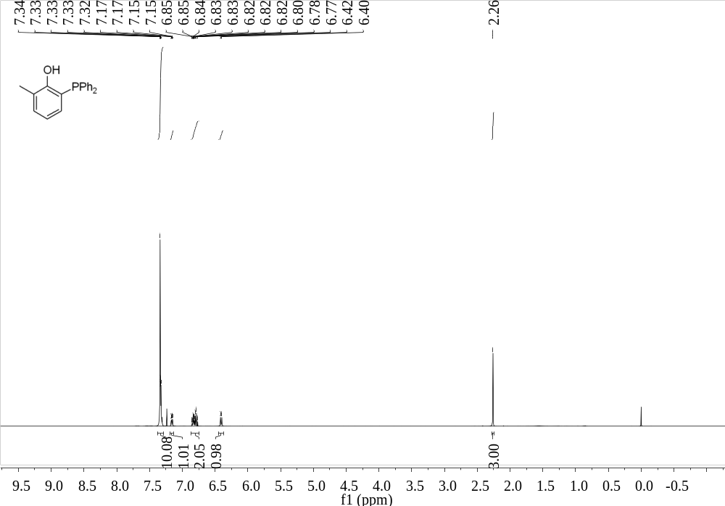
Supplementary Figure 13. ¹H NMR (400 MHz, CDCl₃) spectrum of PO2

¹³C NMR (101 MHz, CDCl₃) spectrum of 2-(diphenylphosphaneyl)-6-methylphenol (PO2)
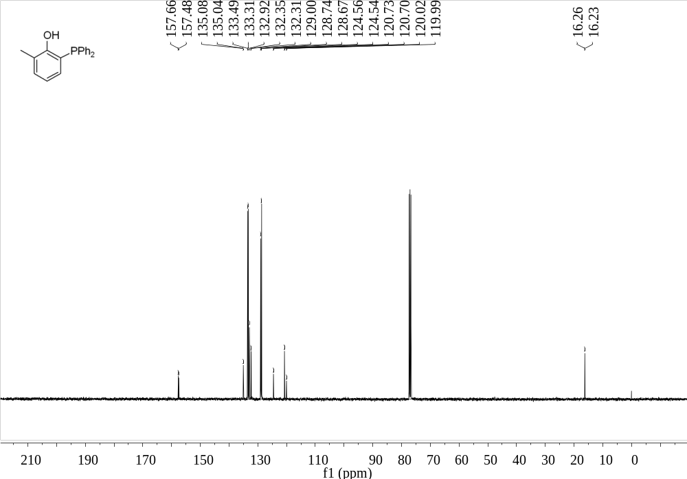
Supplementary Figure 14. ¹³C NMR (101 MHz, CDCl₃) spectrum of PO2
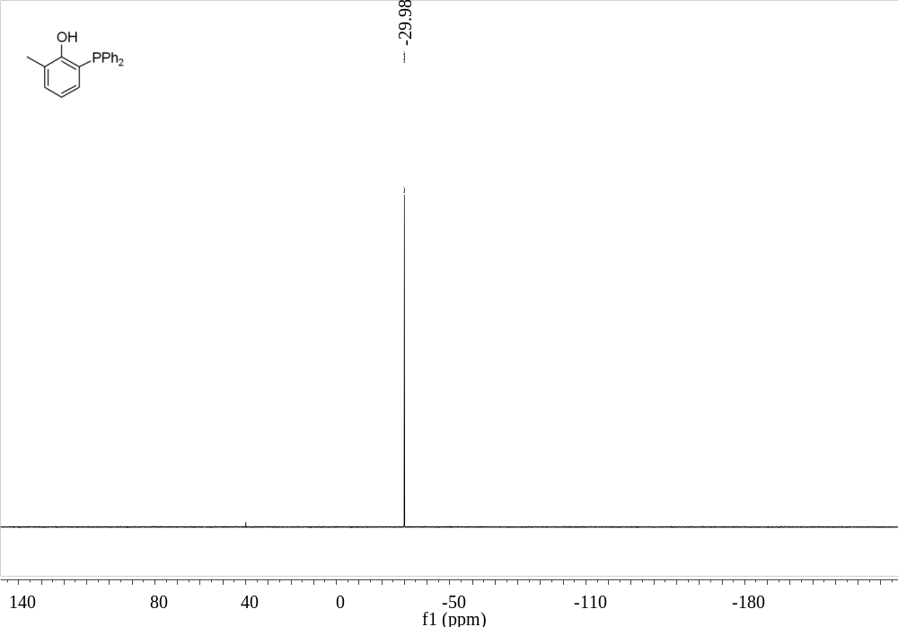
Supplementary Figure 15. ³¹P NMR (162 MHz, CDCl₃) spectrum of PO2

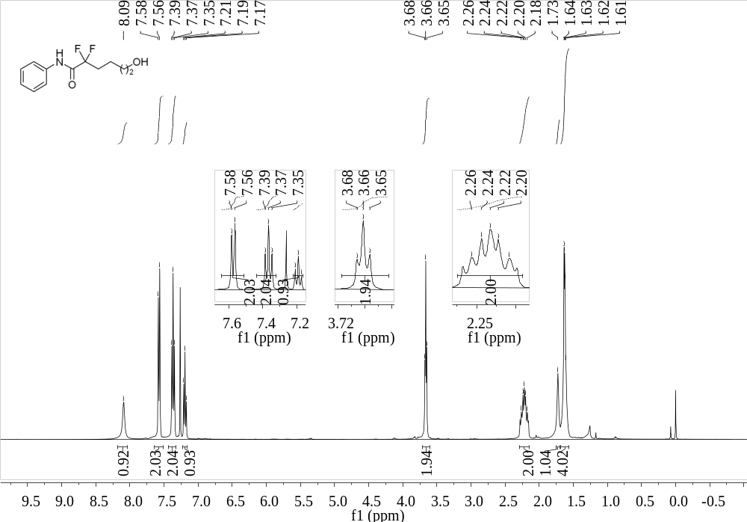
Supplementary Figure 16. ¹H NMR (400 MHz, CDCl₃) spectrum of 3

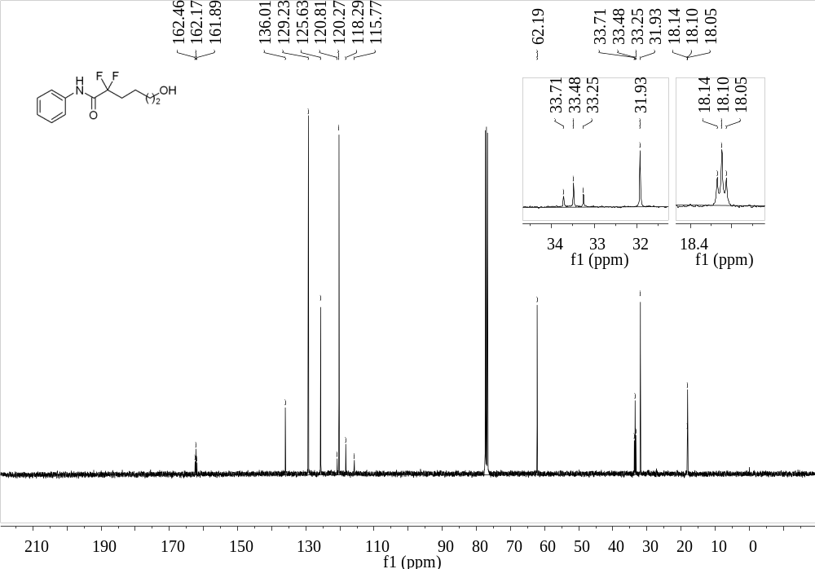
Supplementary Figure 17. ¹³C NMR (101 MHz, CDCl₃) spectrum of 3

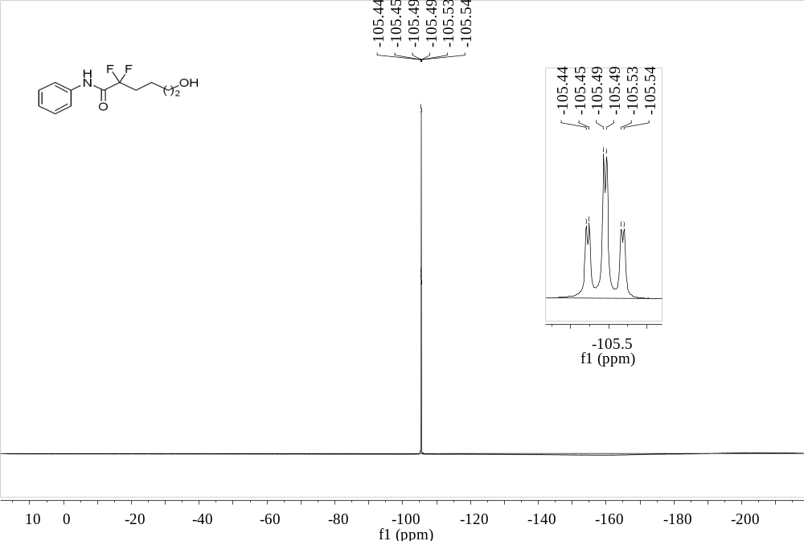
Supplementary Figure 18. ¹⁹F NMR (376 MHz, CDCl₃) spectrum of 3

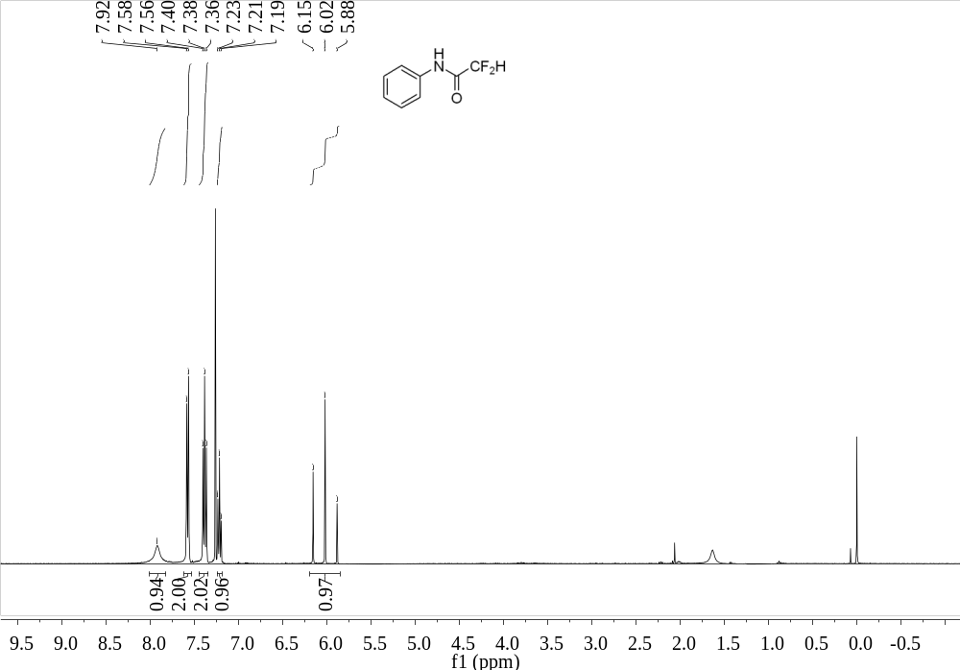
Supplementary Figure 19. ¹H NMR (400 MHz, CDCl₃) spectrum of 4

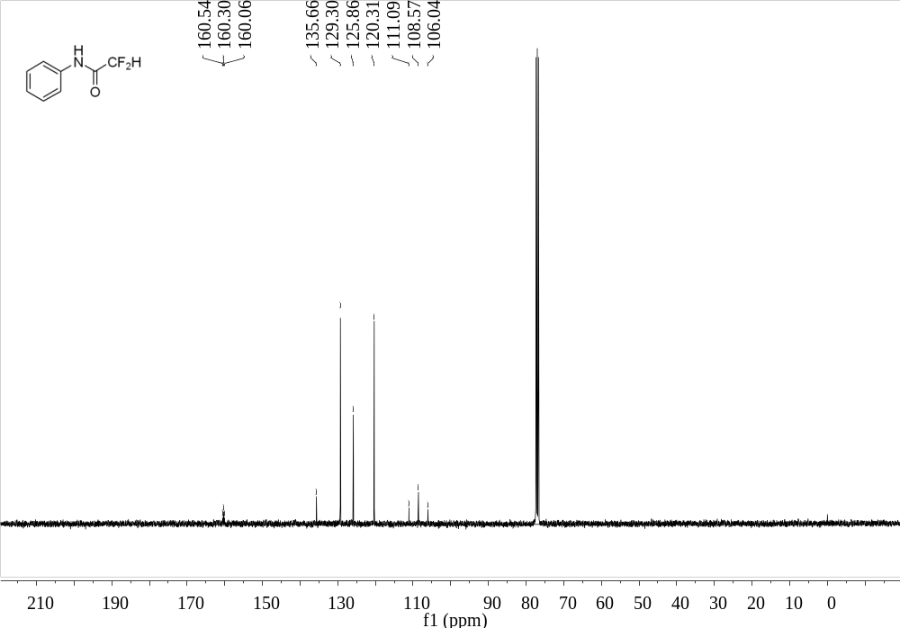
Supplementary Figure 20. ¹³C NMR (101 MHz, CDCl₃) spectrum of 4

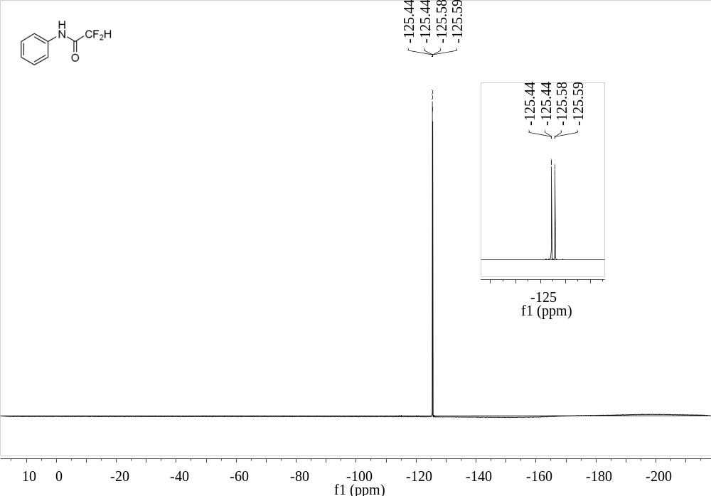
Supplementary Figure 21. ¹⁹F NMR (101 MHz, CDCl₃) spectrum of 4

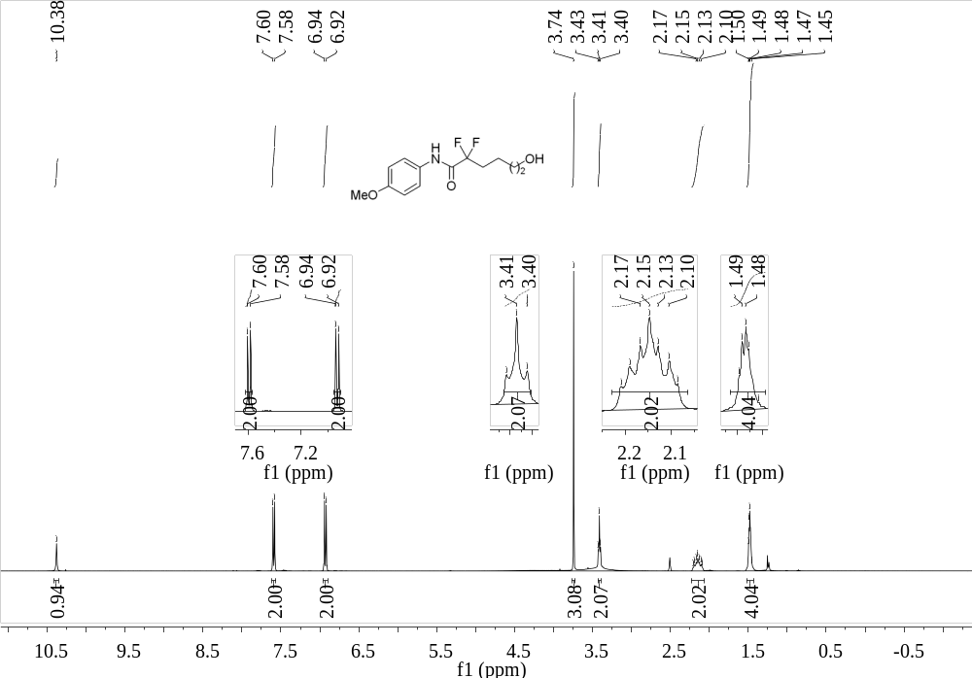
Supplementary Figure 22. ¹H NMR (400 MHz, d₆-DMSO) spectrum of 5
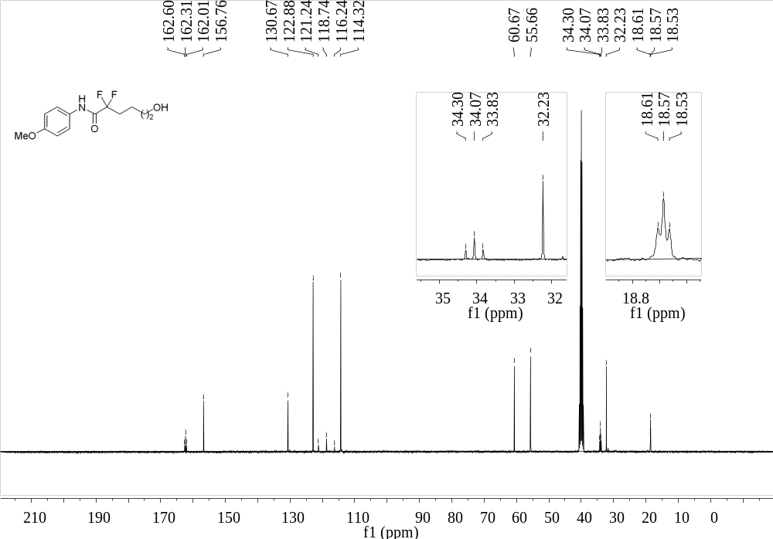
Supplementary Figure 23. ¹³C NMR (101 MHz, d₆-DMSO) spectrum of 5

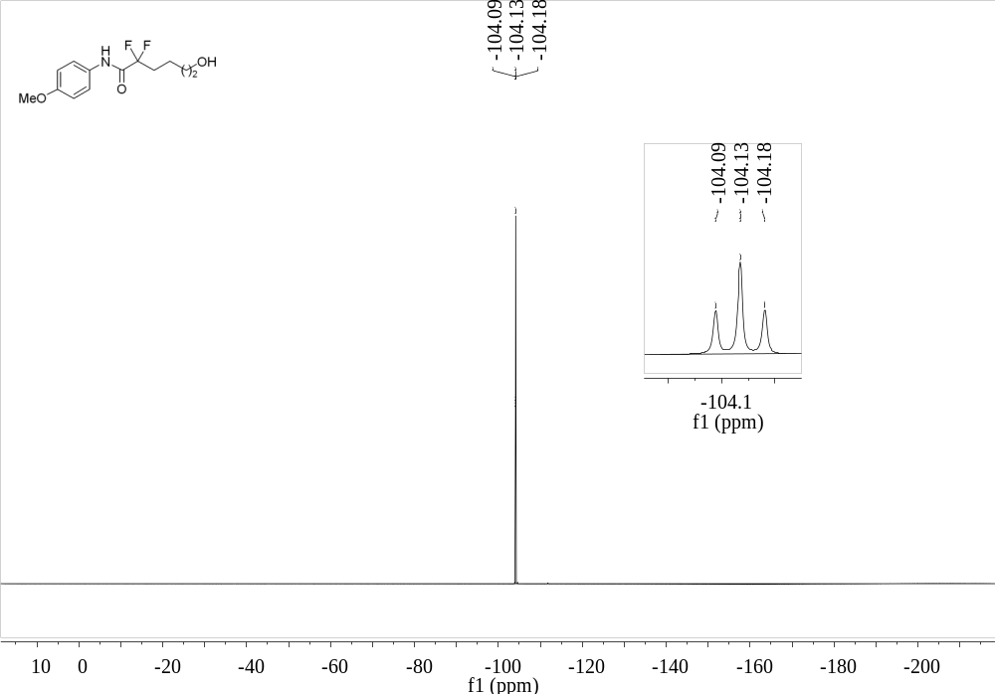
Supplementary Figure 24. ¹⁹F NMR (376 MHz, d₆-DMSO) spectrum of 5
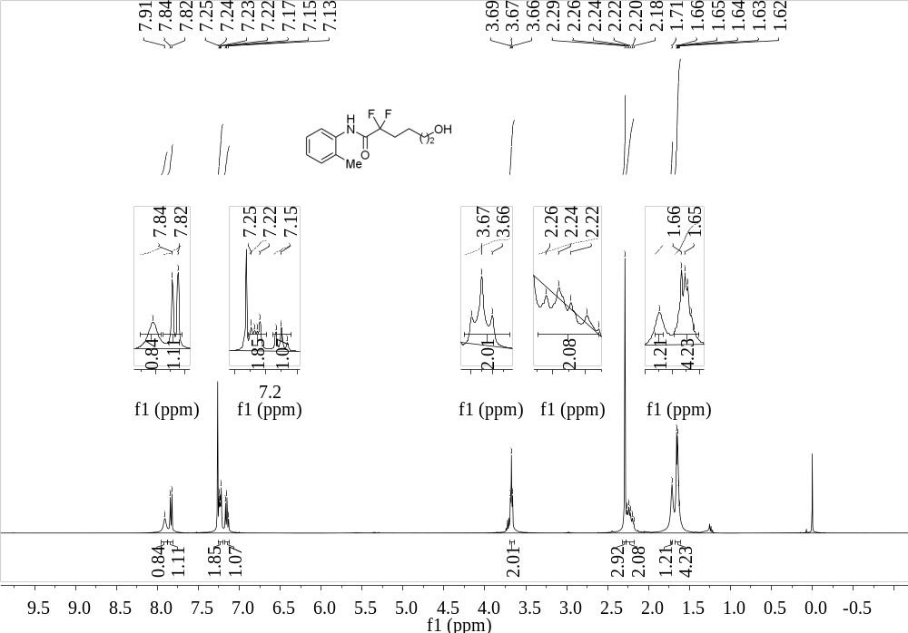
Supplementary Figure 25. ¹H NMR (400 MHz, CDCl₃) spectrum of 6

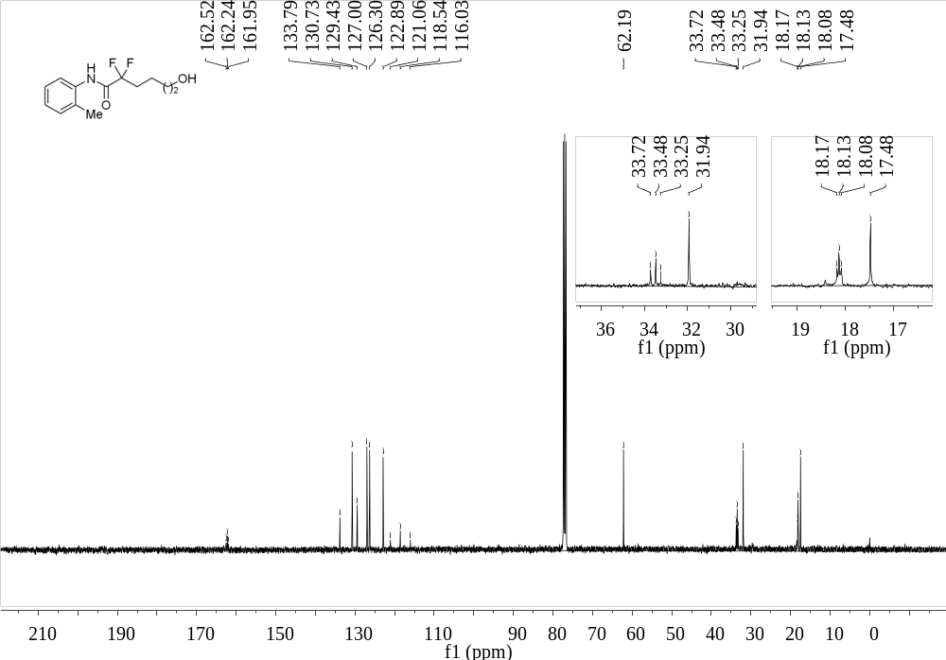
Supplementary Figure 26. ¹³C NMR (101 MHz, CDCl₃) spectrum of 6
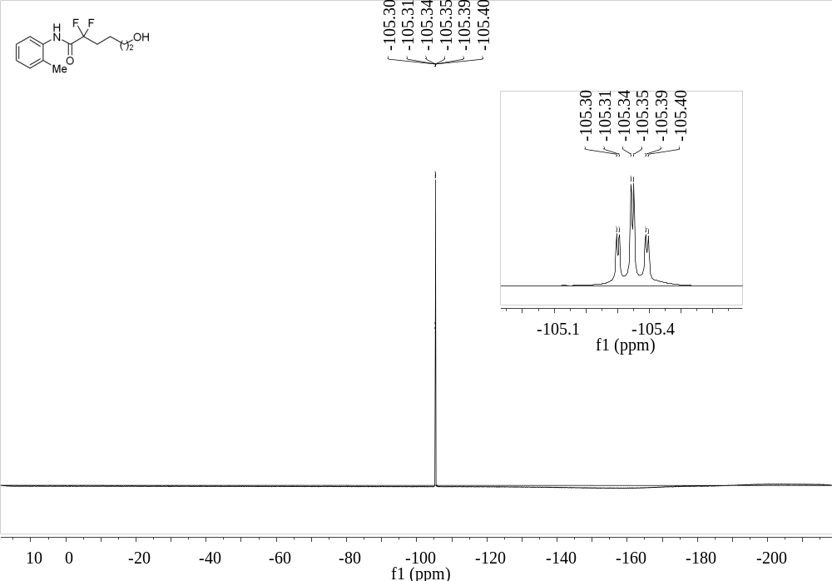
Supplementary Figure 27. ¹⁹F NMR (376 MHz, CDCl₃) spectrum of 6

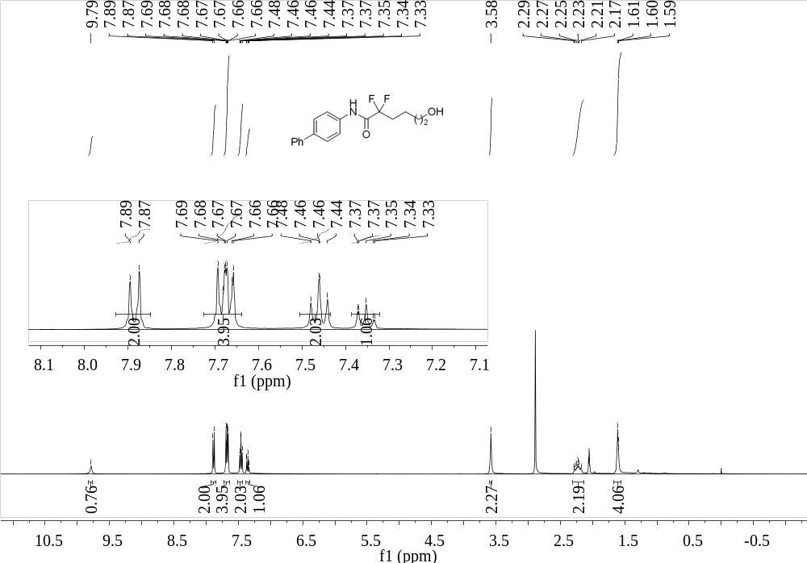
Supplementary Figure 28. ¹H NMR (400 MHz, Acetone-d₆) spectrum of 7
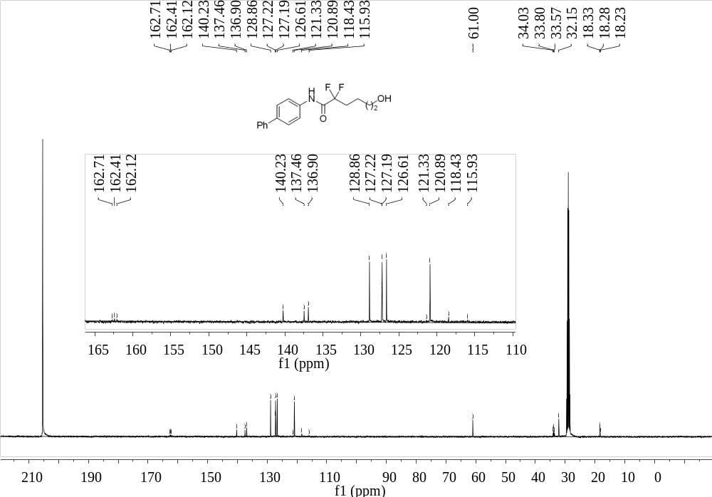
Supplementary Figure 29. ¹³C NMR (101 MHz, Acetone-d₆) spectrum of 7

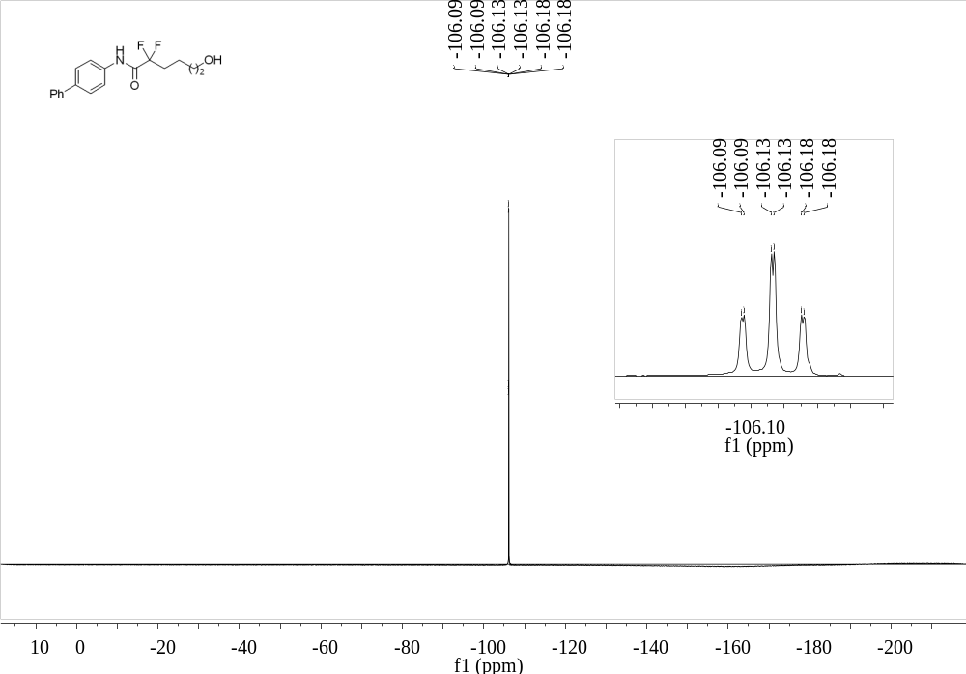
Supplementary Figure 30. ¹⁹F NMR (376 MHz, Acetone-d₆) spectrum of 7
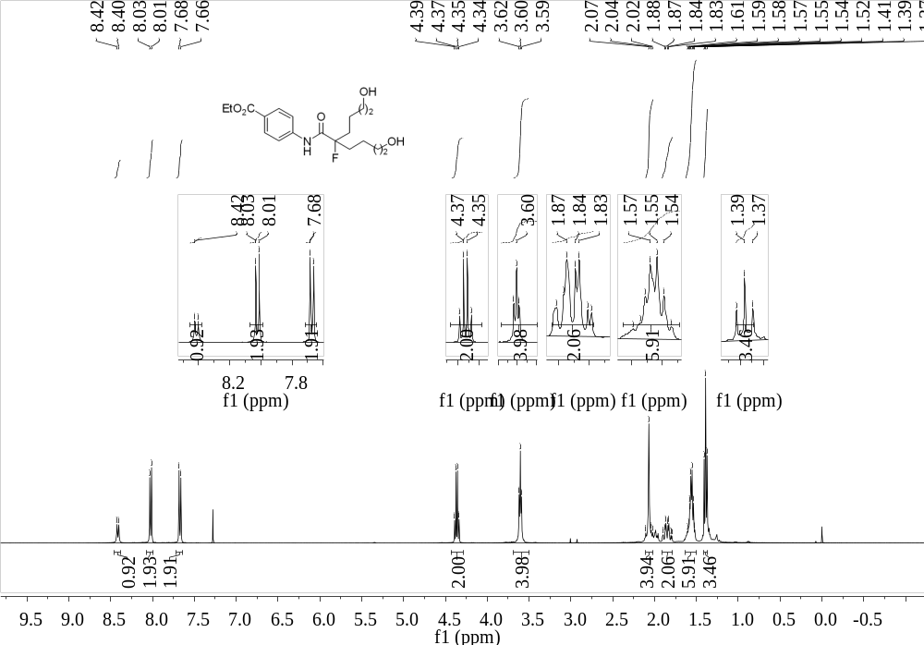
Supplementary Figure 31. ¹H NMR (400 MHz, CDCl₃) spectrum of 8

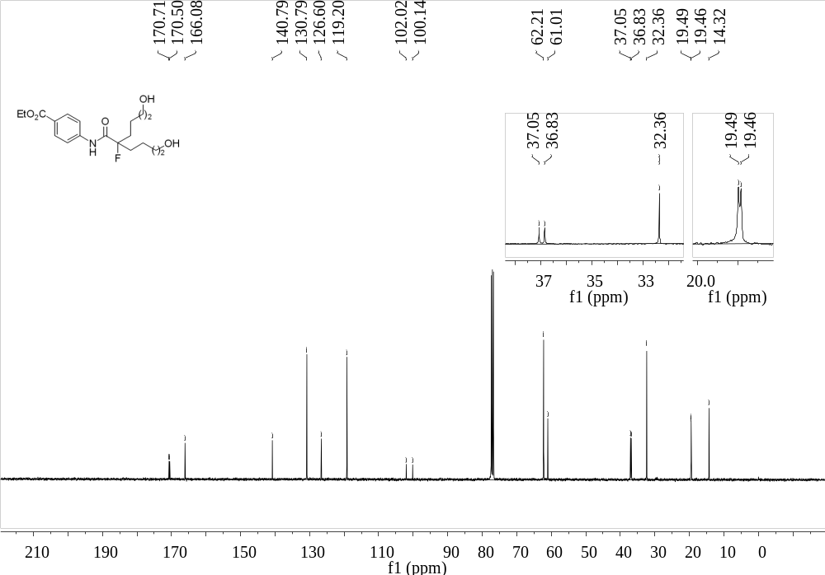
Supplementary Figure 32. ¹³C NMR (101 MHz, CDCl₃) spectrum of 8
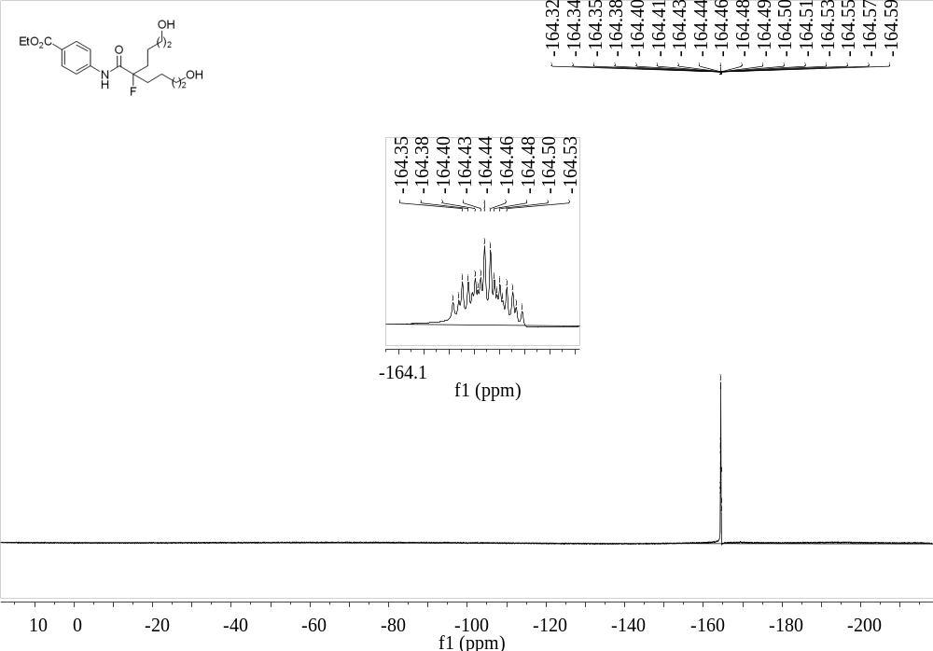
Supplementary Figure 33. ¹⁹F NMR (376 MHz, CDCl₃) spectrum of 8

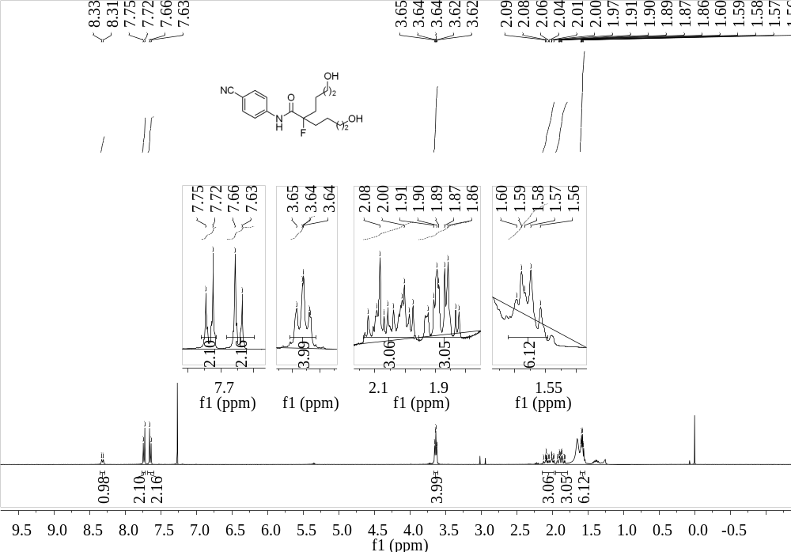
Supplementary Figure 34. ¹H NMR (400 MHz, CDCl₃) spectrum of 9
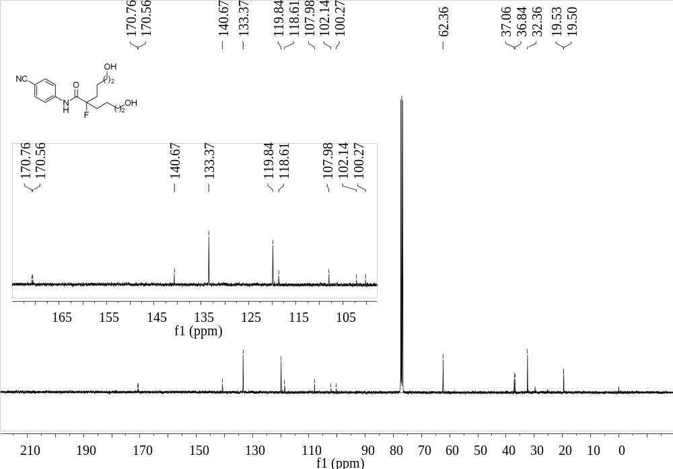
Supplementary Figure 35. ¹³C NMR (101 MHz, CDCl₃) spectrum of 9

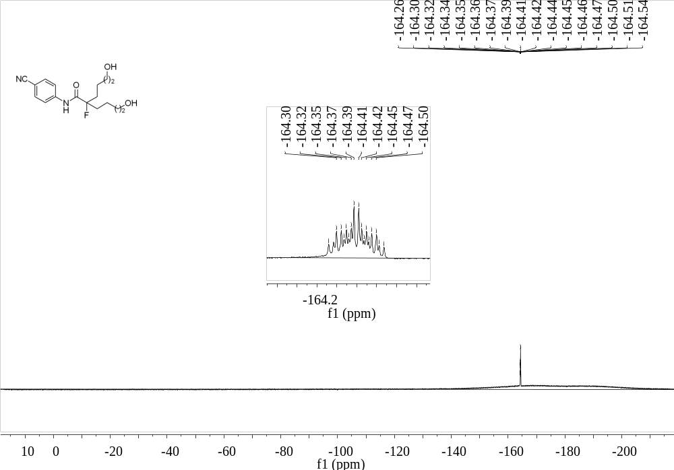
Supplementary Figure 36. ¹⁹F NMR (376 MHz, CDCl₃) spectrum of 9
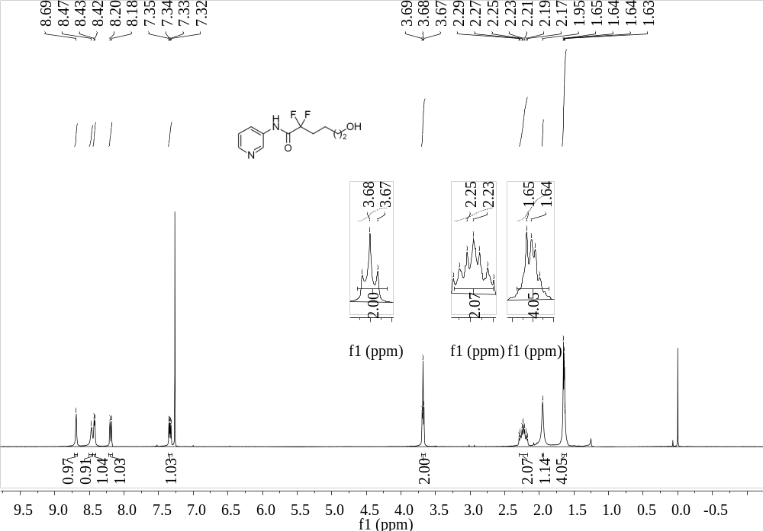
Supplementary Figure 37. ¹H NMR (400 MHz, CDCl₃) spectrum of 10

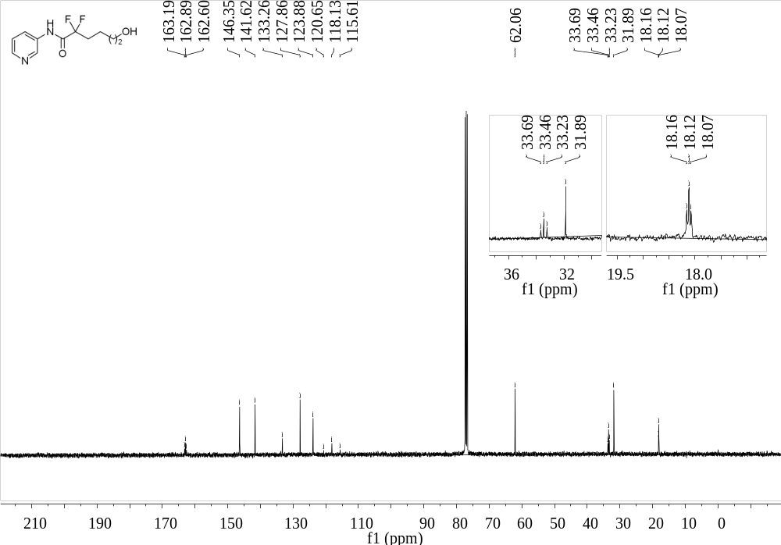
Supplementary Figure 38. ¹³C NMR (101 MHz, CDCl₃) spectrum of 10
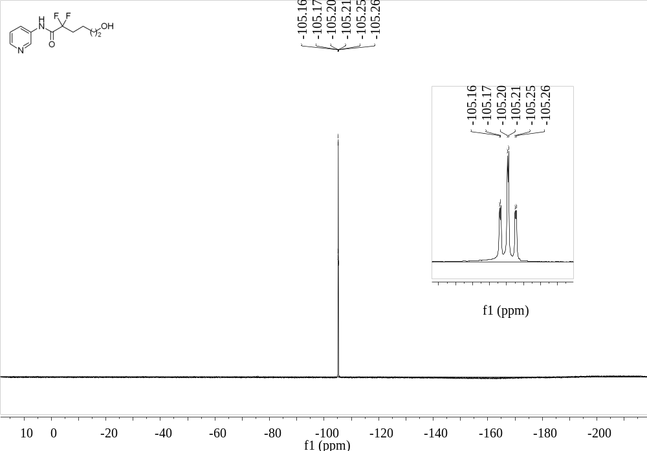
Supplementary Figure 39. ¹⁹F NMR (376 MHz, CDCl₃) spectrum of 10

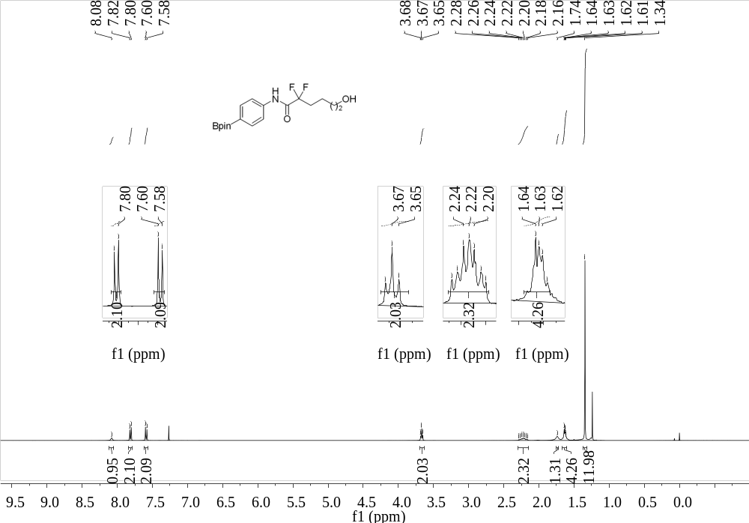
Supplementary Figure 40. ¹H NMR (400 MHz, CDCl₃) spectrum of 11
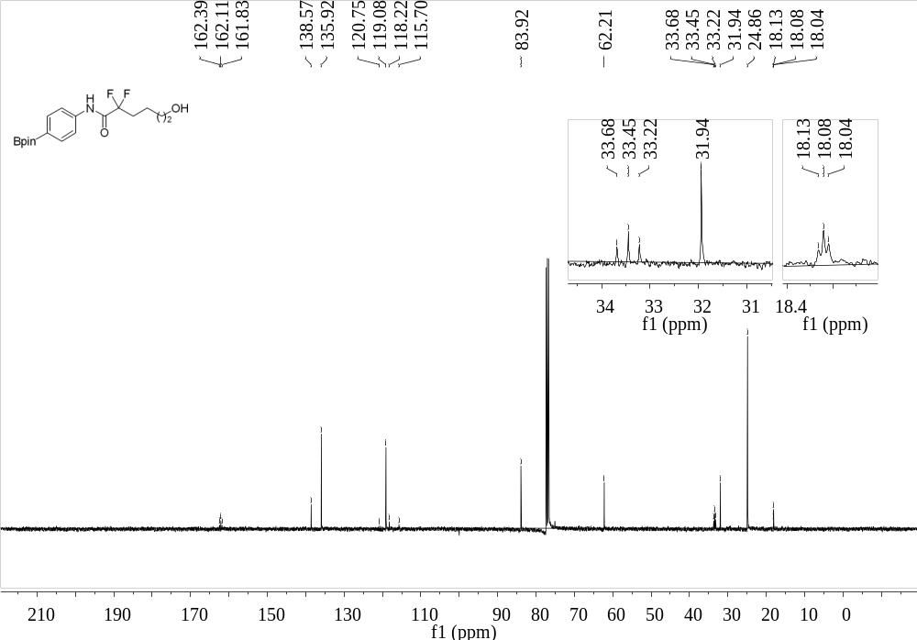
Supplementary Figure 41. ¹³C NMR (101 MHz, CDCl₃) spectrum of 11

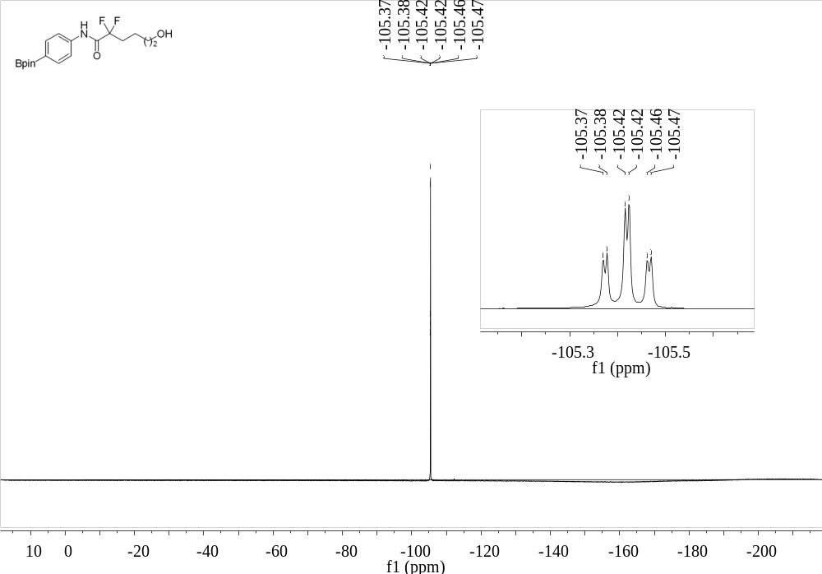
Supplementary Figure 42. ¹⁹F NMR (376 MHz, CDCl₃) spectrum of 11
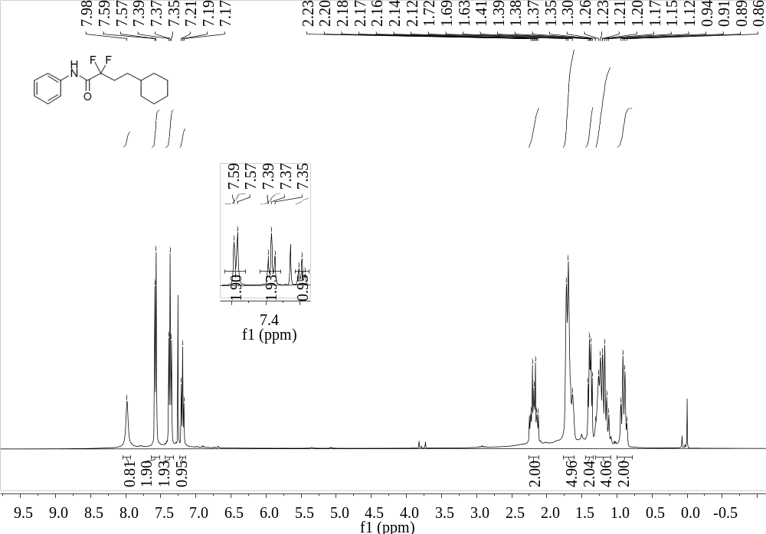
Supplementary Figure 43. ¹H NMR (400 MHz, CDCl₃) spectrum of 15

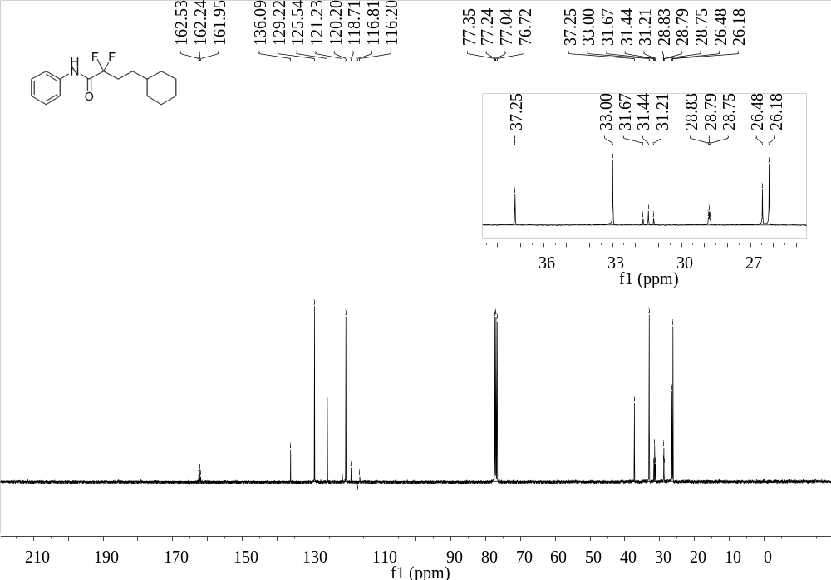
Supplementary Figure 44. ¹³C NMR (101 MHz, CDCl₃) spectrum of 15
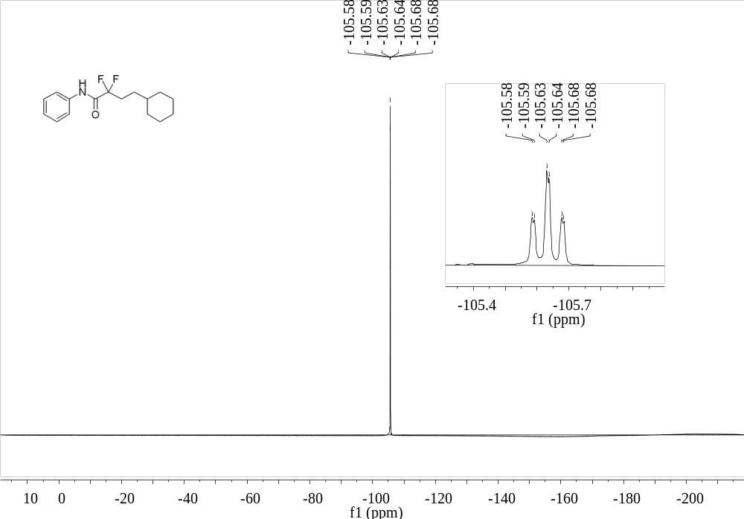
Supplementary Figure 45. ¹⁹F NMR (376 MHz, CDCl₃) spectrum of 15

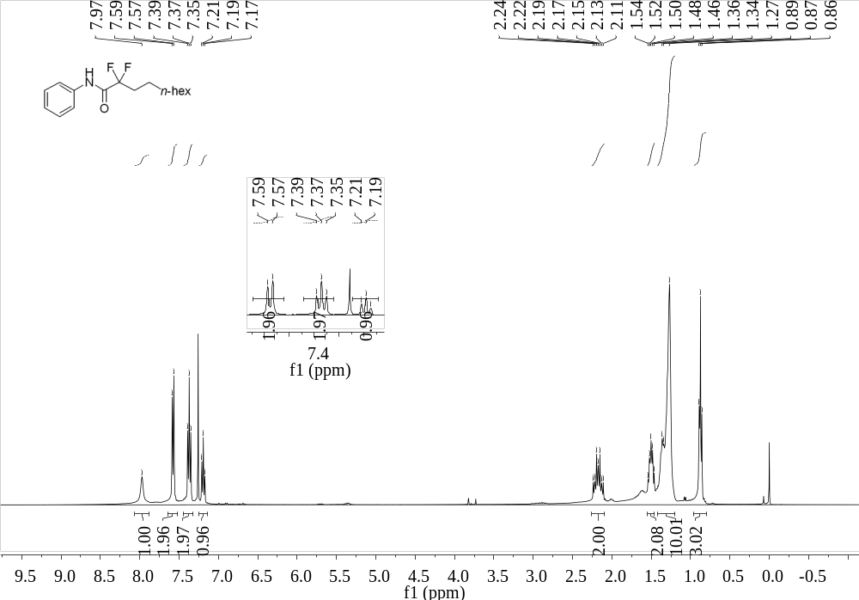
Supplementary Figure 46. ¹H NMR (400 MHz, CDCl₃) spectrum of 16
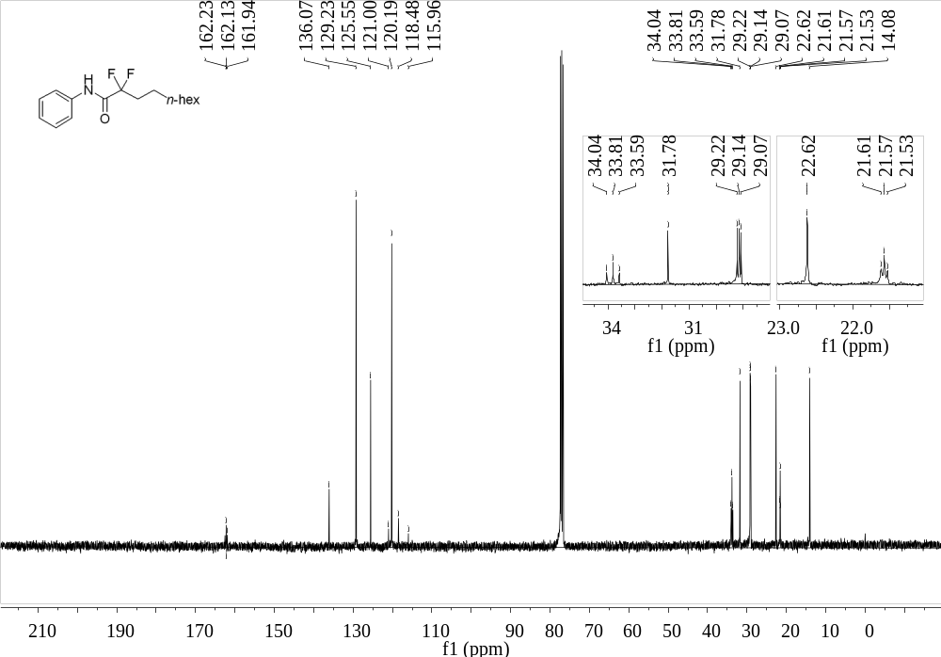
Supplementary Figure 47. ¹³C NMR (101 MHz, CDCl₃) spectrum of 16

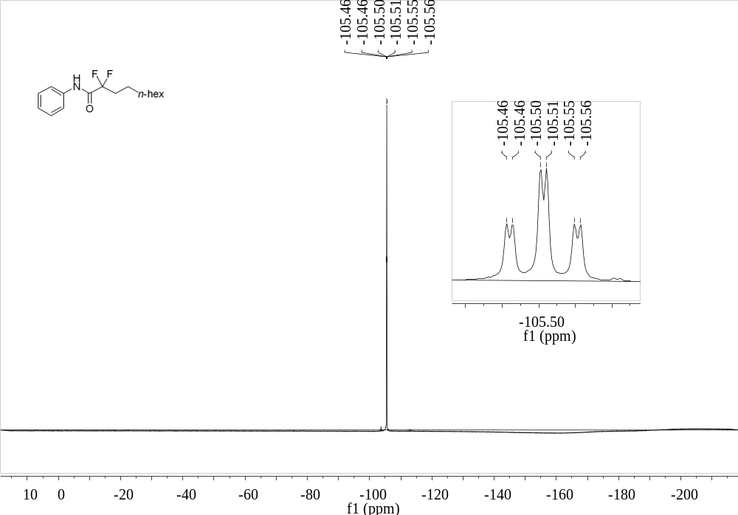
Supplementary Figure 48. ¹⁹F NMR (376 MHz, CDCl₃) spectrum of 16
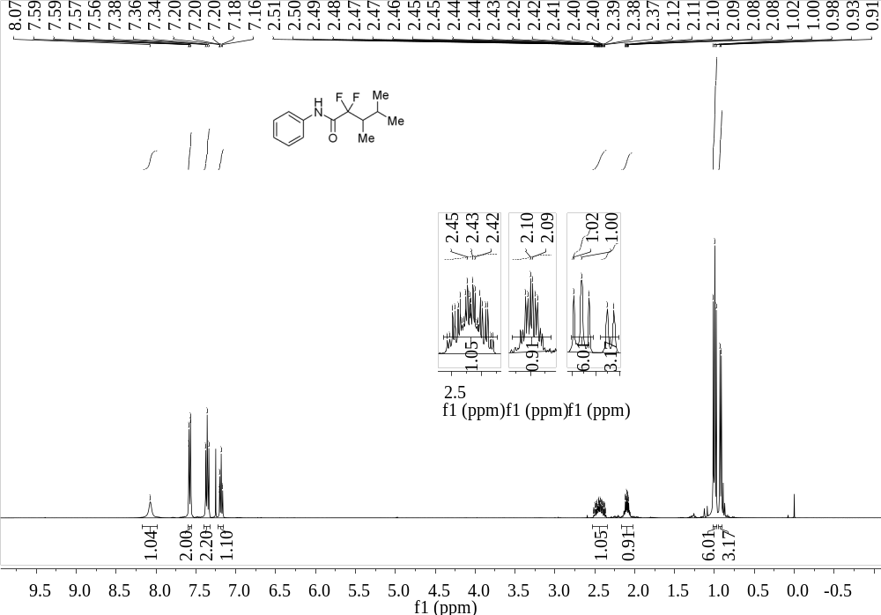
Supplementary Figure 49. ¹H NMR (400 MHz, CDCl₃) spectrum of 17

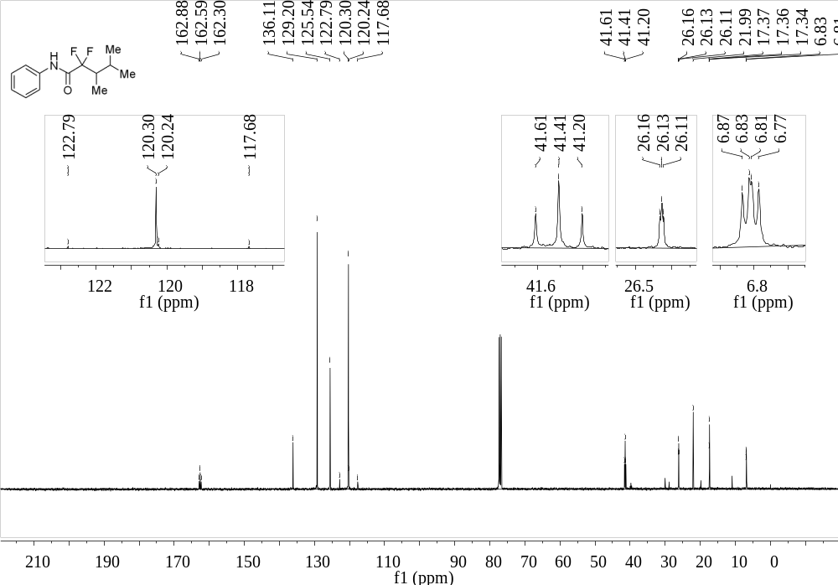
Supplementary Figure 50. ¹³C NMR (101 MHz, CDCl₃) spectrum of 17
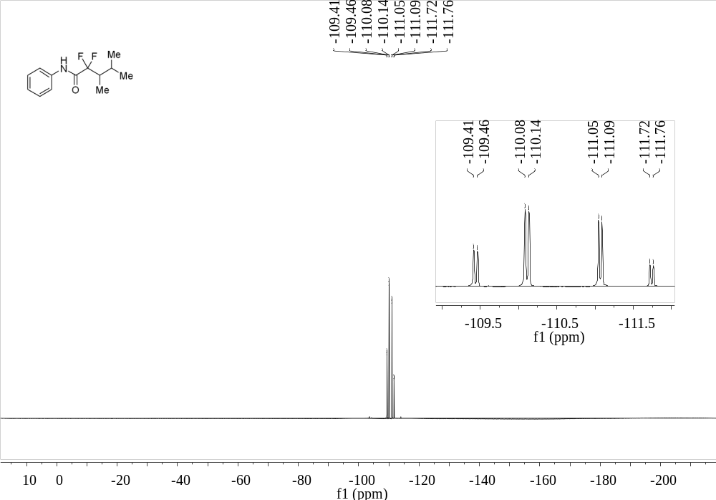
Supplementary Figure 51. ¹⁹F NMR (376 MHz, CDCl₃) spectrum of 17

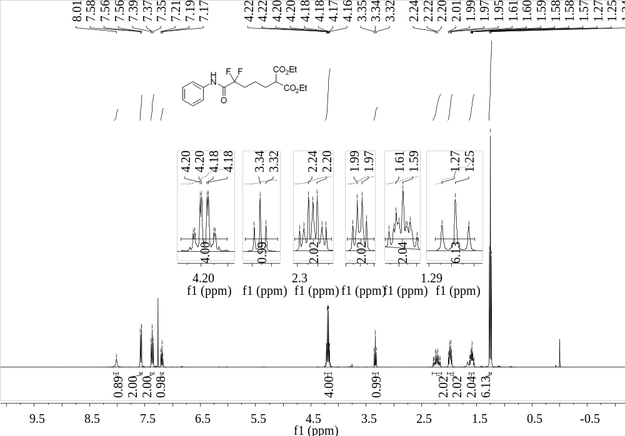
Supplementary Figure 52. ¹H NMR (400 MHz, CDCl₃) spectrum of 18
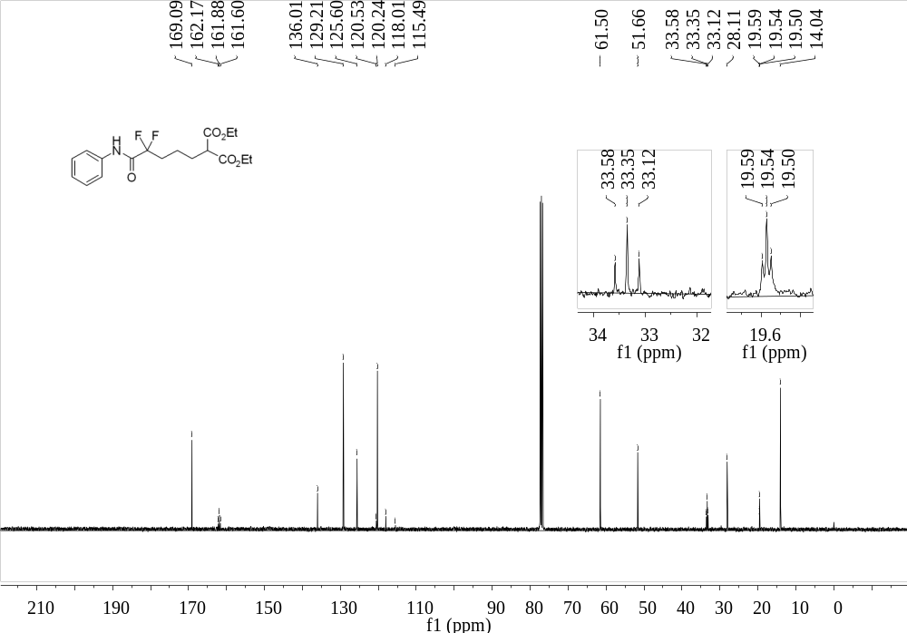
Supplementary Figure 53. ¹³C NMR (101 MHz, CDCl₃) spectrum of 18

¹⁹F NMR (376 MHz, CDCl₃) spectrum of diethyl 2-(4,4-difluoro-5-oxo-5-(phenylamino)pentyl)malonate (18)
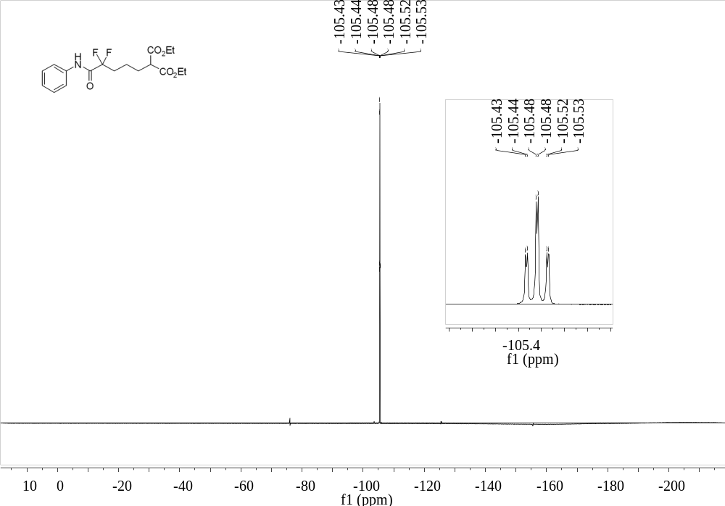
Supplementary Figure 54. ¹⁹F NMR (376 MHz, CDCl₃) spectrum of 18
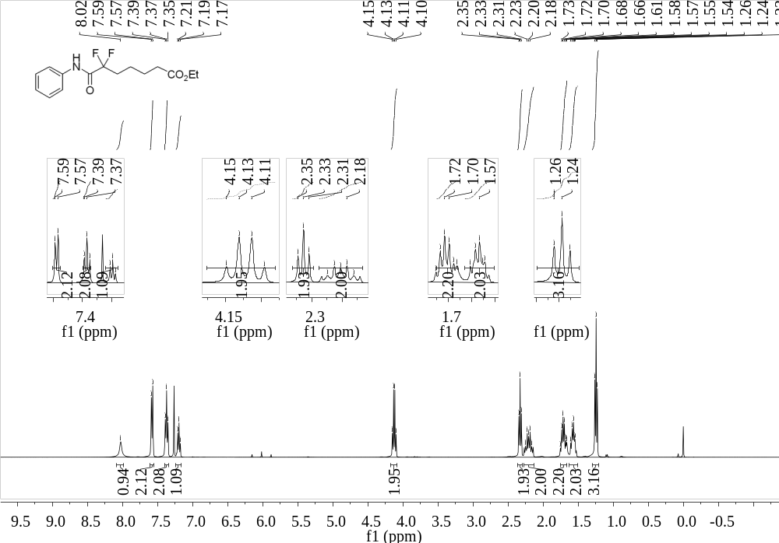
Supplementary Figure 55. ¹H NMR (400 MHz, CDCl₃) spectrum of 19

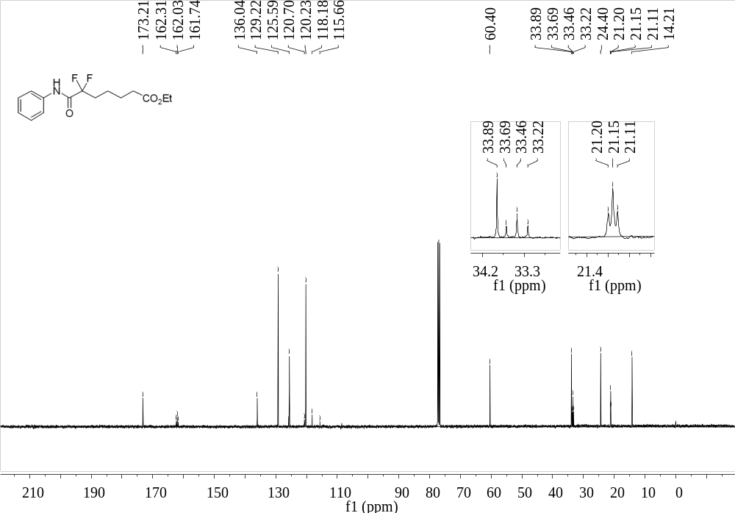
Supplementary Figure 56. ¹³C NMR (101 MHz, CDCl₃) spectrum of 19
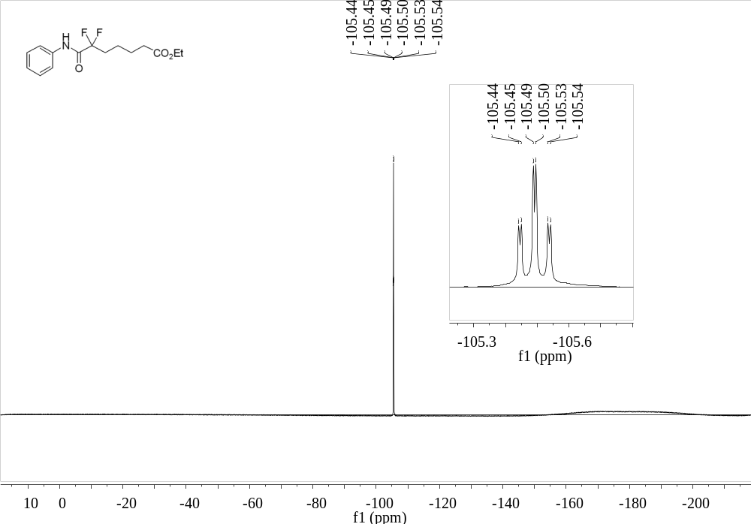
Supplementary Figure 57. ¹⁹F NMR (376 MHz, CDCl₃) spectrum of 19

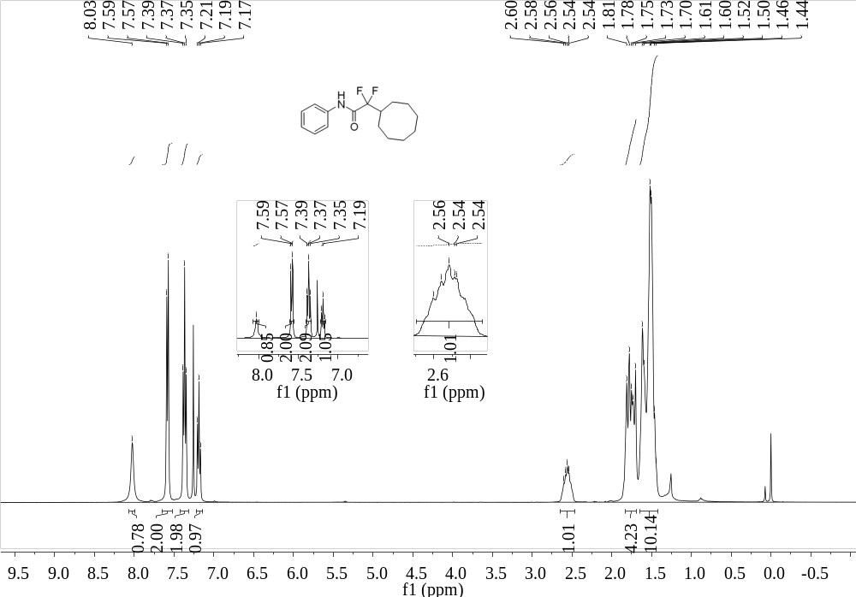
Supplementary Figure 58. ¹H NMR (400 MHz, CDCl₃) spectrum of 20
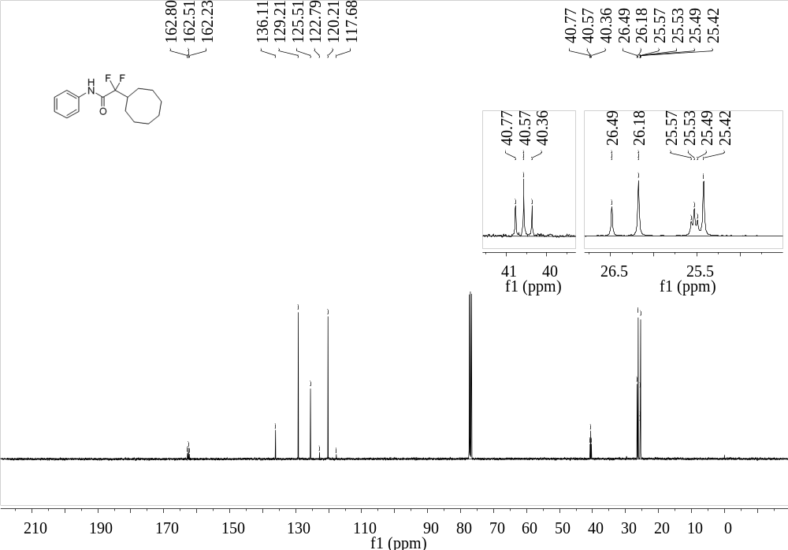
Supplementary Figure 59. ¹³C NMR (101 MHz, CDCl₃) spectrum of 20

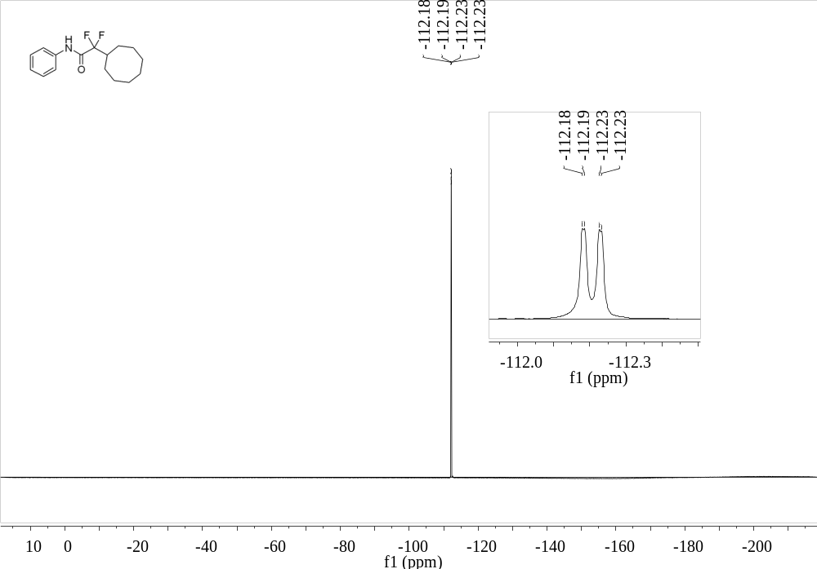
Supplementary Figure 60. ¹⁹F NMR (376 MHz, CDCl₃) spectrum of 20
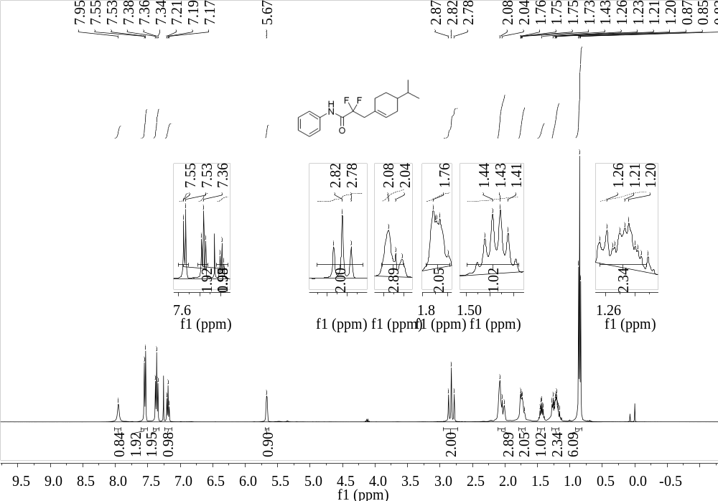
Supplementary Figure 61. ¹H NMR (400 MHz, CDCl₃) spectrum of 21

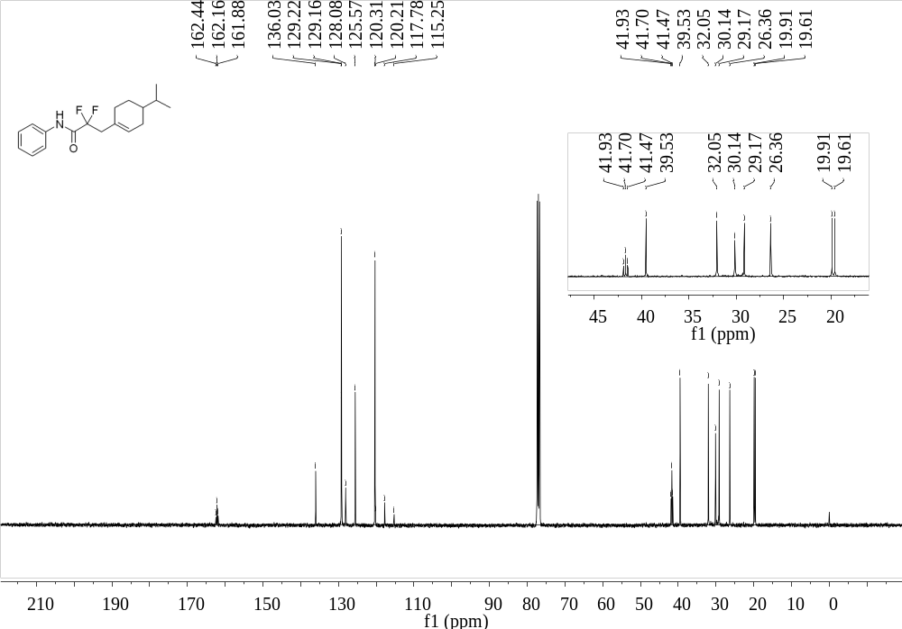
Supplementary Figure 62. ¹³C NMR (101 MHz, CDCl₃) spectrum of 21
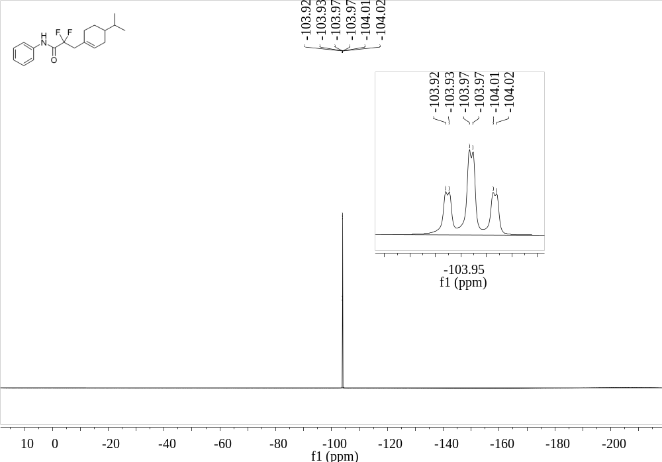
Supplementary Figure 63. ¹⁹F NMR (376 MHz, CDCl₃) spectrum of 21

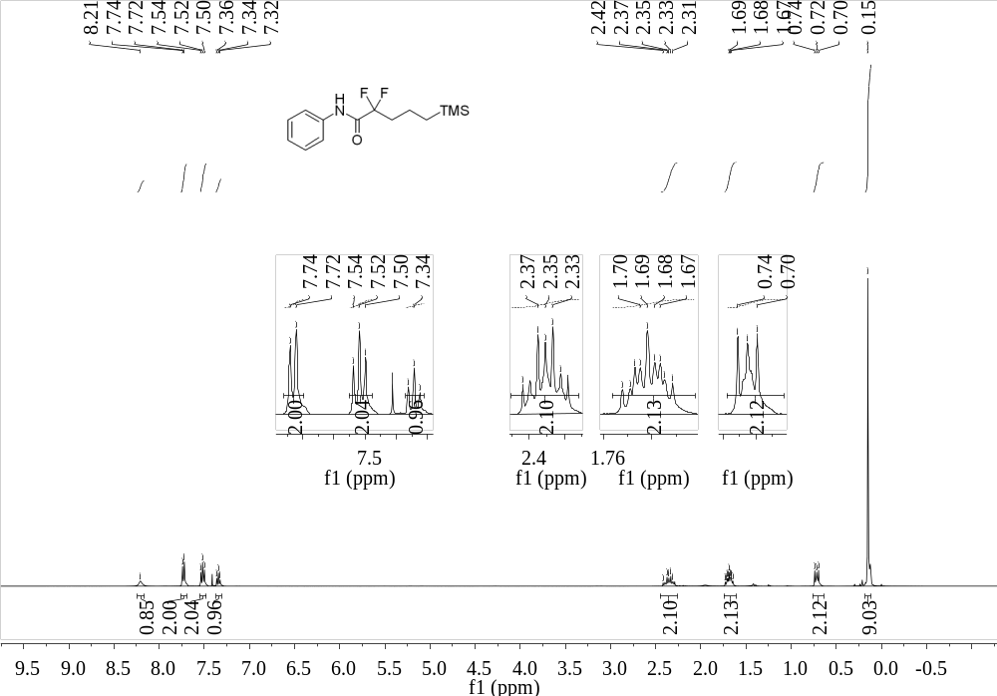
Supplementary Figure 64. ¹H NMR (400 MHz, CDCl₃) spectrum of 22
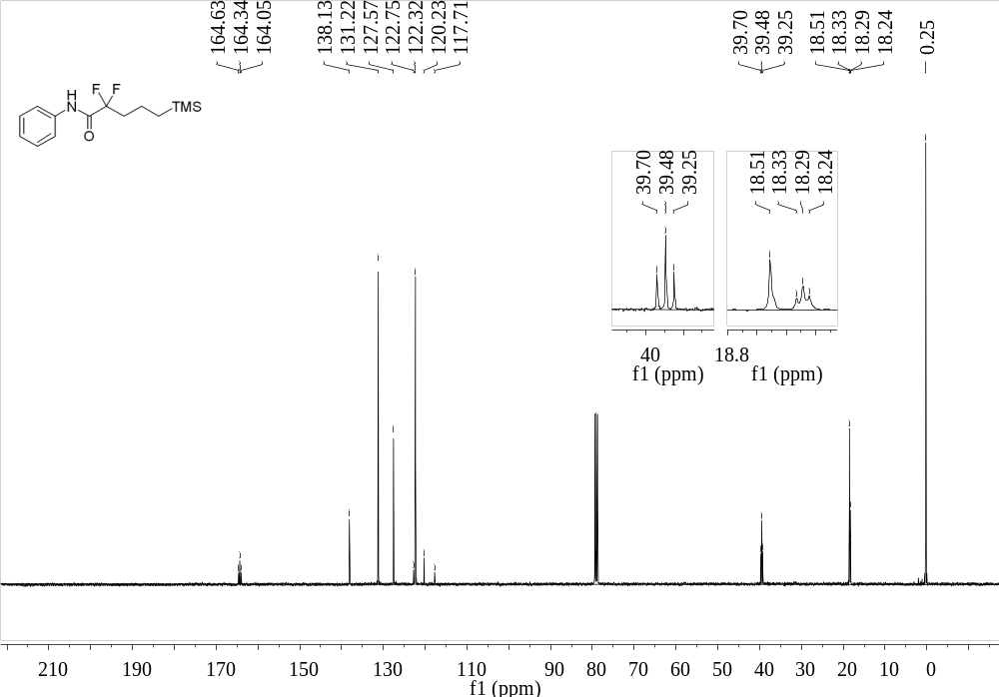
Supplementary Figure 65. ¹³C NMR (101 MHz, CDCl₃) spectrum of 22

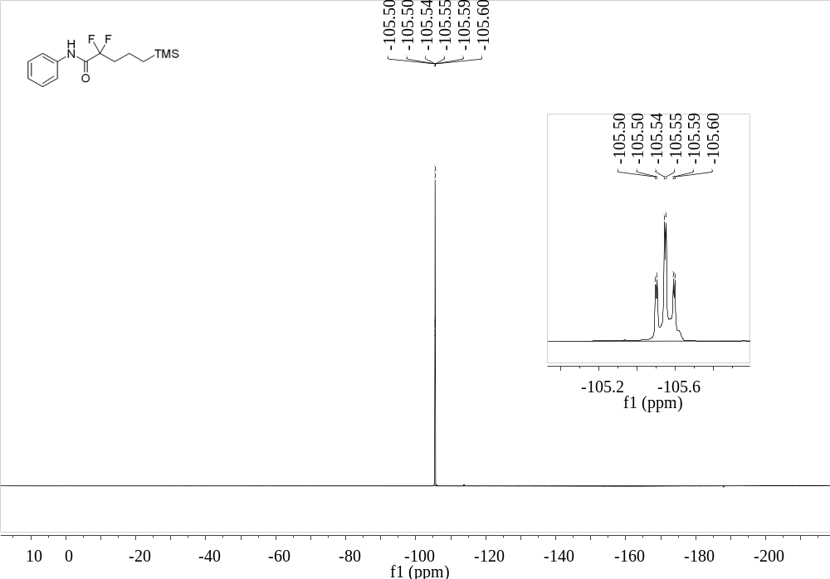
Supplementary Figure 66. ¹⁹F NMR (376 MHz, CDCl₃) spectrum of 22
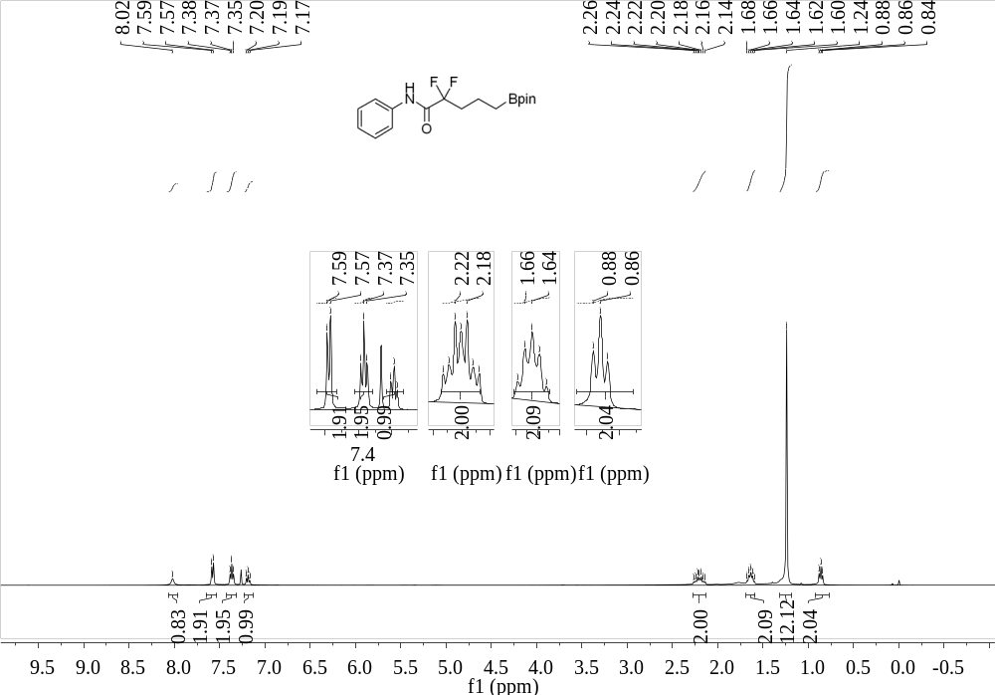
Supplementary Figure 67. ¹H NMR (400 MHz, CDCl₃) spectrum of 23

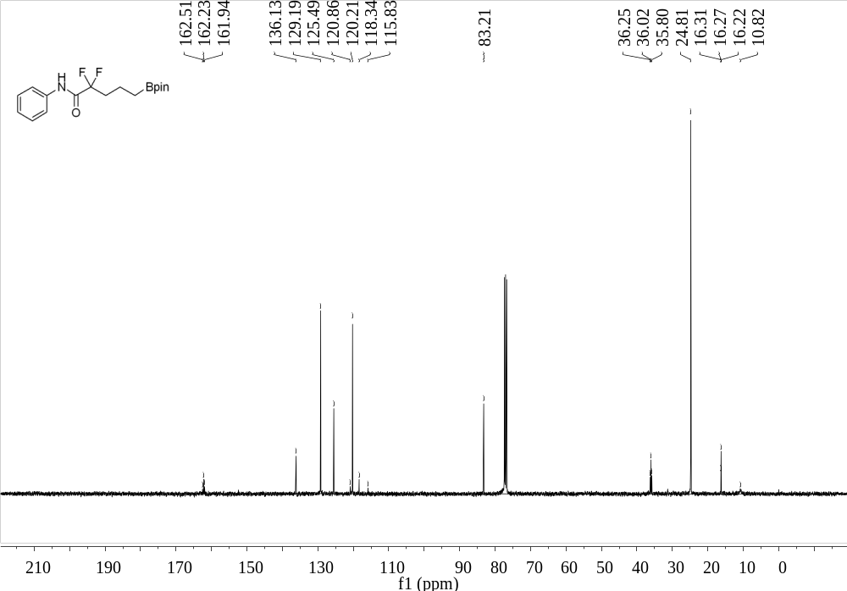
Supplementary Figure 68. ¹³C NMR (101 MHz, CDCl₃) spectrum of 23
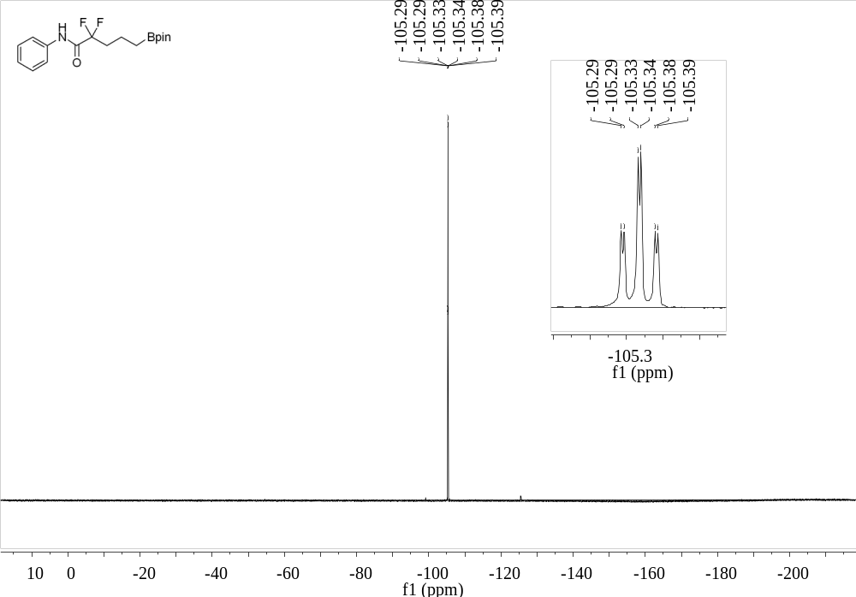
Supplementary Figure 69. ¹⁹F NMR (376 MHz, CDCl₃) spectrum of 23

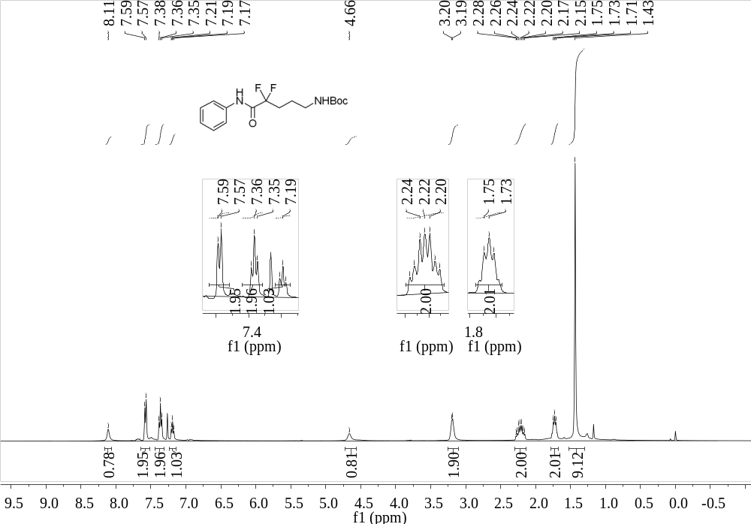
Supplementary Figure 70. ¹H NMR (400 MHz, CDCl₃) spectrum of 24
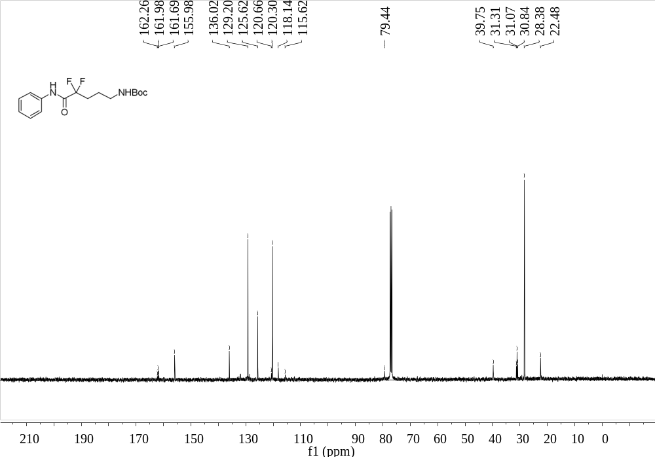
Supplementary Figure 71. ¹³C NMR (101 MHz, CDCl₃) spectrum of 24

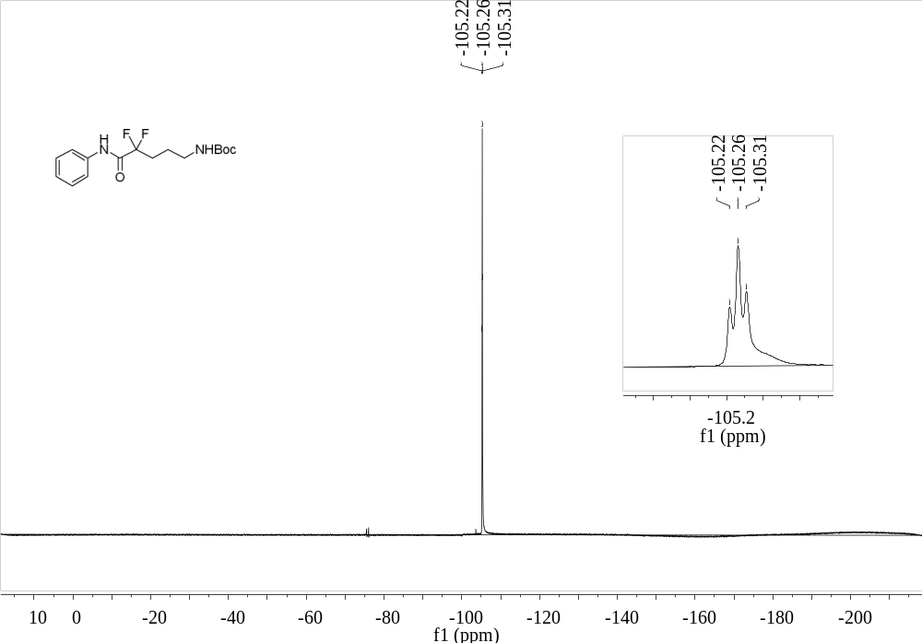
Supplementary Figure 72. ¹⁹F NMR (376 MHz, CDCl₃) spectrum of 24
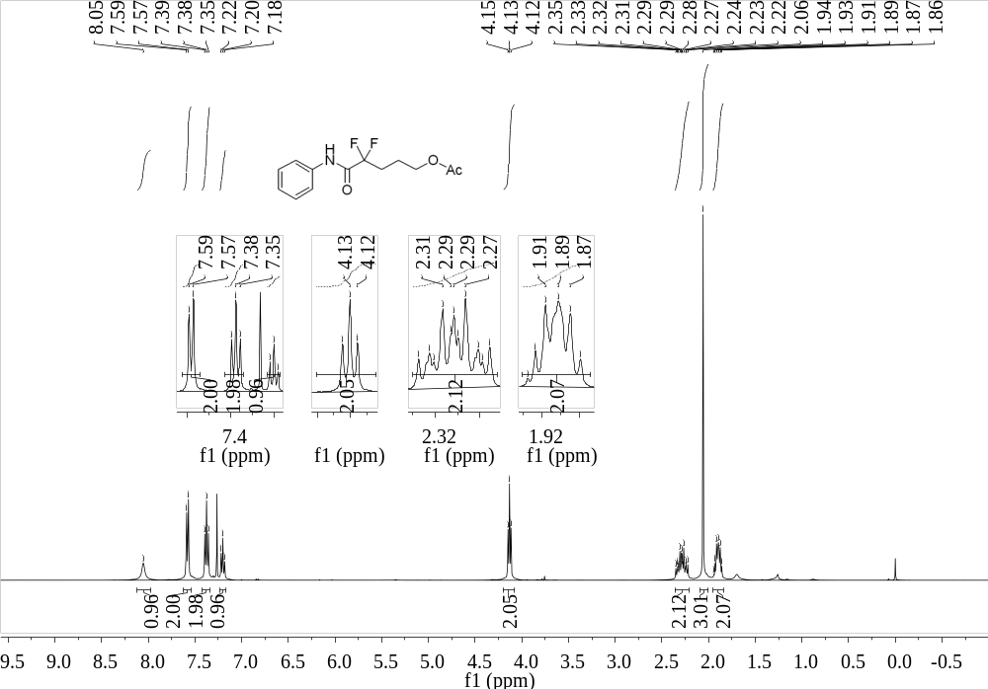
Supplementary Figure 73. ¹H NMR (400 MHz, CDCl₃) spectrum of 25

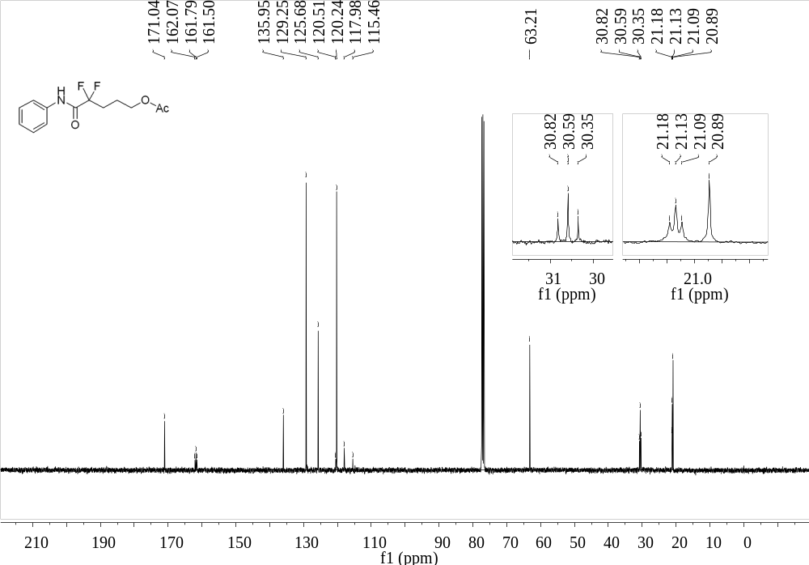
Supplementary Figure 74. ¹³C NMR (101 MHz, CDCl₃) spectrum of 25
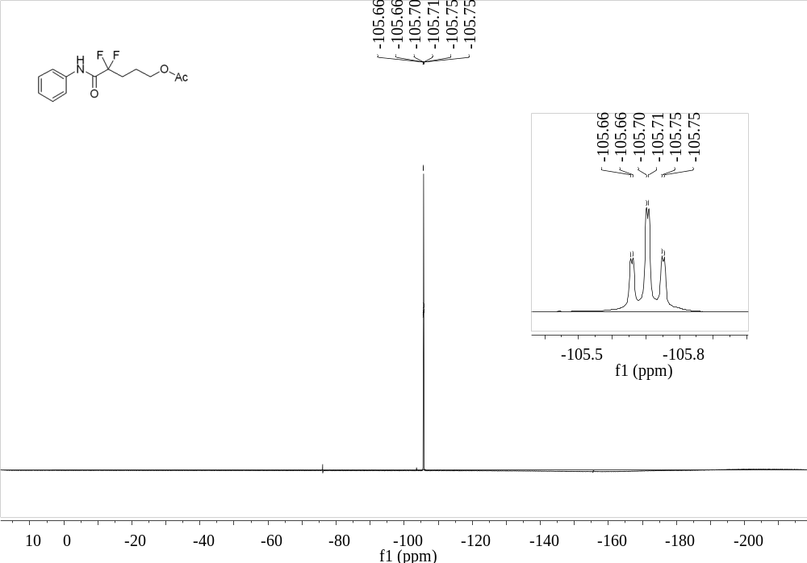
Supplementary Figure 75. ¹⁹F NMR (376 MHz, CDCl₃) spectrum of 25

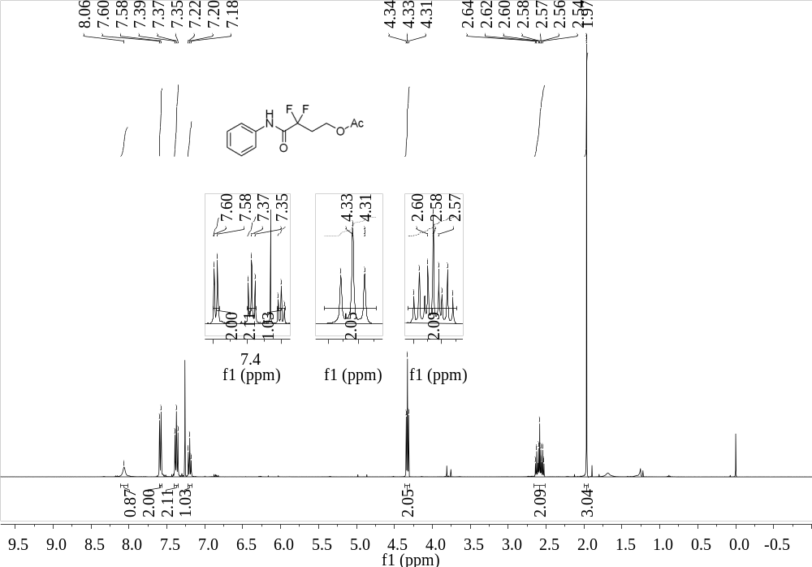
Supplementary Figure 76. ¹H NMR (400 MHz, CDCl₃) spectrum of 26
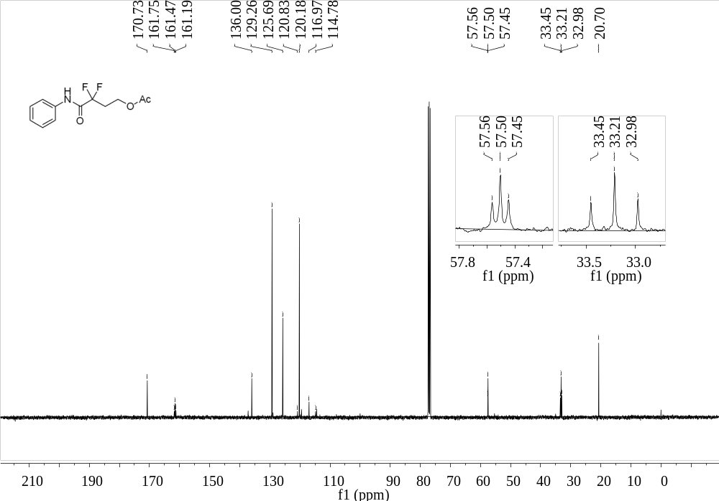
Supplementary Figure 77. ¹³C NMR (101 MHz, CDCl₃) spectrum of 26

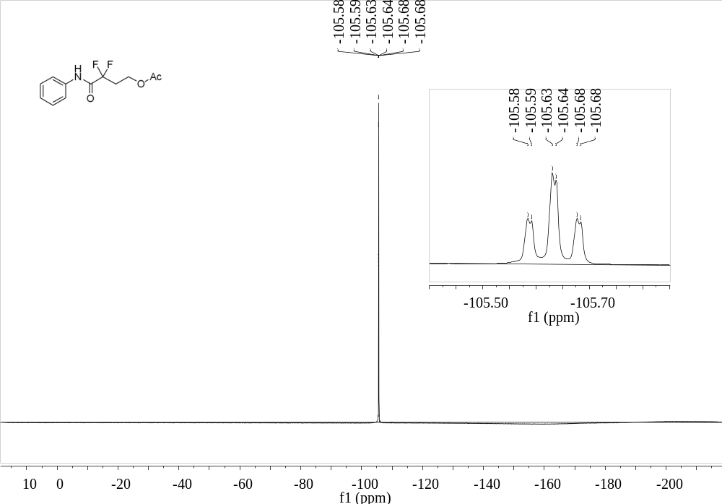
Supplementary Figure 78. ¹⁹F NMR (376 MHz, CDCl₃) spectrum of 26
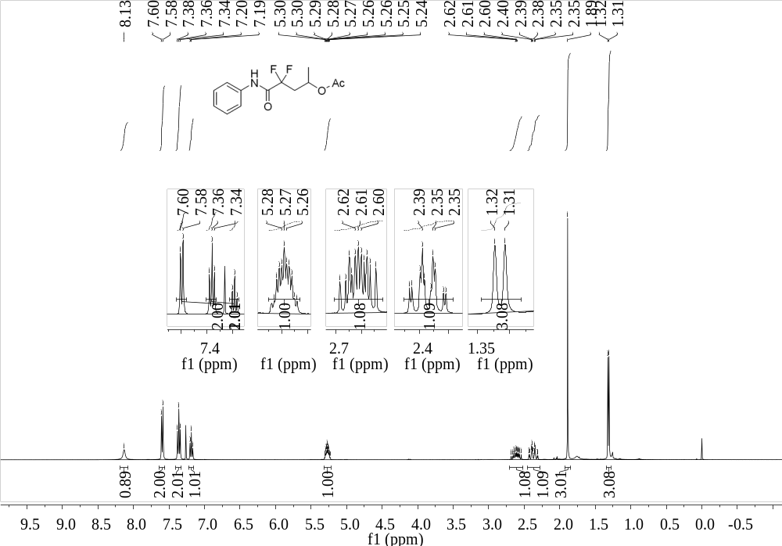
Supplementary Figure 79. ¹H NMR (400 MHz, CDCl₃) spectrum of 27

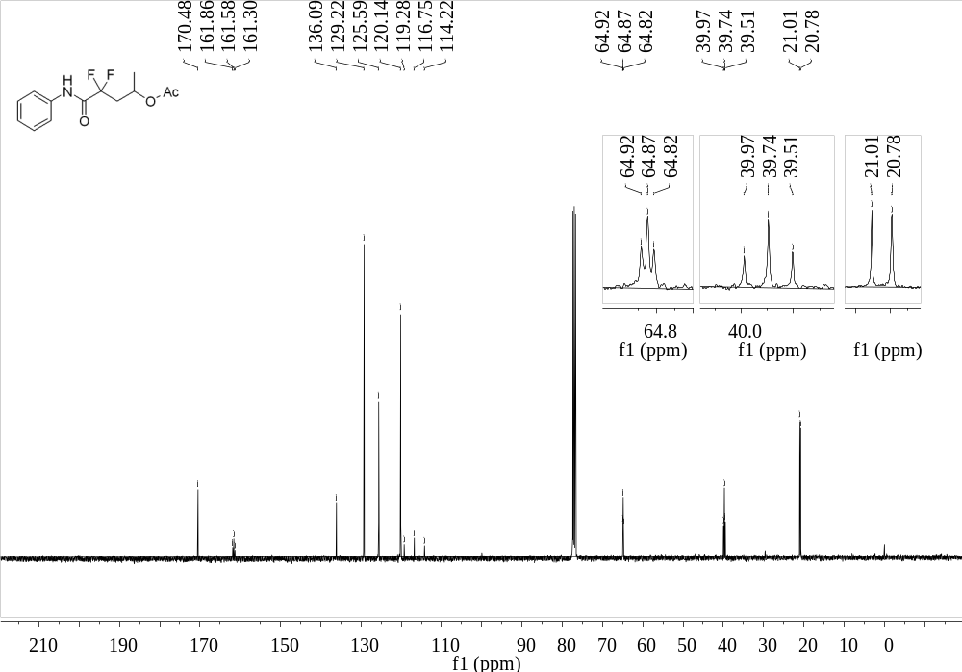
Supplementary Figure 80. ¹³C NMR (101 MHz, CDCl₃) spectrum of 27
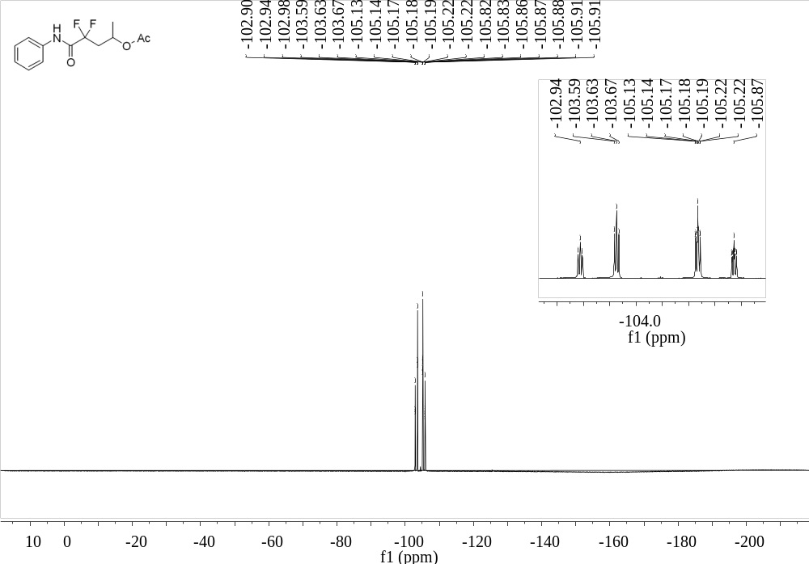
Supplementary Figure 81. ¹⁹F NMR (376 MHz, CDCl₃) spectrum of 27

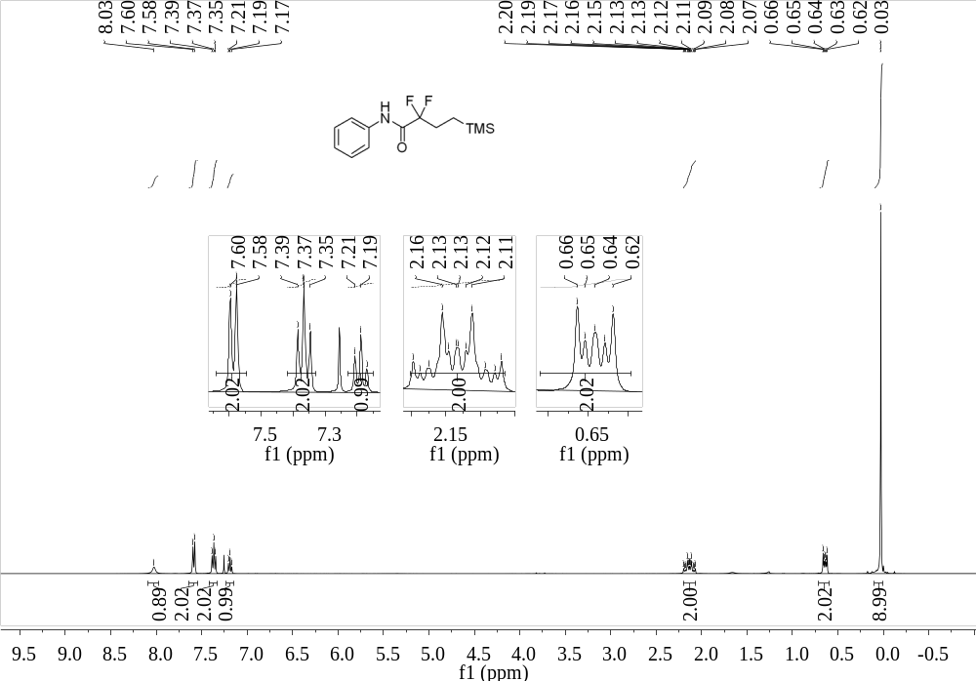
Supplementary Figure 82. ¹H NMR (400 MHz, CDCl₃) spectrum of 28
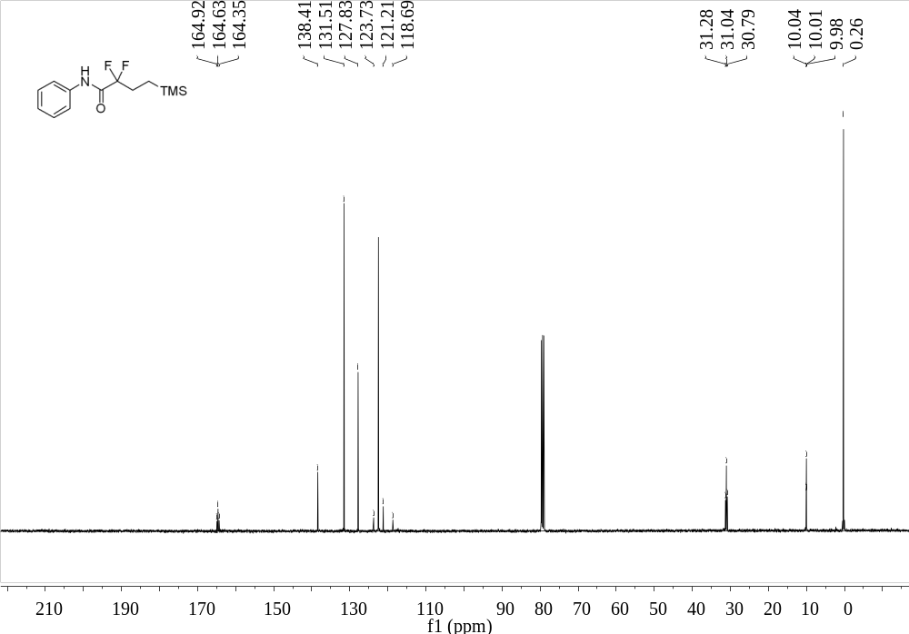
Supplementary Figure 83. ¹³C NMR (101 MHz, CDCl₃) spectrum of 28

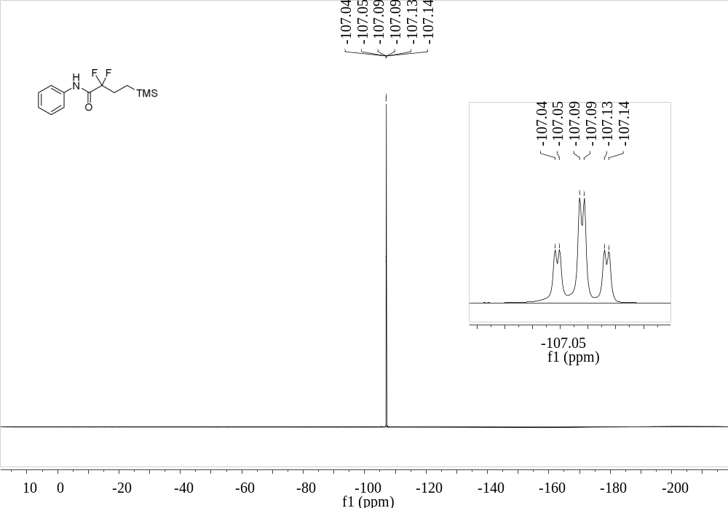
Supplementary Figure 84. ¹⁹F NMR (376 MHz, CDCl₃) spectrum of 28
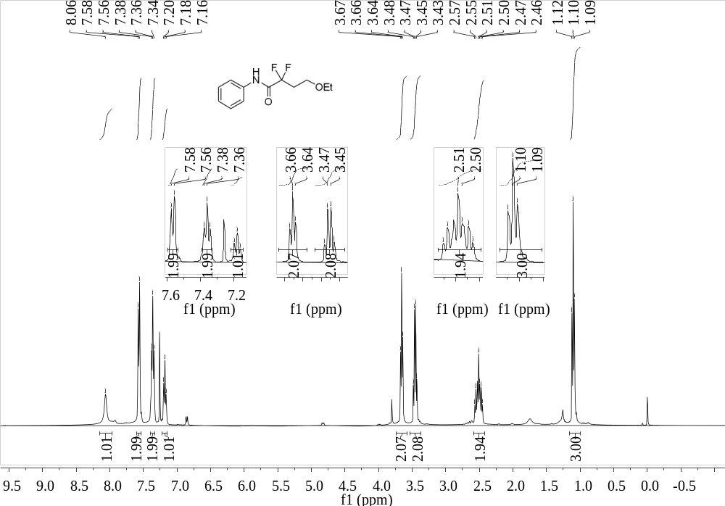
Supplementary Figure 85. ¹H NMR (400 MHz, CDCl₃) spectrum of 29

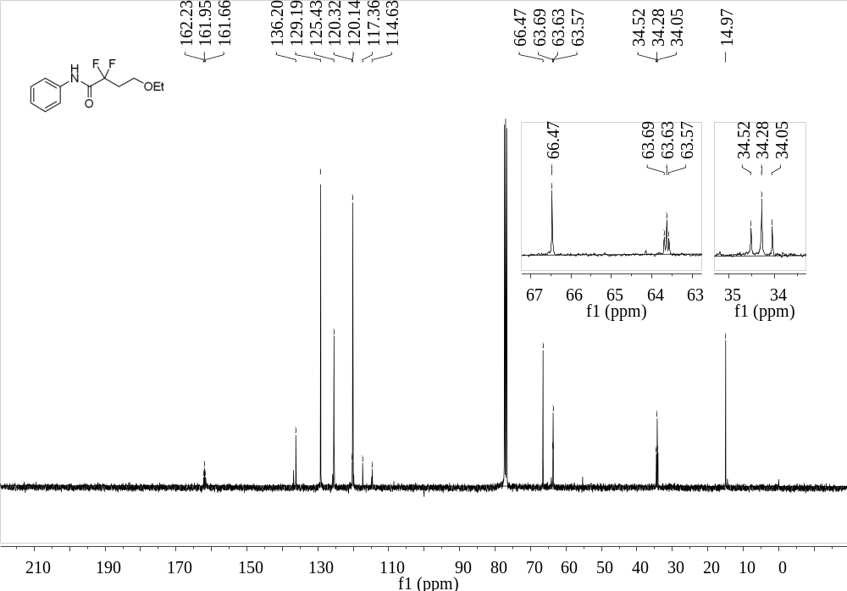
Supplementary Figure 86. ¹³C NMR (101 MHz, CDCl₃) spectrum of 29
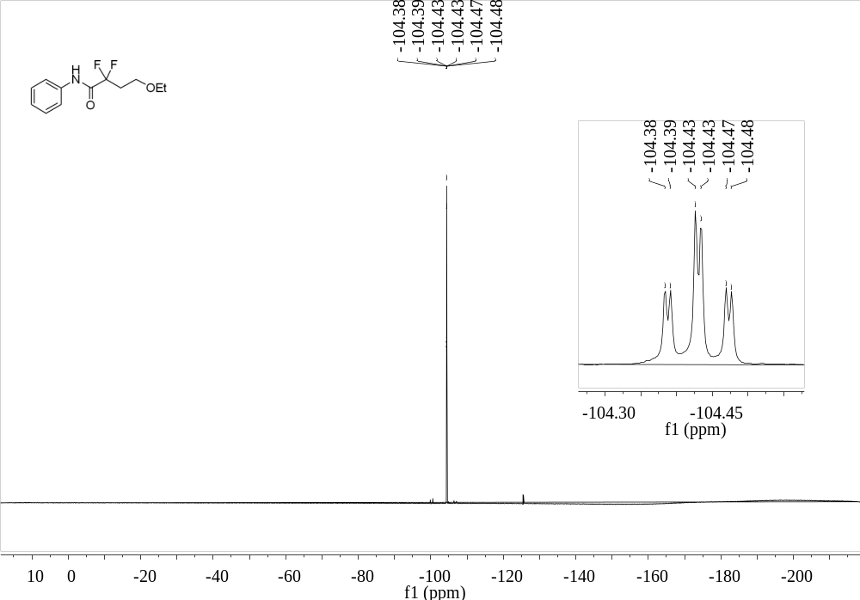
Supplementary Figure 87. ¹⁹F NMR (376 MHz, CDCl₃) spectrum of 29

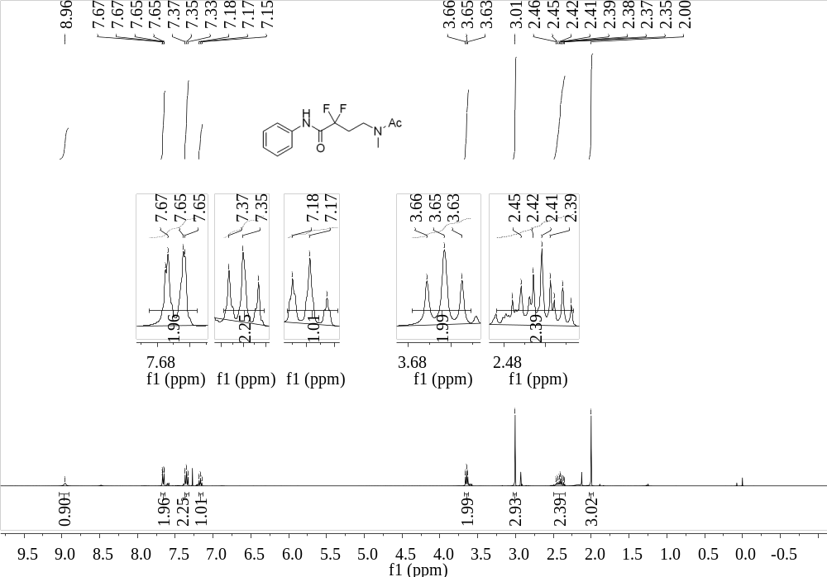
Supplementary Figure 88. ¹H NMR (400 MHz, CDCl₃) spectrum of 30
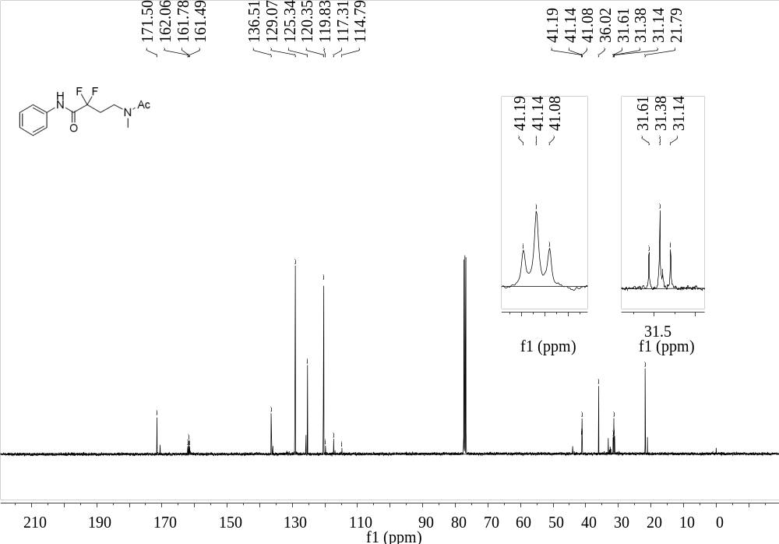
Supplementary Figure 89. ¹³C NMR (101 MHz, CDCl₃) spectrum of 30

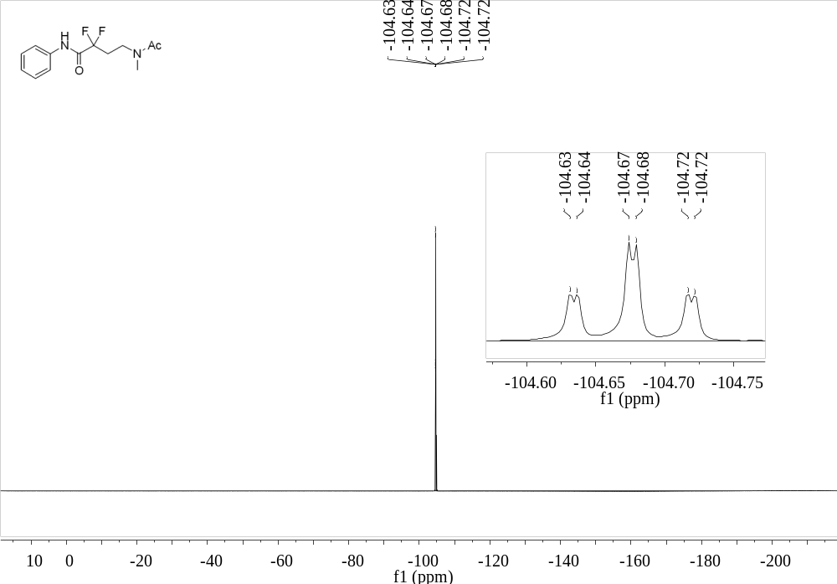
Supplementary Figure 90. ¹⁹F NMR (376 MHz, CDCl₃) spectrum of 30
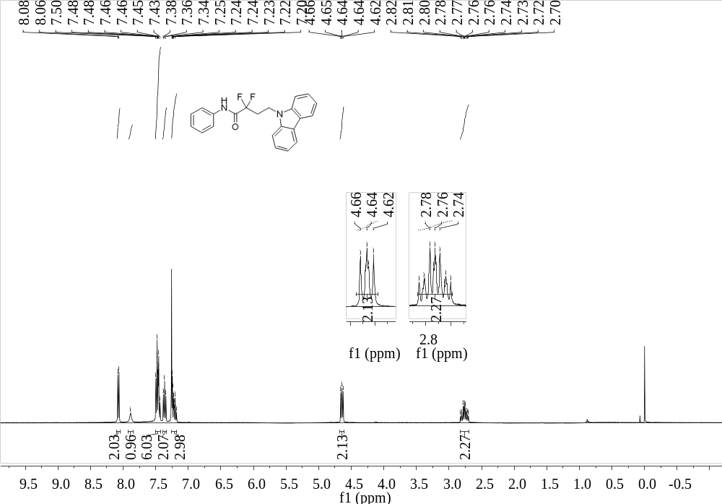
Supplementary Figure 91. ¹H NMR (400 MHz, CDCl₃) spectrum of 31

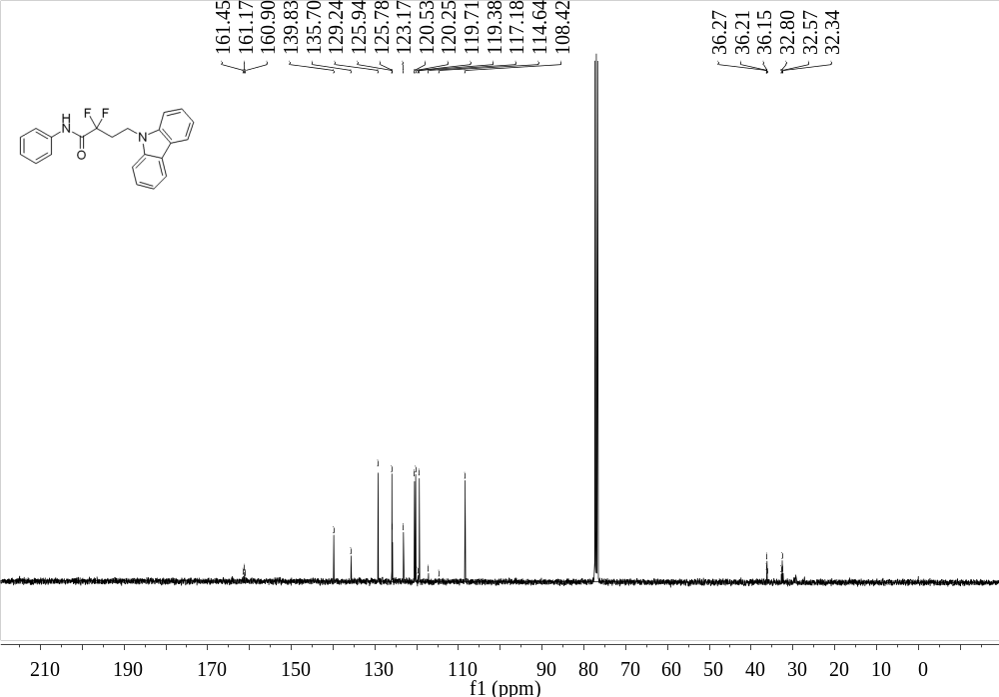
Supplementary Figure 92. ¹³C NMR (101 MHz, CDCl₃) spectrum of 31
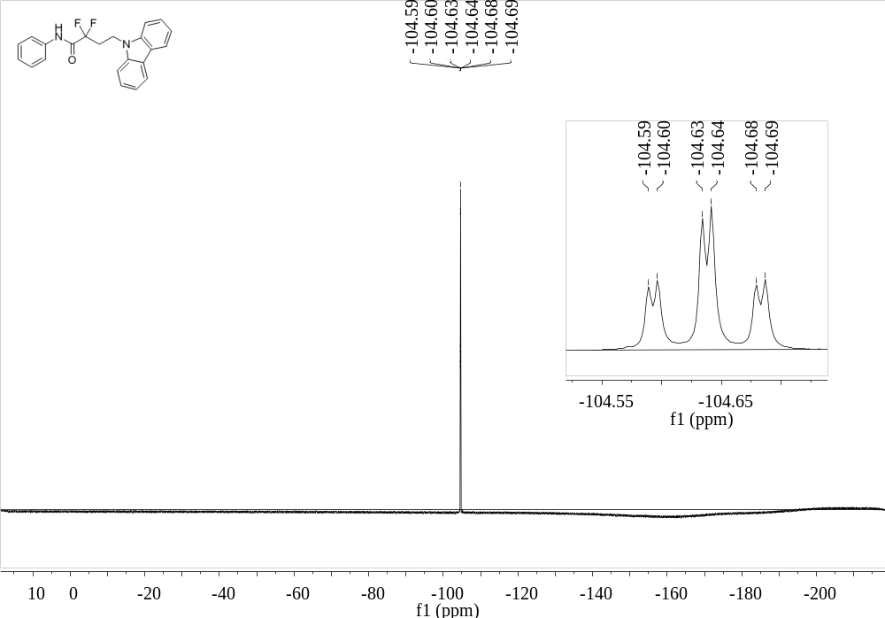
Supplementary Figure 93. ¹⁹F NMR (376 MHz, CDCl₃) spectrum of 31

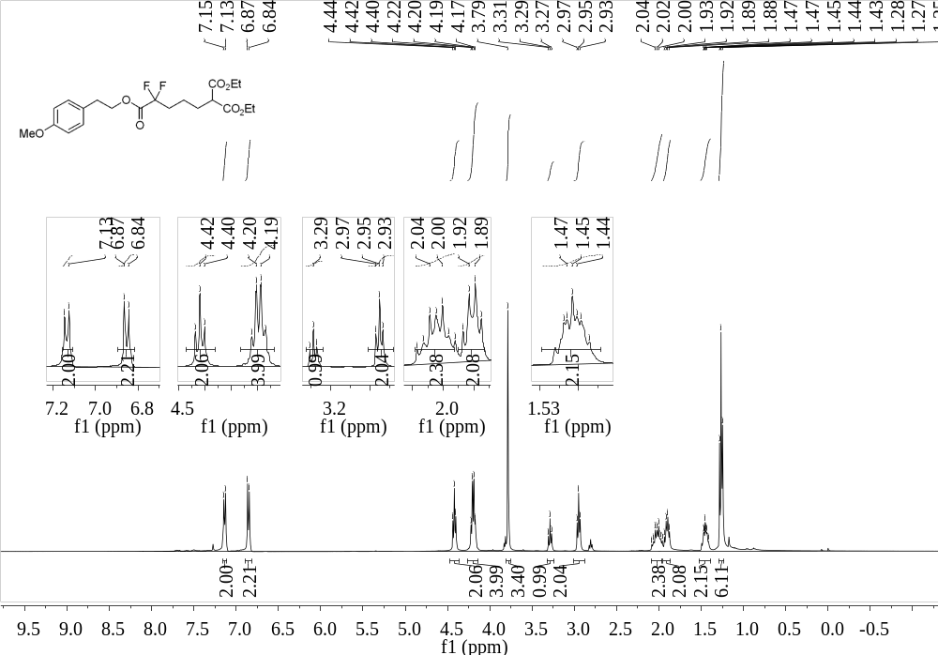
Supplementary Figure 94. ¹H NMR (400 MHz, CDCl₃) spectrum of 32
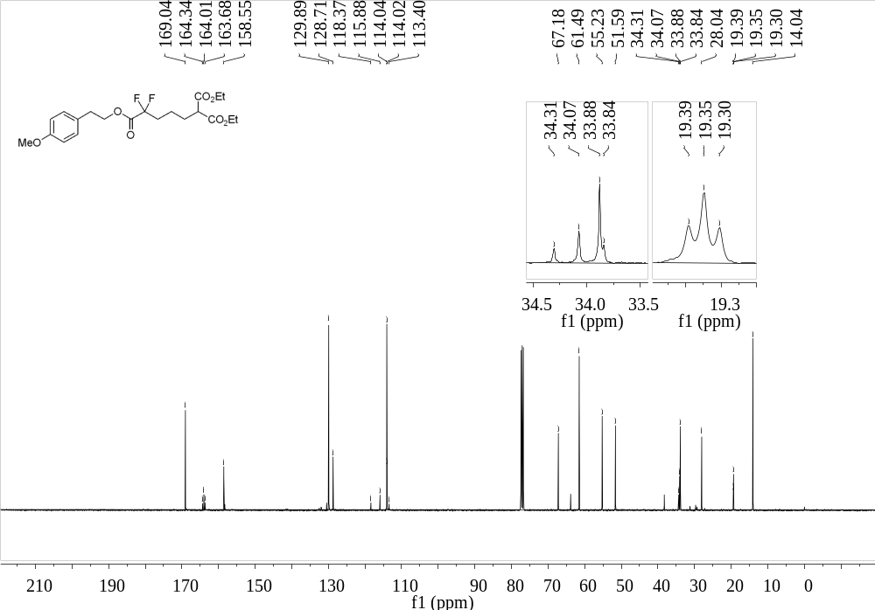
Supplementary Figure 95. ¹³C NMR (101 MHz, CDCl₃) spectrum of 32

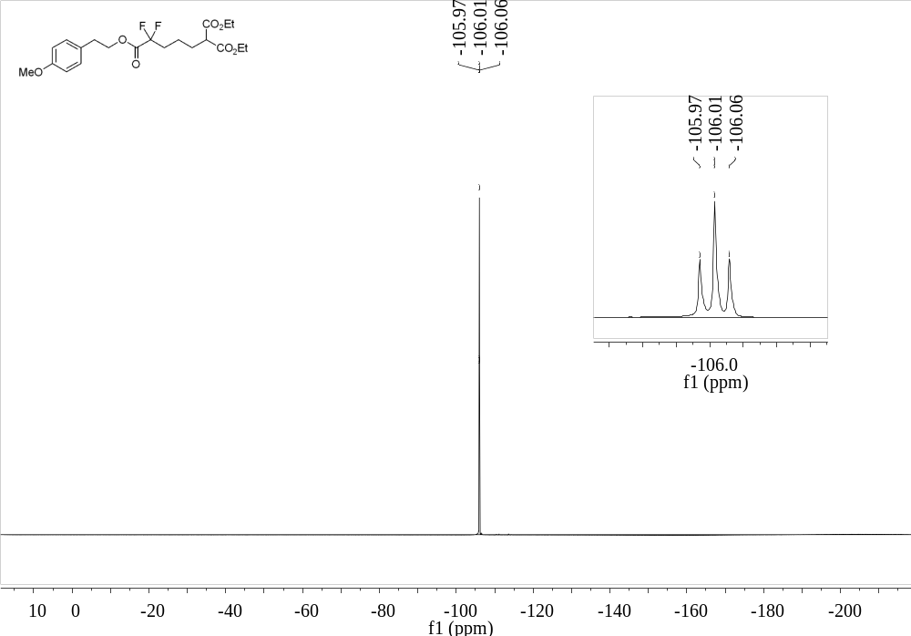
Supplementary Figure 96. ¹⁹F NMR (376 MHz, CDCl₃) spectrum of 32
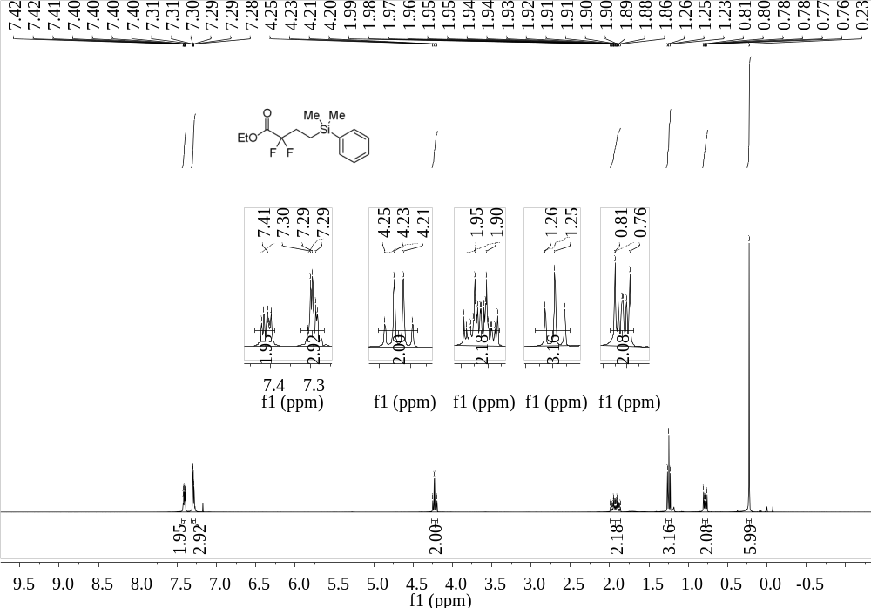
Supplementary Figure 97. ¹H NMR (400 MHz, CDCl₃) spectrum of 33

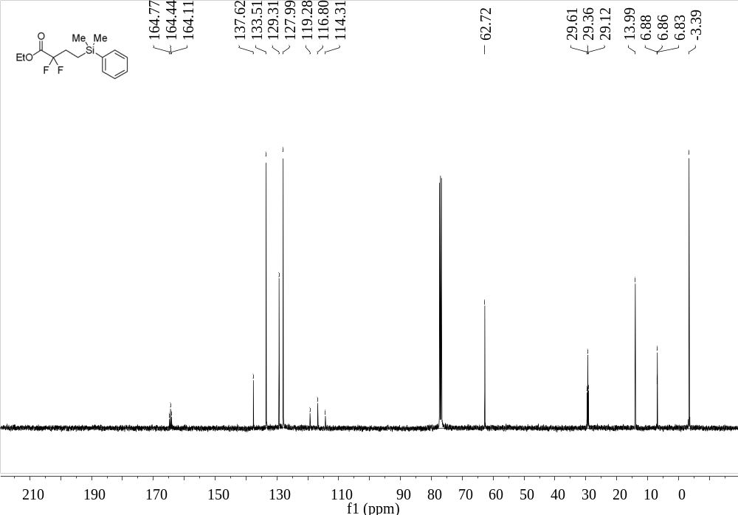
Supplementary Figure 98. ¹³C NMR (101 MHz, CDCl₃) spectrum of 33
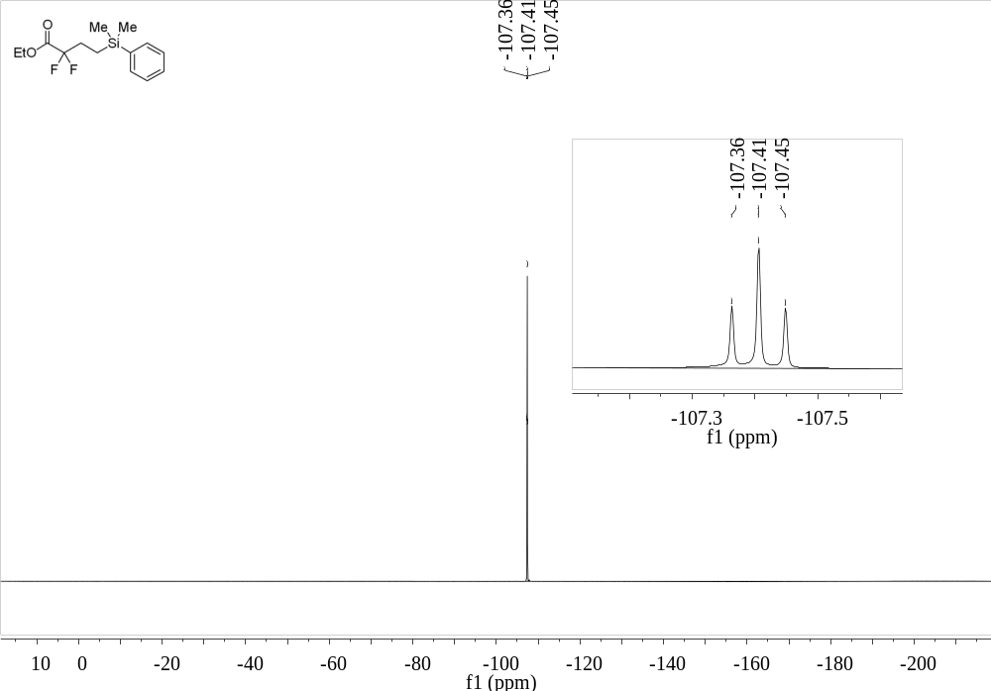
Supplementary Figure 99. ¹⁹F NMR (376 MHz, CDCl₃) spectrum of 33

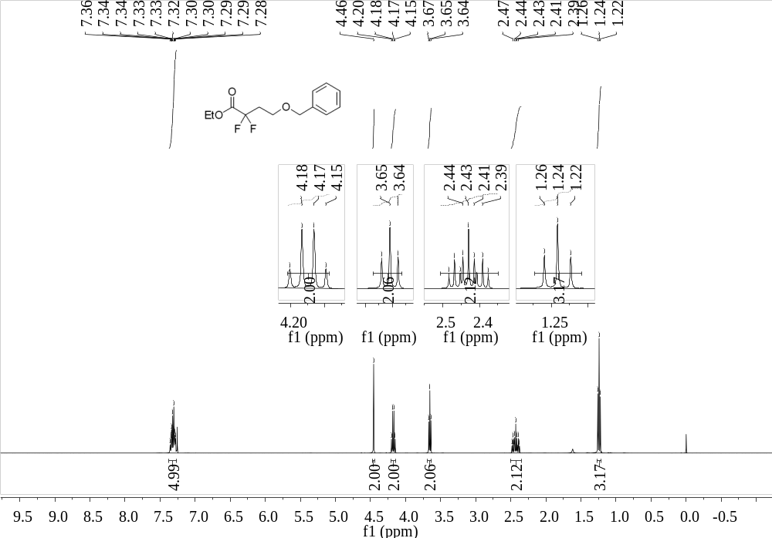
Supplementary Figure 100. ¹H NMR (400 MHz, CDCl₃) spectrum of 34
¹³C NMR (101 MHz, CDCl₃) spectrum of ethyl 4-(benzyloxy)-2,2-difluorobutanoate (34)
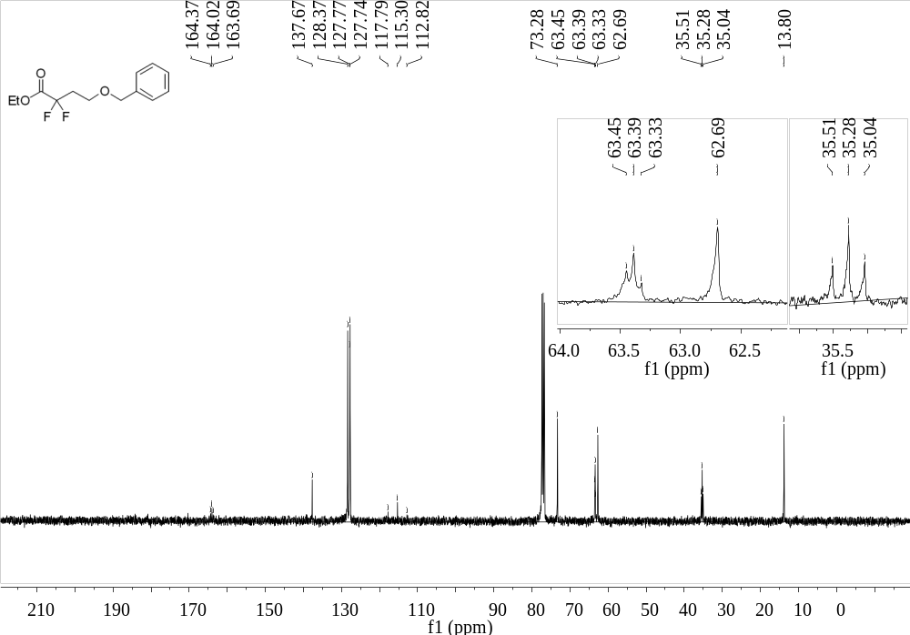
Supplementary Figure 101. ¹³C NMR (101 MHz, CDCl₃) spectrum of 34

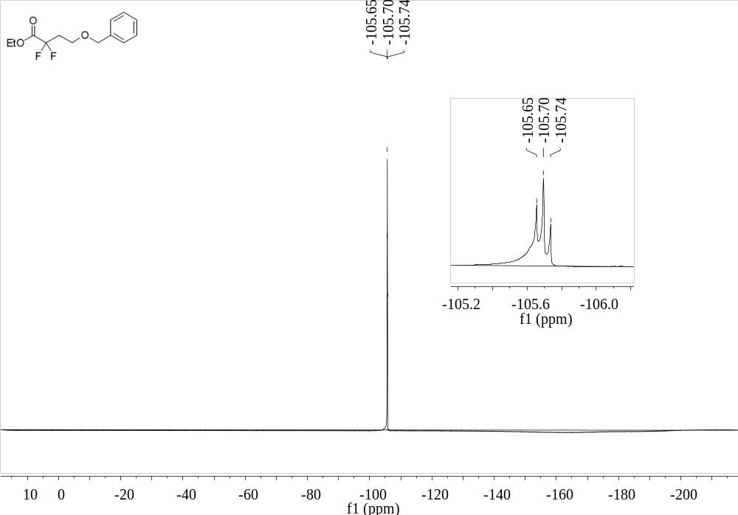
Supplementary Figure 102. ¹⁹F NMR (376 MHz, CDCl₃) spectrum of 34
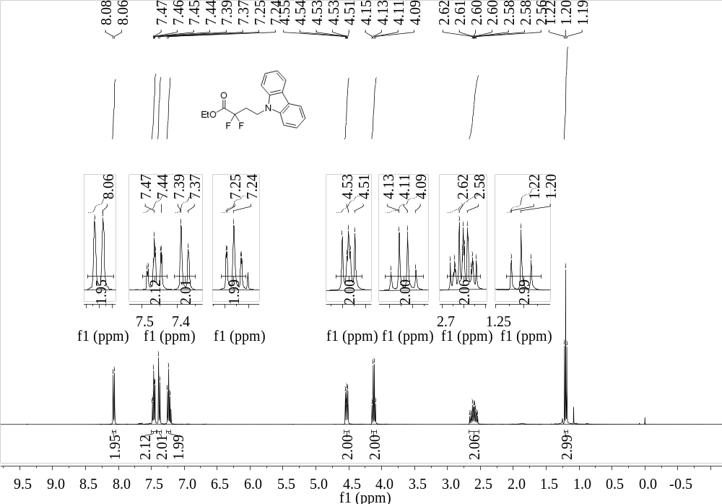
Supplementary Figure 103. ¹H NMR (400 MHz, CDCl₃) spectrum of 35

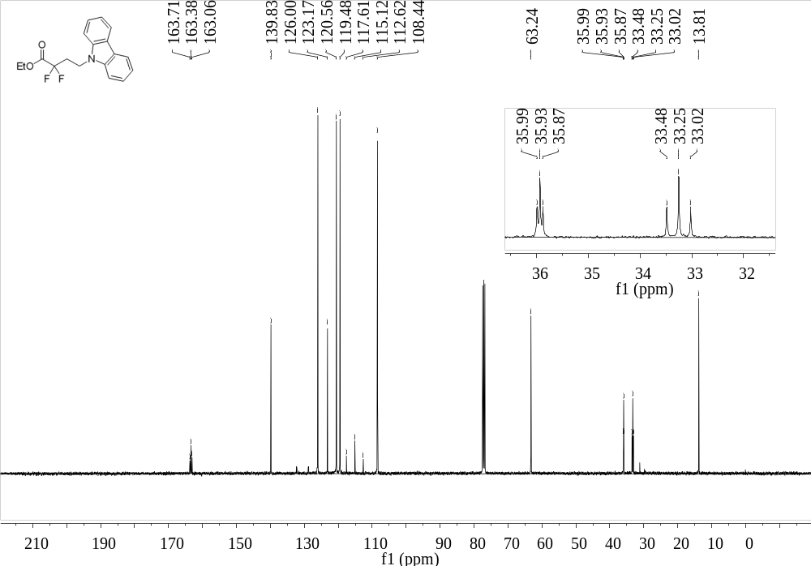
Supplementary Figure 104. ¹³C NMR (101 MHz, CDCl₃) spectrum of 35
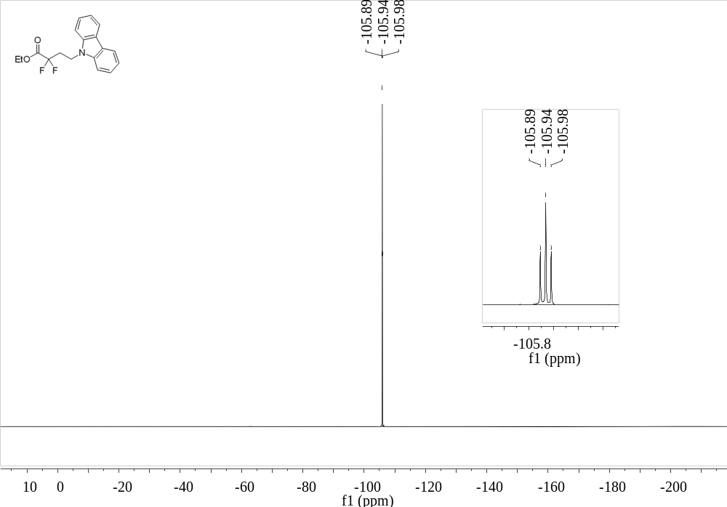
Supplementary Figure 105. ¹⁹F NMR (376 MHz, CDCl₃) spectrum of 35

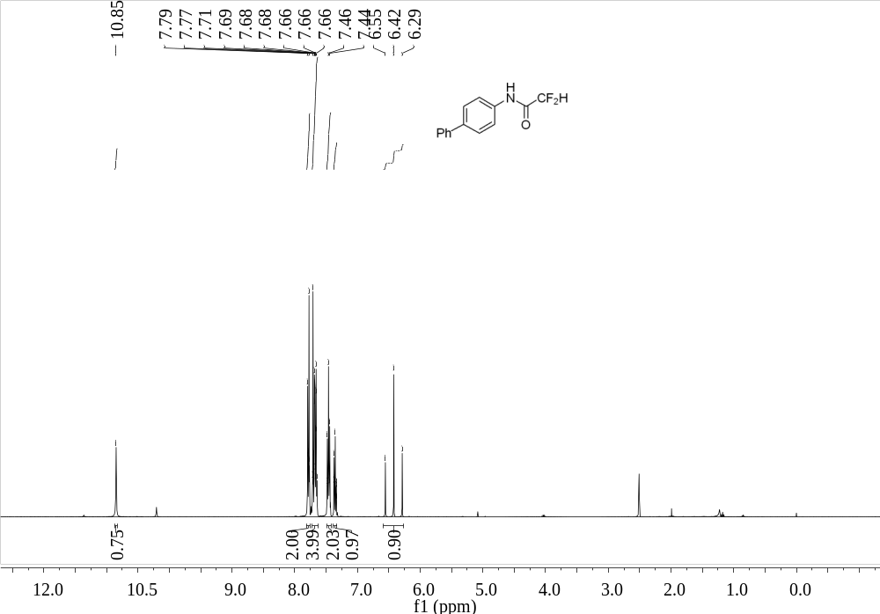
Supplementary Figure 106. ¹H NMR (400 MHz, d₆-DMSO) spectrum of 36
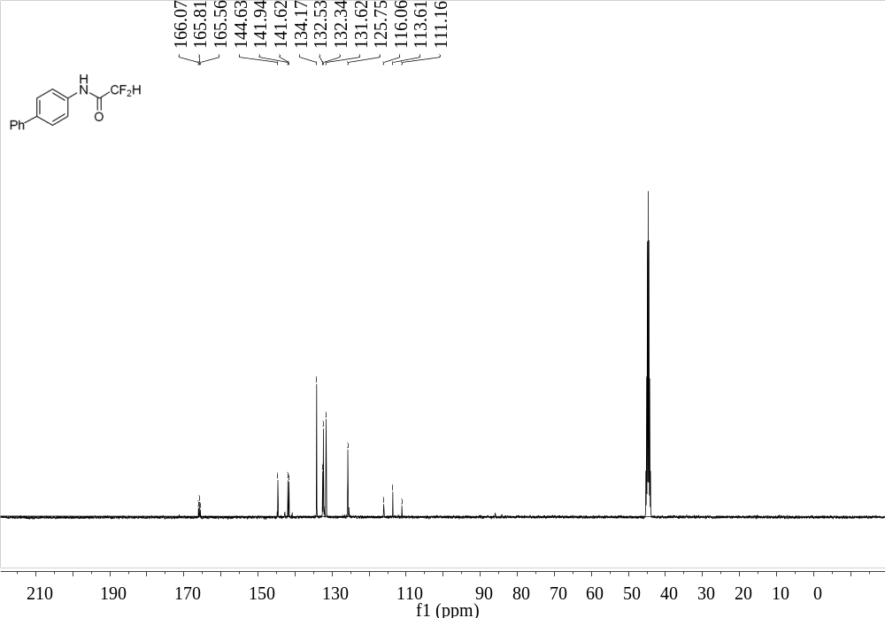
Supplementary Figure 107. ¹³C NMR (101 MHz, d₆-DMSO) spectrum of 36

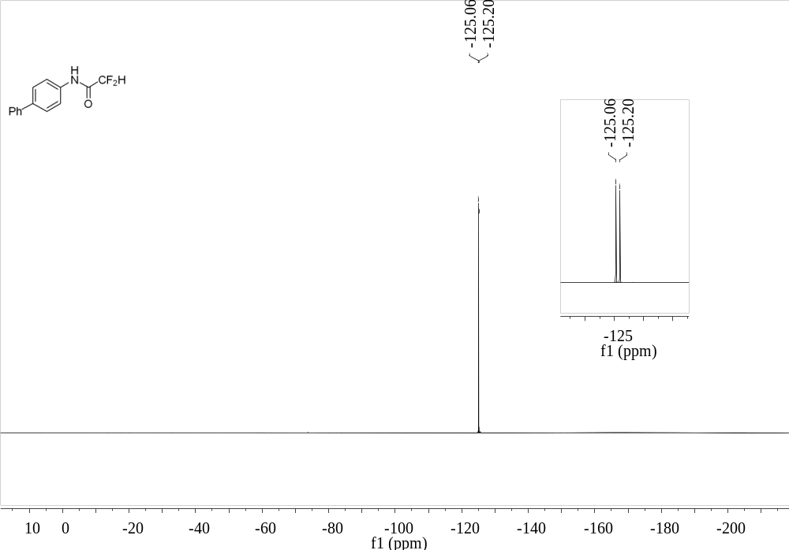
Supplementary Figure 108. ¹⁹F NMR (376 MHz, d₆-DMSO) spectrum of 36
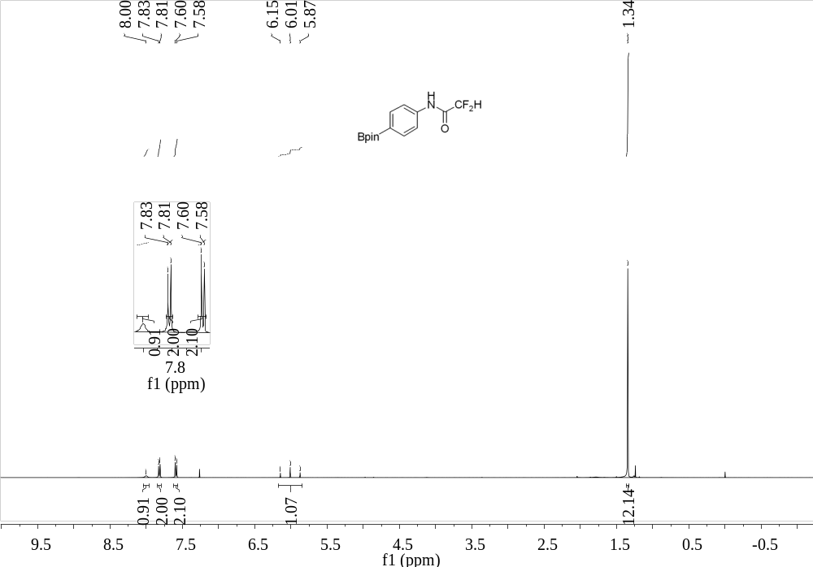
Supplementary Figure 109. ¹H NMR (400 MHz, CDCl₃) spectrum of 37

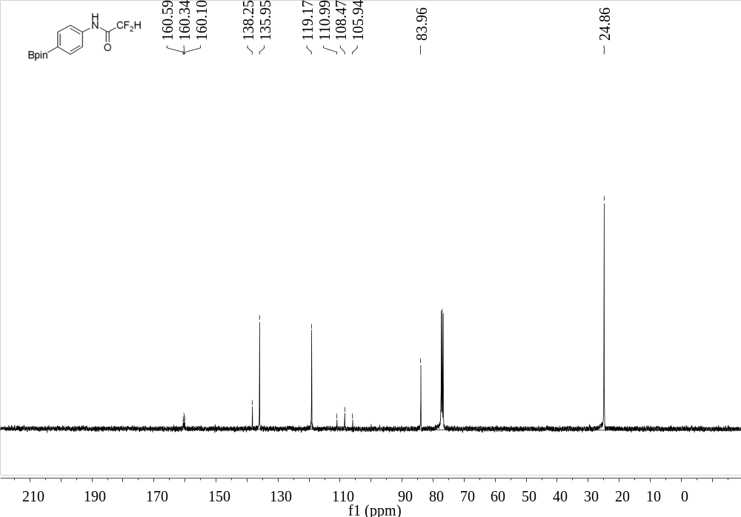
Supplementary Figure 110. ¹³C NMR (101 MHz, CDCl₃) spectrum of 37
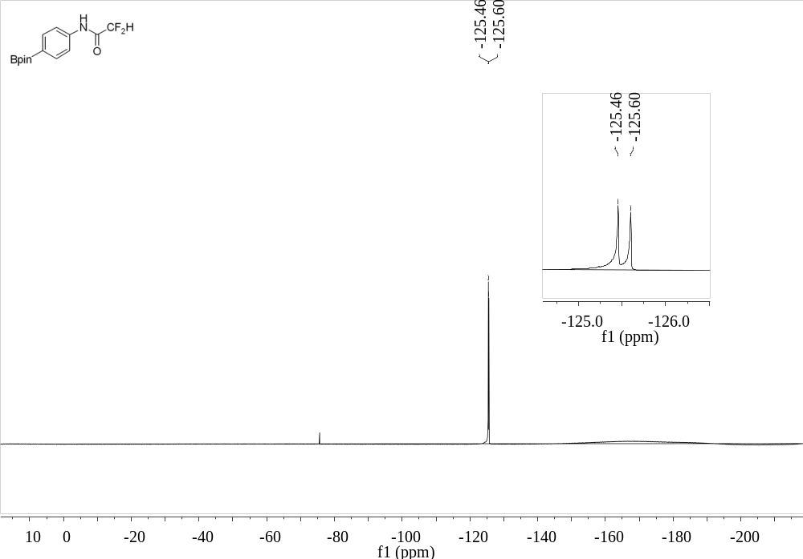
Supplementary Figure 111. ¹⁹F NMR (376 MHz, CDCl₃) spectrum of 37

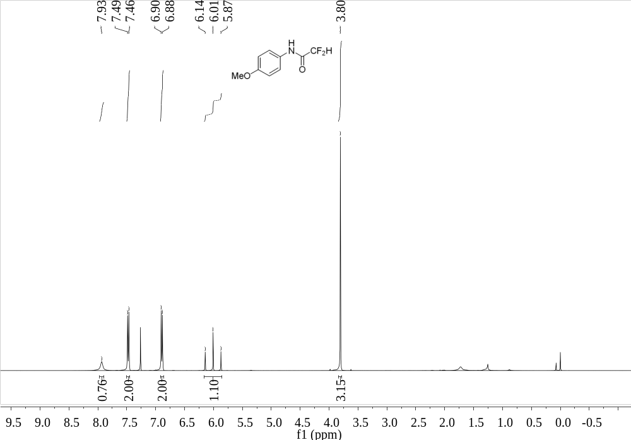
Supplementary Figure 112. ¹H NMR (400 MHz, CDCl₃) spectrum of 38
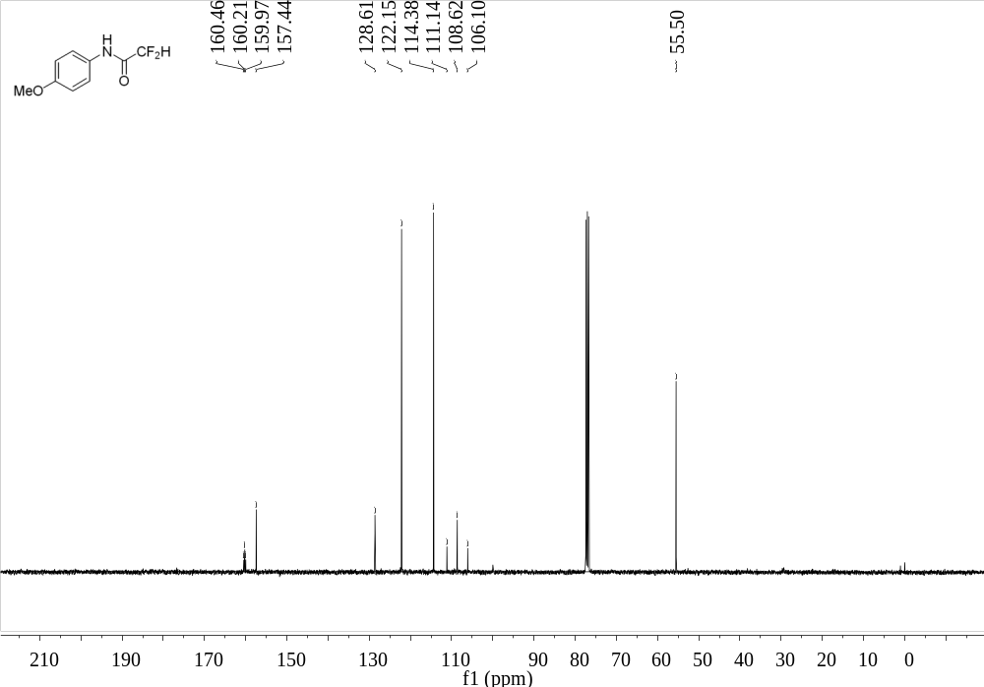
Supplementary Figure 113. ¹³C NMR (101 MHz, CDCl₃) spectrum of 38

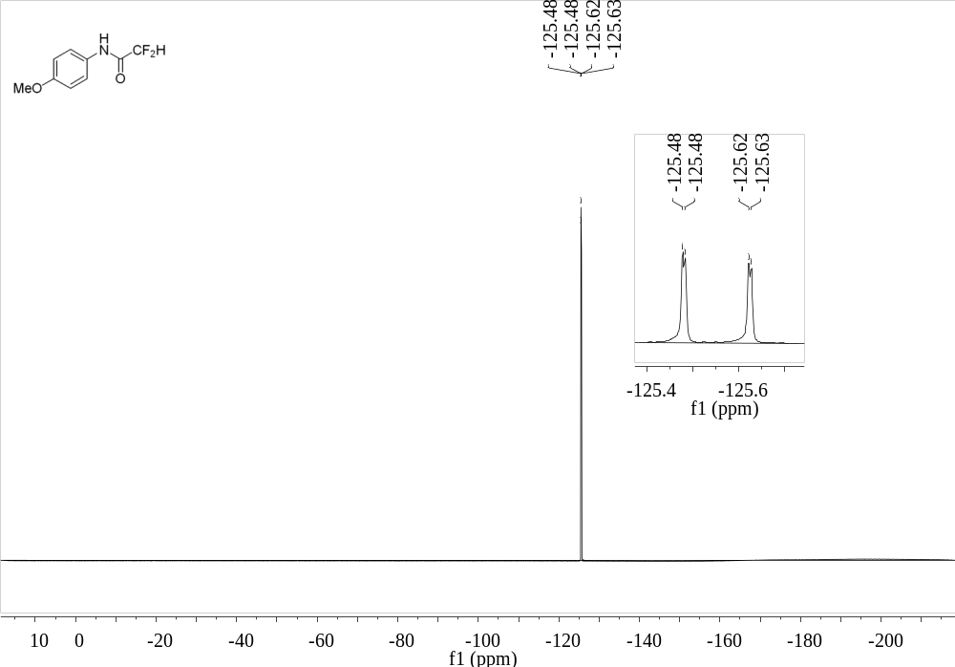
Supplementary Figure 114. ¹⁹F NMR (376 MHz, CDCl₃) spectrum of 38
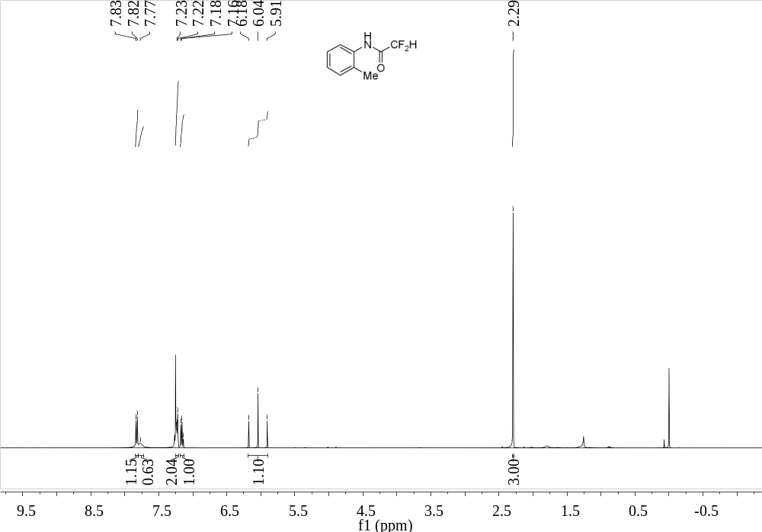
Supplementary Figure 115. ¹H NMR (400 MHz, CDCl₃) spectrum of 39

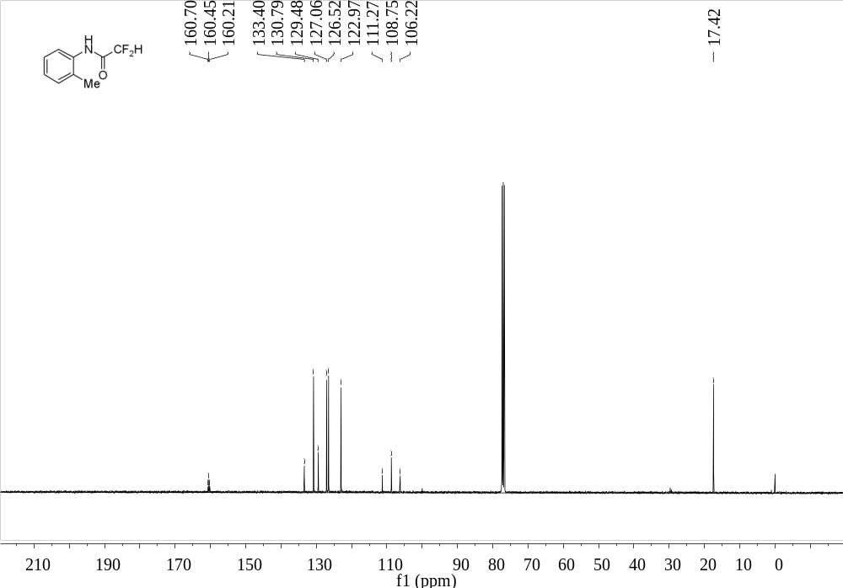
Supplementary Figure 116. ¹³C NMR (101 MHz, CDCl₃) spectrum of 39
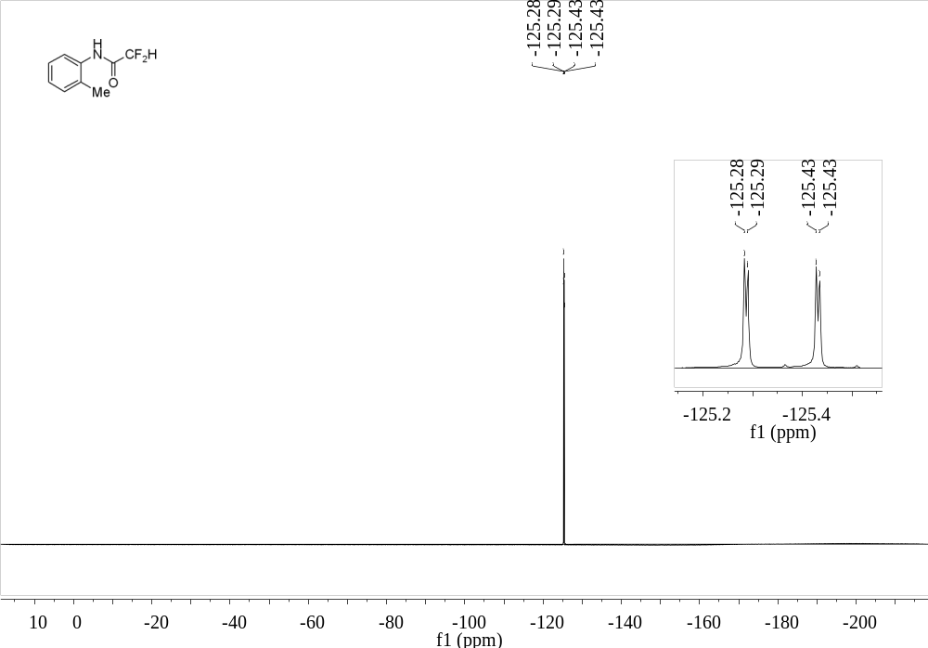
Supplementary Figure 117. ¹⁹F NMR (376 MHz, CDCl₃) spectrum of 39

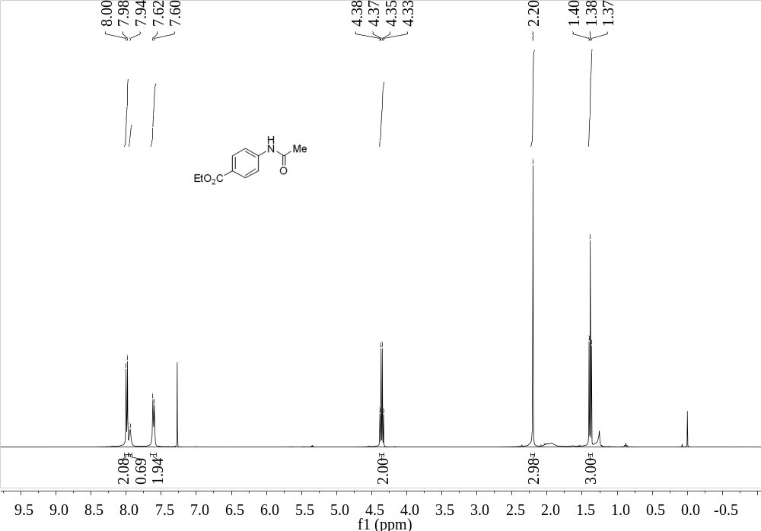
Supplementary Figure 118. ¹H NMR (400 MHz, CDCl₃) spectrum of 40
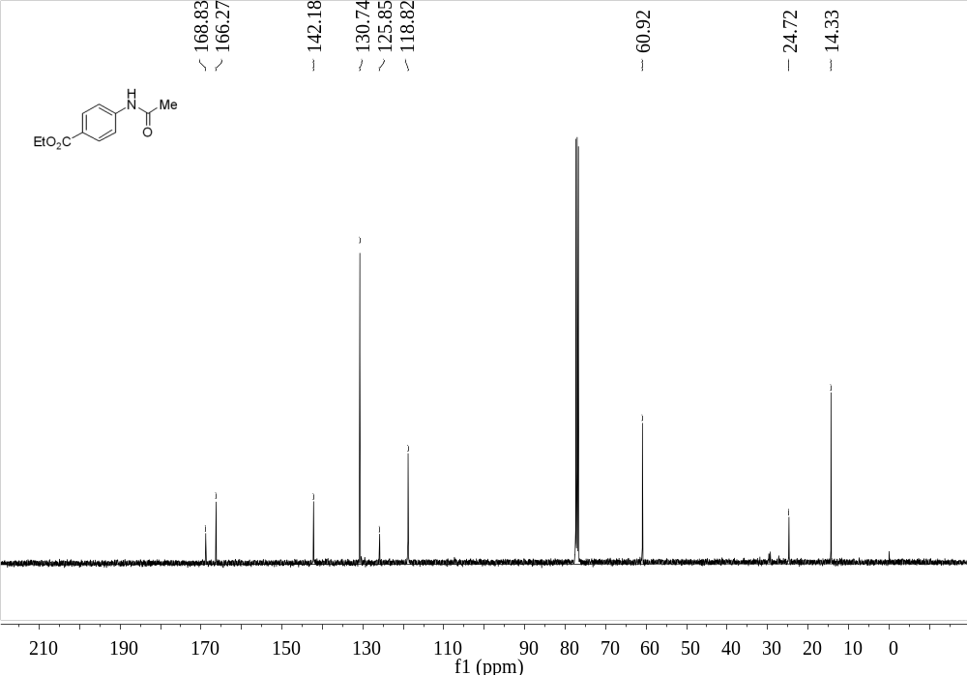
Supplementary Figure 119. ¹³C NMR (101 MHz, CDCl₃) spectrum of 40

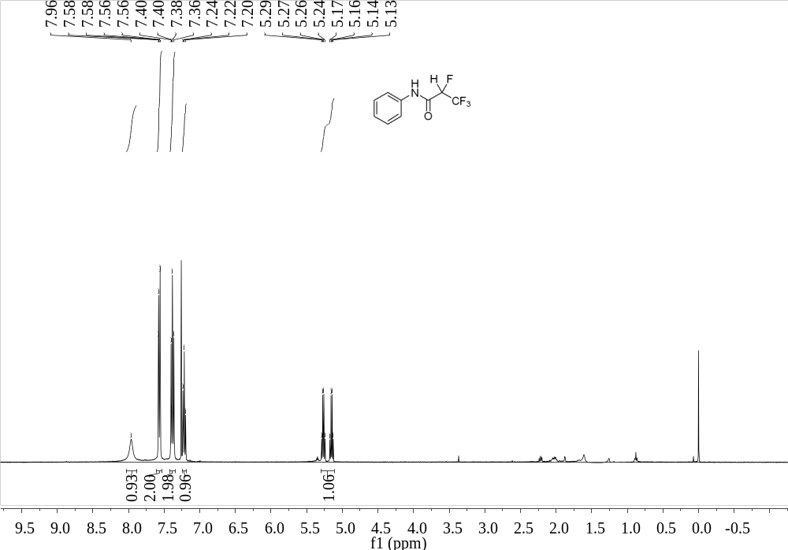
Supplementary Figure 120. ¹H NMR (400 MHz, CDCl₃) spectrum of 41
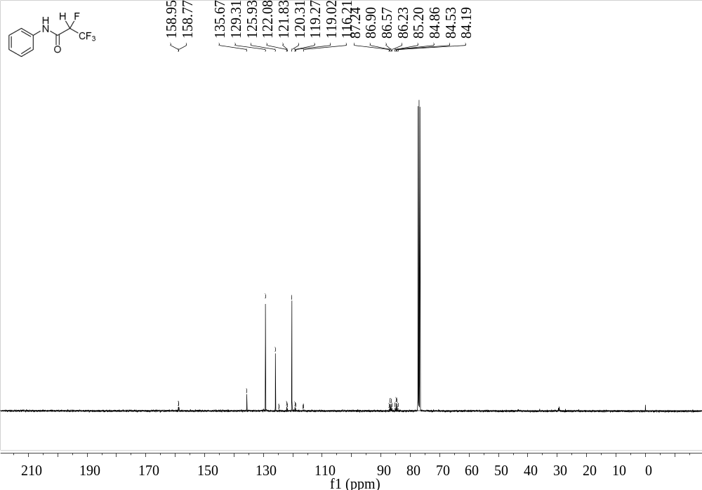
Supplementary Figure 121. ¹³C NMR (101 MHz, CDCl₃) spectrum of 41

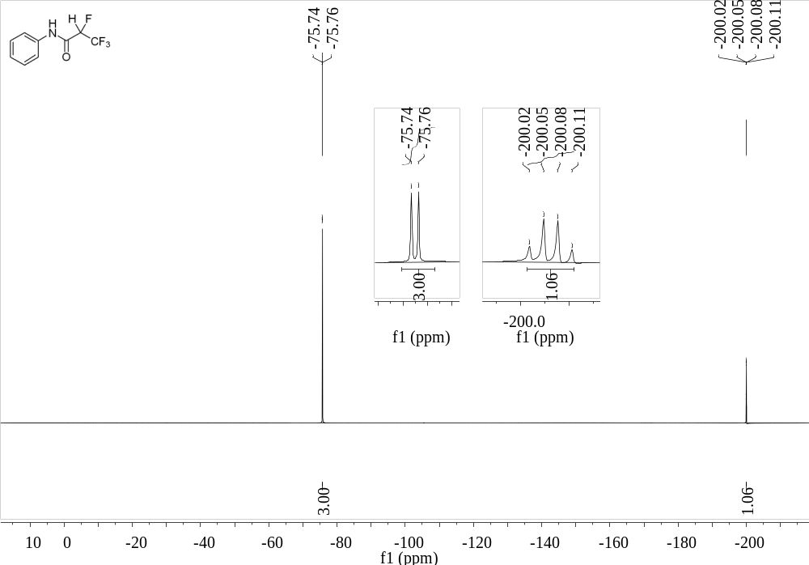
Supplementary Figure 122. ¹⁹F NMR (376 MHz, CDCl₃) spectrum of 41
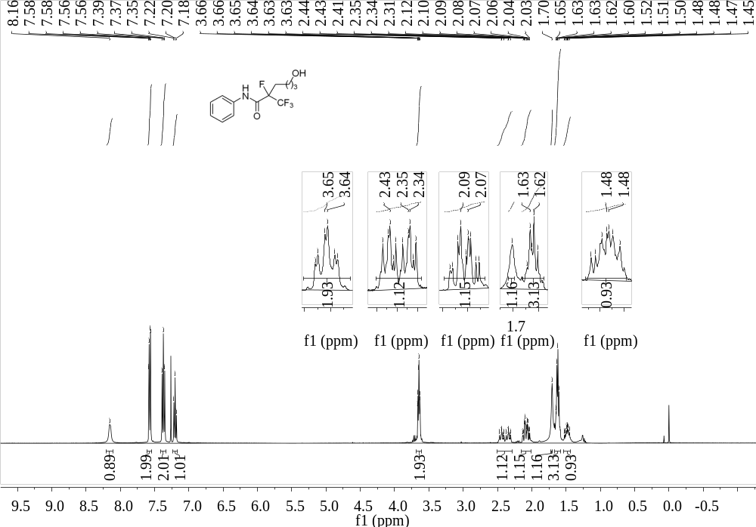
Supplementary Figure 123. ¹H NMR (400 MHz, CDCl₃) spectrum of 43

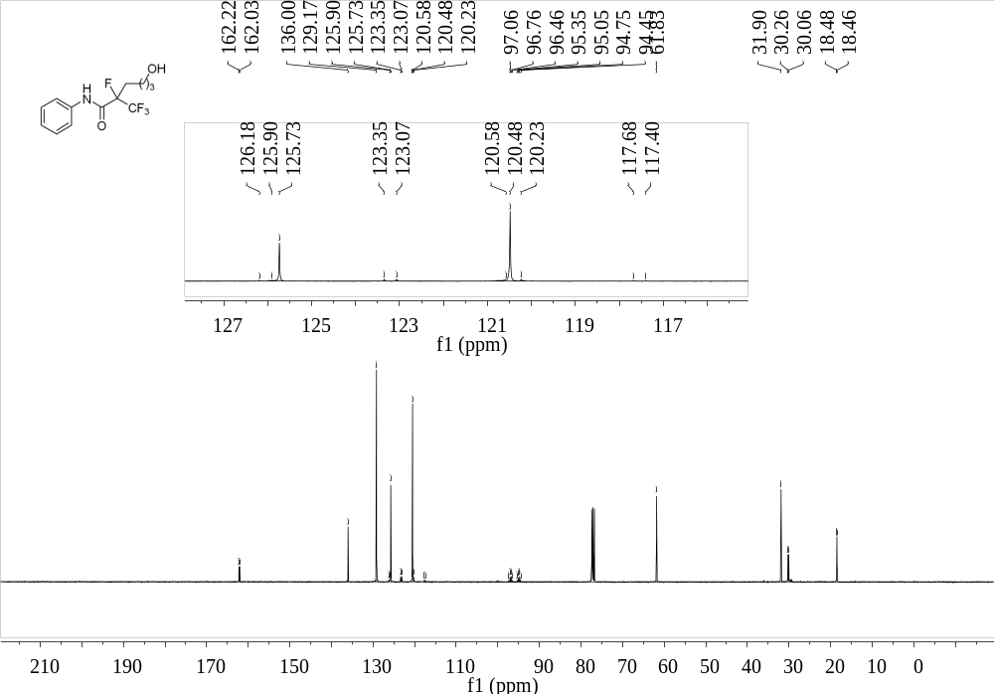
Supplementary Figure 124. ¹³C NMR (101 MHz, CDCl₃) spectrum of 43
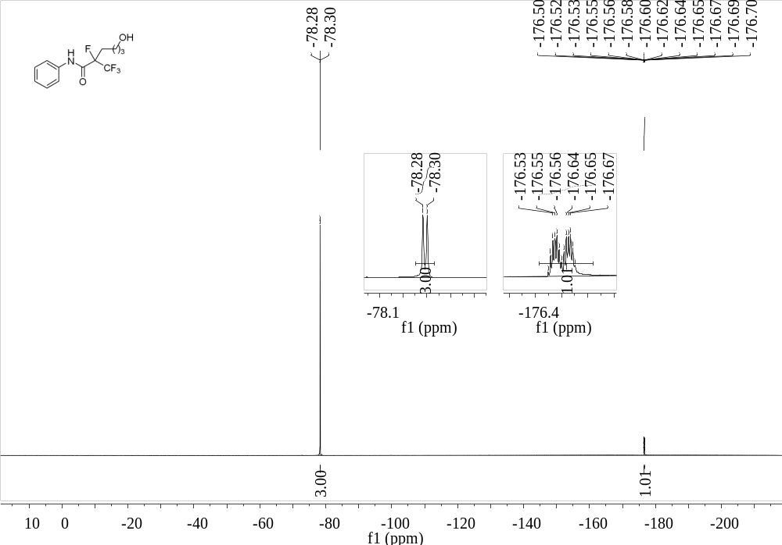
Supplementary Figure 125. ¹⁹F NMR (376 MHz, CDCl₃) spectrum of 43

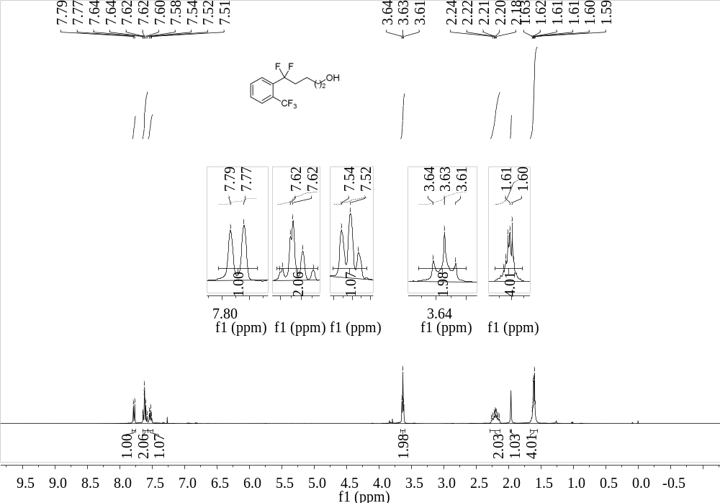
Supplementary Figure 126. ¹H NMR (400 MHz, CDCl₃) spectrum of 44
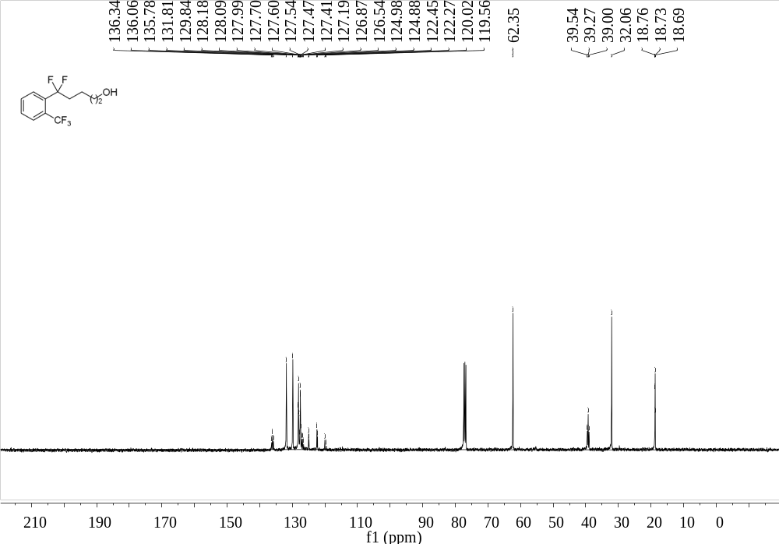
Supplementary Figure 127. ¹³C NMR (101 MHz, CDCl₃) spectrum of 44

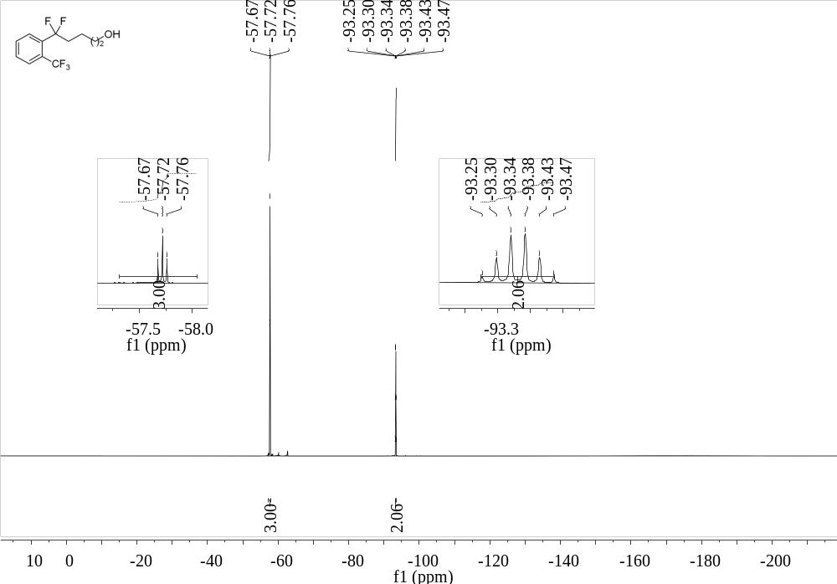
Supplementary Figure 128. ¹⁹F NMR (376 MHz, CDCl₃) spectrum of 44
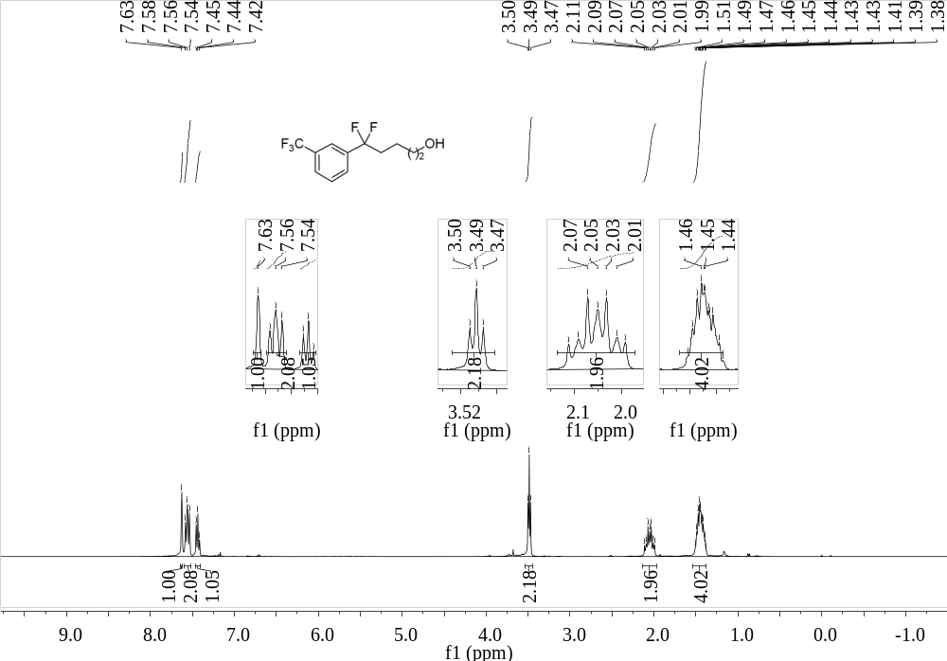
Supplementary Figure 129. ¹H NMR (400 MHz, CDCl₃) spectrum of 45

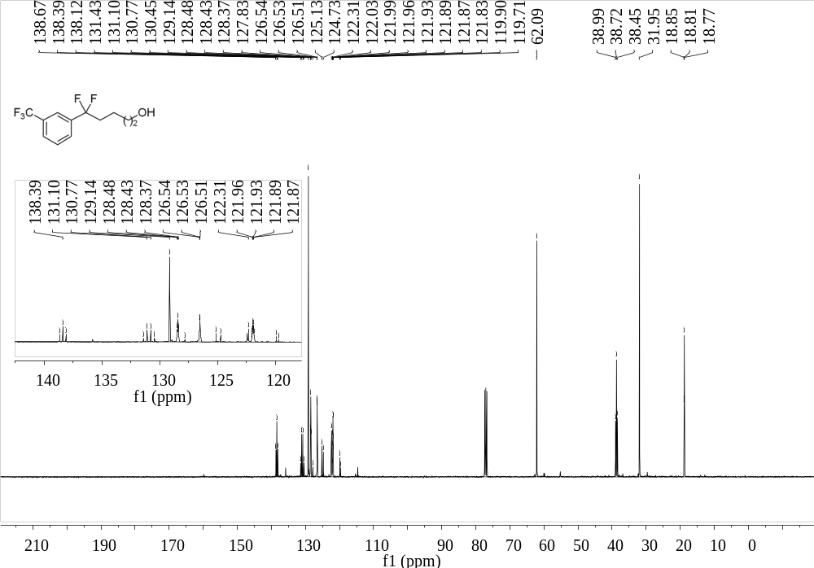
Supplementary Figure 130. ¹³C NMR (101 MHz, CDCl₃) spectrum of 45
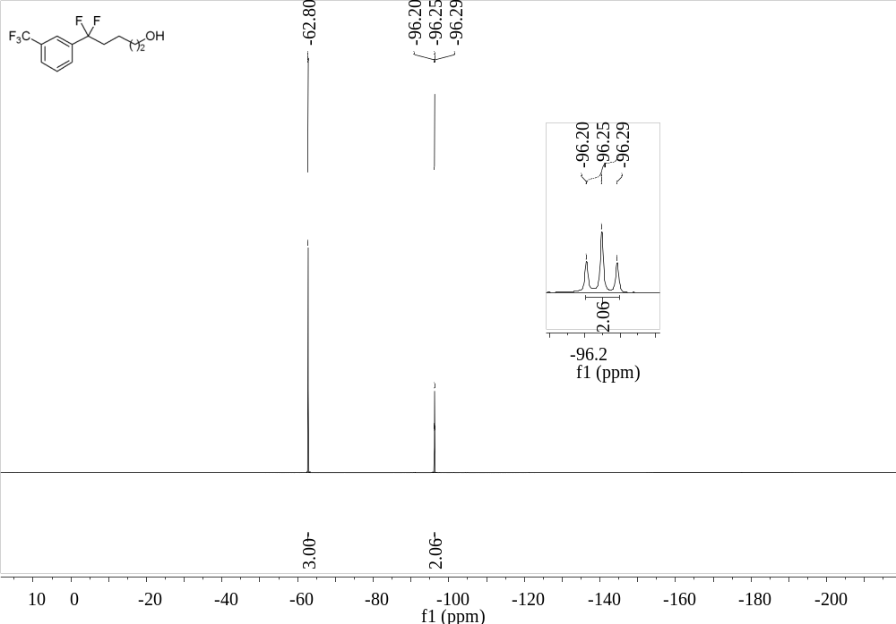
Supplementary Figure 131. ¹⁹F NMR (376 MHz, CDCl₃) spectrum of 45

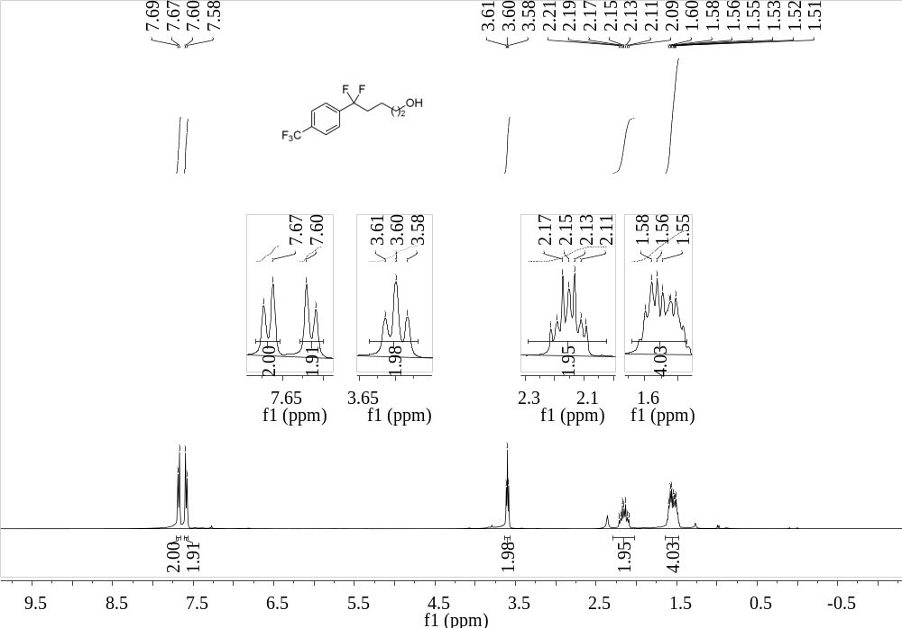
Supplementary Figure 132. ¹H NMR (400 MHz, CDCl₃) spectrum of 46
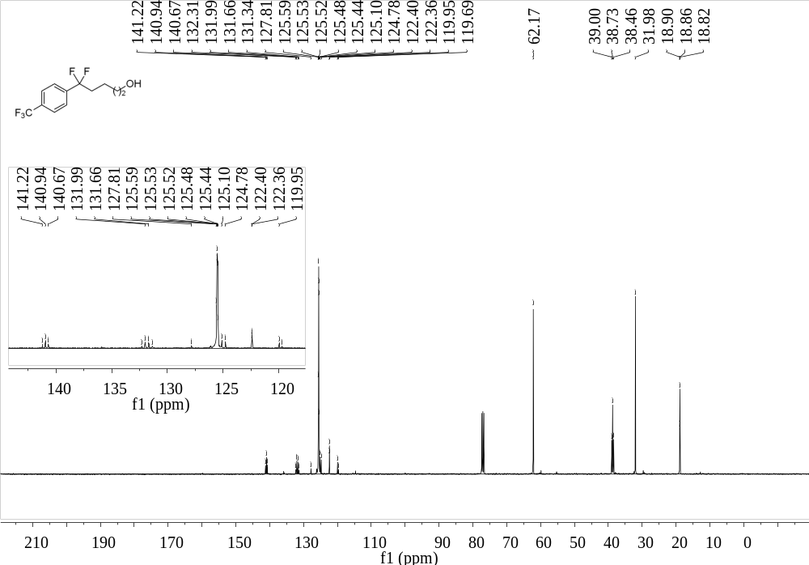
Supplementary Figure 133. ¹³C NMR (101 MHz, CDCl₃) spectrum of 46

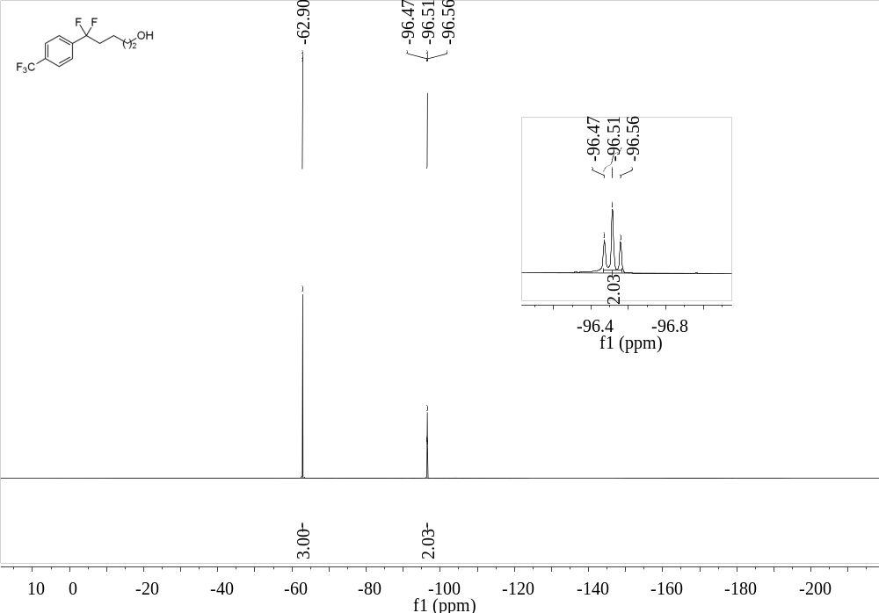
Supplementary Figure 134. ¹⁹F NMR (376 MHz, CDCl₃) spectrum of 46
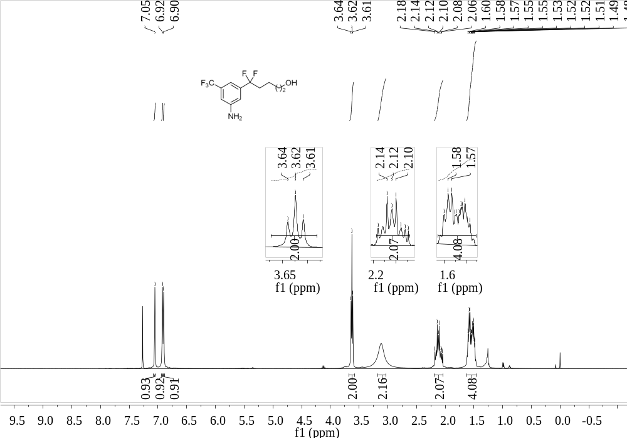
Supplementary Figure 135. ¹H NMR (400 MHz, CDCl₃) spectrum of 47

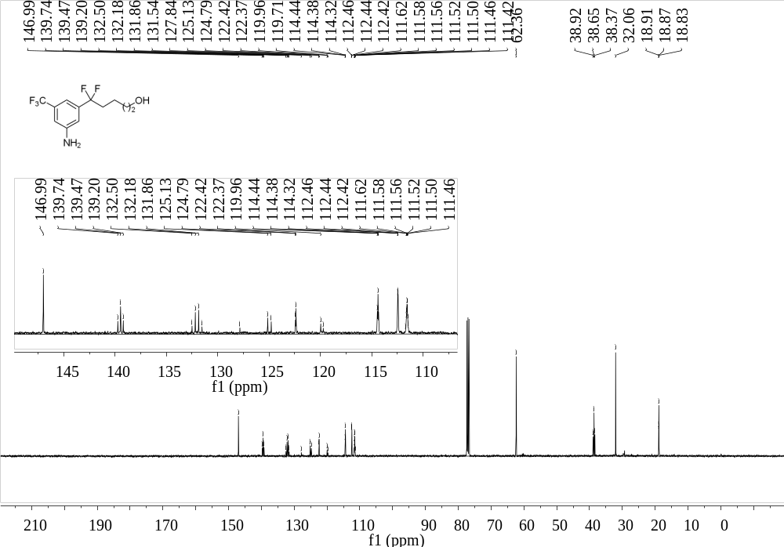
Supplementary Figure 136. ¹³C NMR (101 MHz, CDCl₃) spectrum of 47
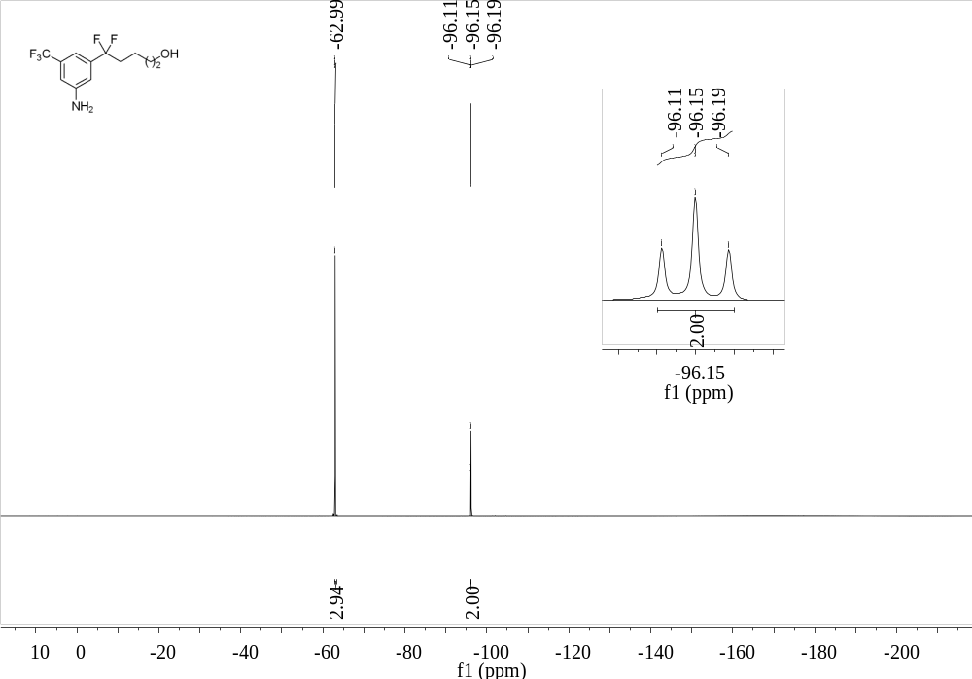
Supplementary Figure 137. ¹⁹F NMR (376 MHz, CDCl₃) spectrum of 47

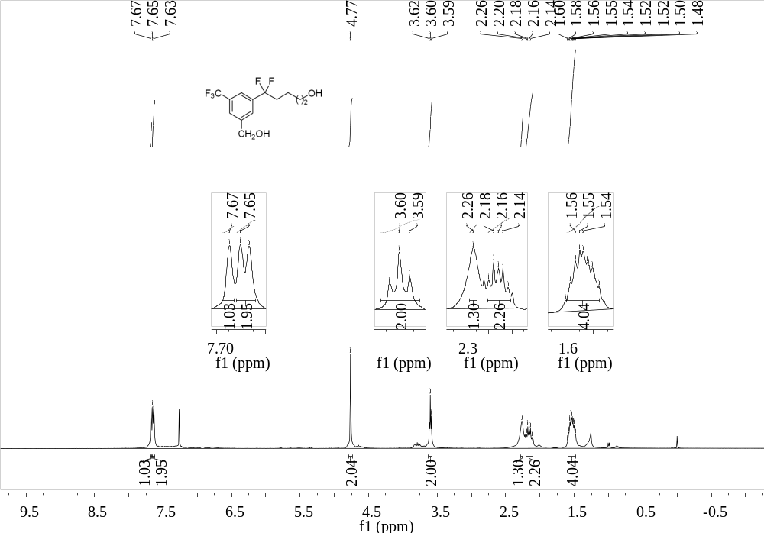
Supplementary Figure 138. ¹H NMR (400 MHz, CDCl₃) spectrum of 48
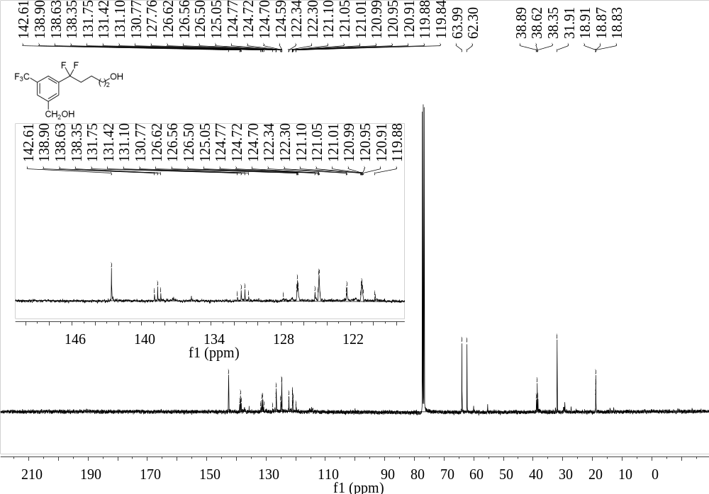
Supplementary Figure 139. ¹³C NMR (101 MHz, CDCl₃) spectrum of 48

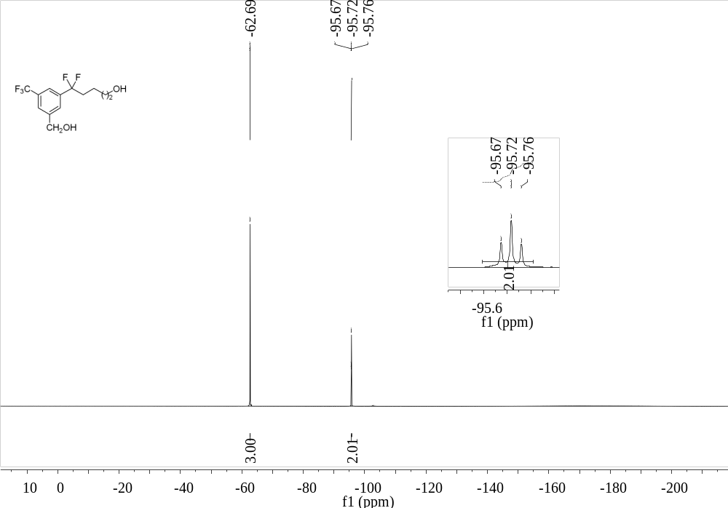
Supplementary Figure 140. ¹⁹F NMR (376 MHz, CDCl₃) spectrum of 48
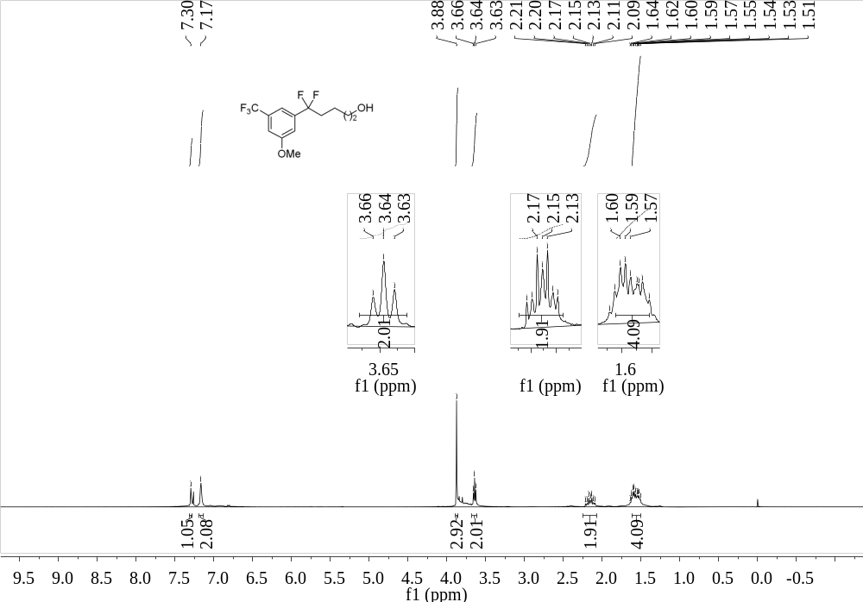
Supplementary Figure 141. ¹H NMR (400 MHz, CDCl₃) spectrum of 49

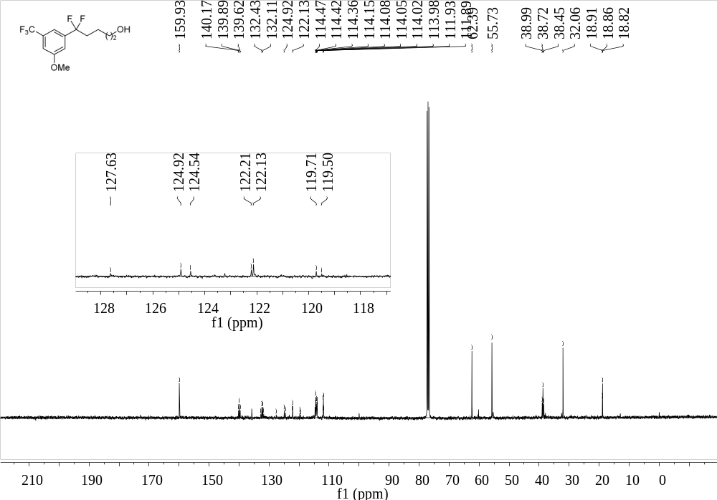
Supplementary Figure 142. ¹³C NMR (101 MHz, CDCl₃) spectrum of 49
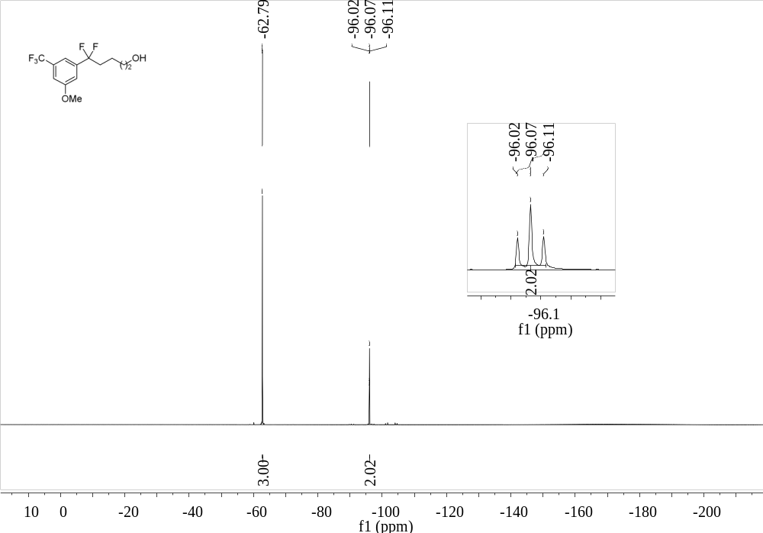
Supplementary Figure 143. ¹⁹F NMR (376 MHz, CDCl₃) spectrum of 49

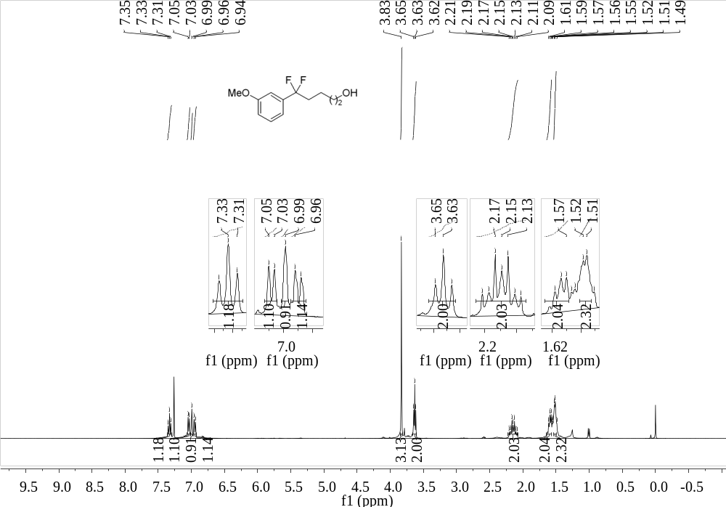
Supplementary Figure 144. ¹H NMR (400 MHz, CDCl₃) spectrum of 50
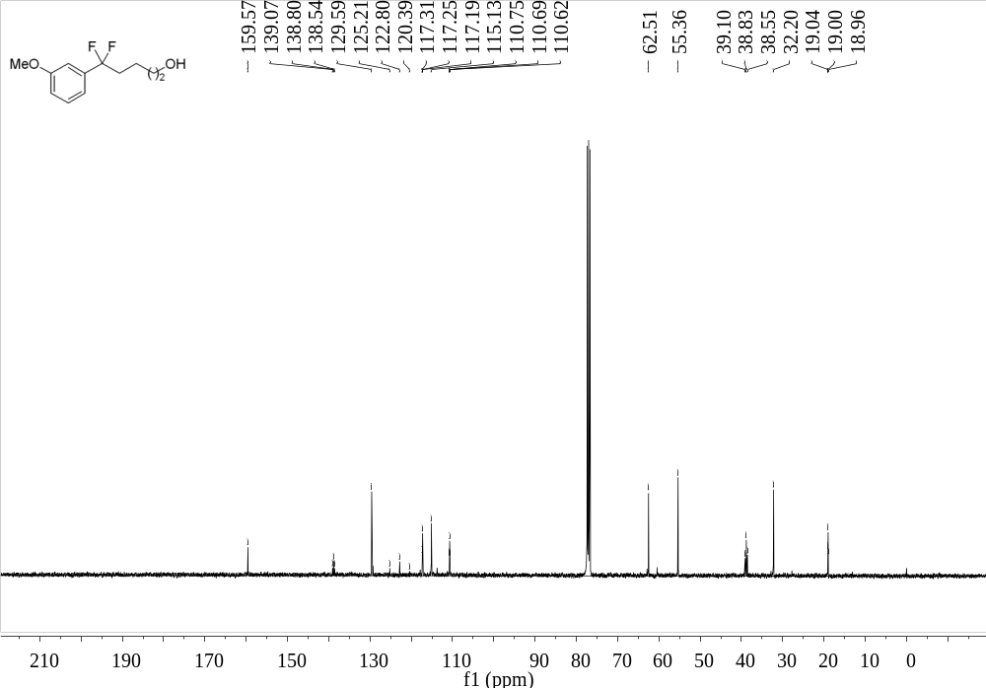
Supplementary Figure 145. ¹³C NMR (101 MHz, CDCl₃) spectrum of 50

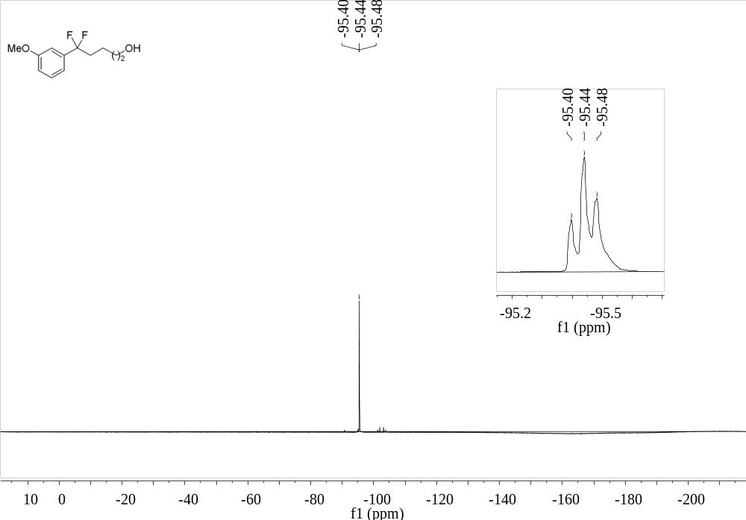
Supplementary Figure 146. ¹⁹F NMR (376 MHz, CDCl₃) spectrum of 50
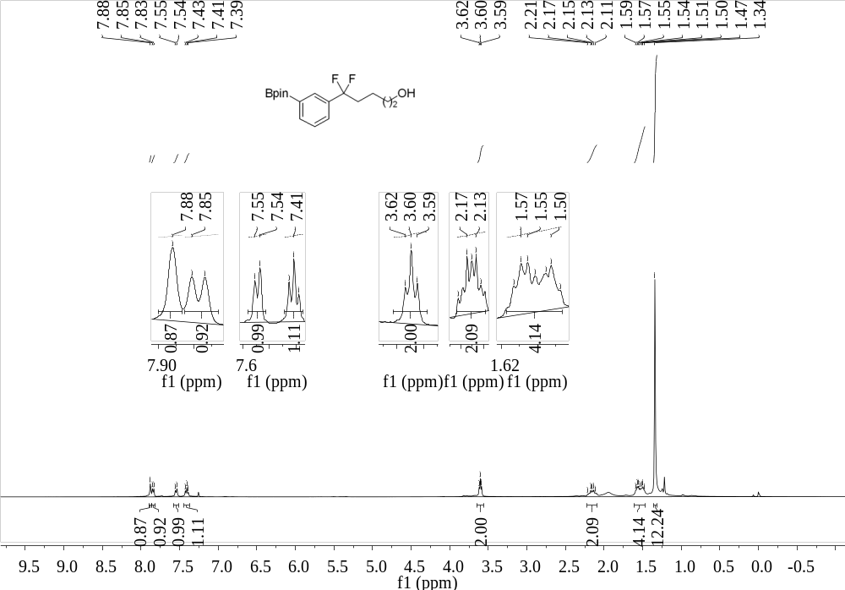
Supplementary Figure 147. ¹H NMR (400 MHz, CDCl₃) spectrum of 51

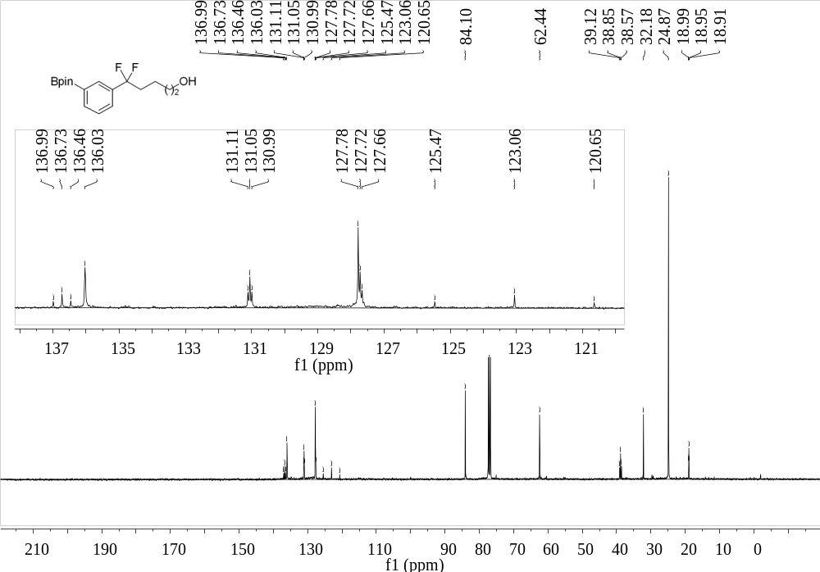
Supplementary Figure 148. ¹³C NMR (101 MHz, CDCl₃) spectrum of 51
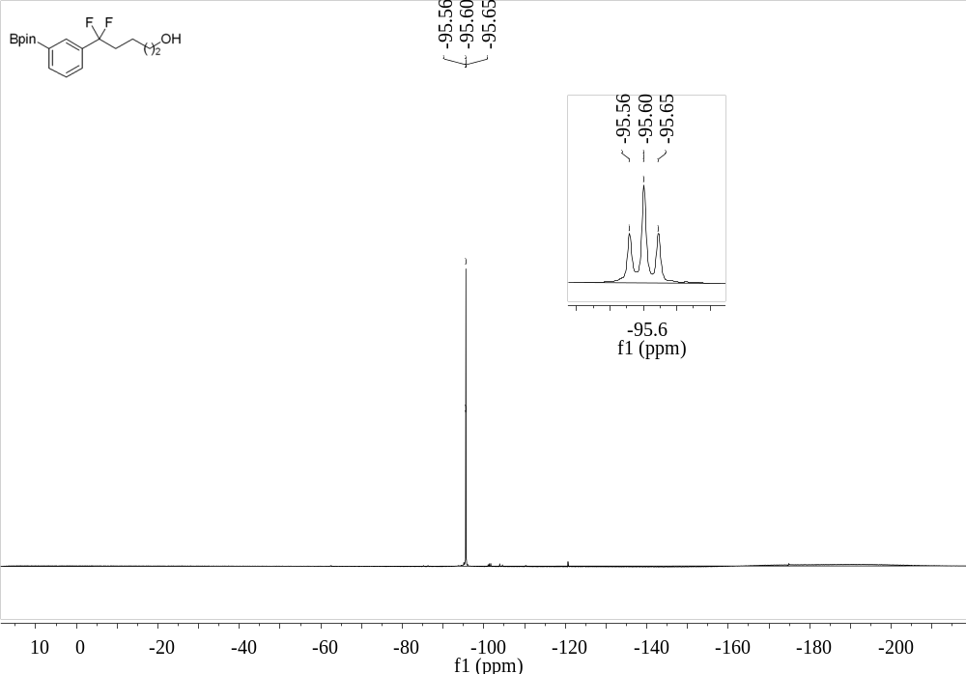
Supplementary Figure 149. ¹⁹F NMR (376 MHz, CDCl₃) spectrum of 51

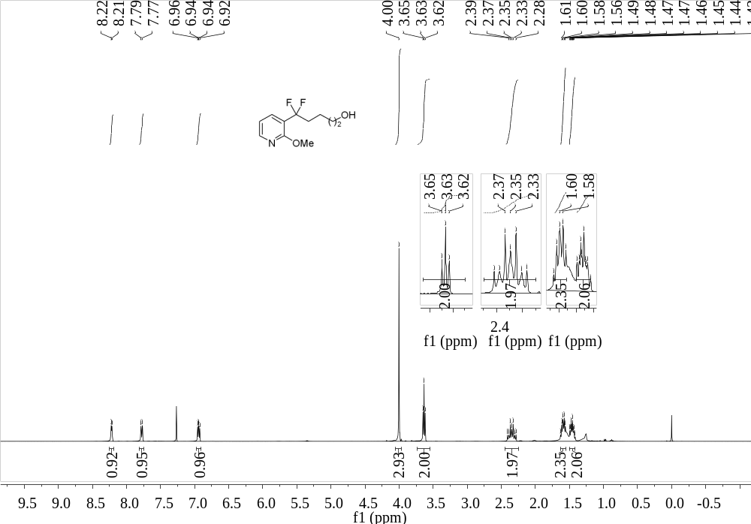
Supplementary Figure 150. ¹H NMR (400 MHz, CDCl₃) spectrum of 52
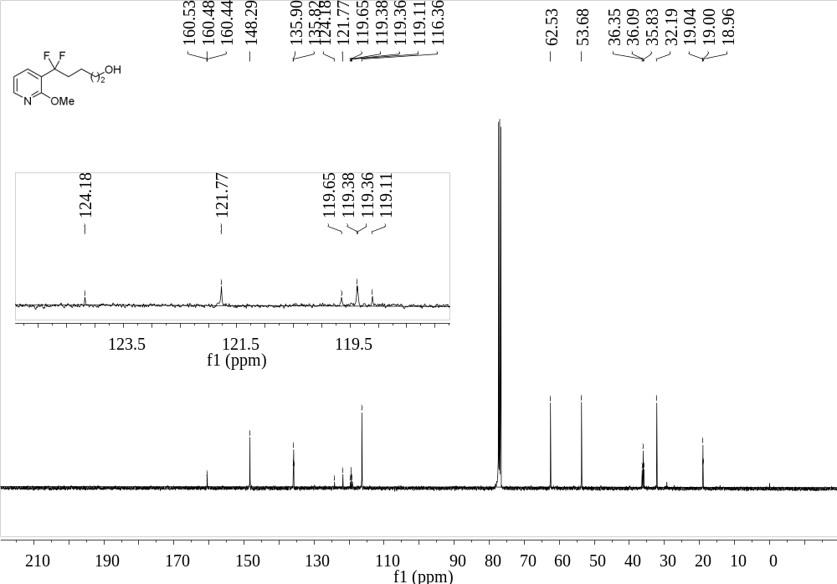
Supplementary Figure 151. ¹³C NMR (101 MHz, CDCl₃) spectrum of 52

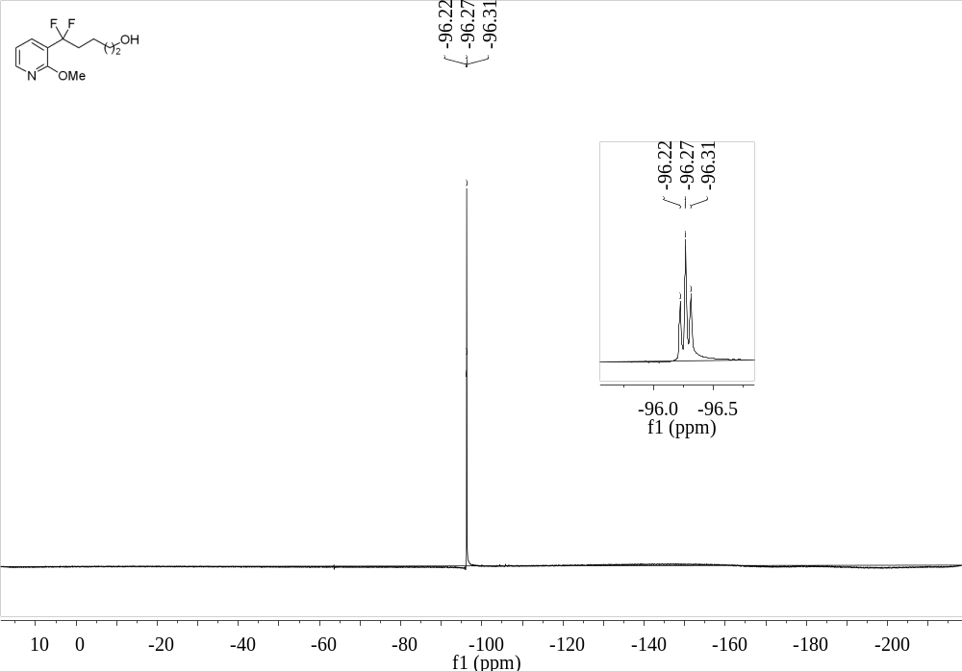
Supplementary Figure 152. ¹⁹F NMR (376 MHz, CDCl₃) spectrum of 52
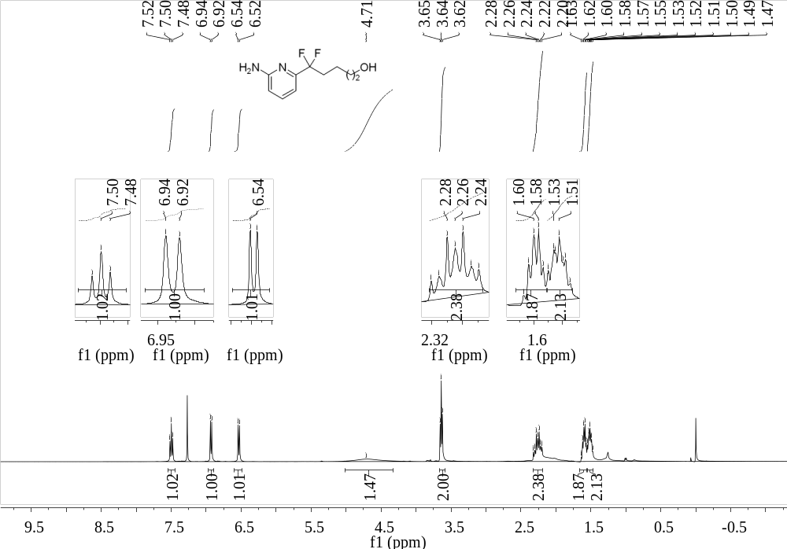
Supplementary Figure 153. ¹H NMR (400 MHz, CDCl₃) spectrum of 53

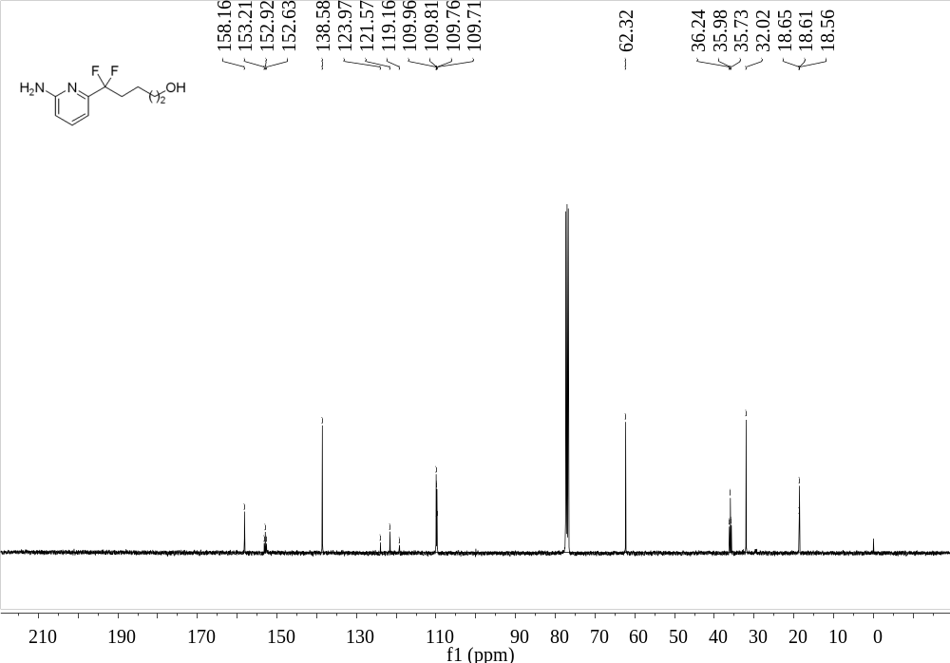
Supplementary Figure 154. ¹³C NMR (101 MHz, CDCl₃) spectrum of 53
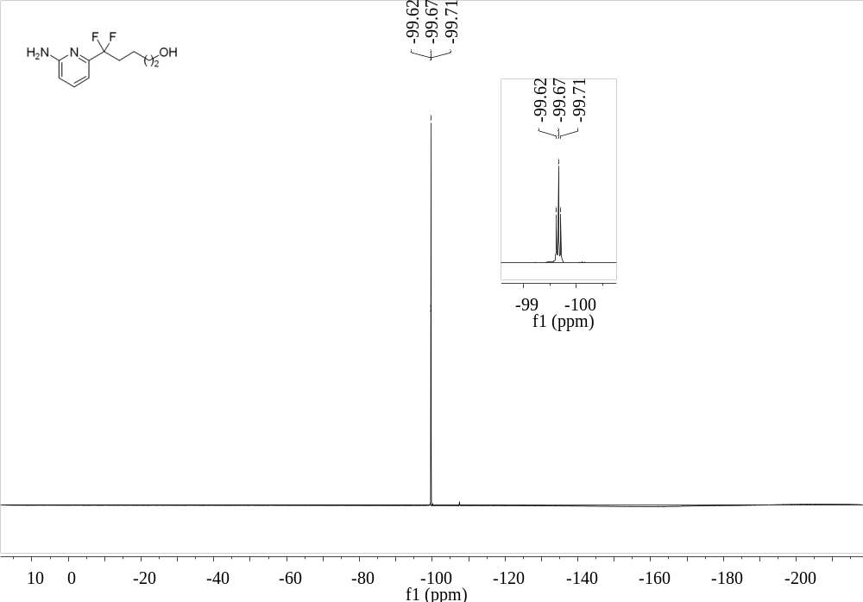
Supplementary Figure 155. ¹⁹F NMR (376 MHz, CDCl₃) spectrum of 53

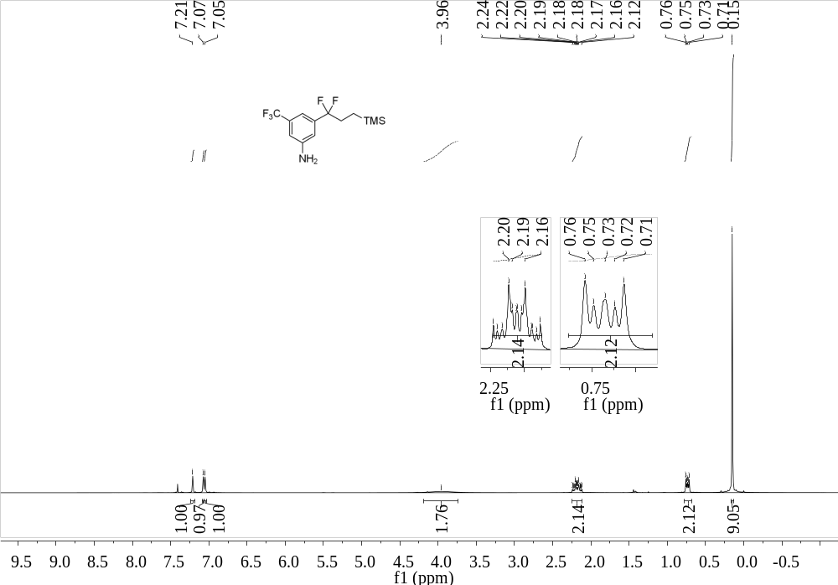
Supplementary Figure 156. ¹H NMR (400 MHz, CDCl₃) spectrum of 54
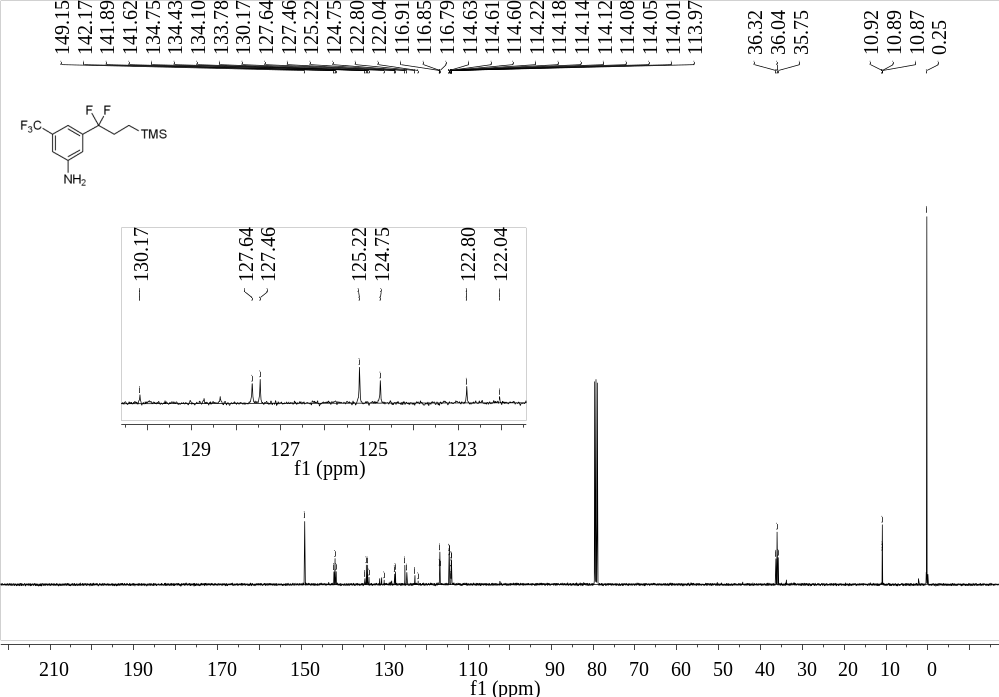
Supplementary Figure 157. ¹³C NMR (101 MHz, CDCl₃) spectrum of 54

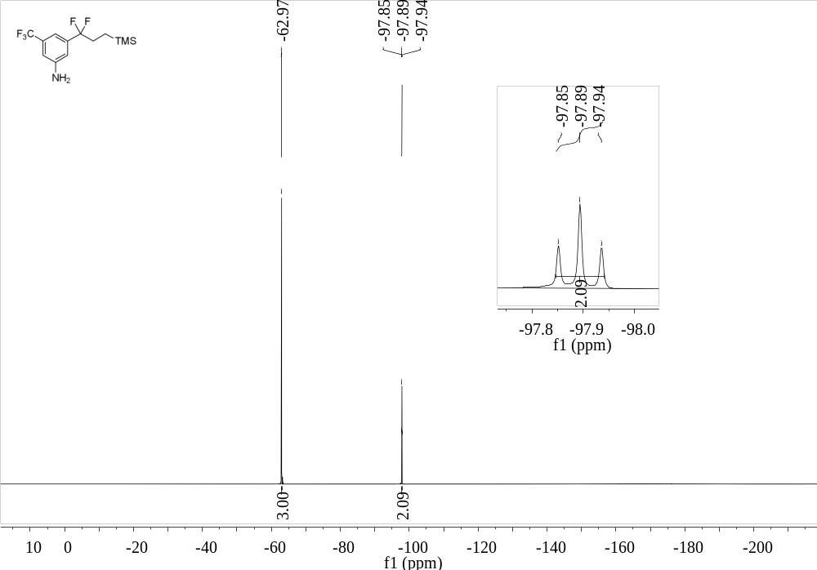
Supplementary Figure 158. ¹⁹F NMR (376 MHz, CDCl₃) spectrum of 54
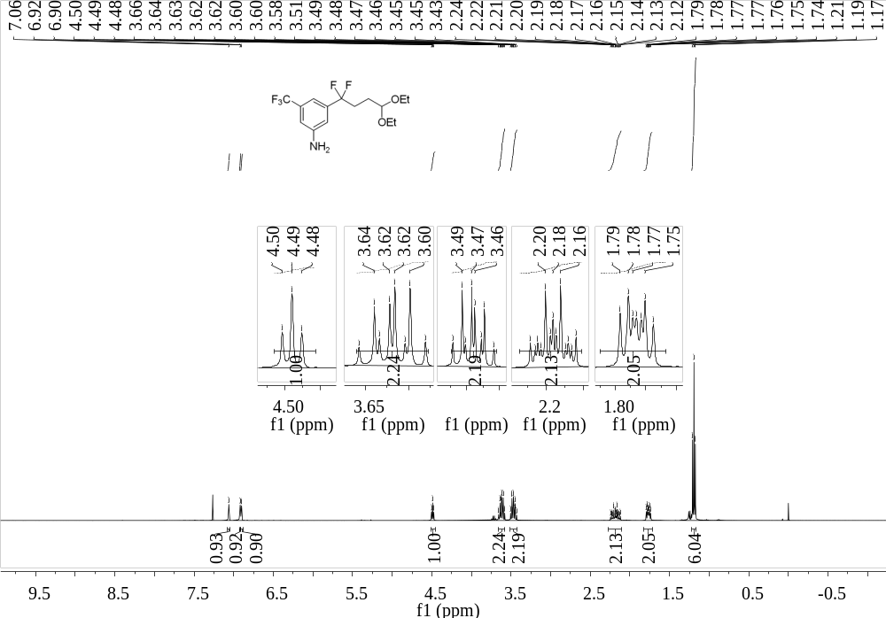
Supplementary Figure 159. ¹H NMR (400 MHz, CDCl₃) spectrum of 55

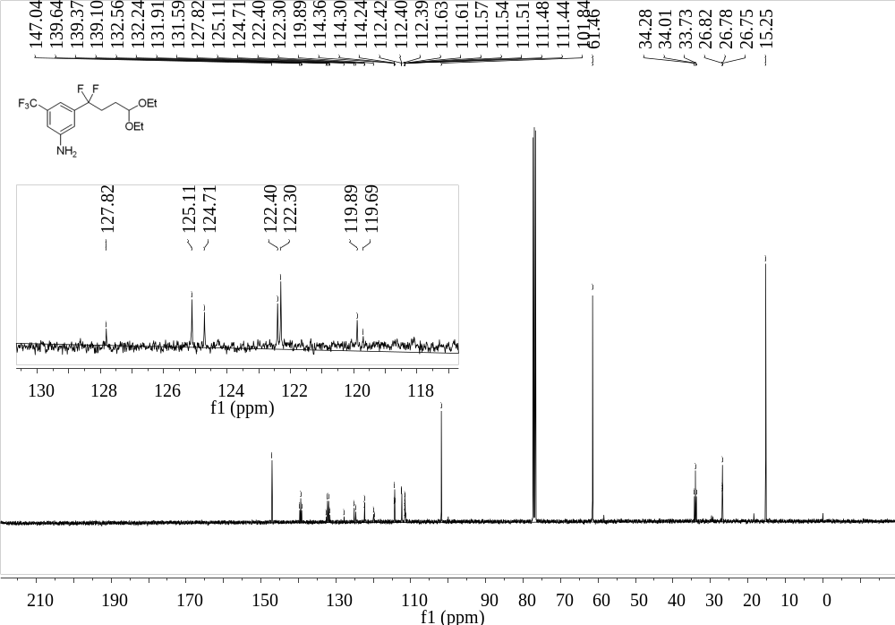
Supplementary Figure 160. ¹³C NMR (101 MHz, CDCl₃) spectrum of 55
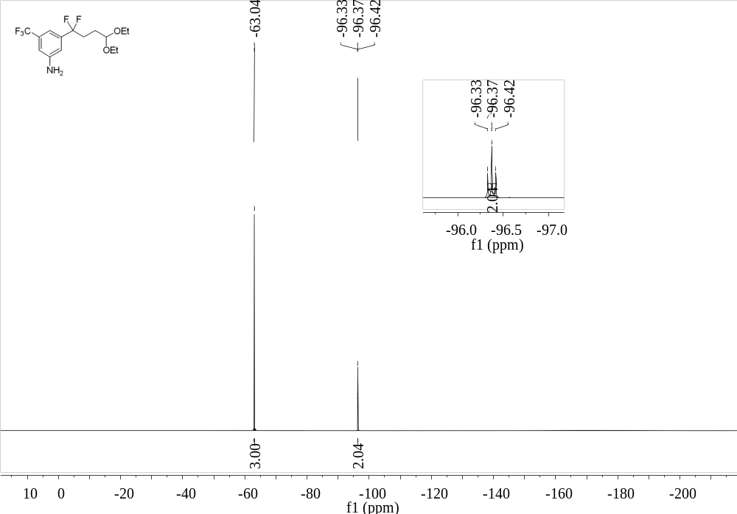
Supplementary Figure 161. ¹⁹F NMR (376 MHz, CDCl₃) spectrum of 55

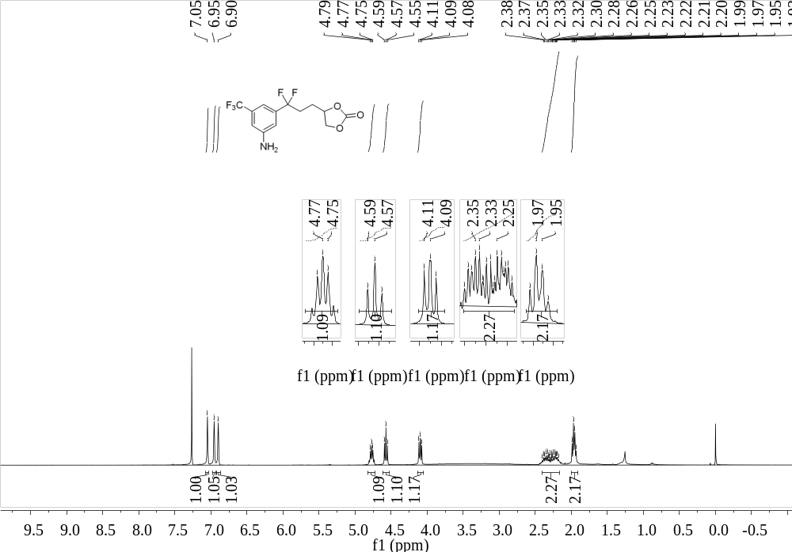
Supplementary Figure 162. ¹H NMR (400 MHz, CDCl₃) spectrum of 56
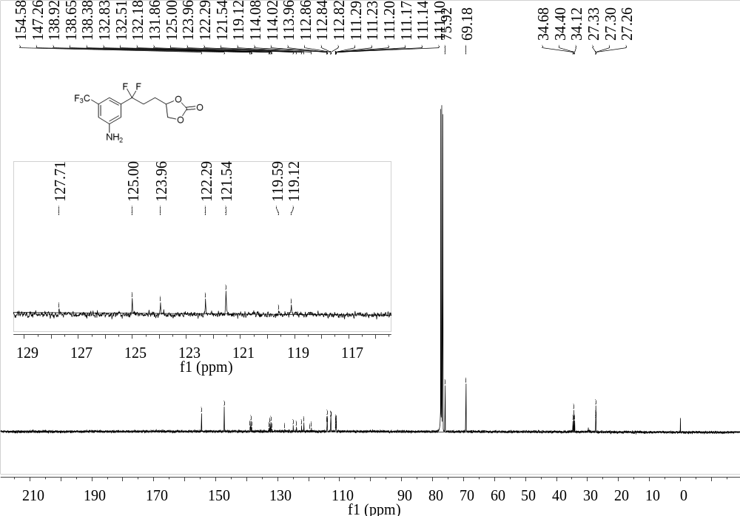
Supplementary Figure 163. ¹³C NMR (101 MHz, CDCl₃) spectrum of 56

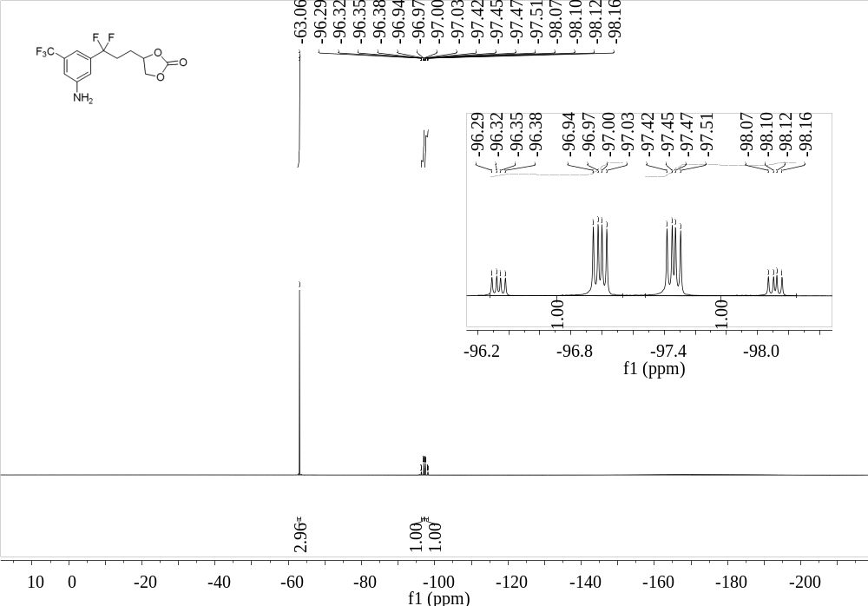
Supplementary Figure 164. ¹⁹F NMR (376 MHz, CDCl₃) spectrum of 56
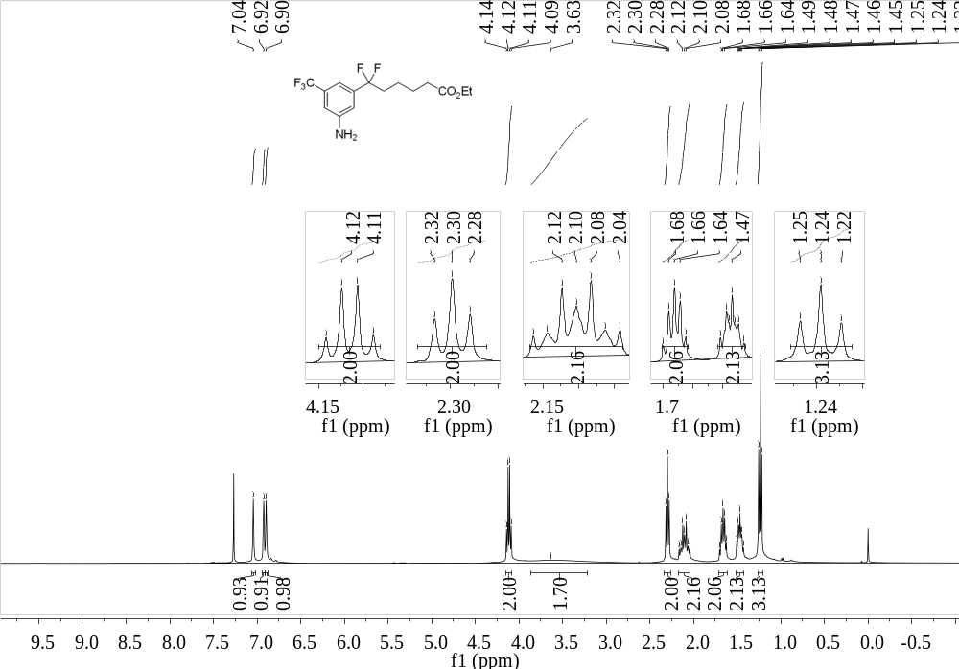
Supplementary Figure 165. ¹H NMR (400 MHz, CDCl₃) spectrum of 57

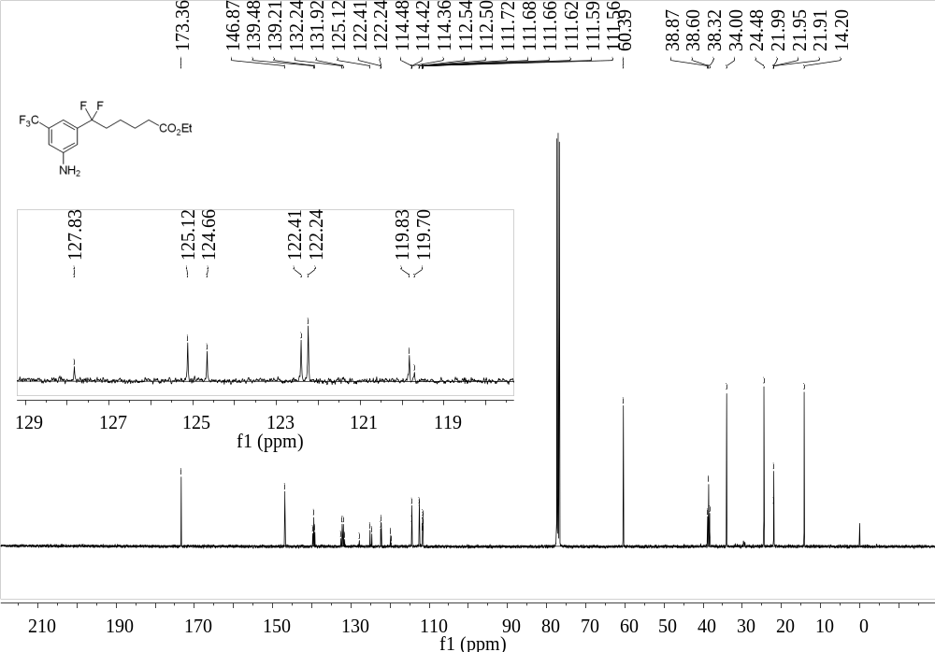
Supplementary Figure 166. ¹³C NMR (101 MHz, CDCl₃) spectrum of 57
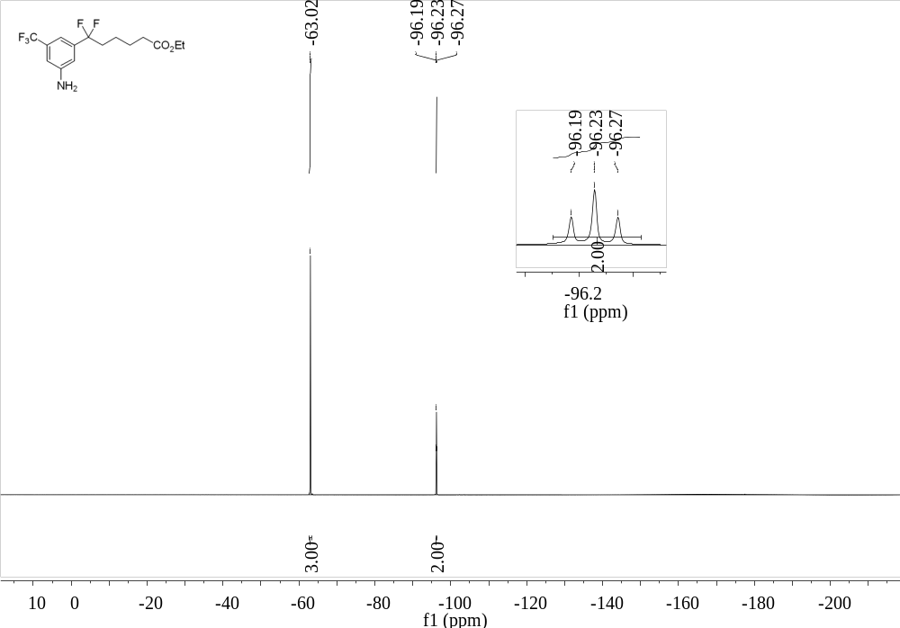
Supplementary Figure 167. ¹⁹F NMR (376 MHz, CDCl₃) spectrum of 57

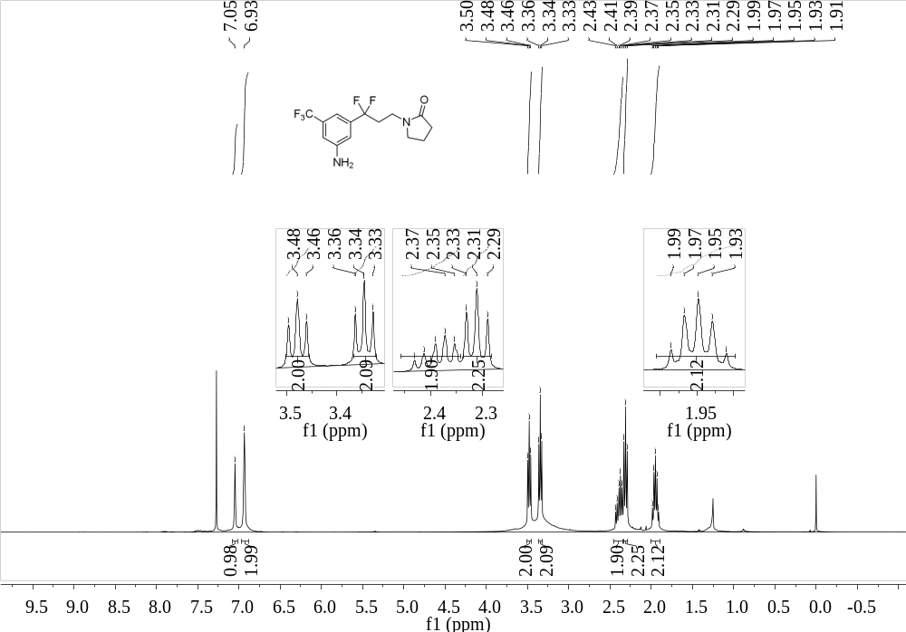
Supplementary Figure 168. ¹H NMR (400 MHz, CDCl₃) spectrum of 58
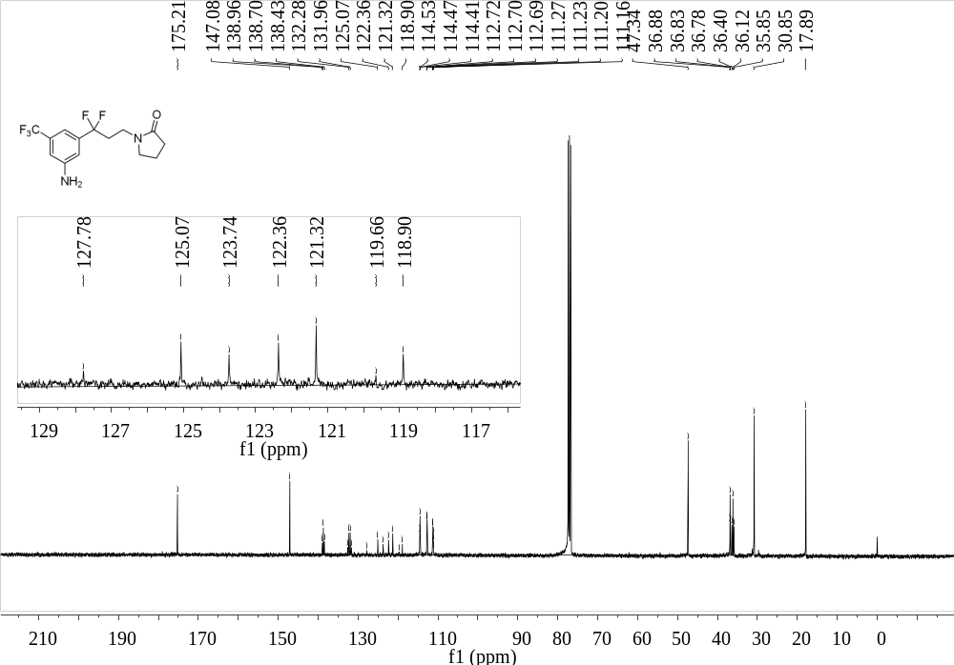
Supplementary Figure 169. ¹³C NMR (101 MHz, CDCl₃) spectrum of 58

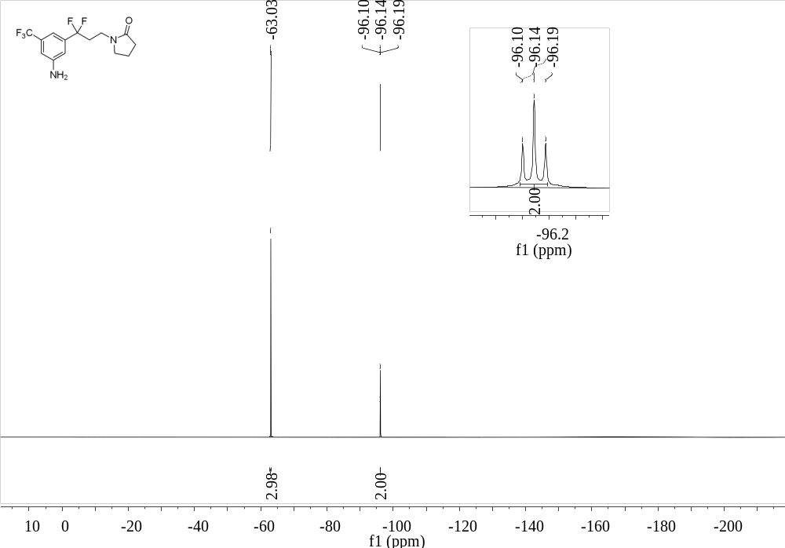
Supplementary Figure 170. ¹⁹F NMR (376 MHz, CDCl₃) spectrum of 58
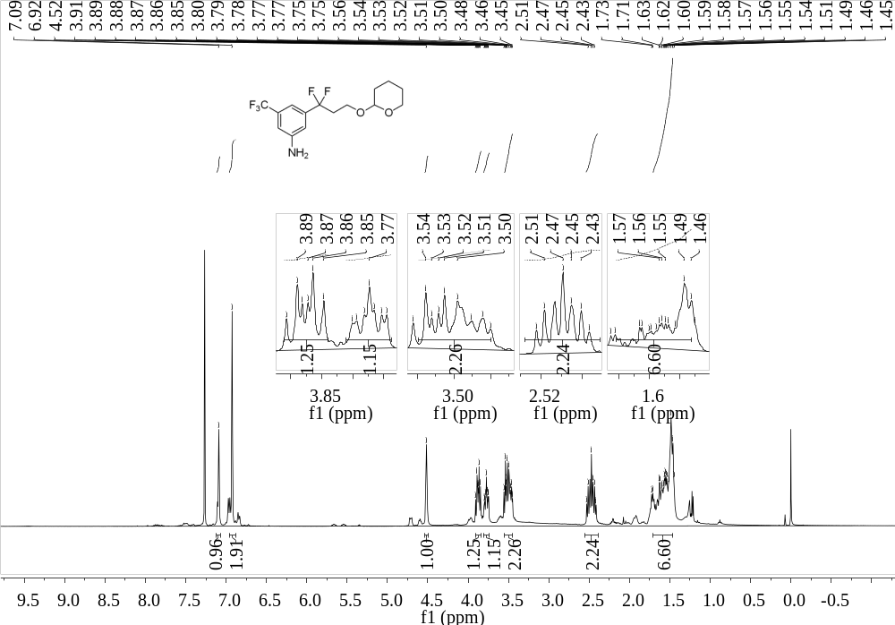
Supplementary Figure 171. ¹H NMR (400 MHz, CDCl₃) spectrum of 59

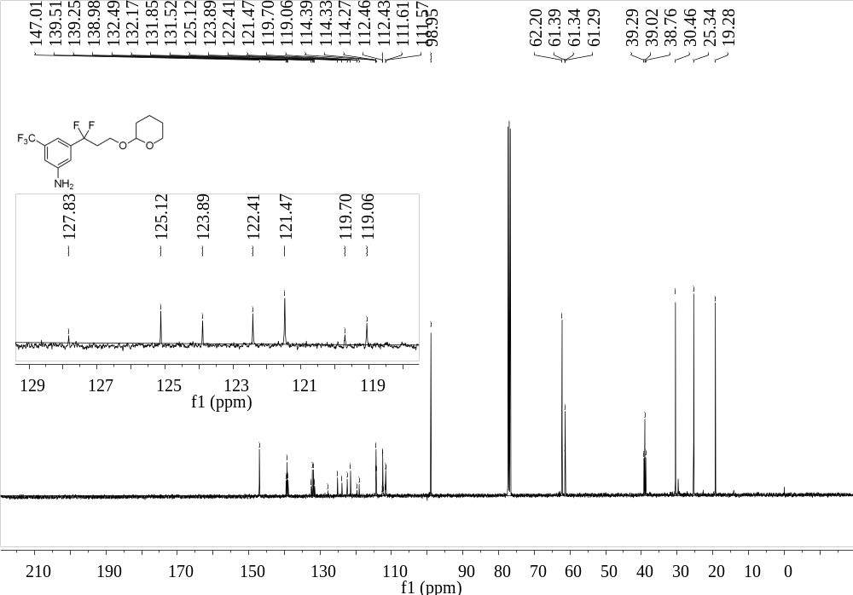
Supplementary Figure 172. ¹³C NMR (101 MHz, CDCl₃) spectrum of 59
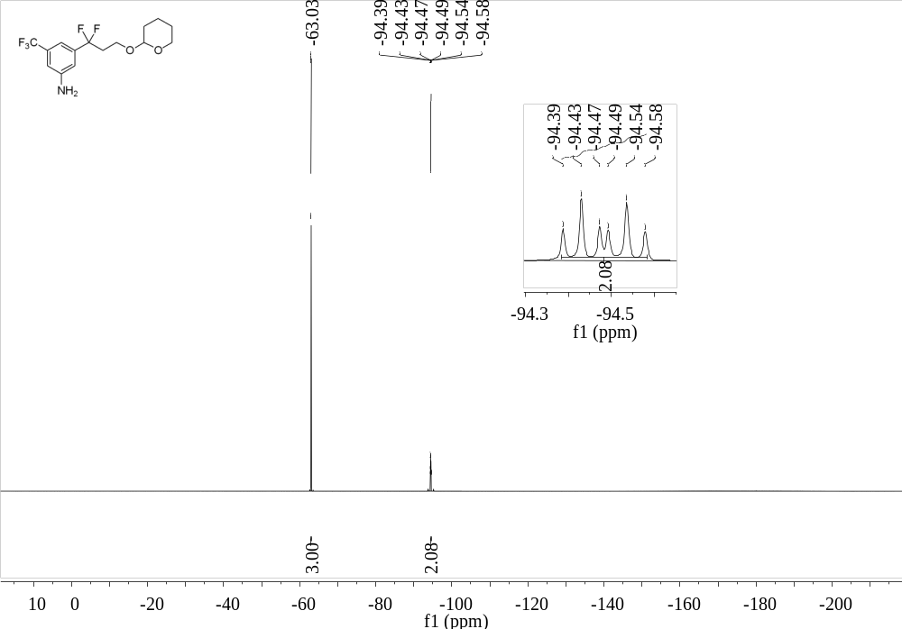
Supplementary Figure 173. ¹⁹F NMR (376 MHz, CDCl₃) spectrum of 59

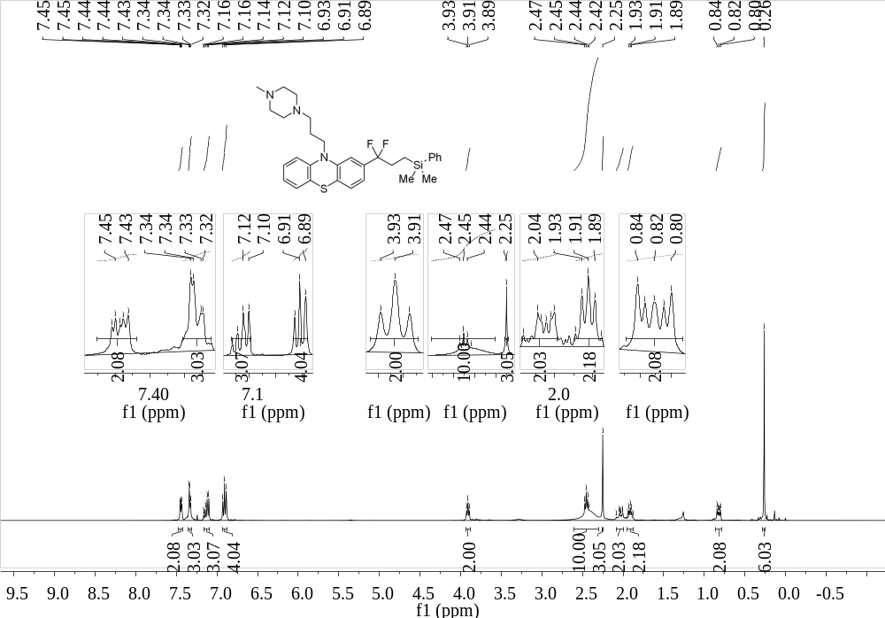
Supplementary Figure 174. ¹H NMR (400 MHz, CDCl₃) spectrum of 60
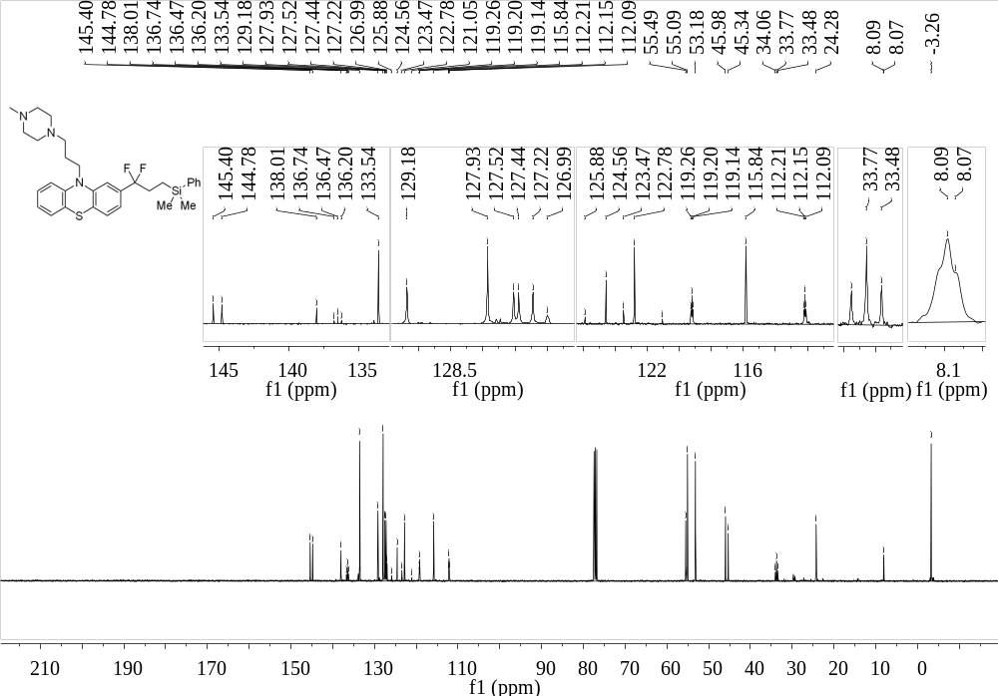
Supplementary Figure 175. ¹³C NMR (101 MHz, CDCl₃) spectrum of 60

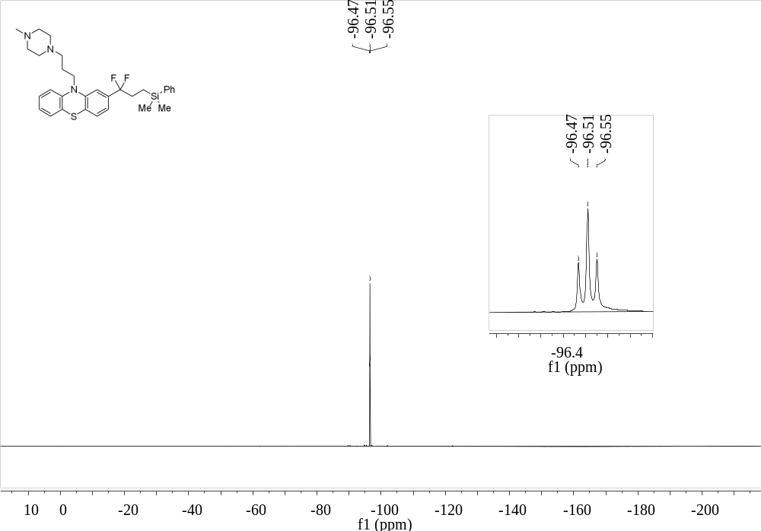
Supplementary Figure 176. ¹⁹F NMR (376 MHz, CDCl₃) spectrum of 60
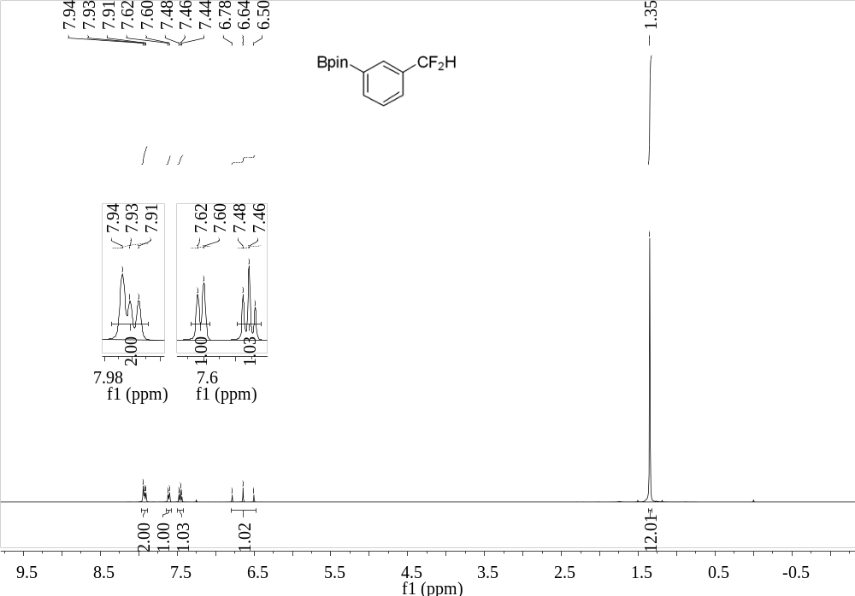
Supplementary Figure 177. ¹H NMR (400 MHz, CDCl₃) spectrum of 61

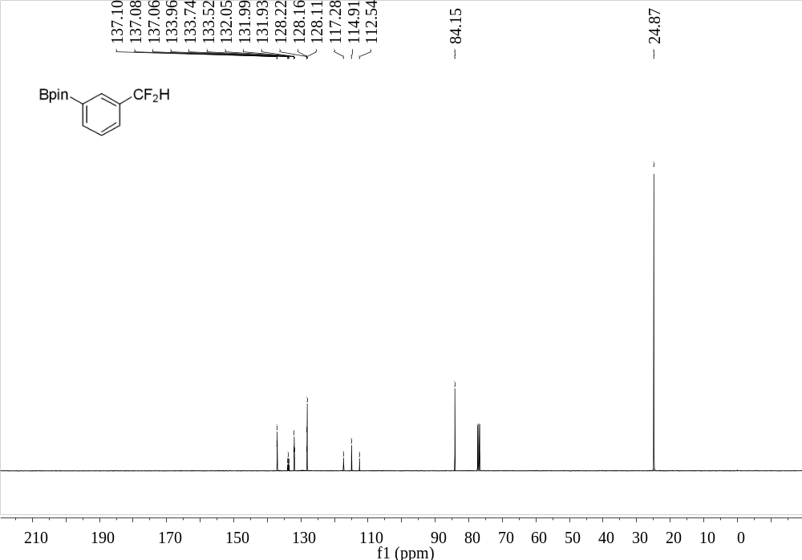
Supplementary Figure 178. ¹³C NMR (101 MHz, CDCl₃) spectrum of 61

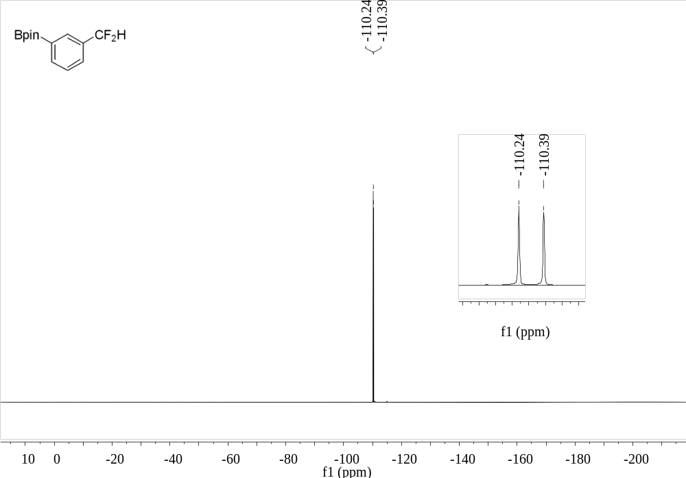
Supplementary Figure 179. ¹⁹F NMR (376 MHz, CDCl₃) spectrum of 61

