Supplementary File.
Supplementary Figures S1–S4.

Supplementary Figure S1. Full uncropped agarose gel images corresponding to Steps 1 and 2 of Figure 2.

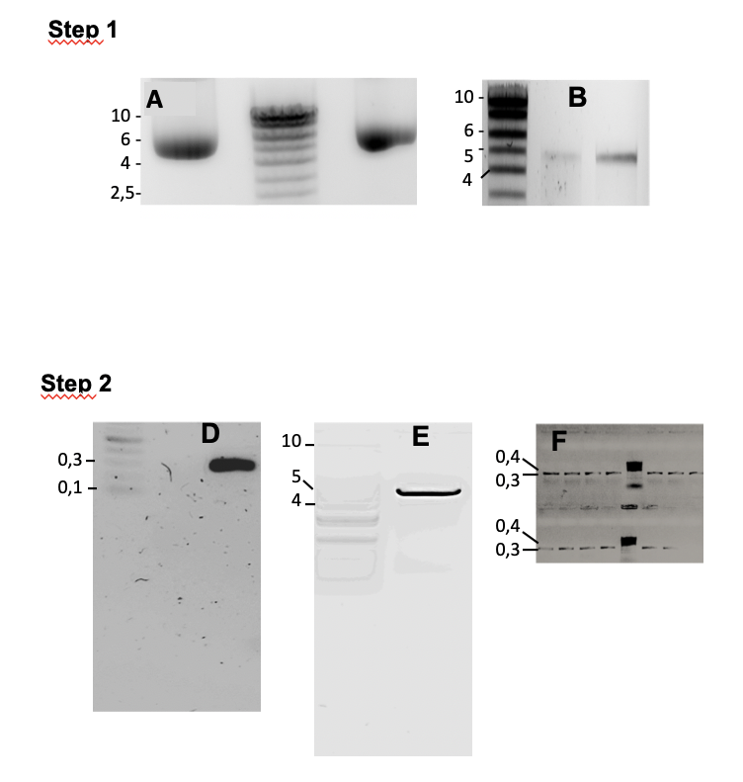

Original uncropped agarose gel images are provided for panels D and E shown in Figure 2, where the original files were available.
For some agarose gel panels shown in Figure 2, the original uncropped images are no longer available.

Supplementary Figure S2. Full uncropped agarose gel images corresponding to Steps 3 and 4 of Figure 2.

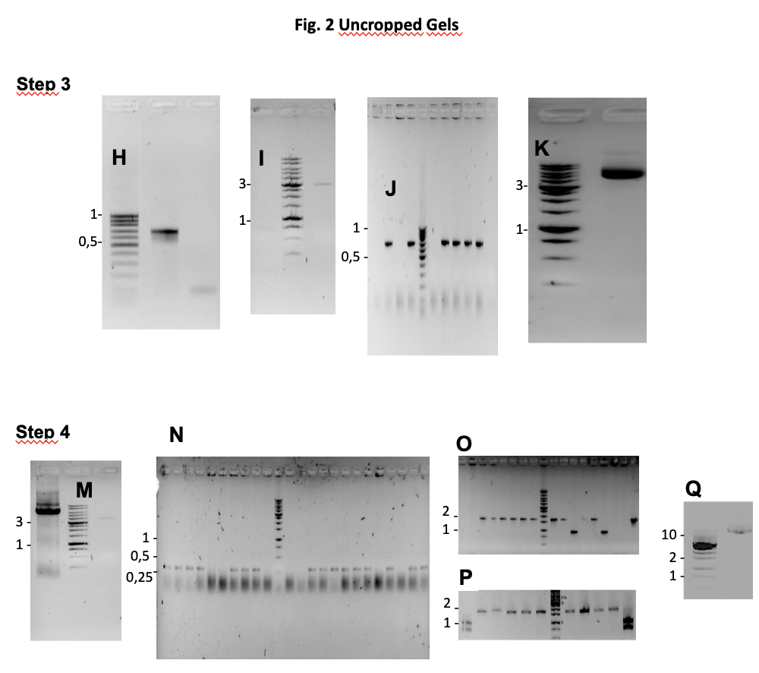
Original uncropped agarose gel images are provided for the panels shown in Figure 2 where the original files were available.
For agarose gel panel Q shown in Figure 2, the original uncropped image is no longer available.

Supplementary Figure S3. Full uncropped SDS-PAGE gel and Wstern blot images corresponding to Figure 3I.

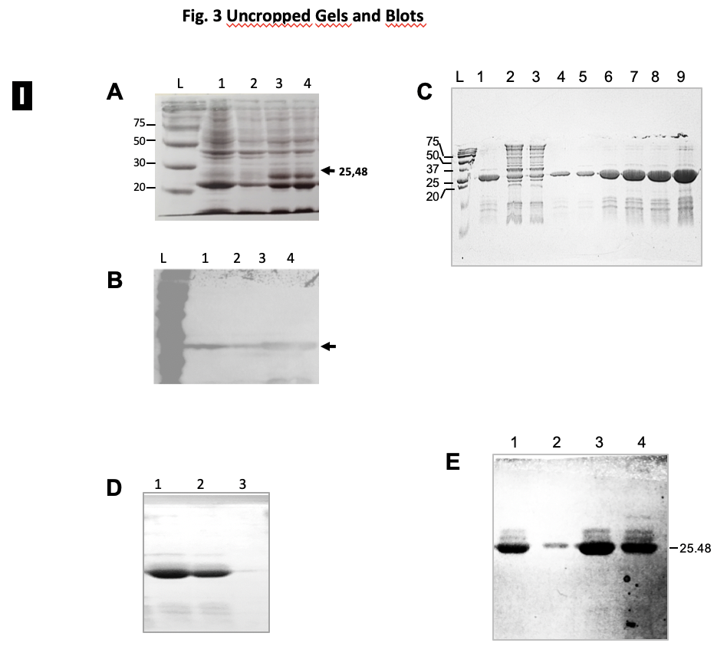

Original uncropped SDS-PAGE gel and Western blot images are provided for all panels shown in Figure 3I.

Supplementary Figure S4. Full uncropped SDS-PAGE gel and Western blot images corresponding to Figure 3II.

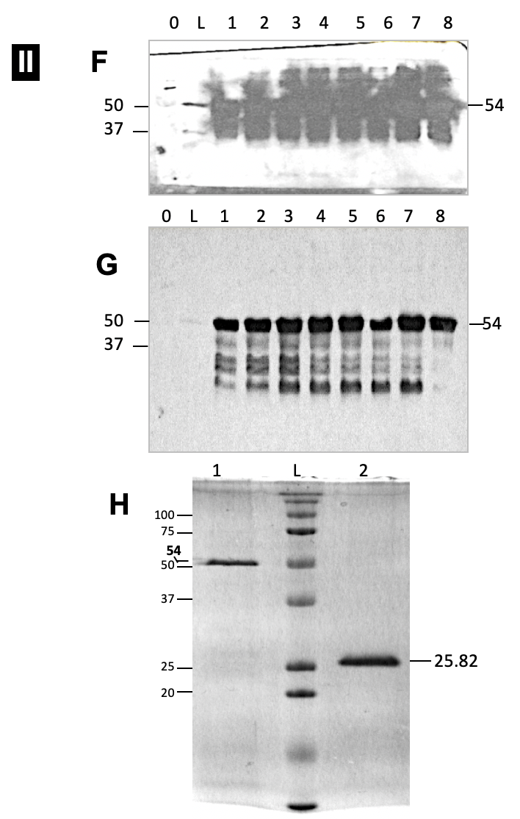
Original uncropped SDS-PAGE gel and Western blot images are provided for all panels shown in Figure 3 II.

