Eggshell-Derived CaO@g-C₃N₄ Catalyst: An Efficient, Reusable and Economical Approach for the Synthesis of Pyrano[2,3-d] Pyrimidine Scaffolds as Potent Anticancer Agents with Molecular Docking Study

Supporting Information:

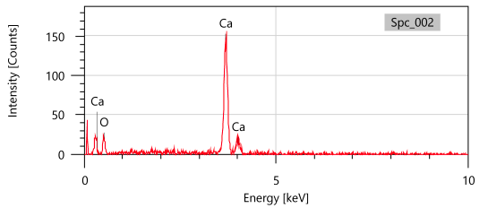 | 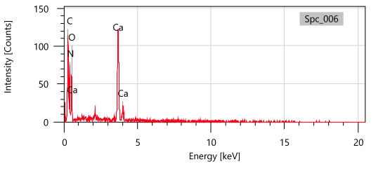
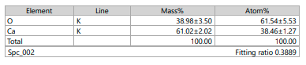 | 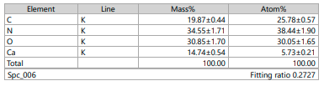
EDX Analysis Report for Calcium Oxide (CaO) and CaO@gC₃N₄ respectively.

Spectral Data of selected compounds 4a to 4e and 4h
4a) Molecular Formula: C₁₆H₁₅N₅O₃, Actual Weight: 325.12, Observed molecular mass m/z: 326.125.
¹H NMR (400 MHz, dmso) δ 11.05 (s, 1H), 10.92 (s, 1H), 8.43 (d, J = 9.3 Hz, 3H), 8.15 (s, 1H), 7.84 (d, J = 9.1 Hz, 1H), 6.80 (d, J = 7.2 Hz, 3H), 3.12 (s, 7H), 3.11 (s, 2H), 2.50 (s, 6H), peaks at 2.45-2.55 arises due to dmso.
¹³C NMR (101 MHz, dmso) δ 164.73, 162.75, 155.49, 154.32, 154.15, 150.35, 139.09, 133.63, 119.99, 111.81, 111.20, 109.51, 68.59, 40.13, 39.92, 38.87.

4b) Molecular Formula: C₂₂H₁₄N₄O₃, Exact Mass: 382.11, Observed molecular mass m/z: 383.27.
¹H NMR (400 MHz, dmso) δ 11.49 (s, 1H), 11.08 (s, 1H), 8.98 (s, 2H), 8.66 (s, 2H), 8.13 (d, J = 7.6 Hz, 3H), 7.95 (d, J = 8.8 Hz, 3H), 7.57 – 7.47 (m, 7H).
¹³C NMR (101 MHz, ) δ 161.30, 158.77, 151.80, 151.01, 133.04, 132.74, 132.62, 128.68, 127.06, 126.89, 125.76, 124.49, 119.04, 93.01, 59.13, 34.86.

4c) Molecular Formula: C₁₄H₉N₅O₅, Molecular Weight: 327.26, Observed molecular mass m/z: 326.28.
¹H NMR (400 MHz, dmso) δ 12.16 (s, 1H), 11.11 (s, 1H), 8.18 – 7.99 (m, 2H), 7.75 (dt, J = 7.8, 1.4 Hz, 1H), 7.61 (t, J = 7.9 Hz, 1H), 7.28 (s, 2H), 4.47 (s, 1H).
¹³C NMR (101 MHz, dmso) δ 162.61, 157.90, 152.66, 149.60, 147.80, 146.48, 134.54, 129.94, 122.14, 122.00, 119.02, 87.55, 57.69, 35.53.

4d) Molecular Formula: C₁₅H₁₂N₄O₅, Molecular Weight: 328.28, Observed m/z: 327.24
1H NMR (400 MHz, dmso) δ 12.00 (s, 1H), 11.04 (s, 1H), 8.85 (s, 1H), 7.04 (s, 2H), 6.74 (d, J = 2.1 Hz, 1H), 6.68 (d, J = 8.1 Hz, 1H), 6.55 (dd, J = 8.1, 2.1 Hz, 1H), 4.13 (s, 1H), 3.73 (s, 3H).
¹³C NMR (101 MHz, dmso) δ 167.80, 162.53, 157.53, 151.70, 149.53, 147.17, 145.40, 135.18, 119.38, 115.30, 111.71, 88.83, 59.28, 55.58, 35.17.

4e) Molecular Formula: C₁₂H₈N₄O₄, Molecular Weight: 272.22, Observed molecular mass m/z: 273.16.
1H NMR (400 MHz, dmso) δ 11.96 (s, 1H), 10.91 (s, 1H), 7.86 (t, J = 2.0 Hz, 1H), 7.55 (d, J = 7.9 Hz, 1H), 7.40 (d, J = 7.9 Hz, 1H), 7.08 (s, 2H), 4.27 (s, 1H).
¹³C NMR (101 MHz, ) δ 161.59, 159.52, 157.80, 151.01, 149.60, 142.60, 118.87, 110.17, 109.72, 98.22, 60.57, 39.24.

4h) Chemical Formula: C₁₄H₁₀N₄O₃, Molecular Weight: 282.26, Observed mass m/z: 282.20.
¹H NMR (400 MHz, dmso) δ 12.07 (s, 1H), 11.07 (s, 1H), 7.30 (d, J = 6.0 Hz, 2H), 7.21 (d, J = 5.9 Hz, 3H), 7.11 (s, 2H), 4.21 (s, 1H).
¹³C NMR (101 MHz, dmso) δ 161.20, 156.49, 151.25, 148.19, 146.38, 145.07, 133.13, 128.53, 120.72, 120.59, 117.61, 86.14, 56.28, 34.12.

