Figure s1
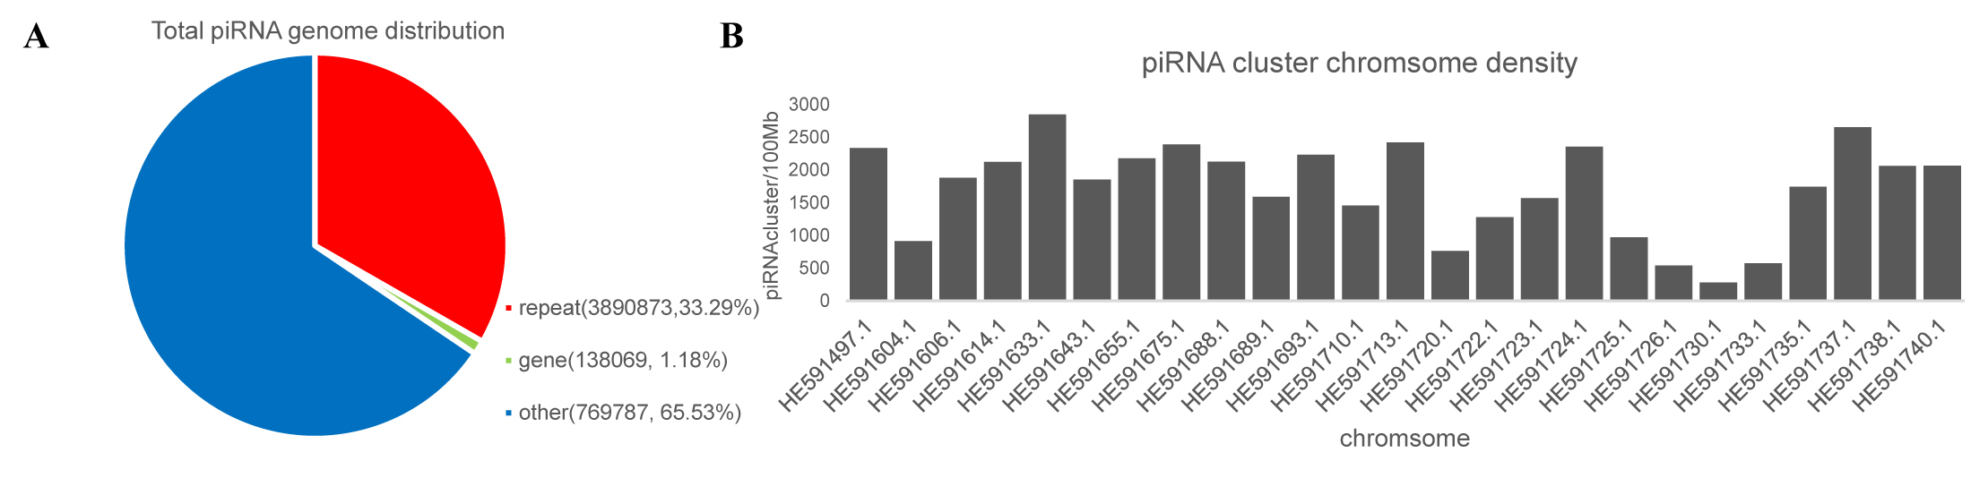
Figure s1 Origin and distribution of the total piRNA cluster in the genome. The origin of the piRNA cluster in the genome (reference genome fTakRub1.2); B, the distribution of piRNA clusters in the different chromosomes (reference genome fTakRub1.2).

