Figure s2
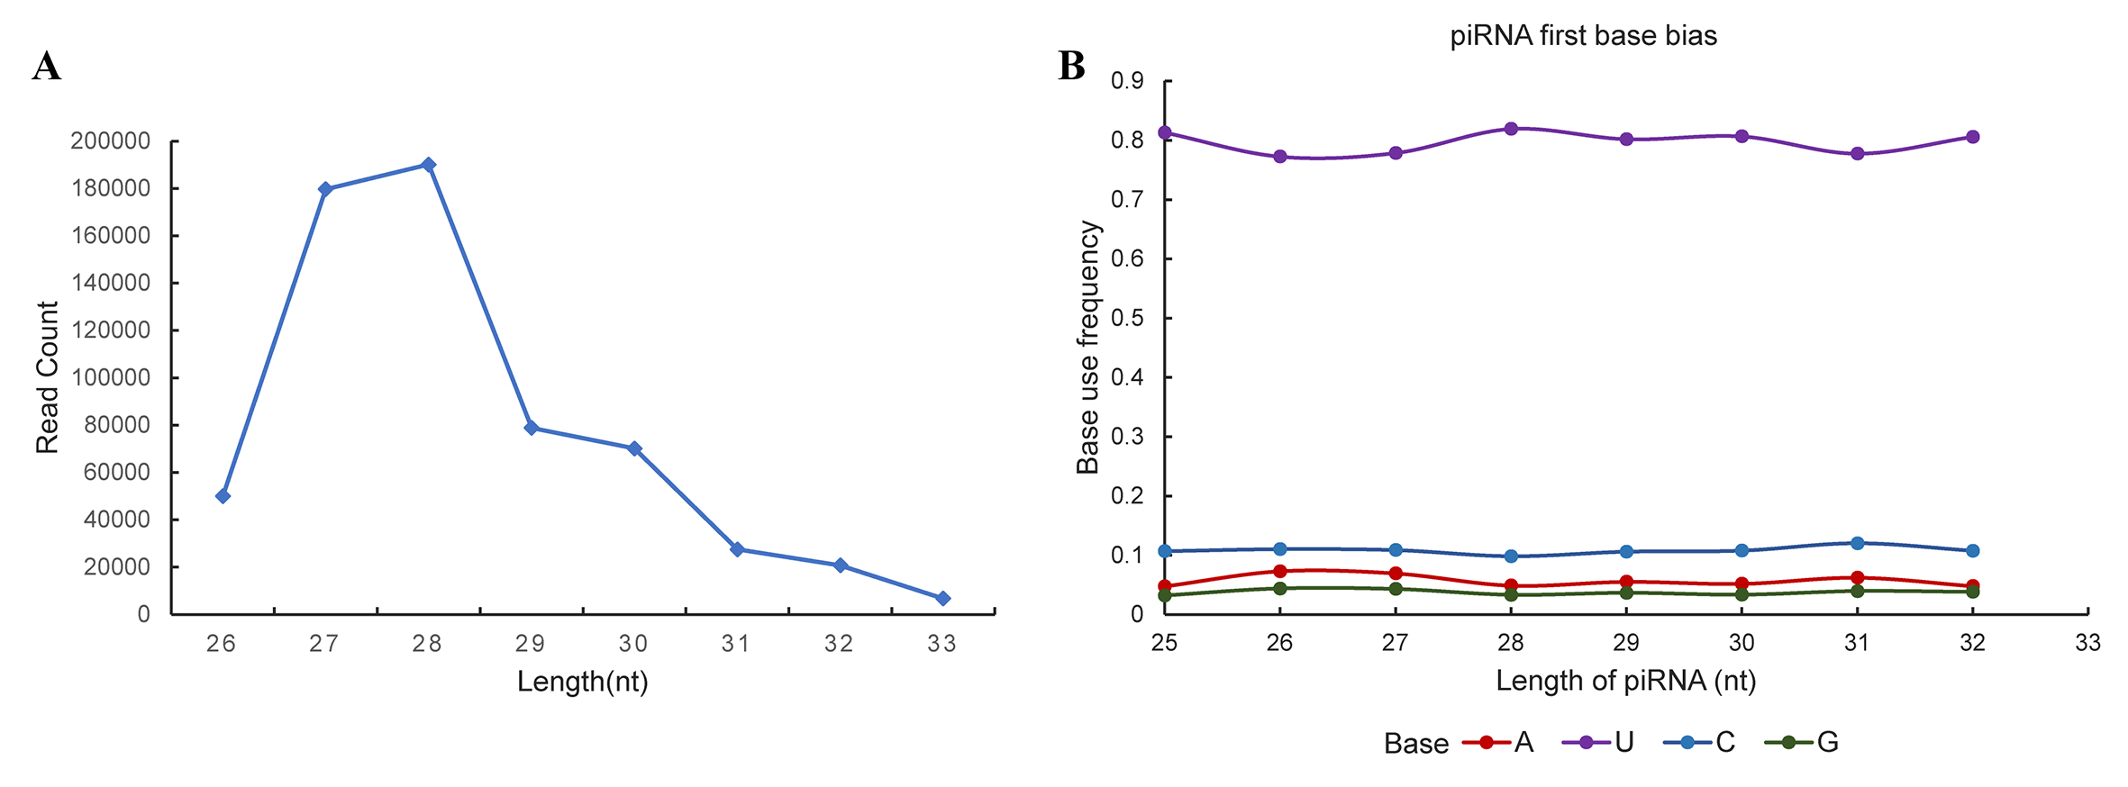

Figure s2 Length range and first base bias of piRNA in the gonad of juvenile Takifugu flavidus. A length distribution of sequenced piRNA from TTX-treated and control gonads of juvenile Takifugu flavidus. The X-axis denotes the piRNA length of 26-31 nucleotides, Y-axis represents the read count of piRNA; B, the first base bias of the sequenced piRNA from TTX-treated and control gonads of juvenile Takifugu flavidus. The X-axis denotes the piRNA length of 26-31 nucleotides, Y-axis represents the percentage of the base use frequency.

