Supplementary Material

Tables

Table S1. PDB codes and interacting chains for the CASP14 set and set with missing templates. The two interactions involving 6TMM are different possible configurations of the same two chains.

PDB | Chain 1 | Chain 2 | Top-ranked DockQ score
CASP 14 heterodimers
7M5F | A | C | 0.85
6XOD | A | B | 0.94
6VN1 | A | H | 0.01
6VN1 | H | L | 0.45
6R17 | A | C | 0.54
6TMM* | A | B | 0.03
6TMM* | A | D | 0.04
Heterodimers without templates
7EIV | A | C | 0.76
7EL1 | A | E | 0.01
7K01 | 1 | 6 | 0.36
7LDG | A | B | 0.45
7LF7 | A | M | 0.02
7LF7 | B | M | 0.02
7MEZ | A | B | 0.53
7NJ0 | A | C | 0.04

Table S2. Pearson correlations between DockQ scores of the different modelling runs. The strongest correlations are found using the same MSAs.

Model | model 1 |  |  |  |  |  | model 1 ptm
MSA | hhblits |  | AF2 |  | AF2+paired |  | hhblits |  | AF2 |  | AF2+paired
Strategy | ens 8 | rec 10 | ens 8 | rec 10 | ens 8 | rec 10 | ens 8 | rec 10 | ens 8 | rec 10 | ens 8 | rec 10
 | 1 | 2 | 3 | 4 | 5 | 6 | 7 | 8 | 9 | 10 | 11 | 12
1 | 0,00 | 0,93 | 0,55 | 0,48 | 0,79 | 0,72 | 0,98 | 0,96 | 0,50 | 0,49 | 0,78 | 0,71
2 | 0,93 | 0,00 | 0,60 | 0,48 | 0,74 | 0,70 | 0,92 | 0,90 | 0,55 | 0,54 | 0,72 | 0,66
3 | 0,55 | 0,60 | 0,00 | 0,87 | 0,70 | 0,66 | 0,56 | 0,56 | 0,82 | 0,80 | 0,65 | 0,60
4 | 0,48 | 0,48 | 0,87 | 0,00 | 0,65 | 0,63 | 0,49 | 0,49 | 0,79 | 0,73 | 0,63 | 0,61
5 | 0,79 | 0,74 | 0,70 | 0,65 | 0,00 | 0,92 | 0,80 | 0,79 | 0,63 | 0,65 | 0,86 | 0,82
6 | 0,72 | 0,70 | 0,66 | 0,63 | 0,92 | 0,00 | 0,73 | 0,72 | 0,63 | 0,62 | 0,84 | 0,82
7 | 0,98 | 0,92 | 0,56 | 0,49 | 0,80 | 0,73 | 0,00 | 0,96 | 0,50 | 0,51 | 0,77 | 0,72
8 | 0,96 | 0,90 | 0,56 | 0,49 | 0,79 | 0,72 | 0,96 | 0,00 | 0,52 | 0,50 | 0,76 | 0,70
9 | 0,50 | 0,55 | 0,82 | 0,79 | 0,63 | 0,63 | 0,50 | 0,52 | 0,00 | 0,89 | 0,71 | 0,66
10 | 0,49 | 0,54 | 0,80 | 0,73 | 0,65 | 0,62 | 0,51 | 0,50 | 0,89 | 0,00 | 0,63 | 0,62
11 | 0,78 | 0,72 | 0,65 | 0,63 | 0,86 | 0,84 | 0,77 | 0,76 | 0,71 | 0,63 | 0,00 | 0,87
12 | 0,71 | 0,66 | 0,60 | 0,61 | 0,82 | 0,82 | 0,72 | 0,70 | 0,66 | 0,62 | 0,87 | 0,00

Table S3. Success rate and median DockQ score for the different modelling strategies on the test set.

Modelling strategy | Success rate | Median DockQ score
RoseTTAFold | 0.096 | 0.011
GRAMM | 0.214 | 0.027
TMdock | 0.336 | 0.040
TMdock interfaces | 0.351 | 0.042
AF2 MSA,  m1-10-1 | 0.439 | 0.119
Paired MSA,  m1-10-1 | 0.481 | 0.196
AF2+Paired MSAs, m1-10-1 | 0.559 | 0.303
AF2+Paired MSAs, top ranked from five initializations, m1-10-1 | 0.590 | 0.338
Fused+Paired MSAs, m1-10-1 | 0.560 | 0.302
Fused+Paired MSAs, top ranked from five initializations, m1-10-1 | 0.590 | 0.334

Table S4. False Positive Rates (FPR) and True Positive Rates (TPR) for the test set using
the average plDDT in the interface of the obtained docking models as a threshold. Additionally, the fraction of acceptable and incorrect models and the Positive Predictive Value (PPV) are reported. The fraction of acceptable and incorrect models are obtained by multiplying the TPR and FPR with the success rate (SR=0.58) and the PPV by dividing the TPR with TPR+FPR. For all rates and thresholds, see: https://gitlab.com/ElofssonLab/FoldDock/-/blob/main/analysis/plots/roc_df_af2_marks.csv.

FPR | TPR | FDR: Fraction FP of all models | Fraction TP of all models | PPV | Average plDDT in interface
0.000 | 0.000 | 0.000 | 0.000 |  | 98.749
0.008 | 0.109 | 0.005 | 0.063 | 0.931 | 95.692
0.016 | 0.183 | 0.009 | 0.106 | 0.920 | 94.959
0.024 | 0.275 | 0.014 | 0.159 | 0.920 | 94.049
0.034 | 0.324 | 0.019 | 0.187 | 0.906 | 93.597
0.042 | 0.345 | 0.024 | 0.199 | 0.892 | 93.296
0.050 | 0.397 | 0.029 | 0.230 | 0.889 | 92.755
0.059 | 0.419 | 0.034 | 0.242 | 0.876 | 92.447
0.069 | 0.463 | 0.040 | 0.267 | 0.871 | 91.970
0.078 | 0.477 | 0.045 | 0.275 | 0.859 | 91.756
0.091 | 0.493 | 0.053 | 0.285 | 0.844 | 91.459
0.104 | 0.507 | 0.060 | 0.293 | 0.830 | 91.170
0.112 | 0.525 | 0.065 | 0.303 | 0.824 | 90.855
0.120 | 0.548 | 0.069 | 0.317 | 0.820 | 90.560
0.128 | 0.568 | 0.074 | 0.328 | 0.816 | 90.230
0.136 | 0.586 | 0.079 | 0.339 | 0.812 | 89.921
0.150 | 0.598 | 0.087 | 0.346 | 0.799 | 89.632
0.162 | 0.614 | 0.093 | 0.355 | 0.792 | 89.347
0.179 | 0.633 | 0.104 | 0.366 | 0.779 | 88.967
0.190 | 0.652 | 0.110 | 0.377 | 0.774 | 88.639
0.205 | 0.660 | 0.118 | 0.381 | 0.763 | 88.414
0.213 | 0.666 | 0.123 | 0.385 | 0.758 | 88.300
0.226 | 0.688 | 0.130 | 0.398 | 0.753 | 87.873
0.238 | 0.699 | 0.138 | 0.404 | 0.746 | 87.659
0.248 | 0.715 | 0.143 | 0.413 | 0.742 | 87.381
0.258 | 0.729 | 0.149 | 0.421 | 0.739 | 87.154
0.270 | 0.739 | 0.156 | 0.427 | 0.732 | 86.941
0.286 | 0.746 | 0.166 | 0.431 | 0.723 | 86.612
0.301 | 0.764 | 0.174 | 0.442 | 0.718 | 86.083
0.317 | 0.784 | 0.183 | 0.453 | 0.712 | 85.756
0.328 | 0.794 | 0.190 | 0.459 | 0.708 | 85.511
0.338 | 0.804 | 0.195 | 0.465 | 0.704 | 85.257
0.354 | 0.819 | 0.204 | 0.473 | 0.698 | 84.882
0.365 | 0.833 | 0.211 | 0.481 | 0.695 | 84.553
0.376 | 0.839 | 0.217 | 0.485 | 0.690 | 84.314
0.386 | 0.852 | 0.223 | 0.492 | 0.688 | 84.079
0.405 | 0.859 | 0.234 | 0.496 | 0.680 | 83.752
0.426 | 0.873 | 0.246 | 0.504 | 0.672 | 83.120
0.462 | 0.886 | 0.267 | 0.512 | 0.657 | 82.336
0.475 | 0.896 | 0.275 | 0.518 | 0.653 | 81.612
0.491 | 0.903 | 0.284 | 0.522 | 0.648 | 81.148
0.515 | 0.917 | 0.298 | 0.530 | 0.640 | 80.197
0.530 | 0.929 | 0.306 | 0.537 | 0.637 | 79.621
0.546 | 0.936 | 0.315 | 0.541 | 0.632 | 79.207
0.574 | 0.943 | 0.332 | 0.545 | 0.621 | 78.148
0.611 | 0.951 | 0.353 | 0.550 | 0.609 | 76.790
0.645 | 0.964 | 0.373 | 0.557 | 0.599 | 75.105
0.685 | 0.970 | 0.396 | 0.560 | 0.586 | 73.530
0.717 | 0.975 | 0.414 | 0.564 | 0.576 | 72.177
0.766 | 0.982 | 0.443 | 0.568 | 0.562 | 70.493
0.816 | 0.989 | 0.472 | 0.572 | 0.548 | 67.201
0.850 | 0.995 | 0.491 | 0.575 | 0.539 | 63.775

Figures

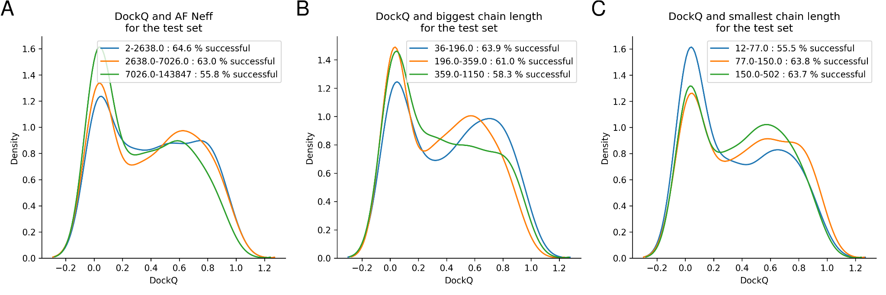
Figure S1. The distribution of DockQ scores for tertiles is derived from A) AF Neff B) biggest chain length C) smallest chain length. The separation between the tertiles is low for all features displaying similar success rates.

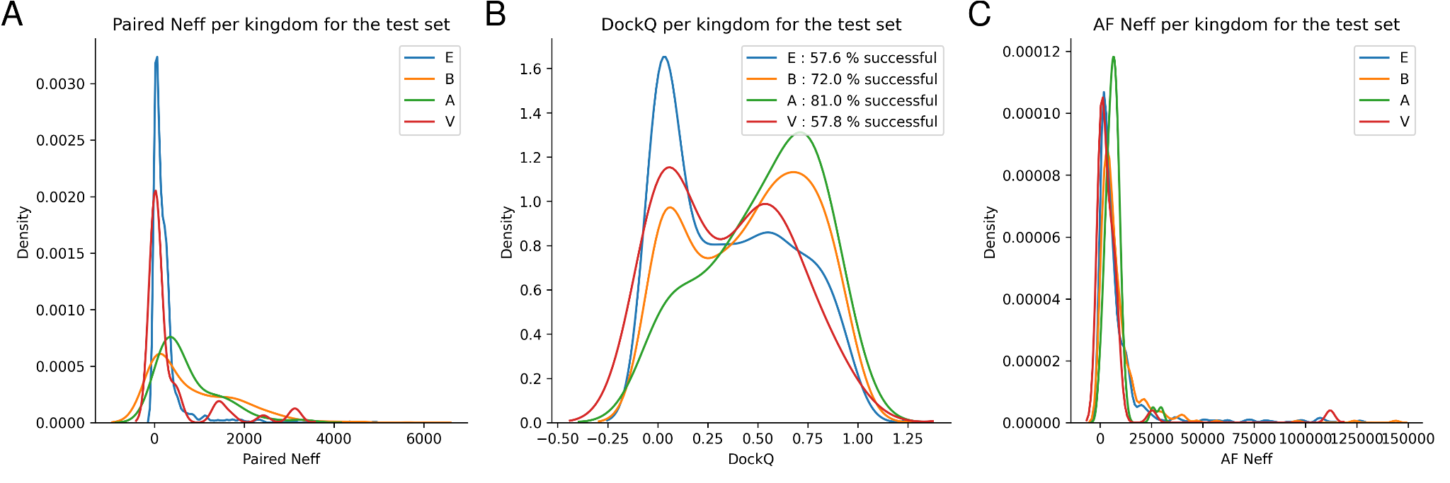
Figure S2. Distribution per kingdom (E=Eukarya, B=Bacteria, A=Archaea, V=Virus) of A) Paired Neff, B) DockQ scores, and C) AF Neff.

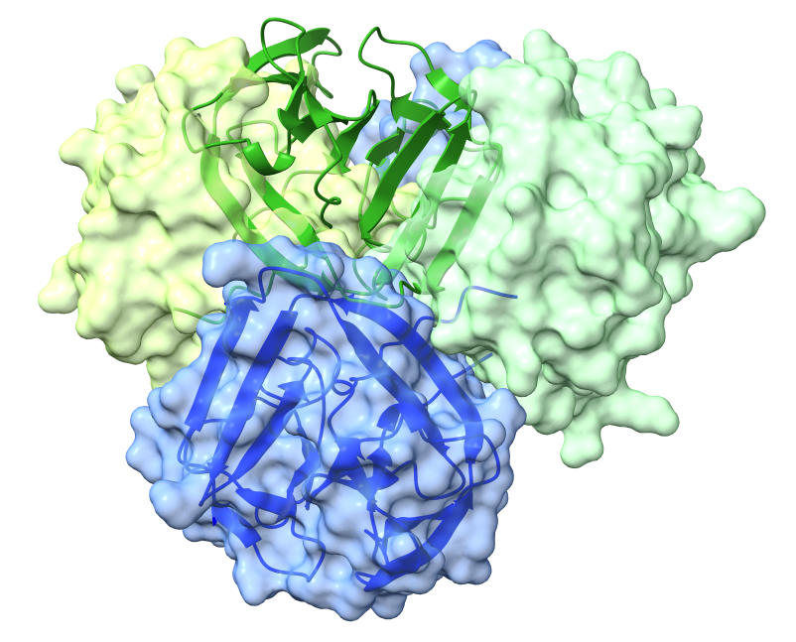
Figure S3. Docking model of CASP14 heterodimer 6TMM (ribbons) superposed to the native heterocomplex (surfaces). The docking model smaller chain (green) is positioned halfway between the two alternative binding sites between blue and green surfaces.

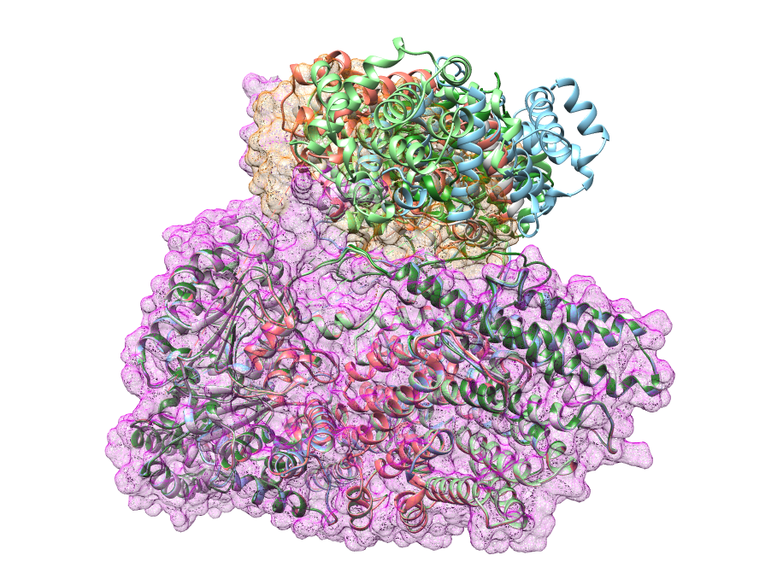
Figure S4. Prediction of 7NJ0_A-7NJ0_C with the native structure represented as a mesh surface (orange and magenta). All predictions (ribbons) get the location of the chains correct, but the interface and orientations are slightly wrong, resulting in DockQ scores f close to 0.

