Construction | Name and direction | Sequence (5′ → 3′) | Reference
pA-gfpOVA | P_{aspA}-insert-FW | AAGCATGCTACCTGAATGGGTTGCGAAT | This study
pA-gfpOVA | P_{aspA}-insert-RV | AATCTAGACGCTCTCAGAGTGTGAACAC | This study
pA-gfpOVA | Seq-GFP-FW | TCTCCACTGACAGAAAATTTGTGC | This study
pA-TP | TP-vector-FW | GCGCGAGGACCTGAAGTAACTGCAGCCAAGCTTGGCT | This study
pA-TP | TP-vector-RV | CTGATCTTTTCTTCATCTTCAAACCCATATGTATATCTCCTTCTTAAATCTAGACGCTCT | This study
pA-TP | P_{aspA}-insert-FW | AGAGCGTCTAGATTTAAGAAGGAGATATACATATGGGTTTGAAGATGAAGAAAAGATCAG | This study
pA-TP | P_{aspA}-insert-RV | AGCCAAGCTTGGCTGCAGTTACTTCAGGTCCTCGCGC | This study
pA-TP | Seq-TP-FW | GCGACTCCTGCATTAGGAAGCAGC | This study
Supplementary Table S1. List of primers for plasmid construction
Supplementary Table S2. Primer sets for qRT-PCR
qRT-PCR primer description |  | Sequence (5′ → 3′) | Reference
dcuS | FW primer | TGCGGTACTGTTCTCGGTGC | This study
dcuS | RV primer | CACTGCCAGTGCCTTGTTGG | This study
aspA | FW primer | ATGTCAAACA ACATTCGTAT | This study
aspA | RV primer | AGTTTTCAATCGCTCTCAGA | This study
dcuB | FW primer | AGAAAGGGTGGTATCGCGCT | This study
dcuB | RV primer | CCACCACCGCAATGATAACC | This study
frdA | FW primer | GCGCAGGCAAATCCGAATGC | This study
frdA | RV primer | CATGATCCTGCGCGACAGCG | This study
dctA | FW primer | GGTCCTGACAGCGATAGCCA | This study
dctA | RV primer | CCGCAATGCCCGTTACGACG | This study
16S rRNA | FW primer | CATGCCGCGTGTATGAAGAA | 42
16S rRNA | RV primer | CGGGTAACGTCAATGAGCAAA | 42

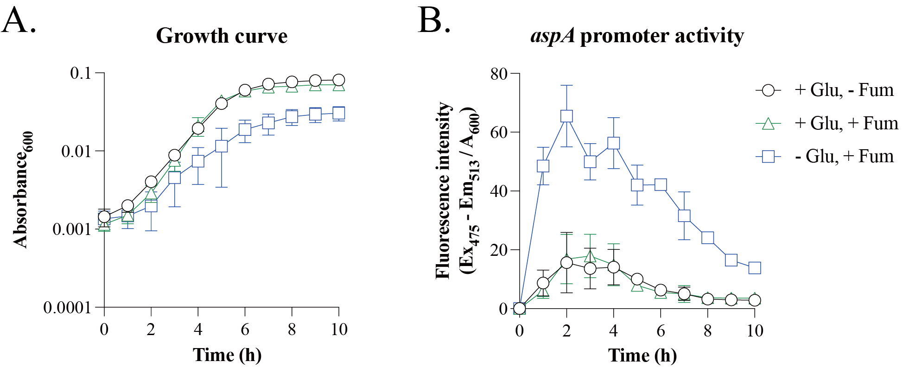Supplementary Figure S1. Growth environment-dependent P_{aspA} activity.
(A and B) E. coli carrying pA-gfpOVA were cultured in M9 medium supplemented with the indicated carbon source in an anaerobic bag. (A) Bacterial growth was monitored by measuring the absorbance at 600 nm hourly. (B) aspA promoter activity was evaluated by utilizing an unstable variant of green fluorescent protein (gfpOVA), with fluorescence detected at excitation and emission wavelengths of 488 nm and 513 nm, respectively. Fluorescence intensity was normalized to absorbance at 600 nm.
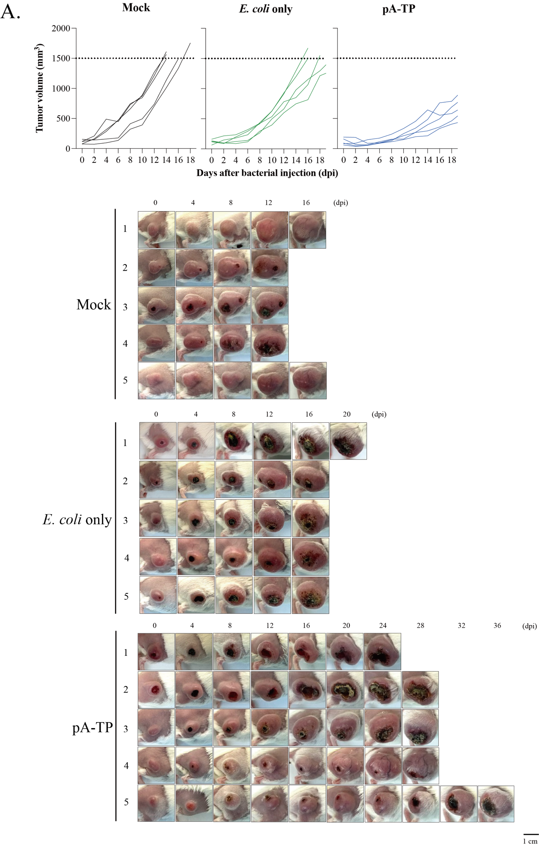
Supplementary Figure S2. Complete set of tumor-bearing mouse images expanded from those shown in Figure 4B. BALB/c mice were subcutaneously implanted with 1 × 10⁶ CT26 colon carcinoma cells on the right thigh. CT26 tumor-bearing mice were intravenously injected with PBS (Mock; black line), wild-type E. coli (E. coli only; green line), or MDG003 (pA-TP; blue line) (n = 5 per group; 10⁸ CFU/mouse) when the tumor size was 100–150 mm³.

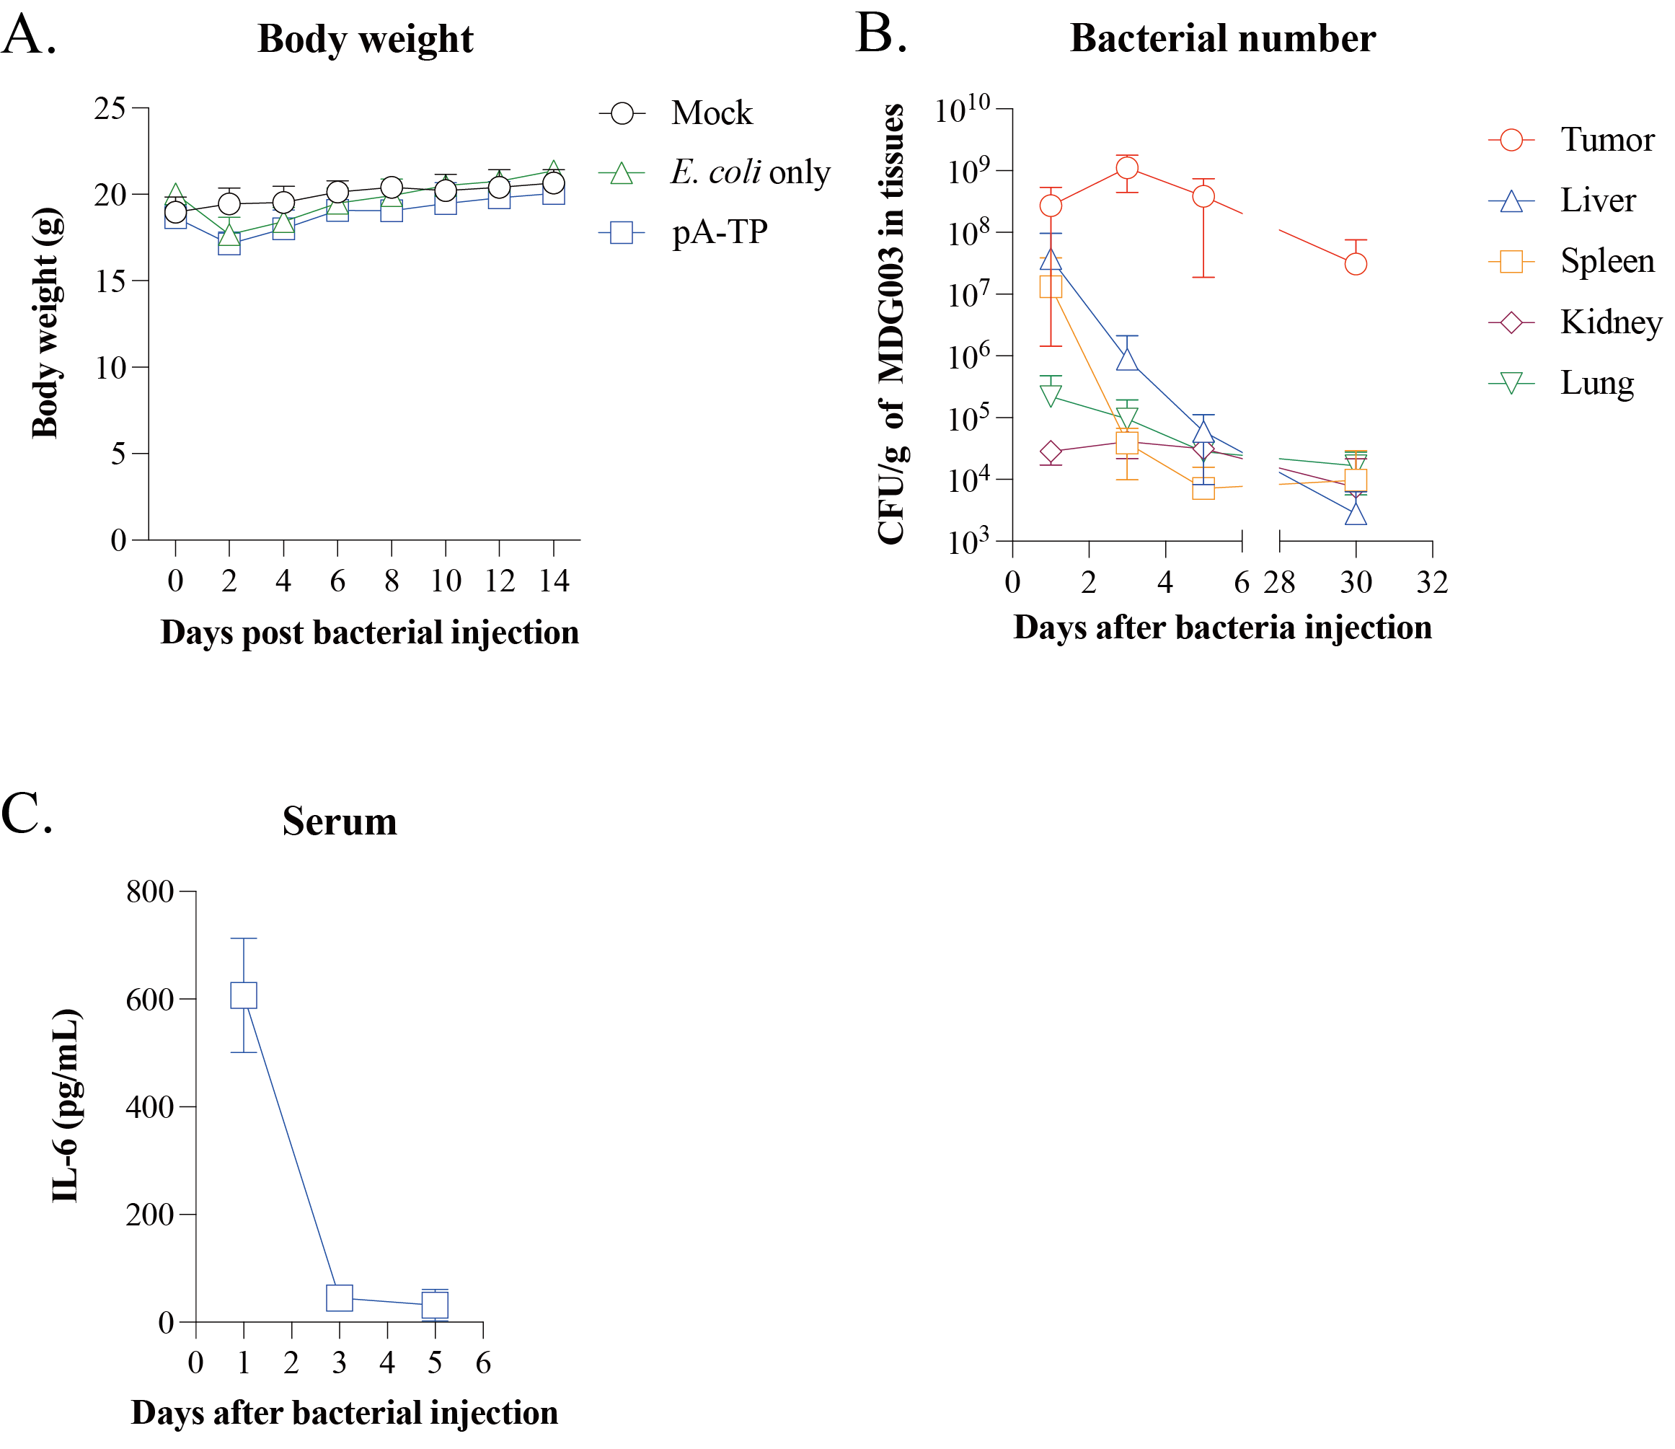
Supplementary Figure S3. Assessment of the host response upon bacterial injection.
(A–C) BALB/c mice were subcutaneously implanted with 1 × 10⁶ CT26 colon carcinoma cells on the thigh. To assess the toxicity of bacterial injection, CT26-bearing BALB/c mice were treated with PBS (Mock; black line circle), wild-type E. coli (E. coli only; green line triangle), or MDG003 (pA-TP; blue line square) by intravenous injection at a dose of 1 × 10⁸ CFU/mouse when the tumor size was 100–150 mm³. (A) The body weight changes in mice grafted with CT26 were measured every 2 days after bacterial injection. (B) Bacterial counts were measured at 1, 3, 5, and 30 dpi in the described tissue. (C) The serum cytokine level was measured at the indicated days.

Supplementary Figure S4. Assessment of the plasmid stability in vivo.
BALB/c mice were subcutaneously implanted with 1 × 10⁶ CT26 colon carcinoma cells on the thigh. To assess the toxicity of bacterial injection, CT26-bearing BALB/c mice were treated with MDG003 by intravenous injection at a dose of 1 × 10⁸ CFU/mouse when the tumor size was 100–150 mm³. Bacterial counts were measured at 1, 3, and 5 dpi in the tumor tissue. To assess plasmid stability, recovered bacteria were plated on both non-selective LB agar and antibiotic-containing LB agar. Plasmid-bearing fraction was calculated as the percentage of CFUs grown on amp-containing plates relative to total CFUs grown on non-selective LB plates.

