Supplementary Figures
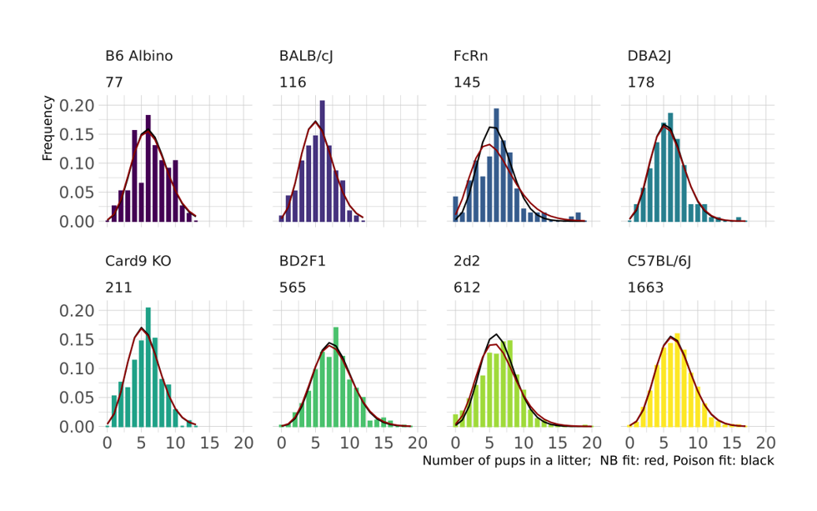Figure S1: Litter size distribution for different mouse strains, estimated from the corresponding number of litters (under the strain name). On top of each histogram, fits of the Negative Binomial (red) and Poisson (black) distributions are displayed. The fits were performed using the Maximum Likelihood approach implemented in the MASS package in R. Strain/line names are indicated and refer to: B6 Albino - B6N-Tyrc-Brd/BrdCrCrl, BD2F1 - B6D2F1, Card9 KO – C57BL/6N-Card9em1ltk, FcRn – C57BL/6.Cg-Fcgrttm1Dcr Tg(FCGRT)32Dcr/DcrJ, 2d2 - Tg(Tcra2D2,Tcrb2D2)1Kuch, total number of used litters is indicated under the line name.

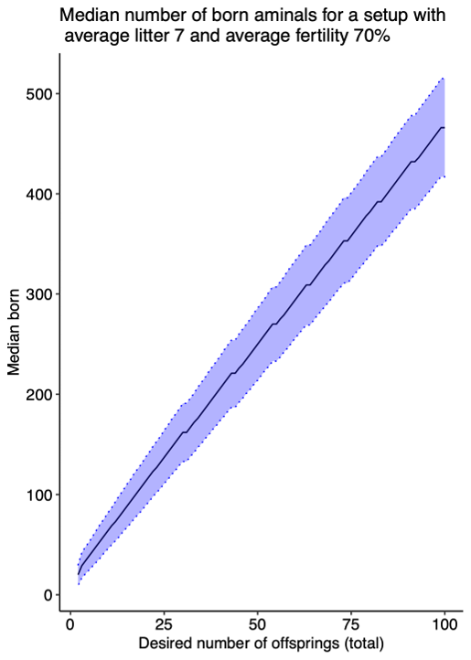

Figure S2: Total number of born animals, when the breeding setup is designed to yield no less than X animals with success probability 90%. Blackline depicts the median number of animals born, the blue area around corresponds to the symmetric confidence interval of 0.8.

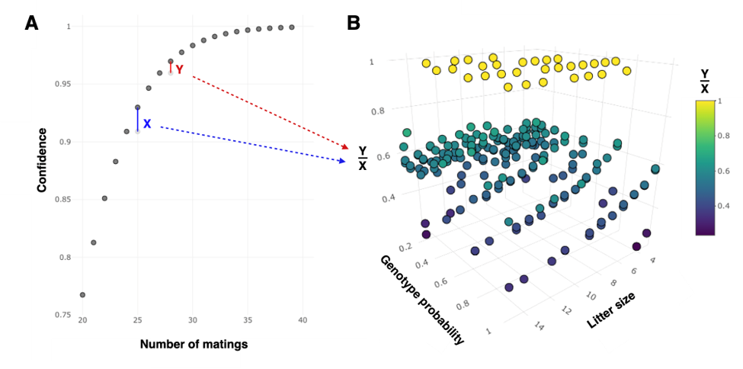

Figure S3: Optimal confidence level choice. Panel A shows an example of the relation between the number of matings and the confidence in the successful outcome of the breeding; segments X (blue) and Y (red) show the confidence increase granted by one additional mating: X – starting from the number of matings sufficient for the 90% confidence, Y – from the number of matings sufficient for the 95% confidence. One can see that the higher the target confidence, the smaller the confidence increase – which is especially pronounced for the high confidence values (flat curve). The parameters used for this example: the average litter size of 5, fertility of 50%, desired genotype probability of 50%, the desired number of pups of this genotype – 20. Panel B shows the ratio of the 95% and the 90% confidence increases from panel A, calculated for different starting parameters for the litter size, the fertility (not shown) and the desired genotype probability. Hence, one point corresponds to a single example as in panel A.
For some cases (yellow), when very few matings are required to yield a successful breeding, there is no difference between X and Y, thus the ratio is 1. However, for the majority of breeding parameters, the increase in confidence above from 95% is from 1.5 to 10 fold smaller than the increase from 90% (Y/X values below 0.6). We therefore recommend choosing the target confidence level not too high (often, below 95%).

