Graphical Abstract
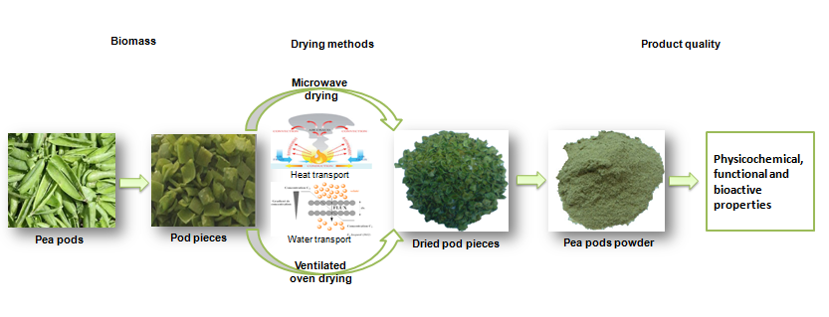

Statement of Novelty
Drying of by-products from pea processing industry was investigated as a critical step prior to their valorization for energy and fuel production as well as chemicals recovery. The drying of pea pods has never been investigated before which is the case of the present study. Our research work reported that microwave drying technique can be used for conservation of this valuable product by preserving quality of fresh materials and to economizing energy and time.

