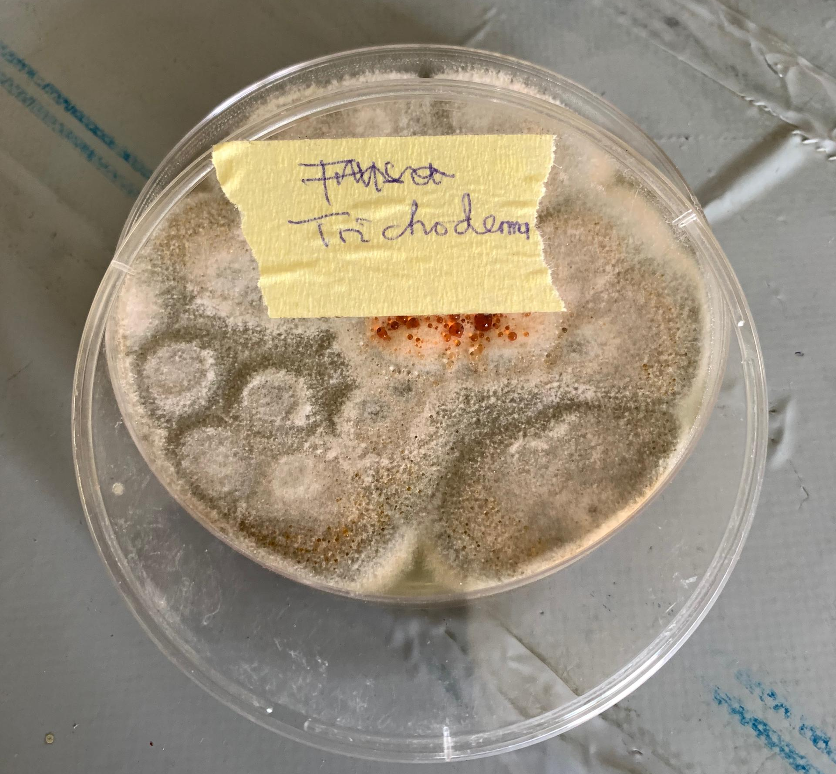
Plate 1: Dual culture interaction between Trichoderma harzianum and Fusarium oxysporum on potato dextrose agar
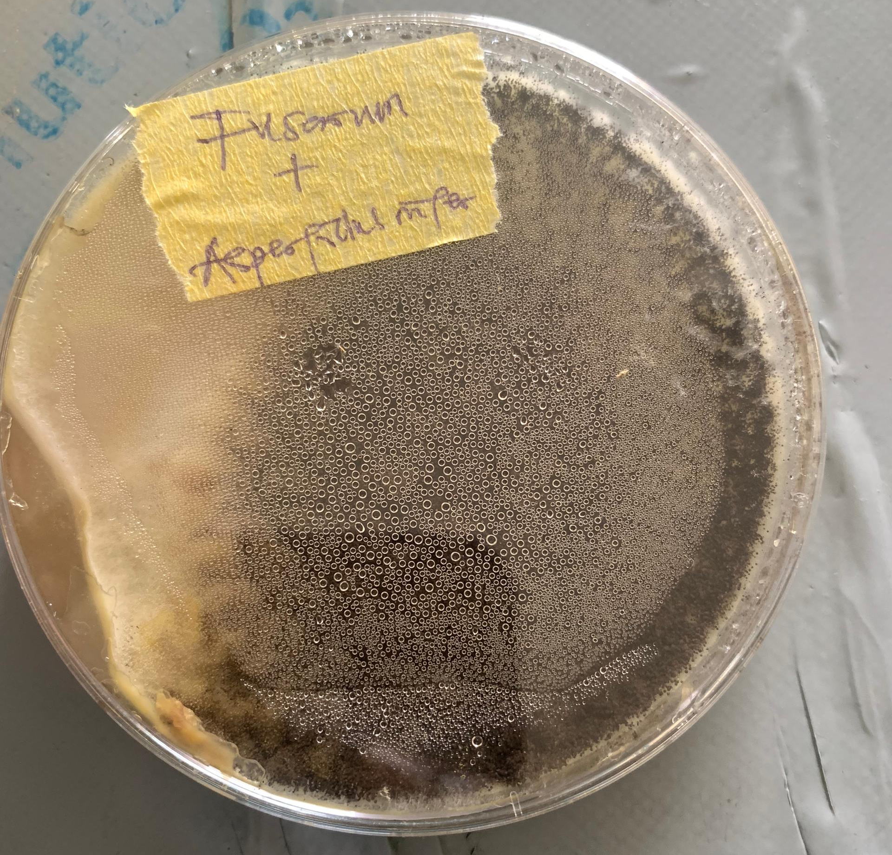
Plate 2: Dual culture interaction between Aspergillus niger and Fusarium oxysporum on potato dextrose agar
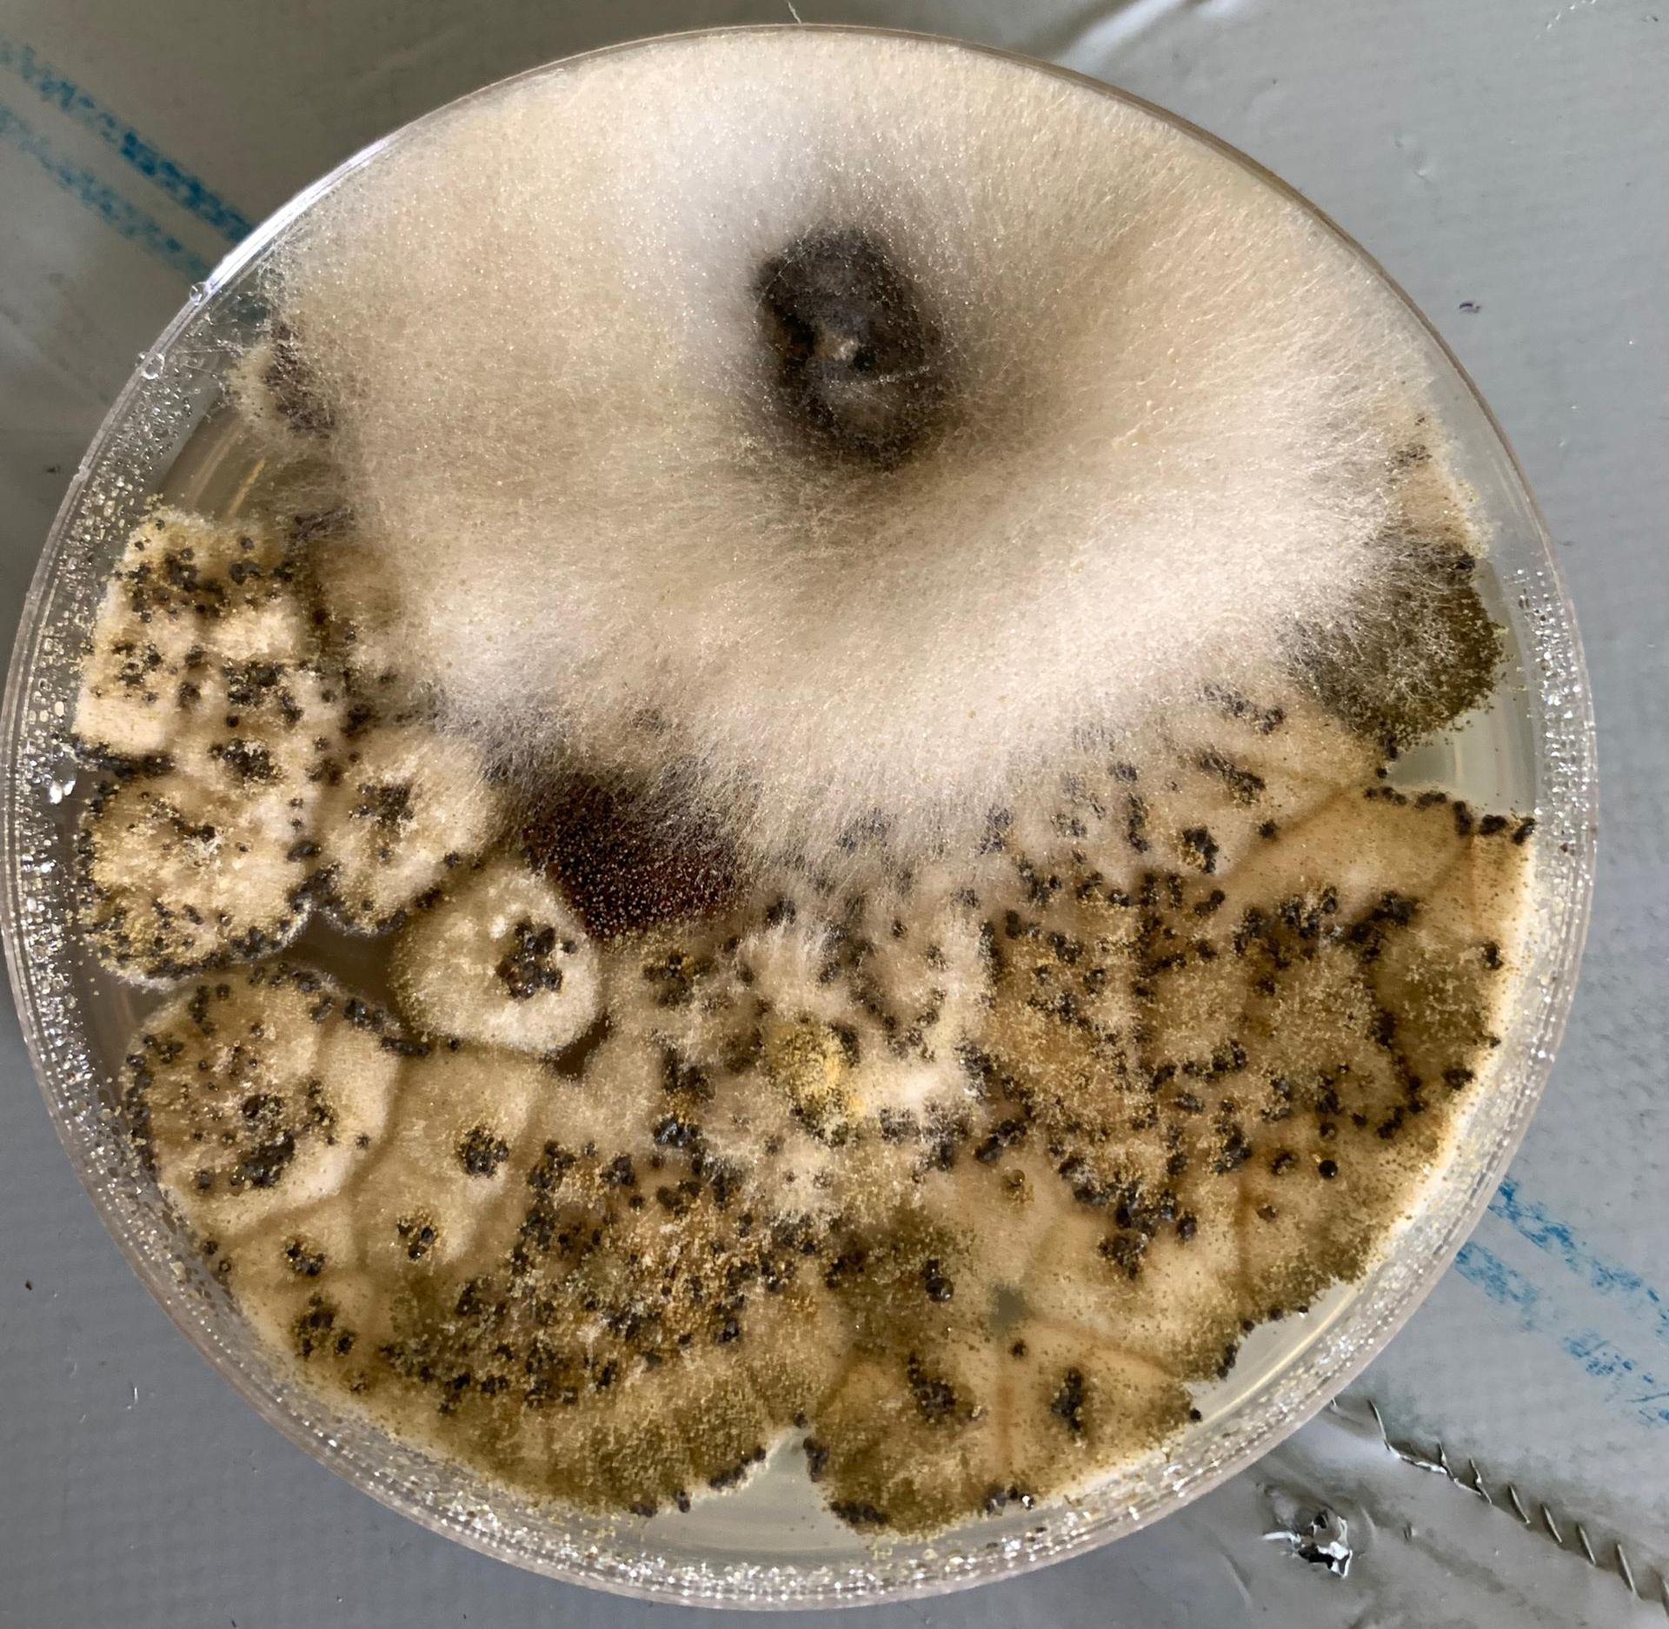
Plate 3: Dual culture interaction between Aspergillus flavus and Fusarium oxysporum on potato dextrose agar

