Supplementary Material

Table S1. Effects of depth, month, and year on coral physiological traits (WLS ANOVA)
Weighted least squares (WLS) ANOVA results testing the effects of Depth, Month, and Year on coral physiological traits for three genera. Models were run separately for each genus and metric.
Genus | Metric | Effect | df | F | p-value | Interpretation
Stylophora | Fv/Fm | Depth | 1 | 17.31 | 0.000836 | Shallow < deep
Stylophora | Fv/Fm | Month | 3 | 8.34 | 0.001683 | Seasonal variation
Stylophora | Fv/Fm | Year | 1 | 6.91 | 0.018968 | Interannual shift
Pocillopora | Fv/Fm | Depth | 1 | 7.64 | 0.014446 | Shallow < deep
Pocillopora | Fv/Fm | Month | 3 | 6.28 | 0.005644 | Seasonal variation
Pocillopora | Fv/Fm | Year | 1 | 0.08 | 0.786021 | n.s.
Acropora | Fv/Fm | Depth | 1 | 0.52 | 0.48213 | n.s.
Acropora | Fv/Fm | Month | 3 | 2.88 | 0.071041 | n.s.
Acropora | Fv/Fm | Year | 1 | 8.87 | 0.00939 | Interannual shift
Stylophora | Symbiont density | Depth | 1 | 0.35 | 0.565606 | n.s.
Stylophora | Symbiont density | Month | 3 | 1.44 | 0.27029 | n.s.
Stylophora | Symbiont density | Year | 1 | 0.31 | 0.583952 | n.s.
Pocillopora | Symbiont density | Depth | 1 | 7.18 | 0.017152 | Shallow < deep
Pocillopora | Symbiont density | Month | 3 | 2.0 | 0.15801 | n.s.
Pocillopora | Symbiont density | Year | 1 | 11.55 | 0.003967 | Interannual shift
Acropora | Symbiont density | Depth | 1 | 4.83 | 0.04411 | Shallow < deep
Acropora | Symbiont density | Month | 3 | 0.87 | 0.477233 | n.s.
Acropora | Symbiont density | Year | 1 | 6.47 | 0.022487 | Interannual shift
Stylophora | Chl per symbiont cell | Depth | 1 | 1.45 | 0.24787 | n.s.
Stylophora | Chl per symbiont cell | Month | 3 | 0.89 | 0.469057 | n.s.
Stylophora | Chl per symbiont cell | Year | 1 | 3.1 | 0.098879 | n.s.
Pocillopora | Chl per symbiont cell | Depth | 1 | 0.22 | 0.643055 | n.s.
Pocillopora | Chl per symbiont cell | Month | 3 | 0.87 | 0.479742 | n.s.
Pocillopora | Chl per symbiont cell | Year | 1 | 0.33 | 0.575139 | n.s.
Acropora | Chl per symbiont cell | Depth | 1 | 0.04 | 0.835045 | n.s.
Acropora | Chl per symbiont cell | Month | 3 | 4.99 | 0.013477 | Seasonal variation
Acropora | Chl per symbiont cell | Year | 1 | 3.37 | 0.08637 | n.s.
Weighted least squares (WLS) ANOVA results testing the effects of depth, month, and year on coral photophysiology (Fv/Fm), symbiont density, and chlorophyll content per symbiont cell for Stylophora, Pocillopora, and Acropora. Significant effects (p < 0.05) are highlighted in bold. “Shallow < deep” indicates lower values in shallow colonies relative to deeper conspecifics. n.s., not significant.

Table S2. Genus-level pairwise comparisons split by metric
Pairwise comparisons among 2024 Bleached, 2024 Healthy, and 2025 Healthy. Welch t-tests computed from summary statistics; BH-FDR adjusted p-values within each metric.

Metric: Fv/Fm
Genus | Group 1 | Group 2 | Comparison | n (Group 1) | Mean (Group 1) | SD (Group 1) | n (Group 2) | Mean (Group 2) | SD (Group 2) | Mean diff (1-2) | 95% CI lo | 95% CI hi | Welch t | df | p | p (FDR within metric) | Hedges g
Acropora | 2024 Bleached | 2024 Healthy | 2024 Bleached minus 2024 Healthy | 3 | 0.52 | 0.027 | 3 | 0.582 | 0.039 | -0.062 | -0.142 | 0.018 | -2.26 | 3.59 | 0.0944 | 0.2551 | -1.48
Acropora | 2024 Bleached | 2025 Healthy | 2024 Bleached minus 2025 Healthy | 3 | 0.52 | 0.027 | 5 | 0.574 | 0.033 | -0.054 | -0.109 | 0.001 | -2.52 | 5.07 | 0.0524 | 0.2095 | -1.52
Acropora | 2024 Healthy | 2025 Healthy | 2024 Healthy minus 2025 Healthy | 3 | 0.582 | 0.039 | 5 | 0.574 | 0.033 | 0.008 | -0.069 | 0.084 | 0.29 | 3.73 | 0.7902 | 0.7902 | 0.19
Astreopora | 2024 Bleached | 2024 Healthy | 2024 Bleached minus 2024 Healthy | 4 | 0.568 | 0.046 | 3 | 0.412 | 0.357 | 0.156 | -0.715 | 1.028 | 0.75 | 2.05 | 0.5279 | 0.6335 | 0.58
Astreopora | 2024 Bleached | 2025 Healthy | 2024 Bleached minus 2025 Healthy | 4 | 0.568 | 0.046 | 5 | 0.543 | 0.03 | 0.025 | -0.043 | 0.093 | 0.94 | 4.95 | 0.3886 | 0.6335 | 0.59
Astreopora | 2024 Healthy | 2025 Healthy | 2024 Healthy minus 2025 Healthy | 3 | 0.412 | 0.357 | 5 | 0.543 | 0.03 | -0.131 | -1.012 | 0.75 | -0.64 | 2.02 | 0.5896 | 0.6432 | -0.55
Millepora | 2024 Bleached | 2024 Healthy | 2024 Bleached minus 2024 Healthy | 3 | 0.262 | 0.04 | 3 | 0.316 | 0.1 | -0.054 | -0.27 | 0.162 | -0.86 | 2.61 | 0.4604 | 0.6335 | -0.56
Millepora | 2024 Bleached | 2025 Healthy | 2024 Bleached minus 2025 Healthy | 3 | 0.262 | 0.04 | 5 | 0.454 | 0.025 | -0.192 | -0.273 | -0.111 | -7.54 | 3.02 | 0.0047 | 0.0284 | -5.42
Millepora | 2024 Healthy | 2025 Healthy | 2024 Healthy minus 2025 Healthy | 3 | 0.316 | 0.1 | 5 | 0.454 | 0.025 | -0.138 | -0.375 | 0.099 | -2.34 | 2.16 | 0.1346 | 0.2691 | -1.96
Stylophora | 2024 Bleached | 2024 Healthy | 2024 Bleached minus 2024 Healthy | 3 | 0.485 | 0.075 | 3 | 0.604 | 0.014 | -0.119 | -0.298 | 0.06 | -2.71 | 2.13 | 0.1063 | 0.2551 | -1.77
Stylophora | 2024 Bleached | 2025 Healthy | 2024 Bleached minus 2025 Healthy | 3 | 0.485 | 0.075 | 5 | 0.448 | 0.056 | 0.037 | -0.113 | 0.187 | 0.74 | 3.35 | 0.51 | 0.6335 | 0.51
Stylophora | 2024 Healthy | 2025 Healthy | 2024 Healthy minus 2025 Healthy | 3 | 0.604 | 0.014 | 5 | 0.448 | 0.056 | 0.156 | 0.088 | 0.224 | 5.99 | 4.74 | 0.0022 | 0.0269 | 2.95

Metric: Cells/cm2
Genus | Group 1 | Group 2 | Comparison | n (Group 1) | Mean (Group 1) | SD (Group 1) | n (Group 2) | Mean (Group 2) | SD (Group 2) | Mean diff (1-2) | 95% CI lo | 95% CI hi | Welch t | df | p | p (FDR within metric) | Hedges g
Acropora | 2024 Bleached | 2024 Healthy | 2024 Bleached minus 2024 Healthy | 3 | 338343.0 | 57533.0 | 3 | 1394643.0 | 470884.0 | -1056300.0 | -2202606.0 | 90006.0 | -3.86 | 2.06 | 0.0583 | 0.1166 | -2.52
Acropora | 2024 Bleached | 2025 Healthy | 2024 Bleached minus 2025 Healthy | 3 | 338343.0 | 57533.0 | 5 | 1089753.0 | 468286.0 | -751410.0 | -1329317.0 | -173503.0 | -3.54 | 4.2 | 0.0221 | 0.0855 | -1.7
Acropora | 2024 Healthy | 2025 Healthy | 2024 Healthy minus 2025 Healthy | 3 | 1394643.0 | 470884.0 | 5 | 1089753.0 | 468286.0 | 304890.0 | -620896.0 | 1230677.0 | 0.89 | 4.32 | 0.421 | 0.5052 | 0.57
Astreopora | 2024 Bleached | 2024 Healthy | 2024 Bleached minus 2024 Healthy | 3 | 403848.0 | 122980.0 | 3 | 781438.0 | 407738.0 | -377591.0 | -1294716.0 | 539535.0 | -1.54 | 2.36 | 0.2456 | 0.3275 | -1.0
Astreopora | 2024 Bleached | 2025 Healthy | 2024 Bleached minus 2025 Healthy | 3 | 403848.0 | 122980.0 | 4 | 600641.0 | 512479.0 | -196793.0 | -984077.0 | 590492.0 | -0.74 | 3.45 | 0.5064 | 0.5525 | -0.41
Astreopora | 2024 Healthy | 2025 Healthy | 2024 Healthy minus 2025 Healthy | 3 | 781438.0 | 407738.0 | 4 | 600641.0 | 512479.0 | 180798.0 | -717404.0 | 1079000.0 | 0.52 | 4.93 | 0.6258 | 0.6258 | 0.32
Millepora | 2024 Bleached | 2024 Healthy | 2024 Bleached minus 2024 Healthy | 4 | 341835.0 | 105396.0 | 4 | 1659585.0 | 677088.0 | -1317751.0 | -2380175.0 | -255326.0 | -3.85 | 3.15 | 0.0285 | 0.0855 | -2.36
Millepora | 2024 Bleached | 2025 Healthy | 2024 Bleached minus 2025 Healthy | 4 | 341835.0 | 105396.0 | 5 | 251575.0 | 84597.0 | 90260.0 | -70202.0 | 250721.0 | 1.39 | 5.74 | 0.2156 | 0.3234 | 0.85
Millepora | 2024 Healthy | 2025 Healthy | 2024 Healthy minus 2025 Healthy | 4 | 1659585.0 | 677088.0 | 5 | 251575.0 | 84597.0 | 1408010.0 | 338719.0 | 2477302.0 | 4.13 | 3.08 | 0.0245 | 0.0855 | 2.79
Stylophora | 2024 Bleached | 2024 Healthy | 2024 Bleached minus 2024 Healthy | 3 | 1687638.0 | 419125.0 | 3 | 2397600.0 | 579438.0 | -709962.0 | -1901990.0 | 482066.0 | -1.72 | 3.64 | 0.1676 | 0.2873 | -1.12
Stylophora | 2024 Bleached | 2025 Healthy | 2024 Bleached minus 2025 Healthy | 3 | 1687638.0 | 419125.0 | 5 | 871752.0 | 526305.0 | 815887.0 | -40389.0 | 1672162.0 | 2.42 | 5.23 | 0.0581 | 0.1166 | 1.44
Stylophora | 2024 Healthy | 2025 Healthy | 2024 Healthy minus 2025 Healthy | 3 | 2397600.0 | 579438.0 | 5 | 871752.0 | 526305.0 | 1525849.0 | 388163.0 | 2663535.0 | 3.73 | 3.98 | 0.0205 | 0.0855 | 2.44

Metric: Chl pg/cell
Genus | Group 1 | Group 2 | Comparison | n (Group 1) | Mean (Group 1) | SD (Group 1) | n (Group 2) | Mean (Group 2) | SD (Group 2) | Mean diff (1-2) | 95% CI lo | 95% CI hi | Welch t | df | p | p (FDR within metric) | Hedges g
Acropora | 2024 Bleached | 2024 Healthy | 2024 Bleached minus 2024 Healthy | 3 | 0.85 | 0.22 | 3 | 0.96 | 0.35 | -0.11 | -0.83 | 0.61 | -0.46 | 3.4 | 0.6764 | 0.6764 | -0.3
Acropora | 2024 Bleached | 2025 Healthy | 2024 Bleached minus 2025 Healthy | 3 | 0.85 | 0.22 | 5 | 2.28 | 1.02 | -1.42 | -2.68 | -0.17 | -2.99 | 4.61 | 0.0339 | 0.0581 | -1.46
Acropora | 2024 Healthy | 2025 Healthy | 2024 Healthy minus 2025 Healthy | 3 | 0.96 | 0.35 | 5 | 2.28 | 1.02 | -1.31 | -2.58 | -0.05 | -2.62 | 5.31 | 0.0445 | 0.0667 | -1.33
Astreopora | 2024 Bleached | 2024 Healthy | 2024 Bleached minus 2024 Healthy | 3 | 0.97 | 0.37 | 3 | 2.22 | 0.38 | -1.25 | -2.1 | -0.4 | -4.08 | 3.99 | 0.0151 | 0.0363 | -2.67
Astreopora | 2024 Bleached | 2025 Healthy | 2024 Bleached minus 2025 Healthy | 3 | 0.97 | 0.37 | 4 | 4.05 | 1.43 | -3.07 | -5.27 | -0.88 | -4.11 | 3.51 | 0.0192 | 0.0385 | -2.28
Astreopora | 2024 Healthy | 2025 Healthy | 2024 Healthy minus 2025 Healthy | 3 | 2.22 | 0.38 | 4 | 4.05 | 1.43 | -1.83 | -4.02 | 0.37 | -2.43 | 3.55 | 0.0799 | 0.0959 | -1.35
Millepora | 2024 Bleached | 2024 Healthy | 2024 Bleached minus 2024 Healthy | 4 | 1.2 | 1.0 | 4 | 1.9 | 0.37 | -0.7 | -2.2 | 0.81 | -1.32 | 3.8 | 0.2621 | 0.2859 | -0.81
Millepora | 2024 Bleached | 2025 Healthy | 2024 Bleached minus 2025 Healthy | 4 | 1.2 | 1.0 | 5 | 4.69 | 1.45 | -3.49 | -5.43 | -1.55 | -4.27 | 6.91 | 0.0038 | 0.0229 | -2.43
Millepora | 2024 Healthy | 2025 Healthy | 2024 Healthy minus 2025 Healthy | 4 | 1.9 | 0.37 | 5 | 4.69 | 1.45 | -2.79 | -4.56 | -1.02 | -4.14 | 4.63 | 0.0105 | 0.0363 | -2.21
Stylophora | 2024 Bleached | 2024 Healthy | 2024 Bleached minus 2024 Healthy | 3 | 1.08 | 0.24 | 3 | 1.65 | 0.3 | -0.57 | -1.2 | 0.05 | -2.58 | 3.83 | 0.0641 | 0.0854 | -1.68
Stylophora | 2024 Bleached | 2025 Healthy | 2024 Bleached minus 2025 Healthy | 3 | 1.08 | 0.24 | 5 | 2.7 | 0.55 | -1.62 | -2.32 | -0.93 | -5.79 | 5.8 | 0.0013 | 0.0158 | -3.03
Stylophora | 2024 Healthy | 2025 Healthy | 2024 Healthy minus 2025 Healthy | 3 | 1.65 | 0.3 | 5 | 2.7 | 0.55 | -1.05 | -1.78 | -0.32 | -3.53 | 6.0 | 0.0124 | 0.0363 | -1.92

Figure S1
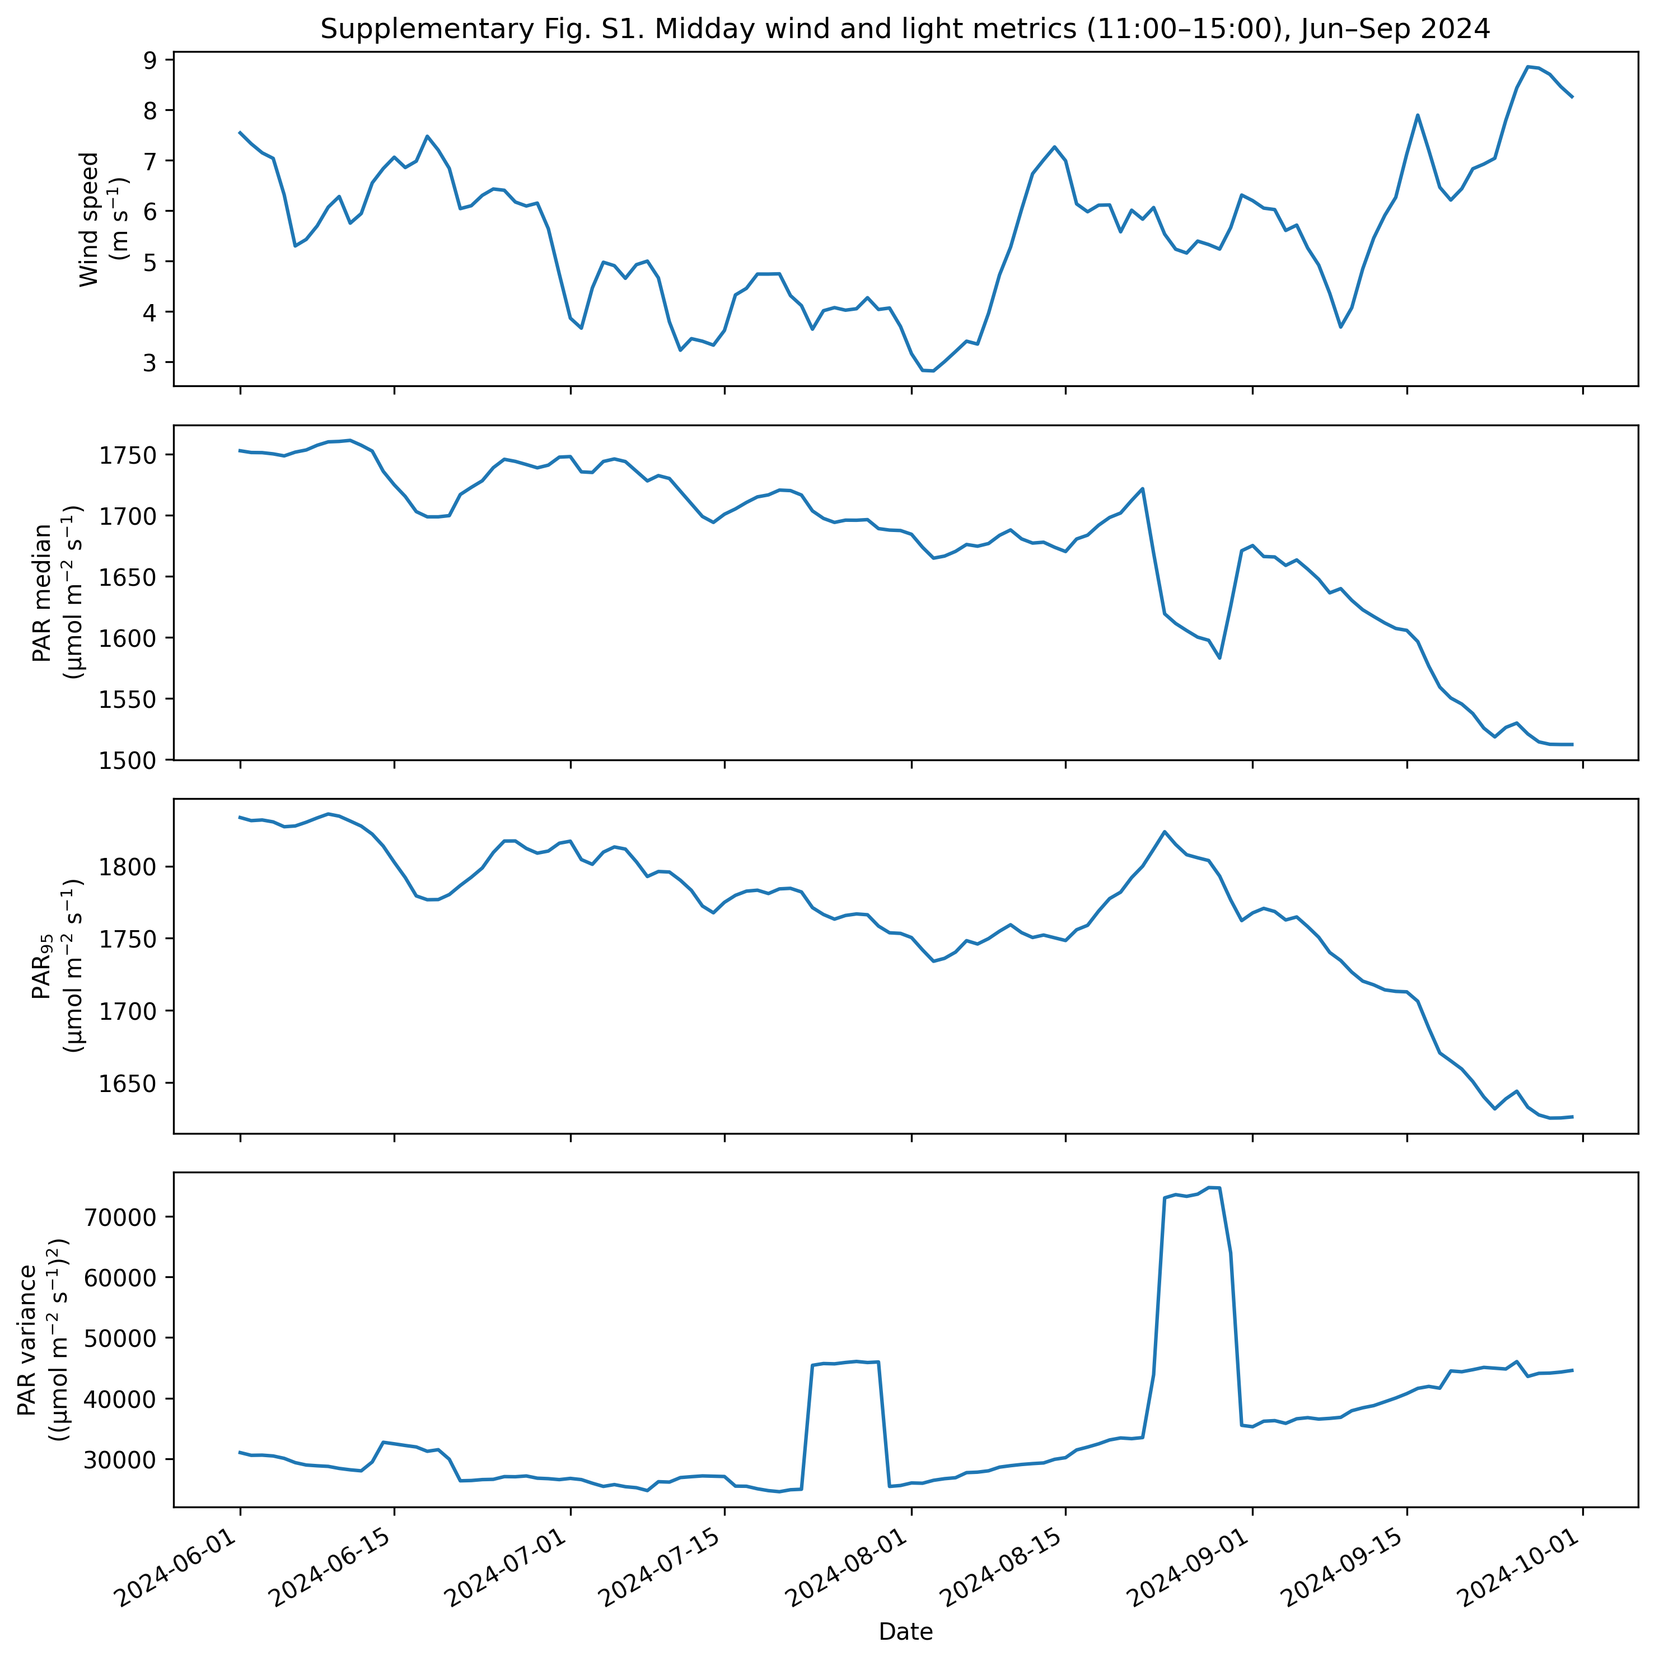

Figure S1. Midday (11:00–15:00) wind speed and underwater irradiance metrics during summer 2024. Panels show wind speed, median PAR, PAR₉₅, and PAR variance, highlighting the temporal evolution of wind speed and underwater light-related metrics during summer 2024, including intervals of elevated irradiance metrics and subsequent calm conditions.

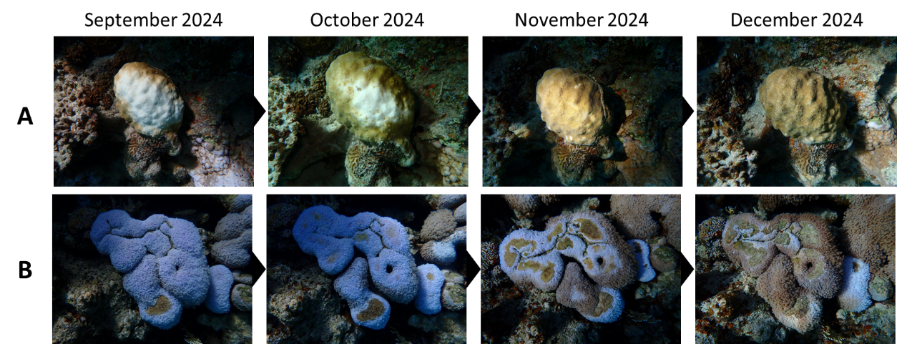

Figure S2. Representative time-series photographs illustrating post-bleaching recovery and mortality trajectories of coral colonies at the Coral Nature Reserve (NR). (A) Example of a colony exhibiting full colour recovery with no detectable tissue loss between September and December 2024. (B) Example of a colony showing colour recovery accompanied by partial mortality, indicated by areas of exposed skeleton.

