Fig S1. The effects of MFD on the maternal gut microbial functions and milk metabolites and pathways. (a) PCA and STAMP analysis of metagenomic functions of maternal gut microbiota. (b) Significantly different milk metabolites identified by partial least squares discriminant analysis (PLS-DA). The colored boxes on the right indicate the relative concentrations of the corresponding metabolites. VIP: variable importance in projection. (d) Bar plot for milk metabolite enrichment. The bar length represents fold enrichment and the color legend indicates P value.

Fig S2. The effects of MFD on the co-occurrence network of the significantly different gut genera of MFD group over time.
Fig S3. The effects of MFD on the longitudinal and horizontal assembly of early life gut microbial functions. (a) sPLS-DA plots of offspring gut microbial functions over time (ANOSIM analysis, P < 0.001). (b) Bacterial toxins and LPS biosynthesis proteins of offspring gut microbiota over time. (c) Differential gut microbial functions of offspring on d 28 (LEfSe analysis, LDA>2.5). ***: P < 0.001, **: 0.001 < P < 0.01, *: 0.01 < P < 0.05 show the significances, respectively.

Fig S4. Screening of effectors that affect the offspring gut health. (a) Variance Partitioning Analysis (VPA) differentiating contributions of milk GLN and maternal gut microbiota to the offspring gut microbiota. (b) NCBI BLAST results of gut Lactobacillus of sows and piglets.

Fig S5. The effects of maternal FMT from MFD on the weight gain, gut permeability and LPS-caused colonic cytokines disorders of pups. (a) Weaning weight and weaning weight gain of pups. (b) Serum DAO and DLA of pups. (c) Colonic cytokines of pups. ***: P < 0.001, **: 0.001 < P < 0.01, *: 0.01 < P < 0.05 represent the significances, respectively.
Fig S6. The effects of LR and GLN on LPS-induced colonic inflammatory impairment. (a) The weight change of mice. (b) Colonic permeability of mice indicated by serum FD4, DAO and DLA. (c) Different treatment concentrations of LR and GLN on cell viability and cytotoxicity of Caco-2. (d) Different treatment concentrations of LR and GLN on cell viability and cytotoxicity of 3D4/2. (e) The effects of LR and GLN on the LPS-induced cell viabilities of Caco-2. (f) The effects of LR and GLN on the Arg1 and iNOS protein expressions of 3D4/2. (g) The effects of LR and GLN on the LPS-induced cell viabilities of Caco-2. (h) The effects of LR and GLN on the LPS-induced cell viabilities of Caco-2 after treating with p38, JNK and ERK1/2 activators. ***: P < 0.001, **: 0.001 < P < 0.01, *: 0.01 < P < 0.05 show the significances, respectively.

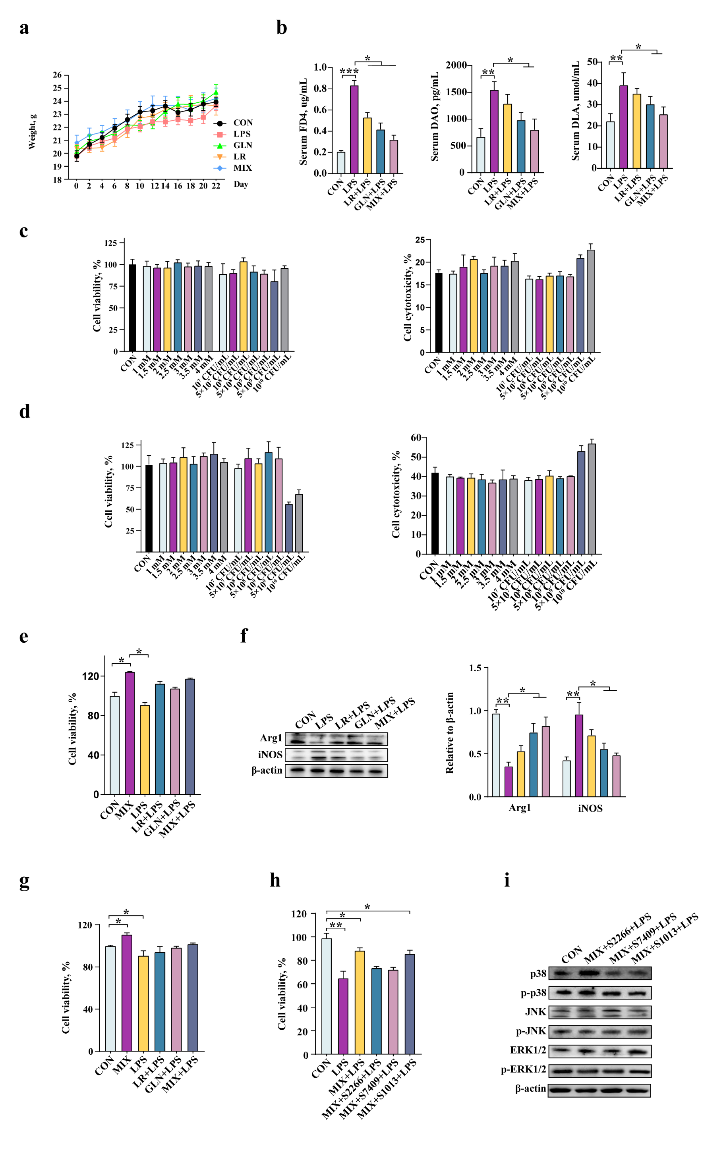

Table 1. Nutrient composition of fermented diet (as-fed basis)¹
Item | Unfermented diet |  | Fermented diet
Dry matter, % | 88.89 | 90.04
Crude protein, % | 27.16 | 29.54
Small peptides, % | 3.35 | 12.41
NDF, % | 15.42 | 9.03
ADF, % | 6.87 | 5.31
Amylose, % | 5.86 | 2.32
Ether extract,⁵ % | 3.67 | 3.37
Ash, % | 3.89 | 4.17
Ca, % | 0.17 | 0.19
Total phosphorus, % | 0.49 | 0.54
pH | 6.34 | 4.67
Lactic acid, mmol/kg | – | 154.73
Live Bacillus subtilis, cfu/g | – | 5.7 × 10⁸
Live Enterococcus faecium, cfu/g | – | 5.9× 10⁸
¹ Analyzed values determined in duplicate. The diet consists of 40% corn, 40% soybean meal, and 20% yellow wine lees.
Table 2. Ingredient composition and nutrient concentration in the experimental (as-fed basis)¹
Item | Diet
Item | Control | 10% Fermented diet | Probiotics
Ingredients
Corn | 50 | 50 | 50
Soybean | 10.0 | 7.0 | 10.0
Extruded soybean | 14.0 | 14.0 | 14.0
Alfalfa meal | 3.0 | 3.0 | 3.0
Fish meal | 3.0 | 3.0 | 3.0
Soy oil | – | 3 | –
Unfermented substrates | 10 | - | 10
Fermented substrates | – | 10 | –
Yeast hydrolysate | 3.8 | 3.8 | 3.8
Citric acid | – | – | –
Baking soda | 0.2 | 0.2 | 0.2
Salt | 0.40 | 0.40 | 0.4
Limestone | 0.6 | 0.6 | 0.6
Premix² | 5.0 | 5.0 | 5.0
Total | 100.00 | 100.00 | 100.00
Nutrition composition
Gross energy, MJ/kg | 15.23 | 15.66 | 15.32
Dry matter, % | 88.55 | 87.89 | 87.63
Crude protein, % | 17.32 | 17.24 | 17.23
Ether extract, % | 5.05 | 4.95 | 5.13
Ash, % | 6.34 | 6.27 | 6.23
Calcium, % | 0.95 | 0.98 | 1.02
Total phosphorus, % | 0.48 | 0.47 | 0.47
pH | 6.11 | 5.46 | 6.02
Live Bacillus subtilis CFU/g | – | 8.2×10⁵ | 8.7×10⁵
Live Enterococcus faecium, CFU/g | – | 2.4×10⁵ | 2.5×10⁵
¹Analyzed values determined in duplicate.
²Provided quantities of the following vitamins per kilogram of the complete diet: 10,000 IU vitamin A as vitamin A acetate, 1,500 IU vitamin D₃ as d-activated animal sterol, 50 IU vitamin E as alpha tocopherol acetate, 4.4 mg vitamin K₃ as menadione dimethylpyrimidinol bisulfite, 3.0 mg thiamin as thiamine mononitrate, 6.0 mg riboflavin, 3.0 mg pyridoxine as pyridoxine hydrochloride, 0.04 mg vitamin B₁₂, 23 mg d-pantothenic acid as calcium pantothenate, 36 mg niacin, 0.8 mg folic acid, 0.15 mg biotin, and 186 mg choline as choline chloride. Also provided the following quantities of minerals per kilogram of the complete diet: 50 mg Cu as copper sulfate, 80 mg Fe as ferrous sulfate, 0.30 mg I as potassium iodate, 20 mg Mn as manganese sulfate, 0.2 mg Se as sodium selenite, and 95 mg Zn as zinc sulfate.
Table 4. Effects of 10% maternal fermented diet and probiotics on the performance of the sows and piglets.
Item | Diet |  |  | SEM | P-value
Item | Control | MFD | PROB | SEM | P-value
Sows
ADFI,¹ kg/d | 5.76^{b} | 6.61ª | 5.89^{b} | 0.07 | 0.01
Milk yield, Kg | 8.60^{b} | 9.02ª | 8.80^{b} | 0.07 | 0.03
Piglets
Number at birth, total | 11.67 | 12.33 | 12.00 | 0.31 | 0.71
Number at birth, live | 11.50 | 12.00 | 11.67 | 0.25 | 0.73
Number at weaning | 11.00 | 11.67 | 11.33 | 0.24 | 0.56
Weaning alive rate,² % | 95.22 | 97.33 | 97.77 | 0.99 | 0.79
Wt at birth,³ kg | 1.20 | 1.23 | 1.22 | 0.01 | 0.62
Wt at weaning,⁴ kg | 5.12^{b} | 5.56ª | 5.34^{b} | 0.06 | 0.05
Wt gain,⁵ kg | 3.92^{b} | 4.33ª | 4.12^{b} | 0.06 | 0.04
Diarrhea incidence,⁶ % | 1.48ª | 1.12^{c} | 1.24^{b} | 0.04 | 0.00
^{a,b}Means within a row with different superscripts significantly differ (P < 0.05).
¹ADFI of the sows were recorded from parturition until weaning (21 d).
²Weaning alive rate = [litter size at weaning (live) − litter size at birth (live)]/litter size at birth (live).
³Piglet weight at birth = litter weight at birth/litter size at birth (live).
⁴Piglet weight at weaning = litter weight at weaning/litter size at weaning (live).
⁵Piglet weight gain = piglet weight at weaning − piglet weight at birth.
⁶Diarrhea incidence = total diarrhea piglets/[litter size at birth (live) × trial days].
All the values contained six repetitions.

