Supplemental Material
Supplemental Video
Average word response of task-responsive electrodes over time. Each sphere is a single electrode, all plotted on the Freesurfer average brain. Word presentation occurs at 0 ms and ends at 1600 ms.
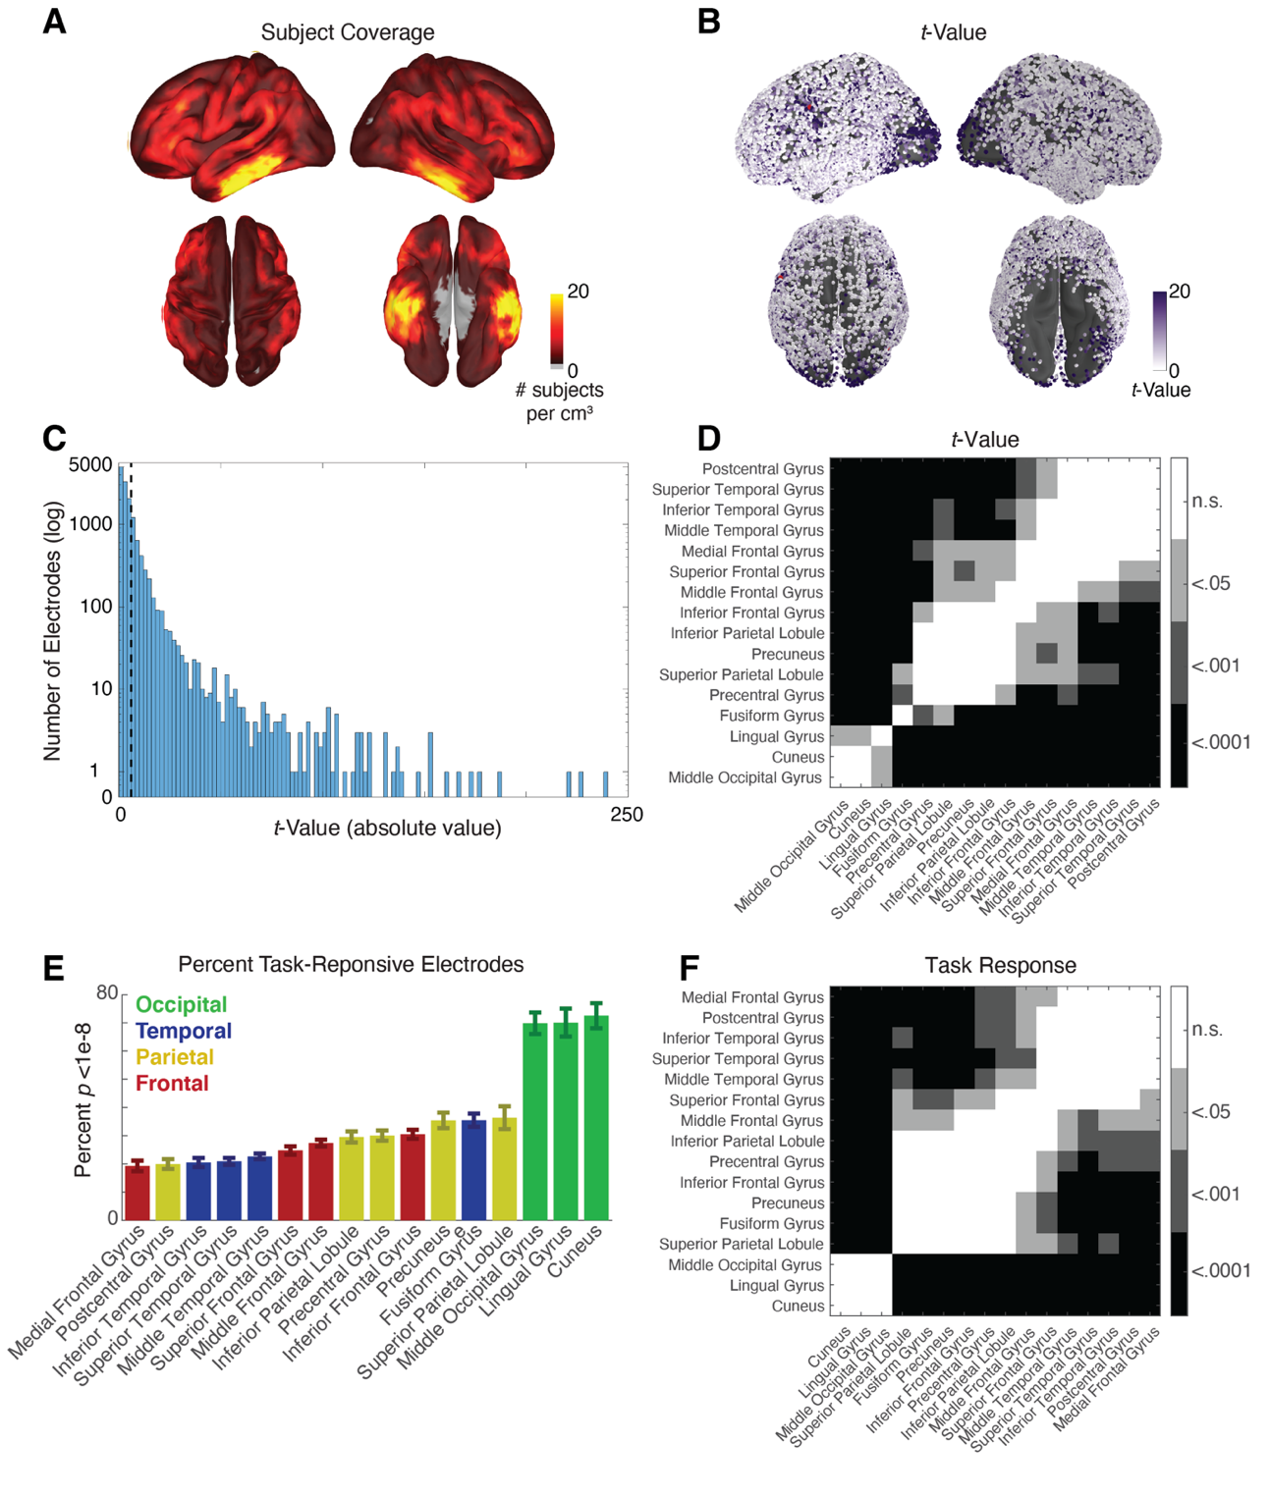
Supplemental Figure 1
- Subject coverage. Count of subjects with coverage within 1cm³ displayed on the Freesurfer average brain.
- Absolute t-values. Data is the same as Figure 1D, but each electrode is plotted as a sphere projected to the cortical surface of the Freesurfer average brain to demonstrate density of coverage and for visual comparison to volume-smoothed data.
- Histogram of absolute value t-values for all electrodes on a logarithmic scale. Vertical dotted line indicates our task responsiveness threshold of p < 1e-8, corresponding to |t| = 6.
- Significance values corresponding to Figure 1C (adjusted p-values after FDR correction). Colormap indicates the p-value threshold met by each pair of values, where white indicates no significant difference and black indicates p<.0001.
- Percentage of task-responsive electrodes (p < 1e-8) by anatomical subregion. Bars are color-coded by lobe.
- Significance values corresponding to Supplemental Figure 1E (adjusted p-values after FDR correction)..
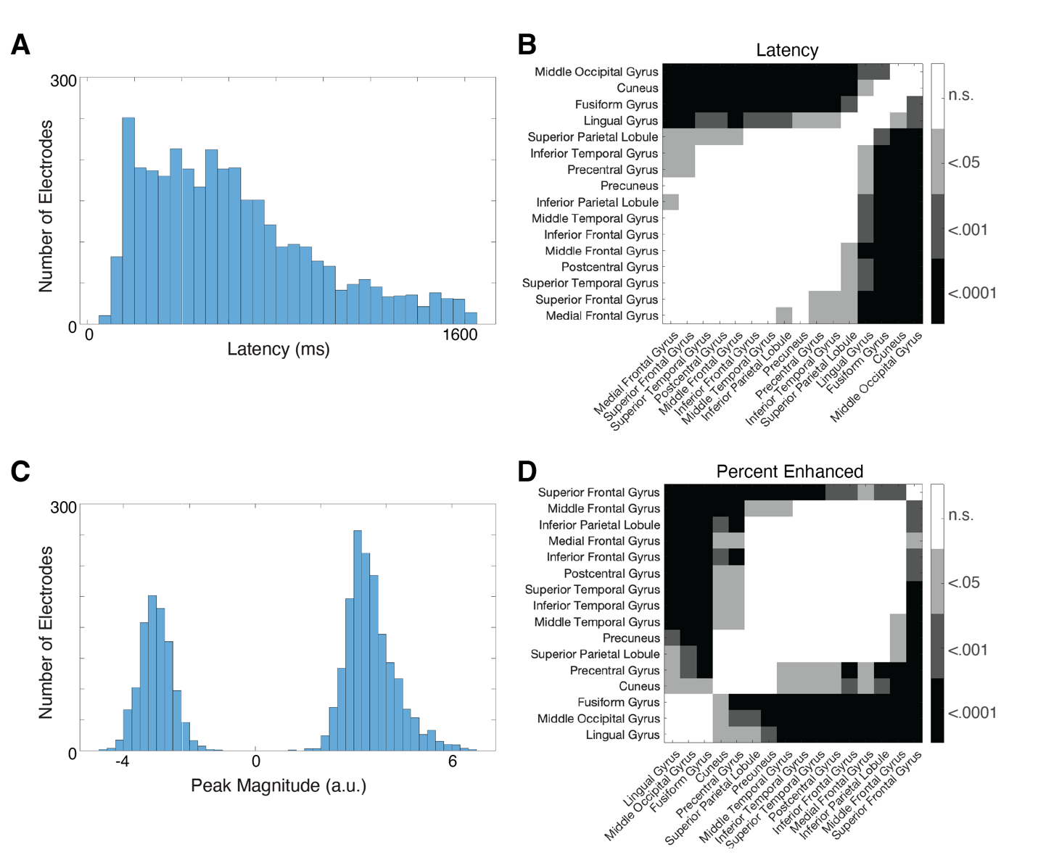
Supplemental Figure 2
- Histogram of latency values for task-responsive electrodes.
- Significance values corresponding to Figure 3A (adjusted p-values after FDR correction).. Colormap indicates the p-value threshold met by each pair of values, where white indicates no significant difference and black indicates p<.0001.
- Histogram of peak magnitude (arbitrary units, z-scored to baseline) for task-responsive electrodes.
- Significance values corresponding to Figure 3C (adjusted p-values after FDR correction)..

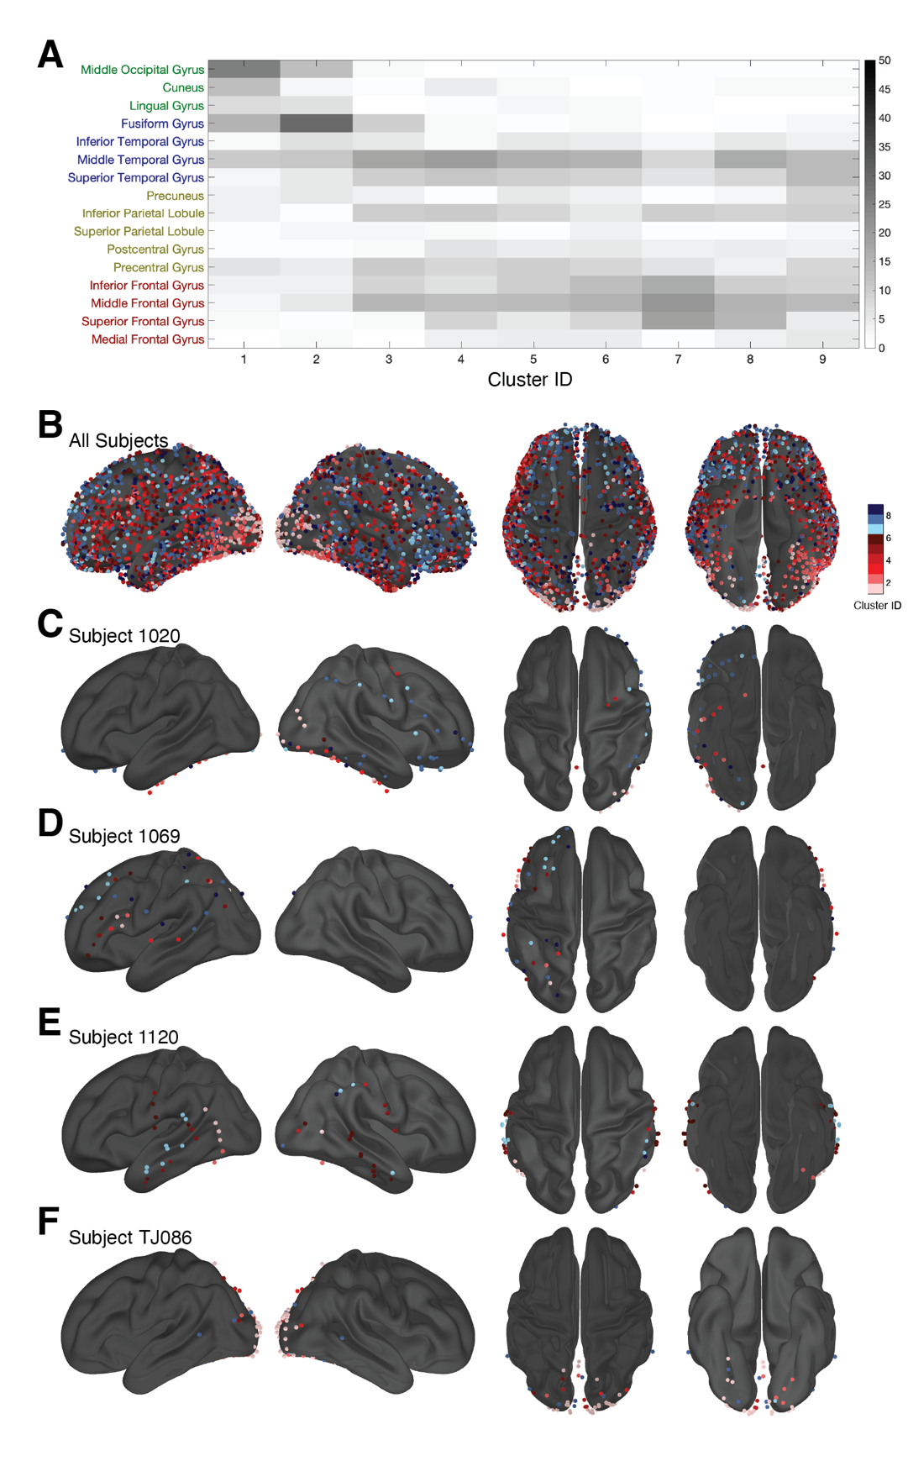
Supplemental Figure 3
- Distribution of each cluster across anatomical regions (columns sum to 100%).
- Cluster membership of all task-responsive electrodes displayed on the average Freesurfer brain.
S3C-F show the cluster membership of task-responsive electrodes in single subjects. Example subjects were selected with right-only coverage (C), left-only coverage (D), bilateral coverage (E), and occipital coverage (F).
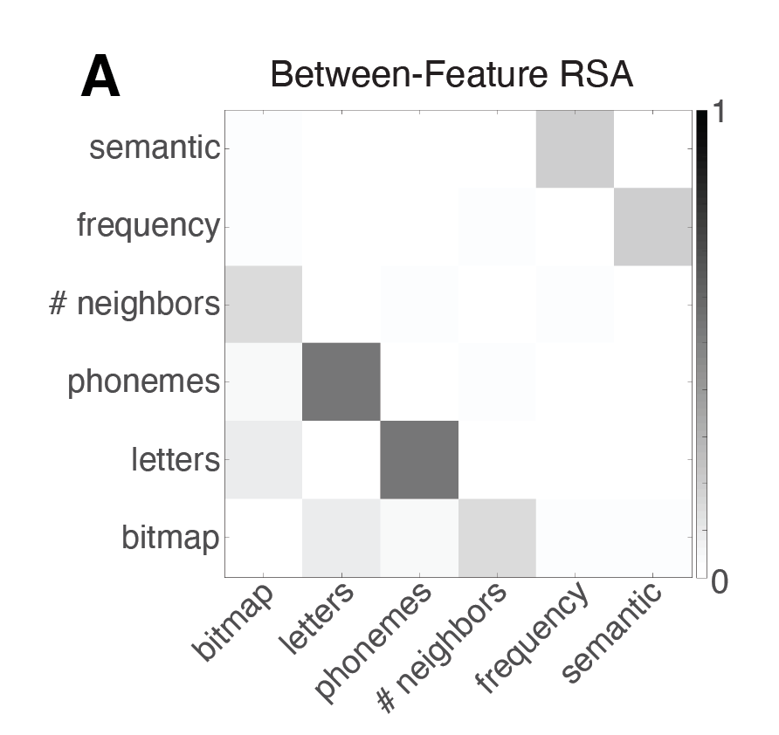
Supplemental Figure 4
RSA correlations between word features in this stimulus set: bitmap, letters, phonemes, number of neighbors (“neighborhood”), frequency, and semantics.

