Periodicity as a Universal Measurand Enabling Traceable Nanoscale Dimensional Metrology - Supplementary Information

Federico Ferrarese Lupi,^{*1} Irdi Murataj,¹ Korinna Altmann,² Büşra Gamze Arslan,^{3,4} Desiree Baruffaldi,⁵ Luca Boarino,¹ Christian Bortolini,⁶ Özgür Bozat,³ Jariya Buajarern,⁷ Eleonora Cara,¹ Umberto Celano,^{8,9} Hsiang-Hung Chen,¹⁰ Richard Ciesielski,¹¹ Charles A. Clifford,⁶ Riccardo Chiarcos,¹² Peter De Wolf,¹³ Andrea Giovannozzi,¹ Christian Gollwitzer,¹¹ Carlo Grazianetti,¹⁴ Dong Kuk Kim,⁹ Petr Klapetek,¹⁵ R. Joseph Kline,¹⁶ Michele Laus,¹² Fang-hsin Lin,¹⁰ Monica Marini,¹ Christian Martella,¹⁴ Mariela Menghini,¹⁷ Filippo Ozino Caligaris,⁸ Patricia Pedraz,¹⁷ Sandeep Singh,¹⁸ Surinder P. Singh,¹⁸ Victor Soltwisch,¹¹ Chiu-Hun Su,¹⁰ Chun-Jen Su,¹⁹ Jai Shankar Tawale,¹⁸ Bruno Torre,^{1,5} Miroslav Valtr,¹⁵ Andras Vladar,²⁰ Sebastian Wood,⁶ Vitor Cabral,^{*21} Gianluca Milano^{*1}

Supplementary Information

Supplementary Section 1: Data-weighted models for evaluating Nanoparticle Dimensions through small angle X-ray scattering (SAXS)
Supplementary Section 2: The concept of Metrological Traceability
Supplementary Section 3: The concept of reference materials
Supplementary Section 4: The case-study on nanoparticle-based reference materials
Supplementary Section 5: Commercially available reference materials
Supplementary Section 6: Self-calibrating gratings
Supplementary Section 7: Engraving the block copolymer (BCP)-templated nanopattern
Supplementary Section 8: Real-space vs reciprocal-space analysis of periodic BCP nanostructures.
Supplementary Section 9: Atomic force microscopy (AFM) traceable measurements
Supplementary Section 10: Scanning electron microscopy (SEM) traceable measurements
Supplementary Section 11: Grazing incidence small angle X-ray scattering (GISAXS) traceable measurements
Supplementary Section 12: Internal homogeneity of BCP-based reference materials.
Supplementary Section 13: Theoretical prediction of domain periodicity
Supplementary Section 14: Experimental equipment
Supplementary Section 15: Measurement protocol for the interlaboratory comparison
Supplementary Section 16: Data analysis protocol for the interlaboratory comparison
Supplementary Section 17: Quantitative evaluation of measurement corrections
Supplementary Section 18: Artifact detection
Supplementary Section 19: Scanning probe microscopy (SPM) techniques – chemical detection
Supplementary Section 20: SEM evaluation for drift and distortion

Supplementary Section 1: Data-weighted models for evaluating Nanoparticle Dimensions through SAXS
The SAXS technique provides information on the nanoparticle size and the size distribution through the measurement of the scattering intensity I(q), that can be expressed by the following equation:
$$I\left(q\right)=〈{|F\left(q\right)|}^{2}S(q)〉$$
where F(q) is the single-particle form factor, S(q) is the structure factor, describing spatial correlations between particles, and q is the scattering vector. In the case of disordered and non-interacting nanoparticles, the interparticle correlations are negligible and the structure factor is S(q) = 1. The squared form factor of the i-th particle population can be expressed as:
$${|F\left(q\right)|}^{2}=V_{i}^{2}{\left(Δρ\right)}^{2}P_{i}(q)$$
where V_{i}​ is the particle volume, Δρ is the scattering length density contrast between the particle and the surrounding medium, and P_{i}​(q) is the normalized form factor, which depends solely on particle shape. The index i labels particle populations of different characteristic sizes within a polydisperse ensemble. The total SAXS intensity can therefore be written as:
$$I\left(q\right)=\sum_{i}^{ }{n_{i}V_{i}^{2}{\left(Δρ\right)}^{2}P_{i}(q)}$$
where n_{i}​ is the number density of particles belonging to the i-th size class. Each size class is characterized by a particle diameter D_{i}​, defined as the diameter of a volume-equivalent sphere (or, more generally, the characteristic size parameter of the chosen shape model). Accordingly, the particle volume scales as V_{i}​ ∝ D_{i}³​. Looking at this equation, it is clear that converting the measured intensity profile into a dimensional quantity requires several a priori assumptions:
- Particle shape (form factor): the form factor P_{i}​(q) depends explicitly on particle geometry. Spheres, cylinders, ellipsoids, core–shell structures, and faceted nanoparticles each produce distinct oscillatory features in I(q). If the assumed shape does not match the real one, the retrieved diameter can be systematically biased. Even small deviations such as surface roughness, nanoparticle truncation or slight asphericity, directly influence the fitted size of the nanoparticle.
- Size distribution: SAXS does not measure individual particles but an ensemble-averaged scattering profile. Extracting a distribution requires choosing a parametric model (e.g., lognormal, Schulz–Zimm)¹ or applying an indirect Fourier transform with smoothing constraints. The type of distribution recovered, such as intensity-weighted, volume-weighted, or number-weighted, depends on how the scattering data are interpreted. Importantly, since the measured SAXS intensity I(q) scales as D_{i}⁶, the raw data are intrinsically intensity-weighted, strongly emphasizing the contribution of larger particles. Converting this signal into a volume-weighted distribution requires additional modelling assumptions (e.g. shape, polydispersity), whereas obtaining a number-weighted distribution requires explicit de-weighting by D_{i}⁶, a procedure that amplifies noise and increases model dependence. As a result, intensity-weighted sizes are generally the most robust and reproducible but tend to overestimate the results, the volume-weighted sizes introduce additional assumptions and number-weighted sizes generally carry the highest uncertainty.
- Composition and scattering contrast: the amplitude of the SAXS signal depends on (Δρ)², which requires knowledge of particle composition, density and internal structure (e.g. porosity or surface hydration layers). A non-accurate estimation of these quantities affects the scaling of the form factor and can shift the extracted diameter.
- Arrangement of nanoparticles: in SAXS the measured size of nanoparticles is strongly influenced by their spatial arrangement relative to one another, not just their individual sizes. The models used to determine the nanoparticle size by fitting the SAXS pattern use the single-particle form factor and assume randomly dispersed nanoparticles that are not agglomerated. Agglomeration of the nanoparticles can result in the overestimation of the size of the nanoparticles. When nanoparticles form ordered arrays or superlattices, constructive interference between scattered waves creates Bragg peaks that denote the spacing of the nanoparticles and not their size. Therefore, a careful understanding of the arrangement of the nanoparticles is necessary for properly interpretating SAXS data.

In this scenario, although SAXS can produce International System of Units (SI)-traceable diameters under well-specified models and assumptions, the obtained values are traceable for the defined measurand only (e.g., volume-weighted diameter of spherical particles with a given distribution) and they cannot be assumed to represent the same diameter as that obtained from Atomic Force Microscopy (AFM), Scanning Electron Microscopy (SEM), Transmission Electron Microscopy (TEM) or hydrodynamic methods such as Dynamic Light Scattering (DLS), which rely on incompatible measurands.
A clear example of the model dependence of the SAXS-derived nanometric size is provided by the certified reference material BAM-N001,¹ consisting of silver nanoparticles with diameter below 20 nm. The corresponding certification report shows that the specific particle diameter that corresponds to 50% of the total particles in the cumulative undersize distribution (d₅₀) obtained from volume-weighted is overestimated with respect to the number-weighted SAXS diameter distribution. Notably the two reported values are not in agreement, as shown in Figure S1, since the uncertainty intervals of these two SAXS-derived diameters do not overlap despite both measurements being performed on the same material by the same laboratory, they are individually certified as SI-traceable, but only under the assumptions of the specific SAXS model used for data interpretation.
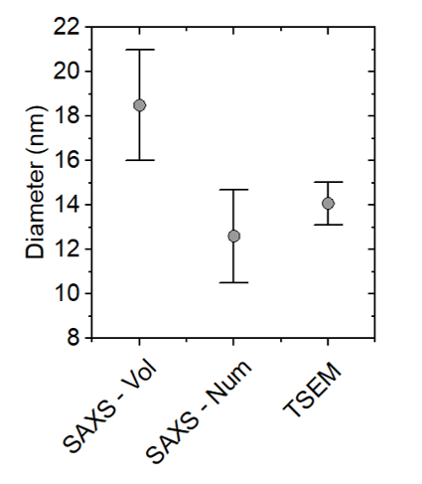
Supplementary Figure S1 | Silver Nanoparticles. Assessment of the diameter values of the nanoparticles contained in the reference material BAM-N001. The diameter values are obtained by volume-weighted and number-weighted SAXS (labelled as “SAXS – Vol” and “SAXS – Num” respectively). The traceable TSEM value is used as an external reference measurement to establish the most reliable data weighting procedure. Bars represent the expanded measurement uncertainty.

To establish which model more faithfully represents the physical particle size, an independent traceable real-space technique must be used for comparison. In the case of BAM-N001 material, transmission scanning electron microscopy (TSEM) provided the necessary external reference. Only the number-weighted SAXS model yielded d₅₀ value metrological compatible with the TSEM measurement result, thereby confirming the reliability of the number-based SAXS interpretation for this material.
Similar considerations can be applied to the reference material ERM-FD100, consisting of spherical silica nanoparticles (NPs) dispersed in water.² In this case, the SAXS particle diameters were obtained from an interlaboratory comparison involving up to five laboratories. The certified intensity-weighted SAXS diameter corresponds to the unweighted mean of the five accepted laboratory means, following outlier screening and full uncertainty evaluation. As reported in Figure S2a, the certified intensity-weighted SAXS diameter is not in agreement with other traceable measurements such as TEM and DLS. Only by applying a volume-weighted correction to the SAXS analysis was it possible to reach a good agreement with the other traceable techniques. However, the volume-weighted SAXS diameter is reported only as an indicative and not certified value due to higher model dependence that contributes to the increase of the uncertainty. Interestingly, Figure S2b highlights that even within the SAXS datasets themselves, intensity- and volume-weighted diameters reported by the individual laboratories do not always agree. In some cases, the uncertainty intervals of the four participating labs do not overlap, demonstrating that SAXS-derived particle sizes are not solely limited by instrumental uncertainty but are also strongly affected by model assumptions and data-evaluation choices.
Similar results were observed for the reference material ERM-FD304 (silica NPs in aqueous solution),³ in which the SAXS measurements performed by different laboratories do not converge to a common particle diameter. Although all participants of the interlaboratory comparison analysed the same silica nanoparticle suspension, the reported SAXS diameters span from ≈27 nm to ≈46 nm (reported in Figure S2c), depending on the instrument, scattering vector range and evaluation model used. This spread indicates that SAXS-derived sizes of isolated nanoparticles are highly model- and instrument-dependent and therefore cannot yield a single technique-independent consensus value for this reference material.

Supplementary Figure S2 | Silica Nanoparticles Reference Materials (RMs). (a) Assessment of the diameter values corresponding to the reference material (labelled as ERM-FD100) obtained by intensity-weighted and number-weighted SAXS, TEM, collective light scattering (CLS) and DLS. The bars represent the expanded measurement uncertainty. (b) Intensity-weighted (black squares) and volume-weighted (red dots) SAXS measurements for the four laboratories involved in the interlaboratory study on ERM-FD100. (c) Diameter of silica NPs (reference material ERM-FD304) assessed by intensity-weighted SAXS in five independent laboratories.

Supplementary Section 2: The concept of Metrological Traceability

According to the VIM (International Vocabulary of Metrology) guide released by the BIPM (Bureau International des Poids et Mesures), the metrological traceability is defined as the “property of a measurement result whereby the result can be related to a reference through a documented unbroken chain of calibrations, each contributing to the measurement uncertainty”.⁴ From a practical point of view, this means that each step of the calibration chain should be documented by a calibration certificate specifying the measured value and its associated uncertainty, together with all other involved relevant parameters (e.g., date of the measurements measurement method used, assured traceability, environmental conditions) thereby providing a complete documentary record of how the result is linked to the SI. This definition highlights that metrological traceability does not rely on a single calibration step, but rather a hierarchical chain linking a measurement result to increasingly accurate references. In dimensional metrology this chain is tied to the realization of the SI unit of length, the meter. Currently the BIPM defines the meter through the fixed numerical value of the speed of light: “The metre, symbol m, is the SI unit of length. It is defined by taking the fixed numerical value of the speed of light in vacuum c to be 299 792 458 when expressed in the unit m s^{–1}, where the second is defined in terms of the caesium frequency Δν_{Cs}.”.⁵
Experimentally the metre is realized through laser interferometry, X-ray interferometry or other atomic-constant-based methods. This implies that a dimensional measurement - as in our case the L₀ of the block copolymer (BCP) systems extracted by AFM, SEM of GISAXS - is considered traceable to the SI only if every calibration step (from the instrument calibration with a reference material, to the certification of that reference material, to the calibration of the measuring system used to do that certification and, to the experimental realization of the SI meter unit used to calibrate a reference standard at the beginning of the chain) maintains a continuous and documented sequence, and contributes explicitly to the combined measurement uncertainty. If any link is missing, undocumented or lacks an uncertainty evaluation, the chain is broken and the result cannot be described as SI-traceable. The procedures used to guarantee metrological traceability to the AFM, SEM and GISAXS measurements are described in Supplementary Sections S9 to S11, respectively

Supplementary Section 3: The concept of reference materials
According to the definition of the BIPM, a reference material (RM) is “a material, sufficiently homogeneous and stable with respect to specified properties, that has been established to be fit for its intended use in a measurement or in the examination of nominal properties”.⁴ When such a material is accompanied by documentation issued by an authoritative body - including one or more specified property values together with their associated uncertainties and traceabilities determined using valid procedures - it is designated as a Certified Reference Material (CRM).⁴ RMs play a central role in evaluating and quantifying the performance of instruments and methodologies for the physical and dimensional characterization of nanoscale materials. Formally, they must be provided with clear traceability to the SI units, ensuring that measurements performed using the material can be related unambiguously to the International System of Units (SI).

Supplementary Section 4: The case-study on gold nanoparticle-based reference materials
One of the most widely used families of RMs in nanometrology is the gold nanoparticle (AuNP) series available from the National Institute of Standards and Technology (NIST). In this case, the measurands are the nanoparticle sizes determined by the measurement methods specified for each RM. The reference values reported in the corresponding Reports of Investigation are metrologically traceable to the SI unit of length and expressed in nanometers.^{6–8} A comparison of these reference values highlight the strong method dependence of the diameter concept at the nanoscale. Figure S3 summarizes the AuNPs diameters reported in the respective NIST Reports of Investigation for RM 8011, RM 8012 and RM 8013. The data reported in Figure S3 are taken directly from those reports and are based on measurements performed by the material producer using traceable techniques and are shown without additional measurements or data processing. The plotted values correspond to the results obtained using several independent techniques including AFM, SEM, TEM, Electrospray-differential mobility analysis (ES-DMA), DLS and SAXS. Interestingly, despite all values being traceable to the SI unit of length, no single consensus value can be identified, as many measurements are not metrologically compatible. This lack of agreement illustrates the inherent incompatibility of method-specific diameter definitions and underscores the intrinsic difficulty of establishing a unique size value for isolated nanoparticles.
Supplementary Figure S3 | Gold Nanoparticles RMs. Assessment of the diameter of NIST AuNPs reference materials (a) RM 8011 (b) RM 8012 and (c) RM8013 as reported in the respective NIST Report of Investigation. The nominal diameters certified by NIST are (a) 10 nm, (b) 30 nm and (c) 60 nm. Error bars represent the corresponding expanded uncertainties. In panel (c), some error bars extend beyond the plotted y-axis range and are therefore partially truncated. All the reported reference values are metrologically traceable to the SI unit for length, expressed as nanometers.

Supplementary Section 5: Commercially available reference materials

Table S1 | Summary nanoparticles-based reference materials. The table includes nanoparticle-based reference materials (RM), certified reference materials (CRM) and standard reference materials (SRM). The table is mainly based on the results of the NanoDefine Technical Report D1.1⁹ and the review by Orts-Gil et al.¹⁰. It is notable that some of the materials may no longer be available on the market at the time of the present publication, but they are still used in laboratories for calibration purposes. Each material is associated with specific dimensional measurands (e.g., geometric, hydrodynamic, or scattering-based diameters), assessed via techniques such as TEM, SEM, AFM, DLS, centrifugal liquid sedimentation (CLS), particle tracking analysis (PTA), SAXS and Electrospray-differential mobility analysis (ES-DMA).
Material | Name/Code | Reference of certified value | Description | Provider | RM/CRM/SRM | Techniques used for dimensional assessment
Silica | ERM-FD100 | 20 nm | silica nanoparticles | IRMM/JRC* | CRM | DLS, CLS, TEM/SEM, SAXS
Silica | ERM-FD101b | 90 nm | silica nanoparticles | IRMM/JRC | CRM | DLS, CLS, PTA, electron microscopy , SAXS
Silica | ERM-FD102 | 18 nm /85 nm | bimodal silica nanoparticles | IRMM/JRC | CRM | DLS, CLS, electron microscopy
Silica | ERM-FD304 | 40 nm | silica nanoparticles | IRMM/JRC | CRM | DLS, CLS
Silver | BAM-N001 | 35 nm | silver nanoparticles | BAM | CRM | SAXS
Silver | RM8016 | 10 nm | silver nanoparticles | NIST | RM | TEM, optical spectroscopy
Silver | RM8017 | 75 nm | silver nanoparticles | NIST | RM | TEM, optical spectroscopy
Gold | RM 8011 | 10 nm | gold nanoparticles | NIST | RM | TEM, DLS, SAXS, ES-DMA
Gold | RM 8012 | 30 nm | gold nanoparticles | NIST | RM | TEM, DLS, SAXS, ES-DMA
Gold | RM 8013 | 60 nm | gold nanoparticles | NIST | RM | TEM, DLS, SAXS
Polystyrene | SRM 1964 | 60 nm | polystyrene latex spheres in deionized filtered water | NIST | SRM | DLS, TEM, CLS
Polystyrene | SRM 1963a | 100 nm | polystyrene spheres | NIST | SRM | DLS, TEM, CLS
Polystyrene | STADEX PS SC-0030-A | 29 nm | polystyrene latex spheres | JSR* | RM | DLS, TEM
Polystyrene | STADEX PS SC-0050-D | 48 nm | polystyrene latex spheres | JSR | RM | DLS, TEM
Polystyrene | STADEX PS SC-0055-D | 55 nm | polystyrene latex spheres | JSR | RM | DLS, TEM
Polystyrene | STADEX PS SC-0060-D | 61 nm | polystyrene latex spheres | JSR | RM | DLS, TEM
Polystyrene | STADEX PS SC-0070-D | 70 nm | polystyrene latex spheres | JSR | RM | DLS, TEM
Polystyrene | STADEX PS SC-0076-D | 76 nm | polystyrene latex spheres | JSR | RM | DLS, TEM
Polystyrene | STADEX PS SC-0080-D | 80 nm | polystyrene latex spheres | JSR | RM | DLS, TEM
* Certain equipment, instruments, software, or materials, commercial or non-commercial, are identified in this paper in order to specify the experimental procedure adequately. Such identification is not intended to imply recommendation or endorsement of any product or service by the National Institute of Standards and Technology (NIST), nor is it intended to imply that the materials or equipment identified are necessarily the best available for the purpose.
Table S2 | Summary of linear and periodic reference materials for dimensional calibration in nanometrology. In the following table are reported some of the most used linear RM and CRM that are commercially available. The linear structure can be either isolated or can form periodic patterns.
Material | Name/Code | Reference value | Description | Provider | RM/CRM/SRM | Techniques used for dimensional assessment
AlGaAs/GaAs | BAM‑L200 | 587 nm to 6.9 nm | Nanoscale stripe and grating pattern for calibration based on multilayer cross‑section | BAM | CRM | TEM, SEM, HR-XRD
Amorphous Silicon | NanoCD | 25 nm, 70 nm, 110 nm | Single and isolated stripes with variable width (3 mm length) | VLSI Standards | CRM | TEM, CD‑AFM, CD‑SEM
Silicon | NLSM | 100 nm, 200 nm, 400 nm, 800 nm, 1000 nm | NanoLattice pitch standard periodicities over a certified area of 800 µm x 800 µm | VLSI Standards | RM | CD‑SEM, AFM and Interferometric Pitch Comparators
Silicon dioxide | STS | 1.8 µm, 3 µm, 5 µm, 10 µm and 20 µm | 3D topography standard combining multiple pitches and step heights | VLSI Standards | RM | AFM and Optical Interferometric Microscopy
Silicon | Nanoscale AFM‑CD Standard | 50 nm, 100 nm, 150 nm | AFM‑oriented CD standard with sets of narrow lines for calibration of lateral scale and tip‑convolution effects | BAM / VLSI | RM | CD‑AFM and TEM
Silicon | Pelcotec™ G‑1 | 1 µm, 10 µm, 100 µm | Silicon calibration specimen with etched 1D/2D grid for instrument magnification and distortion checks | Ted Pella / Pelcotec | CRM | SEM, AFM Optical Microscopy
Silicon | MRS‑4 | 0.5 µm | Multi‑scale pitch standards for magnification calibration from 10× to 1000000× | Ted Pella | CRM | SEM, AFM
Silicon | MRS‑6 | 80 nm, 100 nm, 200 nm | Multi‑scale pitch standards for magnification calibration from 10× to 1000000× | Ted Pella | CRM | SEM, AFM
Silicon | KRC-HMC-100 | 20 nm to 80 nm | Used to calibrate the magnification of AFM and SEM by comparing the measured and certified pitch values. | Kims Reference Corp | CRM | SEM, AFM

Supplementary Section 6: Self-calibrating gratings
Recent advances in traceability for dimensional metrology, such as the self-traceable gratings proposed by Deng et al.,¹¹ demonstrate that embedding a physical constant into a periodic artifact can simplify the traceability chain and achieve exceptional sub-nanometer reproducibility. In this approach, the pitch of a laser-focused atomic deposition (LFAD)¹² grating is directly formed from the transition wavelength of chromium, enabling SI traceability without intermediate calibration steps and yielding uncertainties below 0.1 %. However, this approach relies on highly specialized atom-lithography instrumentation that is not commercially available and is operated only in a very limited number of atomic-physics or national metrology laboratories worldwide, making its deployment as a general-purpose calibration standard impractical. Furthermore, the periodicities generated by these natural-constant-based gratings remain in the range of ≈200 nm, far above the dimensions relevant to modern semiconductor devices. This limitation is significant considering the International Roadmap for Devices and Systems (IRDS) - Metrology Chapter,¹³ which explicitly states that reference materials must be representative of the structures actually encountered in advanced device manufacturing and must support measurement of sub-10 nm half-pitch features. Although this pitch can be reduced by an additional factor of two by using the chromium patterns as a lithographic mask for extreme ultraviolet (EUV) exposure¹⁴ such an approach introduces further complexity and cost and is accessible only to an even smaller number of EUV-enabled research facilities, thereby limiting its wide use and applicability as a nanoscale reference material.

Supplementary Section 7: Engraving the BCP-templated nanopatterns
In order to enhance the resistance of the BCP-templated nanopatterns to chemical agents and mechanical stresses, thereby ensuring greater long-term durability, it is necessary to transfer the nanoscale pattern from the polymer matrix to a more stable material. To this end, we identified two main methods reported in the literature useful for the pattern transfer: engraving and sequential infiltration synthesis (SIS). The first method, illustrated in Figure S4a, relies on the selective removal of one of the two polymer components constituting the BCP. This process is carried out through sequential treatments of the polymer matrix with UV radiation, acetic acid, and O₂ plasma.¹⁵ Once this process is completed, the resulting nanometric pattern can be transferred to the underlying substrate by means of a reactive ion etching (RIE) process.^{16,17} The compatibility of this process with a wide range of materials (e.g., silicon, silicon oxide and nitride, quartz, diamond and copper), as well as with curved or flexible substrates, has been demonstrated in the literature.^{18–20} The second method, depicted in Figure S4b, consists of the sequential infiltration of inorganic materials into one of the two polymeric phases of the BCP.^{21–23} This process is typically carried out through a defined number of cycles involving a metal–organic precursor and an oxidizing agent in an atomic layer deposition (ALD) system. In this case, the final outcome is the formation of a perfect replica of the original nanostructured pattern that is now inorganic compatible with SIS (AlOx, SiOx, TiOx, ZnO, etc.).^{24,25}
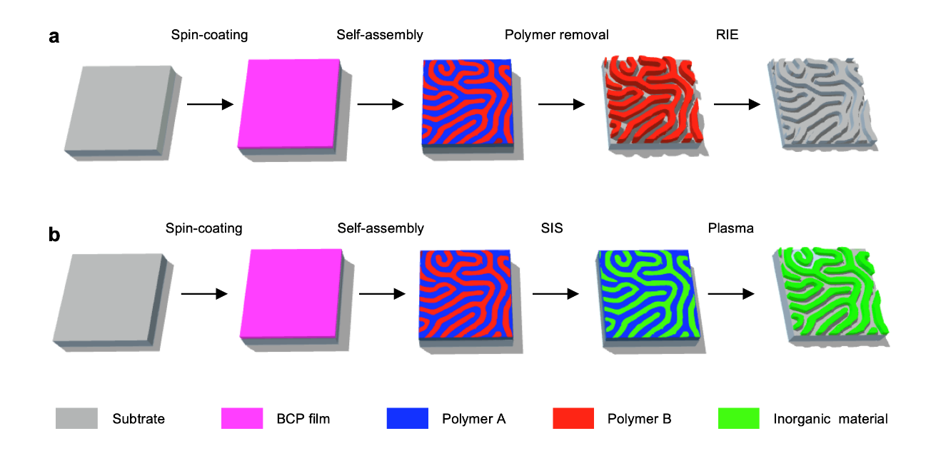
Figure S4 | Pattern transfer processes. (a) Engraving-based pattern transfer into the underlying substrate by RIE. This process consists of spin coating a thin BCP film on the target substrate, inducing the self-assembly process, selective removal of one of the two homopolymers and pattern transfer by RIE. (b) SIS of self-assembled BCP templates. After inducing the self-assembly process, inorganic precursors are sequentially infiltrated into one of the polymer domains, followed by polymer removal, yielding an inorganic replica of the original nanoscale pattern.
Supplementary Section 8: Real-space vs reciprocal-space analysis of periodic BCP nanostructures
Supplementary Figure S5 illustrates a practical example of how the periodicity of self-assembled block-copolymer (BCP) nanostructures is extracted in real space and in reciprocal space using AFM and SEM micrographs describing the morphology of the “Lamellar A” reference sample. The panel (S5a) shows a height image of a lamellar BCP film, where local variations in contrast and curvature make it difficult to identify a unique pitch directly from the morphology. The corresponding real-space analysis in (S5b) reports the local pitch L₀ evaluated along the profile extracted in correspondence of the yellow line in Figure S5a: the apparent period fluctuates significantly due to all source of distortions described in the main manuscript (i.e., local defects, curvature, tip–sample convolution and imaging noise). This behaviour mimics the conceptual example shown in Figure 1d, where periodic signals with different degrees of deformation yield non-uniform real-space spacing. Figure S5c reports the radially averaged power spectral density (PSDF) of the whole AFM image, highlighting the dominant spatial frequency of the pattern in reciprocal space. Despite the distortions observed in real space, the PSDF exhibits a well-defined peak corresponding to the intrinsic periodicity L₀ of the BCP pattern. The same kind of analysis can be applied to SEM micrographs (Figure S5d) representing the same self-assembled pattern analysed by AFM. In this case the periodicity distortion is even more accentuated by the grayscale fluctuations of the SEM micrograph (see Figure S5e).
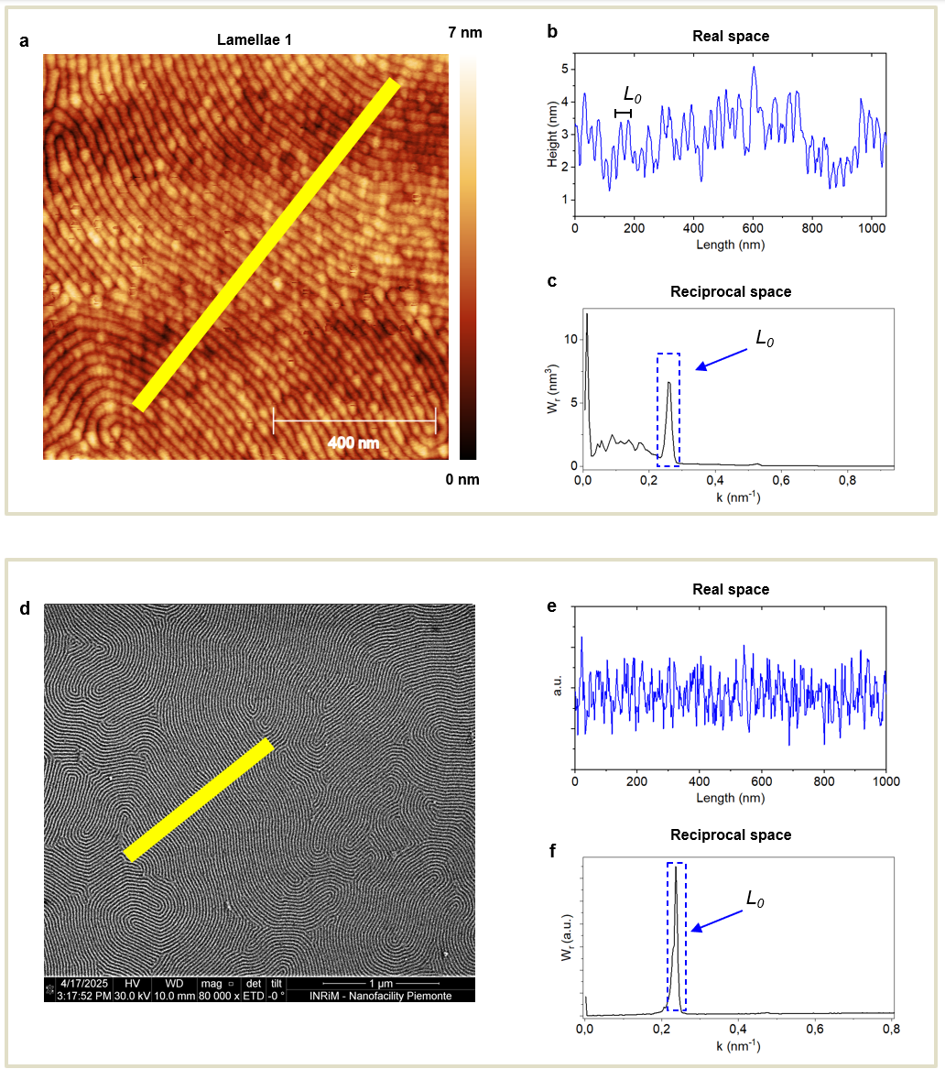
Supplementary Figure S5 | Real and reciprocal-space analysis BCP lamellae. (a–c) AFM height image of a lamellar BCP pattern (a). The yellow line indicates the zone in which the height profile reported in (b) was extracted, corresponding to the real-space trace. (c) Radially averaged power spectral density (PSDF), expressed as a function of the spatial frequency k, exhibiting a single, well-defined dominant peak corresponding to the characteristic periodicity L₀​ of the BCP. (d) SEM micrograph of the same BCP lamellar pattern, with the yellow line marking the extracted intensity profile. As in the AFM case, the real-space signal (e) shows no clearly distinguishable periodicity due to contrast fluctuations and noise typical of SEM imaging. The reciprocal-space representation (f), however, reveals a sharp PSDF peak at the same spatial frequency k₀, corresponding to the true pitch L₀​. Together, these examples confirm experimentally that the periodicity of self-assembled BCP nanostructures is stable and technique-independent in reciprocal space, even when real-space measurements are strongly affected by method-specific artifacts and distortions.
Supplementary Section 9: AFM traceable measurements
Traceable AFM measurements corresponding to the Český metrologický institut (CMI, REF 1) were performed by means of a Physik Instrumente stage and a home-built AFM head, where the position of the stage is measured by a six-axis interferometer, while another differential interferometer is used to measure the position of the AFM probe. All interferometers use a frequency-doubled Nd:YAG laser operating at 532 nm, which is stabilized through linear spectroscopy of molecular iodine in an external absorption cell. The laser is traceable to CMI standards. Parasitic tilting of the stage is compensated by a set of three piezoelectric actuators combining vertical and horizontal shear motion based on the measurements of the six-axis interferometer. The interferometer detection units are read out using Gwyscope data acquisition system.²⁶
The measurements were made in non-contact mode using commercial probes (Adama AD-2.8-AS). Topography of each sample was measured on five arbitrarily chosen spots. Measurement range and resolution of final images were 1 µm x 1 µm and 500 pixel x 500 pixel, respectively. The open-source software Gwyddion²⁷ was used for data processing.
The procedure for data processing can be summarized in the following steps:
- Calculate XYZ volume data from raw interferometer data using a dedicated software.
- Subtract mean plane from XYZ data (choose rotate option).
- Crop measured data to 1 µm x 1 µm.
- Rasterize XYZ data to 500 pixels in the X axis. Resolution in the Y axis is such that the pixels are square in size.
- Level horizontal lines by subtracting 1st order polynomial.
- Set minimum value to zero, (optionally) set color scale to Gwyddion.
- Calculate radial PSDF (Hann window, fix resolution to 500 px).
- Fit the main peak with Gaussian function while saving the resulting x₀ and b parameters.
- Calculate periodicity P_{i} as 2π/x₀ and its uncertainty u_{i} as 2π/(x₀)²b.

The periodicity of each sample was calculated from five values as a weighted average:
$$P=\frac{\sum_{i=1}^{5}{w_{i}P_{i}}}{\sum_{i=1}^{5}{w_{i}}}$$
where $w_{i}=\frac{1}{u_{i}^{2}}$. The combined standard uncertainty u_{c} and expanded uncertainty U using k=2 was calculated as follows:
$u_{c}^{2}(P)=u_{a}^{2}+u_{fit}^{2}+u_{thermal}^{2}+u_{SE}^{2}$ and $U(P)=2⋅\sqrt{u_{c}^{2}(P)}$,
where u_{a} is the type A uncertainty related to statistical error of measured values and u_{fit}, u_{thermal} and u_{SE} are all type B uncertainties and are related to residual error of the fit of the PSDF function, thermal expansion of the sample and uncertainty of the CMI metrology AFM, respectively.

Supplementary Section 10: SEM traceable measurements

The National Institute of Standards and Technology (NIST, REF 2) SEM measurement establishes SI traceability through use of a calibrated reference sample certified by the NIST calibrated atomic force microscope (C-AFM).²⁸ A line grating reference sample was determined to have a pitch of 99.936 nm ± 0.063 nm. The NIST SEM was evaluated extensively for stability and repeatability using the calibrated reference sample. Before taking measurements with of the SEM, it was evaluated using a sample of evaporated gold on polished carbon. Images were evaluated using ThermoFisher/FEI Image software (based on the measurement method described by ISO/TS 24597:2011) to prove that the SEM’s spatial “resolution” was at least 0.8 nm with a 35 % to 65 % signal rise and fall setting. The traceable measurement procedure involved loading the calibrated reference sample and unknown artifacts on the same holder. The calibrated reference sample was measured three times at the beginning of the measurement session in both the vertical and horizontal orientations. The unknown artifacts were then measured at four or more locations using identical SEM conditions to the calibrated reference sample. At the conclusion of the measurement session the calibrated reference sample was measured three additional times in both the horizontal and vertical orientations.
The NIST SEM was a ThermoFisher Helios. The measurement conditions included a landing energy of 15 keV, beam current of 43 pA, working distance of 4 mm (+/-2 mm), dwell time of 10 m/spixel, and use the in-lens secondary electron (SE) detector. The images were collected at 4k resolution with a nominal pixel size depending on the pitch of the evaluation sample. The calibration sample was measured at each magnification (pixel size of either ≈1.5 nm or ≈3 nm). The working distance was calibrated for each measurement spot to ensure an identical working distance was used.
A two-dimensional fast Fourier transform (FFT) was applied to all uncalibrated images. The pixel position for each Bragg peak order in the FFT was determined by fitting the peak with a Gaussian for the block copolymer and a five-point weighted average for the traceable calibration line grating. We then fit the Bragg peak position in pixels versus peak order with a linear model. The known pitch of the traceable calibration sample was used to convert the linear fit slope from pixels to nanometers. This procedure was repeated for both the vertically and horizontally oriented line gratings to calibrate the SEMs image-acquisition fast and slow axes separately. The block copolymer structure was isotropic, so we were able to determine both the radial average spacing and the horizontal and vertical spacing. The uncertainty was determined by propagating the traceable calibration sample pitch uncertainty through the FFT conversion process and combining the result in quadrature with the uncertainty of the linear regression slope of the FFT peak position vs peak order, for both the calibration sample and the block copolymer sample. In all measurements the determined measurement uncertainty was less than the standard deviation of the repeated measurements across a target.

Supplementary Section 11: GISAXS traceable measurements

Physikalisch Technische Bundesanstalt’s (PTB, REF 3) laboratory at BESSY II is embedded in a complete metrological traceability chain that links synchrotron-based measurements directly to the SI. This traceability is established through a combination of primary source standards (that is the electron storage ring itself) and primary detector standards (i.e., cryogenic electrical substitution radiometers) ensuring absolute and reproducible radiometric calibration.
- Primary source standard: BESSY II storage ring. The BESSY II storage ring is operated under precisely known and highly stable electron beam parameters, including electron energy, beam current, and magnetic field configuration. Under these well-defined conditions, the spectral radiant intensity and photon flux of synchrotron radiation can be calculated from classical electrodynamics with low uncertainty. In the X-ray spectral range, bending-magnet and undulator radiation therefore constitute calculable primary source standards. The emitted radiation fields are fully characterized by beam diagnostics, machine parameters, and well-defined geometrical conditions.
- Primary detector standard: cryogenic radiometers. PTB employs cryogenic electrical substitution radiometers as primary detector standards for the realization of radiant power. These radiometers achieve relative standard uncertainties on the order of 0.2 %. When directly exposed to monochromatized synchrotron radiation, they define the absolute scale of spectral radiant power and photon flux in SI units.
The GISAXS experiments were performed at the four-crystal monochromator (FCM) beamline by using radiation with a 6 keV photon energy with well-defined slit geometries and thoroughly characterized beam profiles. The incident beam, having a spot size of 0.5 mm × 0.5 mm, impinged on the samples at grazing angle θ = 0.70°, with an acquisition time of 30 s, at which the highest intensity of the diffraction pattern was observed. The elastically scattered waves were detected by an in-vacuum PILATUS 1 M hybrid pixel detector with 172 μm × 172 μm pixel size, installed on a movable sledge and positioned at a distance of 5063 mm from the samples, with an associated relative uncertainty of 0.06 %. The GISAXS patterns were recorded on 10 different positions of each sample, integrating 20 measurements on each position. The uncertainty contributions of the pitch arise from the pixel size (0.1 %), sample–detector distance (0.06 %), photon energy (0.02 %), and first-zero diffraction order distance (0.04 %).
Supplementary section 12: Internal homogeneity of BCP-based reference materials
The internal homogeneity of the BCP-based reference material should be evaluated by disentangling the contribution of spatial variability from the effect of measurement repeatability. A reliable evaluation of spatial variability is only possible when the influence of measurement repeatability is negligible or independently quantified. In this work, we evaluated the internal homogeneity of BCP-based systems through GISAXS prior to their distribution to the Versailles Project on Advanced Materials and Standards (VAMAS) partners. This specific technique was chosen due to the millimetre-scale footprint related to the grazing-incidence geometry, allowing to probe the periodicity L₀ over large regions.

Measurement repeatability
To quantify the measurement repeatability of the GISAXS technique, 35 consecutive measurements were performed on the sample labelled as “Lamellar A”, yielding a standard deviation of 0.033 nm (Figure S6).
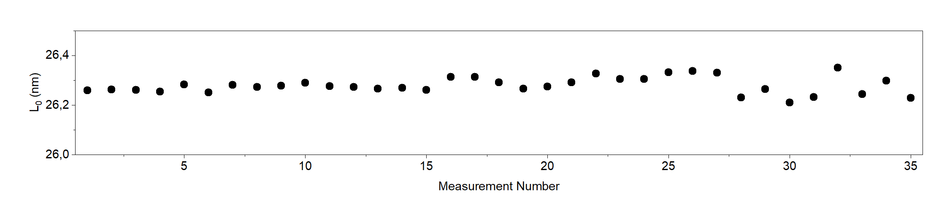
Figure S6 | Repeatability of the GISAXS measurements over the Lamellar A system. 35 measurements were performed in the same spot of the sample. The acquisition time of each measurement is 300 s.

Because each point used in the homogeneity analysis was itself the average of 20 repeated GISAXS measurements (details in Supplementary Section S11 regarding the GISAXS traceable measurements procedure), the repeatability contribution scales as:

$\frac{0.33 nm}{\sqrt{20}}= 0.007 nm$,
This value obtained on the “Lamellae A” system was exploited to compare the measurement repeatability with the spatial variability of all BCP-based systems in the following.

Spatial variability
To avoid sample-to-sample reproducibility effects, the self-assembly process of each BCP system was carried out on a single large substrate with an area of 2 cm × 2 cm. This substrate was subsequently cut into four individual samples of 1 cm × 1 cm, which were then individually distributed to the participating laboratories. Consequently, the 1 cm × 1 cm samples can be regarded as nominally identical and any observed sample-to-sample differences can be attributed to the spatial variability inherent to the original 2 cm × 2 cm substrate. The spatial variability was evaluated by measuring each 2 cm × 2 cm sample at 11 distinct positions spanning the entire surface. The periodicity L₀​ were extracted at each position, and the standard deviation of the resulting L₀​ values was taken as a quantitative measure of the internal spatial homogeneity of the BCP-based reference material.
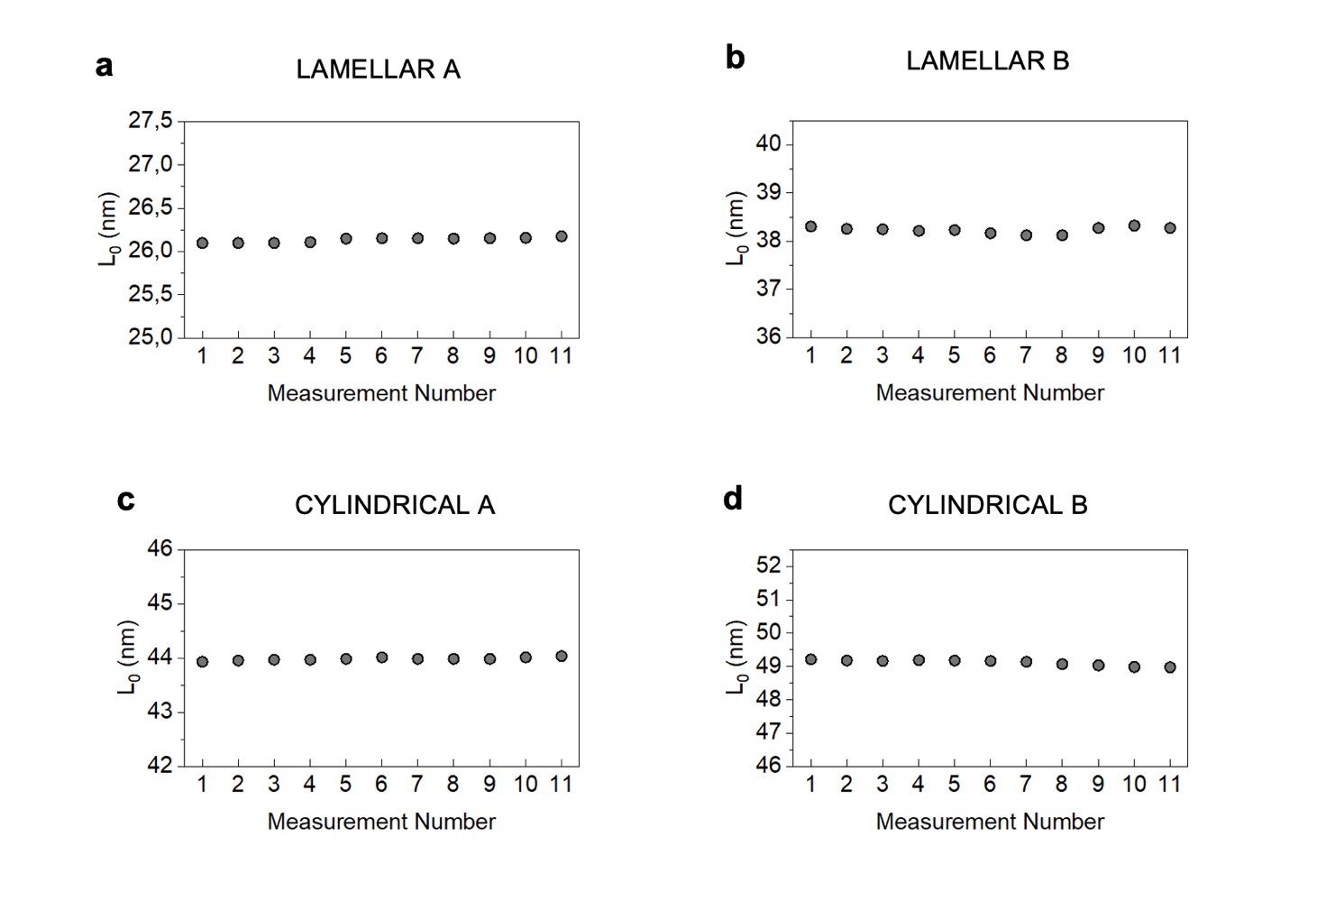
Figure S7 | Spatial variability of the characteristic periodicity L₀​​ determined by GISAXS for the four BCP-based reference materials. The extracted L₀​​ values are shown as a function of measurement position for (a) Lamellae A, (b) Lamellae B, (c) Cylinders A and (d) Cylinders B. Each data point corresponds to one of the 11 distinct positions measured across the original 2 × 2 cm² substrate. The small dispersion of L₀​ values demonstrates the high degree of spatial homogeneity of the samples over the probed area.

Since the contribution of measurement repeatability is significantly smaller than the measured spatial variability for each sample, it can be concluded that the measure of the internal homogeneity extracted through GISAXS reflects the spatial variability that can be observed in different regions of the same sample. For each system, the measures of internal homogeneity reported in Supplementary Table S3 were considered for the evaluation of the expanded uncertainty on the reference value (Methods).
Table S3 | Internal homogeneity values assessed by GISAXS at eleven different points of the BCP samples.
Sample | Lamellae A | Lamellae B | Cylinders A | Cylinders B
Internal Homogeneity | 0.030 nm | 0.058 nm | 0.029 nm | 0.087 nm

Supplementary Section 13: Theoretical prediction of domain periodicity
The equilibrium periodicity L₀ of the BCP nanostructures investigated in this work was interpreted within a unified theoretical framework that combines the strong-segregation scaling law with corrections accounting for molecular weight M_{n} dispersity (PDI) and homopolymer-induced swelling. In the strong-segregation limit (SSL), the equilibrium spacing of a BCP scales according to the well-known model proposed by Semenov^{29,30}:
$$L_{0}^{SSL}\left(N,T\right)=C_{morph} a N^{2/3}χ(T)^{1/6}$$
where N is the total degree of polymerization, a is the statistical segment length,³¹ χ(T) is the Flory–Huggins interaction parameter and C_{morph}​ is a morphology-dependent coefficient. The morphology-dependent coefficient C_{morph}​ has been calculated in literature using strong-stretching theory and unit cell approximations, and the most commonly reported values of C_{L} = 1.1 for lamellae and C_{L} = 1.25 for cylinders (considering L₀ as the center-to-center distance of the lamellar and cylindrical features). However, it is important to note that different conventions renormalize the effective prefactor C_{morph}∙a, potentially leading to systematic deviations³² (more details will be given later in the discussion). For polystyrene-block-polymethylmethacrylate (PS-b-PMMA) BCPs the temperature dependence of the interaction parameter is described by χ(𝑇) = 0.028 + 3.9/T (with 𝑇 expressed in Kelvin). Under this condition the thermal effects enter only through the weak scaling factor χ^{1/6}, while variations in molecular weight dominate over temperature-induced changes within the explored ranges (See Table 1 in the main manuscript). It is important to underline that the Semenov model represents the asymptotic limit χN → ∞ and for perfectly dispersed BCP (polydispersity PDI = 1). In real-world scenarios these assumptions are not met, thus the following correction factors must be applied in order to provide a theoretical prediction of the L₀.
Finite segregation correction. Within the χN considered in this work (χN < 40), self-consistent field theory (SCFT) and strong-stretching theory (SST) show that the convergence toward SSL is governed by corrections scaling as (χN)^{-1/3}.³³ We therefore include the finite-segregation correction:
$$L_{0}^{FS}=L_{0}^{SSL}[1-\frac{A_{morph}}{{(χ(T)N)}^{1/3}}]$$
where the morphology-dependent coefficient A_{morph} can be derived from the asymptotic expansion of lamellar (A_{L} = 0.29) and cylindrical (A_{C} = 0.56) morphologies.³³
Molecular weight dispersity. As reported in Table 1, BCPs considered in this study are not perfectly monodisperse (PDI ≠ 1). For narrow distributions (PDI ≤ 1.1), SCFT predicts that the relative change in periodicity scales approximately linearly with (PDI − 1), with sensitivity decreasing as segregation strength increases. The following correction factor can be used to take into account this issue:
$$L_{0}^{PDI}=L_{0}^{SSL}[1+\frac{C_{PDI}}{χ(T)N}(PDI-1)]$$
where C_{PDI} = 20 is a coefficient reflecting the magnitude of dispersity-induced stretching asymmetry.

Homopolymer-induced swelling. Recent advances in BCP self-assembly suggest that the integration of low-molecular-weight homopolymers during fabrication can significantly enhance the long-range translational order of the resulting nanostructures (the so-called BCP ternary blends).^{34,35} This approach typically induces an expansion of the equilibrium L₀ driven by the preferential localization of the short homopolymer chains at the BCP interphase. In our study, the Lamellar B system was obtained by blending the BCP with low molecular weight homopolymers (M_{n,PS} = 3.1 kg/mol and M_{n,PMMA} = 3.9 kg/mol as described in ref [³⁶]). Following the empirical relation established for ternary blends,³⁷ the swollen period scales as:
$$L_{B} = L_{0}^{SSL}{(1-ϕ_{H})}^{-β}$$
where φ_{H} = 0.4 is the total homopolymer volume fraction and β = 0.14 is the effective swelling exponent determined by comparing the experimental L₀ values for neat and blend for the specific PS-b-PMMA ternary blend under consideration reported in ref [³⁸].
Final predictive model. Combining all the described contributions we obtain a semi-empirical predictive expression for the domain spacing:
$L_{0}^{pred}\left(N,T,PDI,ϕ_{H} \right)=C_{morph} a N^{2/3}χ(T)^{1/6}[1-\frac{A_{morph}}{{(χ(T)N)}^{1/3}}][1+\frac{C_{PDI}}{χ(T)N}(PDI-1)]{(1-ϕ_{H})}^{-β}$,
This unified expression captures the asymptotic strong-segregation scaling while incorporating the dominant corrections relevant to experimentally accessible systems. As discussed before in the text, the C_{morph}∙a numerical prefactor varies slightly in the literature depending on the assumptions made to describe the system.³²
The main assumptions of this model are:
- Asymptotic SST scaling: systems with χN < 40 require finite-segregation correction, while higher-order terms were neglected.
- Linear PDI correction assumes narrow distributions, while real molecular weight distributions are not strictly described by a single parameter.
Considering all the assumptions, the percentage of difference between the predicted L₀^{pred} and the consensus value L₀^{cons} are described in Table S4:

Supplementary Table S4 |
Sample Code | Consensus Value (nm) | Expanded Uncertainty (nm) | Predicted Value (nm) | L₀^{pred} - L₀^{cons} Variation %
Lamellar A | 26.30 | 0.08 | 27.31 | 3.7
Lamellar B | 38.64 | 0.18 | 39.76 | 2.8
Cylindrical A | 44.74 | 0.13 | 42.95 | - 4.1
Cylindrical B | 49.42 | 0.20 | 50.14 | 1.4

Supplementary Section 14: Experimental equipment
The following tables report the technical characteristics of all the instruments that were used in the VAMAS interlaboratory comparison.
Supplementary table S5 | Atomic Force Microscopy equipment

Participant | Zone | Equipment | Scanning Mode | Cantilever | Resolution (pixels)
CMI | CZ | Physik Instrumente XYZ stage | Non-contact mode | Adama AD-2.8-AS | 500 x 500
ASU | USA | Bruker / Dimension Icon | Soft Tapping | Olympus AC160TS-C3 | 512 x 512
Bruker | USA | Bruker / Dimension Icon | PeakForce Tapping | Bruker SAA-HPI | 1024x1024
CMS/ITRI | TW | Bruker / Dimension Icon | Tapping | OTESPA / ART D300, Diamond tip | 256 x 256
CSIR-NPL | INDIA | Multimode V, Veeco Instruments | Tapping | Budget Sensors Tap300Al-G  Tapping Mode AFM Probe | 512 x 512
CNR-IMM | IT | Park System NX10 | Tapping | PPP-NCLR Nanosensor | 256 x 256
IMDEA | ES | PK, Nanowizard II | Tapping | HQXSC11-D/No Al BS | 512 x 512
IMEC | BE | Bruker / Dimension Icon | Tapping | Platinum Iridium Coated Cantilever | 512 x 512
NIMT | TH | Horiba / OmegaScope | ac mode / Tapping | APPNANO Model HYDRA6R-100NG | 256 x 256
NPL | UK | AIST Combiscope 1000 | Tapping | ATEC-FM | 256 x 256
PoliTo | IT | MFP_3D Bio Asylum Research | ac mode / Tapping | AC160 TSA | 512 x 512
TUBITAK | TUR | Nanosurf Drive AFM | Tapping | PPP-NCLAuD | 512 x 512

Supplementary Table S6 | Scanning Electron Microscopy equipment
Participant | Zone | Equipment | HV | Detector | Magnification
NIST | USA | ThermoFisher Helios | 15 kV | InLens | 40000 x
CMS-ITRI | TW | Zeiss / SUPRA 60VP | 10 kV | InLens | 27960 x
CSIR-NPL | INDIA | Tescan / MAGNA | 20 kV | SE | 150000 x
CNR-IMM | IT | Zeiss / SUPRA 40 | 15 kV | InLens | 25000 x
INRiM | IT | FEI / Inspect-F | 30 kV | ETD | 80000 x
INRiM | IT | FEI / Quanta 3D | 30 kV | ETD | 80000 x
NIMT | TH | FEI / Versa 3D | 20 kV | ETD | 80000 x

Supplementary Table S7 | Grazing Incidence Small-Angle X-ray Scattering equipment
Participant | Zone | Equipment | Photon Energy | Detector | SDD  (mm) | Grazing Angle
PTB | GER | FCM Beamline at BESSY II | 6 keV | PILATUS 1 M hybrid pixel | 5063 | 0.70°
CMS-ITRI | TW | NSRRC TLS BL23A SWAXS | 10 keV | PILATUS 1M (Pixel resolution 172 µm) | 4346.681 | 0.2°
DESY | GER | MiNaXS - P03 at PETRA III | 12 keV | PILATUS | 4050 | 0.40°
INRiM | IT | Anton Paar SAXSpoint 5.0 | 8 keV | EIGER | 1669 | 0.40°

Supplementary Section 15: Measurement protocol for the interlaboratory comparison
i) AFM measurement procedure. For each sample, five AFM topographic micrographs are collected at the center of the specimen. The analyses are carried out in tapping mode, which minimizes sample deformation and preserves the nanometric features while maintaining high spatial resolution. Each scan covers an area of at least 1 μm × 1 μm, sufficient to capture multiple structural periods. According to the procedure described in the Supplementary Section 16, the obtained micrographs were processed using Gwyddion.²³ The characteristics of the AFM instruments used in the present study are summarized in Supplementary table S5.
ii) SEM Measurement procedure. Ten high-resolution micrographs are acquired for each BCP type, focusing on the central region. The measurements are performed in secondary electron detection mode, which enhances surface sensitivity and provides high-contrast images of the nanoscale topography. The scanned area is at least 3 µm × 3 µm, ensuring statistical representativeness, and the acceleration voltage is set between 10 kV and 30 kV, depending on the sample composition and desired image resolution. Image analysis and pitch extraction are carried out at INRiM using the same Gwyddion procedure described in Supplementary Section 16.
iii) GISAXS Measurement procedure
For each specimen (B42, B66, B160, B82, B102), five GISAXS spectra are collected with the X-ray beam perpendicular to one side of the sample. The photon energy ranges between 6 keV and 10 keV, while the incident angle (θ) was selected between 0.2° and 0.7°. The GISAXS intensity profiles analysis was carried out using the procedure described in Supplementary Section 16.

Supplementary Section 16: Data analysis protocol for the interlaboratory comparison
The following protocol describes the standardized procedures adopted for the extraction of the intrinsic periodicity L₀ of the BCP thin films using AFM, SEM and GISAXS. These complementary techniques provide morphological and structural information across different spatial scales. To ensure data reproducibility and comparability among laboratories, each measurement is performed under controlled conditions, following the predefined acquisition protocol described in Supplementary Section S15.
In the case of AFM and SEM micrographs, the L₀​ of the BCP nanopatterns was extracted using freeware software Gwyddion,²⁴ a modular program originally conceived by researchers of the Czech Metrology Institute (partner of the current VAMAS study) for data analysis of scanning probe microscopy techniques (SPM) such as atomic force microscopy, magnetic force microscopy, scanning tunnelling microscopy and near-field scanning optical microscope. However, the same tool can also be used for greyscale image processing such as in SEM micrographs. Hereafter are described the steps of the L₀ extraction protocol applied to the AFM and SEM micrographs:

- First, the modulus of the two-dimensional fast Fourier transform (2D FFT) was computed using the Integral Transforms → 2D FFT module, which converts the spatial periodicities present in the image into corresponding frequency-domain peaks.
- The resulting Fourier map was then processed using the Extract angularly averaged profiles tool to obtain a radially averaged power spectrum. When necessary, the symmetrize function was applied to center the dominant peak and suppress asymmetric noise contributions.
- The position of the principal peak in the radial profile, corresponding to the fundamental spatial frequency of the lamellar pattern, was determined by fitting a Gaussian function using the Fit Graph tool. The inverse of the fitted peak frequency provides the estimate of the real-space periodicity L₀.
It is worth remembering that this FFT-based method allows the entire micrograph to contribute statistically to the determination of L₀​, making it significantly more robust against local distortions, defects and probe-sample interaction artifacts than real-space measurements taken along individual line profiles. In practice, period estimation improves when physically larger images containing a greater number of periods are used, even at the expense of having fewer pixels per period, due to improved statistical averaging.
The extraction of the periodicity L₀ from GISAXS measurements was performed by analysing the intensity distribution along the in-plane scattering vector q_{x}​. Custom-made Python scripts were used to process the 2D GISAXS patterns to extract the line cuts of the scattered intensity I(q_{x}) at fixed exit constant q_{z}, corresponding to the first-order Bragg maxima of the lamellar or cylindrical structures. In case of the lamellar systems, the position of the principal intensity peak in I(q_{x}) was then determined by fitting a Gaussian function and the associated periodicity was obtained from L_{0,LAM} = 2π/q₀, where q₀ is the fitted peak center. For hexagonally packed cylindrical domains, the experimentally measured primary scattering spacing 2π/q₀​ corresponds to the (10) lattice plane spacing of the 2D hexagonal lattice. The center-to-center distance between cylinders L_{0,CYL} is geometrically related to this spacing through L_{0,LAM} = 2/√3•2π/q₀ ​. This procedure provides a direct, model-light estimate of L₀ that is consistent with the previously described reciprocal-space approach used for the FFT/PSDF analysis of AFM and SEM images. To verify the validity of the extracted periodicities and to obtain a more complete description of the nanostructure geometry, the GISAXS patterns were also analysed using the open-source software BornAgain,²⁵ which implements the distorted-wave Born approximation (DWBA) for simulating and fitting the GISAXS patterns.

Supplementary Section 17: Quantitative evaluation of measurement corrections
In this section we provide a quantitative analysis of the systematic deviations (labelled as “Error”) observed in the measured L₀ across participating laboratories, with the aim of assessing how such deviations can be exploited to define measurement correction strategies. The analysis focuses on the comparison between measured values and reference dimensions, thereby enabling the separation of random variability from systematic and operator-dependent effects. Figures S8 to S10 report the measurement errors for each laboratory as a function of the reference value dimension measured respectively by AFM, SEM and GISAXS.
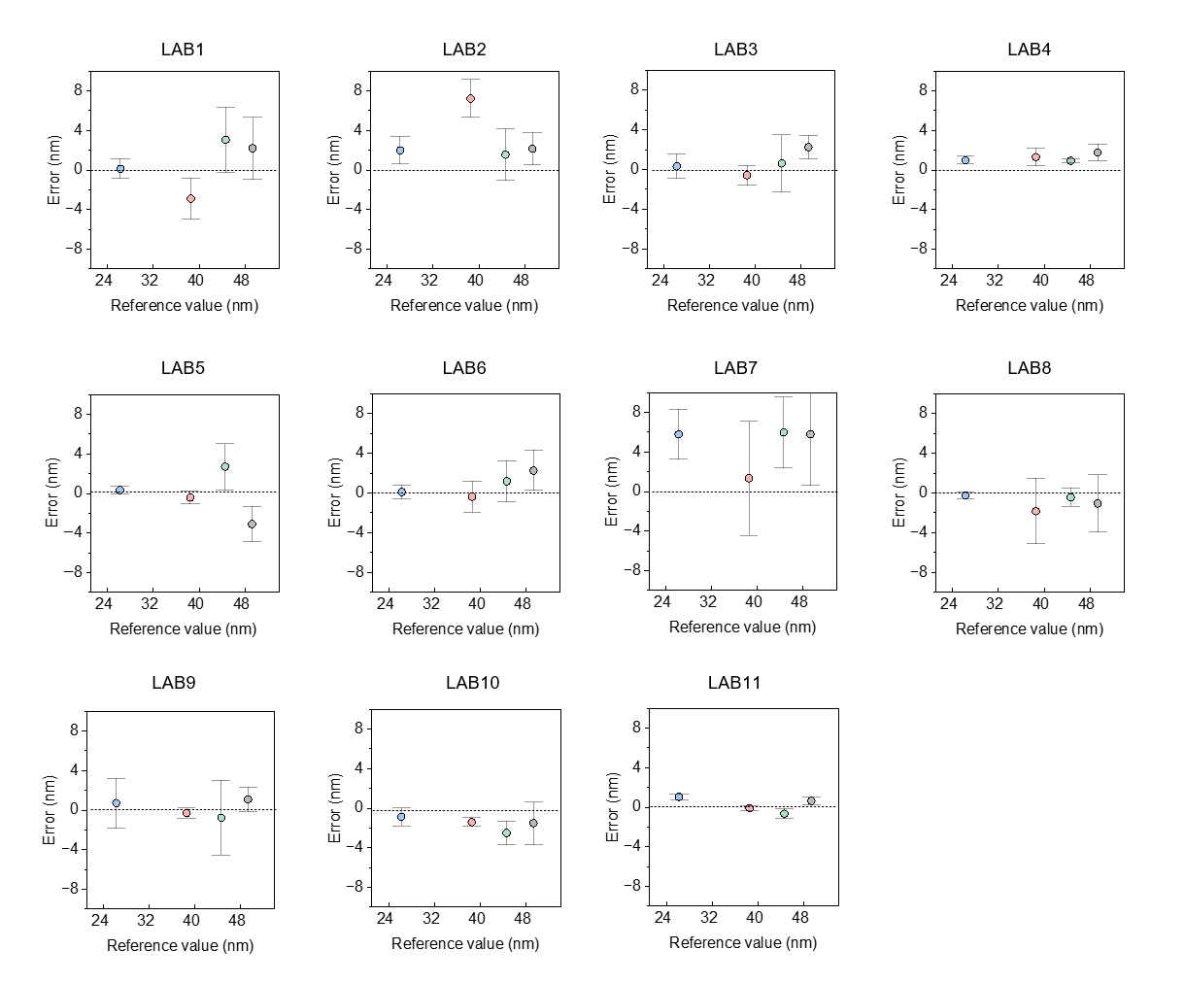
Figure S8 | AFM systematic deviations from the reference L₀. Error plots for each participating AFM instrument (LAB1 to LAB11), showing the difference between the measured L₀​ and the consensus reference values for the four BCP-based nanostructured materials. The blue, red, green and black circles denote the error and vertical bars the associated expanded uncertainty for the Lamellar A, Lamellar B, Cylindrical A and Cylindrical B, respectively. The black dashed line indicates zero deviation from the reference value.
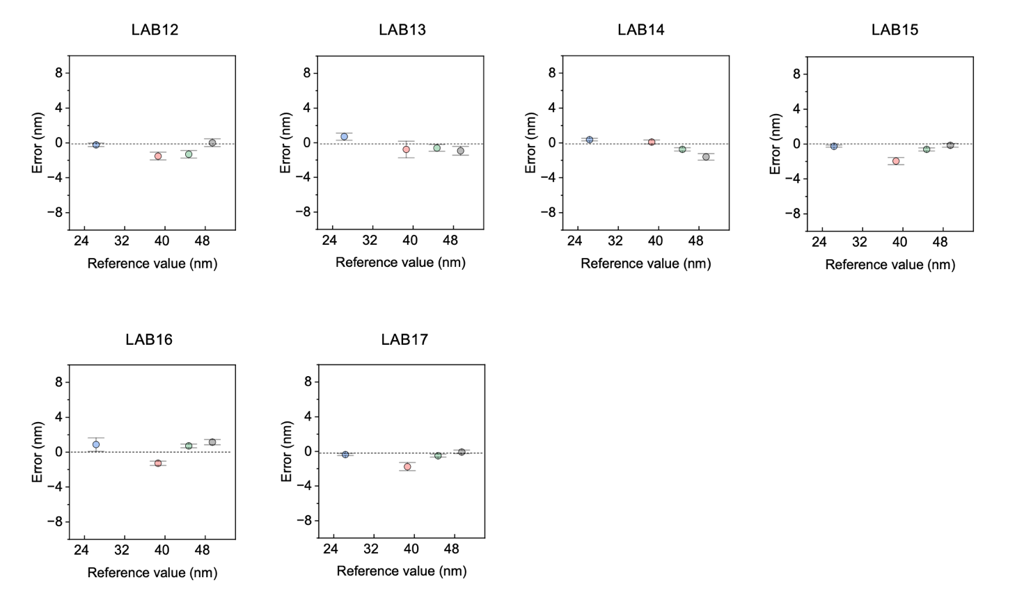
Figure S9 | SEM systematic deviations from the reference L₀. Error plots for each participating SEM instrument (LAB12 to LAB17), showing the difference between the measured L₀​ and the consensus reference values for the four BCP-based lamellar and cylindrical morphologies.

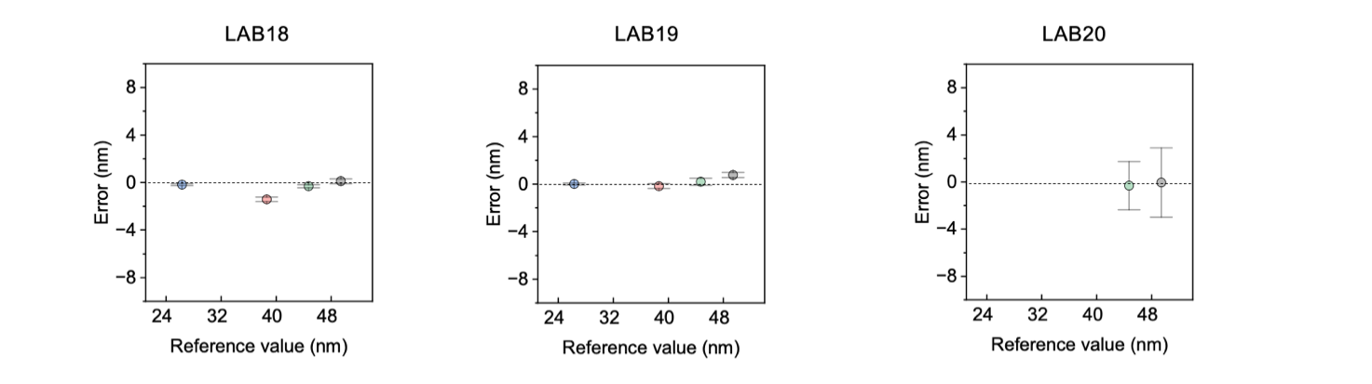
Figure S10 | GISAXS systematic deviations from the reference L₀. Error plots for each participating GISAXS instrument (LAB18 to LAB20), showing the difference between the measured L₀​ and the consensus reference values for the four BCP-based lamellar and cylindrical morphologies.

Supplementary Section 18: Artifact detection
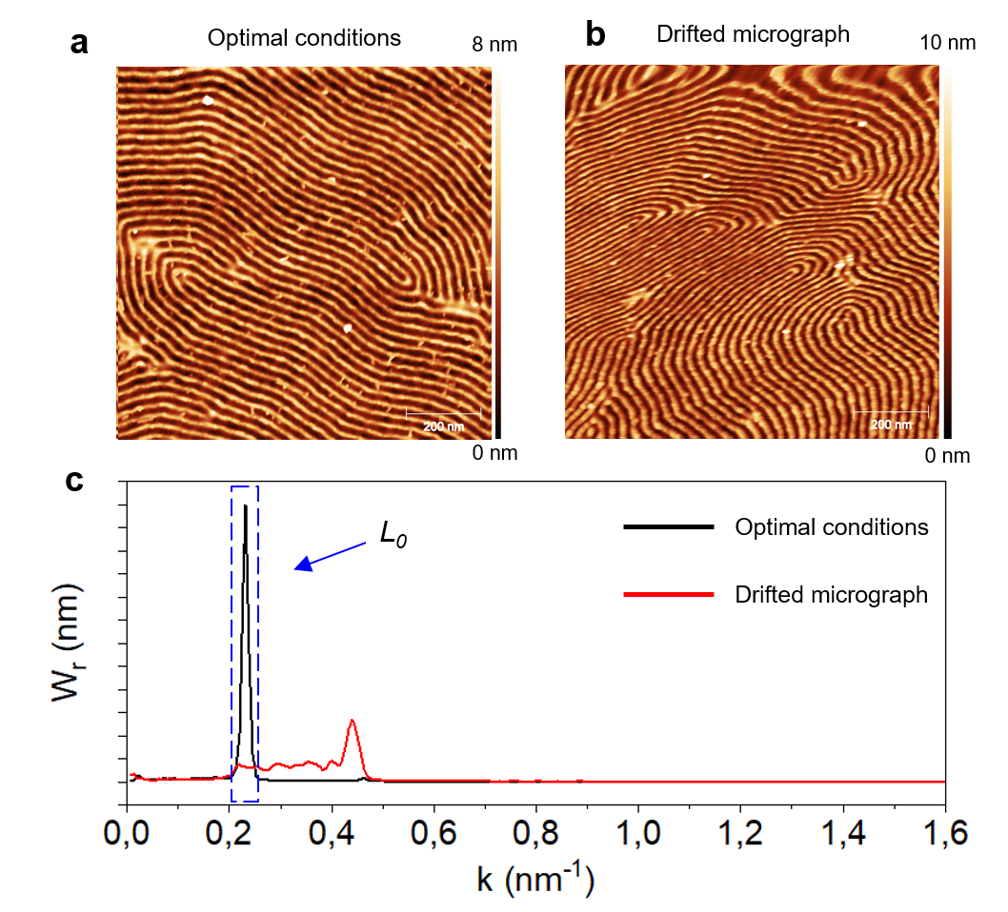
Figure S11 | Artifact detection in AFM micrographs. (a) AFM topographic micrograph of the Lamellae A sample acquired under optimal imaging conditions, showing uniformly spaced periodic structures. (b) AFM micrograph of the same sample acquired under non‑optimal conditions, where lateral drift during scanning distorts the nanostructure. (c) Radially averaged PSDFs corresponding to (a) and (b): the micrograph acquired under optimal conditions (black line) exhibits a single sharp peak at the position expected for the consensus periodicity L₀ determined in the VAMAS interlaboratory comparison, whereas the drifted micrograph (red curve) shows a shifted and broadened peak, together with additional spurious features, revealing the presence of measurement artefacts.

Supplementary Section 19: SPM techniques
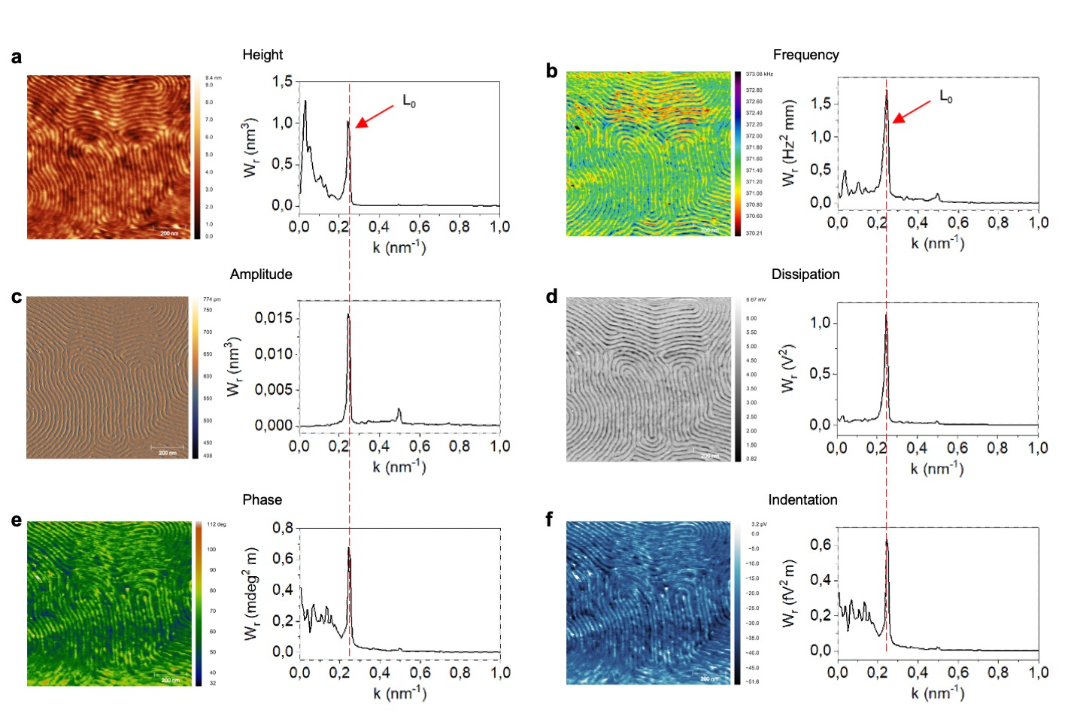
Figure S12 | AFM nanomechanical characterization of lamellar BCP pattern acquired in AM-FM mode. AM-FM is a dual mode dynamic AFM technique capable of providing mechanical contrast with nanoscale resolution while imaging a sample. Briefly, the technique excites two resonant frequencies of the cantilever at the same time, usually the fundamental excitation and one of the first overtones, while mapping a surface. One mode is used to provide a feedback loop in the usual Amplitude Modulation (AM) mode to collect topography (a) while keeping constant the average tip-sample interaction across the sample, providing, in parallel the possibility to acquire Amplitude (c) and Phase (e) channels as well. The resonance of the second mode is tracked in Frequency Modulation (FM) mode while imaging, offering the possibility to track the changes in the AFM (intermittent)-contact resonance frequency (b) its damping due to energy Dissipation (d) and different calculated quantitative local mechanical properties such as Indentation (f) Stiffness or Young modulus, once the tip shape and material has been modelled. This figure presents a comparison between conventional AFM topographic channels acquired in AM mode (a, c, e) and mechanical contrast obtained in FM mode (b, d, f) from the same surface micrographs. As expected for this sample we find a complete correlation between the topography and the mechanical properties of the polymeric patterns protruding out of the flat Silicon substrate, allowing us to assess a clear mechanical contrast on this length scale

Supplementary Section 20: SEM evaluation for drift and distortion
Two-dimensional FFTs can evaluate the uniformity of periodic features in an image. This assessment is crucial for scanning measurements, as nonuniform distortions may happen along both the fast and slow scanning axes. Additional image distortions can also result from positional drift between the sample and the scanner during measurement. This is common in scanning probe methods like AFM, where images may take seconds to minutes to acquire, or in SEM when slow scans are used to improve the signal-to-noise ratio. Nonuniformity of the sample within the measurement field can also cause variations in the measured periodicity based on the sample's orientation. The entire image area should be much larger than the sample's domain size correlation length to statistically average out local orientation nonuniformity. Types of image distortion can be identified by rotating the sample, changing the measurement location, or adjusting the measurement speed. Distortion caused by fixed-rate drift depends on measurement speed, while distortion from sample nonuniformity varies with orientation and position. Figure S13 shows examples of SEM images, 2D-FFT, and polar plots from two different locations on the B42 sample. Insets highlight zoomed-in regions within the larger SEM image that reveal variations in domain orientations. The 2D-FFT displays the periodicity across different orientations, and the polar plot slices the 2D-FFT into wedges plotted as inverse length (periodicity) versus orientation angle. The polar plot helps visualize distortions seen in the rings of the 2D-FFT. Variations in intensity with angle in the polar plots are due to limited sampling of different orientations within the SEM image.
Figure S13 | SEM images and 2D-FFT analysis. (a,d) SEM images from two different spots on sample B42. The insets show zoomed-in regions of the larger SEM to illustrate domain size and orientation variations. (b,e) 2D-FFT plots from the corresponding SEM images. The solid and dashed lines align with plots in Figure S14. The red lines indicate horizontal integrations, while the cyan lines indicate vertical integrations. (c,f) Polar plots displaying the radial variations in the 2D-FFT plots as a function of orientation. The horizontal direction on the 2D-FFT corresponds to 0 degrees on the polar plot. The lines on the polar plots correspond to the same orientations as shown in the 2D-FFTs.
Figure S14 compares the vertical, horizontal, and radial integrations from the 2D-FFTs in Figure S13. The shift between the horizontal and vertical slices indicates small calibration errors in the microscope, which are corrected using separate vertical and horizontal calibration measurements from a traceable dimensional standard sample. Radial integration averages all orientations, greatly reducing noise and also averaging out distortion between vertical and horizontal directions. However, this averaging does not correct scale calibration errors along the horizontal and vertical directions; correcting them would require separate calibration for each direction. Figure S14 shows that the two different spots on the sample have nearly identical periodic spacing.
Figure S14 | Comparison of different orientations on the 2D-FFT. Line integrations from the SEM 2D-FFTs in Figure S13 show differences in peak position based on orientation and measurement location on the sample. Solid and dashed lines represent two different sample locations. The red horizontal lines are shifted to higher inverse pixel values compared to the cyan vertical lines. This shift results from small errors in the microscope's default scale calibration in the two directions.

References

1. Menzel, M. et al. Certified Reference Material BAM-N001 Particle Size Parameters of Nano Silver. 1–23 (2013).
2. Braun, A. et al. Certified Reference Material ERM®- FD100: Certification of Equivalent Spherical Diameters of Silica Nanoparticles in Water. Report EUR 25018 EN (2011). doi:10.2787/33725.
3. Franks, K. et al. Certified Reference Material ERM®-FD304: Certification of the Equivalent Spherical Diameters of Silica Nanoparticles in Aqueous Solution. Eur 24620 En (2012). doi:10.2787/53551.
4. IUPAP, and O. B. I. I. I. I. I. International Vocabulary of Metrology – Basic and general concepts and associated terms (VIM), 3rd edition. Definition 2.41 metrological traceability Preprint at https://doi.org/10.59161/JCGM200-2012 (2012).
5. Mise En Pratique for the Definition of the Metre in the SI. SI Brochure – 9th edition (2019) – Appendix 2 https://www.bipm.org/documents/20126/41489670/SI-App2-metre.pdf/ (2019).
6. Golden, T. W. & Murphy, R. D. Report of Investigation, Reference Material 8011. (2021).
7. Small, J. A. & Robert L. Watters, Jr. Report of Investigation, Reference Materials 8012. (2015).
8. Small, J. A. & Robert L. Watters, J. Report of Investigation, Reference Materials 8013. (2015).
9. Thünemann A. F., E. F. and H. V.-D. Review of existing calibration or refer- ence materials The NanoDefine Consortium, Wageningen, 2014. 1–18 (2014).
10. Orts-Gil, G., Natte, K. & Österle, W. Multi-parametric reference nanomaterials for toxicology: State of the art, future challenges and potential candidates. RSC Adv. 3, 18202–18215 (2013).
11. Deng, X. et al. Shortened and simplified traceability chain for dimensional metrology based on self-traceable standards. Meas. Sci. Technol. 35, (2024).
12. McClelland, J. J., Scholten, R. E., Palm, E. C. & Celotta, R. J. Laser-Focused Atomic Deposition. Science (1979). 262, 877–880 (1993).
13. Devised, I. S. et al. International Technology Roadmap for Devices and Systems - Metrology. https://irds.ieee.org/images/files/pdf/2024/2024IRDS_MET.pdf (2024).
14. Deng, X. et al. Comparison measurements of natural constants based on laser-focused atomic deposition and extreme ultraviolet interference lithography. Meas. Sci. Technol. 36, (2025).
15. Ferrarese Lupi, F. et al. Rapid thermal processing of self-assembling block copolymer thin films. Nanotechnology 24, 315601 (2013).
16. Dialameh, M. et al. Influence of block copolymer feature size on reactive ion etching pattern transfer into silicon. Nanotechnology 28, (2017).
17. Kim, C. E., Shim, J. W., Ham, S. J. & Kim, S. H. Utilizing Block Copolymer Films as an Etch Mask for Pattern Transfer. ACS Omega 10, 8579–8587 (2025).
18. Cho, J. H. et al. Ultrasmooth Polydopamine Modified Surfaces for Block Copolymer Nanopatterning on Flexible Substrates. ACS Appl. Mater. Interfaces 8, 7456–7463 (2016).
19. Murataj, I. et al. Artificial fingerprints engraved through block-copolymers as nanoscale physical unclonable functions for authentication and identification. Nat. Commun. 15, 1–12 (2024).
20. Kim, J. Y. et al. Highly tunable refractive index visible-light metasurface from block copolymer self-assembly. Nat. Commun. 7, 1–9 (2016).
21. Tseng, Y. C., Peng, Q., Ocola, L. E., Elam, J. W. & Darling, S. B. Enhanced block copolymer lithography using sequential infiltration synthesis. Journal of Physical Chemistry C 115, 17725–17729 (2011).
22. Cara, E. et al. Recent advances in sequential infiltration synthesis (Sis) of block copolymers (bcps). Nanomaterials 11, 1–26 (2021).
23. Peng, Q., Tseng, Y., Darling, S. B. & Elam, J. W. A Route to Nanoscopic Materials via Sequential Infiltration Synthesis on Block Copolymer Templates. ACS Nano 5, 4600–4606 (2011).
24. Shi, L. Y. et al. Selective sequential infiltration synthesis of ZnO in the liquid crystalline phase of silicon-containing rod-coil block copolymers. Nanoscale 14, 1807–1813 (2022).
25. Waldman, R. Z. et al. The chemical physics of sequential infiltration synthesis - A thermodynamic and kinetic perspective. Journal of Chemical Physics 151, (2019).
26. Valtr, M. et al. Scanning Probe Microscopy controller with advanced sampling support. HardwareX 15, e00451 (2023).
27. Nečas, D. & Klapetek, P. Gwyddion: an open-source software for SPM data analysis. centr.eur.j.phys 10, 181–188 (2012).
28. Dixson, R. G., Koening, R. G., Vorburger, T. V., Fu, J. & Tsai, V. W. Measurement of pitch and width samples with the NIST calibrated atomic force microscope. in (ed. Singh, B.) 420 (1998). doi:10.1117/12.308751.
29. Semenov, A. N. Contribution to the theory of microphase layering in block-copolymer melts. Zh. Eksp. Teor. Fiz 88, 1242–1256 (1985).
30. Semenov, A. N. Theory of block copolymer interfaces in the strong segregation limit. Macromolecules 26, 6617–6621 (1993).
31. Kramer, E. J. Grafting Kinetics of End‐Functional Polymers at Melt Interfaces. Isr. J. Chem. 35, 49–54 (1995).
32. Matsen, M. W. & Bates, F. S. Unifying weak- and strong-segregation block copolymer theories. Macromolecules 29, 1091–1098 (1996).
33. Matsen, M. W. Strong-segregation limit of the self-consistent field theory for diblock copolymer melts. European Physical Journal E 33, 297–306 (2010).
34. Doerk, G. S. & Yager, K. G. Rapid Ordering in ‘wet Brush’ Block Copolymer/Homopolymer Ternary Blends. ACS Nano 11, 12326–12336 (2017).
35. Wan, L., Ruiz, R., Gao, H. & Albrecht, T. R. Self-Registered Self-Assembly of Block Copolymers. ACS Nano 11, 7666–7673 (2017).
36. Ferrarese Lupi, F. et al. Tailored and Guided Dewetting of Block Copolymer/Homopolymer Blends. Macromolecules 53, 7207–7217 (2020).
37. Liu, G. et al. Phase behavior and dimensional scaling of symmetric block copolymer-homopolymer ternary blends in thin films. Macromolecules 42, 3063–3072 (2009).
38. Magosso, C. et al. Enabling data-driven design of block copolymer self-assembly. Scientific Data 12, 1–10 (2025).

