Text S1
The analysis of the adsorption and oxidation of Mn(Ⅱ) by ss21 using an adapted version of the four-stage sequential extraction protocol detailed: (1) Residual fraction: a 5 mL culture sample was centrifuged at 10,000 rpm for 10 min; the supernatant was retained for the measurement of soluble Mn. (2) Extracellularly adsorbed fraction: the pellet was washed three times with deionized water, resuspended in 5 mL of 50 mM CuSO₄ solution, and shaken at 170 rpm and 25 °C for 8 h. The supernatant was then analyzed for Mn content. (3) Intracellularly adsorbed fraction: following extracellular extraction, the cells were thoroughly disrupted via ultrasonication (5 s work, 3 s interval, for a total of 12 cycles). The same volume of CuSO₄ was added again, and the mixture was shaken overnight. The Mn(Ⅱ) concentration in the supernatant was measured as the intracellularly adsorbed portion. (4) Total oxidized fraction: 5 mL of 20 mM hydroxylamine hydrochloride was added to the residue to reduce and solubilize Mn oxides. After centrifugation at 10,000 rpm for 10 min, the Mn concentration in the supernatant was determined and defined as the total oxidized Mn.

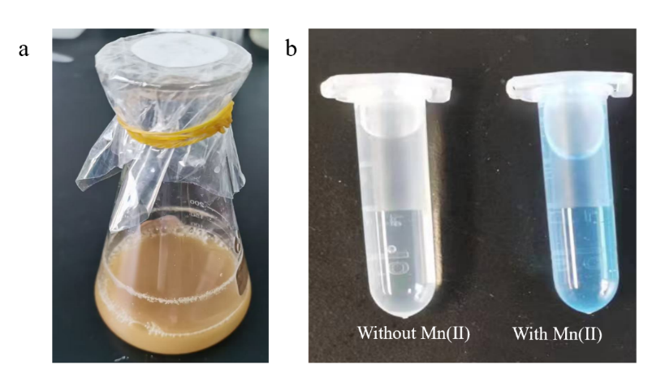
Fig.S1. Conical flask containing Mn(Ⅱ) and ss21 cultured for 5 d (a), LBB test of strain ss21 cultivated with 40 mg/L Mn(Ⅱ) (b).
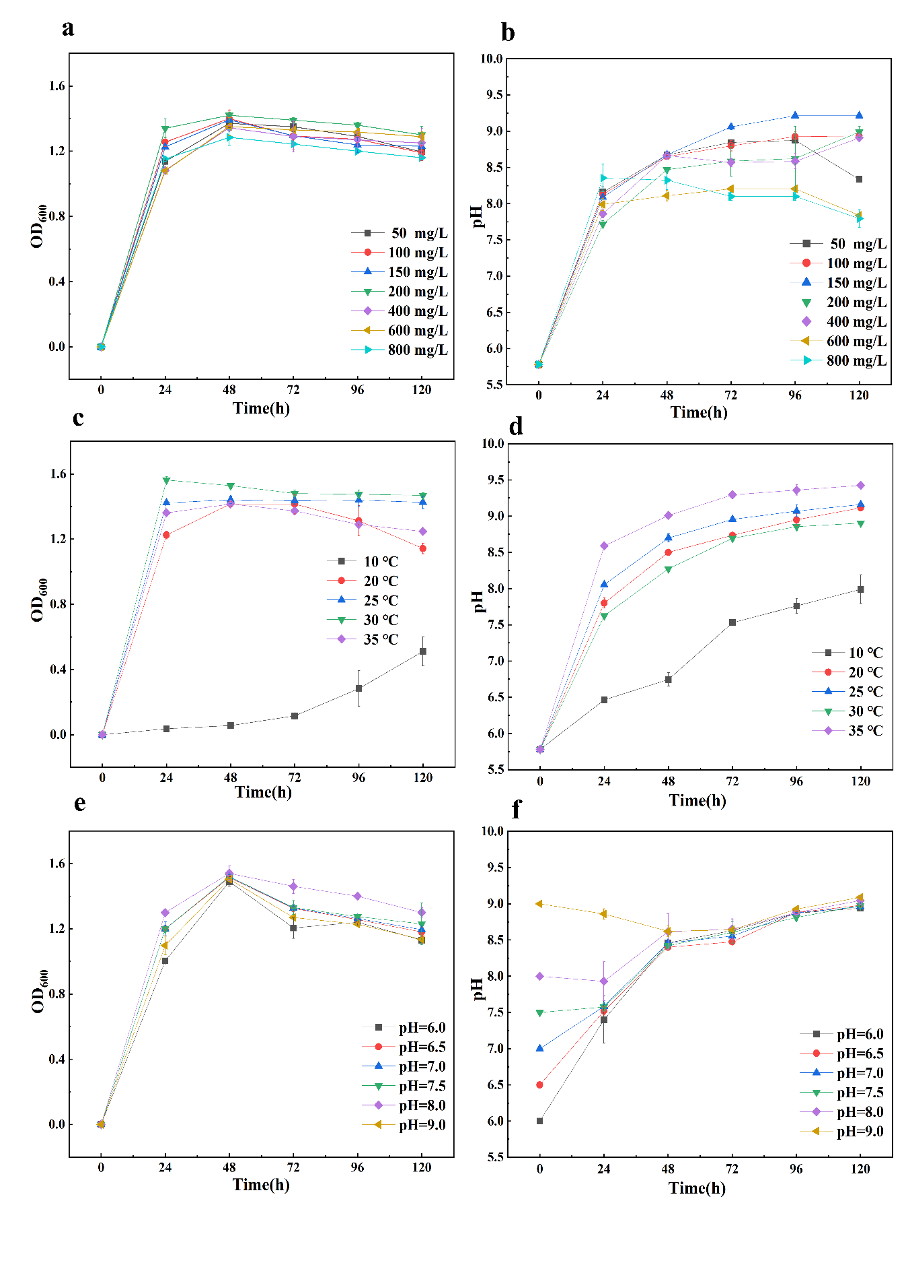
Fig.S2. OD₆₀₀ and pH change under different initial Mn(Ⅱ) concentrations (a and b), different temperature (c and d), different initial pH (e and f).
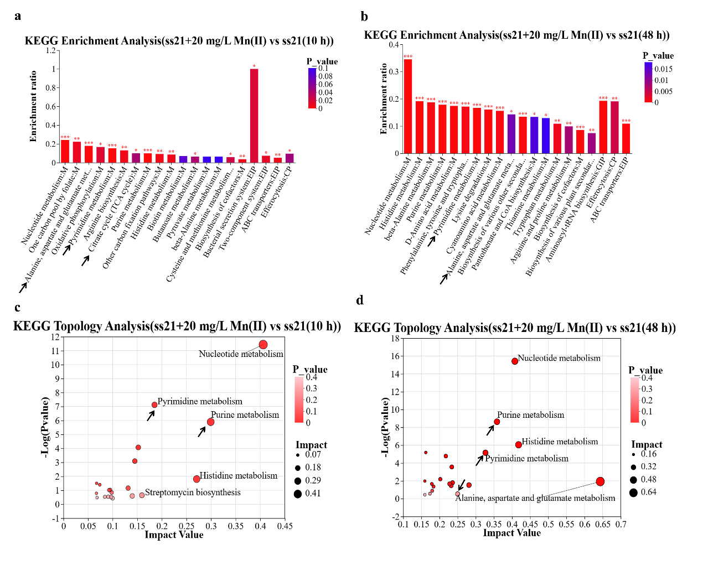
Fig. S3. Analysis of different metabolites and metabolic pathways in bacterial culture systems: KEGG enrichment analysis of (a) ss21 + 20 mg/L Mn(Ⅱ) vs ss21 (10 h),(b) ss21 + 20 mg/L Mn(Ⅱ) vs ss21(48 h); KEGG topology analysis of (c) ss21 + 20 mg/L Mn(Ⅱ) vs ss21 (10 h),(d) ss21 + 20 mg/L Mn(Ⅱ) vs ss21(48 h).

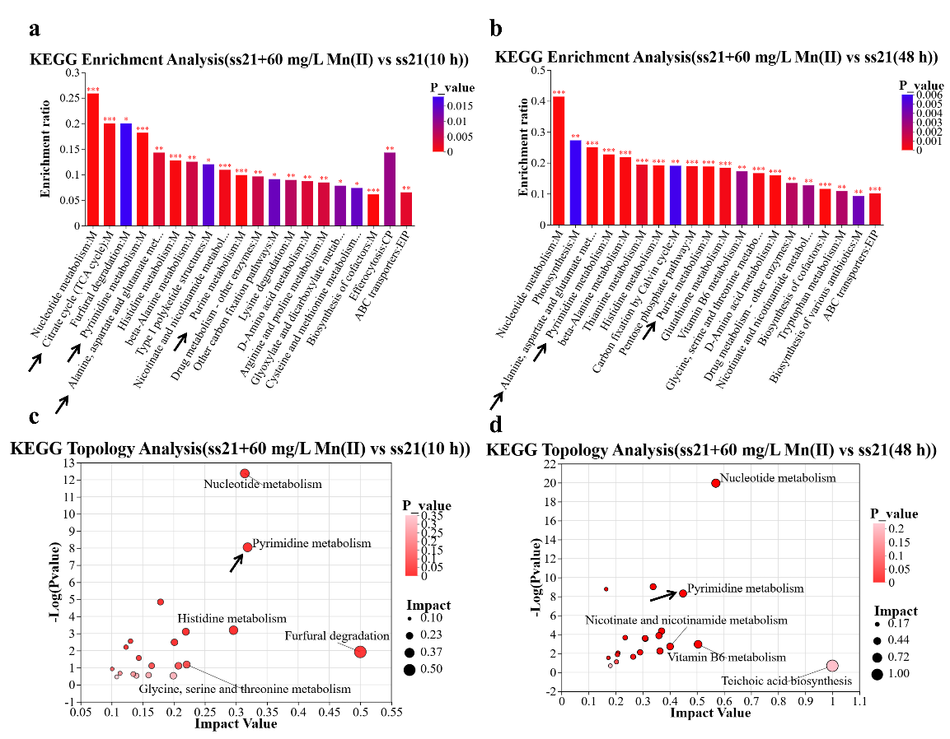
Fig.S4. Analysis of different metabolites and metabolic pathways in bacterial culture systems: KEGG enrichment analysis of (a) ss21 + 60 mg/L Mn(Ⅱ) vs ss21 (10 h), (b) ss21 + 60 mg/L Mn(Ⅱ) vs ss21(48 h); KEGG topology analysis of (c) ss21 + 60 mg/L Mn(Ⅱ) vs ss21 (10 h), (d) ss21 + 60 mg/L Mn(Ⅱ) vs ss21(48 h).

Table S1
GO enrichment pathway related to the Mn(Ⅱ) oxidation process was increased in 48 h (ss21+20 mg/L Mn(Ⅱ)).
GO ID | Function Description | gene id | gene name | gene description
GO:0001539 | cilium or flagellum-dependent cell motility | HV701_RS25670 | flgG | flagellar basal-body rod protein FlgG
GO:0001539 | cilium or flagellum-dependent cell motility | HV701_RS25690 | flgC | flagellar basal body rod protein FlgC
GO:0001539 | cilium or flagellum-dependent cell motility | HV701_RS25695 | flgB | flagellar basal body rod protein FlgB
GO:0001539 | cilium or flagellum-dependent cell motility | HV701_RS26070 | fliS | flagellar export chaperone FliS
GO:0001539 | cilium or flagellum-dependent cell motility | HV701_RS26180 | fliE | flagellar hook-basal body complex protein FliE
GO:0001539 | cilium or flagellum-dependent cell motility | HV701_RS26190 | fliG | flagellar motor switch protein FliG
GO:0048870 | cell motility | HV701_RS25670 | flgG | flagellar basal-body rod protein FlgG
GO:0048870 | cell motility | HV701_RS25690 | flgC | flagellar basal body rod protein FlgC
GO:0048870 | cell motility | HV701_RS25695 | flgB | flagellar basal body rod protein FlgB
GO:0048870 | cell motility | HV701_RS26070 | fliS | flagellar export chaperone FliS
GO:0048870 | cell motility | HV701_RS26180 | fliE | flagellar hook-basal body complex protein FliE
GO:0048870 | cell motility | HV701_RS26190 | fliG | flagellar motor switch protein FliG
GO:0016226 | iron-sulfur cluster assembly | HV701_RS02490 | iscX | Fe-S cluster assembly protein IscX
GO:0016226 | iron-sulfur cluster assembly | HV701_RS02500 | hscA | Fe-S protein assembly chaperone HscA
GO:0016226 | iron-sulfur cluster assembly | HV701_RS02510 | iscA | iron-sulfur cluster assembly protein IscA
GO:0016226 | iron-sulfur cluster assembly | HV701_RS02515 | iscU | Fe-S cluster assembly scaffold IscU
GO:0003677 | DNA binding | HV701_RS02525 | iscR | Fe-S cluster assembly transcriptional regulator IscR
GO:0003677 | DNA binding | HV701_RS19430 | cueR | Cu(I)-responsive transcriptional regulator

Table S2
GO enrichment pathway related to the Mn(Ⅱ) oxidation process was increased in 48 h (ss21+60 mg/L Mn(Ⅱ)).
GO ID | Function Description | gene id | gene name | gene description
GO:0003700 | DNA-binding transcription factor activity | HV701_RS19430 | cueR | Cu(I)-responsive transcriptional regulator
GO:0003700 | DNA-binding transcription factor activity | HV701_RS02525 | iscR | Fe-S cluster assembly transcriptional regulator IscR
GO:0140110 | transcription regulator activity | HV701_RS03300 | HV701_RS03300 | MerR family transcriptional regulator
GO:0140110 | transcription regulator activity | HV701_RS17390 | HV701_RS17390 | MerR family transcriptional regulator
GO:0140110 | transcription regulator activity | HV701_RS10460 | HV701_RS10460 | LysR family transcriptional regulator
GO:0140110 | transcription regulator activity | HV701_RS18625 | HV701_RS18625 | LysR family transcriptional regulator
GO:0140110 | transcription regulator activity | HV701_RS06395 | HV701_RS06395 | LysR family transcriptional regulator

Table S3
GO enrichment pathway related to the Mn(Ⅱ) oxidation process was increased in 48 h (ss21+200 mg/L Mn(Ⅱ)).
GO ID | Function Description | gene id | gene name | gene description
GO:0048870 | cell motility | HV701_RS19230 | motA | flagellar motor stator protein MotA
GO:0048870 | cell motility | HV701_RS25670 | flgG | flagellar basal-body rod protein FlgG
GO:0048870 | cell motility | HV701_RS26190 | fliG | flagellar motor switch protein FliG
GO:0048870 | cell motility | HV701_RS26195 | fliH | flagellar assembly protein FliH
GO:0048870 | cell motility | HV701_RS26200 | flⅡ | flagellar protein export ATPase FlⅡ
GO:0048870 | cell motility | HV701_RS26205 | fliJ | flagellar export protein FliJ
GO:0005575 | cellular_component | HV701_RS19365 | HV701_RS19365 | LLM class flavin-dependent oxidoreductase
GO:0005575 | cellular_component | HV701_RS24690 | HV701_RS24690 | quinone oxidoreductase family protein
GO:0005575 | cellular_component | HV701_RS19360 | HV701_RS19360 | thioredoxin family protein
GO:0005575 | cellular_component | HV701_RS19445 | HV701_RS19445 | glutathione peroxidase
 |  | HV701_RS04390 | HV701_RS04390 | copper resistance system multicopper oxidase

