Supplementary Materials

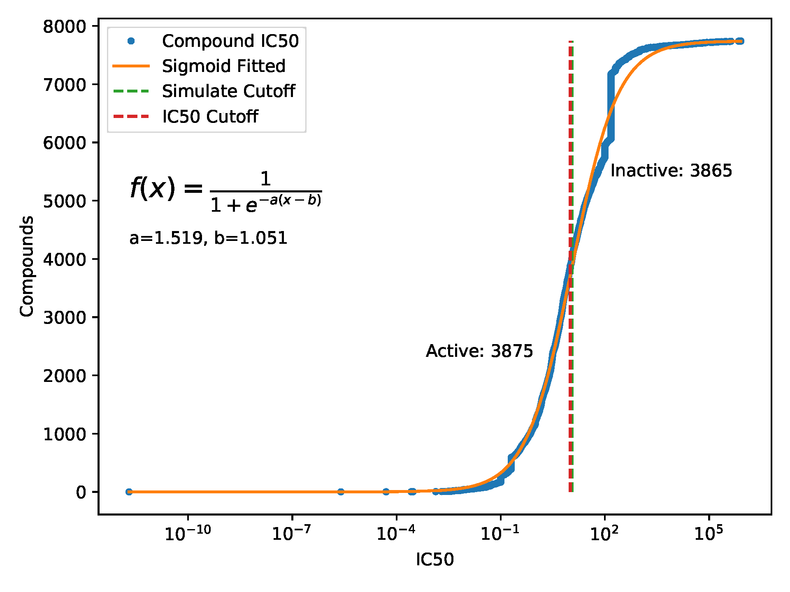
Supplementary Figure 1. Curve fitting of IC50 values of antibacterial compounds. The blue point indicates the IC50 values of all compounds. Sigmiod function was used to perform curve fitting and calculate the fitting parameters (yellow curve). The position of the maximum intercept of the function is defined as the fitting threshold (green dotted line), which is very close to the IC50 cutoff (10 μmol/L). Therefore, compounds with IC50 less than 10 μmol/L were defined as active antibacterial compounds, and those with IC50 higher than 10 μmol/L were considered as inactive antibacterial compounds.

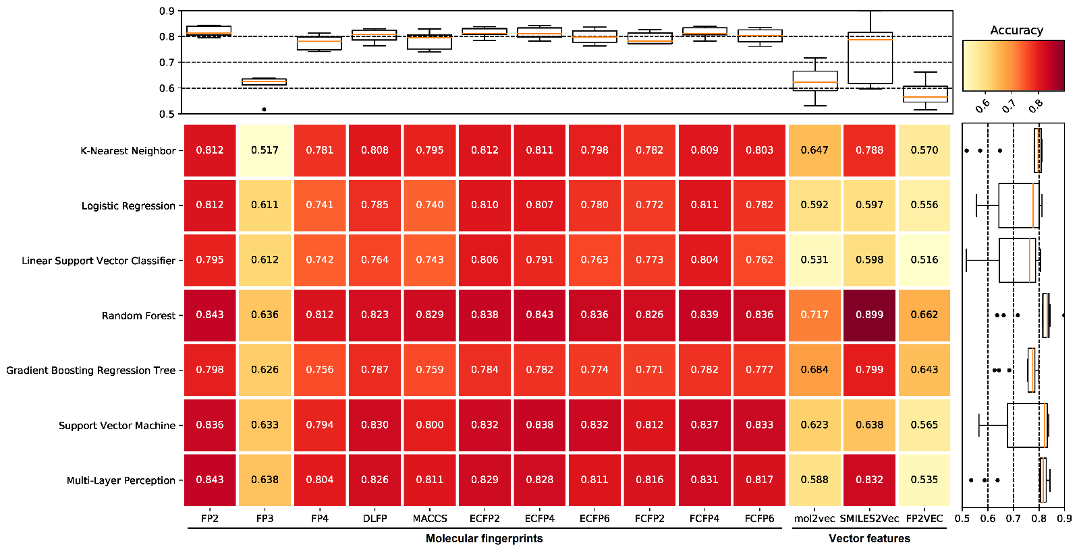
Supplementary Figure 2. The prediction accuracy of different machine learning methods for benchmark datasets. The filtered datasets including one positive dataset and 10 negative datasets (see Methods 2.3), therefore, each value in the figure is the average of 10 prediction accuracy. Compared with other machine learning methods, random forest (RF), support vector machine (SVM), and multi-layer perception (MLP) all show higher prediction accuracy. The benchmark dataset based on FP2 molecular fingerprints shows the highest prediction accuracy in the RF and MLP methods, and also shows high prediction accuracy in the SVM method among all molecular fingerprints. The accuracy fluctuates greatly among different machine learning methods in the benchmark dataset based on vector features.

Supplementary Figure 3. Parameter optimization of the support vector machine (SVM) model. The optimal parameter gamma and C was determined according to the maximum 5-fold cross-validation accuracy (A) and the maximum area under the curve (AUC) (B). The red box indicates the maximum 5-fold cross-validation accuracy or AUC.

Supplementary Figure 4. Parameter optimization of the random forest (RF) model. The optimal parameter n_estimators was determined according to the maximum 5-fold cross-validation accuracy (A) and the maximum area under the curve (AUC) (B). The red box indicates the maximum 5-fold cross-validation accuracy or AUC.

Supplementary Figure 5. Parameter optimization of the multi-layer perception (MLP) model. The optimal parameter hidden_layer_sizes and alpha was determined according to the maximum 5-fold cross-validation accuracy (A) and the maximum area under the curve (AUC) (B). The red box indicates the maximum 5-fold cross-validation accuracy or AUC.

Supplementary Figure 6. The receiver operating characteristic (ROC) curve and area under the curve (AUC) for the optimal SVM, RF, and MLP models. ROC and AUC were calculated for each cross-validation, all 10 times were shown in the figure. The figure showed the use of one of the benchmark datasets (see Methods 2.2 and 2.5) for model construction and its prediction performance.

Supplementary Figure 7. Venn diagram of predicted and FDA approved antibacterial drugs in a single model (A) and the combination of two models (B).

Supplementary Figure 8. FP2 molecular fingerprint similarity between FDA approved antibacterial drugs and predicted antibacterial compounds. The color bar indicates the similarity from low (0) to high (1).

Supplementary Table 1. Binary bits of different types of molecular fingerprints or vector features were used for machine learning modeling.
Compound Features | Description | Number of features
Molecular fingerprints
FP2 | FP2 Fingerprints | 1024
FP3 | FP3 Fingerprints | 210
FP4 | FP4 Fingerprints | 307
DLFP | Daylight-like Fingerprints | 2048
MACCS | MACCS keys | 166
ECFP2 | Extended-Connectivity Fingerprints, Iteration 1 | 1024
ECFP4 | Extended-Connectivity Fingerprints, Iteration 2 | 1024
ECFP6 | Extended-Connectivity Fingerprints, Iteration 3 | 1024
FCFP2 | Functional-Class Fingerprints, Iteration 1 | 1024
FCFP4 | Functional-Class Fingerprints, Iteration 2 | 1024
FCFP6 | Functional-Class Fingerprints, Iteration 3 | 1024
Vector features
mol2vec | Vector features based on Morgan fingerprints | 200
SMILES2Vec | Vector features based on molecule SMILES | 100
FP2VEC | Trainable embedding vectors based on fingerprints | 100

Supplementary Table 2. The prediction summary of different machine learning models.
Model | Number of predicted drugs | Number of overlapped drugs | P-value
SVM | 1482 | 166 | 1.88E-8
RF | 1539 | 170 | 2.45E-8
MLP | 1398 | 153 | 4.21E-6
SVM, RF | 1272 | 145 | 7.09E-7
SVM, MLP | 1228 | 144 | 8.35E-8
RF, MLP | 1162 | 137 | 2.56E-7
SVM, RF, MLP | 1090 | 133 | 4.24E-8
Abbr. SVM, support vector machine; RF, random forest; MLP, multi-layer perception.
P-values were calculated by hypergeometric distribution model.

Supplementary Table 3. Core scaffolds and representative drugs of antibacterial compounds.
Categories | Core Structure | Represented | Name | Structure
Quinolones | 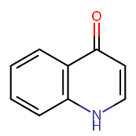 | DB00218 | Moxifloxacin | 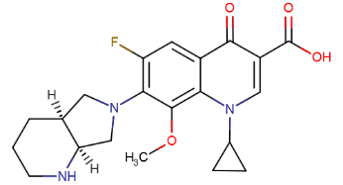
Penicillins | 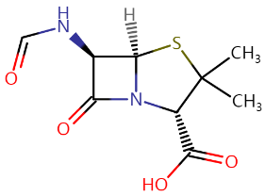 | DB00578 | Carbenicillin | 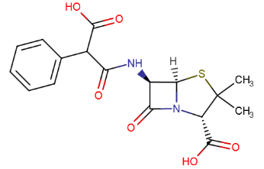
Oxazolidinones | 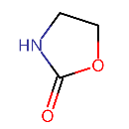 | DB00601 | Linezolid | 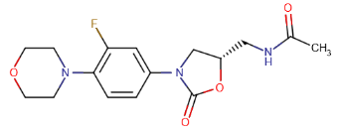
β-lactams | 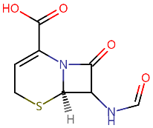 | DB00689 | Cephaloglycin | 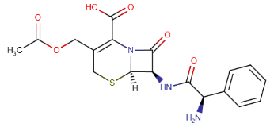
Sulfonamides | 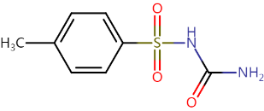 | DB01124 | Tolbutamide | 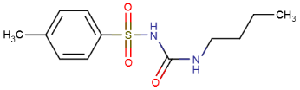
Lincosamides | 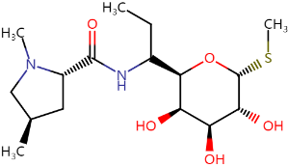 | DB01190 | Clindamycin | 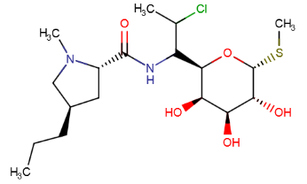
Carbapenems | 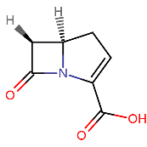 | DB01598 | Imipenem | 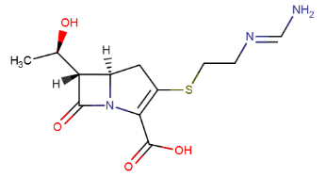
Cephalosporins | 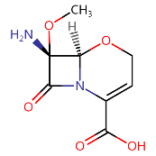 | DB04570 | Latamoxef | 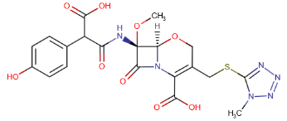

Supplementary Table 4. Novel predicted antibacterial drugs with high similarity to core scaffolds.
Categories | Predicted Drug | Query Size | Target Size | MCS Size | Tanimoto Coefficient | Overlap Coefficient
Quinolones | DB08820 | 11 | 29 | 11 | 0.38 | 1.00
Sulfonamides | DB00222 | 14 | 34 | 14 | 0.41 | 1.00
Sulfonamides | DB01016 | 14 | 33 | 14 | 0.42 | 1.00
Sulfonamides | DB01067 | 14 | 31 | 14 | 0.45 | 1.00
Sulfonamides | DB01251 | 14 | 37 | 14 | 0.38 | 1.00
Oxazolidinones | DB00315 | 6 | 21 | 6 | 0.29 | 1.00
Oxazolidinones | DB00660 | 6 | 16 | 6 | 0.38 | 1.00
Oxazolidinones | DB06228 | 6 | 29 | 6 | 0.21 | 1.00
Sulfonamides | DB00559 | 14 | 39 | 13 | 0.33 | 0.93
Sulfonamides | DB08439 | 14 | 26 | 13 | 0.48 | 0.93
Quinolones | DB00385 | 11 | 51 | 10 | 0.19 | 0.91
Quinolones | DB00445 | 11 | 39 | 10 | 0.25 | 0.91
Quinolones | DB00524 | 11 | 24 | 10 | 0.40 | 0.91
Quinolones | DB00670 | 11 | 26 | 10 | 0.37 | 0.91
Quinolones | DB00694 | 11 | 38 | 10 | 0.26 | 0.91
Quinolones | DB00695 | 11 | 21 | 10 | 0.45 | 0.91
Quinolones | DB00796 | 11 | 45 | 10 | 0.22 | 0.91
Quinolones | DB00904 | 11 | 22 | 10 | 0.43 | 0.91
Quinolones | DB00963 | 11 | 20 | 10 | 0.48 | 0.91
Quinolones | DB00997 | 11 | 39 | 10 | 0.25 | 0.91
Quinolones | DB01009 | 11 | 19 | 10 | 0.50 | 0.91
Quinolones | DB01022 | 11 | 33 | 10 | 0.29 | 0.91
Quinolones | DB01117 | 11 | 26 | 10 | 0.37 | 0.91
Quinolones | DB01148 | 11 | 29 | 10 | 0.33 | 0.91
Quinolones | DB01177 | 11 | 36 | 10 | 0.27 | 0.91
Quinolones | DB01204 | 11 | 32 | 10 | 0.30 | 0.91
Quinolones | DB01205 | 11 | 22 | 10 | 0.43 | 0.91
Quinolones | DB01325 | 11 | 18 | 10 | 0.53 | 0.91
Quinolones | DB01419 | 11 | 42 | 10 | 0.23 | 0.91
Quinolones | DB01698 | 11 | 43 | 10 | 0.23 | 0.91
Quinolones | DB02266 | 11 | 20 | 10 | 0.48 | 0.91
Quinolones | DB04880 | 11 | 17 | 10 | 0.56 | 0.91
Quinolones | DB05239 | 11 | 30 | 10 | 0.32 | 0.91
Quinolones | DB06193 | 11 | 24 | 10 | 0.40 | 0.91
Quinolones | DB06207 | 11 | 35 | 10 | 0.28 | 0.91
Quinolones | DB08822 | 11 | 42 | 10 | 0.23 | 0.91
Quinolones | DB08881 | 11 | 33 | 10 | 0.29 | 0.91
Quinolones | DB08911 | 11 | 37 | 10 | 0.26 | 0.91
Quinolones | DB08995 | 11 | 43 | 10 | 0.23 | 0.91
Quinolones | DB09079 | 11 | 40 | 10 | 0.24 | 0.91
Quinolones | DB09183 | 11 | 35 | 10 | 0.28 | 0.91
Quinolones | DB09214 | 11 | 19 | 10 | 0.50 | 0.91
Quinolones | DB11363 | 11 | 36 | 10 | 0.27 | 0.91
Quinolones | DB11577 | 11 | 28 | 10 | 0.34 | 0.91
Quinolones | DB11689 | 11 | 27 | 10 | 0.36 | 0.91
Quinolones | DB11699 | 11 | 21 | 10 | 0.45 | 0.91
Quinolones | DB11967 | 11 | 27 | 10 | 0.36 | 0.91
Quinolones | DB11986 | 11 | 41 | 10 | 0.24 | 0.91
Quinolones | DB13225 | 11 | 22 | 10 | 0.43 | 0.91
Quinolones | DB15477 | 11 | 30 | 10 | 0.32 | 0.91
Lincosamides | DB09419 | 24 | 10 | 9 | 0.36 | 0.90
Abbr. MCS, maximum common substructure.
Tanimoto Coefficient = MCS Size / (Query Size + Target Size − MCS Size)
Overlap Coefficient = MCS Size / min(Query Size, Target Size)
The MCS algorithm was used to calculate structural similarities among small molecules. A total of 957 predicted novel antibacterial drugs were calculated among 8 core structures. The table showed 51 predicted drugs with an overlap coefficient > 0.9 among 8 core structures, the results are sorted by overlap coefficient from high to low.

Supplementary Table 5. Details of the 9 predicted novel antibacterial drugs.
Drug ID | Name | Structure | Class | Indication
DB00228 | Enflurane | 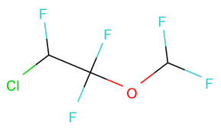 | Organofluorides | Analgesia  General anesthesia
DB00531 | Cyclophosphamide | 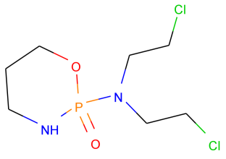 | Organonitrogen compounds | Lymphoma  Multiple myeloma  Leukemia  Mycosis fungoides  Neuroblastoma  Ovarian adenocarcinoma  Retinoblastoma  Breast cancer
DB00753 | Isoflurane | 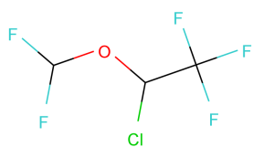 | Organofluorides | General anesthesia
DB00964 | Apraclonidine | 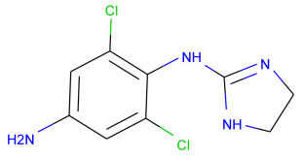 | Benzene and substituted derivatives | Ocular hypertension  Postsurgical ocular hypertension
DB01028 | Methoxyflurane | 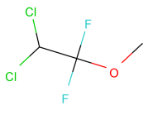 | Organooxygen compounds | General anesthesia
DB01057 | Echothiophate | 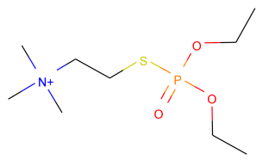 | Organonitrogen compounds | Accommodative component in esotropia  Chronic angle-closure glaucoma  Open-angle glaucoma  Nonuveitic secondary glaucoma
DB01181 | Ifosfamide | 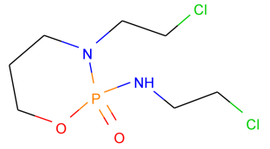 | Oxazaphosphinanes | Germ cell testicular cancer  Cervical cancer  Soft tissue sarcomas  Osteosarcoma  Bladder cancer  Ovarian cancer  Small cell lung cancer  Non-Hodgkin's lymphoma
DB01189 | Desflurane | 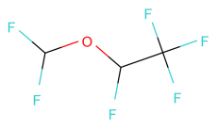 | Organofluorides | General anesthesia  Maintenance of anesthesia therapy
DB01236 | Sevoflurane | 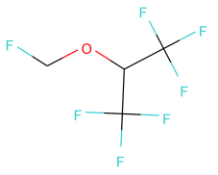 | Organooxygen compounds | General anesthesia

