Supplementary Data
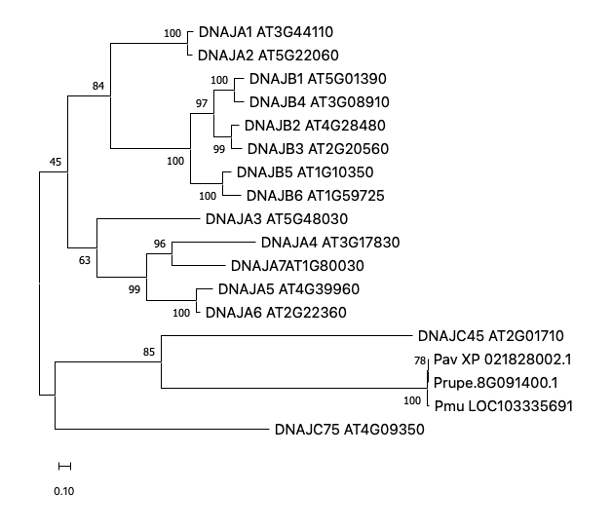
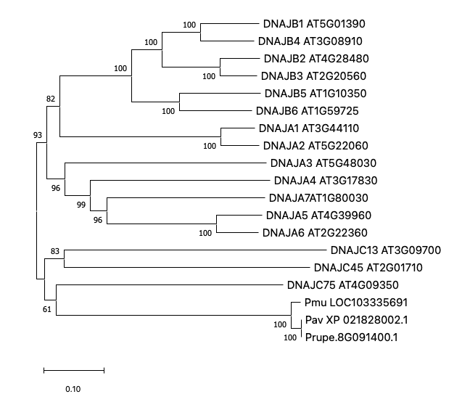
Supplementary Fig S1
Supplementary Fig. S1 Phylogenetic placement of PavSDJ relative to Arabidopsis DnaJ proteins and closely related Prunus homologs. Two phylogenetic reconstructions are shown to assess the placement of PavSDJ within the plant DnaJ family. The PavSDJ-containing clade is boxed in red. Numbers at nodes indicate bootstrap support values, and the scale bars represent amino acid substitutions per site. Sequences included should refer to supplementary table S1. Left: NJ Tree. Right: ML tree with removal of a short sequence DNAJC13.
SDJ
SDJ

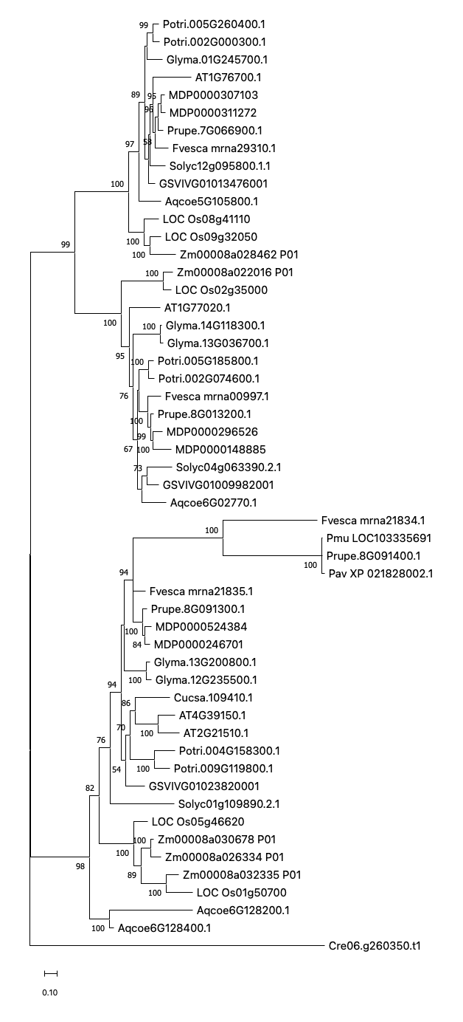
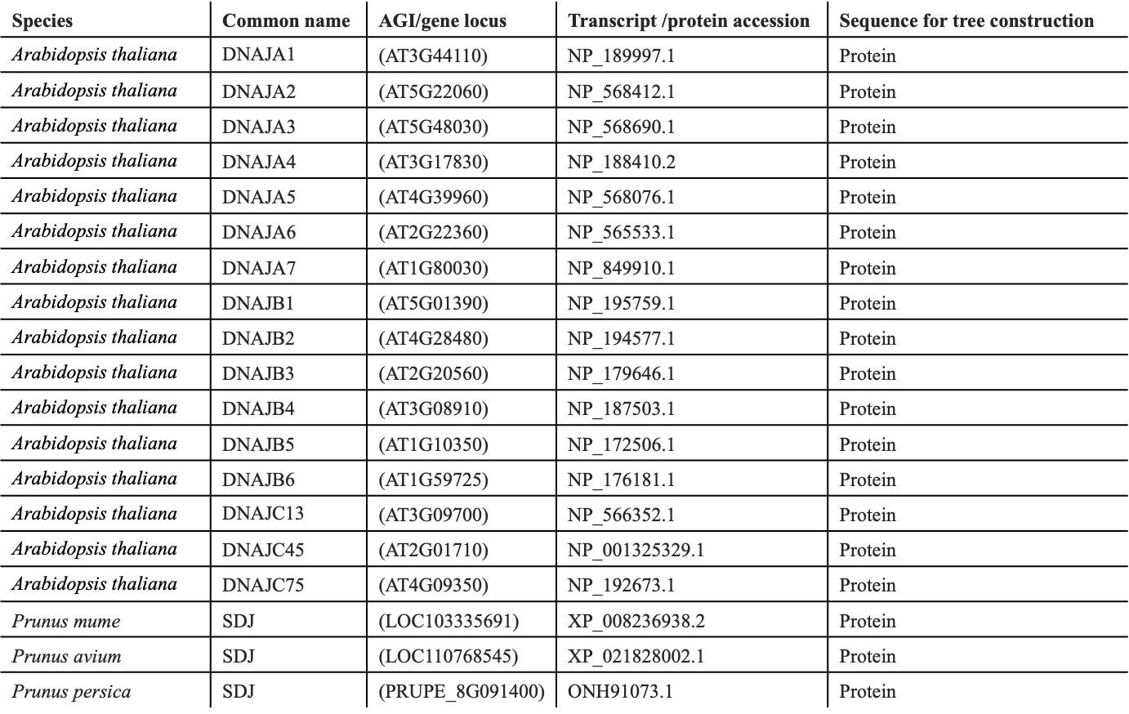
Supplementary Fig S2
Supplementary Fig. S2 Phylogenetic analysis of SDJ-related proteins identifies three major clades
The deduced amino acid sequences were from peach (prefixed with Prupe), strawberry (Fvesca), apple (MDP), soybean (Glyma), poplar (Potri), grapevine (GSV), cucumber (Cucsa), Arabidopsis thaliana (AT), tomato (Solyc), Aquilegia coerulea (Aqcoe), maize (Zm) and rice (LOC_Os). The ML tree was generated with 1000 bootstrap replicates. Bootstrap values over 50 are shown. PavSDJ-like protein of Chlamydomonas reinhardtii (Cre06.g260350.t1) was used as the outgroup. Clades 1–3 are indicated, and PavSDJ is marked by a red star within Clade 3. Numbers at nodes indicate bootstrap support values, and the scale bar represents amino acid substitutions per site.
Clade 1
Clade 2
Clade 3
Supplementary Table S1 Information of sequences used for defining SDJ family

