Supplementary Materials
Table of Contents
Supplementary Materials 1
Student Attention Tracking (SAT) Table 1
Demographics & Performance 1
Principle Component Analysis 2
Woodcock Johnson IV 2
Parent / caregiver report questionnaires 2
EEG Cluster Results 3
Posterior cluster 3
Central cluster 4

Student Attention Tracking (SAT) Table
Table S1. Behavioral Categories and Codes of the Student attention Tracking (SAT)
Category | Code | Definition | Examples | Adapted From
Engagement | Active Engagement | Actively engaging with the task. | Answering instructor’s questions; following the task or instructor’s directions. | Shapiro (2004)
Engagement | Passive Engagement | Attending to the task without active interaction. | Listening to the instructor; watching a visual display without conversing; nodding to show understanding. | Shapiro (2004)
Fidgeting | Macro Fidgeting | Moving the head, appendages, or body with a complete spatial displacement relative to a starting position, when not required by the task. | Raising hands over the head; sliding down in the chair. | Farley et al. (2013)
Fidgeting | Micro Fidgeting | Exhibiting repeated or small movements with minimal spatial displacement. | Shaking feet or legs; playing with fingers; tapping a pencil on the table. | Farley et al. (2013)
Off-Task | Passive Off-Task | Showing gaze away from the task or instructor for two or more seconds. | Looking at the door; peeking at the recording cameras; staring out the windows. | Rapport et al. (2009)
Off-Task | Verbal Off-Task | Making audible verbalizations unrelated to the task. | Making random noises; asking task-irrelevant questions. | Shapiro (2004)
Note. This scheme is cited in Mao et al., under review.

Demographics & Performance
Table S2 presents sample characteristics for the full sample, reflecting variability in demographic characteristics, ADHD symptom measures, and task performance.
Table S2. Participant Demographics & Assessments
 | (M, SD)
N | 51
Sex (male : female) | 27:24
Age (year) | 8.46 (1.36)
Socioeconomic status (SES) | 0.12 (0.75)
ADHD Rating Scale Measure
Conners - Inattention scale | 59.82 (17.69)
Conners - Hyperactivity scale | 57.75 (15.88)
SWAN - Inattention scale | 3.84 (1.13)
SWAN - Hyperactivity scale | 3.74 (1.03)
Academic achievement (WJ)
Letter-Word Identification | 125.29 (51.36)
Passage Comprehension | 117.26 (31.61)
Applied Problems | 102.13 (23.20)
Math Facts Fluency | 103.51 (23.30)
Cognitive Processing Speed (WJ)
Pair Cancellation | 101.82 (18.02)
Spatial Working Memory (SWM)
Load 1 RT (ms) | 1354.71 (234.60)
Load 3 RT (ms) | 1589.58 (260.02)
Load 1&3 RT (ms) | 1462.96 (228.15)
Load 1 RTcv | 0.29 (0.07)
Load 3 RTcv | 0.30 (0.09)
Load 1&3 RTcv | 0.31 (0.06)
Load 1 Accuracy | 0.88 (0.12)
Load 3 Accuracy | 0.74 (0.16)
Load 1&3 Accuracy | 0.81 (0.13)
Hearts and Flowers
Hearts (congruent) RT (ms) | 513.63 (133.50)
Flowers (incongruent) RT (ms) | 593.29 (155.32)
Mixed RT (ms) | 750.79 (138.79)
Hearts (congruent) RTcv | 0.25 (0.14)
Flowers (incongruent) RTcv | 0.25 (0.10)
Mixed RTcv | 0.26 (0.12)
Hearts (congruent) Accuracy | 0.96 (0.07)
Flowers (incongruent) Accuracy | 0.90 (0.15)
Mixed Accuracy | 0.73 (0.15)
Note. N = number; M = mean; SD = standard deviation; RT = mean reaction time; Mixed = Hearts and Flowers combined; RTcv = coefficient of variation of reaction time.

Principle Component Analysis

Woodcock Johnson IV
The PCA identified one component accounting for 59.91% of the total variance (Table S3 and S4). WJ-IV academic measures loaded strongly on the first component, reflecting general academic ability.
Table S3. Variance Explained by PCA Component
Component | Eigenvalue | Variance % | Cumulative %
1 | 2.995 | 59.91 | 59.91

Table S4. PCA Loadings for Cognitive Measures
Measure | Component 1
Letter Word | 0.635
Applied Problem | 0.876
Passage Comprehension | 0.833
Math Fluency | 0.790
Pair Cancellation | 0.712
Note. Extraction method: Principal Component Analysis. Values represent component loadings.

Parent / caregiver report questionnaires
The PCA identified four components that together accounted for 81.98% of the total variance (Tables S5 and S6). Several externalizing and behavioral dysregulation measures loaded strongly on the first component.
Table S5. Variance Explained by PCA Component
Component | Eigenvalue | Variance % | Cumulative %
1 | 13.623 | 56.763 | 56.763
2 | 3.154 | 13.141 | 69.904
3 | 1.626 | 6.774 | 76.678
4 | 1.272 | 5.301 | 81.979

Table S6. PCA Loadings for Cognitive Measures
Measure | Component 1 | Component 2 | Component 3 | Component 4
Conners Inattention | 0.318 | 0.733 | -0.038 | -0.023
Conners Hyperactivity | 0.321 | 0.698 | -0.119 | -0.042
Conners EF | 0.597 | 0.310 | -0.012 | -0.007
Conners Learning Problems | -0.278 | 0.860 | 0.137 | -0.015
SWAN Inattention | -0.179 | 0.961 | -0.030 | 0.002
SWAN Hyperactivity | -0.250 | 0.953 | 0.045 | 0.133
BRIEF Composite | 0.580 | 0.443 | 0.023 | -0.036
CBCL Anxious/Depressed | -0.760 | -0.030 | 1.117 | -0.226
CBCL Withdrawn/Depressed | 0.346 | -0.128 | 0.537 | 0.115
CBCL Somatic Complaints | 0.074 | 0.003 | -0.004 | 0.938
CBCL Social Problems | 0.014 | 0.279 | 0.666 | -0.017
CBCL Thought Problems | 0.327 | 0.221 | 0.352 | 0.184
CBCL Attention Problems | 0.374 | 0.677 | -0.070 | -0.035
CBCL Rule-Breaking Behavior | 1.016 | -0.140 | -0.093 | 0.117
CBCL Aggressive Behavior | 0.910 | 0.056 | 0.038 | -0.090
CBCL Internalizing Problems | 0.037 | -0.136 | 0.869 | 0.205
CBCL Externalizing Problems | 1.028 | -0.247 | 0.085 | 0.002
CBCL Total Problems | 0.546 | 0.022 | 0.421 | 0.117
DSM Depressive | -0.027 | 0.132 | 0.746 | 0.203
DSM Anxiety | -0.064 | -0.007 | 1.072 | -0.212
DSM Somatic | -0.122 | 0.031 | -0.118 | 1.046
DSM ADHD | 0.387 | 0.648 | -0.052 | -0.025
DSM Oppositional Defiant | 1.011 | 0.018 | -0.061 | -0.185
DSM Conduct | 0.888 | -0.080 | 0.095 | 0.047
Note. Extraction method: Principal Component Analysis. Rotation method: Promax with Kaiser normalization. Rotation converged in 7 iterations.

EEG Cluster Results

Posterior cluster

Alpha power correlations between lab task and learning activities
Associations between SWM ERMs and activity ERMs during learning activities for encoding (Figure S1, left column) and maintenance (Figure S1, middle column) are shown (cf. main text for probe; see Figure S1, right column).
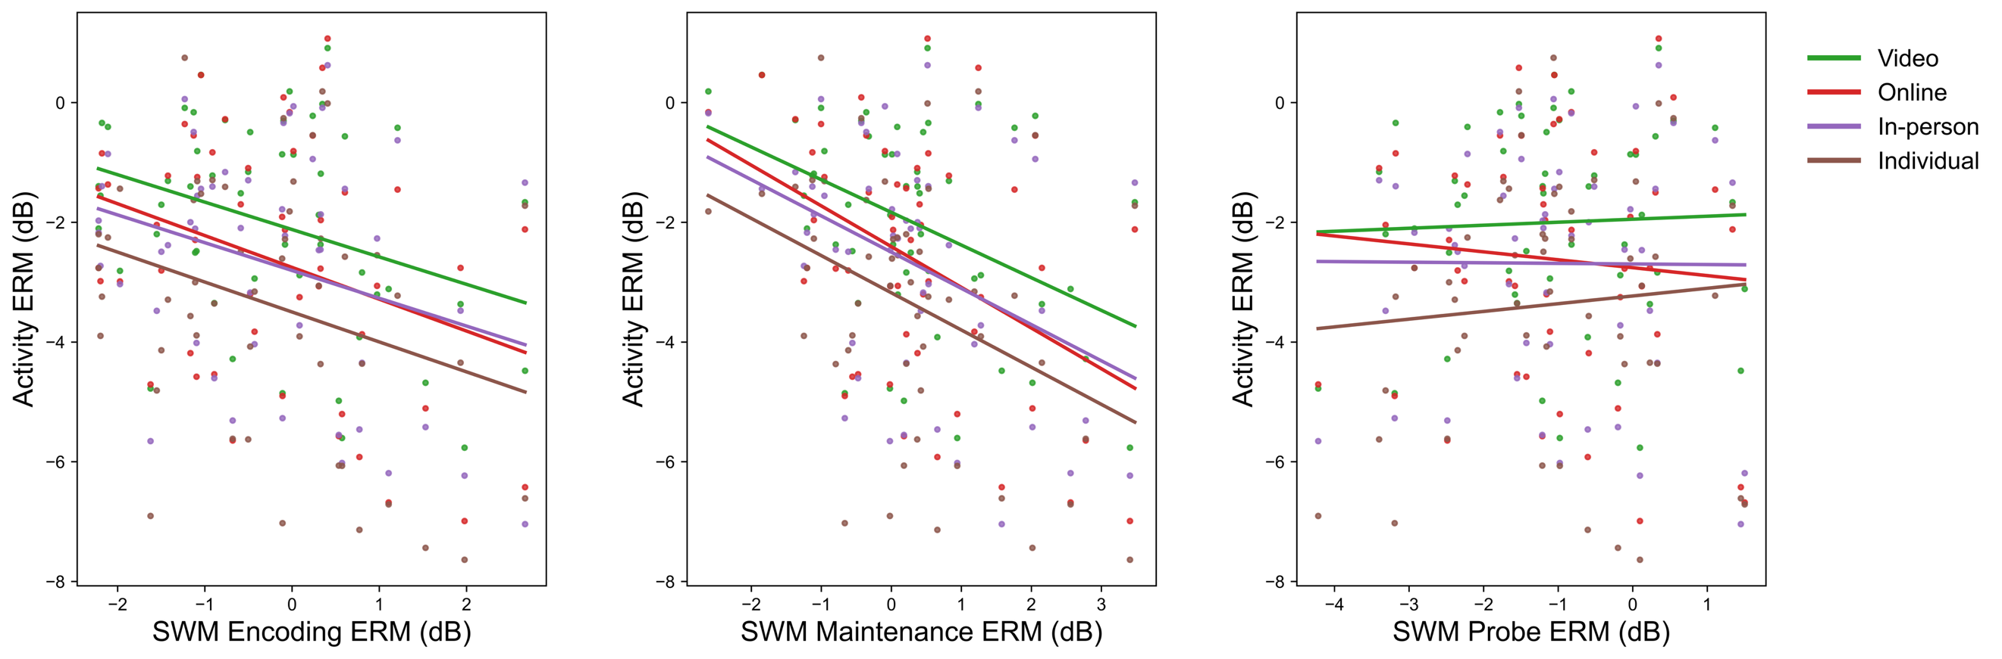
Figure S1. Associations between SWM ERMs and EO-normalized alpha power during learning activities in O1, O2, and POz. Scatter plots show relationships between SWM ERMs during encoding and maintenance and EO-normalized alpha power across learning activities (video, online, in-person, and individual). Consistent with the interpretation that alpha power during maintenance returned to baseline levels, significant negative associations were observed between maintenance ERM and activity-related alpha power across all activities, whereas associations for encoding and probe ERM (i.e., during stimulus processing) were not significant. Lines represent ordinary least-squares linear fits for each activity.

Alpha Power Prediction of Outcomes: Neurocognitive Functioning
Finally, we examined whether EEG-extracted features in either setting predicted academic performance and caregiver-reported neurocognitive functioning. As detailed in the main manuscript, maintenance alpha power and ERM during the laboratory task were associated with higher WJ-IV performance (Table S7), whereas models predicting caregiver-reported measures were not significant. Age was a robust predictor of academic achievement across models (Table S8). Overall, alpha power showed weak associations with these outcomes.

Table S7. Multiple Regression Models of Academic Performance and Caregiver-Reported Symptoms on EEG Source Measures in the Laboratory Setting
 | tβ (regression coefficient) |  |  |  |  |  |  |  |  |  |  | Model fit
 | Alpha_{b} | Alpha_{e} | Alpha_{m⊥e} | Alpha_{p⊥e} | ERM_{e} | ERM_{m⊥e} | ERM_{p⊥e} | Age (yr) | Sex | Symptom |  | R²_{adj} | F
WJ-IV PC | 1.299 | -0.684 | 2.223* | -0.355 | 1.678 | -2.077* | 0.767 | 8.246*** | 0.020 | 1.449 |  | 0.606 | 8.689***
PC1 (Rule Breaking) | -0.906 | -0.943 | 1.485 | 1.205 | -0.480 | -1.326 | -2.810** | -0.443 | -1.502 | n/a |  | 0.132 | 1.848
PC2  (Attention) | -1.238 | -0.130 | -0.817 | 1.279 | -2.120* | 0.701 | -1.536 | 0.409 | -2.005 | n/a |  | 0.092 | 1.560
PC3  (Anxiety) | -0.966 | -0.646 | 0.693 | 2.086* | -0.303 | -0.171 | -2.724** | 0.333 | -1.809 | n/a |  | 0.063 | 1.371
PC4 (Somatic Complaints) | -1.137 | 0.247 | 0.541 | 0.100 | -0.233 | -0.333 | -0.532 | 0.407 | -0.726 | n/a |  | -0.064 | 0.667
Note. ***p < .001, **p < .01, *p < .05. Alpha = background alpha power; ERM = event-related modulation; b = baseline; e = encoding; m⊥e = maintenance; p⊥e = probe; sex: 1 = male, 2 = female; symptom: 1 = high, 2 = low. PC denotes components derived from factor analysis. WJ-IV PC = Woodcock–Johnson IV component; Survey PC1 = rule breaking, PC2 = attention symptoms, PC3 = anxiety, PC4 = somatic complaints.
Table S8. Multiple Regression Models of Academic Performance and Caregiver-Reported Symptoms on EEG Source Measures in Learning Activities
 | tβ (regression coefficient) |  |  |  |  |  |  |  | Model fit
 | Alpha | ERM | Age (yr) | Sex | Symptom |  |  | R²_{adj} |  | F
Video
WJ-IV PC | -0.342 | 1.744 | 8.476*** | -0.548 | 1.651 |  |  | 0.603 |  | 16.167***
PC1 (Rule Breaking) | -1.051 | -0.179 | -0.128 | -0.836 | n/a |  |  | -0.042 |  | 0.494
PC2  (Attention) | -0.777 | 0.033 | 0.871 | -1.408 | n/a |  |  | -0.010 |  | 0.873
PC3  (Anxiety) | -0.105 | 0.100 | 0.803 | -1.432 | n/a |  |  | -0.023 |  | 0.714
PC4 (Somatic Complaints) | -0.712 | 0.034 | 0.072 | -0.591 | n/a |  |  | -0.066 |  | 0.228
Online
WJ-IV PC | -0.528 | 1.657 | 8.515**** | -0.463 | 1.532 |  |  | 0.599 |  | 15.926***
PC1 (Rule Breaking) | -1.370 | 0.167 | -0.106 | -0.895 | n/a |  |  | -0.024 |  | 0.708
PC2  (Attention) | -1.330 | -0.183 | 0.954 | -1.442 | n/a |  |  | 0.016 |  | 1.197
PC3  (Anxiety) | -0.392 | -0.084 | 0.851 | -1.427 | n/a |  |  | -0.020 |  | 0.752
PC4 (Somatic Complaints) | -1.742 | -0.529 | 0.213 | -0.587 | n/a |  |  | -0.003 |  | 0.967
In-person
WJ-IV PC | 0.011 | 2.009 | 8.427*** | -0.436 | 1.474 |  |  | 0.608 |  | 16.516***
PC1 (Rule Breaking) | -1.181 | -0.093 | -0.087 | -0.952 | n/a |  |  | -0.036 |  | 0.569
PC2  (Attention) | -1.625 | -0.457 | 1.069 | -1.519 | n/a |  |  | 0.035 |  | 1.456
PC3  (Anxiety) | 0.367 | 0.470 | 0.709 | -1.450 | n/a |  |  | -0.016 |  | 0.801
PC4 (Somatic Complaints) | -0.261 | 0.490 | -0.010 | -0.654 | n/a |  |  | -0.071 |  | 0.175
Individual
WJ-IV PC | -0.331 | 1.579 | 8.628*** | -0.423 | 1.629 |  |  | 0.597 |  | 15.818***
PC1 (Rule Breaking) | -1.150 | 0.077 | -0.236 | -0.985 | n/a |  |  | -0.037 |  | 0.558
PC2  (Attention) | -0.291 | 0.499 | 0.804 | -1.482 | n/a |  |  | -0.016 |  | 0.804
PC3  (Anxiety) | 0.850 | 0.634 | 0.801 | -1.425 | n/a |  |  | -0.001 |  | 0.982
PC4 (Somatic Complaints) | -1.013 | 0.060 | 0.019 | -0.689 | n/a |  |  | -0.054 |  | 0.360
Note. ***p < 0.001, **p < 0.01, *p < 0.05. Alpha = background alpha power; ERM = event-related modulation; sex: 1 = male, 2 = female; symptom: 1 = high, 2 = low; PC denotes components derived from factor analysis. WJ-IV PC = Woodcock–Johnson IV component; Survey PC1 = rule breaking, PC2 = attention symptoms, PC3 = anxiety, PC4 = somatic complaints.

Central cluster

Alpha Power Decreases with Visual Engagement
We first sought to validate that alpha power is reliably modulated within each recording context, as expected given its proposed role in visuospatial system engagement. During the lab SWM task, as shown in Figure 2 (main manuscript), central alpha power decreased during stimulus processing (encoding and probe) relative to the pre-trial baseline and increased during the maintenance phase. Neither the main effect of load (i.e., number of dots in stimulus, F(1, 48) = 0.030, p = 0.863), nor trial phase (F(2, 96) = 2.700, p = 0.072), nor their interaction (F(2, 96) = 0.882, p = 0.417) was significant. Thus, relative to pre-stimulus baseline, alpha power showed the expected decreases during stimulus processing though it was not sensitive to stimulus complexity. The ERM of the encoding (p < 0.001) and maintenance (p < 0.001) phases were significantly different from 0, but not in the probe phase (p = 0.093). In addition, the correlations among phases were positive and moderate to high (ρ_{encoding–maintenance} = 0.837, ρ_{maintenance–probe} = 0.690, ρ_{encoding–probe} = 0.670, all p < 0.001).
Next, we tested whether absolute alpha power is also modulated in continuous data collected during the learning activities. Across central electrodes, there was a significant main effect of activity (F(5, 240) = 2.471, p = 0.033), with alpha power decreasing across the two resting-state conditions and learning activities (from left to right in Figure 3, manuscript). Post hoc pairwise comparisons indicated that alpha power was highest in EC relative to all learning activities (p < 0.001), as expected given the elimination of visual input to the visual cortices. Alpha power was also higher in EO relative to all learning activities (p < 0.001), suggesting greater visual engagement during the activities. Among instructional contexts, alpha power was highest during video watching (p < 0.001) relative to the other activities and lowest during the individual activity (p < 0.001) relative to the other activities. However, post hoc pairwise comparisons showed that alpha power did not differ significantly between the online and in-person conditions (p = 0.200). Overall, the stepwise decrease in absolute alpha power across learning activities suggests a progressive increase in visual engagement from asynchronous (video watching) to teacher-led (online and in-person) to student-led (individual) contexts. In sum, in both the lab task and learning activities decreases in alpha power co-occurred with inferred increases in visual processing.

Alpha power correlations across lab task and learning activities
Next, we sought to quantify associations between laboratory-derived and activity-based EEG measures. As shown in Figure S2a, event-related alpha modulations during the lab task were not significantly correlated overall with alpha power during learning activities across posterior electrodes. ERM during stimulus processing (encoding, maintenance, or probe) was not significantly correlated with alpha power in EC, EO, video, online, in-person, or individual activities (all p > 0.05). These data indicate limited correspondence between event-related modulation of alpha power during stimulus processing and alpha power observed during learning activities. During the maintenance period, modest positive associations emerged. Specifically, ERM during maintenance was significantly correlated with EC and EO alpha power, as well as alpha power during video watching (ρ_{EC} = 0.47, p_{EC} < 0.001; ρ_{EO} = 0.43, p_{EO} = 0.003; ρ_{video} = 0.36, p_{video} = 0.013). These findings suggest a selective correspondence between maintenance-related ERM and EC and EO alpha power, but not with activity-related alpha during learning activities in general.
The lack of correspondence between event-related modulations in alpha power manipulated through a laboratory task and alpha power during naturalistic learning activities may suggest that visual encoding processes captured by task ERMs are not the primary drivers of individual differences in visual engagement during activities that are not constrained to stimulus processing. However, given that the alpha measure derivations differed between the lab (ERM) and activity (absolute alpha power), the lack of correlations could also be attributed to differences in the derivation of the measure (event-related versus absolute). To test this hypothesis, we normalized absolute alpha power during activities relative to that in the EO condition, thereby creating an analogous ERM metric to that used during visual processing in the lab task. However, this normalized ERM metric during activities remained statistically uncorrelated with encoding and probe ERMs (Figure S2b, p > 0.05; cf. Figure S4 for additional results for encoding and maintenance). As such, the lack of correspondence between event-related modulations in alpha power during stimulus processing (SWM) and those during learning activities is unlikely to be due to differences in measure derivation.

Finally, we sought to confirm that individual differences in absolute alpha power, unrelated to event-related modulation, are preserved across laboratory and learning activity contexts. This would speak to the internal consistency of the alpha measures within the experiment. Indeed, absolute, non-event-related alpha power was significantly correlated between SWM trials and learning activities (Figure S2c) (ρ_{baseline} = 0.52–0.69, ρ_{encoding} = 0.46–0.70, ρ_{maintenance} = 0.47–0.79, ρ_{probe} = 0.56–0.82; all p < 0.001), suggesting that these metrics faithfully capture individual differences across lab and activity conditions.

Baseline alpha power correlation with event-related alpha power
These results indicate that absolute and event-related alpha power capture distinct sources of variance, likely reflecting cognitive processing differences between laboratory and activity contexts (cf. Figure 6). We next tested whether baseline absolute alpha power—assumed to reflect a resting state—predicts the magnitude of event-related modulation during active task performance. To this end, we correlated baseline alpha power with ERMs separately in the activity and laboratory datasets. Baseline was defined as the pre-trial period in the SWM task and as the EO condition in the activity context. As shown in Figure S3, these relationships were less consistent than those observed in the posterior cluster. Although higher baseline alpha power was associated with stronger task-related decreases, this pattern was not significant for online or in-person activities or for encoding, maintenance, and probe periods (ρ_{EO–video} = −0.44, p_{EO–video} = 0.002; ρ_{EO–individual} = −0.40, p_{EO–individual} = 0.005; ρ_{baseline–encoding} = −0.12, p_{baseline–encoding} = 0.493; ρ_{baseline–maintenance} = 0.22, p_{baseline–maintenance} = 0.174; ρ_{baseline–probe} = −0.04, p_{baseline–probe} = 0.774).
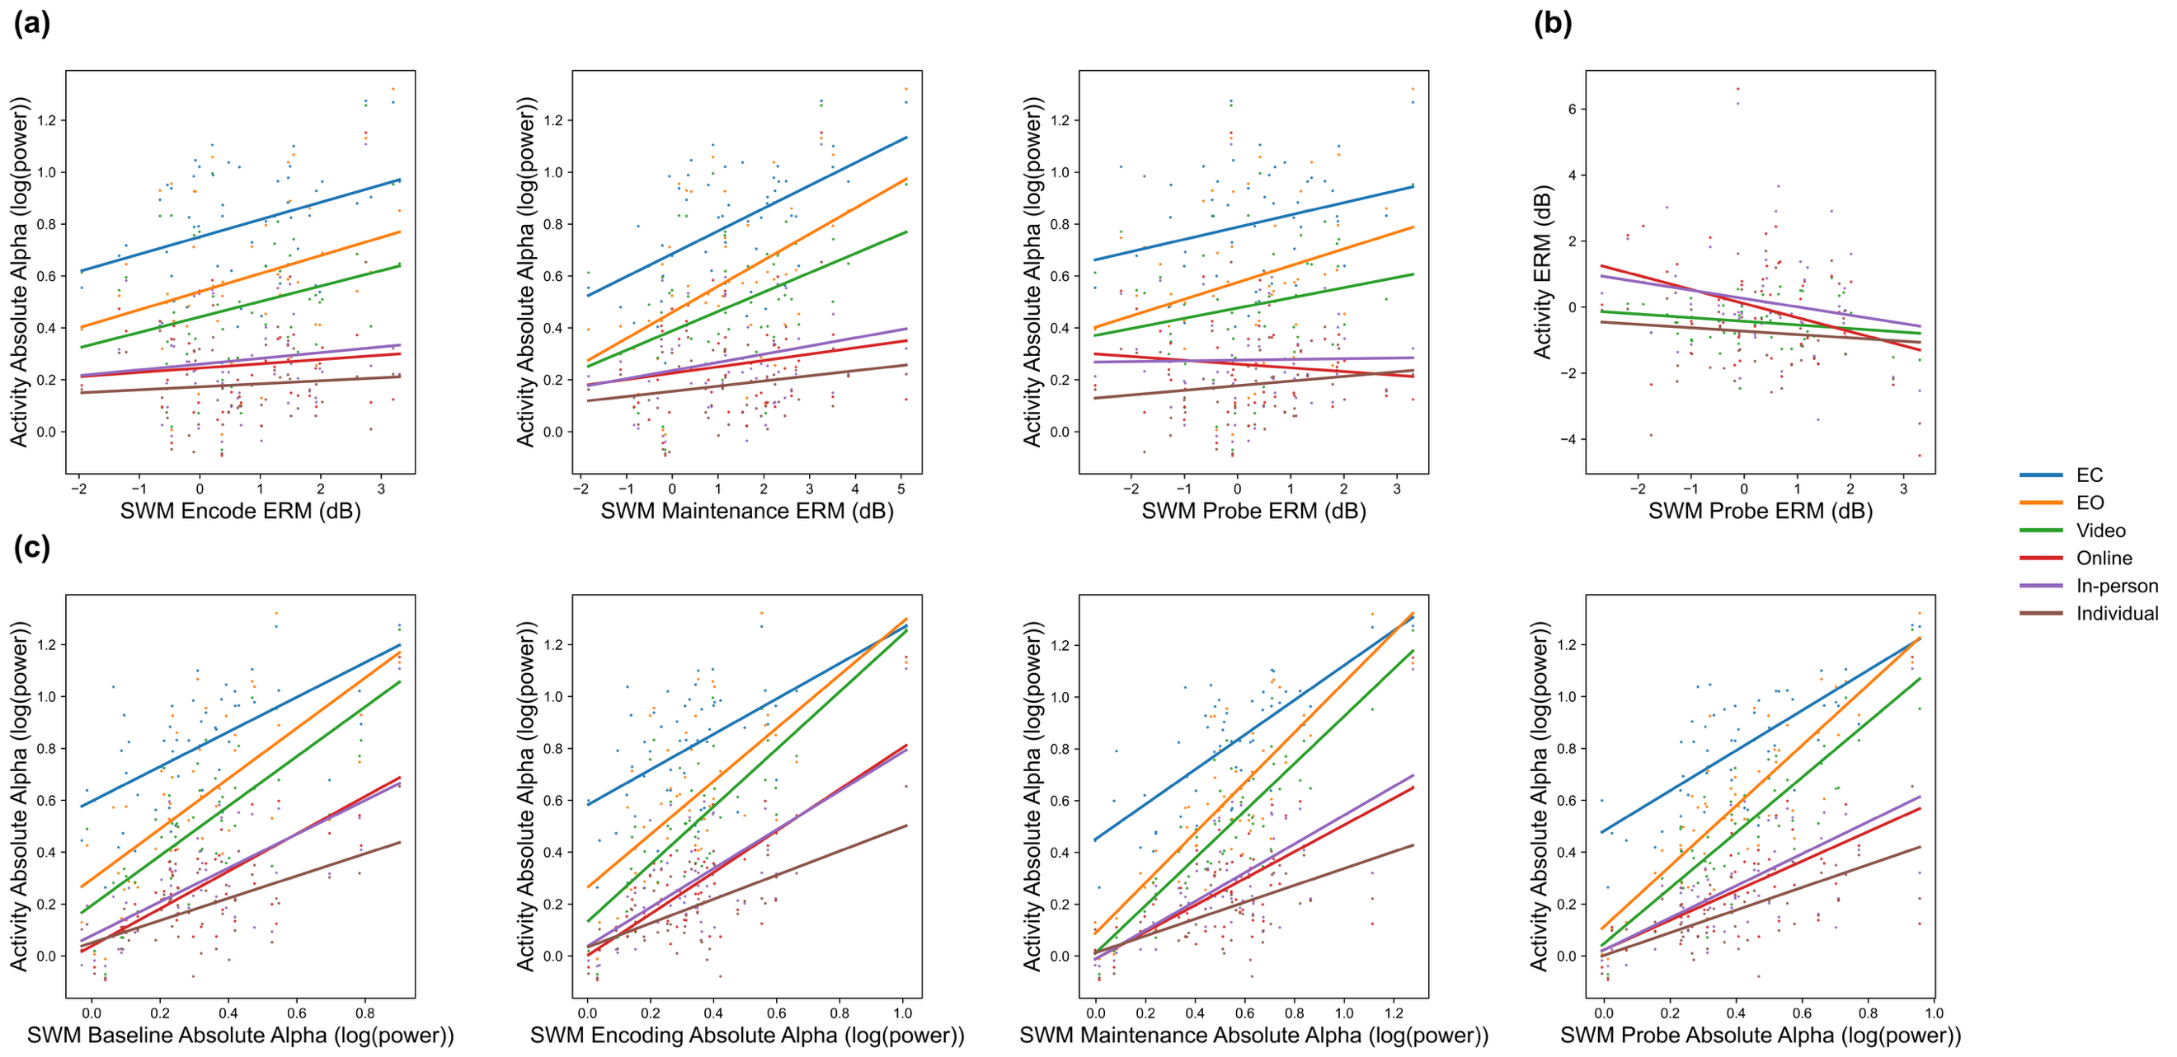
Figure S2. Associations between alpha power during SWM task measures and learning activities in C3, C4, and Cz. Top Row: (a) No correlations were observed between alpha ERM in stimulus processing phases of the SWM task (encoding, probe) and absolute alpha power during learning activities (video, online, in-person, individual). Similarly, (b) correlations were not significant for EO-normalized ERM during activities relative to the SWM ERMs (probe shown, c.f., supplemental materials for full results), suggesting that the absence of correlations in (a) is not due to differences in measure derivation. Bottom Row: In contrast, (c) positive correlations were observed between absolute (non-ERM) SWM alpha power during each trial phase (baseline, encoding, maintenance, probe) and absolute alpha power during each learning activity. The results suggest that ERMs of alpha power during task capture different processes than modulations during the activities, unlike absolute SWM alpha power. Lines represent ordinary least squares linear fits.

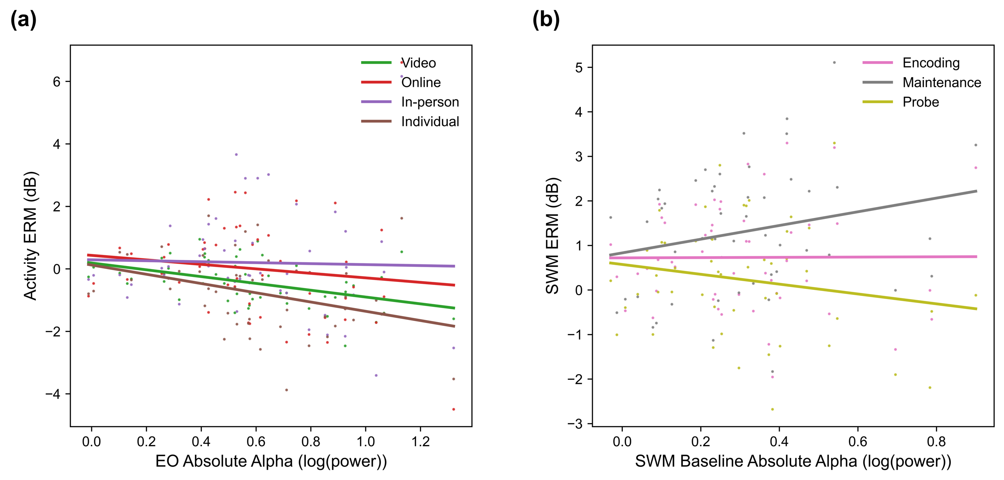
Figure S3. Alpha ERMs versus baseline power in C3, C4, Cz. (a) Associations between alpha power modulation (normalized to eyes-open, EO) during learning activities (video, online, in-person, individual) and reference (i.e., EO) alpha power. (b) Associations between SWM event-related modulation (ERM) and SWM baseline alpha power across task phases (encoding, maintenance, probe). Across lab and activities, greater baseline alpha power is associated with a greater decrease during ERM. Lines represent ordinary least squares linear fits.
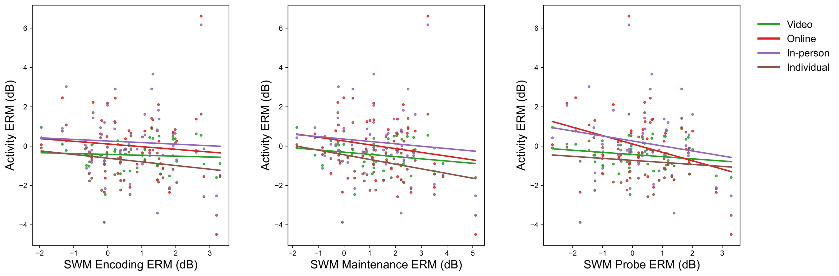
Figure S4. Associations between SWM ERMs and EO-normalized alpha power during learning activities in C3, C4, and Cz. Scatter plots show relationships between SWM ERMs during encoding and maintenance and EO-normalized alpha power across learning activities (video, online, in-person, individual). Consistent with the correlation analyses, significant negative associations were observed between maintenance ERM and activity alpha power across all activities, whereas associations for encoding ERM were not significant. Lines represent ordinary least squares linear fits for each activity.

Alpha power prediction of outcomes: Lab task versus learning activity measures
Table S9. Multiple Regression Models of Behavioral Measures on EEG Source Measures in Laboratory Setting
 | tβ (regression coefficient) |  |  |  |  |  |  |  |  |  |  | Model fit
 | Alpha_{b} | Alpha_{e} | Alpha _{m⊥e} | Alpha_{p⊥e} | ERM_{e} | ERM_{m⊥e} | ERM_{p⊥e} | Age (yr) | Sex | Symptom |  | R²_{adj} | F
Accuracy | -1.656 | 1.250 | 1.213 | 0.761 | -0.482 | -0.758 | -0.736 | 3.431** | -1.687 | 1.577 |  | 0.280 | 2.947**
RTmean | -1.149 | 0.632 | 0.075 | 0.732 | -0.165 | 1.012 | -0.021 | -1.660 | 0.390 | -1.267 |  | 0.096 | 1.533
RTCV | 0.273 | -0.588 | 0.231 | -0.543 | 0.660 | -0.830 | 0.540 | -0.978 | 0.478 | -0.903 |  | -0.041 | 0.804
Attention | 0.246 | 1.766 | 1.274 | -1.117 | 0.611 | -1.601 | 2.249* | 5.292*** | 0.457 | 1.137 |  | 0.442 | 4.960***
Fidgeting | -0.292 | -1.708 | -0.827 | 1.140 | -0.751 | 1.367 | -2.316* | -5.172*** | -0.698 | -0.948 |  | 0.437 | 4.876**
Off-task | 0.082 | -0.609 | -1.690 | 0.200 | 0.281 | 1.113 | -0.343 | -1.660 | 0.635 | -0.861 |  | -0.002 | 0.988
Note. ***p < 0.001, **p < 0.01, *p < 0.05. Alpha = background alpha power; ERM = event-related modulation; b = baseline; e = encoding; m⊥e = maintenance; p⊥e = probe; sex: 1 = male, 2 = female; symptom: 1 = high, 2 = low. RTmean = mean reaction time; RTCV = coefficient of variation of reaction time.
Laboratory Task Measures. We first evaluated if EEG features (absolute alpha power and ERM during encoding, maintenance, and probe) predict either task performance or video-coded behavior in the laboratory SWM task (Table S9). As shown in Table S9 significant relationships to performance and behavior during task were primarily observed for event-related measures. Specifically, more positive alpha ERM during probe predicted higher attention (b_{attention} = 0.526, t(40) = 2.249, p = 0.030) and lower fidgeting (b_{fidgeting} = −0.544, t(40) = −2.316, p = 0.026). This result is difficult to interpret, however, as the overall model fit was not significant when predicting off-task behavior. Note that absolute alpha power measures during each phase was not related to behavioral outcomes. Taken together, it appears that absolute alpha power appears to contribute less consistently to task performance & behavior, than event-related modulation. ERMs show significant associations with task accuracy and video-coded behavior (attention, fidgeting, off-task gaze/verbalizations), which is consistent with ERMs capturing transient cognitive processes related directly to task demands.

Table S10. Multiple Regression Models of Behavioral Measures on EEG Source Measures in Learning Activities
 | tβ (regression coefficient) |  |  |  |  |  |  |  | Model fit
 | Alpha | ERM | Age (yr) | Sex | Symptom |  |  | R²_{adj} |  | F
Video
AE | 0.295 | 0.727 | 0.710 | -0.962 | -1.073 |  |  | -0.033 |  | 0.678
PE | 2.800** | 2.302* | 2.022* | 1.771 | 1.293 |  |  | 0.297 |  | 5.225***
Fidgeting | -2.871** | -2.018 | -1.907 | -2.326* | -0.972 |  |  | 0.295 |  | 5.194***
Off-task | -0.358 | -1.549 | -0.916 | 1.226 | -0.750 |  |  | 0.017 |  | 1.177
Online
AE | -0.503 | -0.747 | 0.375 | -1.413 | 0.304 |  |  | 0.005 |  | 1.050
PE | 1.770 | 1.839 | 3.668*** | -0.606 | 1.474 |  |  | 0.465 |  | 9.692***
Fidgeting | -1.632 | -1.305 | -2.985** | 1.054 | -1.423 |  |  | 0.369 |  | 6.835***
Off-task | 0.426 | -0.577 | -3.338*** | 1.660 | -1.069 |  |  | 0.186 |  | 3.290*
In-person
AE | -0.435 | 0.087 | -0.050 | -0.106 | -0.559 |  |  | -0.082 |  | 0.239
PE | 1.417 | 1.599 | 3.607*** | 0.033 | 1.545 |  |  | 0.398 |  | 7.615***
Fidgeting | -0.662 | -1.674 | -2.261* | 0.217 | -1.077 |  |  | 0.237 |  | 4.114**
Off-task | -0.919 | 0.159 | -2.618* | -0.557 | -0.308 |  |  | 0.062 |  | 1.666
Individual
AE | 0.121 | -1.133 | 0.072 | 0.201 | 1.939 |  |  | -0.004 |  | 0.960
PE | 1.441 | 1.133 | 0.908 | 1.071 | 0.204 |  |  | 0.059 |  | 1.626
Fidgeting | -0.161 | -0.763 | -0.382 | -0.213 | -1.764 |  |  | 0.003 |  | 1.029
Off-task | -2.191* | 1.276 | -1.041 | -1.719 | -1.872 |  |  | 0.136 |  | 2.569*
Note. ***p < 0.001, **p < 0.01, *p < 0.05. Alpha = background alpha power; ERM = event-related modulation; sex: 1 = male, 2 = female; symptom: 1 = high, 2 = low; AE = active engagement; PE = passive engagement.
Finally, it is notable and consistent with expectation that across models, older age predicted higher accuracy (b_{accuracy} = 0.513, t(40) = 3.431, p < 0.001), higher attention (b_{attention} = 0.697, t(40) = 5.292, p < 0.001), and lower fidgeting (b_{fidgeting} = −0.684, t(40) = −5.172, p < 0.001).

Learning Activity Measures. We next examined whether similar EEG–behavior relationships were observed during naturalistic learning activities (Table S10). As shown in Table S10, greater background alpha power was associated with higher levels of attention, as indexed by active and passive engagement, during video watching (b_{PE} = 0.279, t(45)_{PE} = 2.302, p_{PE} = 0.026). In addition, greater background alpha power was associated with lower levels of fidgeting during video watching (b = -0.347, t(45) = -2.817, p = 0.006) and off-task behavior during individual activity (b = -0.350, t(45) = -2.191, p = 0.034).
Finally, echoing the lab task models, age showed significant associations with behavioral outcomes, with older age predicting higher passive engagement during video watching (b = 0.336, t(45) = 2.022, p = 0.008), online (b = 0.336, t(45) = 3.668, p = 0.008), and in-person (b = 0.312, t(45) = 3.607, p = 0.011), lower fidgeting during online (b = -0.288, t(45) = -2.261, p = 0.023), and lower off-task behavior during online (b = -0.442, t(45) = -3.338, p < 0.001) and in-person (b = -0.326, t(45) = -2.618, p = 0.025) activities.
Neurocognitive Measures. Finally, we examined whether EEG-extracted features in either setting predicted academic performance and caregiver-reported neurocognitive functioning scores. For alpha power derived during the laboratory task, stronger encoding alpha ERM (b = 0.242, t(40) = 2.202, p = 0.034) predicted higher scores in WJ-IV PC (Table S11). In contrast, regression models predicting caregiver-reported survey measures were not significant, not significant for either lab task– or learning activity–derived alpha measures. Additionally, we note that age was a robust predictor of academic achievement, with older age associated with higher WJ-IV performance across models (Table S12) (b > 0.75, t(45) > 8.02, all p < 0.001). As such, alpha power showed sparse associations with individual differences in academic achievement and neurocognitive functioning scores.
Table S11. Multiple Regression Models of Academic Performance and Caregiver-Reported Symptoms on EEG Source Measures in the Laboratory Setting
 | tβ (regression coefficient) |  |  |  |  |  |  |  |  |  |  | Model fit
 | Alpha_{b} | Alpha_{e} | Alpha_{m⊥e} | Alpha_{p⊥e} | ERM_{e} | ERM_{m⊥e} | ERM_{p⊥e} | Age (yr) | Sex | Symptom |  | R²_{adj} | F
WJ-IV PC | -0.235 | 0.817 | 1.877 | -1.264 | 2.202* | -1.536 | 0.432 | 7.951*** | 0.292 | 0.932 |  | 0.677 | 11.504***
PC1 (Rule Breaking) | -0.136 | -0.398 | -0.471 | 0.427 | -0.629 | 0.001 | -0.307 | -0.086 | -0.917 | n/a |  | -0.114 | 0.430
PC2  (Attention) | 0.992 | -1.132 | -1.696 | 0.664 | -0.532 | 0.315 | 0.627 | 1.197 | -1.285 | n/a |  | 0.100 | 1.618
PC3  (Anxiety) | -0.088 | -0.135 | -0.141 | -0.431 | -0.149 | 0.454 | 0.500 | 0.609 | -1.279 | n/a |  | -0.092 | 0.533
PC4 (Somatic Complaints) | -1.627 | 0.921 | 0.798 | 0.171 | -1.220 | 0.383 | 0.544 | 0.481 | -0.651 | n/a |  | 0.040 | 1.230
Note. ***p < .001, **p < .01, *p < .05. Alpha = background alpha power; ERM = event-related modulation; b = baseline; e = encoding; m⊥e = maintenance; p⊥e = probe; sex: 1 = male, 2 = female; symptom: 1 = high, 2 = low. PC denotes components derived from factor analysis. WJ-IV PC = Woodcock–Johnson IV component; Survey PC1 = rule breaking, PC2 = attention symptoms, PC3 = anxiety, PC4 = somatic complaints.
Table S12. Multiple Regression Models of Academic Performance and Caregiver-Reported Symptoms on EEG Source Measures in Learning Activities
 | tβ (regression coefficient) |  |  |  |  |  |  |  | Model fit
 | Alpha | ERM | Age (yr) | Sex | Symptom |  |  | R²_{adj} |  | F
Video
WJ-IV PC | 0.001 | 0.643 | 8.259*** | -0.359 | 1.320 |  |  | 0.577 |  | 14.637***
PC1 (Rule Breaking) | -0.410 | -0.221 | -0.242 | -0.873 | n/a |  |  | -0.061 |  | 0.277
PC2  (Attention) | -0.555 | 0.028 | 0.757 | -1.426 | n/a |  |  | -0.017 |  | 0.790
PC3  (Anxiety) | -0.038 | 0.370 | 0.755 | -1.460 | n/a |  |  | -0.021 |  | 0.744
PC4 (Somatic Complaints) | -0.286 | 0.211 | -0.037 | -0.623 | n/a |  |  | -0.075 |  | 0.123
Online
WJ-IV PC | -0.353 | -0.052 | 8.326*** | -0.344 | 1.441 |  |  | 0.576 |  | 14.605***
PC1 (Rule Breaking) | -0.387 | -0.393 | -0.267 | -0.956 | n/a |  |  | -0.037 |  | 0.552
PC2  (Attention) | -0.602 | -0.134 | 0.754 | -1.500 | n/a |  |  | 0.003 |  | 1.038
PC3  (Anxiety) | -0.277 | -0.202 | 0.789 | -1.472 | n/a |  |  | -0.013 |  | 0.841
PC4 (Somatic Complaints) | -0.020 | -0.710 | -0.564 | -0.683 | n/a |  |  | -0.004 |  | 0.953
In-person
WJ-IV PC | -0.293 | 0.034 | 8.299*** | -0.333 | 1.386 |  |  | 0.575 |  | 14.509***
PC1 (Rule Breaking) | -0.293 | -0.634 | -0.297 | -0.974 | n/a |  |  | -0.022 |  | 0.725
PC2  (Attention) | -0.526 | -0.437 | 0.735 | -1.530 | n/a |  |  | 0.022 |  | 1.276
PC3  (Anxiety) | -0.217 | -0.303 | 0.774 | -1.477 | n/a |  |  | -0.010 |  | 0.874
PC4 (Somatic Complaints) | -0.341 | -0.060 | -0.039 | -0.635 | n/a |  |  | -0.073 |  | 0.153
Individual
WJ-IV PC | -0.585 | -0.254 | 8.026*** | -0.386 | 1.508 |  |  | 0.580 |  | 14.797***
PC1 (Rule Breaking) | -0.597 | -0.360 | -0.459 | -0.978 | n/a |  |  | -0.045 |  | 0.457
PC2  (Attention) | -0.617 | 0.115 | 0.633 | -1.481 | n/a |  |  | -0.014 |  | 0.823
PC3  (Anxiety) | 0.040 | 0.488 | 0.878 | -1.400 | n/a |  |  | -0.016 |  | 0.801
PC4 (Somatic Complaints) | -0.364 | 0.176 | -0.604 | -0.632 | n/a |  |  | -0.075 |  | 0.129
Note. ***p < 0.001, **p < 0.01, *p < 0.05. Alpha = background alpha power; ERM = event-related modulation; sex: 1 = male, 2 = female; symptom: 1 = high, 2 = low; PC denotes components derived from factor analysis. WJ-IV PC = Woodcock–Johnson IV component; Survey PC1 = rule breaking, PC2 = attention symptoms, PC3 = anxiety, PC4 = somatic complaints.

