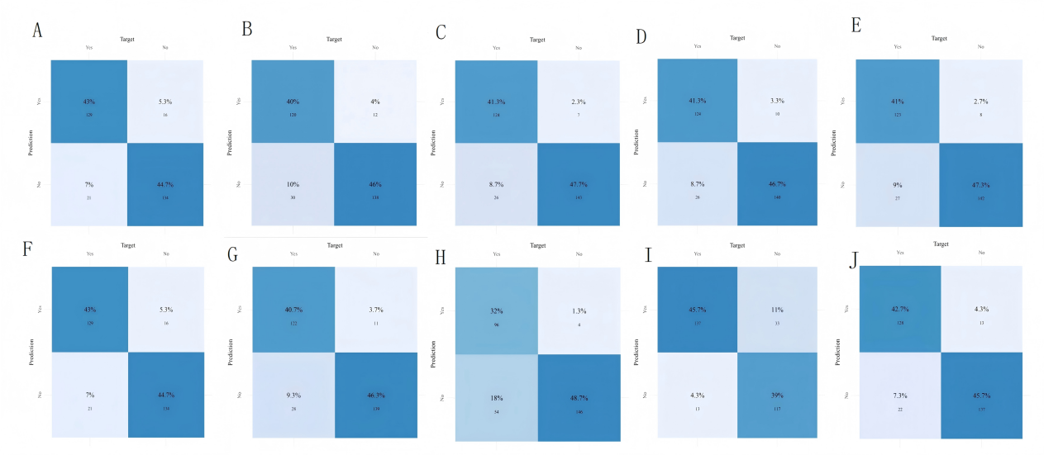
Supplementary Figure S2. Confusion matrices for all ten candidate machine-learning models evaluated in this study.（A.Logistic;B.SVM;C.GBM;D.NN;E.RF;F.XGboost;G.KNN;H.Adaboost;I.LightGBM;J.Catboost）

