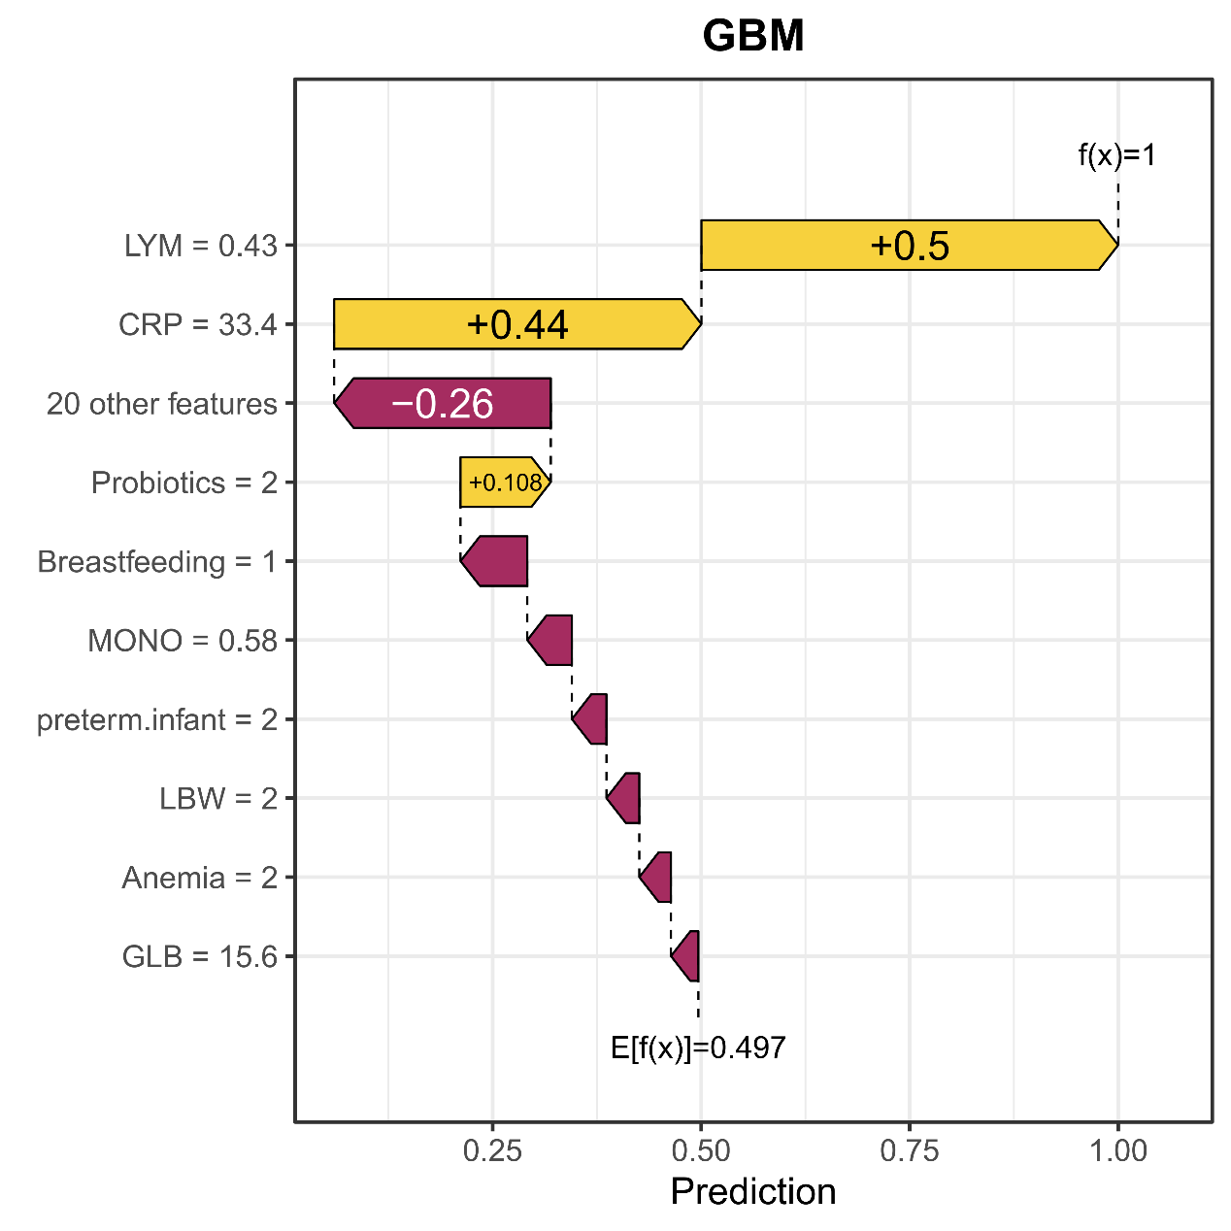
Supplementary Figure S1. Individual SHAP waterfall plot illustrating the local decomposition of model prediction for a representative NEC case.

