Supplementary material
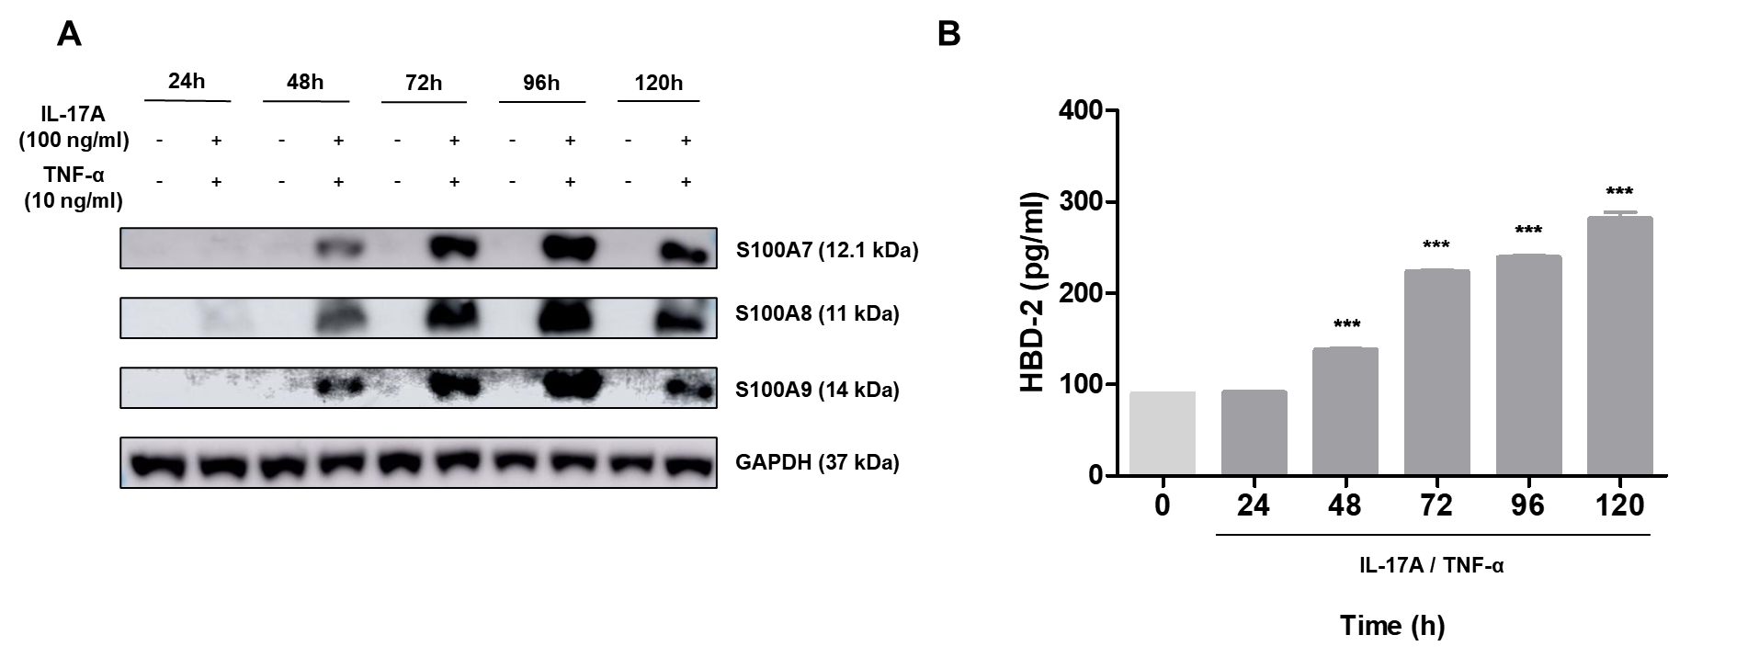
Supplementary Figure 1. Establishment of an IL-17A/TNF-α–induced psoriasis-like inflammation model in NHEKs.
Keratinocytes were stimulated with 100 ng/mL IL-17A and 10 ng/mL TNF-α for 24–120 h. (A) Protein expression of psoriasis markers (S100A7, S100A8, and S100A9) was determined by western blotting. (B) HBD-2 secretion was measured using an ELISA kit. Data are expressed as mean ± SD (n = 3). Statistical significance was determined relative to the untreated control (*** p < 0.01).
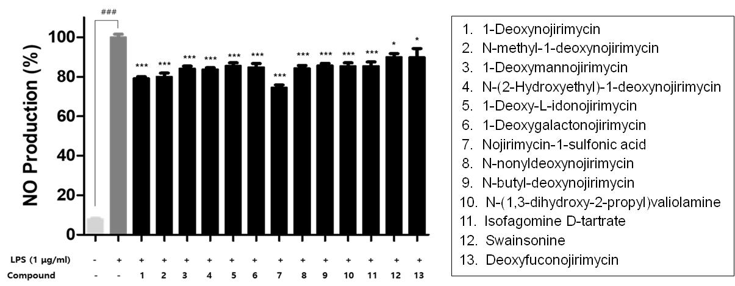
Supplementary Figure 2. Effect of DNJ derivatives on NO production in LPS-stimulated RAW264.7 cells.
The cells were pretreated with DNJ derivatives at equal concentrations of 25 μM for 1 h and then stimulated for 24 h with or without 1 μg/mL LPS. NO levels were measured using a Griess assay. Data are expressed as mean ± SD (n = 3). Compared with the untreated control group, ### p < 0.001 was considered statistically significant, and compared with the LPS-alone-treated group, * p < 0.05 and *** p < 0.01 were considered statistically significant.
The purchase information for each compound used in the experiment is as follows: 1-deoxynojirimycin, nojirimycin-1-sulfonic acid, and N-(1,3-dihydroxy-2-propyl)valiolamine (Sigma-Aldrich); N-methyl-1-deoxynojirimycin (AdipoGen Life Sciences); 1-deoxymannojirimycin, N-(2-hydroxyethyl)-1-deoxynojirimycin, 1-deoxy-l-idonojirimycin, isofagomine d-tartrate, and deoxyfuconojirimycin (Santa Cruz Biotechnology); 1-deoxygalactonojirimycin (Cayman Chemical); N-nonyldeoxynojirimycin, N-butyl-deoxynojirimycin, and Swainsonine (Tocris Bioscience).
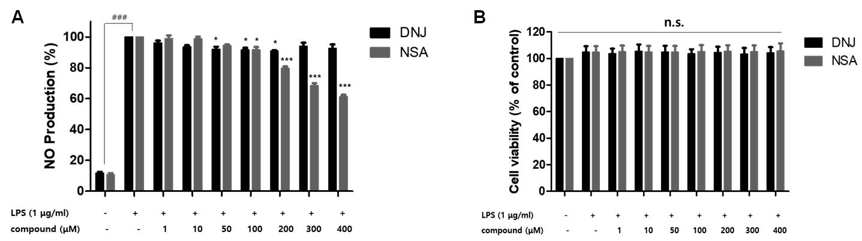

Supplementary Figure 3. Effects of DNJ and NSA on NO production in LPS-stimulated RAW 264.7 cells.
The cells were pretreated with various concentrations (1, 10, 50, 100, 200, 300, and 400 μM) of DNJ and NSA for 1 h, followed by stimulation with 1 μg/mL LPS for 24 h. (A) NO level was measured using the Griess assay, and (B) cell cytotoxicity was evaluated using the Ez-cytox kit. Data are expressed as mean ± SD (n = 3). ### p < 0.001 indicates statistical significance compared with the untreated control group, and * p < 0.05 and *** p < 0.001 indicate statistical significance compared with the LPS-alone-treated group. n.s. not significant.

