Posterior Results of Bayesian Logistic Regression (Posterior distribution statistics and odds ratios (95% credible intervals))
Variable | Posterior Median (95% CrI) | aOR (95% CrI)
Age | 0.59 (-0.38, 1.54) | 1.80 (0.69, 4.68)
Disease duration | 0.12 (-0.76, 1.11) | 1.12 (0.47-3.02)
Disease activity and damage
ESSDAl | -0.18 (-1.01, 0.57) | 0.84 (0.37, 1.77)
Serological abnormality
anti-SSB | 0.14 (-0.74, 1.01) | 1.15 (0.48, 2.76)
IgG | 0.61 (-0.23, 1.48) | 1.84 (0.79, 4.37)
C3 | -0.08 (-0.95, 0.78) | 0.92 (0.39, 2.19)
C4 | 0.51 (-0.34, 1.36) | 1.66 (0.71, 3.91)
SII | 0.91 (0.01, 1.93) | 2.50 (1.01, 6.88)
Neuropsychological tests
FS-14 | 1.13 (0.19, 2.17) | 3.10 (1.21, 8.75)
Imaging indicators
CP/eTIV | 1.21 (0.24, 2.29) | 3.37 (1.27, 9.91)
Fazekas.L | -0.31 (-2.10, 1.47) | 0.73 (0.12, 4.36)
Fazekas.Q | -0.16 (-1.82, 1.51) | 0.85 (0.16, 4.51)
Fazekas.C | -0.47 (-2.01, 1.09) | 0.62 (0.13, 2.99)
Fazekas^4 | -0.31 (-1.80, 1.16) | 0.73 (0.17, 3.18)
Fazekas^5 | 0.22 (-1.22, 1.68) | 1.25 (0.29, 5.38)
Fazekas^6 | -0.31 (-1.64, 1.04) | 0.73 (0.19, 2.84)
PVS.L | -0.69 (-2.15, 0.81) | 0.50 (0.12, 2.24)
PVS.Q | 0.49 (-0.73, 1.75) | 1.63 (0.48, 5.73)

Supplement Table 1
CrI: credible interval; aOR: adjusted odds ratio; ESSDAI: EULAR Sjögren’s Syndrome Disease Activity Index; anti-SSB: anti-SSB antibody; SII: systemic immune-inflammation index; FS-14: Fatigue scale-14; CP: choroid plexus; eTIV: estimated total intracranial volume; PVS: perivascular spaces.

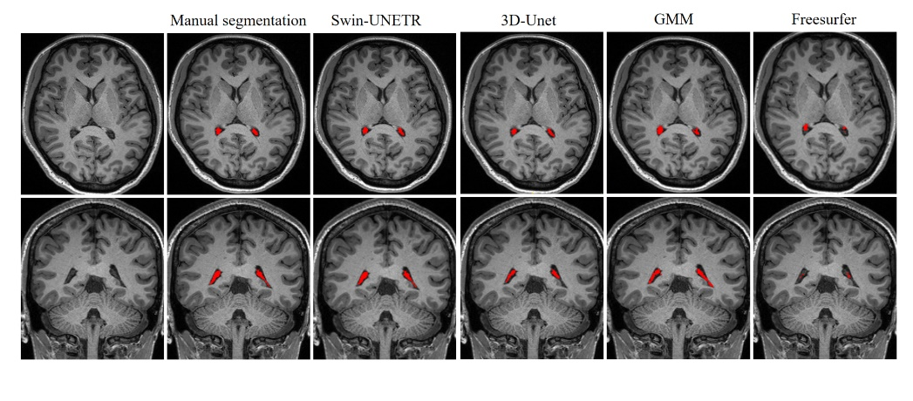
Supplement Figure 1
An example illustrating the differences among the segmentation methods for the CP.
GMM: Gaussian mixture model.

