Evaluating the relationship between dermatoglyphics and mandibular third molar impaction: a cross-sectional study

FINGERPRINT PATTERN
Appendix Figure 1: WHORL PATTERN
1A: PLAIN WHORL
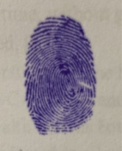
1B: CENTRAL POCKET WHORL
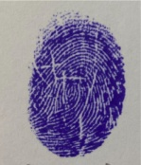
1C: DOUBLE LOOP WHORL
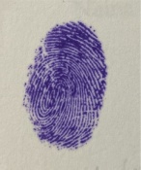
1D: IRREGULAR WHORL
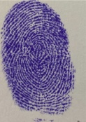
Appendix Figure 2: LOOP PATTERN
2A: LOOP RADIAL
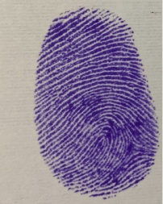
2B:LOOP ULNAR
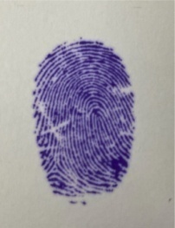
Appendix Figure 3: ARCH PATTERN
3A: PLAIN ARCH
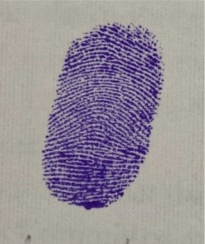
3B:TENTED ARCH
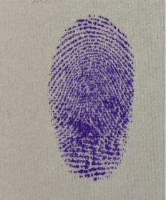

INFORMED CONSENT & STUDY PROFORMA SHEET
CONTROL GROUP:
Appendix Figure 4: Signed informed consent of Control Subject 1 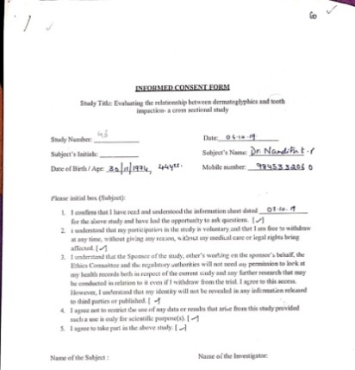

Appendix Figure 5:Study proforma sheet of Control Subject 1
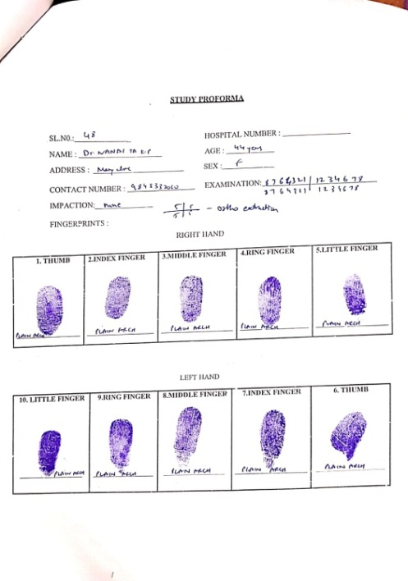
Appendix Figure 6: Signed informed consent of Control Subject 2 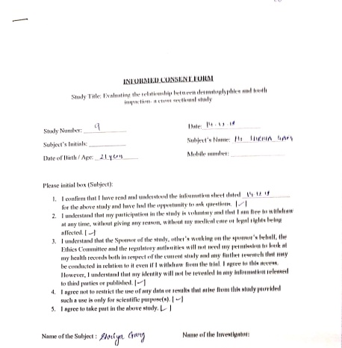

Appendix Figure 7:Study proforma sheet of Control Subject 2
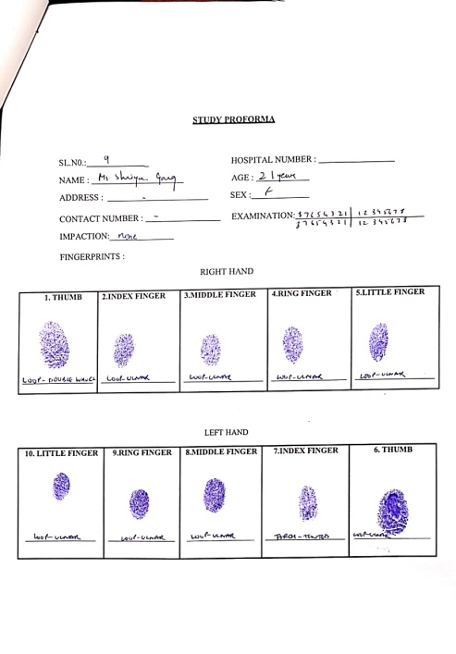

Appendix Figure 8: Signed informed consent of Control Subject 3 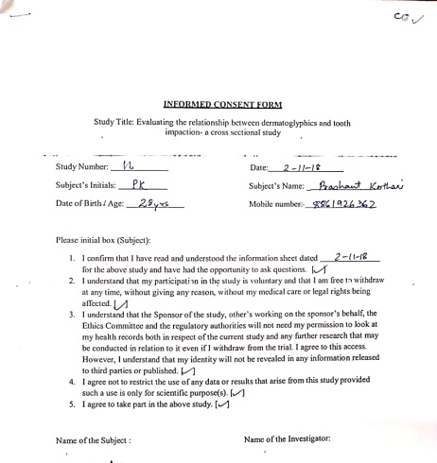

Appendix Figure 9:Study proforma sheet of Control Subject 3

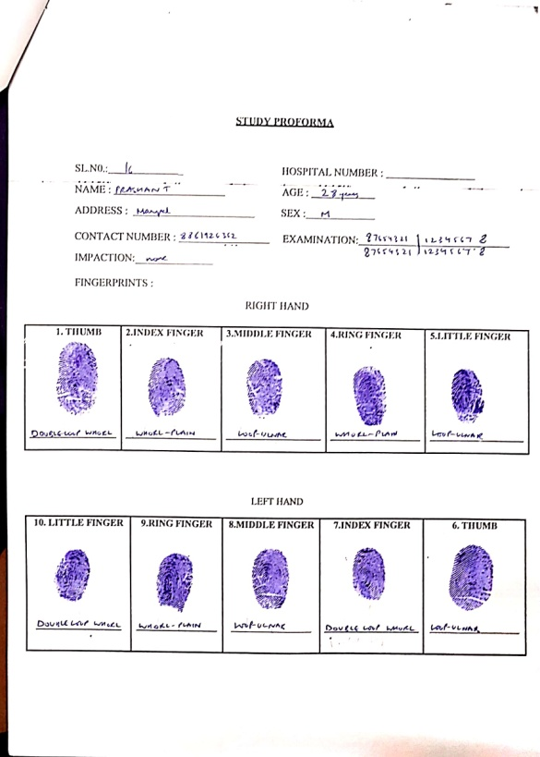

Appendix Figure 10: Signed informed consent of Control Subject 4
: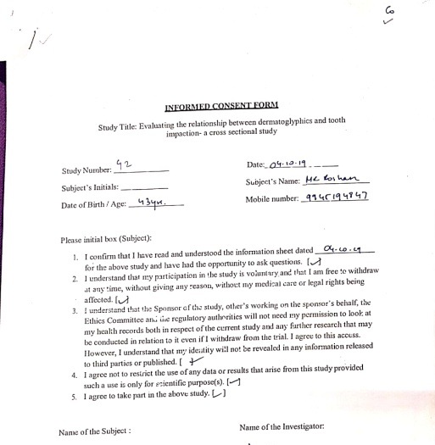
Appendix Figure 11 :Study proforma sheet of Control Subject 4

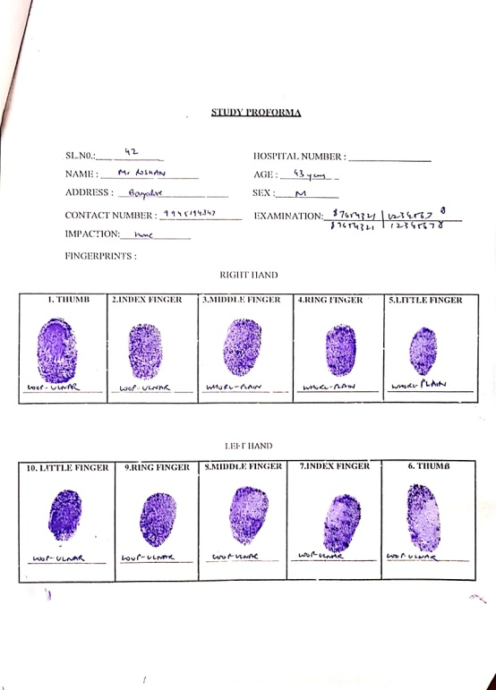

Appendix Figure 12: Signed informed consent of Control Subject 5
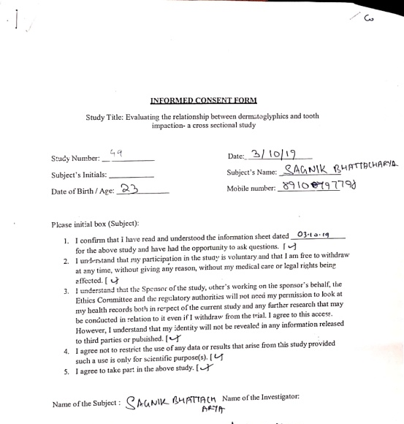
Appendix Figure 13 :Study proforma sheet of Control Subject 5

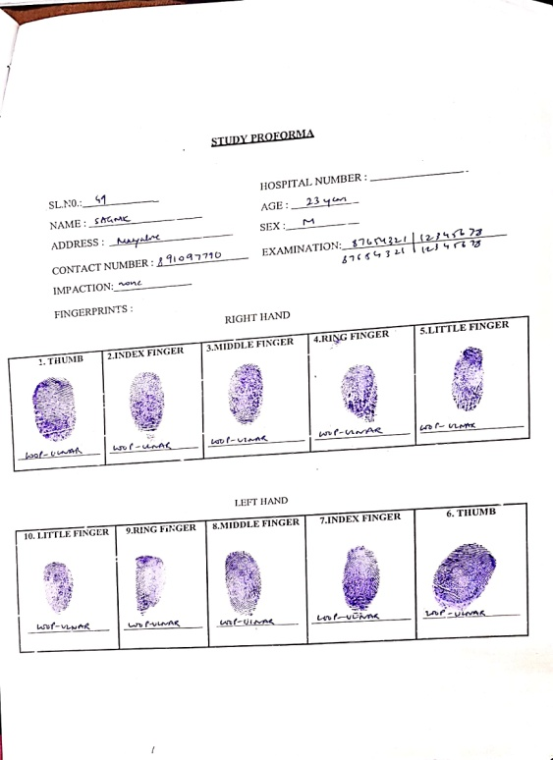

CASE GROUP:
Appendix Figure 14: Signed informed consent of Case Subject 1
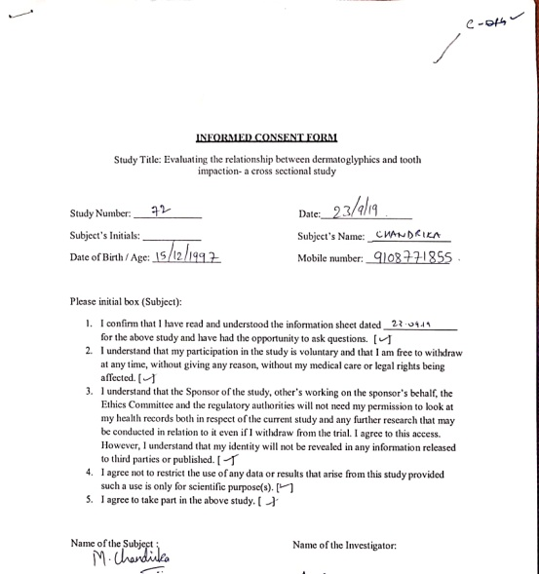
Appendix Figure 15 :Study proforma sheet of Case Subject 1
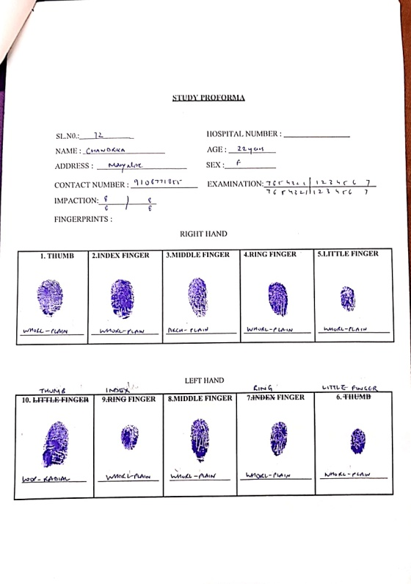

Appendix Figure 16: Signed informed consent of Case Subject 2
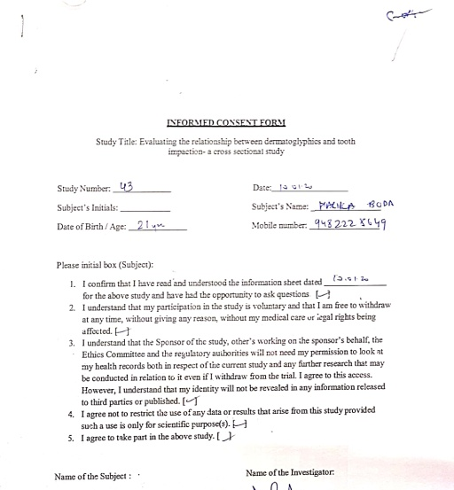
Appendix Figure 17 :Study proforma sheet of Case Subject 2

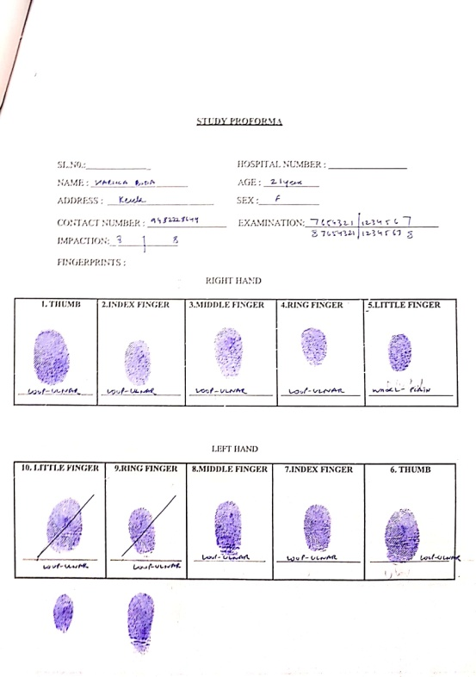

Appendix Figure 18: Signed informed consent of Case Subject 3
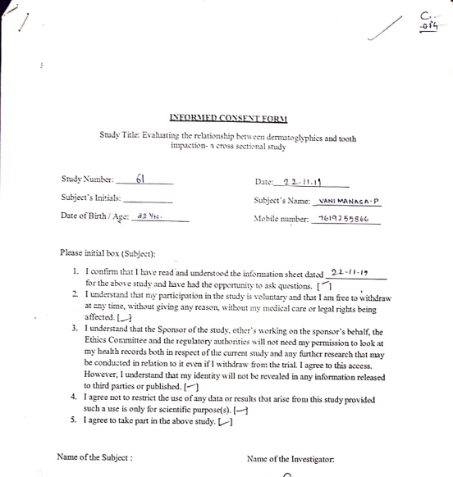
Appendix Figure 19:Study proforma sheet of Case Subject 3

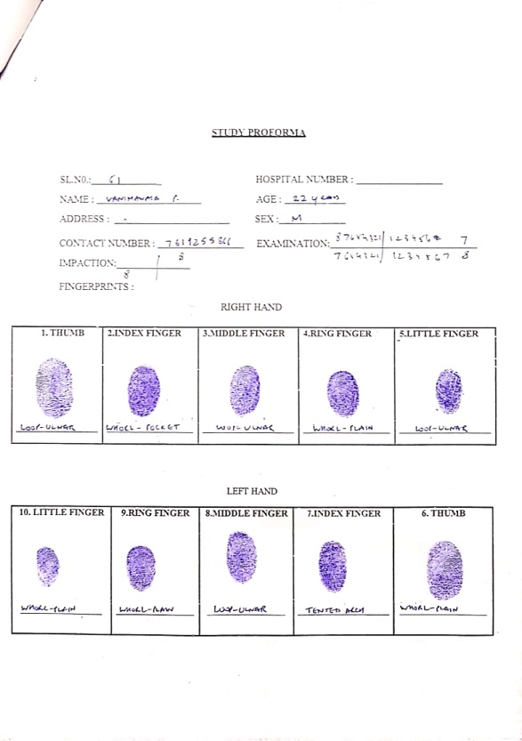
Appendix Figure 20: Signed informed consent of Case Subject 4
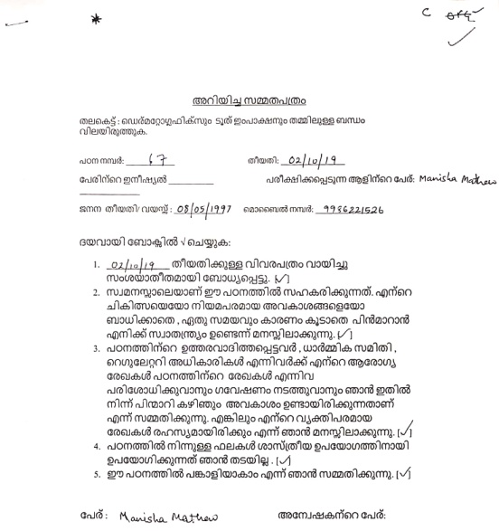
Appendix Figure 21 :Study proforma sheet of Case Subject 4

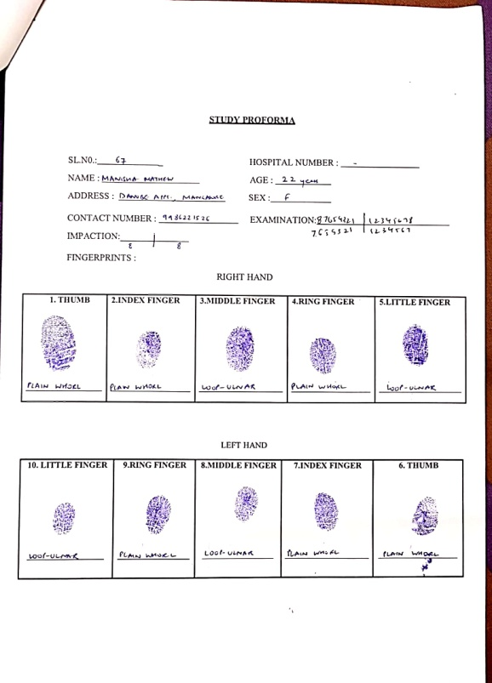

Appendix Figure 22: Signed informed consent of Case Subject 5
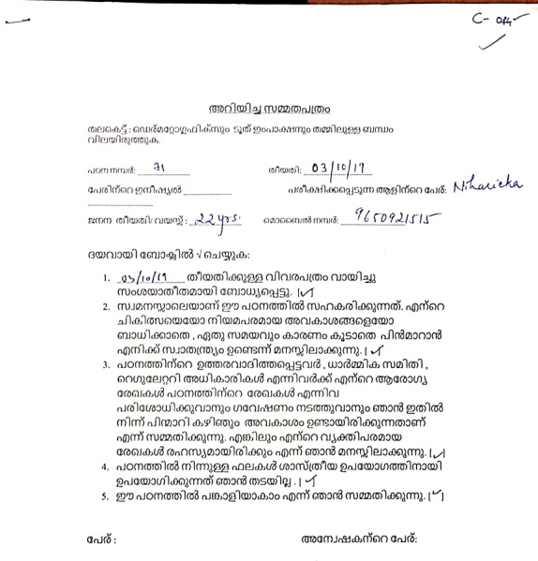
Appendix Figure 23 :Study proforma sheet of Case Subject 5

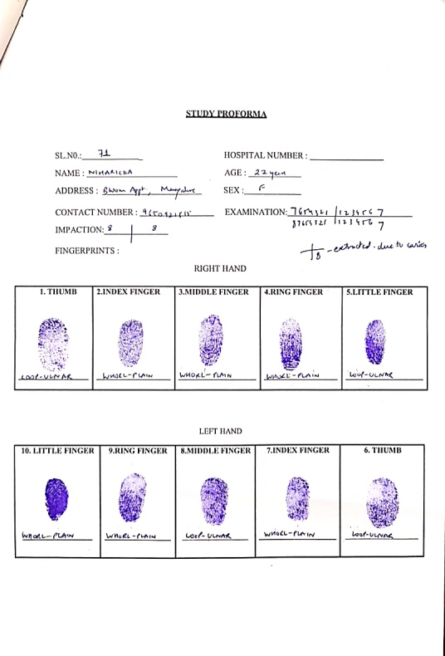

PATIENT INFORMATION SHEET
Appendix Figure 24: PATIENT INFORMATION SHEET IN KANNADA
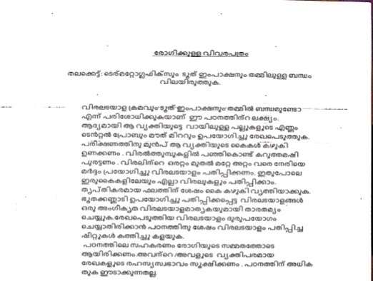
Appendix Figure 25: PATIENT INFORMATION SHEET IN MALAYALAM

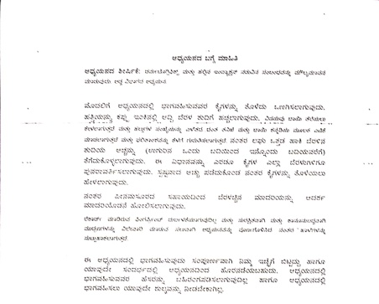

Appendix Figure 26: PATIENT INFORMATION SHEET IN ENGLISH

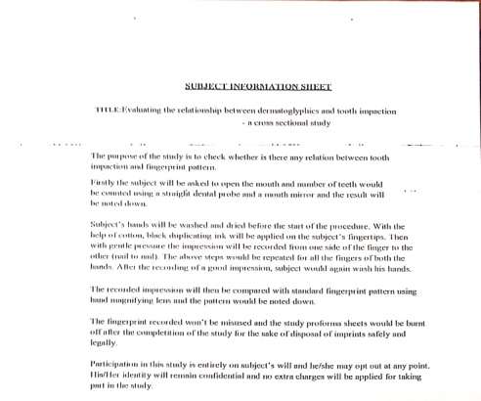

OPG X-RAY
Appendix Figure 27: OPG X-RAY OF CASE SUBJECT 1
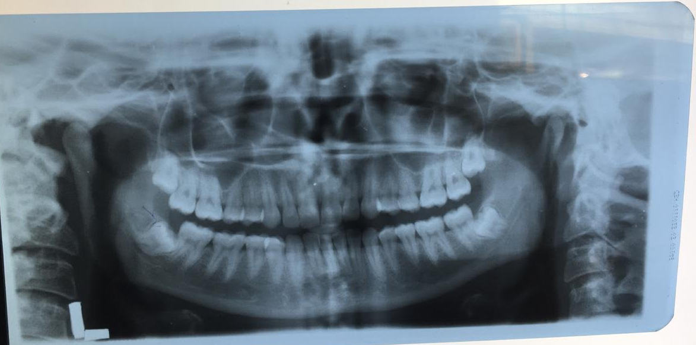

Appendix Figure 28: OPG X-RAY OF CASE SUBJECT 2
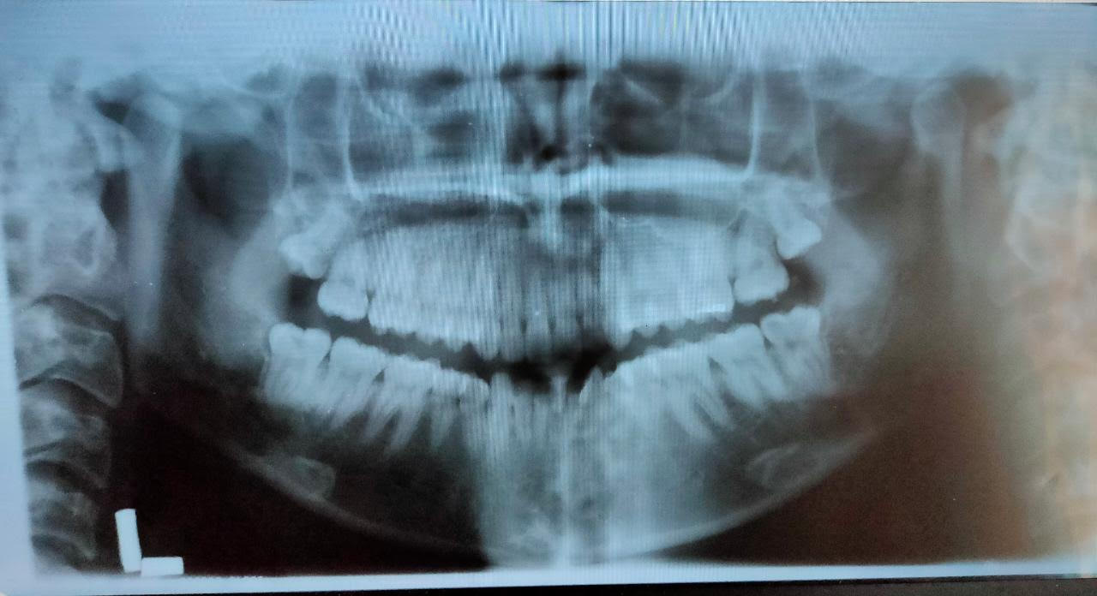

Appendix Figure 29: OPG X-RAY OF CASE SUBJECT 3
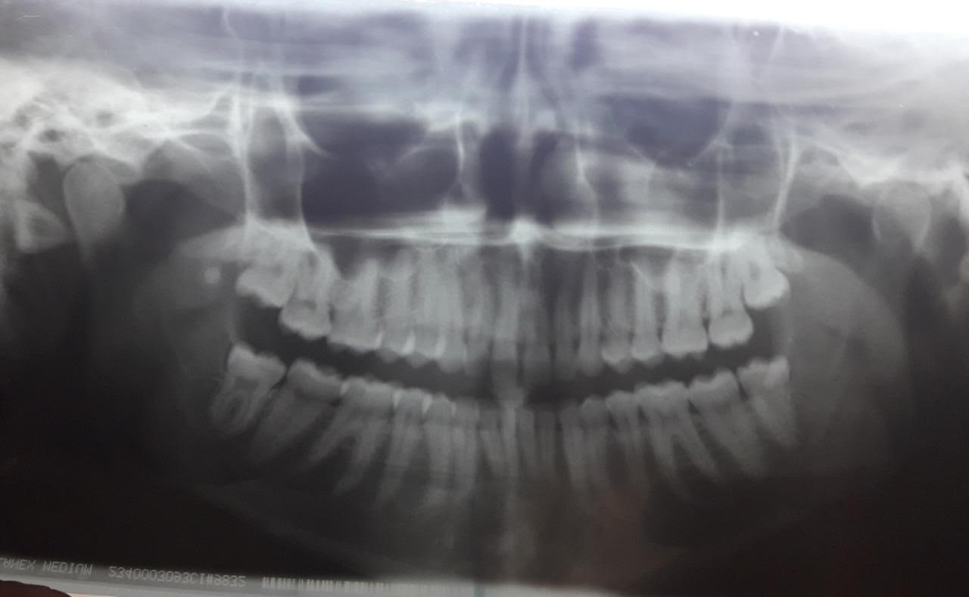

Appendix Figure 30: OPG X-RAY OF CASE SUBJECT 4
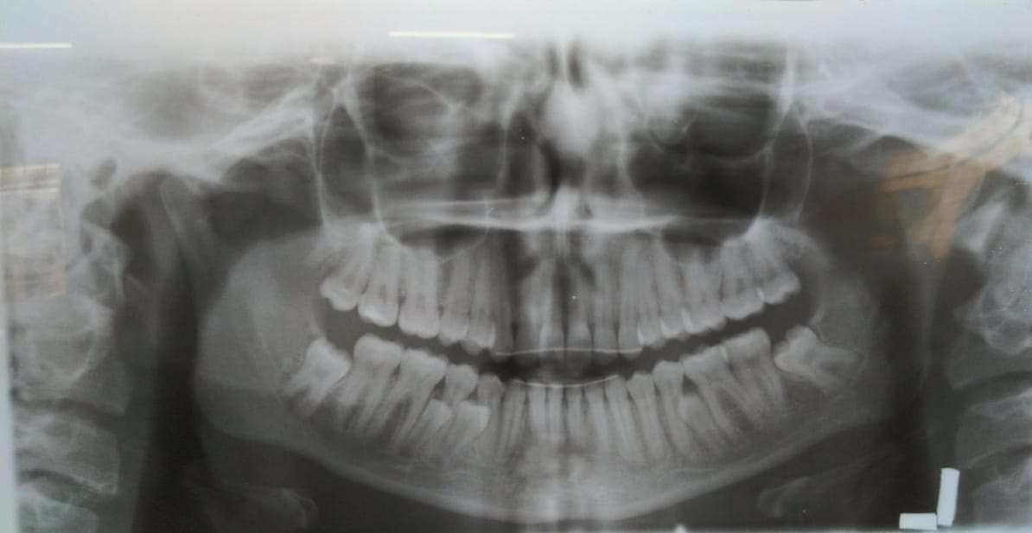
Appendix Figure 31: OPG X-RAY OF CASE SUBJECT 5
