Supplementary information for “Improving maize self-sufficiency in Northern Latin America to reduce imports and land clearing”

Supplementary Figures
Supplementary Figure 1. …………………………………………………………………… 2

Supplementary Tables
Supplementary Table 1. ……………………………………………………………………. 3
Supplementary Table 2. ……………………………………………………………………. 4
Supplementary Table 3. ……………………………………………………………………. 5
Supplementary Table 4. ……………………………………………………………………. 6
Supplementary Table 5. ……………………………………………………………………. 7
Supplementary Table 6. ……………………………………………………………………. 8
Supplementary Table 7. ……………………………………………………………………. 9
References …………………………………………………………………………………. 10
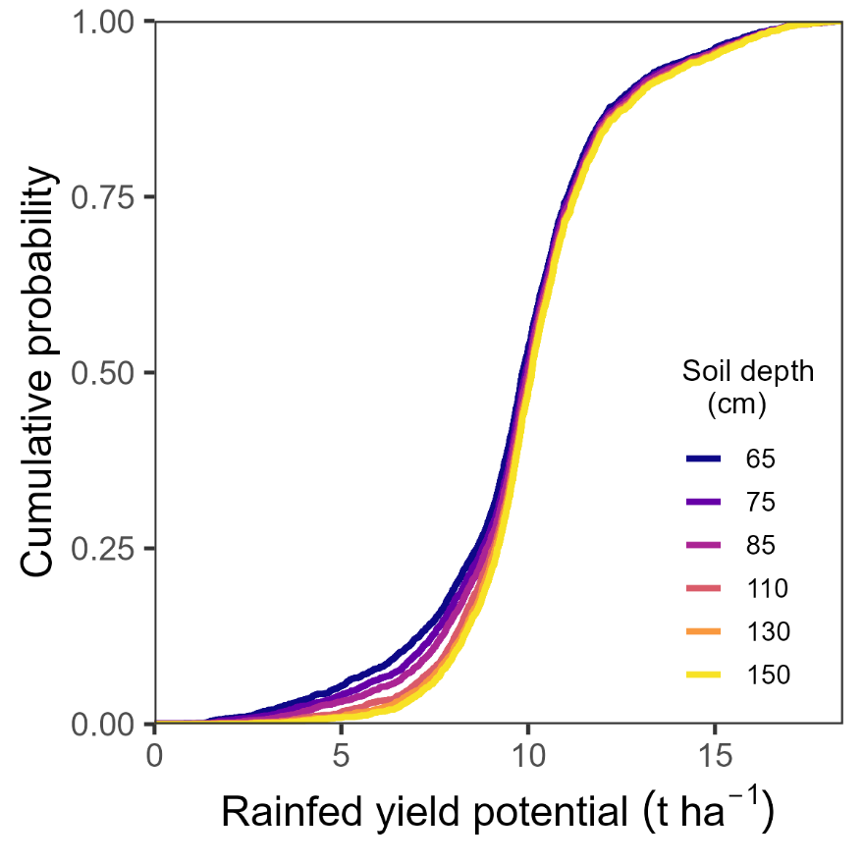
Supplementary Fig. 1. Sensitivity analysis of rainfed yield potential to maximum rootable soil depth of tropical soils. Cumulative distribution functions of rainfed yield potential across Northern Latin America for 6 values of maximum rootable soil depth. Each line includes 2554 yield observations that results from a combination of 35 sites, 68 soil types (up to three per site), 22 years, and up to two crop cycles per year. Rainfed yield potential was estimated with a locally calibrated crop simulation model and local weather, soil, and crop calendar data.

Supplementary Table 1. Baseline (2020) and future (2050) population (million), per-capita maize demand (kg), and total national demand per year (Mt) in Northern Latin America. Current (2020) and future (2050) population estimates were derived from United Nations data¹. Current maize demand per capita was determined by dividing total domestic maize consumption based on FAOSTAT food balances by the current population. Future per-capita maize demand was calculated based on current per-capita maize demand and the relative change in per-capita maize demand projected by the IMPACT model (SSP2 scenario)². Total future maize demand was estimated as the product of future per-capita maize demand and population.
Country | Population (million) |  |  | Demand per-capita (kg) |  |  | Total demand (Mt)
Country | 2020 | 2050 |  | 2020 | 2050 |  | 2020 | 2050
Colombia | 50.6 | 59.4 |  | 142 | 166 |  | 7.2 | 9.9
Costa Rica | 5.0 | 5.4 |  | 186 | 290 |  | 0.9 | 1.6
Cuba | 11.2 | 9.4 |  | 102 | 218 |  | 1.1 | 2.0
Dominican Republic | 11.0 | 13.0 |  | 130 | 225 |  | 1.4 | 2.9
Ecuador | 17.5 | 21.3 |  | 83 | 123 |  | 1.5 | 2.6
El Salvador | 6.2 | 6.7 |  | 236 | 366 |  | 1.5 | 2.4
Guatemala | 17.4 | 24.7 |  | 198 | 275 |  | 3.4 | 6.8
Haiti | 11.2 | 14.7 |  | 32 | 38 |  | 0.4 | 0.6
Honduras | 10.1 | 14.8 |  | 130 | 156 |  | 1.3 | 2.3
Mexico | 126.8 | 148.9 |  | 357 | 404 |  | 45.3 | 60.1
Nicaragua | 6.6 | 8.8 |  | 103 | 119 |  | 0.7 | 1.0
Panama | 4.3 | 5.6 |  | 152 | 252 |  | 0.7 | 1.4
Peru | 32.8 | 40.6 |  | 164 | 303 |  | 5.4 | 12.3
Venezuela | 28.4 | 31.1 |  | 109 | 150 |  | 3.1 | 4.6
TOTAL | 339.3 | 404.4 |  | 217.6 | 273.7 |  | 73.8 | 110.7

Supplementary Table 2. Maize harvested area and average farmer yield around 2020 (2018 – 2022 average) and for two scenarios of yield intensification: half and full closure of the exploitable yield gap. In full closure of the exploitable yield gap, average farmer yields reach 80% of the water-limited yield potential of rainfed crops and 80% of the yield potential for irrigated crops. For those cases without yield potential estimates (Nicaragua, Costa Rica, Panama, Cuba, Dominican Republic, Haiti, and Mexico native varieties), we assumed the same relative yield increase as in the rest of the region. See Supplementary Table 7 for sources of current farmer yield and harvested area data
Country |  |  | Harvested area (M ha) | Yield (Mg ha⁻¹)
Country | water regime | seed type | Harvested area (M ha) | Current | 50% closure | Full closure
Colombia |  |  | 0.4 | 3.9 | 5.8 | 7.7
Costa Rica |  |  | 0.01 | 1.9 | 3.0 | 4.1
Cuba |  |  | 0.1 | 2.4 | 3.8 | 5.2
Dominican Republic |  |  | 0.03 | 1.8 | 2.8 | 3.9
Ecuador |  |  | 0.4 | 4.2 | 5.5 | 6.8
El Salvador |  |  | 0.3 | 2.9 | 7.7 | 12.5
Guatemala |  |  | 1.0 | 2.0 | 5.6 | 9.1
Haiti |  |  | 0.3 | 0.8 | 1.2 | 1.6
Honduras |  |  | 0.4 | 1.8 | 6.5 | 11.1
Mexico | rainfed | native | 3.2 | 1.2 | 1.9 | 2.6
 | rainfed | hybrid | 2.2 | 4.4 | 7.0 | 9.6
 | rainfed | total | 5.5 | 2.5 | 4.0 | 5.5
 | irrigated |  | 1.5 | 8.8 | 11.1 | 13.5
 | total |  | 7.0 | 3.9 | 5.6 | 7.2
Nicaragua |  |  | 0.3 | 1.3 | 2.1 | 2.9
Panama |  |  | 0.05 | 2.7 | 4.3 | 5.9
Peru | rainfed |  | 0.3 | 2.1 | 4.6 | 7.1
 | irrigated |  | 0.1 | 7.4 | 11.0 | 14.6
 | total |  | 0.5 | 3.5 | 6.2 | 9.0
Venezuela |  |  | 0.5 | 3.8 | 6.6 | 9.3

Supplementary Table 3. National maize demand, production, and balance (production minus demand) in 2020 and 2050 for three scenarios of yield progress in Northern Latin America. The no yield gain scenario (NYG) assumes same yields as around 2020 (2018 – 2022 average). The full yield gap closure scenario (Full) projects acceleration of yield gain so yields reach the attainable yield by 2050, defined as 80% of the yield potential. The half yield gap closure scenario is the midpoint between the NYC and Full scenarios.
Country | Demand (Mt) |  |  | Production (Mt) |  |  |  |  | Balance (Mt)
Country | 2020 | 2050 |  | 2020 | 2050 |  |  |  | 2020 | 2050
Country | 2020 | 2050 |  | 2020 | NYG | Half | Full |  | 2020 | NYC | Half | Full
Colombia | 7.5 | 9.9 |  | 1.5 | 1.5 | 2.3 | 3.0 |  | -5.9 | -8.4 | -7.6 | -6.9
Costa Rica | 1.0 | 1.6 |  | 0.0 | 0.0 | 0.0 | 0.0 |  | -0.9 | -1.5 | -1.5 | -1.5
Cuba | 0.9 | 2.0 |  | 0.3 | 0.3 | 0.5 | 0.7 |  | -0.9 | -1.7 | -1.5 | -1.3
Dominican Republic | 1.4 | 2.9 |  | 0.1 | 0.1 | 0.1 | 0.1 |  | -1.4 | -2.9 | -2.8 | -2.8
Ecuador | 1.6 | 2.6 |  | 1.5 | 1.5 | 1.9 | 2.4 |  | -0.1 | -1.1 | -0.7 | -0.2
El Salvador | 1.4 | 2.4 |  | 0.8 | 0.8 | 2.0 | 3.3 |  | -0.7 | -1.7 | -0.4 | 0.9
Guatemala | 3.6 | 6.8 |  | 2.0 | 2.0 | 5.5 | 9.1 |  | -1.6 | -4.8 | -1.3 | 2.3
Haiti | 0.3 | 0.6 |  | 0.2 | 0.2 | 0.3 | 0.4 |  | -0.1 | -0.4 | -0.2 | -0.1
Honduras | 1.4 | 2.3 |  | 0.7 | 0.7 | 2.3 | 4.0 |  | -0.8 | -1.7 | 0.0 | 1.7
Mexico | 44.0 | 60.1 |  | 27.2 | 27.2 | 38.8 | 50.5 |  | -16.9 | -33.0 | -21.3 | -9.7
Nicaragua | 0.8 | 1.0 |  | 0.4 | 0.4 | 0.6 | 0.8 |  | -0.4 | -0.7 | -0.4 | -0.2
Panama | 0.7 | 1.4 |  | 0.1 | 0.1 | 0.2 | 0.3 |  | -0.6 | -1.3 | -1.2 | -1.1
Peru | 5.3 | 12.3 |  | 1.6 | 1.6 | 2.8 | 4.0 |  | -3.8 | -10.7 | -9.5 | -8.3
Venezuela | 2.8 | 4.6 |  | 1.8 | 1.8 | 3.0 | 4.2 |  | -1.6 | -2.9 | -1.7 | -0.5
TOTAL | 72.8 | 110.7 |  | 38.1 | 38.1 | 60.5 | 82.9 |  | -35.4 | -72.6 | -50.2 | -27.7

Supplementary Table 4. Summary of pathways to increase maize production in the Northern Latin America region based on results from the present study and existing literature
Strategy | Potential impacts |  |  | Assumptions and limitations
Strategy | Productivity | Environmental | Socioeconomics
Yield intensification (this study) | Full: +45 Mt  Half: +22.4 Mt | Low if coupled with high input use efficiency | Saves $4.5 (half) to $9 billion (full) in maize imports. | Requires much faster rates of annual yield gain and re-orientation of national programs and policies to achieve faster rates.
Cropland expansion | + 73 Mt | 22.5 M ha of natural ecosystems are lost, releasing up to 4,453 MtCO₂e* and massive biodiversity loss. | Saves $14.5 billion in maize imports but costs up to $846.2 billion in SCC⁺ | Cropland expands into new land to avoid maize deficit and avoid replacement of other food crops. It assumes that maize yield in new cropland is the same as in current area. It requires investment in land development, infrastructure, and storage. Orderly cropland expansion could be limited by land tenure issues^{3,4}.
Irrigation expansion | +29 Mt Mexico⁵, +7.5 Mt in Peru⁶ | Withdrawals rates exceeding replenishment, leading to decline water levels^{7–9} | Requires investments in irrigation infrastructure. | Maize competes for irrigation resources against high-value exportable crops with much higher return on irrigation investment.^{6,9}. Limited in current irrigated areas with shrinking water resources^{7–9}.
Changes in native varieties and hybrid maize | +10.3 Mt in Mexico | Loss of maize genetic diversity¹⁰ . | Saves US$2.1 billion in maize imports. Loss of culinary traditions and culture⁵. | Assumes that area cultivated with native varieties can reach same yield as current rainfed hybrid maize area.
Higher crop intensity | Small and highly uncertain¹¹ | It can lead to higher disease and pest pressure. | Higher production risk as the second crop is less productive and stable, unless coupled with irrigation adoption. | Small room for higher crop intensity due to high water limitation. Farmers already grow two maize crops per year in regions where it is possible.
* Based on Amazon the difference between rainforest biomass and maize carbon socks (151.04 and 5 t C ha⁻¹, respectively), and soil organic carbon stocks losses due to land conversion (1.95 t C ha⁻¹). Carbon losses were converted to CO₂ equivalents by multiplying them by 3.67.¹²
⁺ Based on a Social Cost of Carbon (SCC) of US$190 per tCO₂¹³

Supplementary Table 5. Maize harvested area (thousands of hectares, k ha) and area coverage (%) of selected climate zones and buffer zones at each selected country and water regime combination. Maize harvested area was extracted from SPAM v2010¹⁴.
Country | Water regime | Total | Climate Zone |  | Buffer Zone
Country | Water regime | (k ha) | (k ha) | (%) | (k ha) | (%)
Mexico | Rainfed | 5132 | 2146 | 42 | 1061 | 21
Mexico | Irrigated | 1410 | 736 | 52 | 554 | 39
Mexico | Total | 6542 | 2881 | 44 | 1614 | 25
Guatemala | Rainfed | 762 | 366 | 48 | 156 | 20
Honduras | Rainfed | 296 | 198 | 67 | 73 | 25
El Salvador | Rainfed | 256 | 211 | 83 | 211 | 83
Colombia | Rainfed | 564 | 229 | 41 | 114 | 20
Venezuela | Rainfed | 525 | 291 | 55 | 206 | 39
Ecuador | Rainfed | 386 | 152 | 39 | 94 | 24
Peru | Rainfed | 135 | 17 | 13 | 4 | 3
Peru | Irrigated | 356 | 147 | 41 | 86 | 24
Peru | Total | 491 | 165 | 34 | 90 | 18
TOTAL |  | 9822 | 4493 | 46 | 2557 | 26

Supplementary Table 6. Description of measured weather data used to derive long-term weather data for crop model simulation (2000 – 2021). Measured daily temperature (maximum and minimum) and precipitation values were retrieved from local national weather agencies when available.
Country | Source | Years | Comments
Mexico | CONAGUA¹⁵ | 2000-2021 | Complete records
Guatemala | INSIVUMEH¹⁶ | 2002-2021 | Missing years (2000-2001) were filled with bias-corrected NASA-POWER¹⁷ data
El Salvador | DGOA¹⁸ | 2001-2020 | Missing years (2000, 2021) were filled with bias-corrected NASA-POWER¹⁷ data
Honduras | - | - | NASA-POWER¹⁷ data was used without correction
Colombia | IDEAM¹⁹ | 2000-2021 | Complete records
Venezuela | Local farmers: UNIDO and ASOPORTUGUESA | 2019-2023 | Measured daily data was used to correct and propagate values from NASA-POWER¹⁷ in four sites. NASA-POWER data was used without correction in two sites.
Ecuador | INAHMI²⁰ | - | Measured monthly data was used to correct daily values from NASA-POWER¹⁷
Peru | SENAMHI²¹ | 2000-2021 | Complete records

Supplementary Table 7. Source, resolution, and years of farmer yield data.
Country | Source | Resolution | Years
Mexico | SIAP, SAGARPA and CIMMYT* | Municipality (level 3) | 2010 - 2020
Perú | SISAGRI, MDAR | District (level 4) | 2015 - 2023
Ecuador | ESPAC, INEC | Canton (level 2) | 2012 - 2023
Colombia | Agronet, MinAgric. | Municipality (level 2) | 2010 - 2020
Venezuela | FAOSTAT | National | 2010 - 2023
El Salvador | Anua. Est. Agrop., MAG | Department (level 1) | 2019 - 2023
Honduras | SEN, INE, and FAOSTAT | National | 2010 - 2023
Guatemala | Agro en Cifras, MAGA | Department (level 1) | 2020⁺
* Yields were adjusted to represent the yield of farmers using hybrid seeds based on the area fraction and yield of native varieties reported by CIMMYT²²
⁺ Yields were adjusted to match the national yield average between 2010 and 2023

References associated with Supplementary Information

1. United Nations, Department of Economic and Social Affairs. Population Division Data Portal. Population Division Data Portal https://population.un.org/dataportal/home?df=e6629d43-c560-4832-b9cf-9af1adef2ee2 (2025).
2. Robinson, S. et al. The International Model for Policy Analysis of Agricultural Commodities and Trade (IMPACT): Model Description for Version 3. SSRN Scholarly Paper at https://doi.org/10.2139/ssrn.2741234 (2015).
3. Ceddia, M. G. The impact of income, land, and wealth inequality on agricultural expansion in Latin America. Proceedings of the National Academy of Sciences 116, 2527–2532 (2019).
4. Ceddia, M. G., Gunter, U. & Corriveau-Bourque, A. Land tenure and agricultural expansion in Latin America: The role of Indigenous Peoples’ and local communities’ forest rights. Global Environmental Change 35, 316–322 (2015).
5. Achieving Mexico’s Maize Potential. (2012). doi:10.22004/ag.econ.179101.
6. Aquino, M. Peru to spend $24 billion on irrigation to expand farmlands. Reuters (2025).
7. Ochoa-Noriega, C. A., Aznar-Sánchez, J. A., Velasco-Muñoz, J. F. & Álvarez-Bejar, A. The Use of Water in Agriculture in Mexico and Its Sustainable Management: A Bibliometric Review. Agronomy 10, 1957 (2020).
8. Cruz-Ayala, M. B. & Megdal, S. B. An Overview of Managed Aquifer Recharge in Mexico and Its Legal Framework. Water 12, 474 (2020).
9. Schwarz, J. & Mathijs, E. Globalization and the sustainable exploitation of scarce groundwater in coastal Peru. Journal of Cleaner Production 147, 231–241 (2017).
10. Fenzi, M., Foyer, J., Boisvert, V. & Perales, H. Recalcitrant maize: Conserving agrobiodiversity in the era of genetically modified organisms. PLANTS, PEOPLE, PLANET 6, 1129–1141 (2024).
11. Wu, W. et al. Global cropping intensity gaps: Increasing food production without cropland expansion. Land Use Policy 76, 515–525 (2018).
12. Marin, F. R. et al. Protecting the Amazon forest and reducing global warming via agricultural intensification. Nat Sustain 5, 1018–1026 (2022).
13. EPA, U. EPA report on the social cost of greenhouse gases: estimates incorporating recent scientific advances. (2023).
14. International Policy Research Institute (IFPRI). Global Spatially-Disaggregated Crop Production Statistics Data for 2010 Version 2.0. Harvard Dataverse https://doi.org/10.7910/DVN/PRFF8V (2019).
15. Información Estadística Climatológica. https://smn.conagua.gob.mx/es/climatologia/informacion-climatologica/informacion-estadistica-climatologica.
16. Instituto Nacional de Sismología, Vulcanología, Meteorología e Hidrología. http://181.209.158.184/.
17. NASA. POWER Data Methodology. https://power.larc.nasa.gov/docs/.
18.: : DGOA - Dirección General del Observatorio de Amenazas. https://www.snet.gob.sv/.
19. | Instituto de Hidrología, Meteorología y Estudios Ambientales. https://www.ideam.gov.co/.
20. Instituto Nacional de Meteorología e Hidrología – INAMHI. https://www.inamhi.gob.ec/.
21. Servicio Nacional de Meteorología e Hidrología del Perú - SENAMHI. https://www.gob.pe/senamhi (2024).
22. Govaerts, B. et al. Maíz para México - Plan Estratégico 2030. (CIMMYT, 2019).

