Immortalized smooth muscle cells enhance in vitro vasculogenesis
Mohammad R. Nikmaneshi¹, Lennard M. Weide¹, Noel-Adrian Hollosi¹, Marc Holl¹, Nemo Nöh¹, Franciele Filardi Cimino Silva¹, Dan G. Duda^{1*}, Lance L. Munn^{1*}

¹Edwin L. Steele Laboratories, Department of Radiation Oncology, Harvard Medical School and Massachusetts General Hospital, Boston, Massachusetts, 02114, United States of America

Stability of Immortalized SMCs Under Confluency and Freeze–Thaw Conditions
We also examined the effects of confluency and freeze-thaw (F-T) cycle on immortalized S-SMCs by comparing expression of the genes of interest including CD248, C3 and FBLN1 under conditions of <80%, >90%, and >100% confluency, as well as F-T versus non-F-T control cultures at comparable passages. Expression of CD248, C3, and FBLN1 remained consistent under high confluency and F-T conditions, indicating that immortalized S-SMCs maintain the supportive gene program under these conditions, Fig. S1.A. These findings are consistent with functional vasculogenesis assays demonstrating preserved vessel formation capacity in immortalized SMCs even after freezing or growth at high confluency, Fig. S1.B.

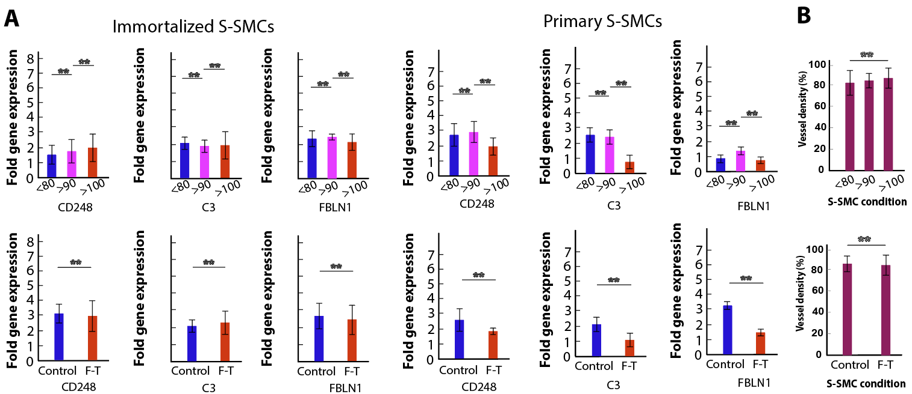
Figure S1. Stability of supportive gene expression and vasculogenic function in immortalized S-SMCs under confluency and freeze–thaw conditions. (A) Relative expression of CD248, C3, and FBLN1 in immortalized S-SMCs cultured at <80%, >90%, and >100% confluency, and in freeze–thaw (F–T) versus non–F–T control conditions at comparable passages. Gene expression remains consistent across confluency levels and after F–T cycles, indicating preservation of the supportive transcriptional program. (B) Functional vasculogenesis assay showing maintained vascular network formation capacity of immortalized S-SMCs following F–T cycles and under high-confluency conditions, consistent with the stable gene expression profile observed in (A).

