Figure 1: Median age of diagnosis with myeloid neoplasms in the United States between years 2001-2021. AML: acute myeloid leukemia, CML: chronic myeloid leukemia, ET: essential thrombocythemia, MDS: myelodysplastic syndromes, PMF: primary myelofibrosis, PV: polycythemia vera

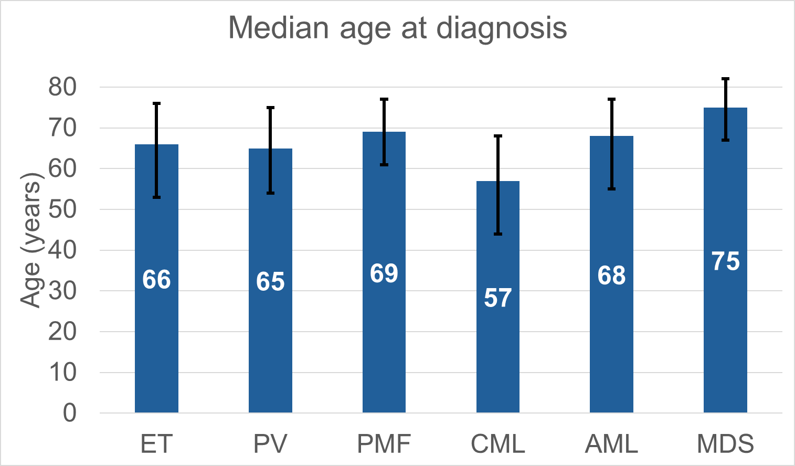

Figure 2: Incidence rate (IR) by year of diagnosis and gender for those diagnosed between years 2001 and 2021 for (a) ET: essential thrombocythemia, (b) PV: polycythemia vera (c) PMF: primary myelofibrosis, and (d) CML: chronic myeloid leukemia. The overall and 2021 specific IR were as follows: ET (1.84, 2.21 per 100,000 person-years), PV (1.78, 1.64 per 100,000 person-years), PMF (0.47, 0.48 per 100,000 person-years), and CML (0.72, 1.18 per 100,000 person-years)
2a

2b

2c

2d

Figure 3: Incidence rate (IR) by age at diagnosis for patients diagnosed between years 2001 and 2021 with (a) ET: essential thrombocythemia, (b) PV: polycythemia vera (c) PMF: primary myelofibrosis, and (d) CML: chronic myeloid leukemia

Figure 4: Population pyramids depicting estimated prevalence on Jan 1, 2024 using SEER 8 registries. (a) ET: essential thrombocythemia, (b) PV: polycythemia vera (c) PMF: primary myelofibrosis, and (d) CML: chronic myeloid leukemia
4a

4b

4c

4d

Figure 5: Relative Survival (RS) for classical MPNs in the 2001-2016 period, followed to the end of 2021. (a) 5-yr RS for MPNs and other select hematologic malignancies in the United States, (b) 5-yr RS for MPNs assessed by year of diagnosis, (c) 5-yr RS for MPNs assessed by age at diagnosis, (d) RS trend from 1 to 10 yrs since diagnosis of MPNs.
5a

5b

5c

5d

Figure 6: Overall survival for MPNs by gender for (a) ET: essential thrombocythemia (b) PV: polycythemia vera (c) PMF: primary myelofibrosis, and (d) CML: chronic myeloid leukemia.

6a
0
.25
.5
.75
1
P
r
o
b
a
b
i
l
i
t
y

o
f

S
u
r
v
i
v
a
l
8981
7007
5232
3789
2646
1883
1279
779
441
199
60
Male
14675
11779
9069
6762
4852
3526
2471
1618
934
449
147
Female
Number at risk
0
24
48
72
96
120
144
168
192
216
240
Time (Months)
Female
Male
Essential thrombocythemia (ET)
Overall Median Survival Time: 152 months
[Female:168 months; Male: 131 months]
Log rank test p≤0.001*

8b
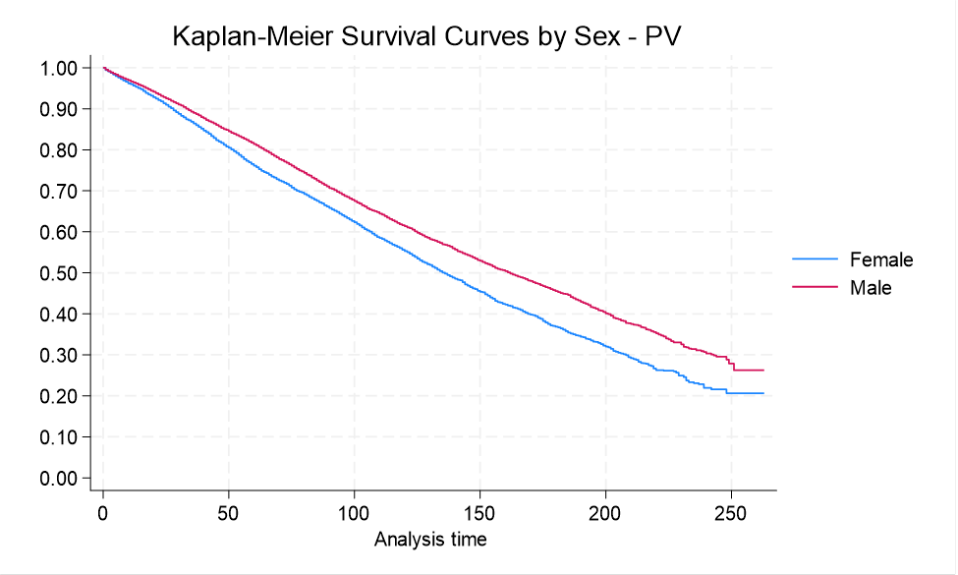

8c

6b

0
.25
.5
.75
1
P
r
o
b
a
b
i
l
i
t
y

o
f

S
u
r
v
i
v
a
l
12970
10790
8592
6782
5091
3669
2661
1852
1138
541
150
Male
9789
7954
6167
4649
3382
2377
1607
1006
593
259
65
Female
Number at risk
0
24
48
72
96
120
144
168
192
216
240
Time (Months)
Female
Male
Polycythemia vera (PV)

Overall Median Survival Time: 150 months
[Female: 136 months; Male: 162 months]
Log rank test p≤0.001*

6c
0
.25
.5
.75
1
P
r
o
b
a
b
i
l
i
t
y

o
f

S
u
r
v
i
v
a
l
3577
2137
1201
711
438
282
176
97
64
30
8
Male
2371
1572
1040
698
439
274
176
109
62
28
12
Female
Number at risk
0
24
48
72
96
120
144
168
192
216
240
Time (Months)
Female
Male
Primary myelofibrosis (PMF)

Overall Median Survival Time: 48 months
[Female:63 months; Male: 42 months]
Log rank test p≤0.001*

Log rank test p≤0.001*

8d

6d

0
.25
.5
.75
1
P
r
o
b
a
b
i
l
i
t
y

o
f

S
u
r
v
i
v
a
l
5234
3894
2913
2088
1383
873
534
344
196
100
38
Male
4045
3020
2265
1654
1146
730
442
287
182
94
29
Female
Number at risk
0
24
48
72
96
120
144
168
192
216
240
Time (Months)
Female
Male
Chronic myelogenous leukemia (CML)

Overall Median Survival Time: 202 months
[Female:212 months; Male: 197 months]
Log rank test p=0.007*

Figure 7 – Overall Survival curves for patients living with Myeloproliferative Neoplasms in the United States between 2000-2021(a) ET: essential thrombocythemia (b) PV: polycythemia vera (c) PMF: primary myelofibrosis, and (d) CML: chronic myeloid leukemia.

0
.25
.5
.75
1
P
r
o
b
a
b
i
l
i
t
y

o
f

S
u
r
v
i
v
a
l
0
24
48
72
96
120
144
168
192
216
240
Time (Months)
CML
ET
PV
PMF
Overall Survival by Diagnosis

Table 1: Baseline characteristics of patients with myeloproliferative neoplasms (MPNs) diagnosed between years 2001-2021. CML: Chronic myeloid leukemia BCR:ABL positive, ET: essential thrombocythemia, F: women, IQR: inter-quartile range, M: men, PMF: primary myelofibrosis, PV: polycythemia vera,)

Variable | ET | PV | PMF | CML | Overall
Total | 24172 (38%) | 23456 (37%) | 6131 (9.7%) | 9483 (15%) | 63242 (100%)
Age (median at diagnosis) IQR | 66 (53-76) | 65 (54-75) | 69 (61-77) | 56 (43-68)
Sex; n (%)  F  M | 4971 (62%)  9201 (38%) | 10118 (43%)  13338 (57%) | 2444 (40%)  3687 (60%) | 4116 (43%)  5367 (57%) | 31649 (50%)  31593 (50%)
Year of Diagnosis; n (%)  2000-2005  2006-2010  2011-2016  2017-2021 | 3354 (14%)  5082 (21%)  7790 (32%)  7945 (33%) | 4729 (20%)  5046 (22%)  7302 (31%)  6379 (27%) | 1013 (17%)  1299 (21%)  2011 (33%)  1808 (29%) | 828 (9%)  1339 (14%)  3754 (40%)  3562 (37%)
Alive  Deceased | 15942 (66%)  8230 (34%) | 14393 (62%)  9063 (38%) | 2209 (36%)  3922 (64%) | 6903 (73%)  2580 (27%) | 39447 (63%)  23795 (37%)

