Supplementary Material
Supplementary Table S1 reports split balance, Supplementary Table S2 the overlap by experience tercile, Supplementary Table S3 alternative outcomes, Supplementary Table S4 the retained threshold and robustness summaries, and Supplementary Table S5 performance of the simple-rule workflow across splits.

Supplementary Figure S1 shows pathology-specific overlap, Supplementary Figure S2 the placebo permutation test, Supplementary Figure S3 the boundary simulation, and Supplementary Figure S4 the simulation-based hidden-confounding sensitivity analysis.

Supplementary Table S1. Split balance.
Feature | Assisted mean | Unassisted mean | Difference | SMD
alg_pred | 0.097005 | 0.096725 | 0.00028 | 0.002177
case_difficulty | 0.140747 | 0.140968 | -0.00022 | -0.00094
case_ai_accuracy | 0.872148 | 0.872082 | 6.58E-05 | 0.000327
rad_experience | 9.10687 | 9.10687 | 0 | 0
pathology_id | 2 | 2 | 0 | 0
spec_enc | 0.194656 | 0.194656 | 0 | 0

Supplementary Table S2. Overlap by experience tercile.
Group | N obs | AUC | OutsidePct
Junior | 35300 | 0.482292 | 0
Mid | 33000 | 0.489888 | 0
Senior | 36500 | 0.461872 | 0

Supplementary Table S3. Alternative outcome metrics.
Outcome metric | Policy | DR estimate | Obs SE
error | No AI | 0.108771 | 0.00215
error | Always AI | 0.106063 | 0.001953
error | Learned | 0.103444 | 0.001983
squared_error | No AI | 0.078259 | 0.001871
squared_error | Always AI | 0.069175 | 0.001659
squared_error | Learned | 0.06897 | 0.001696
zero_one_error | No AI | 0.108105 | 0.002728
zero_one_error | Always AI | 0.096512 | 0.002512
zero_one_error | Learned | 0.096617 | 0.00255

Supplementary Table S4. Threshold and robustness summary.
n_estimators | max_depth | learning_rate | tau | val_ai_show_pct | test_ai_show_pct | cate_sd_test
100 | 2 | 0.01 | 0.003997 | 93.42447 | 94.39981 | 0.004736
100 | 2 | 0.03 | 0.000773 | 77.06209 | 76.32822 | 0.011016
100 | 2 | 0.05 | 0.01119 | 89.91196 | 89.82225 | 0.01608
100 | 3 | 0.01 | 0.000623 | 77.81742 | 77.65279 | 0.007483
100 | 3 | 0.03 | -3.06E-05 | 77.25209 | 77.17068 | 0.015531
100 | 3 | 0.05 | 0.018768 | 91.21872 | 92.91941 | 0.019752
100 | 4 | 0.01 | -0.00112 | 72.22428 | 72.39347 | 0.010423
100 | 4 | 0.03 | 0.00386 | 82.00185 | 81.2223 | 0.021515
100 | 4 | 0.05 | 0.020695 | 90.5051 | 90.60141 | 0.027159
300 | 2 | 0.01 | -0.00107 | 73.92956 | 75.19844 | 0.010683
300 | 2 | 0.03 | 0.006616 | 83.36886 | 83.88118 | 0.01934
300 | 2 | 0.05 | 0.009408 | 84.89342 | 86.72997 | 0.02482
300 | 3 | 0.01 | 0.005425 | 87.78962 | 89.0431 | 0.015897
300 | 3 | 0.03 | 0.008022 | 85.35681 | 86.10178 | 0.027587
300 | 3 | 0.05 | 0.033695 | 91.3253 | 93.56708 | 0.031304
300 | 4 | 0.01 | 0.016486 | 90.94532 | 92.07694 | 0.020614
300 | 4 | 0.03 | 0.013328 | 85.96849 | 89.24763 | 0.032777
300 | 4 | 0.05 | 0.006963 | 80.93142 | 81.86024 | 0.038943
500 | 2 | 0.01 | 0.004117 | 83.00278 | 82.1086 | 0.014276
500 | 2 | 0.03 | 0.030538 | 92.66914 | 93.869 | 0.025472
500 | 2 | 0.05 | 0.029535 | 91.40408 | 92.6467 | 0.031009
500 | 3 | 0.01 | 0.00327 | 80.68119 | 80.23862 | 0.021275
500 | 3 | 0.03 | 0.02427 | 89.59685 | 91.00073 | 0.03247
500 | 3 | 0.05 | 0.016464 | 87.11307 | 88.30777 | 0.037469
500 | 4 | 0.01 | 0.000538 | 71.71455 | 69.8953 | 0.027481
500 | 4 | 0.03 | 0.04426 | 92.03892 | 94.56538 | 0.040371
500 | 4 | 0.05 | 0.018628 | 87.6367 | 87.9328 | 0.046858

Supplementary Table S5. Performance of the decision-tree-based simple rule.
Split | N obs | Full policy AI shown (%) | Simple rule AI shown (%) | Concordance (%) | Full policy DR MAE | Simple rule DR MAE | Full policy DR 0-1 error | Simple rule DR 0-1 error
Train | 62685 | 92.4894 | 90.9516 | 94.1836
Validation | 21580 | 88.8091 | 85.1344 | 93.9527
Test | 20535 | 90.319 | 85.8242 | 93.9664 | 0.1034 | 0.1033 | 0.0964 | 0.0983

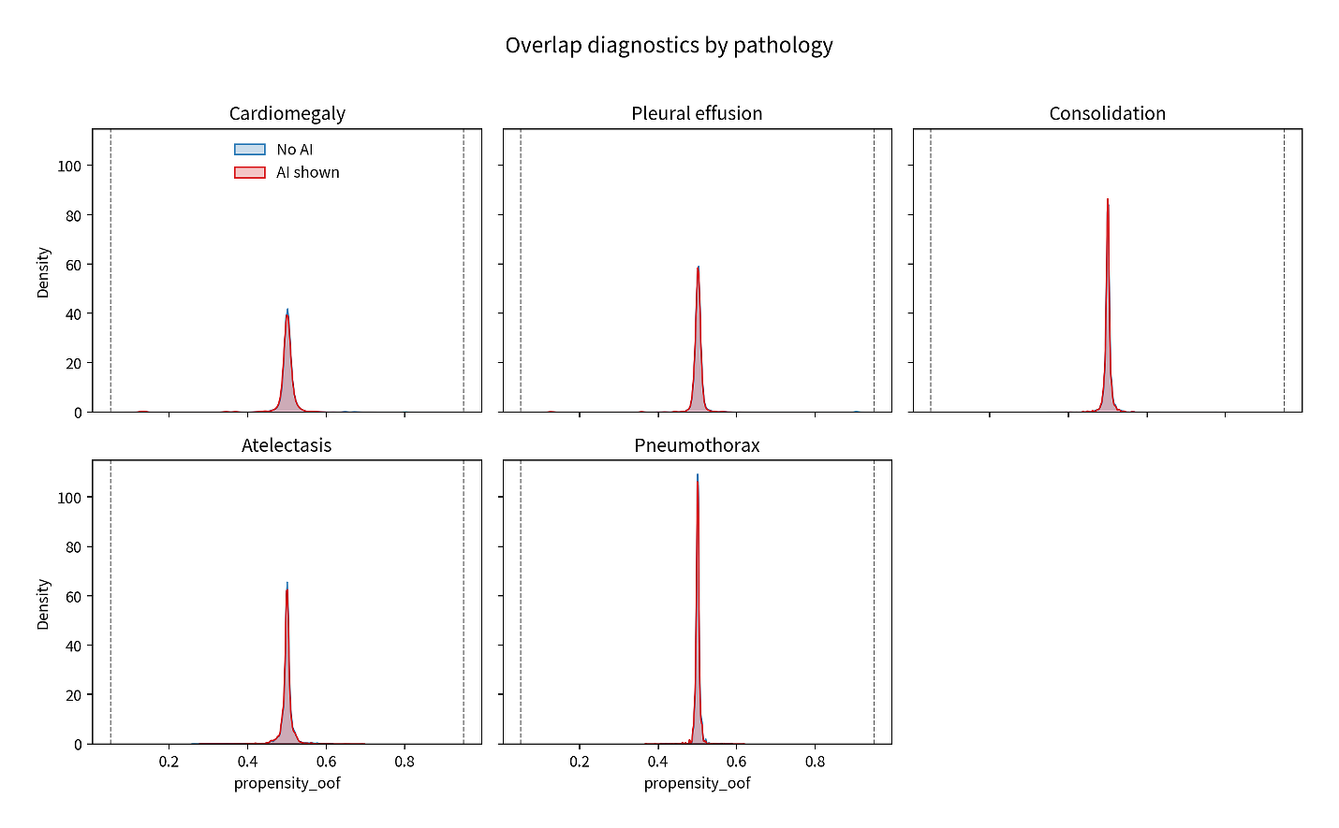
Supplementary Figure S1. Pathology-specific overlap diagnostics.

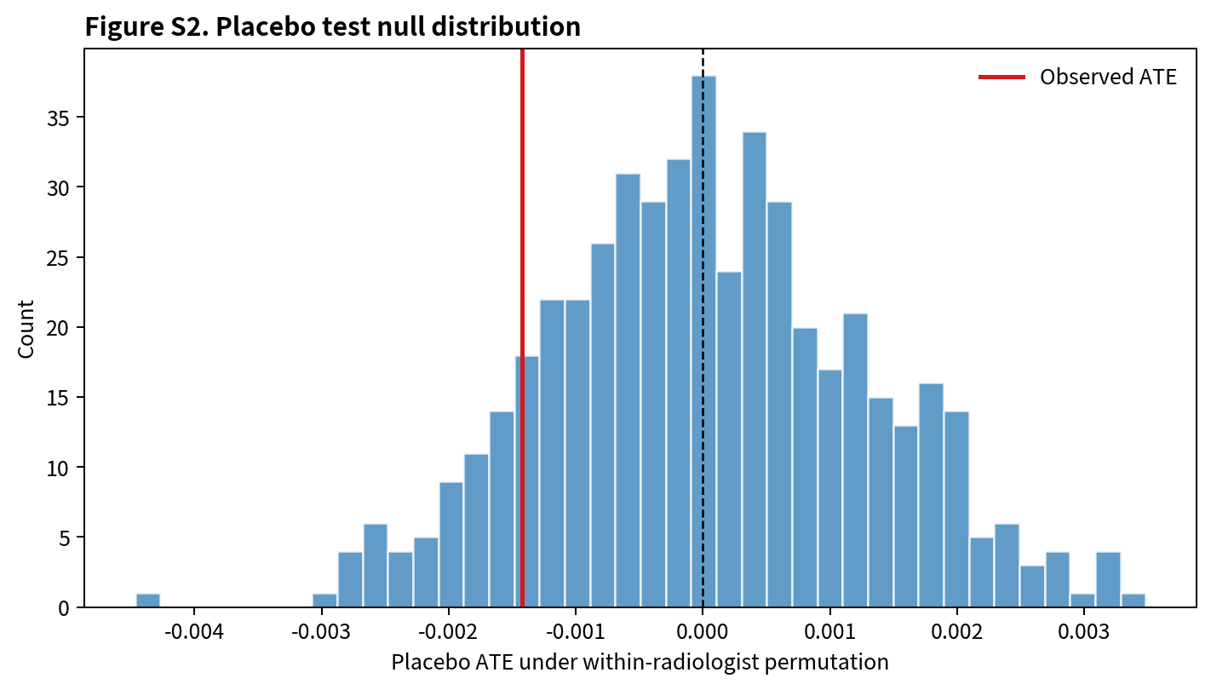
Supplementary Figure S2. Placebo permutation distribution.

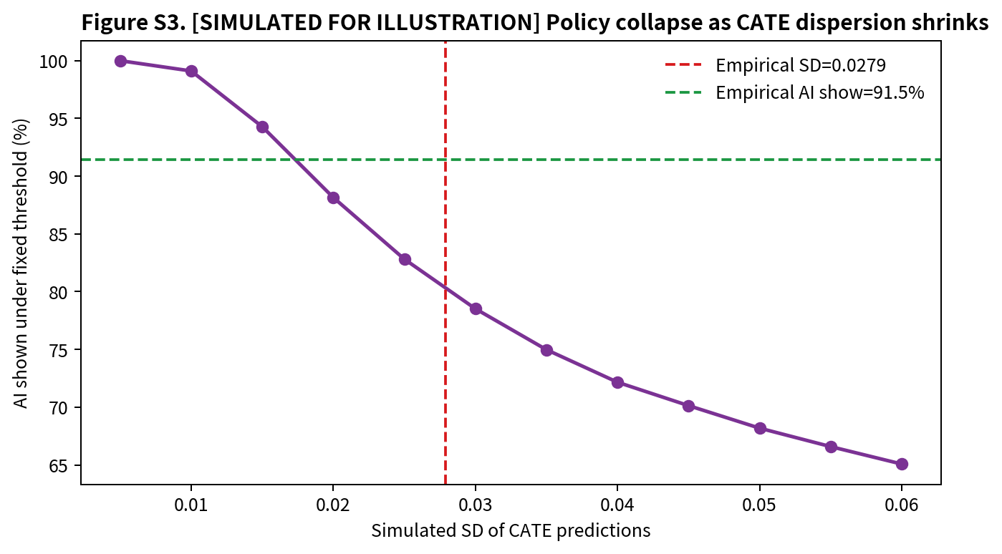
Supplementary Figure S3. Boundary simulation from the released analysis outputs.

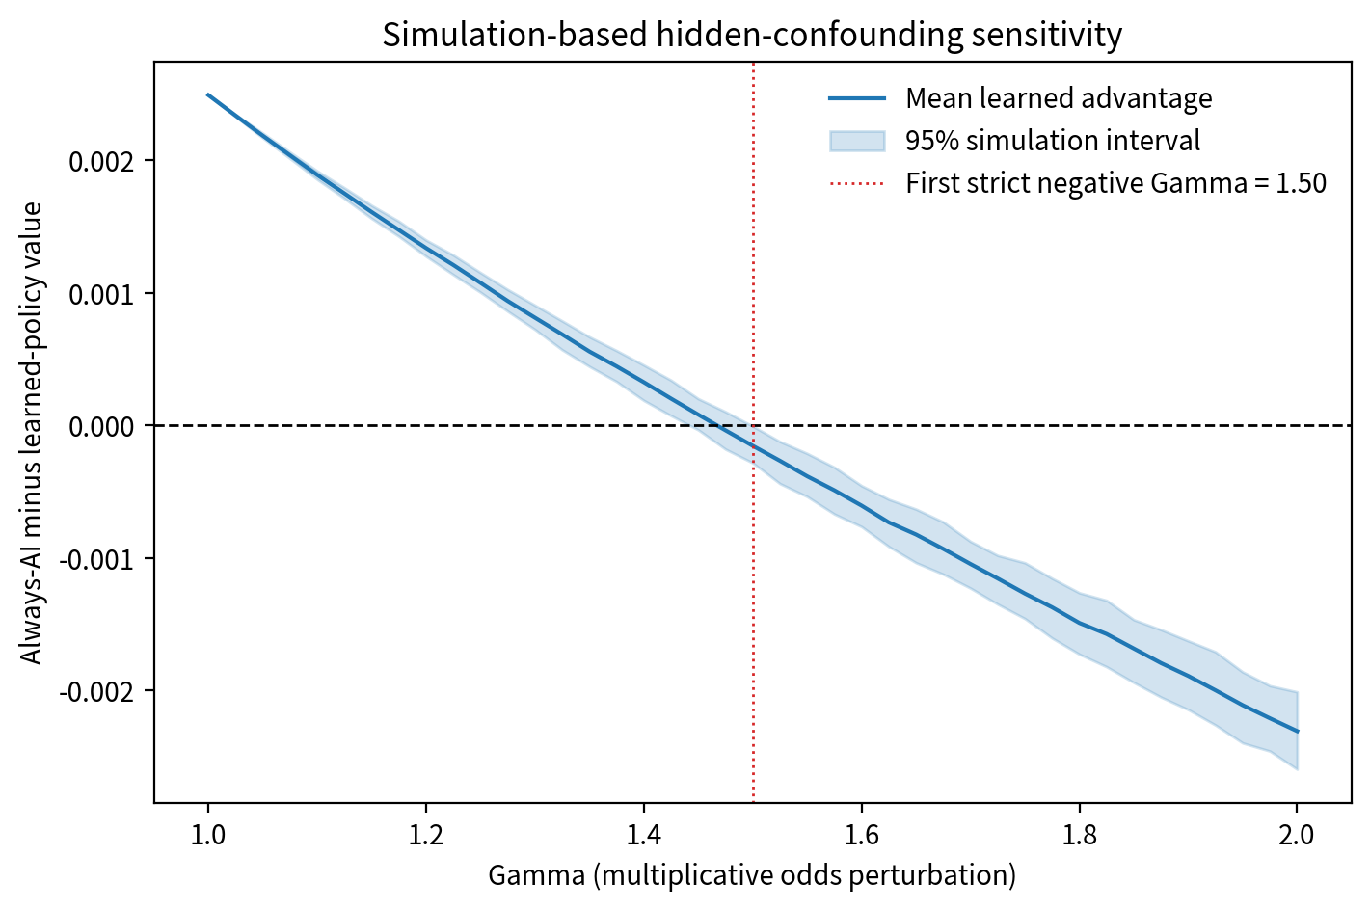
Supplementary Figure S4. Simulation-based hidden-confounding sensitivity analysis for the learned-versus-always policy contrast.

