Supporting Information

Text S1

Plastic shaping and metal contamination in experiment round 1
Round 1 comprised four treatments (75 jars per treatment): control, virgin microplastic, biofouled macroplastic, and combined virgin microplastic plus biofouled macroplastic. In the biofouled macroplastic and combined treatments, we introduced sub-treatments with varying macroplastic abundance (1 or 2 pieces of 5 × 4 cm plastic) and shape (plain sheet, folded, corner, tube). The plain sheet served as the shape sub-control. Folded, corner, and tube shapes were formed using office metal staples (one staple per piece). Therefore, jars assigned to the high-abundance sub-treatment contained two staples. Within each of these two treatments, the 75 jars were allocated as follows: 18 plain sheets, 19 folded, 19 corners, and 19 tubes. Each shape category included jars at both abundance levels. Control and virgin microplastic treatments did not involve staples.
We analyzed snail survival via a proportional hazard regression model using the coxme and survival packages in R. We found the number of staples present caused significantly higher mortality in the biofouled macroplastic treatment (p < 0.005) and in the combined treatment (p < 0.001). To remove metal contamination as a confounder, we excluded all jars containing staples (57 per treatment), retaining the 18 plain sheet jars for subsequent analyses in each treatment.

Table S1. Impact of the number of staples and biofouled macroplastic abundance on snail survival. Model output with coefficients, standard error, HR, lower and upper bounds of HR under 95% CI, and p value between treatments in experiment round 1.
Term | estimate | standard.error | HR | HR.low | HR.high | p.value
Number of staples | 0.59 | 0.20 | 1.80 | 1.21 | 2.67 | 0.003
Biofouled macroplastic abundance | -0.01 | 0.14 | 0.99 | 0.75 | 1.30 | 0.930

Table S2. Impact of the number of staples and biofouled macroplastic abundance on snail survival, co-exposed to virgin microplastic. Model output with coefficients, standard error, HR, lower and upper bound of HR under 95% CI, and p value between treatments in experiment round 1.
Term | estimate | standard.error | HR | HR.low | HR.high | p.value
Number of staples | 0.68 | 0.20 | 1.97 | 1.32 | 2.94 | < 0.001
Biofouled macroplastic abundance | -0.15 | 0.14 | 0.86 | 0.66 | 1.13 | 0.284

Text S2
Macroplastic biofouling protocols
Field biofouling was conducted at Jasper Ridge Biological Reserve (Searsville Lake) during experiment round one and the latter half of round two. Plastic sheets were skewered onto a Nylon rope with knots separating each other to prevent contact. We attached a weight bag to ensure constant full submergence and deployed it in locations with steady water flow for two months (round one) or one month (round two). During the first half of experiment round two, biofouling was conducted under laboratory conditions due to unsuitable field conditions (extreme precipitation, high flow velocity, and low temperatures). Plastic sheets were submerged in 10 L water tanks containing 9 L of Searsville Lake water, 9 ml of lake sediments, and 9 ml of periphyton concentrate (collected by brushing off from aquatic plants' and dam bridge surface). The water mixture was replaced biweekly, and biofouling proceeded for one month. Following biofouling, all plastic sheets (field- or lab-conditioned) were trimmed into uniform 5 cm x 4 cm pieces.

Text S3
Macroplastic surface periphyton profiling protocols
We collected 18 samples per batch by scrubbing three pieces of 5 cm x 4 cm biofouled macroplastic into 15 ml of DI water. Solutions were mixed thoroughly, and 20 mL of solution was vacuum filtered onto pre-ashed and weighed 0.7 μm glass fiber filters. We dried six samples on glass fiber filters for at least 48 h at 60°C, weighed, ashed at 550°C for 4 h, cooled and reweighed. Percentage of ash-free dry mass was calculated as ash-free dry mass over total dry mass. Six samples on glass fiber filters were dried for at least 48 h at 60°C, preserved in a desiccation cabinet, scraped off dried material into pre-weighted sterile tin capsules, crushed into a ball with tweezers, and reweighed. The tin balls were processed with a Thermo® FlashSmart Soil NC Elemental Analyzer to measure C to N ratio. Six samples on glass fiber filters were individually soaked in 5 mL of 90% acetone at 5°C for 24 h, thawed at room temperature for 1 h, and analyzed on a Turner Designs Model 10AU Fluorometer before and after acidification to measure chlorophyll and pheophytin a. concentration. All procedures were done in the dark. Chlorophyll a. to pheophytin ratio was calculated. Microscopic pictures at 40 times magnification were taken for representative microbial communities.

Table S3. Data cleaning decisions in handling snail growth measurement errors and measurement cross-validation counts with error rates reported.
 | Cleaning decision or specifications | Experiment round 1 | Experiment round 2
Total snail length could be observed | NA | 6207 | 6581
Total snail length analyzed | NA | 5958 (96.0%) | 6431 (97.7%)
Snail picture taken when mating | Eliminated length of that jar that week due to snail 3D orientation in a 2D measurement system | 212  (3.4%) | 130  (2.0%)
Snail picture orientation inconsistency | Analyzed length corrected by multiplying a ratio systematically deducted from 30 snails of 8 possible angles facing from 0 to 360 degrees based on snail angle inconsistency | 10  (0.2%) | 1282 (19.5%)
Missing/duplicate snail picture | Not available length of that jar that week | 19  (0.3%) | 20  (0.3%)
Snail-jar misplacement within the same treatment | Eliminated length of that jar that week due to invalid comparison to length of the previous week | 18  (0.3%) | 0  (0%)
Length cross validation remeasurements | Randomly generated 30 snails within each treatment each week to remeasure, and if less than 30 snails alive to check for, all snails available were measured. | 1359 | 1645
Length cross validation error rates | Length was considered wrong when discrepancy exceeds the mean growth of 0.0255 cm; We confirmed all discrepancies are not in one direction systematically | 4.24% | 2.40%

Text S4
data cleaning decisions growth measurements
Given that shell length cannot biologically decrease, any negative weekly growth values were considered artifacts of measurement error. In instances where true growth was minimal and therefore indistinguishable from negative measurement noise, growth values were set to zero. We derive somatic growth at the jar level, with weekly average shell growth included in the study only when there were no snail deaths during that week, as the death of a smaller or larger snail could skew the average growth.

Effect of plastic pollution on snail survival
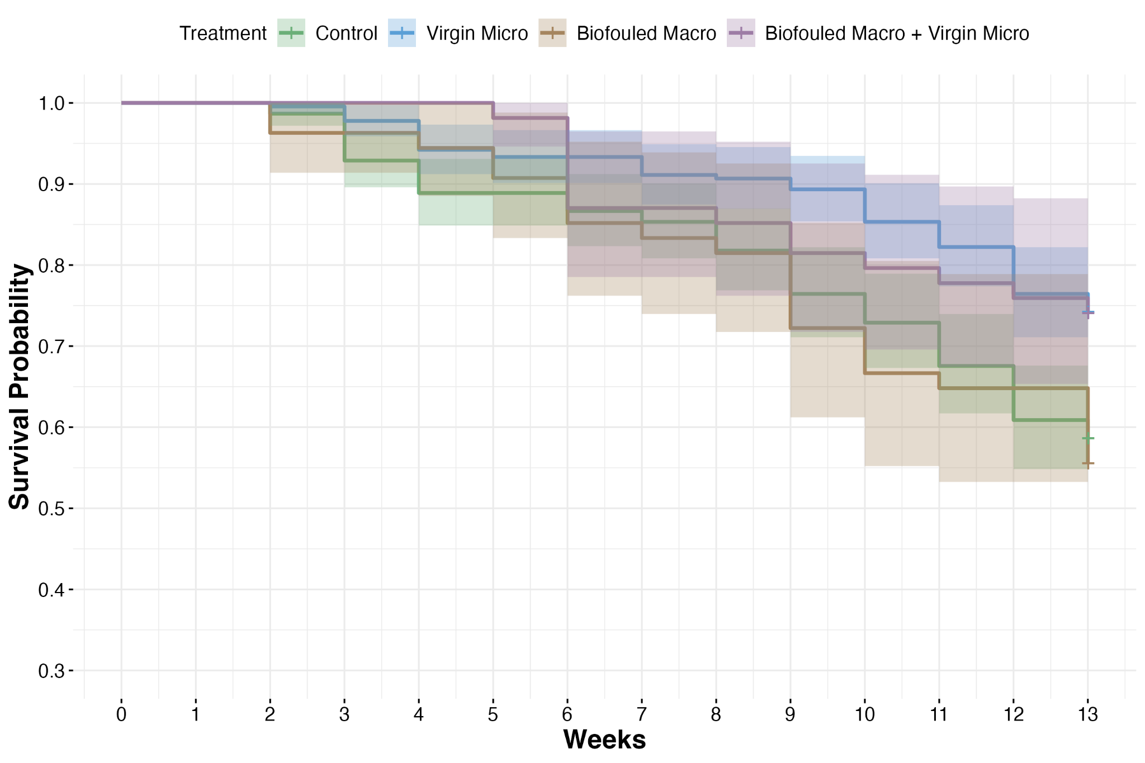
Figure S1. Weekly snail survival of experimental round 1

Table S4. Snail survival model output with coefficients, standard error, HR, lower and upper bound of HR under 95% CI, and p value between treatments in experiment round 1.
Term | estimate | standard.error | HR | HR.low | HR.high | p.value
Virgin Micro | -0.60 | 0.17 | 0.55 | 0.40 | 0.76 | < 0.001
Biofouled Macro | 0.08 | 0.23 | 1.09 | 0.69 | 1.70 | 0.713
Biofouled Macro + Virgin Micro | -0.56 | 0.29 | 0.57 | 0.32 | 1.00 | 0.050
Table S5. Pairwise comparison of snail survival output with coefficients, standard error, HR, lower and upper bound of HR under 95% CI, and p value between treatments in experiment round 1.
Contrast | estimate | standard.error | HR | HR.low | HR.high | p.value
Virgin Micro vs Control | 0.60 | 0.17 | 0.55 | 0.36 | 0.84 | 0.002
Biofouled Macro vs Control | -0.08 | 0.23 | 1.09 | 0.61 | 1.96 | 0.983
(Biofouled Macro+Virgin Micro) vs Control | 0.56 | 0.29 | 0.57 | 0.27 | 1.20 | 0.215
Biofouled Macro vs Virgin Micro | -0.68 | 0.24 | 1.98 | 1.07 | 3.68 | 0.024
(Biofouled Macro+Virgin Micro) vs Virgin Micro | -0.04 | 0.30 | 1.04 | 0.48 | 2.25 | 0.999
(Biofouled Macro+Virgin Micro) vs Biofouled Macro | 0.65 | 0.34 | 0.52 | 0.22 | 1.25 | 0.225

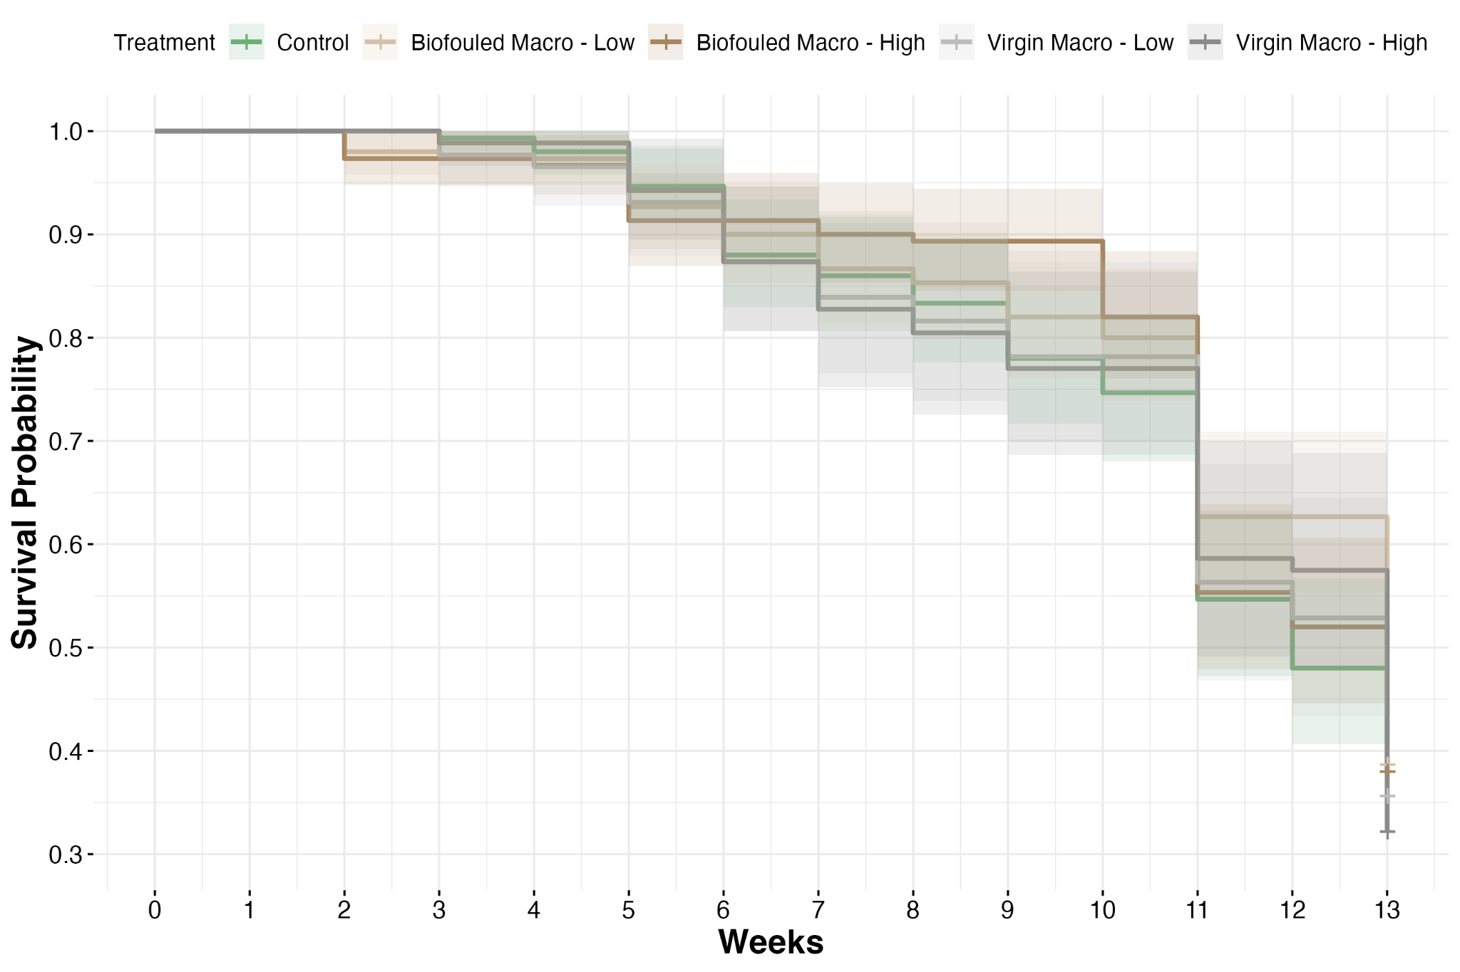
Figure S2. Weekly snail survival of experimental round 2

Table S6. Snail survival model output with coefficients, standard error, HR, lower and upper bound of HR under 95% CI, and p value between treatments in experiment round 2.
Term | estimate | standard.error | HR | HR.low | HR.high | p.value
Biofouled Macro - Low | 0.10 | 0.15 | 0.90 | 0.68 | 1.21 | 0.489
Biofouled Macro - High | 0.05 | 0.15 | 0.96 | 0.72 | 1.27 | 0.759
Virgin Macro - Low | -0.02 | 0.17 | 1.02 | 0.73 | 1.42 | 0.915
Virgin Macro - High | -0.06 | 0.17 | 1.06 | 0.77 | 1.47 | 0.710

Table S7. Pairwise comparison of snail survival output with coefficients, standard error, HR, lower and upper bound of HR under 95% CI, and p value between treatments in experiment round 2
Contrast | estimate | standard.error | HR | HR.low | HR.high | p.value
(Biofouled Macro - Low) vs Control | 0.10 | 0.15 | 0.90 | 0.60 | 1.35 | 0.959
(Biofouled Macro - High) vs Control | 0.05 | 0.15 | 0.96 | 0.64 | 1.44 | 0.998
(Virgin Macro - Low) vs Control | -0.02 | 0.17 | 1.02 | 0.64 | 1.63 | 1.000
(Virgin Macro - High) vs Control | -0.06 | 0.17 | 1.06 | 0.68 | 1.67 | 0.996
(Biofouled Macro - High) vs (Biofouled Macro - Low) | -0.06 | 0.15 | 1.06 | 0.71 | 1.57 | 0.995
(Virgin Macro - Low) vs (Biofouled Macro - Low) | -0.12 | 0.17 | 1.13 | 0.71 | 1.78 | 0.953
(Virgin Macro - High) vs (Biofouled Macro - Low) | -0.16 | 0.16 | 1.18 | 0.76 | 1.83 | 0.847
(Virgin Macro - Low) vs (Biofouled Macro - High) | -0.06 | 0.17 | 1.07 | 0.67 | 1.69 | 0.996
(Virgin Macro - High) vs (Biofouled Macro - High) | -0.11 | 0.16 | 1.11 | 0.72 | 1.73 | 0.965
(Virgin Macro - High) vs (Virgin Macro - Low) | -0.04 | 0.18 | 1.05 | 0.63 | 1.72 | 0.999

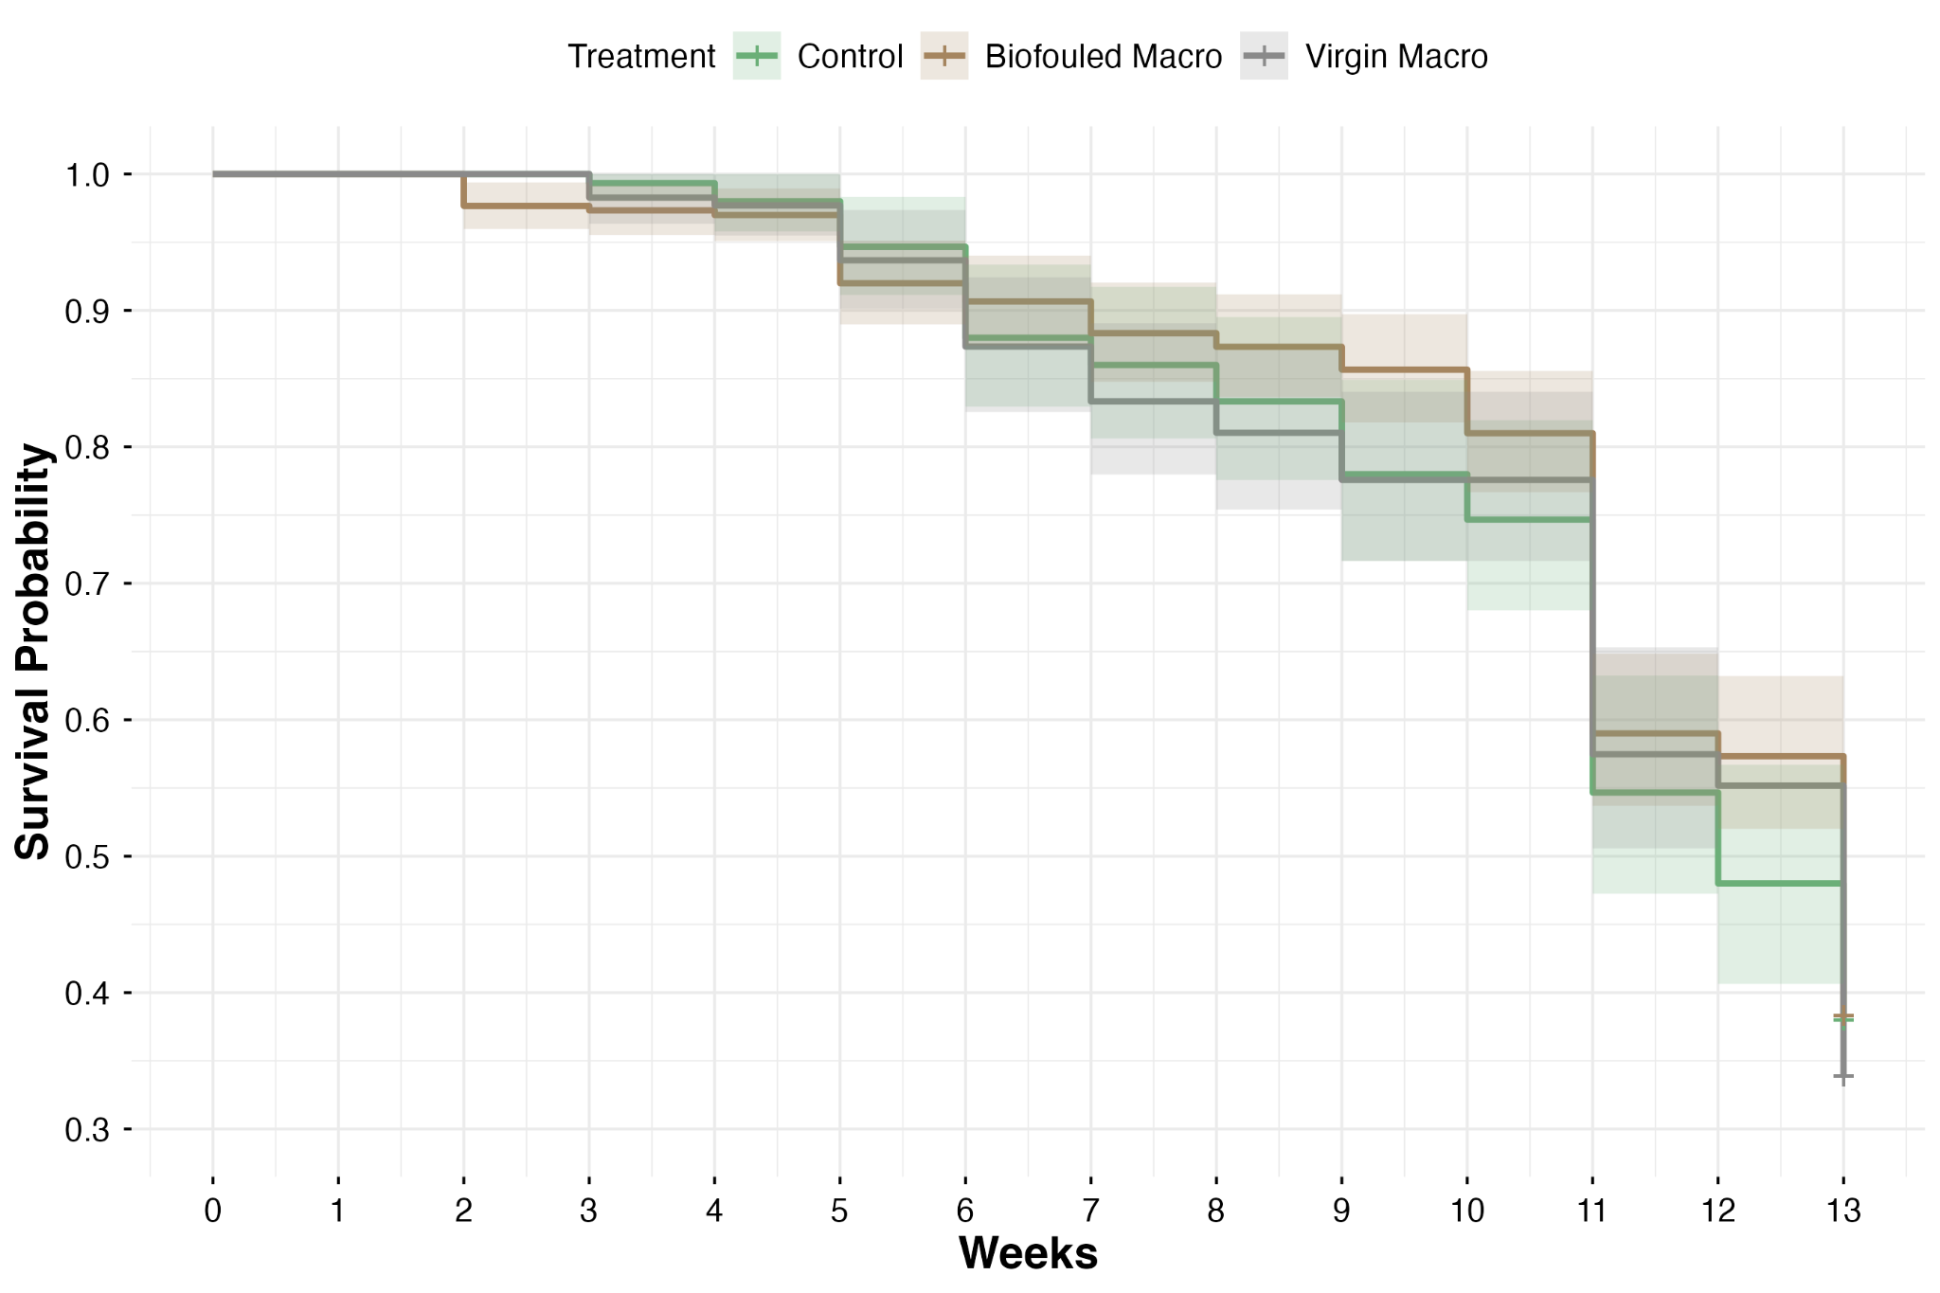
Figure S3. Weekly snail survival of experimental round 2 with grouped macroplastic treatment of various abundance

Table S8. Snail survival model output with coefficients, standard error, HR, lower and upper bound of HR under 95% CI, and p value between combined treatments with various abundance in experiment round 2.
Group | estimate | standard.error | HR | HR.low | HR.high | p.value
Biofouled Macro | -0.07 | 0.13 | 0.93 | 0.72 | 1.19 | 0.563
Virgin Macro | 0.04 | 0.14 | 1.04 | 0.79 | 1.37 | 0.773
Table S9. Pairwise comparison of snail survival output with coefficients, standard error, HR, lower and upper bound of HR under 95% CI, and p value between combined treatments with various abundance in experiment round 2
Contrast | estimate | standard.error | HR | HR.low | HR.high | p.value
Biofouled Macro vs Control | 0.07 | 0.13 | 0.93 | 0.69 | 1.26 | 0.838
Virgin Macro vs Control | -0.04 | 0.14 | 1.04 | 0.75 | 1.45 | 0.956
Virgin Macro vs Biofouled Macro | -0.11 | 0.12 | 1.12 | 0.85 | 1.47 | 0.591

Effect of plastic pollution on snail shell growth
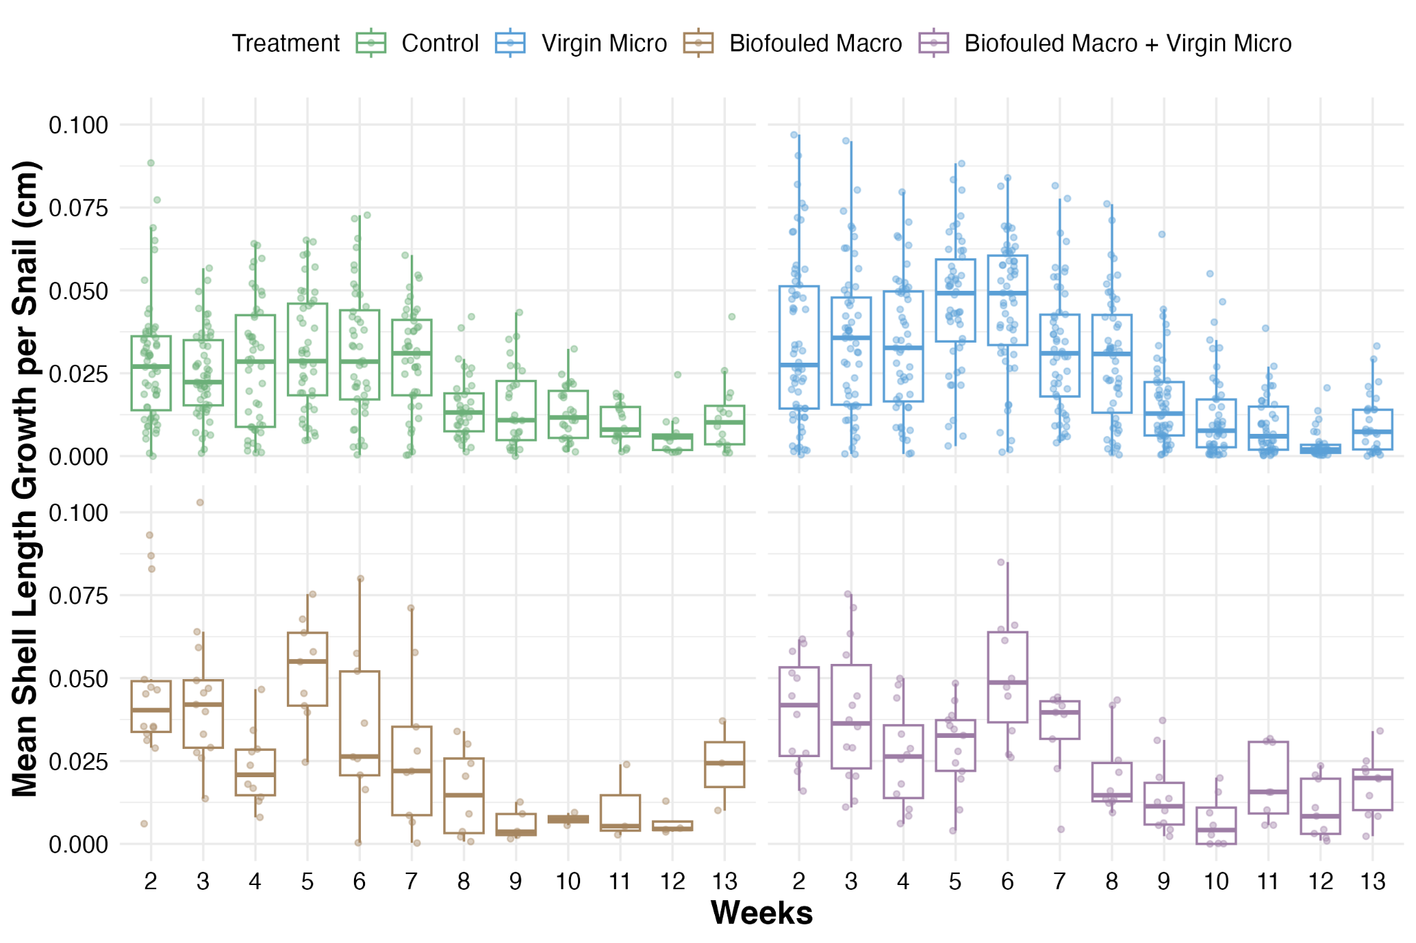
Figure S4. Weekly snail shell length growth of experimental round 1

Table S10. Snail shell length growth model output with coefficients in cm, standard error, and p value between treatments in experiment round 1.
Term | estimate | standard.error | p.value
Virgin Micro | 0.0040 | 0.0011 | < 0.001
Biofouled Macro | 0.0093 | 0.0020 | < 0.001
Biofouled Macro + Virgin Micro | 0.0051 | 0.0018 | 0.004

Table S11. Pairwise comparison of snail shell length growth model output with coefficients, standard error, and p value between treatments in experiment round 1 across snail lengths of 0.789 cm, 0.875 cm, and 0.956 cm (0.25, 0.50, and 0.75 quantile).
Contrast | estimate | standard.error | p.value
Control vs Virgin Micro | -0.0040 | 0.0011 | 0.003
Control vs Biofouled Macro | -0.0093 | 0.0020 | < 0.001
Control vs (Biofouled Macro + Virgin Micro) | -0.0051 | 0.0018 | 0.023
Virgin Micro vs Biofouled Macro | -0.0053 | 0.0020 | 0.042
Virgin Micro vs (Biofouled Macro + Virgin Micro) | -0.0011 | 0.0017 | 0.921
Biofouled Macro vs (Biofouled Macro + Virgin Micro) | -0.0042 | 0.0024 | 0.307

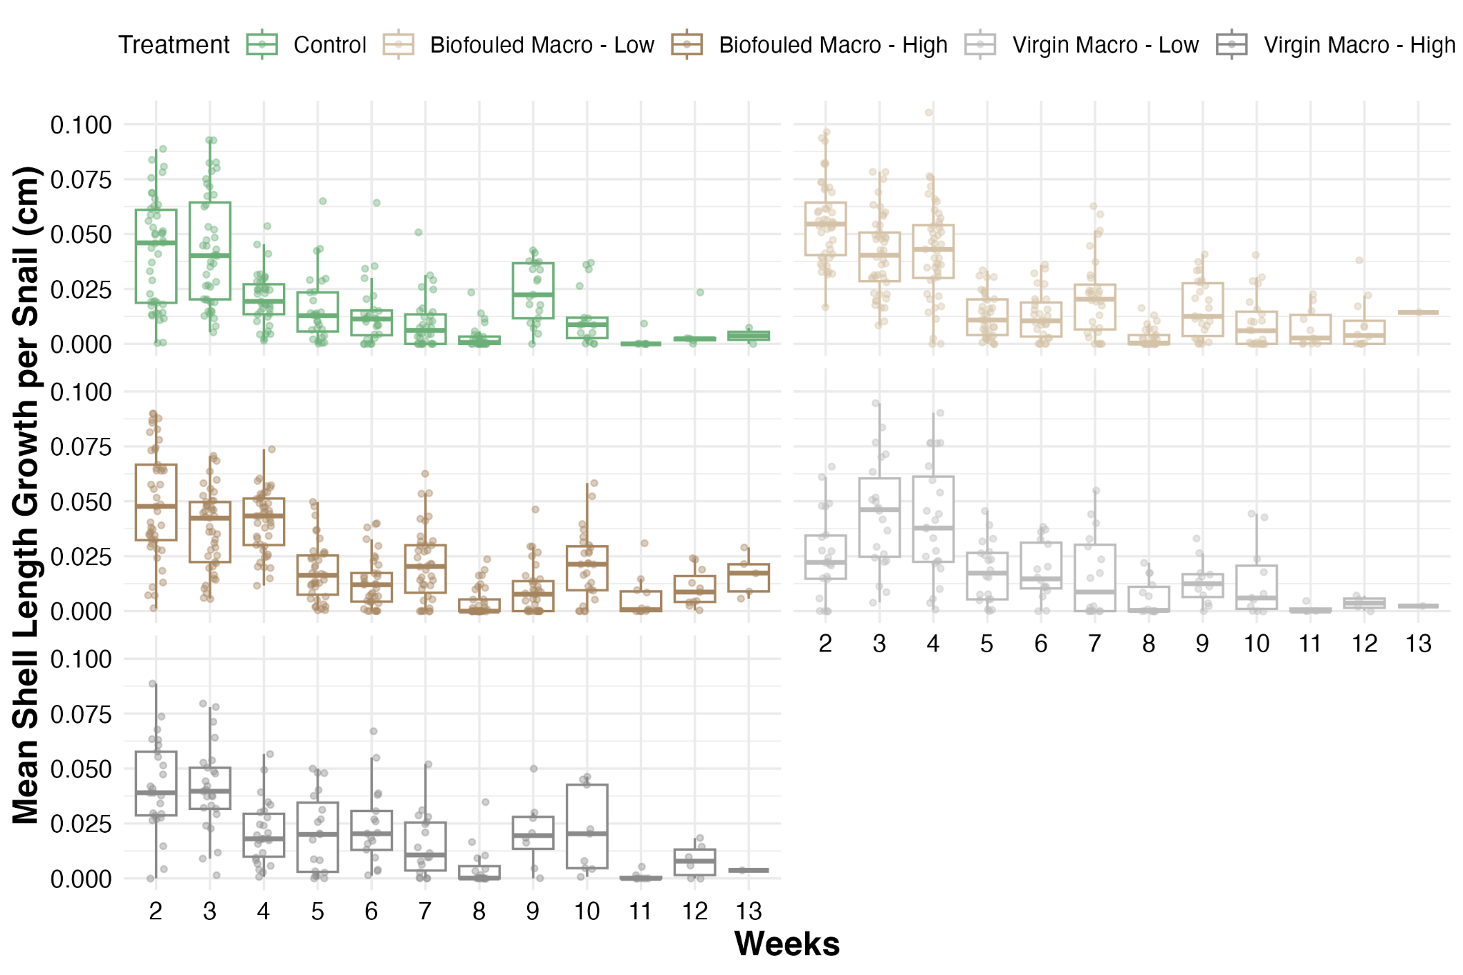
Figure S5. Weekly snail shell length growth of experimental round 2

Table S12. Snail shell length growth model output with coefficients in cm, standard error, and p value between treatments in experiment round 2.
Term | estimate | standard.error | p.value
Biofouled Macro - Low | 0.0030 | 0.0013 | 0.026
Biofouled Macro - High | 0.0036 | 0.0013 | 0.005
Virgin Macro - Low | 0.0016 | 0.0016 | 0.319
Virgin Macro - High | 0.0039 | 0.0016 | 0.014

Table S13. Pairwise comparison of snail length growth model output with coefficients, standard error, and p value between treatments in experiment round 2 across snail lengths of 0.812 cm, 0.876 cm, and 0.919 cm (0.25, 0.50, and 0.75 quantile)
Contrast | estimate | standard.error | p.value
Control vs (Biofouled Macro - Low) | -0.0030 | 0.0013 | 0.170
Control vs (Biofouled Macro - High) | -0.0036 | 0.0013 | 0.043
Control vs (Virgin Macro - Low) | -0.0016 | 0.0016 | 0.857
Control vs (Virgin Macro - High) | -0.0039 | 0.0016 | 0.102
(Biofouled Macro - Low) vs (Biofouled Macro - High) | -0.0007 | 0.0013 | 0.983
(Biofouled Macro - Low) vs (Virgin Macro - Low) | 0.0013 | 0.0016 | 0.916
(Biofouled Macro - Low) vs (Virgin Macro - High) | -0.0009 | 0.0016 | 0.975
(Biofouled Macro - High) vs (Virgin Macro - Low) | 0.0020 | 0.0016 | 0.695
(Biofouled Macro - High) vs (Virgin Macro - High) | -0.0003 | 0.0015 | 1.000
(Virgin Macro - Low) vs (Virgin Macro - High) | -0.0023 | 0.0018 | 0.716
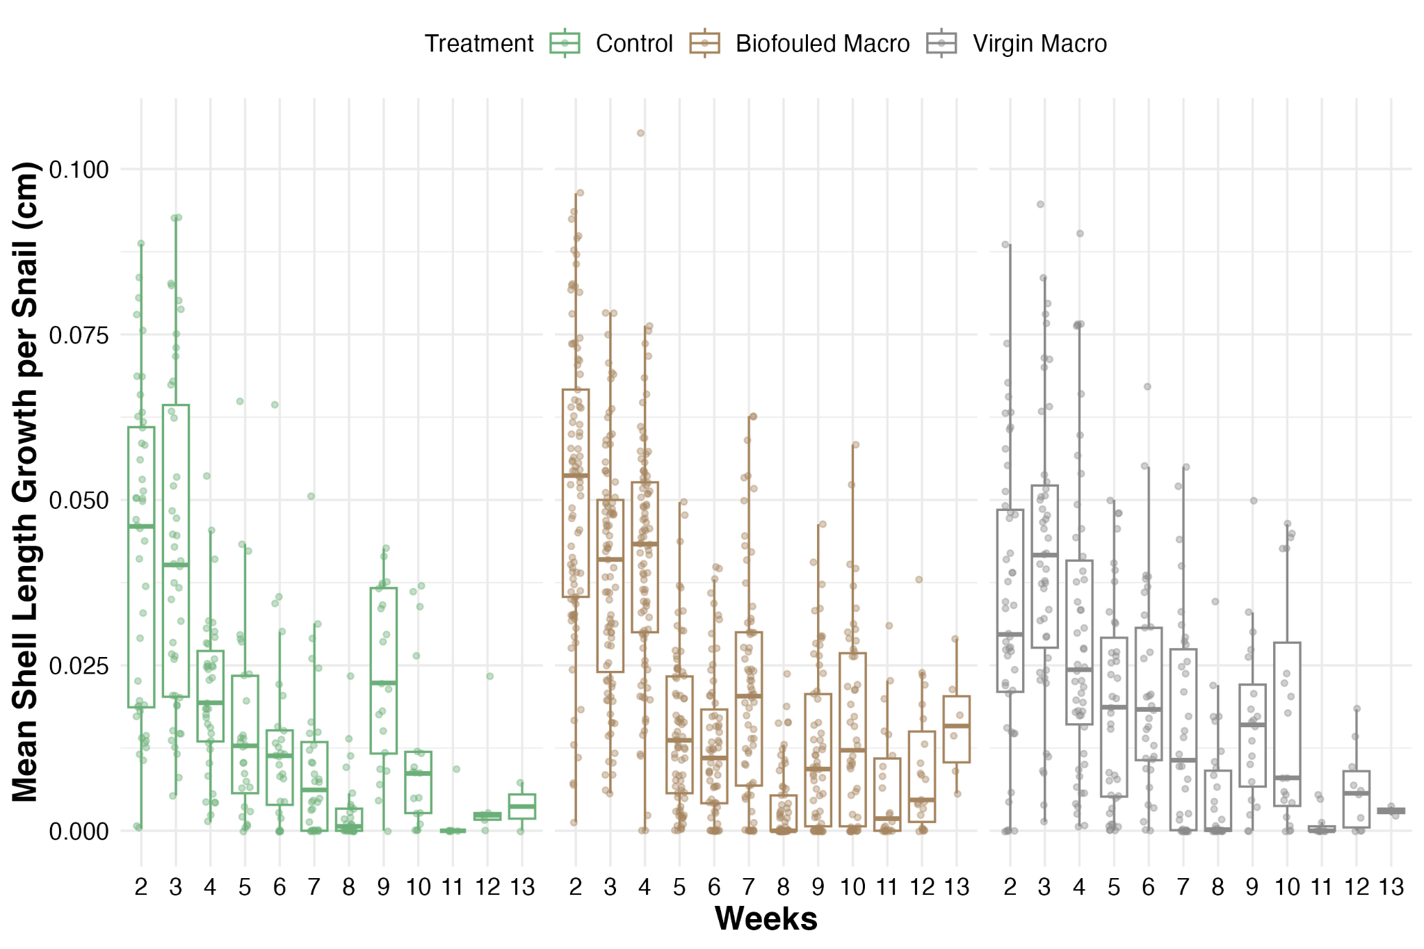
Figure S6. Weekly snail shell length growth of experimental round 2 with grouped macroplastic treatment of various abundance

Table S14. Snail shell length growth model output with coefficients in cm, standard error, and p value between combined treatments with various abundance in experiment round 2.
Group | estimate | standard.error | p.value
Biofouled Macro | 0.0033 | 0.0012 | 0.004
Virgin Macro | 0.0028 | 0.0013 | 0.036

Table S15. Pairwise comparison of snail shell length growth model output with coefficients, standard error, and p value between combined treatments with various abundance in experiment round 2 across snail lengths of 0.812 cm, 0.876 cm, and 0.919 cm (0.25, 0.50, and 0.75 quantile)
Contrast | estimate | standard.error | p.value
Control vs Biofouled Macro | -0.0033 | 0.0012 | 0.012
Control vs Virgin Macro | -0.0028 | 0.0013 | 0.089
Biofouled Macro vs Virgin Macro | 0.0005 | 0.0011 | 0.882

Effect of plastic pollution on snail egg mass production
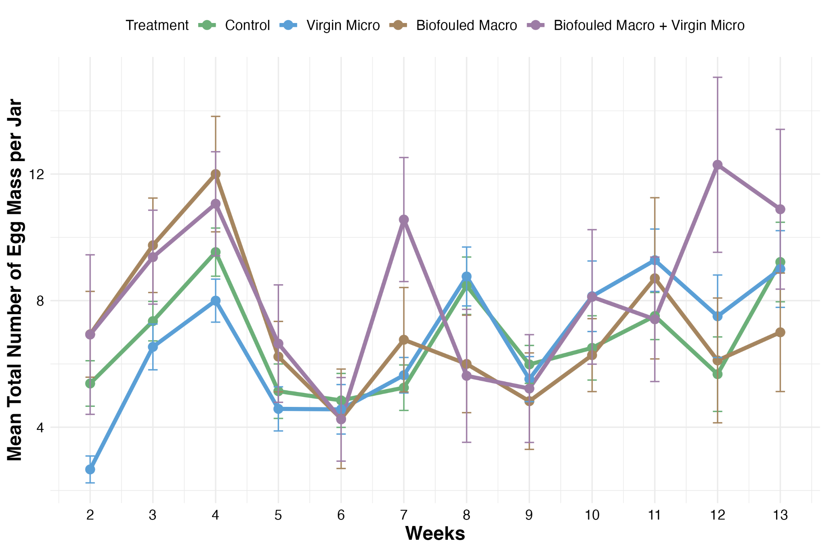
Figure S7. Weekly snail egg mass production per jar of experiment round 1

Table S16. Snail egg mass production model output with coefficients at the log scale, standard error, exponent of the coefficient, and p value between treatments in experiment round 1.
Term | estimate | standard.error | exp.estimate | p.value
Virgin Micro | -0.02 | 0.03 | 0.99 | 0.599
Biofouled Macro | 0.02 | 0.05 | 1.02 | 0.763
Biofouled Macro + Virgin Micro | 0.19 | 0.05 | 1.21 | < 0.001
Snail Shell Length Avg per Jar | 1.39 | 0.14 | 4.00 | < 0.001
Number of Snails per Jar | 0.18 | 0.03 | 1.19 | < 0.001

Table S17. Pairwise comparison of snail egg mass production model output with coefficients at the log scale, standard error, exponent of the coefficient, and p value between treatments in experiment round 1.
Contrast | estimate | standard.error | exp.estimate | p.value
Control vs Virgin Micro | 0.02 | 0.03 | 1.02 | 0.953
Control vs Biofouled Macro | -0.02 | 0.05 | 0.99 | 0.991
Control vs (Biofouled Macro + Virgin Micro) | -0.19 | 0.05 | 0.83 | < 0.001
Virgin Micro vs Biofouled Macro | -0.03 | 0.05 | 0.97 | 0.927
Virgin Micro vs (Biofouled Macro + Virgin Micro) | -0.20 | 0.05 | 0.82 | < 0.001
Biofouled Macro vs (Biofouled Macro + Virgin Micro) | -0.17 | 0.06 | 0.84 | 0.027

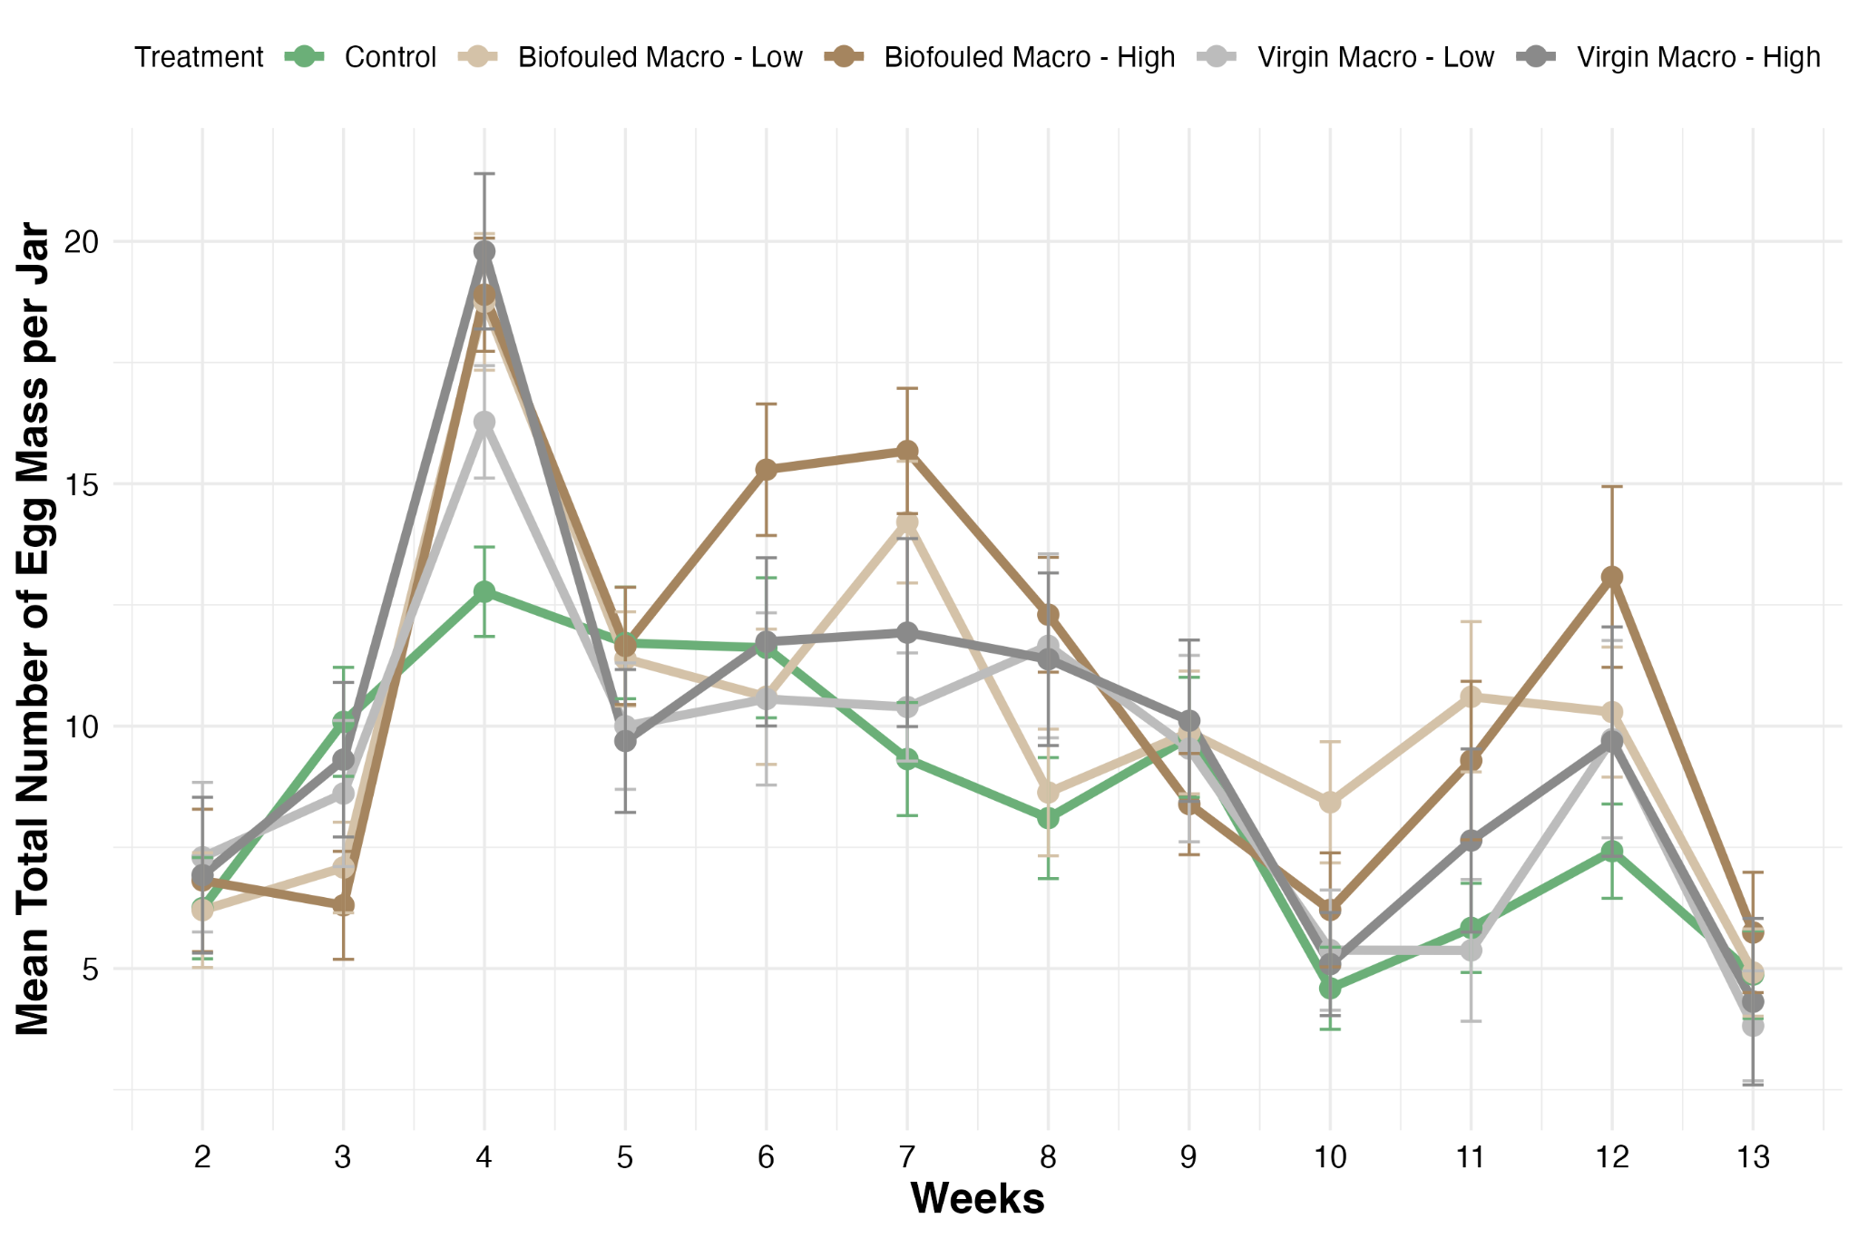
Figure S8. Weekly snail egg mass production per jar of experiment round 2

Table S18. Snail egg mass production model output with coefficients at the log scale, standard error, exponent of the coefficient, and p value between treatments in experiment round 2.
Term | estimate | standard.error | exp.estimate | p.value
Biofouled Macro - Low | 0.14 | 0.03 | 1.15 | < 0.001
Biofouled Macro - High | 0.18 | 0.03 | 1.20 | < 0.001
Virgin Macro - Low | 0.07 | 0.04 | 1.07 | 0.080
Virgin Macro - High | 0.13 | 0.04 | 1.14 | < 0.001
Snail Shell Length Avg per Jar | 0.90 | 0.18 | 2.45 | < 0.001
Number of Snails per Jar | 0.35 | 0.02 | 1.42 | < 0.001

Table S19. Pairwise comparison of snail egg mass production model output with coefficients at the log scale, standard error, exponent of the coefficient, and p value between treatments in experiment round 2
Contrast | estimate | standard.error | exp.estimate | p.value
Control vs (Biofouled Macro - Low) | -0.14 | 0.03 | 0.87 | < 0.001
Control vs (Biofouled Macro - High) | -0.18 | 0.03 | 0.84 | < 0.001
Control vs (Virgin Macro - Low) | -0.07 | 0.04 | 0.93 | 0.403
Control vs (Virgin Macro - High) | -0.13 | 0.04 | 0.88 | 0.007
(Biofouled Macro - Low) vs (Biofouled Macro - High) | -0.04 | 0.03 | 0.96 | 0.766
(Biofouled Macro - Low) vs (Virgin Macro - Low) | 0.07 | 0.04 | 1.08 | 0.325
(Biofouled Macro - Low) vs (Virgin Macro - High) | 0.01 | 0.04 | 1.01 | 0.999
(Biofouled Macro - High) vs (Virgin Macro - Low) | 0.11 | 0.04 | 1.12 | 0.034
(Biofouled Macro - High) vs (Virgin Macro - High) | 0.05 | 0.04 | 1.05 | 0.731
(Virgin Macro - Low) vs (Virgin Macro - High) | -0.06 | 0.04 | 0.94 | 0.596

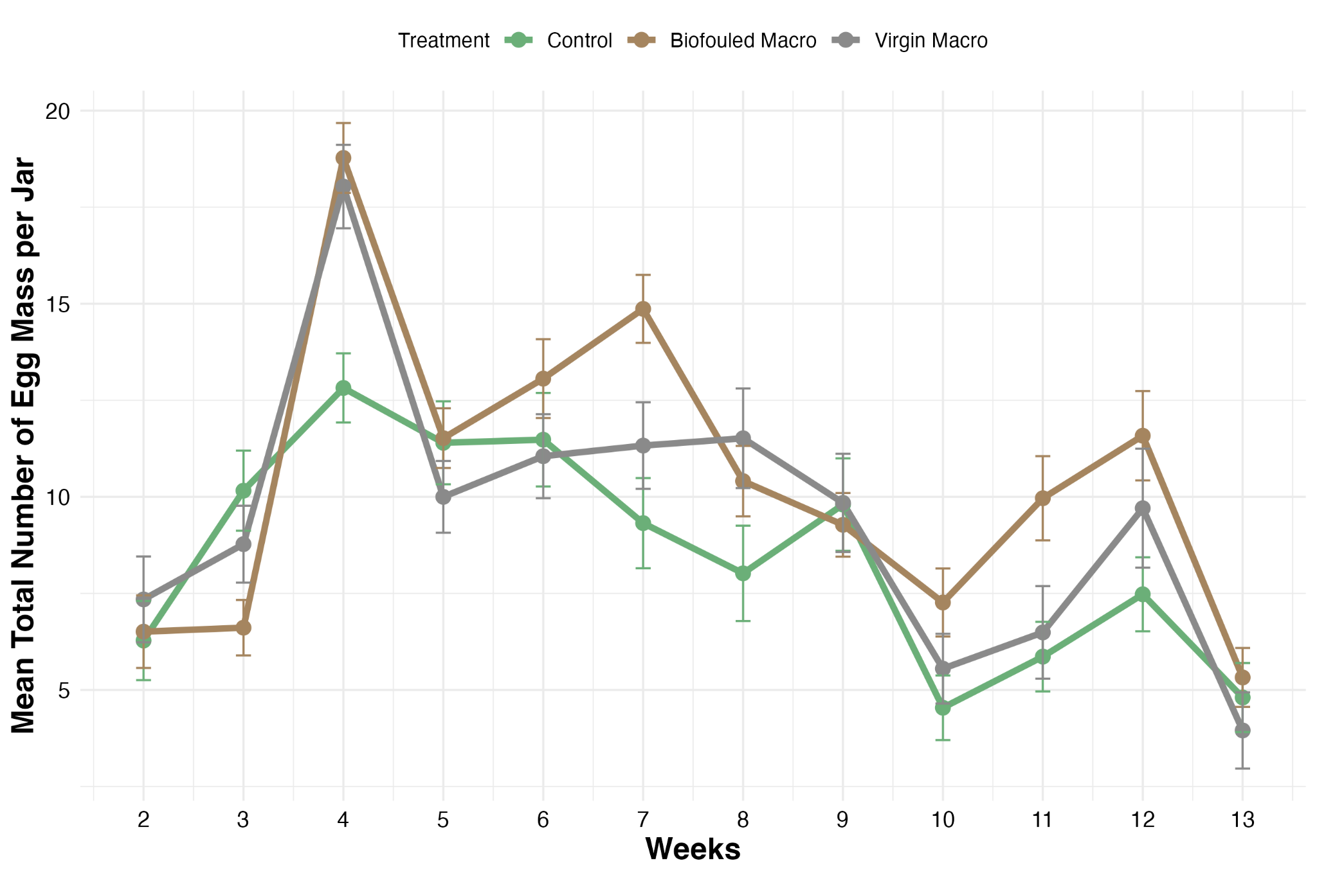
Figure S9. Weekly snail egg mass production per jar of experiment round 2 with grouped macroplastic treatment of various abundance

Table S20. Snail egg mass production model output with coefficients at the log scale, standard error, exponent of the coefficient, and p value between combined treatments with various abundance in experiment round 2.
Grouped Term | estimate | standard.error | exp.estimate | p.value
Biofouled Macro | 0.16 | 0.03 | 1.17 | < 0.001
Virgin Macro | 0.10 | 0.03 | 1.11 | 0.002
Snail Shell Length Avg per Jar | 0.92 | 0.18 | 2.50 | < 0.001
Number of Snails per Jar | 0.35 | 0.02 | 1.42 | < 0.001

Table S21. Pairwise comparison of snail egg mass production model output with coefficients at the log scale, standard error, exponent of the coefficient, and p value between combined treatments with various abundance in experiment round 2
Contrast | estimate | standard.error | exp.estimate | p.value
Control vs Biofouled Macro | -0.16 | 0.03 | 0.85 | < 0.001
Control vs Virgin Macro | -0.10 | 0.03 | 0.91 | 0.006
Biofouled Macro vs Virgin Macro | 0.06 | 0.03 | 1.06 | 0.072

Effect of plastic pollution on snail hatching success
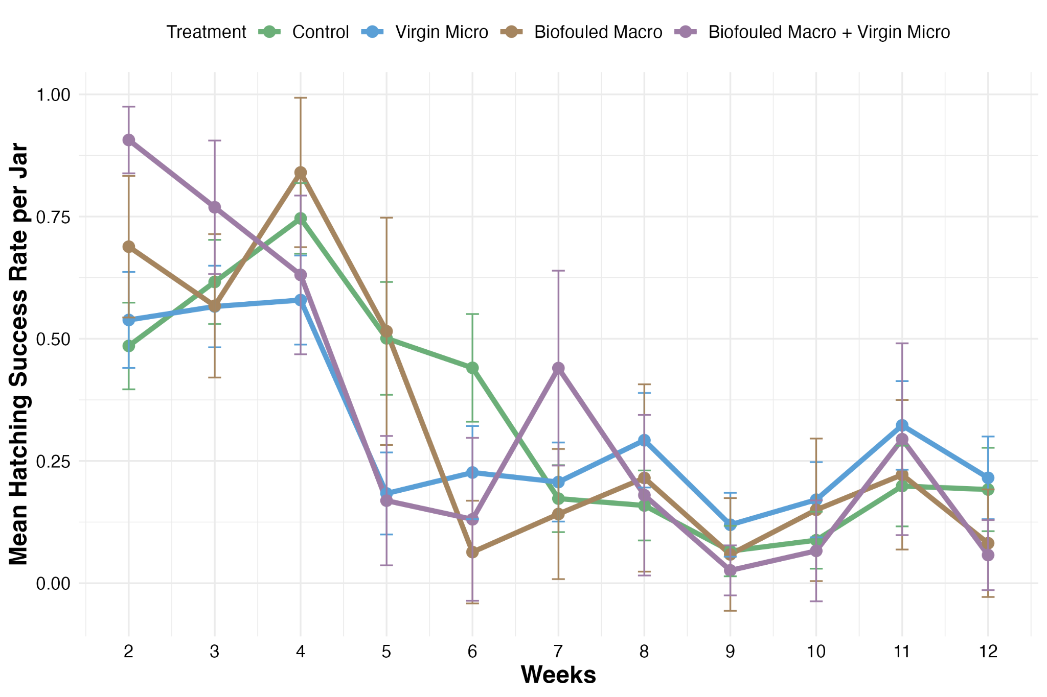
Fig S10. Weekly snail hatching success of experiment round 1

Table S22. Snail egg hatching success conditional model and zero-inflation model with coefficients at the log scale, standard error, exponent of the coefficient, and p value between treatments in experiment round 1.
Conditional model: | Term | estimate | standard.error | exp.estimate | p.value
 | Virgin Micro | -0.09 | 0.05 | 0.91 | 0.081
 | Biofouled Macro | -0.14 | 0.09 | 0.87 | 0.105
 | Biofouled Macro + Virgin Micro | 0.01 | 0.09 | 1.01 | 0.877
 | Snail Shell Length Avg per Jar | -2.8 | 0.25 | 0.06 | < 0.001
 | Number of Snails per Jar | -0.09 | 0.05 | 0.91 | 0.054
Zero-inflation model: | Term | estimate | standard.error | exp.estimate | p.value
 | Virgin Micro | 0.45 | 0.12 | 1.57 | < 0.001
 | Biofouled Macro | -0.01 | 0.18 | 0.99 | 0.959
 | Biofouled Macro + Virgin Micro | 0.27 | 0.19 | 1.31 | 0.145
 | Snail Shell Length Avg per Jar | 9.86 | 0.62 | 19184.98 | < 0.001
 | Number of Snails per Jar | 0.17 | 0.1 | 1.18 | 0.087

Table S23. Pairwise comparison of snail egg hatching success (conditional) model output with coefficients at the log scale, standard error, exponent of the coefficient, and p value between treatments in experiment round 1.
Contrast | estimate | standard.error | exp.estimate | p.value
Control vs Virgin Micro | 0.09 | 0.05 | 1.09 | 0.302
Control vs Biofouled Macro | 0.14 | 0.09 | 1.15 | 0.366
Control vs (Biofouled Macro + Virgin Micro) | -0.01 | 0.09 | 0.99 | 0.999
Virgin Micro vs Biofouled Macro | 0.05 | 0.09 | 1.05 | 0.932
Virgin Micro vs (Biofouled Macro + Virgin Micro) | -0.1 | 0.09 | 0.9 | 0.658
biofouled Macro vs (Biofouled Macro + Virgin Micro) | -0.16 | 0.12 | 0.86 | 0.535

Table S24. Pairwise comparison of snail egg hatching success (zero-inflated) model output with coefficients at the log scale, standard error, exponent of the coefficient, and p value between treatments in experiment round 1.
Contrast | estimate | standard.error | exp.estimate | p.value
Control vs Virgin Micro | -0.45 | 0.12 | 0.64 | < 0.001
Control vs Biofouled Macro | 0.01 | 0.18 | 1.01 | 1.000
Control vs (Biofouled Macro + Virgin Micro) | -0.27 | 0.19 | 0.76 | 0.464
Virgin Micro vs Biofouled Macro | 0.46 | 0.19 | 1.58 | 0.068
Virgin Micro vs (Biofouled Macro + Virgin Micro) | 0.18 | 0.19 | 1.20 | 0.779
Biofouled Macro vs (Biofouled Macro + Virgin Micro) | -0.28 | 0.24 | 0.75 | 0.631

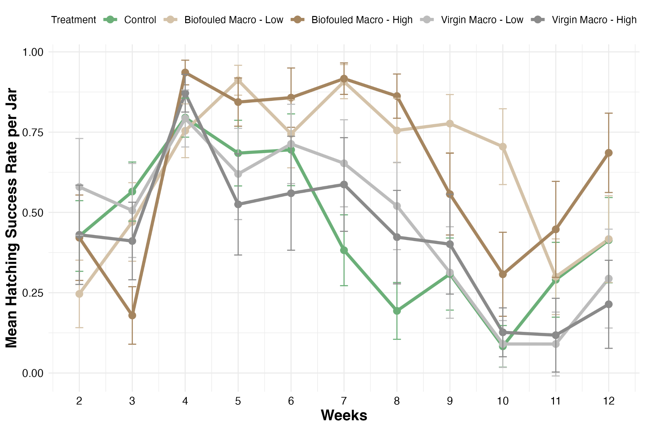
Fig S11. Weekly snail hatching success of experiment round 2

Table S25. Snail egg hatching success conditional model and zero-inflation model with coefficients at the log scale, standard error, exponent of the coefficient, and p value between treatments in experiment round 2
Conditional model: | Term | estimate | standard.error | exp.estimate | p.value
 | Biofouled Macro - Low | 1.00 | 0.05 | 2.72 | < 0.001
 | Biofouled Macro - High | 1.37 | 0.06 | 3.93 | < 0.001
 | Virgin Macro - Low | 0.02 | 0.05 | 1.02 | 0.697
 | Virgin Macro - High | 0.18 | 0.06 | 1.19 | 0.002
 | Experimental Week Number | -0.02 | 0.01 | 0.98 | 0.006
 | Number of Snails per Jar | 0.05 | 0.04 | 1.05 | 0.142
Zero-inflation model: | Term | estimate | standard.error | exp.estimate | p.value
 | Biofouled Macro - Low | -0.43 | 0.15 | 0.68 | 0.005
 | Biofouled Macro - High | -0.45 | 0.16 | 0.65 | 0.004
 | Virgin Macro - Low | -0.04 | 0.17 | 0.93 | 0.803
 | Virgin Macro - High | 0.29 | 0.16 | 1.28 | 0.074
 | Experimental Week Number | 0.13 | 0.02 | 1.16 | < 0.001
 | Number of Snails per Jar | 0.12 | 0.10 | 1.04 | 0.201

Table S26. Pairwise comparison of snail egg hatching success (conditional) model output with coefficients at the log scale, standard error, exponent of the coefficient, and p value between treatments in experiment round 2
Contrast | estimate | standard.error | exp.estimate | p.value
Control vs (Biofouled Macro - Low) | -1.00 | 0.05 | 0.37 | < 0.001
Control vs (Biofouled Macro - High) | -1.37 | 0.06 | 0.26 | < 0.001
Control vs (Virgin Macro - Low) | -0.02 | 0.05 | 0.98 | 0.995
Control vs (Virgin Macro - High) | -0.18 | 0.06 | 0.84 | 0.019
(Biofouled Macro - Low) vs (Biofouled Macro - High) | -0.37 | 0.06 | 0.70 | < 0.001
(Biofouled Macro - Low) vs (Virgin Macro - Low) | 0.98 | 0.06 | 2.66 | < 0.001
(Biofouled Macro - Low) vs (Virgin Macro - High) | 0.83 | 0.06 | 2.28 | < 0.001
(Biofouled Macro - High) vs (Virgin Macro - Low) | 1.35 | 0.06 | 3.84 | < 0.001
(Biofouled Macro - High) vs (Virgin Macro - High) | 1.19 | 0.07 | 3.29 | < 0.001
(Virgin Macro - Low) vs (Virgin Macro - High) | -0.15 | 0.06 | 0.86 | 0.105

Table S27. Pairwise comparison of snail egg hatching success (zero-inflated) model output with coefficients at the log scale, standard error, exponent of the coefficient, and p value between treatments in experiment round 2
Contrast | estimate | standard.error | exp.estimate | p.value
Control vs (Biofouled Macro - Low) | 0.43 | 0.15 | 1.54 | 0.037
Control vs (Biofouled Macro - High) | 0.45 | 0.16 | 1.57 | 0.036
Control vs (Virgin Macro - Low) | 0.04 | 0.17 | 1.04 | 0.999
Control vs (Virgin Macro - High) | -0.29 | 0.17 | 0.75 | 0.383
(Biofouled Macro - Low) vs (Biofouled Macro - High) | 0.02 | 0.16 | 1.02 | 1.000
(Biofouled Macro - Low) vs (Virgin Macro - Low) | -0.39 | 0.17 | 0.68 | 0.156
(Biofouled Macro - Low) vs (Virgin Macro - High) | -0.73 | 0.17 | 0.48 | < 0.001
(Biofouled Macro - High) vs (Virgin Macro - Low) | -0.41 | 0.18 | 0.67 | 0.144
(Biofouled Macro - High) vs (Virgin Macro - High) | -0.74 | 0.17 | 0.48 | < 0.001
(Virgin Macro - Low) vs (Virgin Macro - High) | -0.34 | 0.18 | 0.71 | 0.354

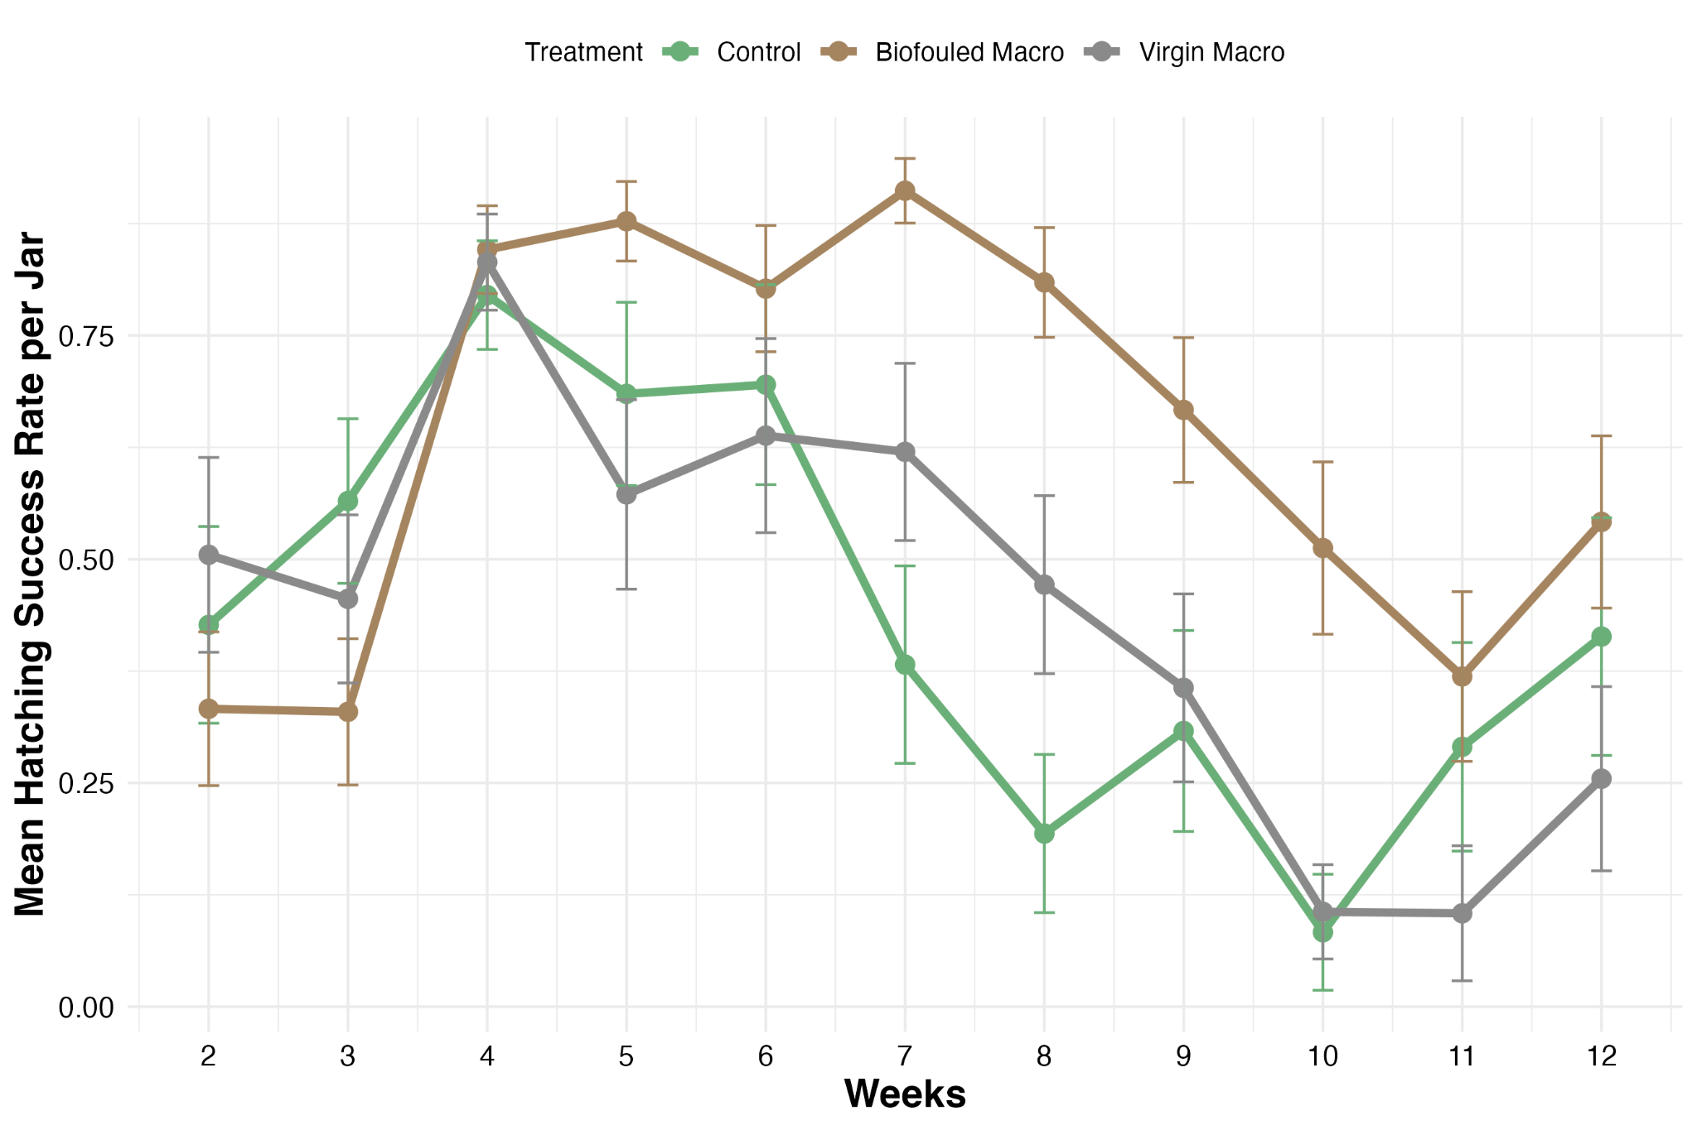
Figure S12. Weekly snail hatching success of experimental round 2 with grouped macroplastic treatment of various abundance.

Table S28. Snail egg hatching success conditional model and zero-inflation model with coefficients at the log scale, standard error, exponent of the coefficient, and p value between combined treatments with various abundance in experiment round 2.
Conditional model: | Term | estimate | standard.error | exp.estimate | p.value
 | Biofouled Macro | 1.16 | 0.05 | 3.20 | < 0.001
 | Virgin Macro | 0.09 | 0.05 | 1.10 | 0.043
 | Experimental Week Number | -0.02 | 0.01 | 0.98 | 0.013
 | Number of Snails per Jar | 0.07 | 0.04 | 1.07 | 0.057
Zero-inflation model: | Term | estimate | standard.error | exp.estimate | p.value
 | Biofouled Macro | -0.44 | 0.13 | 0.64 | < 0.001
 | Virgin Macro | 0.13 | 0.14 | 1.14 | 0.359
 | Experimental Week Number | 0.13 | 0.02 | 1.14 | < 0.001
 | Number of Snails per Jar | 0.13 | 0.10 | 1.14 | 0.182

Table S29. Pairwise comparison of snail egg hatching success (conditional) model output with coefficients at the log scale, standard error, exponent of the coefficient, and p value between combined treatments with various abundance in experiment round 2
Contrast | estimate | standard.error | exp.estimate | p.value
Control vs Biofouled Macro | -1.16 | 0.05 | 0.31 | < 0.001
Control vs Virgin Macro | -0.09 | 0.05 | 0.91 | 0.106
Biofouled Macro vs Virgin Macro | 1.07 | 0.04 | 2.91 | < 0.001

Table S30. Pairwise comparison of snail egg hatching success (zero-inflated) model output with coefficients at the log scale, standard error, exponent of the coefficient, and p value between combined treatments with various abundance in experiment round 2
Contrast | estimate | standard.error | exp.estimate | p.value
Control vs Biofouled Macro | 0.44 | 0.13 | 1.56 | 0.003
Control vs Virgin Macro | -0.13 | 0.14 | 0.88 | 0.629
Biofouled Macro vs Virgin Macro | -0.57 | 0.12 | 0.57 | < 0.001

Overall effect of plastic pollution on the Bulinus snail population
Table S31. Summary statistics with mean and standard deviation of cumulative viable offspring per snail from population permutation test between treatments in experiment round 1
Treatment | Mean population of accumulative viable offsprings per snail from each treatment | DS of population of accumulative viable offsprings per snail from each treatment
Control | 97.12 | 5.19
Biofouled Macro | 122.61 | 9.71
Biofouled Macro + Virgin Micro | 121.71 | 14.85
Virgin Micro | 89.10 | 6.00

Table S32. Pairwise comparisons of population permutation test with observed difference, raw p value, and Bonferroni adjusted p value between treatments in experiment round 1
Contrast | Observed population difference | p value raw | p value  Bonferroni adjusted
Control vs Biofouled Macro | -25.49 | <0.001 | <0.001
Control vs (Biofouled Macro + Virgin Micro) | -24.59 | <0.001 | <0.001
Control vs Virgin Micro | 8.02 | <0.001 | <0.001
Macro vs (Biofouled Macro + Virgin Micro) | 0.90 | <0.001 | <0.001
Biofouled Macro vs Virgin Micro | 33.51 | <0.001 | <0.001
(Biofouled Macro + Virgin Micro) vs Virgin Micro | 32.61 | <0.001 | <0.001

Table S33. Summary statistics with mean and standard deviation of cumulative viable offspring per snail from population permutation test between treatments in experiment round 2
Treatment | Mean population of cumulative viable offsprings per snail from each treatment | DS of population of cumulative viable offsprings per snail from each treatment
Control | 190.79 | 9.86
Biofouled Macro - High | 361.04 | 16.00
Biofouled Macro - Low | 317.38 | 14.62
Virgin Macro - High | 236.64 | 17.16
Virgin Macro - Low | 227.90 | 11.78

Table S34. Pairwise comparisons of population permutation test with observed difference, raw p value, and Bonferroni adjusted p value between treatments in experiment round 2
Contrast | Observed population difference | p value raw | p value Bonferroni  adjusted
Control vs (Biofouled Macro - High) | -126.59 | <0.001 | <0.001
Control vs (Biofouled Macro - Low) | -170.25 | <0.001 | <0.001
Control vs (Virgin Macro - High) | -37.11 | <0.001 | <0.001
Control vs (Virgin Macro - Low) | -45.85 | <0.001 | <0.001
(Biofouled Macro - High) vs (Biofouled Macro - Low) | -43.65 | <0.001 | <0.001
(Biofouled Macro - High) vs (Virgin Macro - High) | 89.49 | <0.001 | <0.001
(Biofouled Macro - High) vs (Virgin Macro - Low) | 80.74 | <0.001 | <0.001
(Biofouled Macro - Low) vs (Virgin Macro - High) | 133.14 | <0.001 | <0.001
(Biofouled Macro - Low) vs (Virgin Macro - Low) | 124.39 | <0.001 | <0.001
(Virgin Macro - High) vs (Virgin Macro - Low) | -8.75 | <0.001 | <0.001

Text S5

Periphyton profiling results and interpretation
We found a significant amount of periphyton grown on the surface of biofouled macroplastic. Microscopic pictures from experiment round 2 demonstrated a diverse microbial community, shown in Figure S13, which consists of various bacteria, diatoms, green algae, cyanobacteria, protozoa, and helminths, which are shown to be nutritious to grazers like freshwater snails(1). The mean AFDM: DM ratio indicates a low to medium organic load, mostly inorganic substances such as sediments and silica(2). Sediments such as silt and clay were gradually accumulated onto the macroplastic during the biofouling process. In systems with high diatom populations with cell walls made from silica, silica could become a major component of the periphyton layer(3). An mean autotrophic index much larger than 400 indicates that the organic matter is heterotroph-dominant(2). The mean Chlorophyll: pheophytin ratio of the algae is much larger than 1 indicates healthy, active algae(2). The mean C:N ratio of lettuce and periphyton, indicating nutritional level per gram, is not significantly different. This suggests that periphyton is nutritionally comparable to lettuce. Therefore, supplementing lettuce with periphyton ad libitum could provide both nutritional diversity and abundance.
The lab versus field biofouling methodology significantly impacts the majority of aspects of the periphyton differently (absolute abundance in dry mass, amount of organic content in AFDM: DM ratio, physiological condition of algae in Chlorophyll: pheophytin ratio, and nutritional quality in C:N ratio), except autotrophic index (Figure S14).

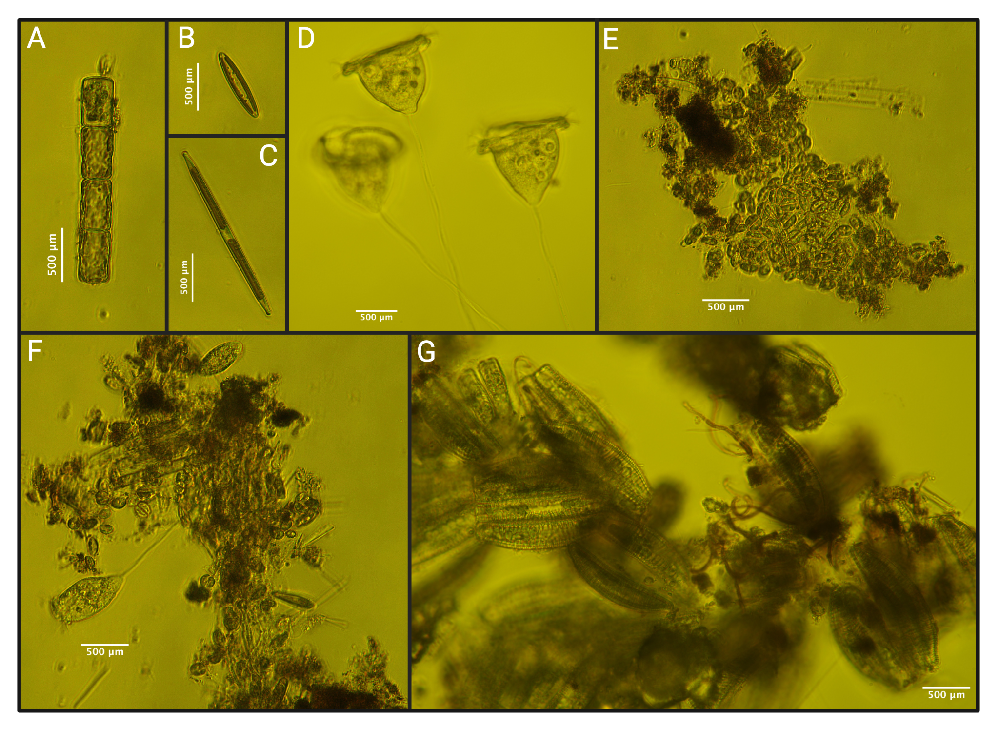
Figure S13. Microscopic pictures at 40 times magnification of the representative microbial community grown on the surface of biofouled macroplastic from round 2 experiment. The community consists of green algae (A), diatoms (B & C & G), various protozoa (D & F), cyanobacteria (E & F), helminth (G), and detritus (E - G).

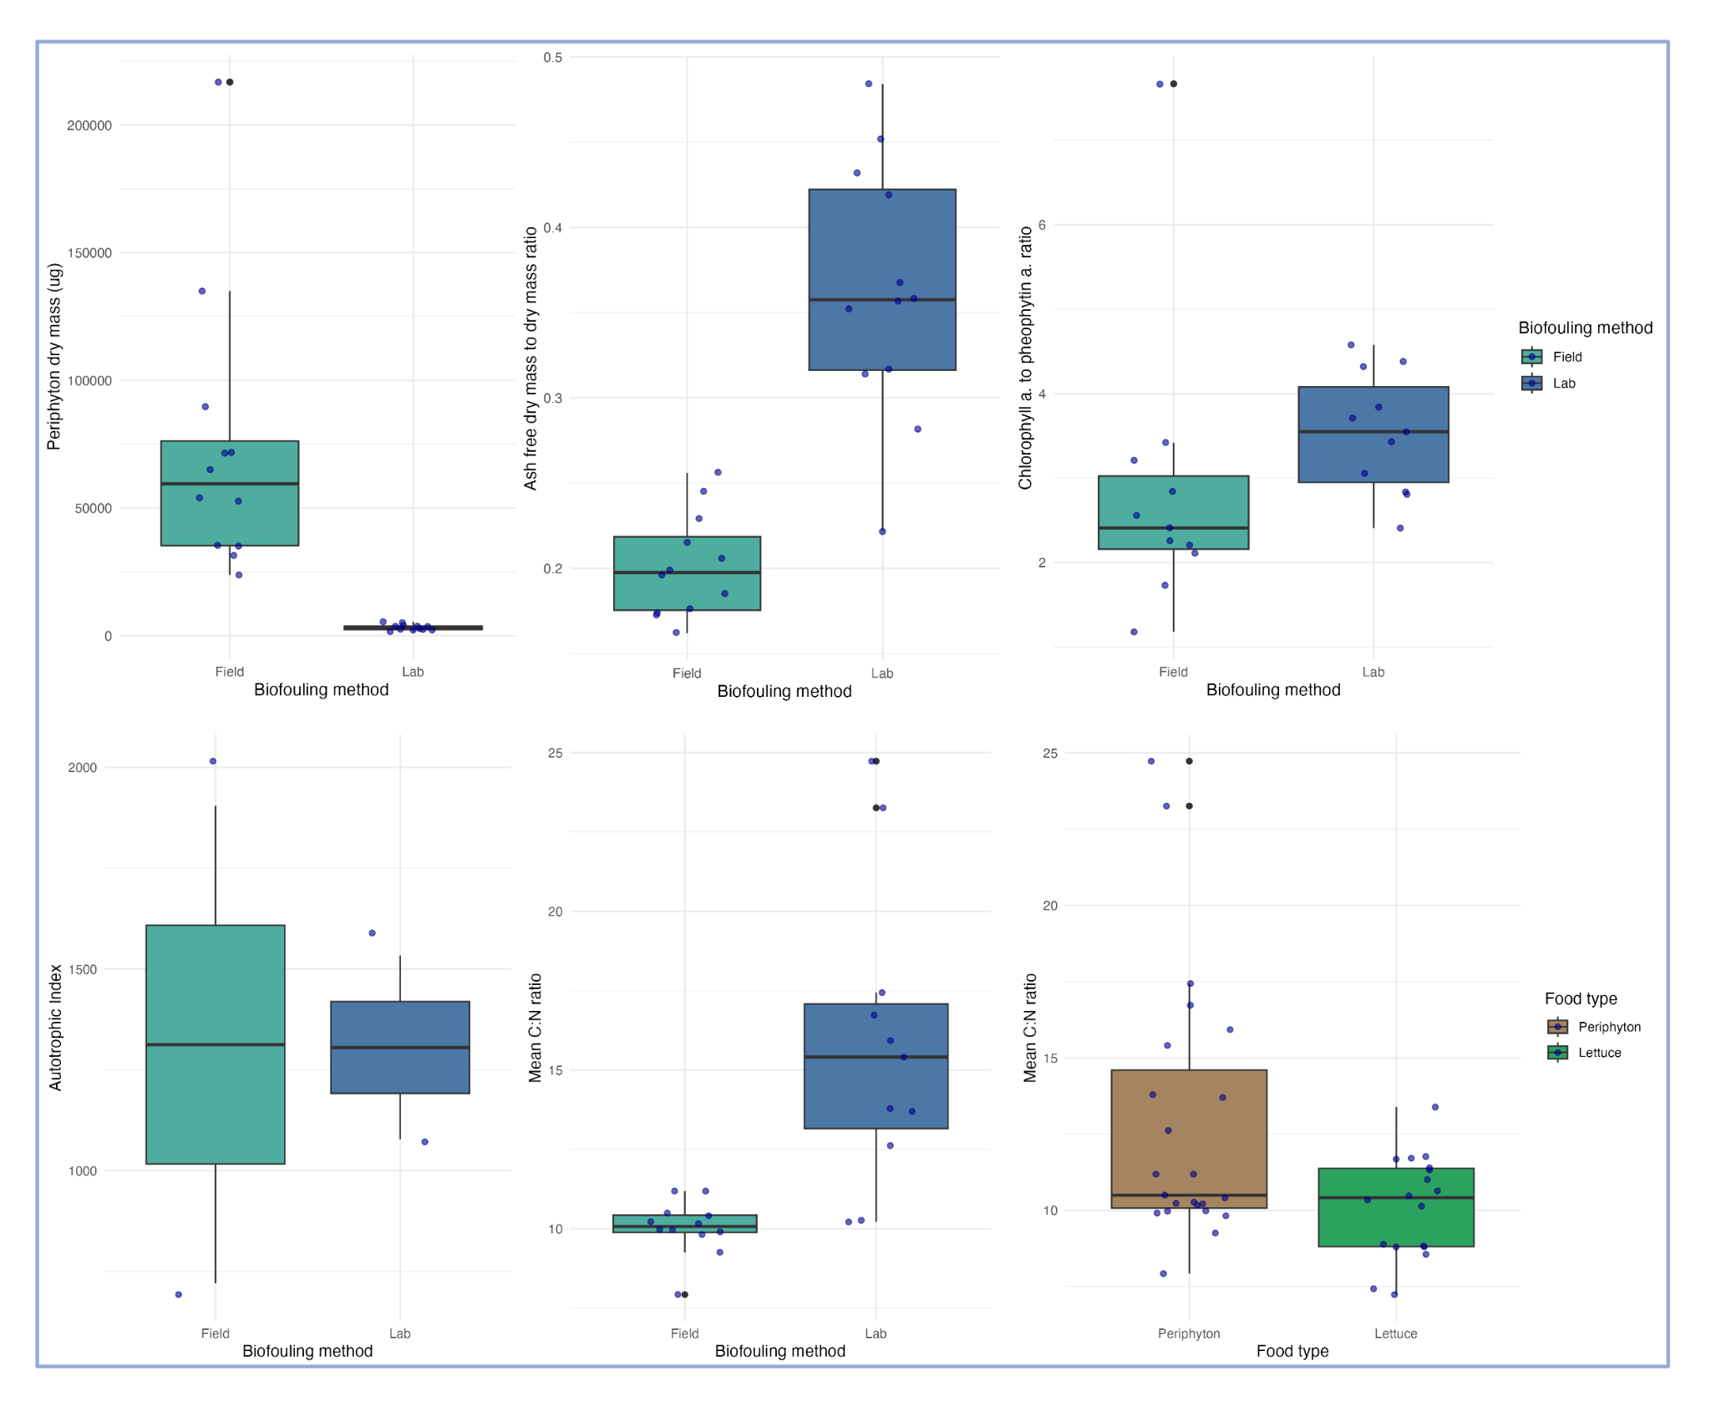
Figure S14. Field versus lab biofouling methodology comparison on all aspects of periphyton. From left to right: Absolute abundance in periphyton dry mass, AFDM: DM ratio, Chlorophyll: pheophytin ratio, autotrophic index, and C:N ratio. The lower right figure shows the nutritional quality comparison between periphyton and lettuce based on C:N ratio.

Microplastic ingestion and egestion in snail feces under microscopy

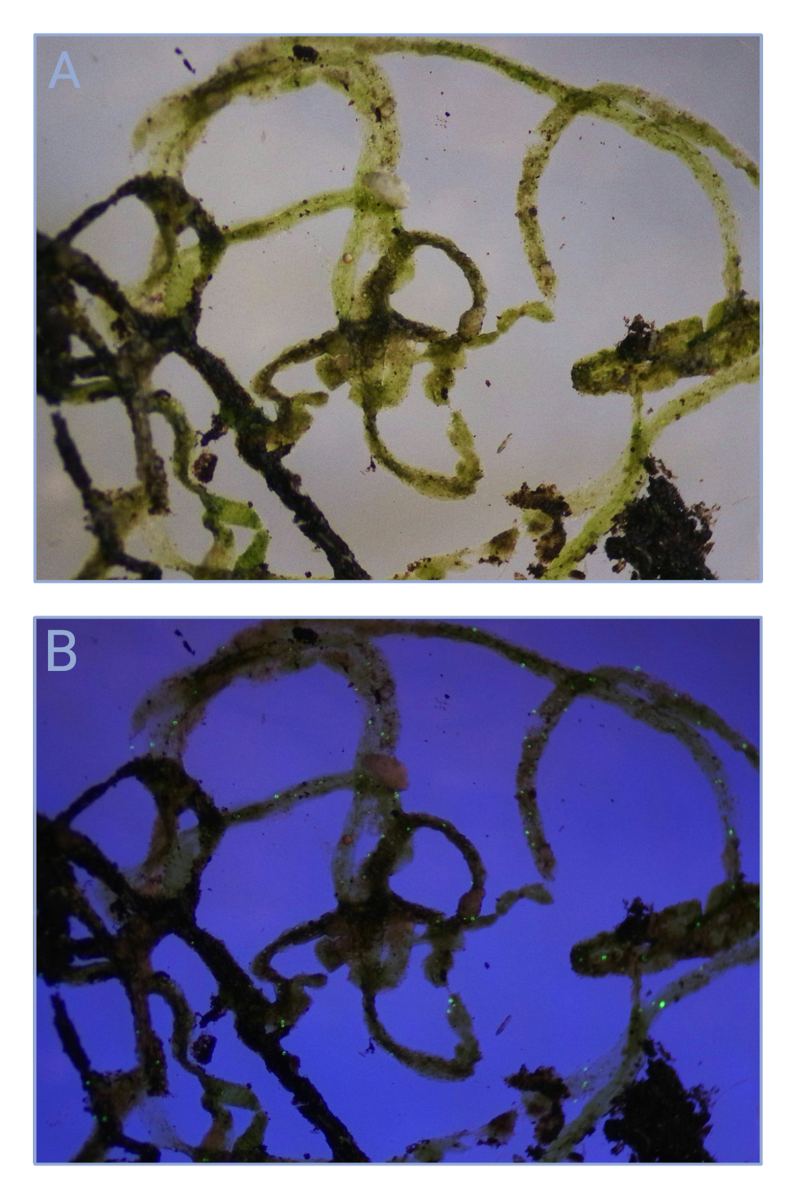
Figure S15. Representative microscopic pictures of snail feces under natural light (A) and UV light (B) from a co-exposed jar with microplastic and macroplastic. Microplastics are light green and almost transparent under natural light, but they are fluorescent under UV light, which allows confirmation of microplastic egestion in snail feces. Snail feces coloration differs from ingestion of romaine lettuce (light green) and biofouled surface periphyton (dark brown green).

SI Reference
1. Bilka RH, Edward P. L. The Invasive New Zealand Mud Snail (Potamopyrgus antipodarum) Grows Faster When Consuming Periphyton Compared to Detritus. Journal of the Pennsylvania Academy of Science [Internet]. 2013 [cited 2025 Nov 3];87(3). Available from: https://dx.doi.org/10.5325/jpennacadscie.87.3.0125
2. Azim ME, Verdegem MCJ, Dam AA van, Beveridge MCM. Periphyton: ecology, exploitation and management [Internet]. CABI; 2005 [cited 2025 Nov 3]. Available from: https://research.wur.nl/en/publications/periphyton-ecology-exploitation-and-management/
3. De Tommasi E, Gielis J, Rogato A. Diatom Frustule Morphogenesis and Function: a Multidisciplinary Survey. Marine Genomics. 2017 Oct 1;35:1–18. doi:10.1016/j.margen.2017.07.001

