USP24-GSDMB complex promotes bladder cancer proliferation via activation of the STAT3 pathway

Haiqing He, Bin Zhang, Bin Yan, Ming Xiao, Jiannan Ren, Dong Zi, Liang Zhu, Zhaohui Zhong, Xiaokun Zhao, Xin Jin, Wei Xiong

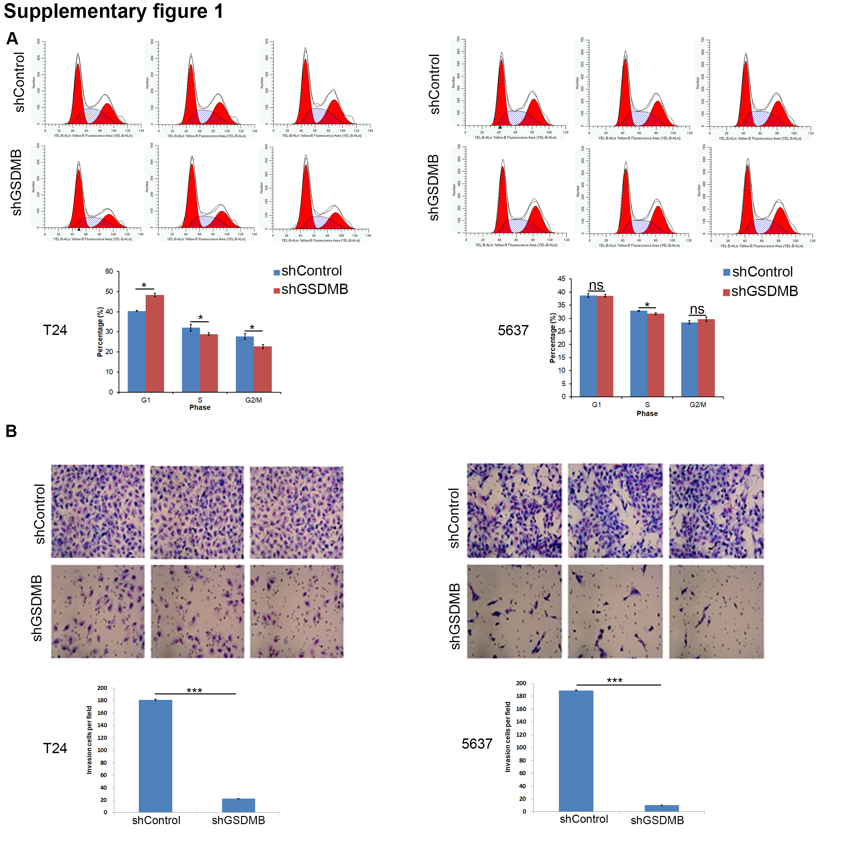
Supplementary figure 1. A and B, T24 and 5637 cells were infected with indicated constructs for 48 h. The cells were harvested for cell cycle assay (A) and transwell invasion assay (B). Data presented as three replicates. ns, not significant; *, P < 0.05; ***, P < 0.001.

Table S1: Sequences of RT-qPCR primers

Species | Gene | Forward (5’-3’) | Reverse (5’-3’)
Human | GAPDH | CCAGAACATCATCCCTGCCT | CCTGCTTCACCACCTTCTTG
Human | HK2 | TCTATGCCATCCCTGAGGAC | TCTCTGCCTTCCACTCCACT
Human | LDHA | GGCCTGTGCCATCAGTATCT | CGCTTCCAATAACACGGTTT
Human | ENO2 | GAAGAAAAGGCCTGCAACTG | CCAGGTCAGCAATGAATGTG
Human | GSDMB | AGTCTTTGGGTTCGGAGGAT | CTTGTCTGGGTCCTCCATGT
Human | IGFBP3 | CCTGCCGTAGAGAAATGGAA | AGGCTGCCCATACTTATCCA

Table S2: Sequences of ChIP-qPCR primers
Species | Gene | Forward (5’-3’) | Reverse (5’-3’)
Human | IGFBP3 | CCCCTGGGGATATAAACAGC | GCATTCGTGTGTACCTCGTG

Table S3: Sequences of gene-specific shRNAs

shGSDMB-1 | 5′- CCGGGCCTTGTTGATGCTGATAGATCTCGAGATCTATCAGCATCAACAAGGCTTTTTTG-3′
shGSDMB-2 | 5′- CCGGGCTGTATGTTGTTGTCTCTATCTCGAGATAGAGACAACAACATACAGCTTTTTTG-3′
shSTAT3 | 5′- CCGGGCACAATCTACGAAGAATCAACTCGAGTTGATTCTTCGTAGATTGTGCTTTTTG-3′
shUSP24-1 | 5′- CCGGCTCTCGTATGTAACGTATTTGCTCGAGCAAATACGTTACATACGAGAGTTTTTGTG-3′
shUSP24-2 | 5′- CCGGACAATACTGTGACCGTATAAACTCGAGTTTATACGGTCACAGTATTGTTTTTTG-3′

