Figure S1. Sensitivity analysis of epigenetic age acceleration across diagnostic groups.

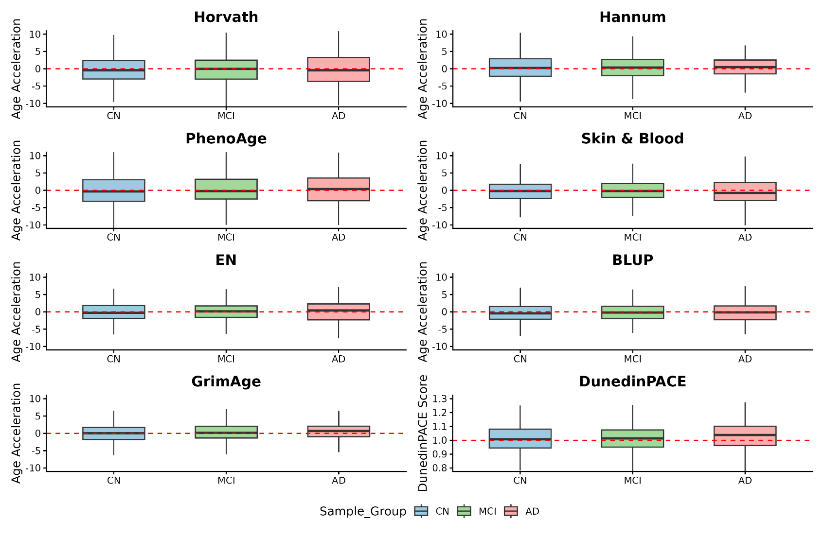
Distribution of epigenetic age acceleration across diagnostic groups after batch correction. Patterns are consistent with primary analyses.

Figure S2. Sensitivity analysis of differential methylation across diagnostic groups.

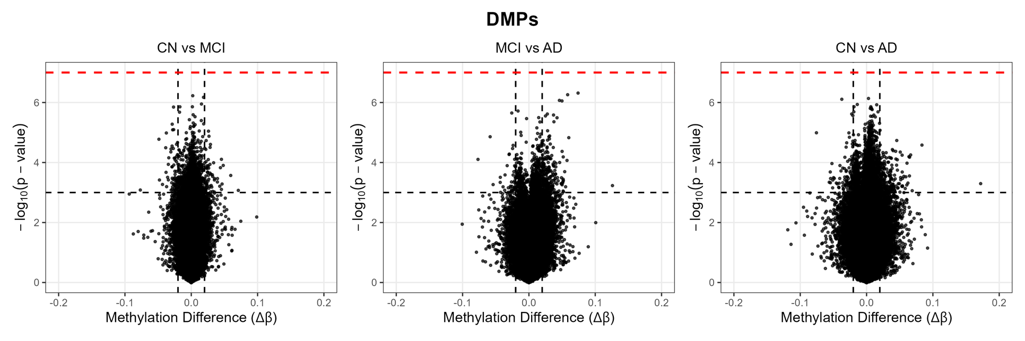
Volcano plots showing differential methylation after batch correction. No CpG sites remained significant after multiple testing correction.

Table S1. Associations between principal components and technical and biological variables.

PC | Term | N | p_ANOVA | p_KW | p_ANOVA_FDR | p_KW_FDR
PC1 | Sample_Group | 639 | 0.748 | 0.611 | 0.748 | 0.655
PC2 | Sample_Group | 639 | 0.726 | 0.902 | 0.748 | 0.902
PC3 | Sample_Group | 639 | 0.283 | 0.312 | 0.472 | 0.520
PC4 | Sample_Group | 639 | 0.123 | 0.217 | 0.416 | 0.520
PC5 | Sample_Group | 639 | 0.319 | 0.297 | 0.478 | 0.520
PC6 | Sample_Group | 639 | 0.038 | 0.110 | 0.416 | 0.520
PC7 | Sample_Group | 639 | 0.477 | 0.565 | 0.650 | 0.655
PC8 | Sample_Group | 639 | 0.620 | 0.578 | 0.748 | 0.655
PC9 | Sample_Group | 639 | 0.109 | 0.167 | 0.416 | 0.520
PC10 | Sample_Group | 639 | 0.715 | 0.386 | 0.748 | 0.579
PC11 | Sample_Group | 639 | 0.245 | 0.458 | 0.472 | 0.625
PC12 | Sample_Group | 639 | 0.283 | 0.228 | 0.472 | 0.520
PC13 | Sample_Group | 639 | 0.167 | 0.293 | 0.417 | 0.520
PC14 | Sample_Group | 639 | 0.139 | 0.091 | 0.416 | 0.520
PC15 | Sample_Group | 639 | 0.068 | 0.056 | 0.416 | 0.520

Table S1. (Cont.) Associations between principal components and technical and biological variables.

PC | Term | N | p_ANOVA | p_KW | p_ANOVA_FDR | p_KW_FDR
PC1 | Slide | 639 | 5.851 × 10⁻⁹² | 9.250 × 10⁻²⁰ | 8.776 × 10⁻⁹¹ | 6.938 × 10⁻¹⁹
PC2 | Slide | 639 | 0.001 | 0.002 | 0.001 | 0.002
PC3 | Slide | 639 | 4.944 × 10⁻²⁷ | 1.065 × 10⁻⁸ | 8.239 × 10⁻²⁷ | 1.598 × 10⁻⁸
PC4 | Slide | 639 | 2.965 × 10⁻³⁶ | 1.535 × 10⁻¹⁷ | 7.413 × 10⁻³⁶ | 3.837 × 10⁻¹⁷
PC5 | Slide | 639 | 8.930 × 10⁻⁵¹ | 3.057 × 10⁻²⁰ | 6.698 × 10⁻⁵⁰ | 4.585 × 10⁻¹⁹
PC6 | Slide | 639 | 2.010 × 10⁻⁵ | 0.002 | 2.319 × 10⁻⁵ | 0.002
PC7 | Slide | 639 | 5.495 × 10⁻⁴⁴ | 2.144 × 10⁻¹⁸ | 2.061 × 10⁻⁴³ | 8.039 × 10⁻¹⁸
PC8 | Slide | 639 | 4.568 × 10⁻²⁶ | 4.444 × 10⁻¹¹ | 6.851 × 10⁻²⁶ | 7.407 × 10⁻¹¹
PC9 | Slide | 639 | 1.352 × 10⁻⁴⁰ | 3.167 × 10⁻¹⁸ | 4.055 × 10⁻⁴⁰ | 9.502 × 10⁻¹⁸
PC10 | Slide | 639 | 5.171 × 10⁻⁵ | 0.0002 | 5.541 × 10⁻⁵ | 0.0003
PC11 | Slide | 639 | 2.497 × 10⁻⁶ | 1.040 × 10⁻⁵ | 3.121 × 10⁻⁶ | 1.300 × 10⁻⁵
PC12 | Slide | 639 | 6.706 × 10⁻⁴⁷ | 8.636 × 10⁻¹⁹ | 3.353 × 10⁻⁴⁶ | 4.318 × 10⁻¹⁸
PC13 | Slide | 639 | 1.607 × 10⁻³² | 1.076 × 10⁻¹³ | 3.444 × 10⁻³² | 2.017 × 10⁻¹³
PC14 | Slide | 639 | 1.175 × 10⁻¹⁵ | 6.060 × 10⁻⁸ | 1.603 × 10⁻¹⁵ | 8.264 × 10⁻⁸
PC15 | Slide | 639 | 1.580 × 10⁻³¹ | 3.679 × 10⁻¹⁴ | 2.963 × 10⁻³¹ | 7.884 × 10⁻¹⁴

Table S2. Cox model results of epigenetic clocks

A) Horvath: Concordance: 0.652 | Likelihood ratio test p-value: 1 × 10⁻⁹
Variable | HR | 95% CI | p-value
SecondTertile | 1.413 | 0.98–2.04 | 0.065
ThirdTertile | 1.998 | 1.39–2.88 | 0.00021
PTGENDER | 1.084 | 0.79–1.48 | 0.62
GENOTYPE | 2.049 | 1.66–2.53 | 2.6 × 10⁻¹¹
PTEDUCAT | 0.965 | 0.91–1.02 | 0.19
Bcell | 0.003 | ~0–68 | 0.25
NK | 6087 | ~0–5 × 10⁸ | 0.13
CD4T | 121 | ~0–1 × 10⁶ | 0.30
CD8T | 26.60 | ~0–3 × 10⁵ | 0.49
Mono | 723 | ~0–2 × 10⁷ | 0.22
Neu | 239 | ~0–1 × 10⁶ | 0.22

B) skinHorvath: Concordance: 0.662 | Likelihood ratio test p-value: 1 × 10⁻¹⁰
Variable | HR | 95% CI | p-value
SecondTertile | 1.676 | 1.15–2.45 | 0.0075
ThirdTertile | 2.267 | 1.57–3.28 | 1.5 × 10⁻⁵
PTGENDER | 1.038 | 0.76–1.42 | 0.82
GENOTYPE | 2.062 | 1.67–2.55 | 2.7 × 10⁻¹¹
PTEDUCAT | 0.971 | 0.92–1.02 | 0.28
Bcell | 0.0057 | ~0–147 | 0.32
NK | 2755 | ~0–2.7 × 10⁸ | 0.18
CD4T | 83.9 | ~0–7 × 10⁵ | 0.34
CD8T | 20.3 | ~0–2 × 10⁵ | 0.53
Mono | 296 | ~0–1 × 10⁷ | 0.30
Neu | 159 | ~0–1 × 10⁶ | 0.26

C) Hannum: Concordance: 0.654 | Likelihood ratio test p-value: 1 × 10⁻⁹
Variable | HR | 95% CI | p-value
SecondTertile | 1.552 | 1.07–2.25 | 0.02
ThirdTertile | 2.113 | 1.43–3.12 | 0.00017
PTGENDER | 1.022 | 0.75–1.40 | 0.89
GENOTYPE | 2.071 | 1.67–2.56 | 2.2 × 10⁻¹¹
PTEDUCAT | 0.966 | 0.92–1.02 | 0.21
Bcell | 0.0020 | ~0–54 | 0.23
NK | 425 | ~0–4 × 10⁷ | 0.30
CD4T | 84.9 | ~0–6 × 10⁵ | 0.33
CD8T | 21.0 | ~0–2 × 10⁵ | 0.52
Mono | 123 | ~0–5 × 10⁶ | 0.38
Neu | 77.0 | ~0–5 × 10⁵ | 0.33

D) Levine: Concordance: 0.654 | Likelihood ratio test p-value: 2 × 10⁻⁹
Variable | HR | 95% CI | p-value
SecondTertile | 1.433 | 0.97–2.11 | 0.069
ThirdTertile | 2.025 | 1.36–3.01 | 0.00049
PTGENDER | 1.051 | 0.77–1.44 | 0.76
GENOTYPE | 2.022 | 1.64–2.49 | 4.3 × 10⁻¹¹
PTEDUCAT | 0.970 | 0.92–1.02 | 0.27
Bcell | 0.0014 | ~0–44 | 0.21
NK | 239 | ~0–2 × 10⁷ | 0.36
CD4T | 42.9 | ~0–3 × 10⁵ | 0.41
CD8T | 16.4 | ~0–2 × 10⁵ | 0.56
Mono | 91.3 | ~0–4 × 10⁶ | 0.41
Neu | 42.4 | ~0–3 × 10⁵ | 0.41

E) BLUP: Concordance: 0.662 | Likelihood ratio test p-value: 1 × 10⁻¹⁰
Variable | HR | 95% CI | p-value
SecondTertile | 1.577 | 1.08–2.30 | 0.017
ThirdTertile | 2.284 | 1.57–3.33 | 1.7 × 10⁻⁵
PTGENDER | 1.027 | 0.75–1.41 | 0.87
GENOTYPE | 2.060 | 1.67–2.55 | 2.1 × 10⁻¹¹
PTEDUCAT | 0.976 | 0.93–1.03 | 0.38
Bcell | 0.015 | ~0–388 | 0.42
NK | 7026 | ~0–7 × 10⁸ | 0.13
CD4T | 294 | ~0–2 × 10⁶ | 0.22
CD8T | 91.4 | ~0–1 × 10⁶ | 0.34
Mono | 416 | ~0–1 × 10⁷ | 0.27
Neu | 511 | ~0–3 × 10⁶ | 0.17

F) EN: Concordance: 0.654 | Likelihood ratio test p-value: 8 × 10⁻¹⁰
Variable | HR | 95% CI | p-value
SecondTertile | 1.332 | 0.91–1.95 | 0.14
ThirdTertile | 2.058 | 1.41–3.00 | 0.00018
PTGENDER | 1.019 | 0.74–1.40 | 0.91
GENOTYPE | 2.083 | 1.68–2.58 | 1.7 × 10⁻¹¹
PTEDUCAT | 0.966 | 0.92–1.02 | 0.21
Bcell | 0.0015 | ~0–43 | 0.21
NK | 341 | ~0–3 × 10⁷ | 0.32
CD4T | 43.7 | ~0–3 × 10⁵ | 0.41
CD8T | 16.6 | ~0–2 × 10⁵ | 0.55
Mono | 72.9 | ~0–3 × 10⁶ | 0.43
Neu | 75.2 | ~0–5 × 10⁵ | 0.34

G) DunedinPACE: Concordance: 0.653 | Likelihood ratio test p-value: 2 × 10⁻⁸
Variable | HR | 95% CI | p-value
SecondTertile | 0.955 | 0.66–1.38 | 0.81
ThirdTertile | 1.532 | 1.07–2.20 | 0.02
PTGENDER | 1.027 | 0.75–1.41 | 0.87
GENOTYPE | 2.010 | 1.63–2.48 | 7.8 × 10⁻¹¹
PTEDUCAT | 0.960 | 0.91–1.01 | 0.14
Bcell | 0.011 | ~0–358 | 0.39
NK | 6411 | ~0–7 × 10⁸ | 0.14
CD4T | 380 | ~0–4 × 10⁶ | 0.21
CD8T | 250 | ~0–3 × 10⁶ | 0.25
Mono | 6572 | ~0–2 × 10⁸ | 0.10
Neu | 687 | ~0–5 × 10⁶ | 0.15

H) GrimAge: Concordance: 0.659 | Likelihood ratio test p-value: 2 × 10⁻¹¹
Variable | HR | 95% CI | p-value
SecondTertile | 2.189 | 1.49–3.22 | 7.2 × 10⁻⁵
ThirdTertile | 2.556 | 1.69–3.87 | 9 × 10⁻⁶
PTGENDER | 1.137 | 0.83–1.56 | 0.42
GENOTYPE | 2.151 | 1.73–2.67 | 4.8 × 10⁻¹²
PTEDUCAT | 0.976 | 0.92–1.03 | 0.37
Bcell | 0.12 | ~0–3302 | 0.68
NK | 12600 | ~0–1 × 10⁹ | 0.11
CD4T | 412 | ~0–3 × 10⁶ | 0.19
CD8T | 189 | ~0–2 × 10⁶ | 0.27
Mono | 265 | ~0–1 × 10⁷ | 0.30
Neu | 427 | ~0–2 × 10⁶ | 0.18

Table S3. Methylation status at the single CpG level and conversion

CpG | SD_cpg | HR_per_SD | lower_95_SD | upper_95_SD | p_value | FDR | log2HR | neglog10 | CI95_SD
cg11863237 | 0.015 | 1.293 | 1.181 | 1.415 | 2.34 × 10⁻⁸ | 0.014 | 0.371 | 7.630 | [1.18 - 1.41]
cg24953682 | 0.021 | 0.769 | 0.700 | 0.844 | 3.58 × 10⁻⁸ | 0.014 | -0.380 | 7.447 | [0.7 - 0.84]
cg14031964 | 0.027 | 0.755 | 0.682 | 0.836 | 6.31 × 10⁻⁸ | 0.016 | -0.405 | 7.200 | [0.68 - 0.84]
cg02408252 | 0.045 | 0.726 | 0.645 | 0.818 | 1.27 × 10⁻⁷ | 0.024 | -0.461 | 6.895 | [0.65 - 0.82]
cg09701580 | 0.027 | 0.730 | 0.649 | 0.822 | 1.72 × 10⁻⁷ | 0.026 | -0.453 | 6.764 | [0.65 - 0.82]
cg26306080 | 0.027 | 0.762 | 0.688 | 0.845 | 2.23 × 10⁻⁷ | 0.028 | -0.391 | 6.652 | [0.69 - 0.84]
cg22034077 | 0.038 | 0.740 | 0.658 | 0.833 | 6.51 × 10⁻⁷ | 0.071 | -0.434 | 6.187 | [0.66 - 0.83]
cg08502322 | 0.031 | 0.612 | 0.503 | 0.746 | 1.09 × 10⁻⁶ | 0.092 | -0.708 | 5.962 | [0.5 - 0.75]
cg22685718 | 0.036 | 1.285 | 1.162 | 1.421 | 1.02 × 10⁻⁶ | 0.092 | 0.362 | 5.990 | [1.16 - 1.42]
cg03551964 | 0.032 | 1.273 | 1.154 | 1.405 | 1.52 × 10⁻⁶ | 0.115 | 0.348 | 5.819 | [1.15 - 1.4]
cg16887640 | 0.026 | 0.702 | 0.608 | 0.812 | 1.73 × 10⁻⁶ | 0.120 | -0.510 | 5.762 | [0.61 - 0.81]
cg13629345 | 0.018 | 1.273 | 1.152 | 1.406 | 2.16 × 10⁻⁶ | 0.126 | 0.348 | 5.666 | [1.15 - 1.41]
cg04709185 | 0.037 | 0.553 | 0.433 | 0.707 | 2.13 × 10⁻⁶ | 0.126 | -0.853 | 5.672 | [0.43 - 0.71]
cg04170192 | 0.007 | 1.482 | 1.258 | 1.748 | 2.79 × 10⁻⁶ | 0.135 | 0.568 | 5.554 | [1.26 - 1.75]
cg03142905 | 0.024 | 0.803 | 0.732 | 0.881 | 3.52 × 10⁻⁶ | 0.135 | -0.316 | 5.453 | [0.73 - 0.88]
cg18002339 | 0.023 | 0.782 | 0.706 | 0.867 | 3.09 × 10⁻⁶ | 0.135 | -0.354 | 5.510 | [0.71 - 0.87]
cg14684108 | 0.025 | 0.673 | 0.570 | 0.796 | 3.54 × 10⁻⁶ | 0.135 | -0.570 | 5.451 | [0.57 - 0.8]
cg06316563 | 0.026 | 0.736 | 0.647 | 0.837 | 3.10 × 10⁻⁶ | 0.135 | -0.442 | 5.509 | [0.65 - 0.84]
cg04547809 | 0.007 | 0.770 | 0.690 | 0.860 | 3.23 × 10⁻⁶ | 0.135 | -0.376 | 5.491 | [0.69 - 0.86]
cg16744168 | 0.045 | 0.734 | 0.645 | 0.836 | 3.20 × 10⁻⁶ | 0.135 | -0.446 | 5.494 | [0.64 - 0.84]
cg26580895 | 0.013 | 1.339 | 1.182 | 1.518 | 4.74 × 10⁻⁶ | 0.157 | 0.421 | 5.324 | [1.18 - 1.52]
cg02461883 | 0.037 | 1.275 | 1.149 | 1.414 | 4.45 × 10⁻⁶ | 0.157 | 0.350 | 5.351 | [1.15 - 1.41]
cg00360679 | 0.036 | 0.758 | 0.673 | 0.853 | 4.63 × 10⁻⁶ | 0.157 | -0.400 | 5.334 | [0.67 - 0.85]

Table S4. Methylation status at the single CpG level and cognitive decline

CpG_Continuous_MMSE | beta | SE | t_value | p_value | R² | FDR
cg04547809 | 1.378 | 0.469 | 2.937 | 0.003 | 0.069 | ~1.000
cg04709185 | 2.082 | 0.807 | 2.579 | 0.010 | 0.066 | ~1.000
cg16744168 | 1.553 | 0.759 | 2.046 | 0.041 | 0.063 | ~1.000
cg08502322 | 1.401 | 0.703 | 1.993 | 0.047 | 0.062 | ~1.000
cg24953682 | 0.921 | 0.477 | 1.929 | 0.054 | 0.062 | ~1.000
cg22685718 | -0.886 | 0.464 | -1.911 | 0.057 | 0.062 | ~1.000
cg02408252 | 0.635 | 0.364 | 1.746 | 0.081 | 0.061 | ~1.000
cg26306080 | 0.768 | 0.574 | 1.339 | 0.181 | 0.059 | ~1.000
cg11863237 | -0.772 | 0.676 | -1.142 | 0.254 | 0.058 | ~1.000
cg02461883 | -0.410 | 0.366 | -1.120 | 0.263 | 0.058 | ~1.000
cg22034077 | 0.566 | 0.535 | 1.057 | 0.291 | 0.058 | ~1.000
cg13629345 | -0.329 | 0.390 | -0.845 | 0.398 | 0.057 | ~1.000
cg03142905 | 0.329 | 0.395 | 0.833 | 0.405 | 0.057 | ~1.000
cg06316563 | 0.517 | 0.669 | 0.772 | 0.440 | 0.057 | ~1.000
cg14031964 | 0.234 | 0.310 | 0.757 | 0.449 | 0.057 | ~1.000
cg03551964 | -0.297 | 0.480 | -0.618 | 0.537 | 0.057 | ~1.000
cg14684108 | 0.369 | 0.723 | 0.510 | 0.610 | 0.057 | ~1.000
cg04170192 | -0.344 | 0.740 | -0.465 | 0.642 | 0.056 | ~1.000
cg18002339 | 0.188 | 0.425 | 0.442 | 0.659 | 0.056 | ~1.000
cg16887640 | -0.124 | 0.610 | -0.203 | 0.839 | 0.056 | ~1.000
cg26580895 | 0.008 | 0.576 | 0.014 | 0.989 | 0.056 | ~1.000
cg09701580 | 0.003 | 0.632 | 0.004 | 0.996 | 0.056 | ~1.000
cg00360679 | -0.001 | 0.581 | -0.002 | 0.999 | 0.056 | ~1.000

Table S5. CpG methylation and plasma biomarker associations

Marker | N_samples | N_FDR_sig_CpGs | Top_P | Top_FDR
pT217_F | 40 | 11 | 4.93 × 10⁻⁸ | 0.019
AB42_F | 40 | 0 | 1.84 × 10⁻⁶ | ~1.000
AB40_F | 40 | 0 | 2.82 × 10⁻⁶ | ~1.000
AB42_AB40_F | 40 | 0 | 4.94 × 10⁻⁷ | 0.331
pT217_AB42_F | 40 | 0 | 1.38 × 10⁻⁷ | 0.105
NfL_Q | 40 | 0 | 6.31 × 10⁻⁶ | ~1.000
GFAP_Q | 40 | 0 | 4.65 × 10⁻⁶ | 0.982

Table S6. CpG methylation and plasma p-tau217 associations

A) Epigenome-wide association analysis: R²: 0.807 | Adjusted R²: 0.732 | F-statistic p-value: 2.43 × 10⁻⁷
Variable | Estimate | Std Error | p-value
Intercept | 1.331 | 0.536 | 0.0193
cg15992932 | 0.243 | 0.081 | 0.0055
cg05774141 | -0.265 | 0.102 | 0.0151
cg09957712 | -0.059 | 0.094 | 0.532
cg14830287 | 0.088 | 0.194 | 0.653
cg26288595 | 0.183 | 0.096 | 0.066
cg05622569 | -0.046 | 0.170 | 0.788
cg27264172 | 0.142 | 0.188 | 0.456
cg08832596 | -0.115 | 0.067 | 0.095
cg03039559 | -0.048 | 0.180 | 0.792
cg02104112 | -0.029 | 0.106 | 0.790
cg09788949 | 0.025 | 0.201 | 0.904

B) Multivariable linear regression model: R²: 0.887 | Adjusted R²: 0.755 | F-statistic p-value: 7.33 × 10⁻⁵
Variable | Estimate | Std Error | p-value
Intercept | 2.457 | 4.287 | 0.574
cg15992932 | 0.276 | 0.114 | 0.0259
cg05774141 | -0.179 | 0.136 | 0.206
cg09957712 | -0.060 | 0.118 | 0.617
cg14830287 | -0.180 | 0.247 | 0.475
cg26288595 | 0.153 | 0.103 | 0.156
cg05622569 | 0.042 | 0.186 | 0.825
cg27264172 | 0.070 | 0.244 | 0.778
cg08832596 | -0.083 | 0.081 | 0.318
cg03039559 | -0.032 | 0.225 | 0.888
cg02104112 | 0.013 | 0.128 | 0.919
cg09788949 | 0.114 | 0.294 | 0.703
Age | -0.003 | 0.008 | 0.722
PTGENDER | 0.074 | 0.149 | 0.623
GENOTYPE | 0.187 | 0.096 | 0.0677
PTEDUCAT | -0.011 | 0.016 | 0.497

B) (Cont.) Multivariable linear regression model: R²: 0.887 | Adjusted R²: 0.755 | F-statistic p-value: 7.33 × 10⁻⁵
Variable | Estimate | Std Error | p-value
Bcell | -0.260 | 4.317 | 0.953
NK | -0.997 | 4.481 | 0.827
CD4T | -2.795 | 4.204 | 0.515
CD8T | -3.259 | 4.579 | 0.486
Mono | 1.495 | 4.604 | 0.749
Neu | -0.827 | 4.229 | 0.847

