Supplemental Data
Supplemental Table 1. Average weight (g), fork length (cm), and stretch total length (cm) of fish and oysters collected from Galveston Bay reported in mean ± standard error.

Common name | n | Weight (g) | Fork length (cm) | Stretch total length (cm) | Maturity
Eastern oyster | 10 | 12.83 ± 2.19 | - | - | Adult (Grizzle et al., 2017)
Gafftopsail catfish | 10 | 1503 ± 97.92 | 45.11 ± 0.80 | 54.51 ± 0.91 | Adult (TPWD, 2024)
Red drum | 10 | 1611.4 ± 185.61 | 47.40 ± 1.35 | 53.67 ± 1.59 | Juvenile (Wenner, 1996)
Spotted seatrout | 10 | 1071 ± 207.23 | 42.07 ± 2.77 | 47.11 ± 2.91 | Adult (Brown-Peterson et al., 2002)

Supplemental Table 2. Concentration of total PAH found in various biotic and abiotic matrix collected from Galveston Bay as well as the Gulf of Mexico and its bays, organized by year.
Location | Year | Air | Water | Sediment | Fish Muscle | Body weight | Fish Liver | Oyster | Body weight | References
Galveston Bay | 1968 |  |  | 479 ng/g |  |  |  |  |  | (Presley et al., 1998)
Galveston Bay | 1971 |  |  |  |  |  |  | 10-210 ng/g DW (Crassostrea virginica) |  | (Pittinger et al., 1985)
Galveston Bay | 1975 |  |  | 250 ng/g |  |  |  |  |  | (Santschi et al., 2001)
Galveston Bay | 1978 |  |  | 180 ng/g |  |  |  |  |  | (Santschi et al., 2001)
Galveston Bay | 1981 |  |  | 220 ng/g |  |  |  |  |  | (Santschi et al., 2001)
Galveston Bay | 1986 |  |  | 190 ng/g |  |  |  |  |  | (Santschi et al., 2001)
Galveston Bay | 1986 |  |  | 94 ng/g |  |  |  |  |  | (Jackson et al., 1998)
Galveston Bay | 1987 |  |  | 52 ng/g |  |  |  |  |  | (Jackson et al., 1998)
Galveston Bay | 1988 |  |  | 174 ng/g |  |  |  |  |  | (Jackson et al., 1998)
Galveston Bay | 1989 |  |  | 202 ng/g |  |  |  |  |  | (Jackson et al., 1998)
Galveston Bay | 1990 |  |  | 310 ng/g |  |  |  |  |  | (Santschi et al., 2001)
Galveston Bay | 1990 |  |  | 120 ng/g |  |  |  |  |  | (Jackson et al., 1998)
Galveston Bay | 1991 |  |  | 24 ng/g |  |  |  |  |  | (Jackson et al., 1998)
Galveston Bay | 1992 |  |  | 43 ng/g |  |  |  |  |  | (Jackson et al., 1998)
Galveston Bay | 1993 |  |  | 78 ng/g |  |  |  |  |  | (Jackson et al., 1998)
Galveston Bay | 1994 |  |  | 168 ng/g |  |  |  |  |  | (Jackson et al., 1998)
Galveston Bay | 1996 |  |  | 52-153 ng/g |  |  |  |  |  | (Presley et al., 1998)
Galveston Bay | 1996 |  |  | 68-724 ng/g |  |  | 393-1,520 ng/g (Hardhead catfish) |  |  | (Willett et al., 1997)
Galveston Bay | 1996 |  |  |  |  |  | 406-587 ng/g (Croaker) |  |  | (Willett et al., 1997)
Galveston Bay | 1998 |  |  | 19.80 ng/g |  |  |  |  |  | (Lauenstein & Cantillo, 1998)
Galveston Bay | 2001 | 0.0246 ng/L |  |  |  |  |  |  |  | (Park et al., 2001b)
Galveston Bay | 2001 |  |  | 88-7,128 ng/g |  |  |  | 488-9,227 ng/g DW (Crassostrea virginica) |  | (Qian et al., 2001)
Galveston Bay | 2001 |  |  | 320 ng/g |  |  |  |  |  | (Santschi et al., 2001)
Galveston Bay | 2002 |  |  | 468.4 ± 1,262.78 ng/g |  |  |  |  |  | (Harmon et al., 2003)
Galveston Bay | 2012 |  | 800 – 18,230 ng/L | 6100-1885000 ng/g | 5.06-28.62 ng/g WW (Spotted sea trout) |  |  | 203 ± 68 ng/g WW (Crassostrea virginica) |  | (Rowe et al., 2021)
Galveston Bay | 2014 |  | 1714000 ng/g oil |  |  |  |  |  |  | (Yin et al., 2015)
Galveston Bay | 2014 |  | 25.32 ng/L |  |  |  |  |  |  | (Williams. et al., 2017)
Galveston Bay | 2017 |  | 25 - 175 ng/L |  |  |  |  |  |  | (Steichen et al., 2020)
Galveston Bay | 2017 |  |  | 89.2 ng/g DW |  |  |  |  |  | (Camargo et al., 2021)
Galveston Bay | 2017 |  | 44.38 ng/L |  |  |  |  |  |  | (Bacosa et al., 2020)
Galveston Bay | 2021 |  |  |  | 328.7 ± 9.73 ng/g DW (Gafftopsail catfish) | 1503 ± 97.92 g | 1644.72 ± 61.99 ng/g DW (Gafftopsail catfish) | 608.51 ± 15.72 ng/g DW (Crassotrea virginica) | 12.83 ± 2.19 g | This study
Galveston Bay | 2021 |  |  |  | 252.06 ± 6.44 ng/g DW (Red drum) | 1611.4 ± 185.61 g | 3995.9 ± 182.84 ng/g DW (Red drum) |  |  | This study
Galveston Bay | 2021 |  |  |  | 605.3 ± 19.08 ng/g DW (Spotted sea trout) | 1071 ± 207.23 g | 1651.56 ± 76.38 ng/g DW (Spotted sea trout) |  |  | This study
Gulf of Mexico (GOM)
Aransas Bay | 1971 |  |  |  |  |  |  | 38 ng/g DW (Crassostrea virginica) |  | (Pittinger et al., 1985)
Matagorda Bay | 1998 |  |  | 11.5 ng/g |  |  |  |  |  | (Geiselbrecht Allison et al., 1998)
Corpus Christi Bay | 2001 | 0.00519 ng/L |  |  |  |  |  |  |  | (Park et al., 2001b)
GOM | 2008 |  |  | 140 ng/g |  |  |  |  |  | (Wade et al., 2008)
DHS | 2010 |  | 47 ng/L | 178,725 ng/g | 28.952 ng/g WW |  |  |  |  | (Sammarco et al., 2013)
DHS | 2010 |  | 12651000 ng/g oil |  |  |  |  |  |  | (Yin et al., 2015)
Gulf of Mexico | 2018 |  |  |  | 1330 ± 164 ng/g WW (Bull shark) |  | 1560 ± 197 ng/g WW (Bull shark) |  |  | (Cullen et al., 2019)
Gulf of Mexico | 2018 |  |  |  | 1150 ± 75.7 ng/g WW (Blacktip shark) |  | 2120 ± 106 ng/g WW (Blacktip shark) |  |  | (Cullen et al., 2019)
Gulf of Mexico | 2018 |  |  |  | 1080 ± 44.2 ng/g WW (Bonnethead shark) |  | 2200 ± 219 ng/g WW (Bonnethead shark) |  |  | (Cullen et al., 2019)
Sabine Lake | 2020 |  |  |  |  |  | 500 ng/g (Gafftopsail catfish) |  |  | (Hernout et al., 2020)
Sabine Lake | 2020 |  |  |  |  |  | 850 ng/g (Red drum) |  |  | (Hernout et al., 2020)
Sabine Lake | 2020 |  |  |  |  |  | 1800 ng/g (Gar) |  |  | (Hernout et al., 2020)
Sabine Lake | 2020 |  |  |  |  |  | 900 ng/g (Bullshark) |  |  | (Hernout et al., 2020)
Matagorda Bay | 2021 |  |  |  | 124.40 ± 3.00 ng/g DW (Gafftopsail catfish) | 415.80 ± 73.92 g | 680.08 ± 20.98 ng/g DW (Gafftopsail catfish) | 230.50 ± 7.87 ng/g DW (Crassostrea virginica) | 41.60 ± 6.52 g | (Mortuza et al., 2025)
Matagorda Bay | 2021 |  |  |  | 198.91 ± 7.94 ng/g DW (Red drum) | 620.71 ± 138.90 g | 2817.79 ± 142.15 ng/g DW (Red drum) |  |  | (Mortuza et al., 2025)
Matagorda Bay | 2021 |  |  |  | 196.40 ± 3.26 ng/g DW (Spotted sea trout) | 297.78 ± 53.53 g | 2812.69 ± 163.38 ng/g DW (Spotted sea trout) |  |  | (Mortuza et al., 2025)

Supplemental Table 3. Concentration of total PCB found in various biotic and abiotic matrix collected from Galveston Bay as well as the Gulf of Mexico and its bays, organized by year.
Location | Year | Air | Water | Sediment | Fish Muscle | Body weight | Fish Liver | Oyster | Body weight | Bird | References
Galveston Bay | 1965 |  |  | ≤13.8 ng/g |  |  |  |  |  |  | (Presley et al., 1998)
Galveston Bay | 1965 |  |  | 40.0 ng/g |  |  |  |  |  |  | (Mahler & Van Metre, 2003)
Galveston Bay | 1968 |  |  | 67-114 ng/g |  |  |  |  |  |  | (Mahler & Van Metre, 2003)
Galveston Bay | 1972 |  |  | 40.0 ng/g |  |  |  |  |  |  | (Mahler & Van Metre, 2003)
Galveston Bay | 1972 |  |  | 8.5 ng/g |  |  |  |  |  |  | (Santschi et al., 2001)
Galveston Bay | 1978 |  |  | 20.0 ng/g |  |  |  |  |  |  | (Mahler & Van Metre, 2003)
Galveston Bay | 1978 |  |  | 7.0 ng/g |  |  |  |  |  |  | (Santschi et al., 2001)
Galveston Bay | 1982 |  |  | 5.5 ng/g |  |  |  |  |  |  | (Santschi et al., 2001)
Galveston Bay | 1984 |  |  | 18.0 ng/g |  |  |  |  |  |  | (Mahler & Van Metre, 2003)
Galveston Bay | 1985 |  |  | 5.2 ng/g |  |  |  |  |  |  | (Santschi et al., 2001)
Galveston Bay | 1986 |  |  | 98 ng/g |  |  |  |  |  |  | (Jackson et al., 1998)
Galveston Bay | 1986 |  |  |  |  |  |  |  |  | 3440-6990 ng/g WW (Black skimmer, gull, O. Cormorant- carcass) | (King & Krynitsky, 1986)
Galveston Bay | 1986 |  |  |  |  |  |  |  |  | 3040-4310 ng/g WW (Black skimmer, gull, O. Cormorant- egg) | (King & Krynitsky, 1986)
Galveston Bay | 1987 |  |  | 63 ng/g |  |  |  |  |  |  | (Jackson et al., 1998)
Galveston Bay | 1988 |  |  | 16.0 ng/g |  |  |  |  |  |  | (Mahler & Van Metre, 2003)
Galveston Bay | 1988 |  |  | 100 ng/g |  |  |  |  |  |  | (Jackson et al., 1998)
Galveston Bay | 1989 |  |  | 113 ng/g |  |  |  |  |  |  | (Jackson et al., 1998)
Galveston Bay | 1989 |  |  |  | 260 ng/g WW (Tidewater silverside) | 0.56 g |  |  |  |  | (King, 1989)
Galveston Bay | 1989 |  |  |  | 540 ng/g WW (Sheepshead minnow) | 1.02 g |  |  |  |  | (King, 1989)
Galveston Bay | 1989 |  |  |  | 70 ng/g WW (Striped mullet) | 7.37 g |  |  |  |  | (King, 1989)
Galveston Bay | 1989 |  |  |  | 450 ng/g WW (Gulf killifish) | 1.31 g |  |  |  |  | (King, 1989)
Galveston Bay | 1989 |  |  |  | 220 ng/g WW (Gulf menhaden) | 5.96 g |  |  |  |  | (King, 1989)
Galveston Bay | 1990 |  |  | 6.8 ng/g |  |  |  |  |  |  | (Santschi et al., 2001)
Galveston Bay | 1990 |  |  | 99 ng/g |  |  |  |  |  |  | (Jackson et al., 1998)
Galveston Bay | 1991 |  |  | 45 ng/g |  |  |  |  |  |  | (Jackson et al., 1998)
Galveston Bay | 1992 |  |  | 13.5 ng/g |  |  |  |  |  |  | (Mahler & Van Metre, 2003)
Galveston Bay | 1992 |  |  | 58 ng/g |  |  |  |  |  |  | (Jackson et al., 1998)
Galveston Bay | 1992 |  |  |  |  |  |  | 77-1100 ng/g DW (Crassostrea virginica) |  |  | (Sericano et al., 1992)
Galveston Bay | 1993 |  |  | 36 ng/g |  |  |  |  |  |  | (Jackson et al., 1998)
Galveston Bay | 1993 |  |  |  |  |  |  | 29.3-53.8 ng/g (Crassostrea virginica) | 9.6 g |  | (Ellis et al., 1993)
Galveston Bay | 1993 |  |  |  |  |  |  | 291.67 ng/g DW (Crassostrea virginica) |  |  | (Sericano et al., 1994)
Galveston Bay | 1994 |  |  | 86 ng/g |  |  |  |  |  |  | (Jackson et al., 1998)
Galveston Bay | 1996 |  |  | 6.1-18.8 ng/g |  |  | 422-3,600 ng/g (Hardhead catfish) |  |  |  | (Willett et al., 1997)
Galveston Bay | 1996 |  |  |  |  |  | 380-1,323 ng/g (Croaker) |  |  |  | (Willett et al., 1997)
Galveston Bay | 1998 |  |  | 8.5 ng/g |  |  |  |  |  |  | (Mahler & Van Metre, 2003)
Galveston Bay | 1998 |  |  | 2.73 ng/g |  |  |  |  |  |  | (Lauenstein & Cantillo, 1998)
Galveston Bay | 2001 |  |  | 7-45 ng/g |  |  |  |  |  |  | (Mahler & Van Metre, 2003)
Galveston Bay | 2001 | 0.0011361 ng/L |  |  |  |  |  |  |  |  | (Park et al., 2001a)
Galveston Bay | 2001 |  |  |  |  |  |  |  |  | 2,390 ng/g WW (Neotropic cormorant, egg) | (Frank et al., 2001)
Galveston Bay | 2001 |  |  |  |  |  |  |  |  | 2,100 ng/g WW (Black-crowned night heron, egg) | (Frank et al., 2001)
Galveston Bay | 2001 |  |  |  |  |  |  |  |  | 1,510 ng/g WW (Great egret, egg) | (Frank et al., 2001)
Galveston Bay | 2001 |  |  | 6.8 ng/g |  |  |  |  |  |  | (Santschi et al., 2001)
Galveston Bay | 2002 |  |  | 7.61 ± 8.60 ng/g |  |  |  |  |  |  | (Harmon et al., 2003)
Galveston Bay | 2002 |  | 0.565 ng/L | 40.3-67 ng/g | 81.8 ng/g |  |  |  |  |  | (Rifai & Palachek, 2007)
Galveston Bay | 2003 |  | 1.365 ng/L |  | 104.2 ng/g |  |  |  |  |  | (Rifai & Palachek, 2007)
Galveston Bay | 2003 |  | 0.49 – 12.49 ng/L | 4.18–4601 ng/g DW | 4.13–1596 ng/g WW (Catfish) |  |  |  |  |  | (Howell et al., 2008)
Galveston Bay | 2005 |  | 2.5 ng/L | 15,000 ng/g | 10,000 ng/g |  |  |  |  |  | (Howell, Rifai, et al., 2011)
Galveston Bay | 2008 |  | 2.2 ± 2.0 ng/L | 26.0 ± 31.0 ng/g DW | 137 ± 108 ng/g WW (Catfish) |  |  |  |  |  | (Lakshmanan et al., 2010)
Galveston Bay | 2008 |  |  |  | 285 ± 303 ng/g WW (Seatrout, Atlantic croaker) |  |  |  |  |  | (Lakshmanan et al., 2010)
Galveston Bay | 2009 |  | 0.46-9.4 ng/L |  |  |  |  |  |  |  | (Howell, Lakshmanan, et al., 2011)
Galveston Bay | 2009 |  | 1-31.2 ng/L |  |  |  |  |  |  |  | (Balasubramani et al., 2014)
Galveston Bay | 2011 |  |  |  | 102 ± 66 ng/g WW (Gafftopsail Catfish) |  |  |  |  |  | (Worth, 2013)
Galveston Bay | 2011 |  |  |  | 21 ± 11 ng/g WW (Red drum) |  |  |  |  |  | (Worth, 2013)
Galveston Bay | 2011 |  |  |  | 52 ± 33 ng/g WW (Spotted seatrout) |  |  |  |  |  | (Worth, 2013)
Galveston Bay | 2013 |  |  |  |  |  |  |  |  | 9-55 ng/mL (Oyster catcher, blood) | (Mora et al., 2020)
Galveston Bay | 2015 |  | 1.6 ± 0.28 ng/L | 17,000 ng/g |  |  |  |  |  |  | (Howell & Rifai, 2015)
Galveston Bay | 2018 |  | 120 ng/g PE | 410 ng/g | 2650 ng/g lipid weight |  |  |  |  |  | (Oziolor et al., 2018)
Galveston Bay | 2021 |  |  |  | 209.29 ± 2.28 ng/g DW (Gafftopsail catfish) | 1503 ± 97.92 g | 1349.75 ± 25.31 ng/g DW (Gafftopsail catfish) | 286.56 ± 5.65 ng/g DW (Crassostrea virginica) | 12.83 ± 2.19 g |  | This study
Galveston Bay | 2021 |  |  |  | 14.9 ± 0.28 ng/g DW (Red drum) | 1611.4 ± 185.61 g | 630.13 ± 12.25 ng/g DW (Red drum) |  |  |  | This study
Galveston Bay | 2021 |  |  |  | 188.69 ± 3.48 ng/g DW (Spotted sea trout) | 1071 ± 207.23 g | 2161.75 ± 33.19 ng/g DW (Spotted sea trout) |  |  |  | This study
Gulf of Mexico (GOM)
Gulf of Mexico | 1987 |  |  |  |  |  |  | 62.3-78.6 ng/g DW (Crassostrea virginica) |  |  | (Sericano et al., 1990)
DHS | 2010 |  |  | 4.2-5.4 ng/g DW |  |  |  |  |  |  | (Yin et al., 2015)
Gulf of Mexico | 2018 |  |  |  | 284 ± 52.7 ng/g WW (Bull shark) |  | 3600 ± 594 ng/g WW (Bull shark) |  |  |  | (Cullen et al., 2019)
Gulf of Mexico | 2018 |  |  |  | 219 ± 24.1 ng/g WW (Blacktip shark) |  | 1110 ± 203 ng/g WW (Blacktip shark) |  |  |  | (Cullen et al., 2019)
Gulf of Mexico | 2018 |  |  |  | 120 ± 11.6 ng/g WW (Bonnethead shark) |  | 498 ± 80.1 ng/g WW (Bonnethead shark) |  |  |  | (Cullen et al., 2019)
Sabine Lake | 2020 |  |  |  |  |  | 1000 ng/g (Gafftopsail catfish) |  |  |  | (Hernout et al., 2020)
Sabine Lake | 2020 |  |  |  |  |  | 400 ng/g (Red drum) |  |  |  | (Hernout et al., 2020)
Sabine Lake | 2020 |  |  |  |  |  | 3600 ng/g (Gar) |  |  |  | (Hernout et al., 2020)
Sabine Lake | 2020 |  |  |  |  |  | 5000 ng/g (Bullshark) |  |  |  | (Hernout et al., 2020)
Matagorda Bay | 2021 |  |  |  | 26.25 ± 0.47 ng/g DW (Gafftopsail catfish) | 415.80 ± 73.92 g | 392.76 ± 6.27 ng/g DW (Gafftopsail catfish) | 290.29 ± 4.49 ng/g DW (Crassostrea virginica) | 41.60 ± 6.52 g |  | (Mortuza et al., 2025)
Matagorda Bay | 2021 |  |  |  | 158.53 ± 3.04 ng/g DW (Red drum) | 620.71 ± 138.90 g | 2032.02 ± 44.35 ng/g DW (Red drum) |  |  |  | (Mortuza et al., 2025)
Matagorda Bay | 2021 |  |  |  | 64.04 ± 1.14 ng/g DW (Spotted sea trout) | 297.78 ± 53.53 g | 709.30 ± 9.65 ng/g DW (Spotted sea trout) |  |  |  | (Mortuza et al., 2025)

Supplemental Table 4. Concentration of total MP found in various biotic and abiotic matrix collected from Galveston Bay as well as the Gulf of Mexico and its bays, organized by year.
 | Location | Year | Water | Sediment | Fish Muscle | Body weight | Fish Liver | Oyster | Body weight | References
 | Galveston Bay | 2000 |  |  | 873,92 µg/g DW (Clupeids) |  |  |  |  | Our data
 | Galveston Bay | 2000 |  |  | 1732.92 µg/g DW (Mullet) |  |  |  |  | Our data
 | Galveston Bay | 2011 |  |  | 2410.20 µg/g DW (Clupeids) |  |  |  |  | Our data
 | Galveston Bay | 2011 |  |  | 762.96 µg/g DW (Mullet) |  |  |  |  | Our data
 | Galveston Bay | 2015 |  |  | 646.40 µg/g DW (Juvenile Trout) |  |  |  |  | Our data
 | Galveston Bay | 2019 |  |  | 640.40 µg/g DW (Juvenile Trout) |  |  |  |  | Our data
 | Galveston Bay | 2021 |  | 0.157 µg/g |  |  |  |  |  | (Wharton, 2021)
 | Galveston Bay | 2021 |  |  | 283.74 ± 150.56 µg/g DW (Gafftopsail catfish) | 1503 ± 97.92 g | 8070.80 ± 970.99 µg/g DW (Gafftopsail catfish) | 11988.55 ± 6392.18 µg/g DW (Crassostrea virginica) | 12.83 ± 2.19 g | This study
 | Galveston Bay | 2021 |  |  | 43.16 ± 9.30 µg/g DW (Red drum) | 1611.4 ± 185.61 g | 2291.35 ± 1268.41 µg/g DW (Red drum) |  |  | This study
 | Galveston Bay | 2021 |  |  | 13063.30 ± 6225.16 µg/g DW (Spotted sea trout) | 1071 ± 207.23 g | 0.00 ± 0.00 µg/g DW (Spotted sea trout) |  |  | This study
 | Galveston Bay | 2022 |  | 3.6-11.5 MPs/m² |  |  |  |  |  | (Hayden & Cowger, 2022)
 | Galveston Bay | 2023 | 0.1-0.3 µg/L |  |  |  |  |  |  | (Wharton et al., 2024)
 | Galveston Bay | 2023 | 8 µg/L | 8.76 µg/g |  |  |  |  |  | Our data
 | Galveston Bay | 2023 |  | 0.0065 µg/g |  |  |  |  |  | (Summers et al., 2024)
 | Gulf of Mexico (GOM)
 | Mobile Bay, Alabama | 2016 |  | 15-75 MPs/m² |  |  |  |  |  | (Wessel et al., 2016)
 | Coast of Louisiana | 2017 | 4.8-18.4 particles/m³ |  |  |  |  |  |  | (Di Mauro et al., 2017)
 | Coast of Florida | 2018 |  | 61.08 ± 34.61 pieces/m² |  |  |  |  |  | (Beckwith & Fuentes, 2018)
 | Mosquito Lagoon, FL | 2018 | 15-35 MPs/L |  |  |  |  | 7-23 MPs/ individual (Crassostrea virginica) |  | (Waite et al., 2018)
 | Campeche Bay | 2020 |  |  | 115 items/intestine (White grunt) | 318 ± 63 g |  |  |  | (Borges-Ramírez et al., 2020)
 | Campeche Bay | 2020 |  |  | 48 items/intestine (Pigfish) | 258 ± 40 g |  |  |  | (Borges-Ramírez et al., 2020)
 | Campeche Bay | 2020 |  |  | 27 items/intestine (Red snapper) | 209 ± 88 g |  |  |  | (Borges-Ramírez et al., 2020)
 | Campeche Bay | 2020 |  |  | 52 items/intestine (Grey snapper) | 428 ± 92 g |  |  |  | (Borges-Ramírez et al., 2020)
 | Campeche Bay | 2020 |  |  | 35 items/intestine (Blue runner) | 230 ± 88 g |  |  |  | (Borges-Ramírez et al., 2020)
 | Campeche Bay | 2020 |  |  | 40 items/intestine (Striped mullet) | 472 ± 59 g |  |  |  | (Borges-Ramírez et al., 2020)
 | Tecolutla, Mexico | 2021 | 151 MPs/L | 121 MPs/Kg DW | 4.7 MPs/ intestine |  |  |  |  | (Sánchez-Hernández et al., 2021)
 | Matagorda Bay | 2021 |  |  | 1636.97 ± 786.63 µg/g DW (Gafftopsail catfish) | 415.80 ± 73.92 g |  | 8925.72 ± 2608.77 µg/g DW (Crassostrea virginica) | 41.60 ± 6.52 g | (Mortuza et al., 2025)
 | Matagorda Bay | 2021 |  |  | 355.42 ± 183.75 µg/g DW (Red drum) | 620.71 ± 138.90 g | 18166.10 ± 7352.24 µg/g DW (Red drum) |  |  | (Mortuza et al., 2025)
 | Matagorda Bay | 2021 |  |  | 966.71 ± 206.69 µg/g DW (Spotted sea trout) | 297.78 ± 53.53 g | 6536.69 ± 5176.33 µg/g DW (Spotted sea trout) |  |  | (Mortuza et al., 2025)
 | Mustang island, Texas | 2022 |  | 2.5-76.6 MPs/m² |  |  |  |  |  | (Hayden & Cowger, 2022)
Mustang island, Texas |  | 2022 |  | 3.6-6.7 MPs/m² |  |  |  |  |  | (Hayden & Cowger, 2022)
 | Tecolutla beach, Mexico | 2022 |  | 2-54 MPs/Kg sediment |  |  |  |  |  | (Flores-Cortés & Armstrong-Altrin, 2022)
 | Louisiana | 2023 | 1.8135 µg/L |  |  |  |  |  |  | Our data
 | Matagorda | 2023 | 0.791 µg/L |  |  |  |  |  |  | Our data
 | Mississippi | 2023 | 0.1445 µg/L |  |  |  |  |  |  | Our data
 | Sontecomapan lagoon, Mexico | 2023 | 7.5 ± 5.3 items/L | 8.5 ± 12.5  items/g |  |  |  |  |  | (Sánchez-Campos et al., 2024)
 | Leguna de Terminos | 2023 | 10-18 MPs/L | 100-385 MPs/g DW |  |  |  | 3-4 MPs/g WW (C. virginica) |  | (Celis-Hernandez et al., 2023)
 | Mississippi sound | 2023 |  |  |  |  |  | 30.7 ± 11.5 to 4.7 ± 0.25 MPs/g WW (C. virginica) | 10.2-21.2 g | (Wontor et al., 2023)
 | Matagorda Bay | 2024 |  | 110,400 items/m³ |  |  |  |  |  | (Bailey et al., 2025)
 | Galveston Bay |  |  |  |  |  |  | MPs/g WW (C. virginica) |  | Ciesielski et al. 2025

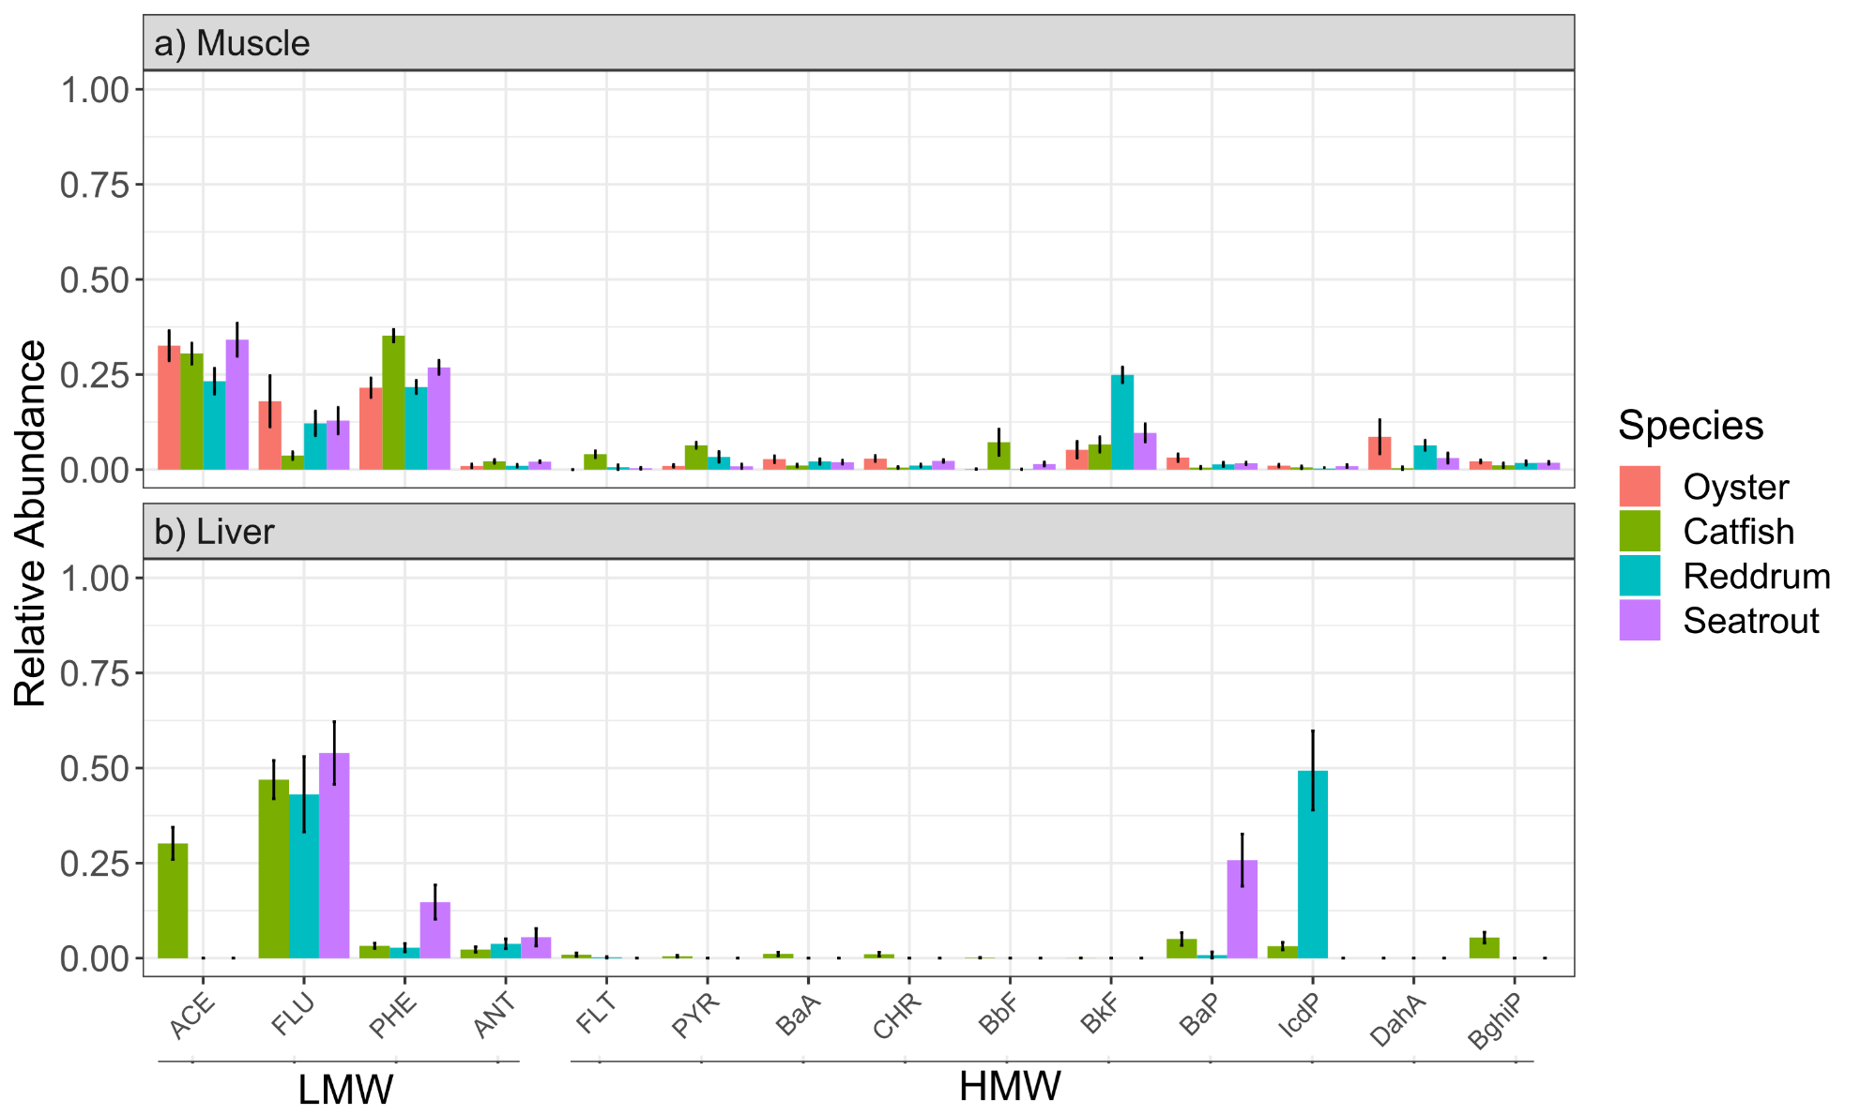
Supplemental Figure 1. Normalized PAH congener profiles of fish a) muscle and b) liver collected from Galveston Bay shown as mean ± standard error. All the mean + standard error values are normalized to total PAH to show relative abundance.

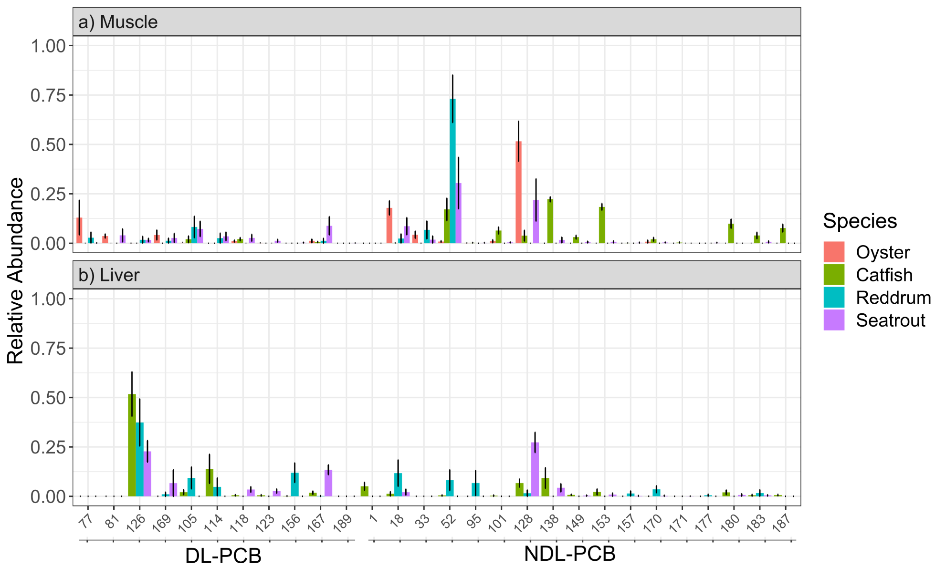
Supplemental Figure 2. Normalized PCB congener profiles of fish a) muscle and b) liver collected from Galveston Bay shown as mean ± standard error. All the mean + standard error values are normalized to total PCB to show relative abundance.

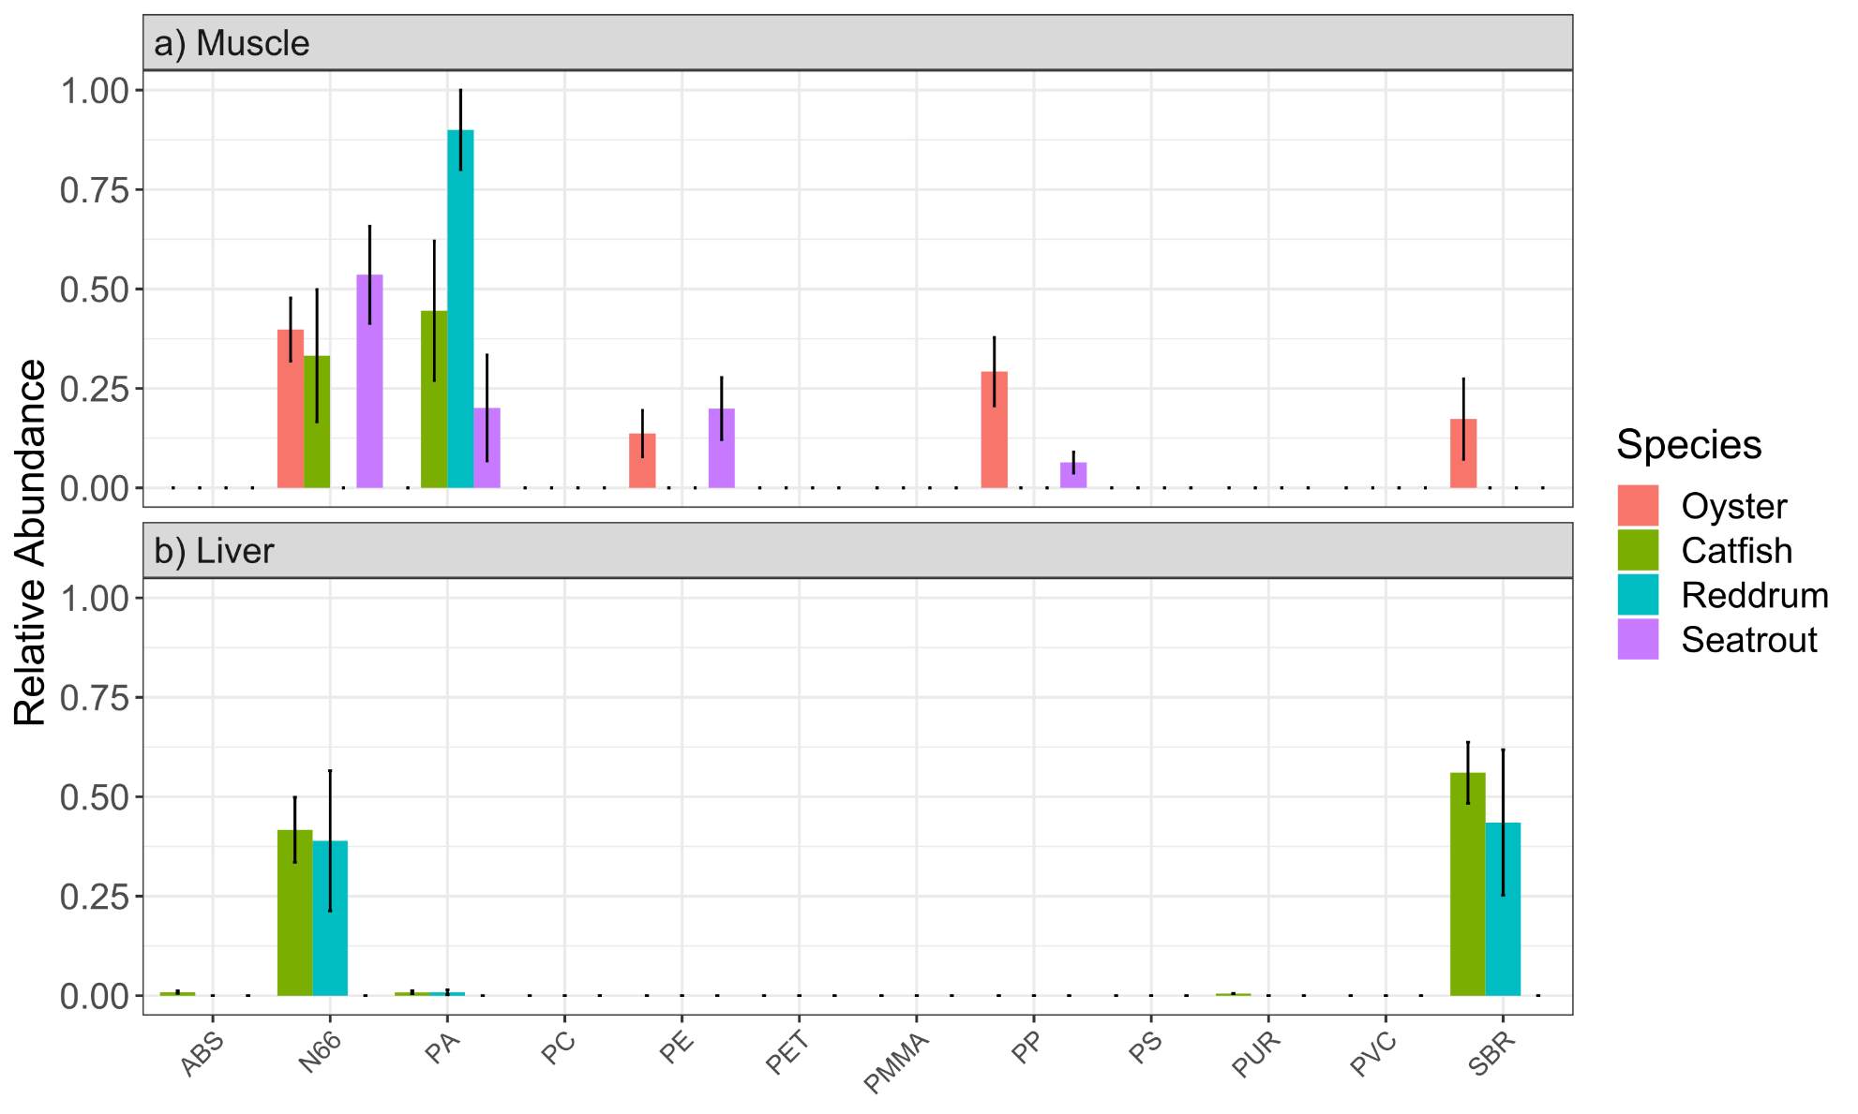
Supplemental Figure 3. Normalized NMP profile of fish a) muscle and b) liver collected from Galveston Bay shown as mean ± standard error. All the mean + standard error values are normalized to total NMP to show relative abundance.

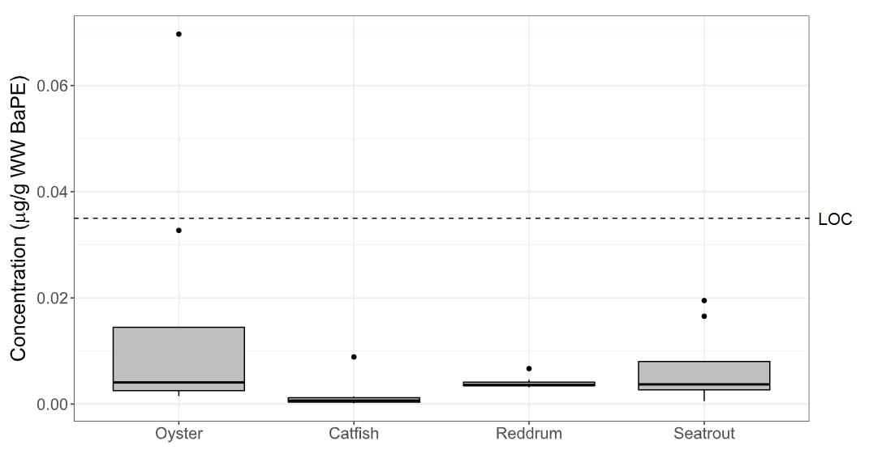
Supplemental Figure 4. Box and whisker plots showing the Benzo[a]pyrene equivalent toxicity (BaPE) concentrations of finfish and oysters collected from Galveston Bay in comparison to the Level of Concern (LOC) for cancer risk set by the FDA for finfish (0.035 µg/g BaPE). The LOC level for oysters is 0.142 µg/g BaPE (not shown) (FDA, 2010).

All the concentrations were below level of concern for cancer risk to consumers. It is important to note that the abovementioned limit (LOC) is considered to be a high threshold for risk and therefore should be interpreted cautiously (FDA, 2010).

Supplemental Table 5. List of a) PAHs, b) PCBs, their abbreviations, retention times (RT), and characteristic mass fragments as measured using GCMS. * = Internal Standard.

a) PAHs
Compound name | Abbreviation | RT (min) | Target ion (m/z) | Qualifier ion (m/z)
Acenaphthene | ACE | 9.022 | 152 | 76
Fluorene | FLU | 10.167 | 166 | 139
Phenanthrene | PHE | 12.301 | 178 | 152
Anthracene | ANT | 12.421 | 178 | 152
Fluoranthene | FLT | 16.049 | 202 | 101
Pyrene | PYR | 16.839 | 202 | 101
Benzo[a]anthracene | BaA | 21.805 | 228 | 114
Chrysene | CHR | 21.965 | 228 | 113
Benzo[b]fluoranthene | BbF | 25.891 | 252 | 126
Benzo[k]fluoranthene | BkF | 25.982 | 252 | 126
Benzo[a]pyrene-d12* | BaP-d12 | 26.903 | 264 | 132
Benzo[a]pyrene | BaP | 26.995 | 252 | 126
Indeno[123-cd]pyrene | IcdP | 30.777 | 276 | 138
Dibenzo[a,h]anthracene | DahA | 30.892 | 278 | 138
Benzo[ghi]perylene | BghiP | 31.555 | 276 | 138

b) PCBs
Compound | RT (min) | Target ion (m/z) | Qualifier ion (m/z)
PCB 1 | 9.371 | 188 | 152
PCB 18 | 12.244 | 186 | 256
PCB 33 | 13.646 | 256 | 186
PCB 52 | 14.298 | 292 | 220
PCB 65-d5* | 14.601 | 297 | 225
PCB 95 | 16.158 | 326 | 254
PCB 101 | 16.839 | 326 | 254
PCB 81 | 17.680 | 292 | 220
PCB 77 | 17.989 | 292 | 220
PCB 123 | 18.732 | 326 | 254
PCB 149 | 18.732 | 360 | 290
PCB 118 | 18.807 | 326 | 254
PCB 114 | 19.167 | 326 | 254
PCB 153 | 19.528 | 360 | 290
PCB 105 | 19.665 | 326 | 254
PCB 138 | 20.420 | 360 | 290
PCB 126 | 20.718 | 326 | 254
PCB 187 | 20.964 | 394 | 324
PCB 183 | 21.136 | 394 | 324
PCB 128 | 21.342 | 360 | 290
PCB 171 | 21.920 | 394 | 324
PCB 177 | 21.920 | 394 | 324
PCB 156 | 22.086 | 360 | 290
PCB 157 | 22.280 | 360 | 290
PCB 180 | 22.606 | 394 | 324
PCB 169 | 23.218 | 360 | 290
PCB 170 | 23.470 | 394 | 324
PCB 189 | 24.300 | 394 | 324

References

Bacosa, H. P., Steichen, J., Kamalanathan, M., Windham, R., Lubguban, A., Labonté, J. M., Kaiser, K., Hala, D., Santschi, P. H., & Quigg, A. (2020, 2020/10/01). Polycyclic aromatic hydrocarbons (PAHs) and putative PAH-degrading bacteria in Galveston Bay, TX (USA), following Hurricane Harvey (2017). Environmental Science and Pollution Research, 27(28), 34987-34999. https://doi.org/10.1007/s11356-020-09754-5

Bailey, W. S., Olariu, C., & Mohrig, D. (2025). Microplastics in Bays along the Central Texas Coast. Environmental Science & Technology, 59(10), 5249-5260.

Balasubramani, A., Howell, N. L., & Rifai, H. S. (2014). Polychlorinated biphenyls (PCBs) in industrial and municipal effluents: concentrations, congener profiles, and partitioning onto particulates and organic carbon. Science of The Total Environment, 473, 702-713.

Beckwith, V. K., & Fuentes, M. M. P. B. (2018, 2018/06/01/). Microplastic at nesting grounds used by the northern Gulf of Mexico loggerhead recovery unit. Marine Pollution Bulletin, 131, 32-37. https://doi.org/https://doi.org/10.1016/j.marpolbul.2018.04.001

Borges-Ramírez, M. M., Mendoza-Franco, E. F., Escalona-Segura, G., & Osten, J. R.-v. (2020, 2020/12/01/). Plastic density as a key factor in the presence of microplastic in the gastrointestinal tract of commercial fishes from Campeche Bay, Mexico. Environmental Pollution, 267, 115659. https://doi.org/https://doi.org/10.1016/j.envpol.2020.115659

Brown-Peterson, N. J., Peterson, M. S., Nieland, D. L., Murphy, M. D., Taylor, R. G., & Warren, J. R. (2002). Reproductive biology of female spotted seatrout, Cynoscion nebulosus, in the Gulf of Mexico: differences among estuaries? Environmental Biology of Fishes, 63, 405-415.

Camargo, K., Sericano, J. L., Bhandari, S., Hoelscher, C., McDonald, T. J., Chiu, W. A., Wade, T. L., Dellapenna, T. M., Liu, Y., & Knap, A. H. (2021, 2021/01/01/). Polycyclic aromatic hydrocarbon status in post-hurricane Harvey sediments: Considerations for environmental sampling in the Galveston Bay/Houston Ship Channel region. Marine Pollution Bulletin, 162, 111872. https://doi.org/https://doi.org/10.1016/j.marpolbul.2020.111872

Celis-Hernandez, O., Ávila, E., Rendón-von Osten, J., Briceño-Vera, E. A., Borges-Ramírez, M. M., Gómez-Ponce, A. M., & Capparelli, V. M. (2023, 2023/06/25/). Environmental risk of microplastics in a Mexican coastal lagoon ecosystem: Anthropogenic inputs and its possible human food risk. Science of The Total Environment, 879, 163095. https://doi.org/https://doi.org/10.1016/j.scitotenv.2023.163095

Cullen, J. A., Marshall, C. D., & Hala, D. (2019, 2019/02/10/). Integration of multi-tissue PAH and PCB burdens with biomarker activity in three coastal shark species from the northwestern Gulf of Mexico. Science of The Total Environment, 650, 1158-1172. https://doi.org/https://doi.org/10.1016/j.scitotenv.2018.09.128

Di Mauro, R., Kupchik, M. J., & Benfield, M. C. (2017, 2017/11/01/). Abundant plankton-sized microplastic particles in shelf waters of the northern Gulf of Mexico. Environmental Pollution, 230, 798-809. https://doi.org/https://doi.org/10.1016/j.envpol.2017.07.030

Ellis, M. S., Choi, K.-S., Wade, T. L., Powell, E. N., Jackson, T. J., & Lewis, D. H. (1993). Sources of local variation in polynuclear aromatic hydrocarbon and pesticide body burden in oysters (Crassostrea virginica) from Galveston Bay, Texas. Comparative Biochemistry and Physiology Part C: Pharmacology, Toxicology and Endocrinology, 106(3), 689-698.

FDA. (2010). Protocol for Interpretation and Use of Sensory Testing and Analytical Chemistry Results for Re-Opening Oil-Impacted Areas Closed to Seafood Harvesting Due to The Deepwater Horizon Oil Spill. FDA. https://www.fda.gov/food/food-safety-during-emergencies/protocol-interpretation-and-use-sensory-testing-and-analytical-chemistry-results-re-opening-oil

Flores-Cortés, M., & Armstrong-Altrin, J. S. (2022, 2022/09/08). Textural characteristics and abundance of microplastics in Tecolutla beach sediments, Gulf of Mexico. Environmental Monitoring and Assessment, 194(10), 752. https://doi.org/10.1007/s10661-022-10447-4

Frank, D. S., Mora, M. A., Sericano, J. L., Blankenship, A. L., Kannan, K., & Giesy, J. P. (2001). Persistent organochlorine pollutants in eggs of colonial waterbirds from Galveston Bay and East Texas, USA. Environmental Toxicology and Chemistry, 20(3), 608-617. https://doi.org/10.1002/etc.5620200321

Geiselbrecht Allison, D., Hedlund Brian, P., Tichi Mary, A., & Staley, J. T. (1998, 1998/12/01). Isolation of Marine Polycyclic Aromatic Hydrocarbon (PAH)-Degrading Cycloclasticus Strains from the Gulf of Mexico and Comparison of Their PAH Degradation Ability with That of Puget Sound Cycloclasticus Strains. Applied and Environmental Microbiology, 64(12), 4703-4710. https://doi.org/10.1128/AEM.64.12.4703-4710.1998

Grizzle, R. E., Ward, K. M., Peter, C. R., Cantwell, M., Katz, D., & Sullivan, J. (2017, Apr). Growth, morphometrics, and nutrient content of farmed eastern oysters, Crassostrea virginica (Gmelin), in New Hampshire, USA. Aquac Res, 48(4), 1525-1537. https://doi.org/10.1111/are.12988

Harmon, M. R., Pait, A. S., & Hameedi, M. J. (2003). Sediment contamination, toxicity, and macroinvertebrate infaunal community in Galveston Bay. Retrieved 12/17/24 from https://repository.library.noaa.gov/view/noaa/2413/noaa_2413_DS1.pdf

Hayden, M., & Cowger, W. (2022). Quantitative Analysis of Microplastics on Texas Beaches. OCEANS 2022, 1-4.

Hernout, B., Leleux, J., Lynch, J., Ramaswamy, K., Faulkner, P., Matich, P., & Hala, D. (2020, 2020/09/01/). The integration of fatty acid biomarkers of trophic ecology with pollutant body-burdens of PAHs and PCBs in four species of fish from Sabine Lake, Texas. Environmental Advances, 1, 100001. https://doi.org/https://doi.org/10.1016/j.envadv.2020.100001

Howell, N. L., Lakshmanan, D., Rifai, H. S., & Koenig, L. (2011). PCB dry and wet weather concentration and load comparisons in Houston-area urban channels. Science of The Total Environment, 409(10), 1867-1888.

Howell, N. L., & Rifai, H. S. (2015). Longitudinal estimates of sediment-water diffusive flux of PCB congeners in the Houston Ship Channel. Estuarine, Coastal and Shelf Science, 164, 19-27.

Howell, N. L., Rifai, H. S., & Koenig, L. (2011). Comparative distribution, sourcing, and chemical behavior of PCDD/Fs and PCBs in an estuary environment. Chemosphere, 83(6), 873-881.

Howell, N. L., Suarez, M. P., Rifai, H. S., & Koenig, L. (2008). Concentrations of polychlorinated biphenyls (PCBs) in water, sediment, and aquatic biota in the Houston Ship Channel, Texas. Chemosphere, 70(4), 593-606.

Jackson, T. J., Wade, T. L., Sericano, J. L., Brooks, J. M., Wong, J. M., Garcia-Romero, B., & McDonald, T. J. (1998, 1998/12/01). Galveston Bay: Temporal changes in the concentrations of trace organic contaminants in national status and trends oysters (1986–1994). Estuaries, 21(4), 718-730. https://doi.org/10.2307/1353276

King, K. A. (1989). Food habits and organochlorine contaminants in the diet of Black Skimmers, Galveston Bay, Texas, USA. Colonial Waterbirds, 109-112.

King, K. A., & Krynitsky, A. J. (1986). Population trends, reproductive success, and organochlorine chemical contaminants in waterbirds nesting in Galveston Bay, Texas. Archives of environmental contamination and toxicology, 15(4), 367-376.

Lakshmanan, D., Howell, N. L., Rifai, H. S., & Koenig, L. (2010). Spatial and temporal variation of polychlorinated biphenyls in the Houston Ship Channel. Chemosphere, 80(2), 100-112.

Lauenstein, G., & Cantillo, A. Y. (1998). Sampling and analytical methods of the national status and trends program mussel watch project: 1993-1996 update. https://repository.library.noaa.gov/view/noaa/22776

Mahler, B., & Van Metre, P. (2003). A chronicle of organochlorine contamination in Clear Creek, Galveston and Harris Counties, Texas, 1960-2002, as recorded in sediment cores (2327-6932).

Mora, M. A., Heath, S. A., Bohannon, M., & Bowerman, W. W. (2020). Organochlorine pesticides and polychlorinated biphenyls in American oystercatchers nesting along the Texas Gulf Coast. Waterbirds, 43(3-4), 292-298.

Mortuza, A., Meese, E. N., Wharton, M., Gahn, B., Petersen, L. H., Quigg, A., Wells, R. J. D., Kaiser, K., & Hala, D. (2025, 2025/12/01/). Comparing persistent (polycyclic aromatic hydrocarbons and polychlorinated biphenyls) and emerging nano(micro)plastics (NMPs) pollutant body-burdens in oysters and fish from Matagorda Bay (Texas, USA). Marine Pollution Bulletin, 221, 118495. https://doi.org/https://doi.org/10.1016/j.marpolbul.2025.118495

Oziolor, E. M., Apell, J. N., Winfield, Z. C., Back, J. A., Usenko, S., & Matson, C. W. (2018). Polychlorinated biphenyl (PCB) contamination in Galveston Bay, Texas: Comparing concentrations and profiles in sediments, passive samplers, and fish. Environmental Pollution, 236, 609-618.

Park, J.-S., Wade, T. L., & Sweet, S. (2001a). Atmospheric deposition of organochlorine contaminants to Galveston Bay, Texas. Atmospheric Environment, 35(19), 3315-3324.

Park, J.-S., Wade, T. L., & Sweet, S. (2001b, 2001/07/01/). Atmospheric distribution of polycyclic aromatic hydrocarbons and deposition to Galveston Bay, Texas, USA. Atmospheric Environment, 35(19), 3241-3249. https://doi.org/https://doi.org/10.1016/S1352-2310(01)00080-2

Pittinger, C. A., Buikema, A. L., Jr., Hornor, S. G., & Young, R. W. (1985). Variation in tissue burdens of polycyclic aromatic hydrocarbons in indigenous and relocated oysters. Environmental Toxicology and Chemistry, 4(3), 379-387. https://doi.org/10.1002/etc.5620040313

Presley, B., Wade, T., Santschi, P., & Baskaran, M. (1998). Historical contamination of Mississippi River Delta, Tampa Bay, and Galveston Bay sediments. https://repository.library.noaa.gov/view/noaa/30783/noaa_30783_DS1.pdf

Qian, Y., Wade, T. L., & Sericano, J. L. (2001, 2001/12/01). Sources and bioavailability of polynuclear aromatic hydrocarbons in Galveston Bay, Texas. Estuaries, 24(6), 817-827. https://doi.org/10.2307/1353173

Rifai, H., & Palachek, R. (2007). Total maximum daily loads for PCBs in the Houston Ship Channel. https://www.tceq.texas.gov/downloads/water-quality/tmdl/houston-ship-galveston-bay-fish-consumption-assessment-78/78-2007-july-quarterly-report.pdf

Rowe, G. T., Fernando, H., Elferink, C., Ansari, G. A. S., Sullivan, J., Heathman, T., Quigg, A., Petronella Croisant, S., Wade, T. L., & Santschi, P. H. (2021). Polycyclic aromatic hydrocarbons (PAHs) cycling and fates in Galveston Bay, Texas, USA. PLOS ONE, 15(12), e0243734. https://doi.org/10.1371/journal.pone.0243734

Sammarco, P. W., Kolian, S. R., Warby, R. A. F., Bouldin, J. L., Subra, W. A., & Porter, S. A. (2013, 2013/08/15/). Distribution and concentrations of petroleum hydrocarbons associated with the BP/Deepwater Horizon Oil Spill, Gulf of Mexico. Marine Pollution Bulletin, 73(1), 129-143. https://doi.org/https://doi.org/10.1016/j.marpolbul.2013.05.029

Sánchez-Campos, M., Ponce-Vélez, G., Sanvicente-Añorve, L., & Alatorre-Mendieta, M. (2024, 2024/10/04). Microplastic contamination in three environmental compartments of a coastal lagoon in the southern Gulf of Mexico. Environmental Monitoring and Assessment, 196(11), 1012. https://doi.org/10.1007/s10661-024-13156-2

Sánchez-Hernández, L. J., Ramírez-Romero, P., Rodríguez-González, F., Ramos-Sánchez, V. H., Márquez Montes, R. A., Romero-Paredes Rubio, H., Sujitha, S. B., & Jonathan, M. P. (2021, 2021/08/01/). Seasonal evidences of microplastics in environmental matrices of a tourist dominated urban estuary in Gulf of Mexico, Mexico. Chemosphere, 277, 130261. https://doi.org/https://doi.org/10.1016/j.chemosphere.2021.130261

Santschi, P. H., Presley, B. J., Wade, T. L., Garcia-Romero, B., & Baskaran, M. (2001). Historical contamination of PAHs, PCBs, DDTs, and heavy metals in Mississippi river Delta, Galveston bay and Tampa bay sediment cores. Marine Environmental Research, 52(1), 51-79.

Sericano, J., Atlas, E. L., Wade, T. L., & Brooks, J. M. (1990). NOAA's status and trends mussel watch program: chlorinated pesticides and PCBs in oysters (Crassostrea virginica) and sediments from the Gulf of Mexico, 1986–1987. Marine Environmental Research, 29(3), 161-203.

Sericano, J., Wade, T. L., El-Husseini, A. M., & Brooks, J. M. (1992). Environmental significance of the uptake and depuration of planar PCB congeners by the American oyster (Crassostrea virginica). Marine Pollution Bulletin, 24(11), 537-543.

Sericano, J. L., Wade, T. L., Brooks, J. M., & Safe, S. H. (1994). Toxicological significance of non-, mono- and di-ortho-substituted polychlorinated biphenyls in oysters from galveston and tampa bays. Environmental Toxicology and Chemistry, 13(11), 1797-1803. https://doi.org/https://doi.org/10.1002/etc.5620131111

Steichen, J. L., Labonté, J. M., Windham, R., Hala, D., Kaiser, K., Setta, S., Faulkner, P. C., Bacosa, H., Yan, G., & Kamalanathan, M. (2020). Microbial, physical, and chemical changes in Galveston Bay following an extreme flooding event, Hurricane Harvey. Frontiers in Marine Science, 7, 186.

Summers, E., Du, J., Park, K., Wharton, M., & Kaiser, K. (2024). Importance of the water-sediment bed interactions in simulating microplastic particles in an estuarine system. Frontiers in Marine Science, 11, 1414459.

TPWD. (2024). Gafftopsail Catfish (Bagre marinus). https://tpwd.texas.gov/huntwild/wild/species/gafftop/

Wade, T. L., Soliman, Y., Sweet, S. T., Wolff, G. A., & Presley, B. J. (2008). Trace elements and polycyclic aromatic hydrocarbons (PAHs) concentrations in deep Gulf of Mexico sediments. Deep Sea Research Part II: Topical Studies in Oceanography, 55(24-26), 2585-2593.

Waite, H. R., Donnelly, M. J., & Walters, L. J. (2018, 2018/04/01/). Quantity and types of microplastics in the organic tissues of the eastern oyster Crassostrea virginica and Atlantic mud crab Panopeus herbstii from a Florida estuary. Marine Pollution Bulletin, 129(1), 179-185. https://doi.org/https://doi.org/10.1016/j.marpolbul.2018.02.026

Wenner, C. A. (1996). Red drum: natural history and fishing techniques in South Carolina https://dc.statelibrary.sc.gov/entities/publication/50f3e455-d732-48df-9696-5a8e92203f48

Wessel, C. C., Lockridge, G. R., Battiste, D., & Cebrian, J. (2016, 2016/08/15/). Abundance and characteristics of microplastics in beach sediments: Insights into microplastic accumulation in northern Gulf of Mexico estuaries. Marine Pollution Bulletin, 109(1), 178-183. https://doi.org/https://doi.org/10.1016/j.marpolbul.2016.06.002

Wharton, B. M. (2021). Analysis and Quantification of Microplastics in Galveston Bay Texas A&M University]. https://oaktrust.library.tamu.edu/items/bec0b76f-ec90-41a8-a268-7d4be2306dcb

Wharton, M., Gahn, M. B., Hala, D., Du, J., Park, K., & Kaiser, K. (2024). Quantifying Microplastic Contamination in Galveston Bay and the Gulf of Mexico watershed. Proceedings of the American Geophysical Union, Ocean Sciences Meeting, New Orleans, LA.

Willett, K. L., McDonald, S. J., Steinberg, M. A., Beatty, K. B., Kennicutt, M. C., & Safe, S. H. (1997). Biomarker sensitivity for polynuclear aromatic hydrocarbon contamination in two marine fish species collected in Galveston Bay, Texas. Environmental Toxicology and Chemistry, 16(7), 1472-1479. https://doi.org/10.1002/etc.5620160721

Williams., Bacosa, H. P., & Quigg, A. (2017, 2017/08/15/). The impact of dissolved inorganic nitrogen and phosphorous on responses of microbial plankton to the Texas City “Y” oil spill in Galveston Bay, Texas (USA). Marine Pollution Bulletin, 121(1), 32-44. https://doi.org/https://doi.org/10.1016/j.marpolbul.2017.05.033

Wontor, K., Cizdziel, J. V., Scircle, A., Gochfeld, D. J., & Pandelides, A. F. (2023, 2023/04/01). Prevalence and Distribution of Microplastics in Oysters from the Mississippi Sound. Journal of Contemporary Water Research & Education, 177(1), 31-45. https://doi.org/https://doi.org/10.1111/j.1936-704X.2022.3379.x

Worth, L. (2013). Characterization of Potential Adverse Health Effects Associated with Consuming Fish from. https://www.dshs.texas.gov/sites/default/files/seafood/PDF2/Risk-Characterization/LakeWorthRC2016R.pdf

Yin, F., Hayworth, J. S., & Clement, T. P. (2015). A Tale of Two Recent Spills—Comparison of 2014 Galveston Bay and 2010 Deepwater Horizon Oil Spill Residues. PLOS ONE, 10(2), e0118098. https://doi.org/10.1371/journal.pone.0118098

