SUPPLEMENTARY MATERIAL

Water, Sanitation, and Hygiene for Everyone process evaluation framework
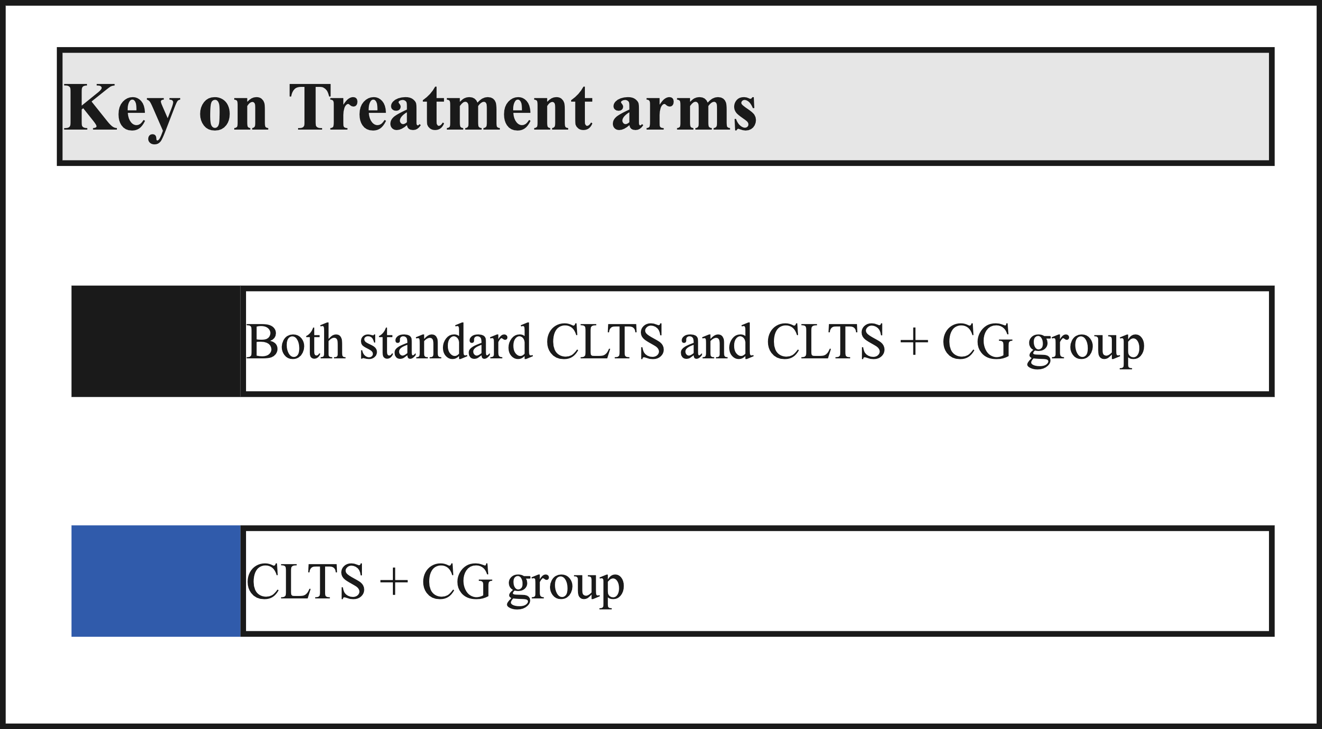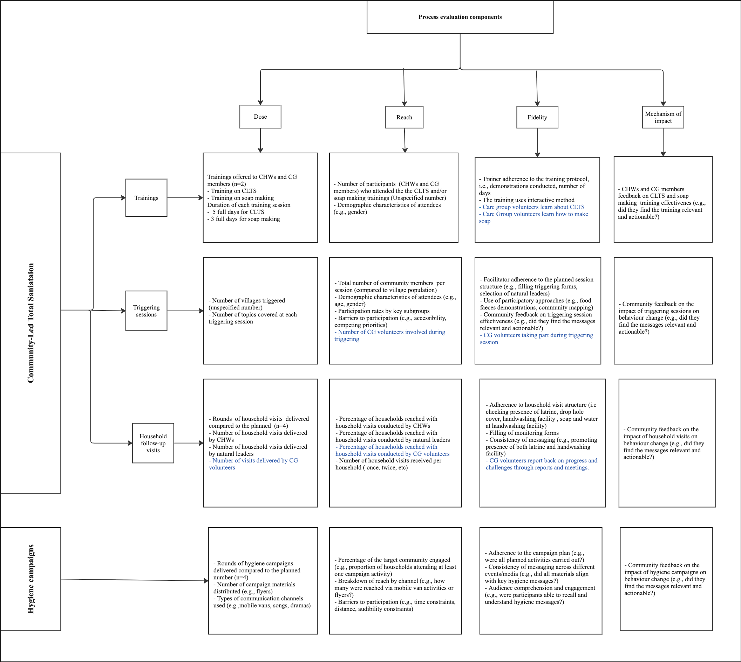

Demographic Characteristics of Intervention Implementers
Variable | CLTS | CLTS+CG | Total
Community Health Workers
Community Health Workers | n= 8 | n= 7 | n= 15
Age
18–39 years | 2 (25.0%) | 1 (14.0%) | 3 (20.0%)
40–59 years | 6 (75.0%) | 6 (86.0%) | 12 (80.0%)
60+ years | - | - | -
Education Level
None | - | - | -
Primary | - | - | -
Secondary | 4 (50.0%) | 7 (100%) | 11(73.0%)
Technical training | 4 (50.0%) | - | 4 (27.0%)
Care Group volunteers
Care Group volunteers |  | n= 12 | n= 12
Age
18–39 years |  | 8 (67.0%) | 8 (67.0%)
40–59 years | - | 4 (33.0%) | 4 (33.0%)
60+ years | - | - | -
Education Level
None | - | - | -
Primary | - | 5 (42.0%) | 5 (42%)
Secondary | - | 7 (58.0%) | 7 (58.0%)
Technical training | - | - | -
Note: Data unavailable (no participants in this category or not applicable

Unadjusted logistic regression estimates of sanitation and hygiene outcomes by participation in CLTS triggering and hygiene campaigns in CLTS and CLTS+CG intervention groups
Respondent participation | Sanitation |  |  |  |  |  | Hygiene
Respondent participation | CLTS (n= 384) |  |  | CLTS+CG (n= 388) |  |  | CLTS (n=386) |  |  | CLTS+CG (n=392)
Respondent participation | uOR | 95% CI | p-value | uOR | 95% CI | p-value | uOR | 95% CI | p-value | uOR | 95% CI | p-value
CLTS Participation (ref = No)
Partial participation | 5.27 | [1.50, 18.44] | 0.009 | 2.28 | [0.91, 5.71] | 0.078 | 0.51 | [0.15, 1.76] | 0.284 | 1.85 | [0.73, 4.69] | 0.194
Full participation | 14.07 | [3.98, 49.80] | <.001 | 3.39 | [1.38, 8.34] | 0.008 | 0.47 | [0.14, 1.61] | 0.228 | 1.3 | [0.52, 3.21] | 0.576
 | CLTS (n=396) |  |  | CLTS+CG (n=398) |  |  | CLTS (n=396) |  |  | CLTS+CG (n=398)
Hygiene campaigns participation (ref = No)
Participation | 1 | [0.99, 1.00] | 0.954 | 1 | [0.99, 1.00] | 0.856 | 1 | [0.99, 1.00] | 0.712 | 1 | [0.99, 1.00] | 0.813

