Structural and biochemical insight into allosteric regulation of the human 2-aminoadipic semialdehyde synthase, a bifunctional enzyme involved in lysine catabolism

Ruoxi Wu,^{1,2} Susmita Khamrui,^{1,2} Tetyana Dodatko,³ Yufei Xiang,¹ Afrooz Golestanian,^{1,2} Ngoc Dung Pham,¹ Kunal Kumar,^{1,2} Yi Shi,¹ Roman Osman,¹ Robert J. DeVita*,^{1,2} Sander M. Houten,*³ and Michael B. Lazarus*^{1,2}
¹Department of Pharmacological Sciences, Icahn School of Medicine at Mount Sinai, New York, NY 10029, USA
²Drug Discovery Institute, Icahn School of Medicine at Mount Sinai, New York, NY 10029, USA
³Department of Genetics and Genomic Sciences, Icahn School of Medicine at Mount Sinai, New York, NY 10029, USA

* co-corresponding authors: michael.lazarus@mssm.edu, sander.houten@mssm.edu, robert.devita@mssm.edu

Supplementary Information

Supplementary Tables

Supplementary Figures

Supplementary Table 1. Cryo-EM data collection, refinement and validation statistics
 | AASS  6-domain structure | SDH  domain  with NADH and saccharopine | LOR  domain  with NADPH and saccharopine | LOR  domain  with 1-MN⁺
Data collection and processing
Magnification | 165,000 | 165,000 | 165,000 | 165,000
Voltage (kV) | 300 | 300 | 300 | 300
Electron exposure (e–/Å²) | 45.57 | 45.57 | 45.57 | 48.25
Defocus range (μm) | -0.6 to -2.0 | -0.6 to -2.0 | -0.6 to -2.0 | -0.6 to -2.0
Pixel size (Å) | 0.73 | 0.73 | 0.73 | 0.730
Symmetry imposed | C1 | C1 | D2 | D2
Initial particle images (no.) | 2,313,553 | 2,313,553 | 4,234,618 | 3,804,426
Final particle images (no.) | 150,578 | 150,578 | 305,971 | 200,000
Map resolution (Å)  FSC threshold | 3.38  0.143 | 3.00  0.143 | 2.54  0.143 | 2.46  0.143
Map resolution range (Å) | 2.5-7.5 | 2.5-4.5 | 2.5-3.5 | 2.3-3.6
Refinement
Initial model used (PDB code) | 8E8U | 5L78 | 8E8U | 8E8U
Model resolution (Å)  FSC threshold | 3.38 Å  0.143 | 3.00  0.143 | 2.54  0.143 | 2.46  0.143
Map sharpening B factor (Å²) | -129.4 Å² | -115.0 | -90.1 | -107.2
Model composition  Non-hydrogen atoms  Protein residues  Nucleotides | 20717  2639  0 | 6894  886  0 | 14307  1772  0 | 13824  1756  0
B factors (Å²)  Protein  Nucleotides | 182.59  151.81 | 58.28  51.52 | 48.53  36.35 | 57.94
R.m.s. deviations  Bond lengths (Å)  Bond angles (°) | 0.003  0.549 | 0.002  0.414 | 0.002  0.450 | 0.002  0.439
Validation  MolProbity score  Clashscore  Poor rotamers (%) | 1.79  10.76  0.09% | 2.04  24.88  0% | 1.44  5.37  0% | 1.33  5.34  0%
Ramachandran plot  Favored (%)  Allowed (%)  Disallowed (%) | 96.37%  3.63%  0% | 97.15%  2.85%  0% | 97.15%  2.85%  0% | 97.80%  2.20%  0%

Supplemental table 2. Maleimide analogs used for this study.
# | Name | Name | LOR activity Compared to NEM
M1 | N-ethylmaleimide (NEM) | 1-ethyl-2,5-dihydro-1H-pyrrole-2,5-dione
M2 | N-phenylmaleimide | 1-phenyl-2,5-dihydro-1H-pyrrole-2,5-dione | ++
M3 | N-tert-butylmaleimide | 1-tert-butyl-2,5-dihydro-1H-pyrrole-2,5-dione | --
M4 | N-hydroxyethylmaleimide | 1-(2-hydroxyethyl)-2,5-dihydro-1H-pyrrole-2,5-dione | -
M5 | N-dimethylphenylmaleimide | 1-(3,5-dimethylphenyl)-2,5-dihydro-1H-pyrrole-2,5-dione | +++
M6 | N-methylmaleimide | 1-methyl-2,5-dihydro-1H-pyrrole-2,5-dione | =
M7 | N-butylmaleimide | 1-butyl-2,5-dihydro-1H-pyrrole-2,5-dione | +
M8 |  | 1-butyl-3,4-dimethyl-2,5-dihydro-1H-pyrrole-2,5-dione | --
M9 |  | 3-bromo-1-phenyl-2,5-dihydro-1H-pyrrole-2,5-dione | ---
M10 |  | 1-(2-fluorophenyl)-2,5-dihydro-1H-pyrrole-2,5-dione | ---
M11 |  | 1-[3-(trifluoromethyl)phenyl]-2,5-dihydro-1H-pyrrole-2,5-dione | ++
M12 | N-(2-aminoethyl)maleimide | 1-(2-aminoethyl)-1H-pyrrole-2,5-dione | +
M13 | N-carboxyethylmaleimide | 3-maleimidopropionic acid | ---
Legend: =, activation of LOR similar to NEM; -, activation of LOR < NEM; --, activation of LOR << NEM; ---, mainly inactivation of LOR; +, activation of LOR > NEM; ++, activation of LOR >> NEM; +++, activation of LOR >>> NEM

Supplementary Table 3. Semi-quantitative labeling efficiency of different cysteine residues of LOR by mass spectrometry.

 | NEM concentration
 | 2 mM | 0.2 mM | 20 µM | 2 µM
Cysteine
Cys414 | 85.85% | 82.53% | 66.91% | 3.00%
Cys87 | 68.99% | 68.81% | 48.02% | 0.00%
Cys369/Cys377 | 98.72% | 90.85% | 0.00% | 0.00%
Cys398 | 20.87% | 5.38% | 3.07% | 0.99%
Cys240 | 77.60% | 34.79% | 0.00% | 0.00%

Supplementary Table 4. Enyme kinetics, nonlinear regression models
Excel file with best-fit values, std. error, 95% confidence intervals and additional statistical values. The accompanying figure number is displayed in each tab.

Supplementary Table 5. Metabolites screened in the library
Excel file

Supplementary Figure 1. Cryo-EM workflow and structure validations. (A) Flow chart outlining data processing performed to obtain 6-domain AASS structures with and without masks. Density is colored by resolution from 2.0 (blue) to 3.5 Å (red), and 3.5 (blue) to 5.5 Å (red), respectively. (B) Flow chart outlining data processing performed to obtain LOR domain AASS with 1-MN⁺ structure. Density is colored by resolution from 2.5 (blue) to 3.5 Å (red). (C) Flow chart outlining data processing performed to obtain AASS full-length and LOR domain alone maps. Density is colored by resolution from 2.5 (blue) to 3.5 Å (red) for LOR domain alone. (D) Representative micrographs of different structures are shown. All processing was performed using CryoSPARC (see Methods for details).

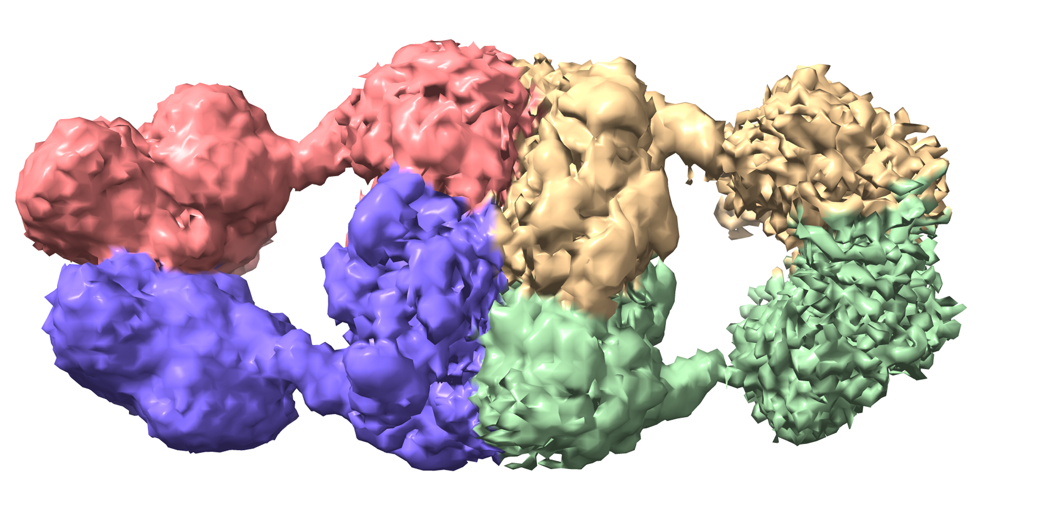
Supplementary Figure 2. Overall structure of AASS. Electron density for full-length AASS shows the conformation of the 8 domains. The flexibility between the SDH and LOR domains leads to low resolution for the overall complex.
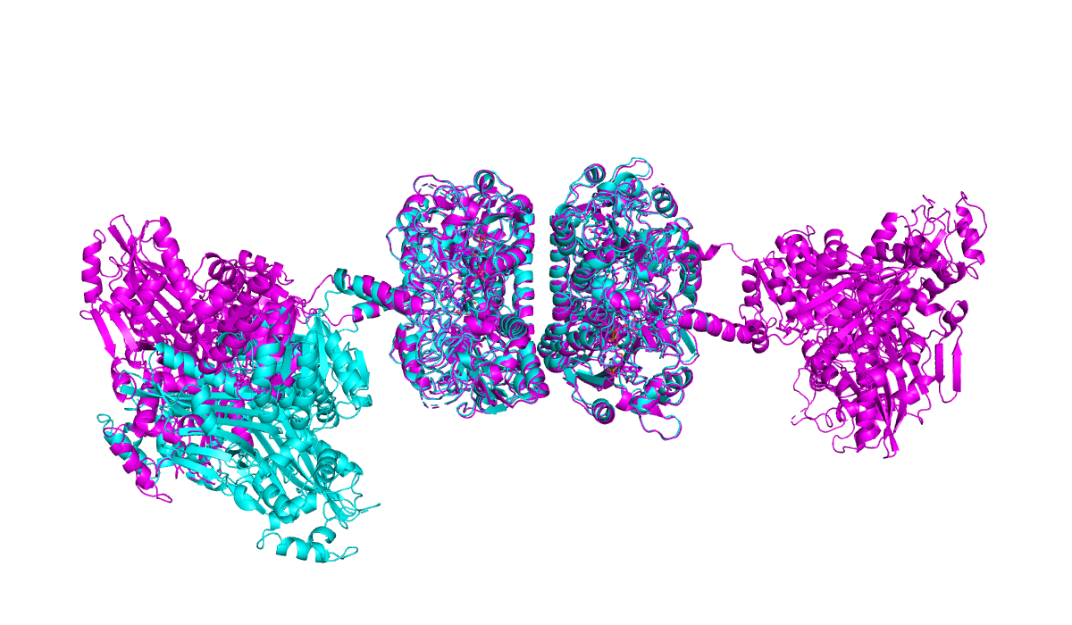
Supplementary Figure 3. Comparison of 6-domain and full-length structures. The 6-domain structure (cyan) is overlaid with the full-length structure (magenta), aligned by the LOR domain. All four LOR domains align between the two structures. However, the SDH domains rotates relative to the LOR domain, indicating the flexibility of the domains with respect to each other.

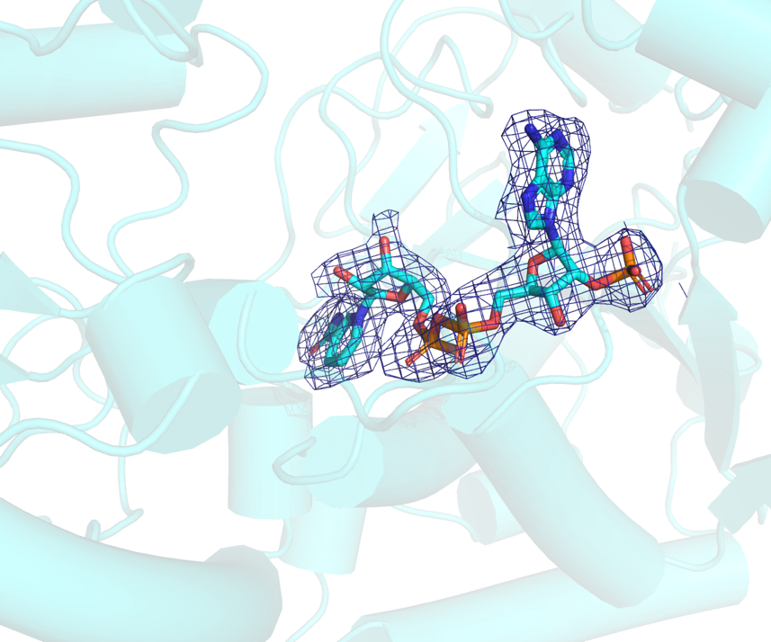

Supplementary Figure 4. Map showing density of NADPH in LOR domain structure. The map was contoured at 4 sigma around the NADPH substrate.

c_elegans MRLPHTAGGMMRQISQRFQ-----SSK-VFHGKGTPTIGIRRETVNSWERRAPLAPTHVK 54
drosophila ---------MWRV-----IQLRATIAHPFTRQRHSRVIAIRREDQSVWERRAPFGPTHVQ 46
human ---------MLQVHRTGLGRLGVSL---SKGLHHKAVLAVRREDVNAWERRAPLAPKHIK 48
mouse ---------MLRAQRPRLARLRACL---SRGLHHKPVMALRREDVNAWERRAPLAPKHIK 48
* : : . .:.:*** . ******:.*.*::

c_elegans RLTKSGVNVLIQPSNRRAYPIQDYISAGAIVREDLSEAHIIMSVKSVPIDQLIPNKTYAF 114
drosophila KLVKQNVKVIVQPSNRRAYPMQAYMQAGAHIQEDISDASVIFGVKQVPIDALIPGKTYCF 106
human GITNLGYKVLIQPSNRRAIHDKDYVKAGGILQEDISEACLILGVKRPPEEKLMSRKTYAF 108
mouse GITKLGYKVLIQPSNRRAIHDKEYVRAGGILQEDITEACLILGVKRPPEEKLMSKKTYAF 108
:.: . :*::******* : *: **. ::**:::* :*:.** * : *: ***.*

c_elegans FSHTIKAQQDNMEMLDTILQRNIRLLDYEKICDDKGKRLVMFGKWAGNAGFIDILHGIGL 174
drosophila FSHTIKAQESNMPLLDAILEKKIRLIDYERIIDERGARQVAFGKYAGVAGMVNILHGIGL 166
human FSHTIKAQEANMGLLDEILKQEIRLIDYEKMVDHRGVRVVAFGQWAGVAGMINILHGMGL 168
mouse FSHTIKAQEANMNLLDEVLKQEIRLIDYEKMVDHRGSRIVAFGQWAGVAGMINILHGMGL 168
********: ** :** :*:::***:***:: *.:* * * **::** **:::****:**

c_elegans RLLALGHNTPFLHMGLAHNYNDSHMAINALRDIGYEIALDRMPRSLGPLIFVFTGSGNVS 234
drosophila RLLALGHHTPFMHIGPAHNYRNSSMARQAIRDCGYEISLGMMPKSIGPLTFVFTGSGNVS 226
human RLLALGHHTPFMHIGMAHNYRNSSQAVQAVRDAGYEISLGLMPKSIGPLTFVFTGTGNVS 228
mouse RLLALGHHTPFMHLGMAHNYRNSSQAVQAVRDAGYEISLGLMPKSIGPLTFVFTGTGNVS 228
*******:***:*:* ****.:* * :*:** ****:*. **:*:*** *****:****

c_elegans QGARELFEHLPHEYVDVATLPKVAQKGQLNKVYGCVVTRKDHFVPKHGGPFDKKEFEQFP 294
drosophila QGAQEVFSELPIEYVPPEMLRKVAEHGNQNKLYGCEVSRSDHLERREGGGFDAKEYDEFP 286
human KGAQAIFNELPCEYVEPHELKEVSQTGDLRKVYGTVLSRHHHLVRKTDAVYDPAEYDKHP 288
mouse KGAQEVFNELPCEYVEPHELREVSKTGDLRKVYGTVLSRHHHLVRKTDGVYDPVEYEKYP 288
:**: :*..** *** * :*:: *: .*:** ::* .*: : .. :* *:::.*

c_elegans DRYTSKFATEIAPYASVIINGVYWDAQSPRLITIPDAKNLLTPVQRY---DTPGCPTLPH 351
drosophila ERYISTFSTKIAPYASVIVNGIYWAVGSPKLISIPDAKNLLRPANTPWLPTSKGSPALPH 346
human ERYISRFNTDIAPYTTCLINGIYWEQNTPRLLTRQDAQSLLAPGKFSPA-GVEGCPALPH 347
mouse ERYTSRFNTDIAPYTTCLINGIYWEQNTPRLLTRQDAQSLLVPVKSSVV-PVEGCPELPH 347
:** * * *.****:: ::**:** :*:*:: **:.** * : *.* ***

c_elegans HLIALCDISADPGGSVEFMRECTTIDKPFAIYDADFNTSSDSFDAASGCLVCSIDNMPAQ 411
drosophila RMLAICDISADPGGSIEFMNECTTIDTPFCLYDADRNKDTKSFK-GPGVLVCSIDNMPTQ 405
human KLVAICDISADTGGSIEFMTECTTIEHPFCMYDADQHIIHDSVE-GSGILMCSIDNLPAQ 406
mouse KLVAICDISADTGGSIDFMTECTTIERPFCMYDADQQIIHDSVE-GSGILMCSIDNLPAQ 406
:::*:****** ***::** *****: **.:**** : .*.. . * *:*****:*:*

c_elegans MPIEATEQFGNLLYPWLWDLLNTSNDQHFDRLQCRTEIKNAIITDQGKLTPNFEYIAQLR 471
drosophila LPRESTDLFGELLAPHVHDIIKSDAKKPLAEENFSYPIQSAIIASNGQLTEGFQYIQELR 465
human LPIEATECFGDMLYPYVEEMILSDATQPLESQNFSPVVRDAVITSNGTLPDKYKYIQTLR 466
mouse LPIEATEYFGDMLYPYVEEMLLSDASQPLESQNFSPVVRDAVITSNGLLTDKYKYIQKLR 466
:* *:*: **::* * : ::: :. : : : ::.*:*:.:* * ::** **

Supplementary Figure 5. Sequence alignment of the LOR domain. LOR sequences from 4 species were aligned with Clustal Omega. The key Cys residues in this study are highlighted in yellow (Cys369, Cys377, and Cys414). The conserved catalytic residues (Lys93 and His111) are also highlighted.

Supplementary Figure 6. Activation of LOR by maleimide analogs. (A) Effect of different concentrations of M1-M13 as detailed in supplemental table 2 on activity of the isolated LOR enzyme. (B) Time dependency of LOR activation by N-phenylmaleimide (M2, left panel) and N-dimethylphenylmaleimide (M5, right panel). LOR was preincubated with the indicated concentration of maleimide for 10 or 30 minutes after which the reaction was started with 2-oxoglutarate. Each condition was tested in duplicate.

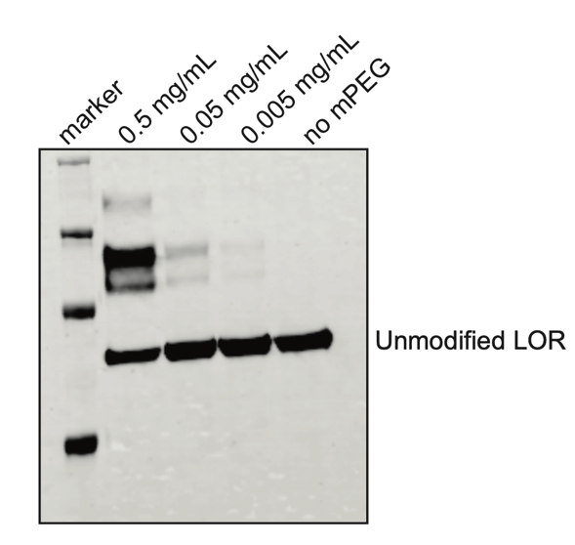

Supplementary Figure 7. Dose-dependent labeling of LOR by 10K mPEG. Protein was treated at the indicated concentrations and then immunoblotted with His antibody.

Supplementary Figure 8. pH dependent changes in steady-state kinetics of LOR are mediated by Cys414. (A) Progress curves for NADPH consumption measured at 340 nm at different NADPH concentrations of LOR with and without alkylation by NEM (n=4 per condition). (B) Activation of LOR by different concentration of NEM in KPi buffer of different pH (n=4 per condition). (C) Apparent pH optimum of LOR and full-length AASS-Myc-DDK under standard assay conditions in 50 mM KPi buffers (n=4 per condition). (D) Progress curves for NADPH consumption measured at 340 nm at different NADPH concentrations of LOR in KPi buffer of different pH (n=4 per condition). (E) Apparent pH optimum of LOR under standard assay conditions in 50 mM KPi buffers with and without activation by different maleimides (NEM upper panel n=8 per condition, lower panel n=4 for M2, M4 and M12). All error bars indicate SD.

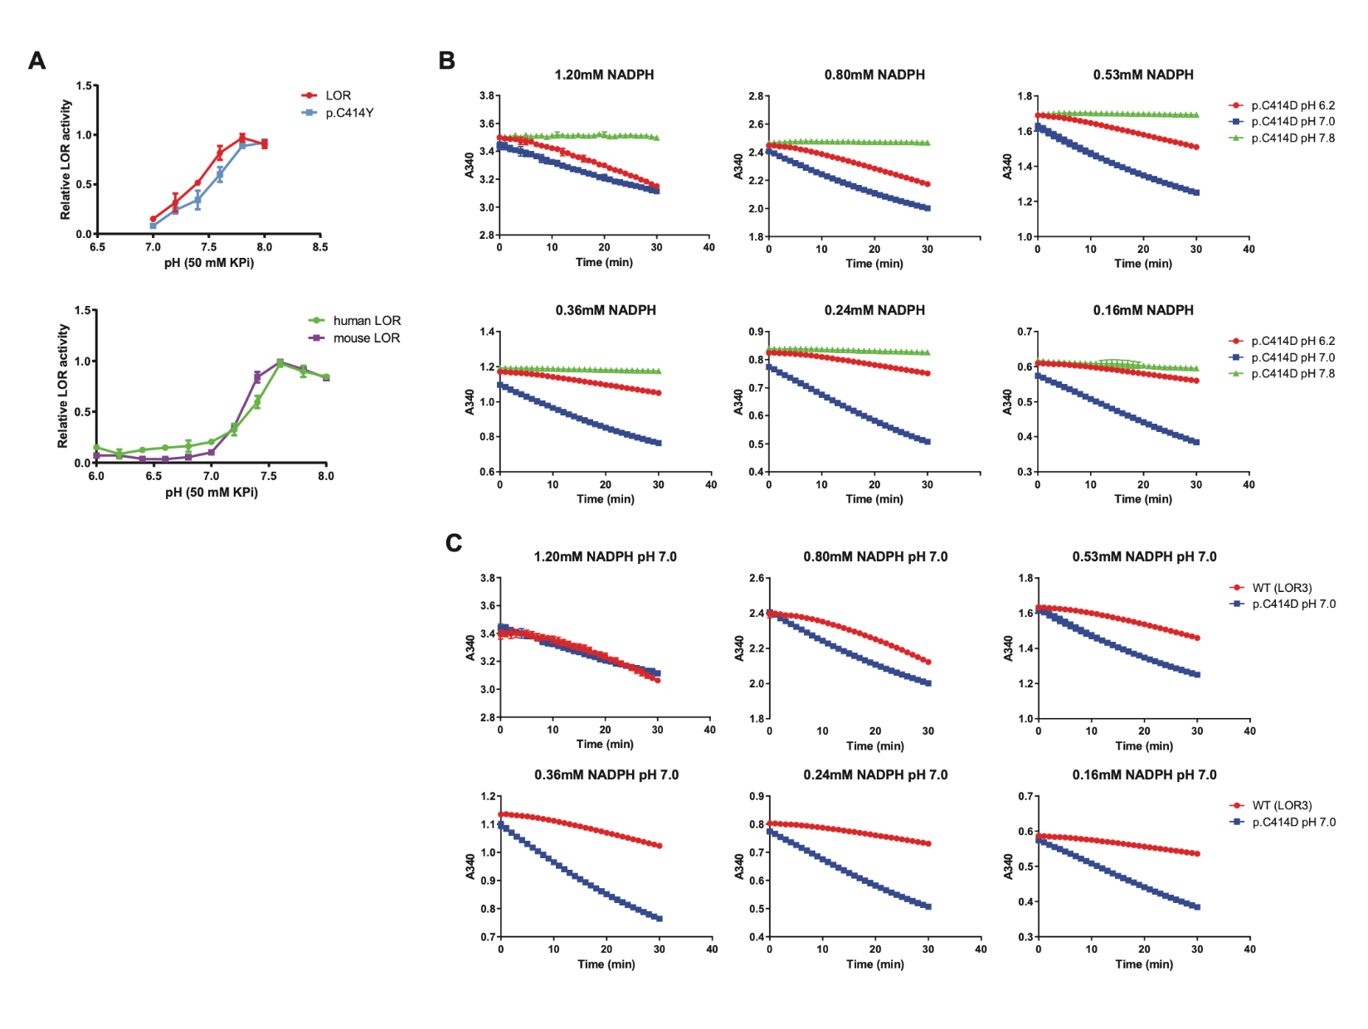

Supplementary Figure 9. pH dependent changes in steady-state kinetics of LOR are mediated by Cys414. (A) Apparent pH optimum of a murinized C414Y human LOR variant (upper panel, n=3 per condition) and human and mouse LOR (lower panel, n=4 per condition) under standard assay conditions in 50 mM KPi buffers. All error bars indicate SD. (B) Progress curves for NADPH consumption measured at 340 nm at different NADPH concentrations of the C414D LOR variant in KPi buffer of different pH (n=4 per condition). (C) Progress curves for NADPH consumption measured at 340 nm at different NADPH concentrations of wild-type and C414D variant LOR in KPi buffer of pH 7 (n=4 per condition).

Supplementary Figure 10. Thermal stability of DHTKD1 protein at different pH values, n=4, line shows the mean.

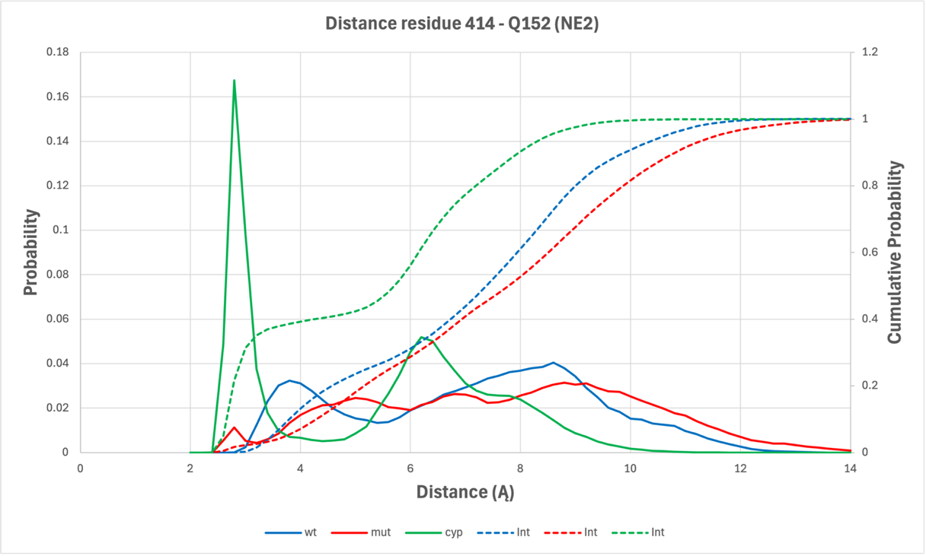

Supplementary Figure 11. Molecular dynamics interactions at residue 414 with Gln152. Wild-type is colored in blue, Asp414 variant in red and CYP variant in green. The broken lines represent the cumulative probability.

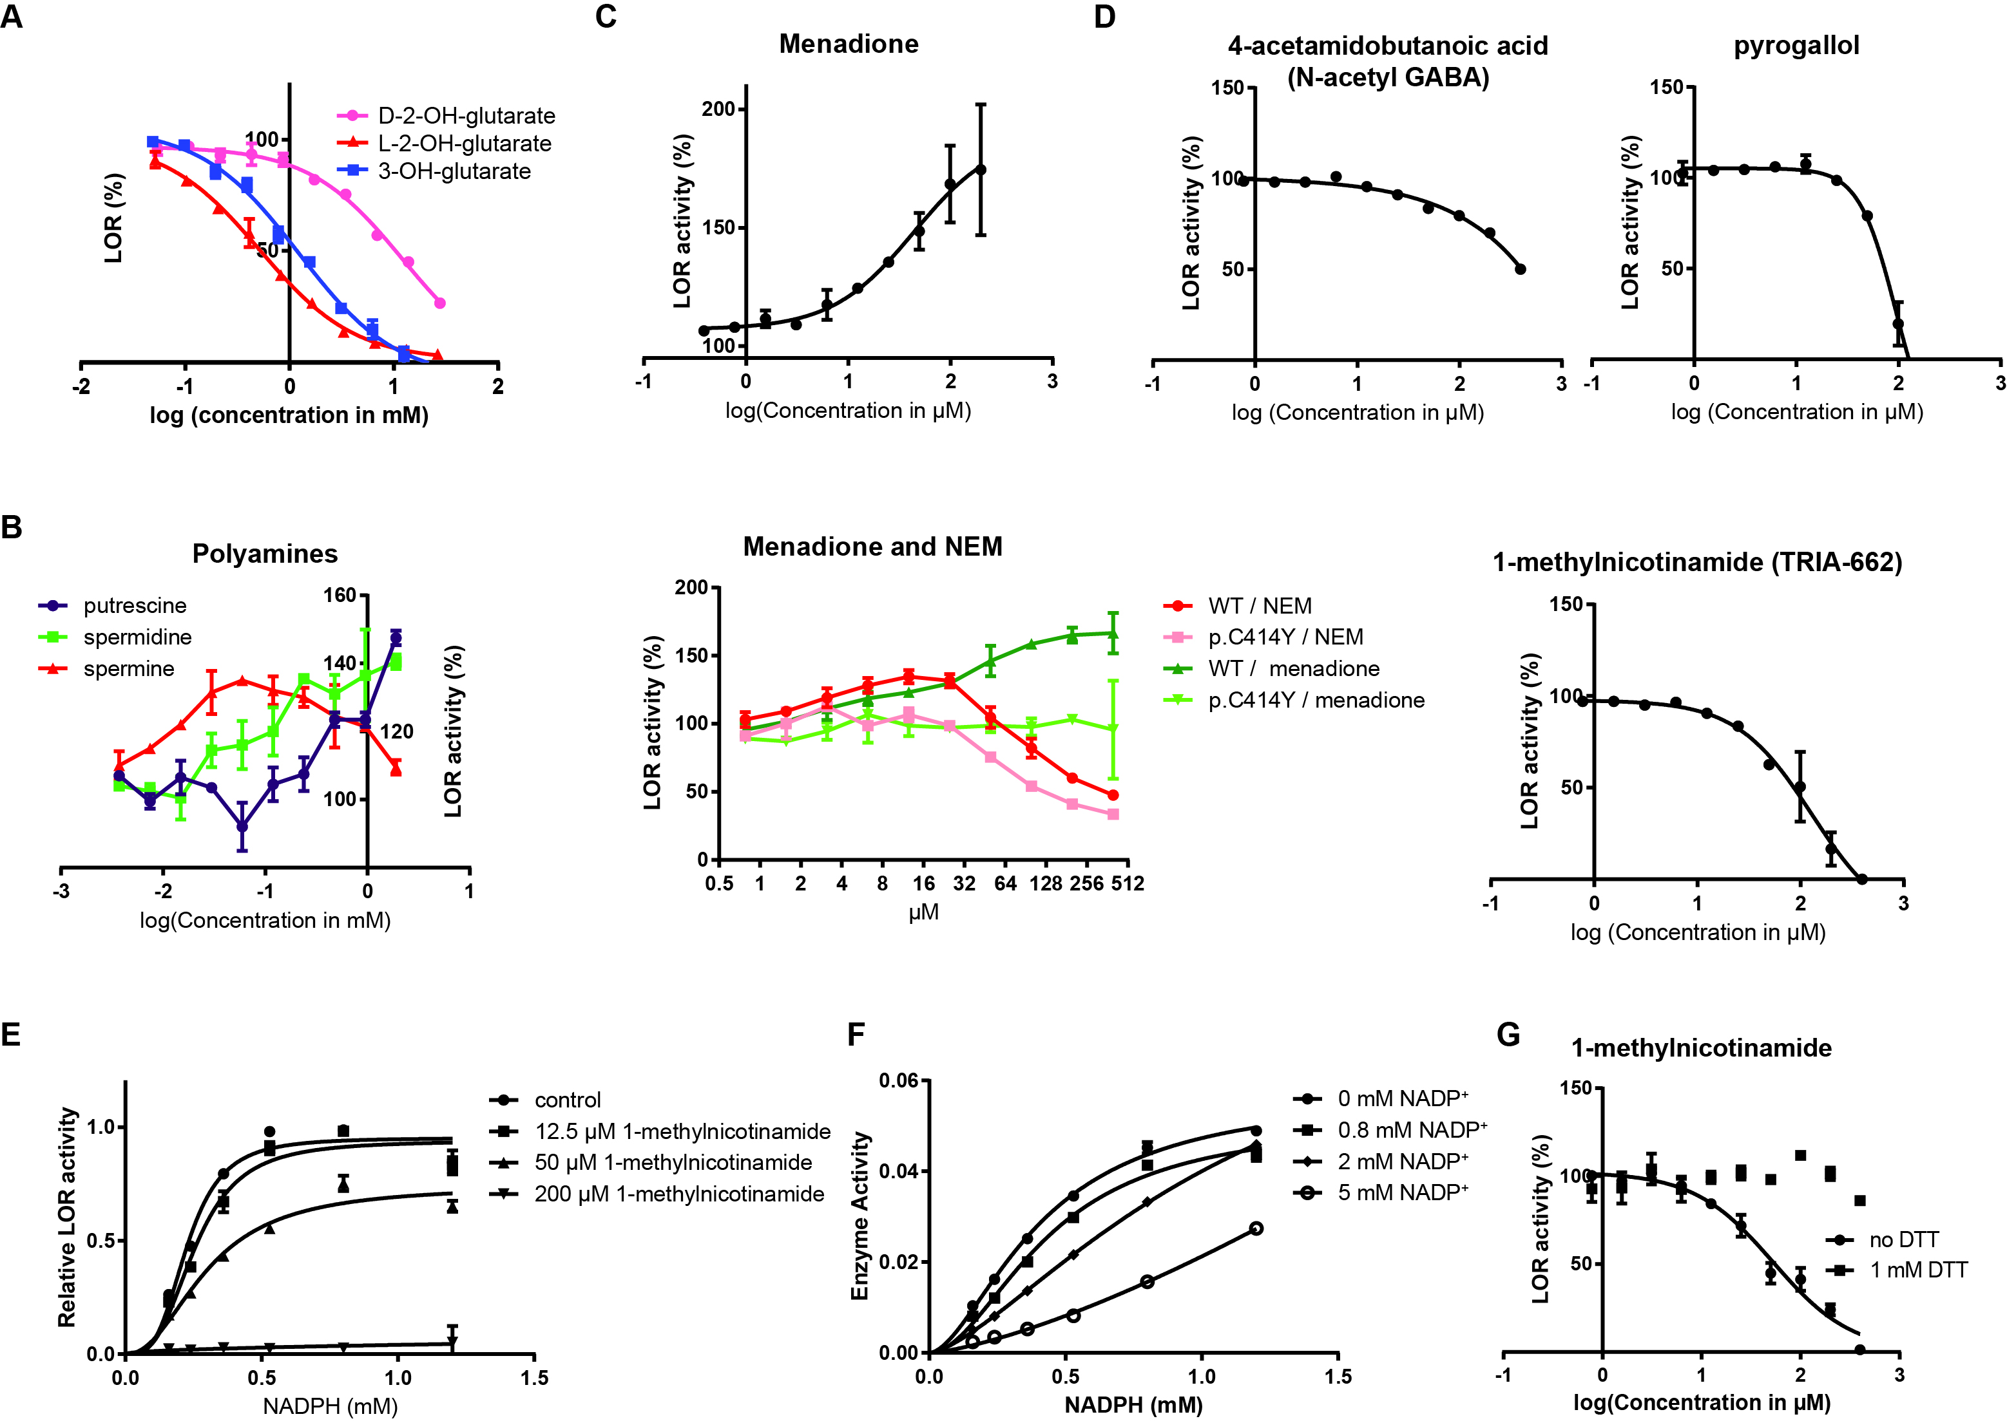

Supplementary Figure 12. High throughput screen of an endogenous metabolite library reveals inhibition of LOR by 1-MN⁺. (A) Inhibition of LOR by different hydroxyglutarate metabolites (n=2 per condition). (B) Activation of LOR by polyamines (n=2 per condition). (B) Activation of LOR by menadione (left panel, EC₅₀ = 44 µM, n=2 per condition) and its dependence on Cys414 (right panel, n=2 per condition). Activation by NEM was determined in parallel for comparison. (C) Inhibition of LOR by 4-acetamidobutanoic acid (N-acetyl-GABA; IC₅₀ = ~400 µM), pyrogallol (IC₅₀ = 94 µM)) and 1-MN⁺ (TRIA-662, IC₅₀ = 129 µM). Each condition was tested in duplicate. (D) Inhibitor kinetics for 1-MN⁺ for the dependence of rate on NADPH concentration (n=4 per condition). (E) Inhibitor kinetics for NADP⁺ for the dependence of rate on NADPH concentration (n=2 per condition). (F) Inhibition of LOR activity by 1-MN⁺ in presence and absence of 1 mM DTT (n=4 per condition, IC₅₀ for 1-MN⁺ = 53 µM). All error bars indicate SD.

