Supplementary File
Thiazolidin-4-one Derivatives Against Glioblastoma: Mcl-1 Inhibition at the Cost of Selectivity
Farah Chafika Kaouche *, Nahide Gulsah Deniz*, Cigdem Sayil, Gülsima Arik, Evren Onay Ucar, Nazli Arda and Abdelkader Chouaih

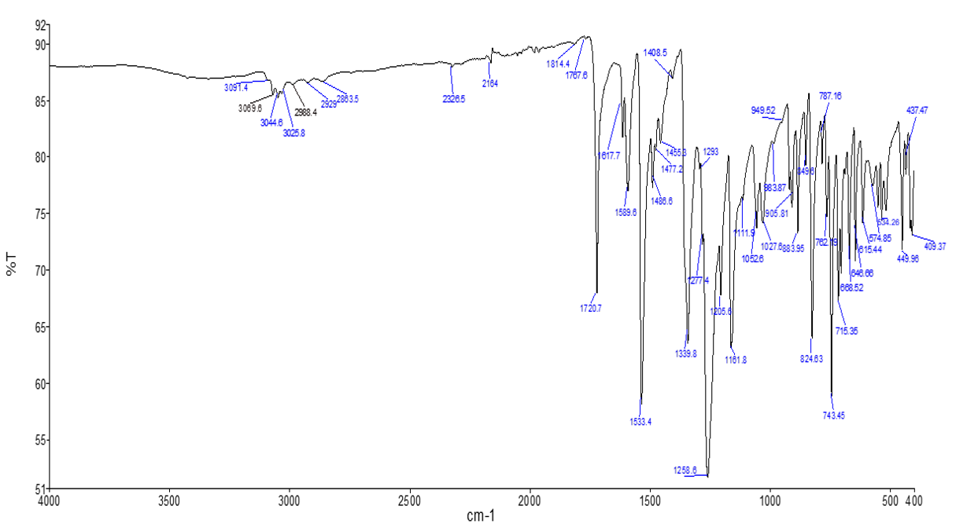
S1. FT-IR analysis of compound 7a

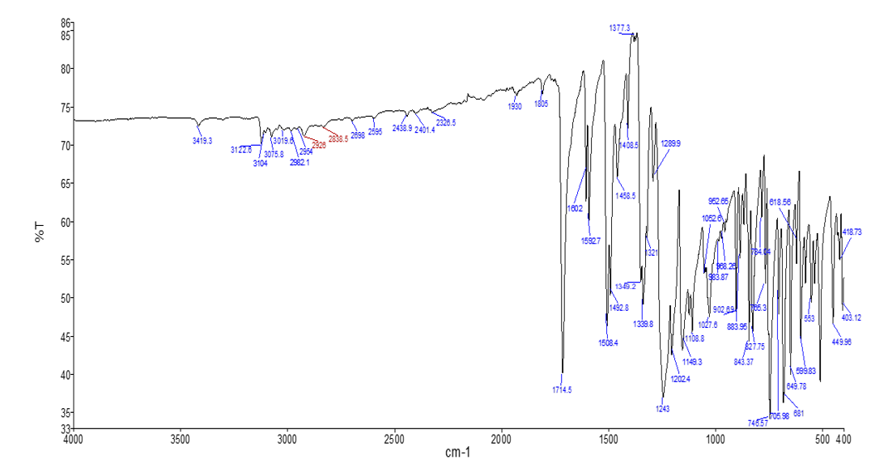
S2. FT-IR analysis of compound 7b
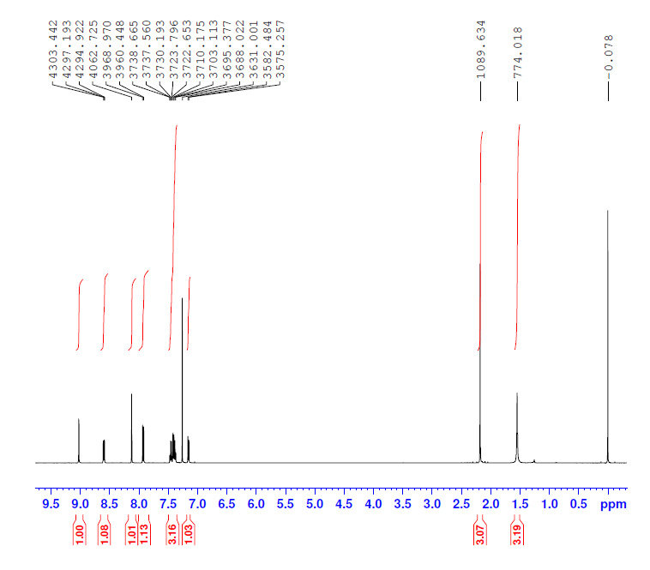
S3. ¹H NMR Spectra of compound 7a

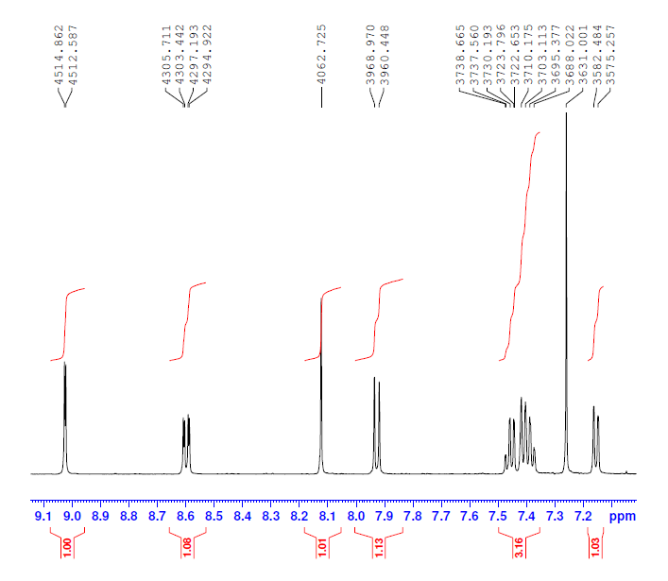
S4. ¹H NMR Spectra of compound 7a (between δ 7.0-9.1 ppm)
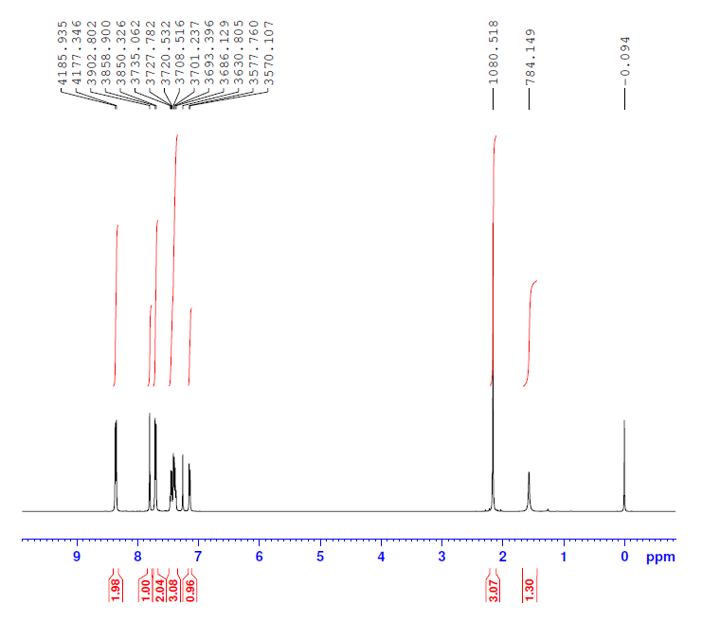
S5. ¹H NMR Spectra of compound 7b
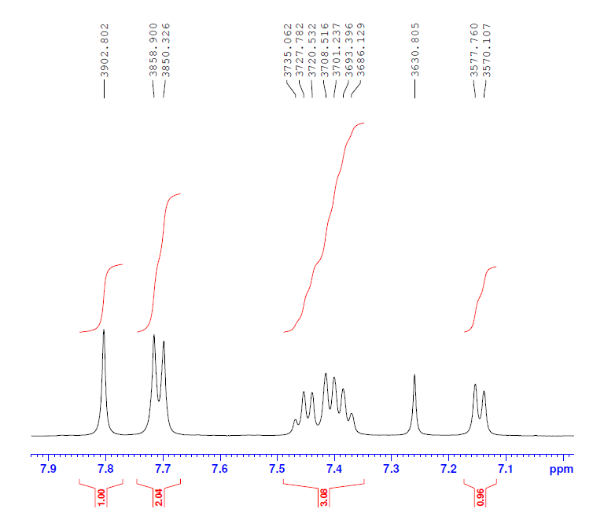
S6. ¹H NMR Spectra of compound 7b (between δ 7.0-8.00 ppm)

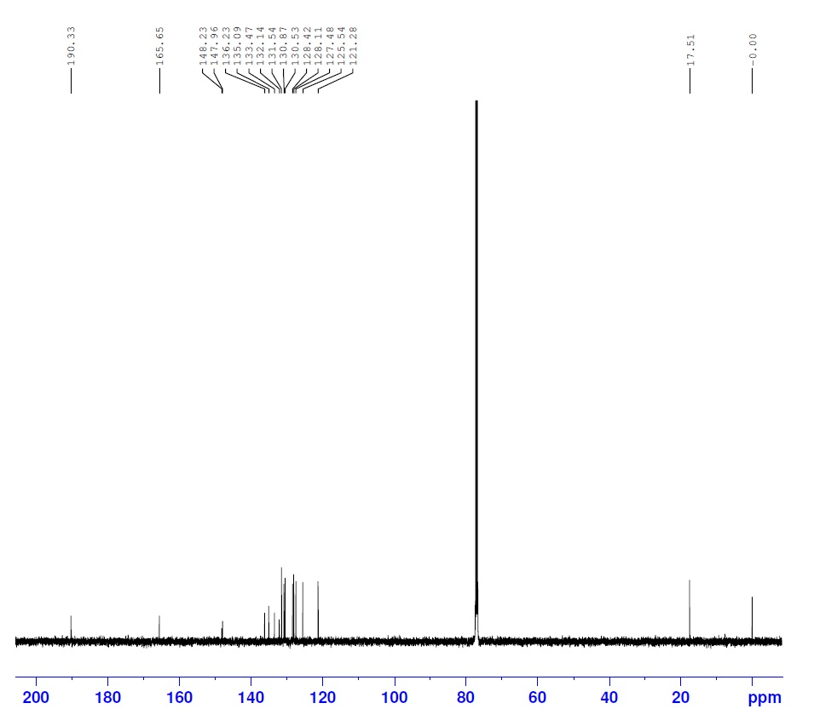
S7. ¹³C NMR Spectra of compound 7a

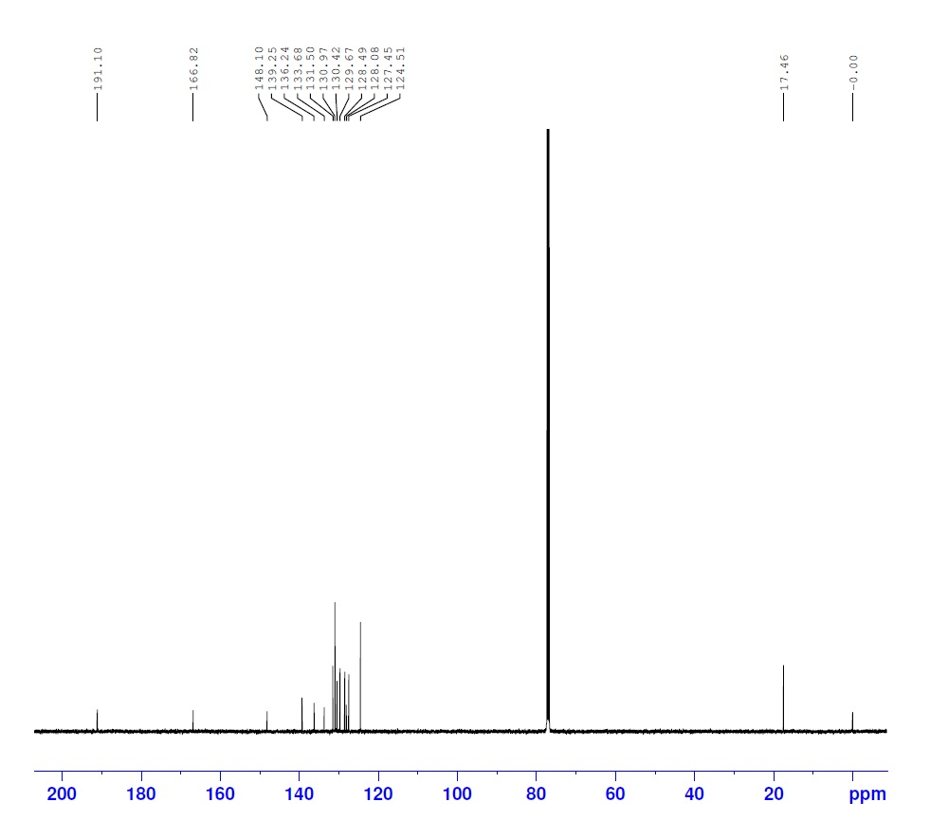
S8. ¹³C NMR Spectra of compound 7b

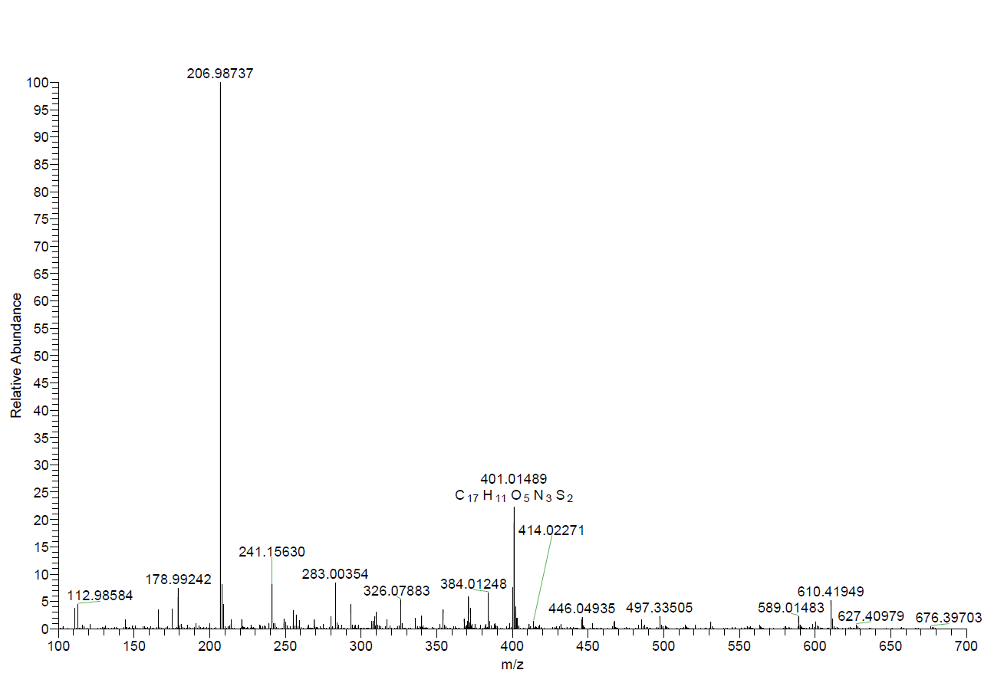
S9. HRMS[-ESI] Spectra of compound 7a

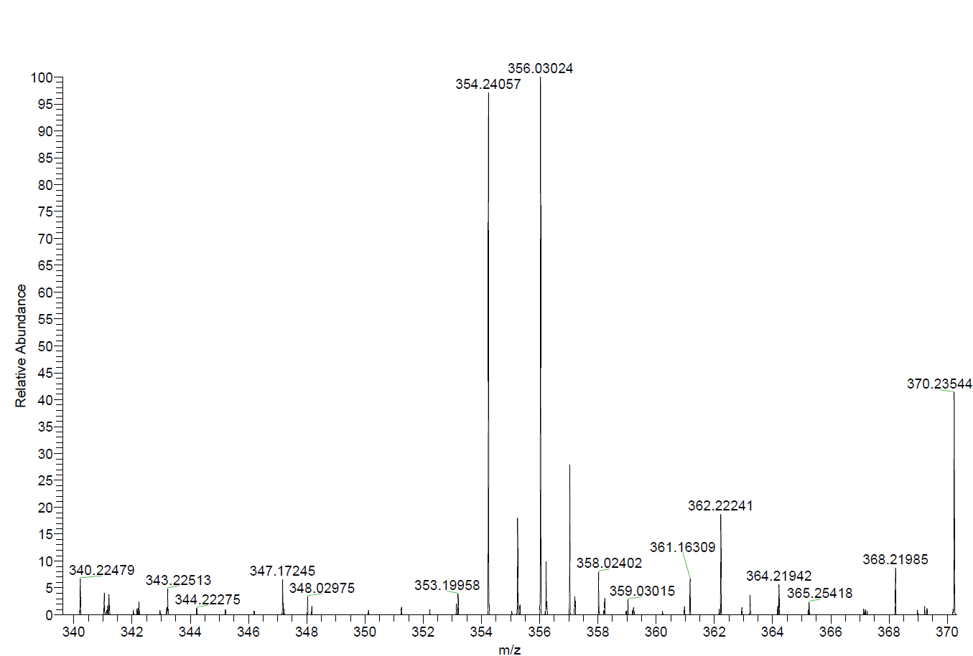
S10. HRMS[-ESI] Spectra of compound 7b

